

|  |  |
| --- | --- |
| **Web technologies | Front-End** | |
| Student(s’) name(s): | Abylaikhan Abdraman, Daniyar Usenhanov, Alina Mitroshina |
| Teacher name: | Dariya Bissengaliyeva |
| Project name: | Pharmacy helper |
| Project type: | Group |

**INTRODUCTION**

Our team chose a pharmacy as the topic for assignments. Our goal was to create a practical assistant site for a pharmacy, which will include tabs: home page, "Contact us", “Reviews", “Members”, “Locates of Pharmacy” and especially the helper that called “What hurts?”

**MAIN PART (Practical) | Information about developers and their responsibilities.**

Abyl's Responsibilities: animation js, scrollbar style, contact information page (internal attributes) and carousel:

There is examples of Abyl’s code:

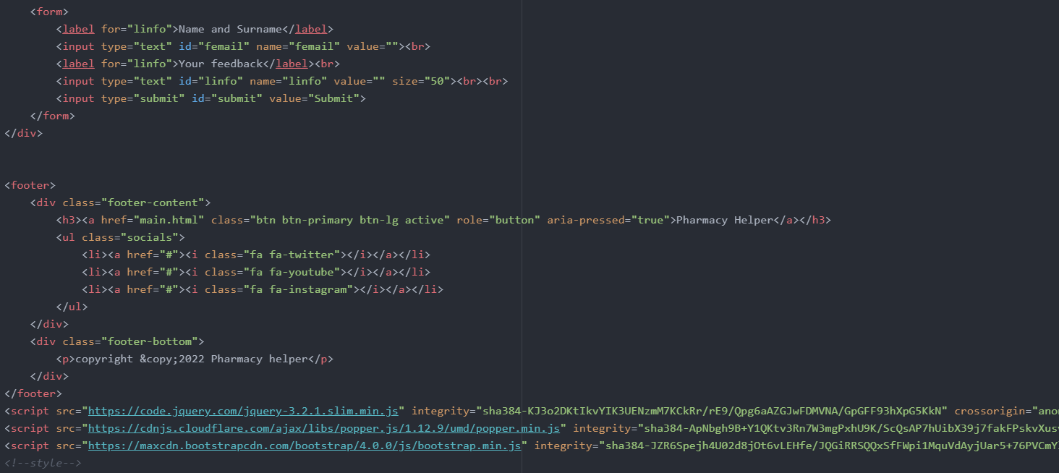

Carousel - is a slideshow component for cycling through elements—images or slides of text. The carousel is a slideshow for cycling through a series of content, built with CSS 3D transforms and a bit of JavaScript. It works with a series of images, text, or custom markup. It also includes support for previous/next controls and indicators, so we added some controls in our carousel:

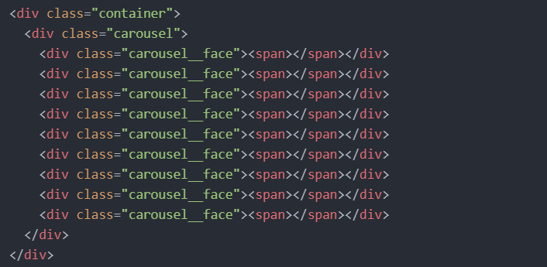

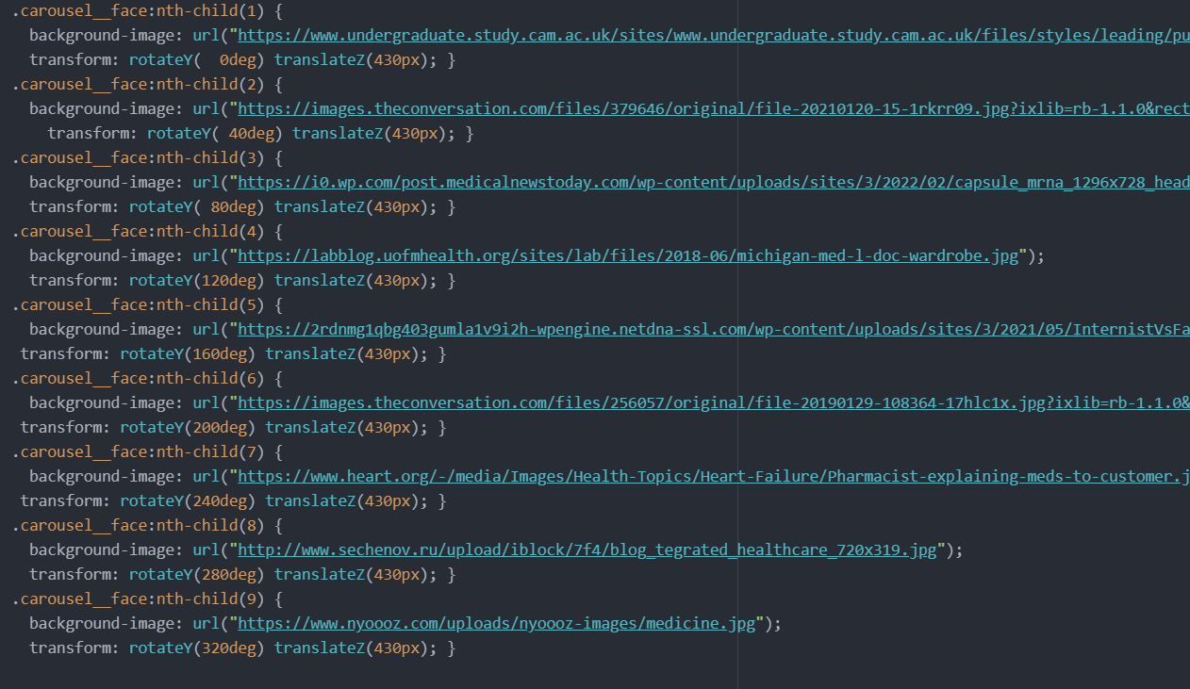

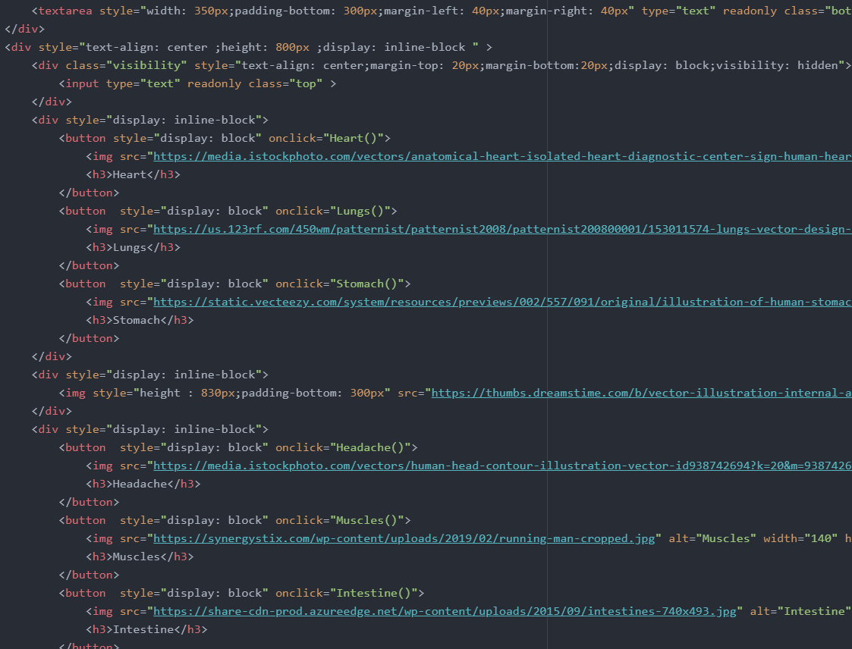

Setting -webkit-scrollbar styles is a good way to force your webpage to show horizontal or vertical scrollbars on versions of Mac OS newer than Lion, on which scrollbars are usually hidden by default:

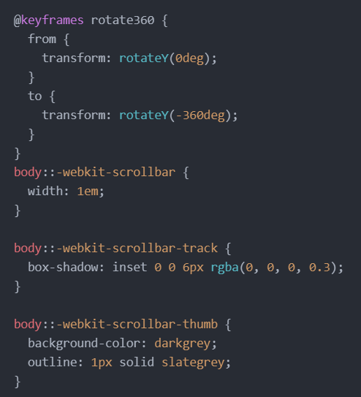

Our goal was to make a faithful assistant, giving brief information with recommendations on medicines for the main human organs. So, “What hurts?” tab Daniyar did hit.js, Abyl and Alina helped with style (in hit.html).

Daniyar’s Responsibilities: AddeventListener with click , mouseover, keypress, navbar with Alina, Padresses.html, in review.html javascript elements, js in participation.html with Alina:

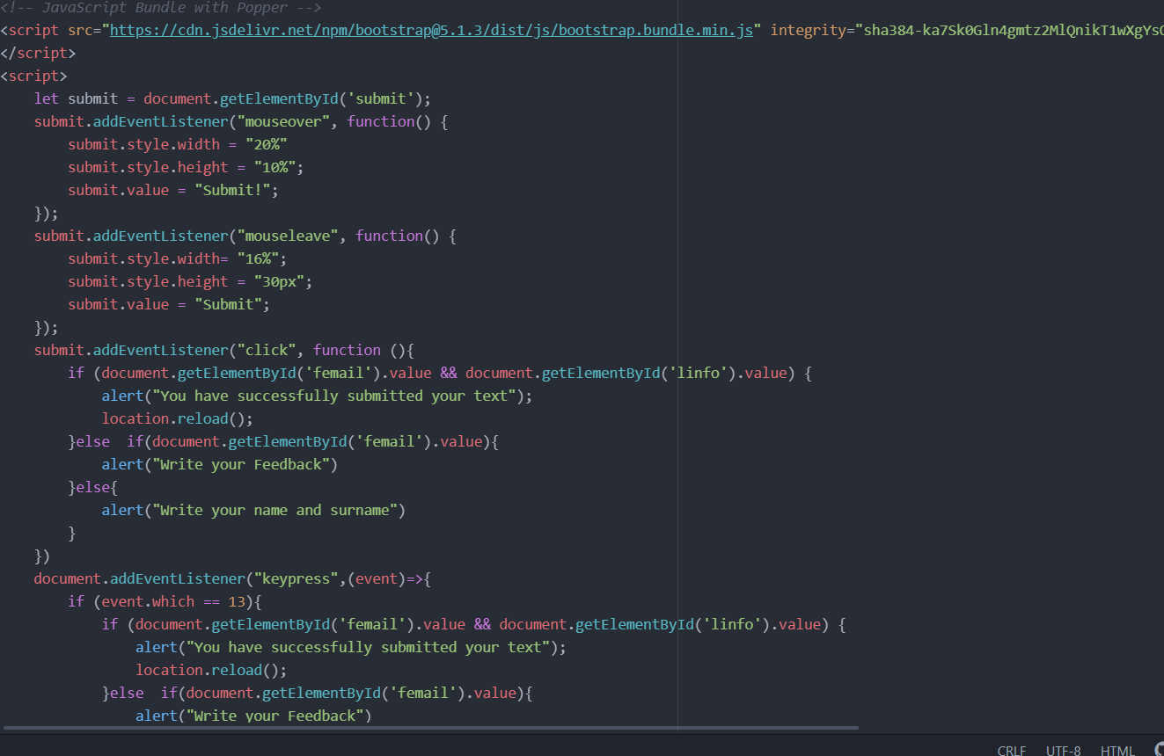

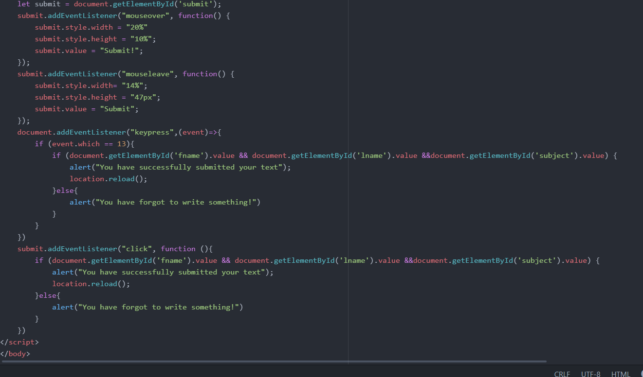

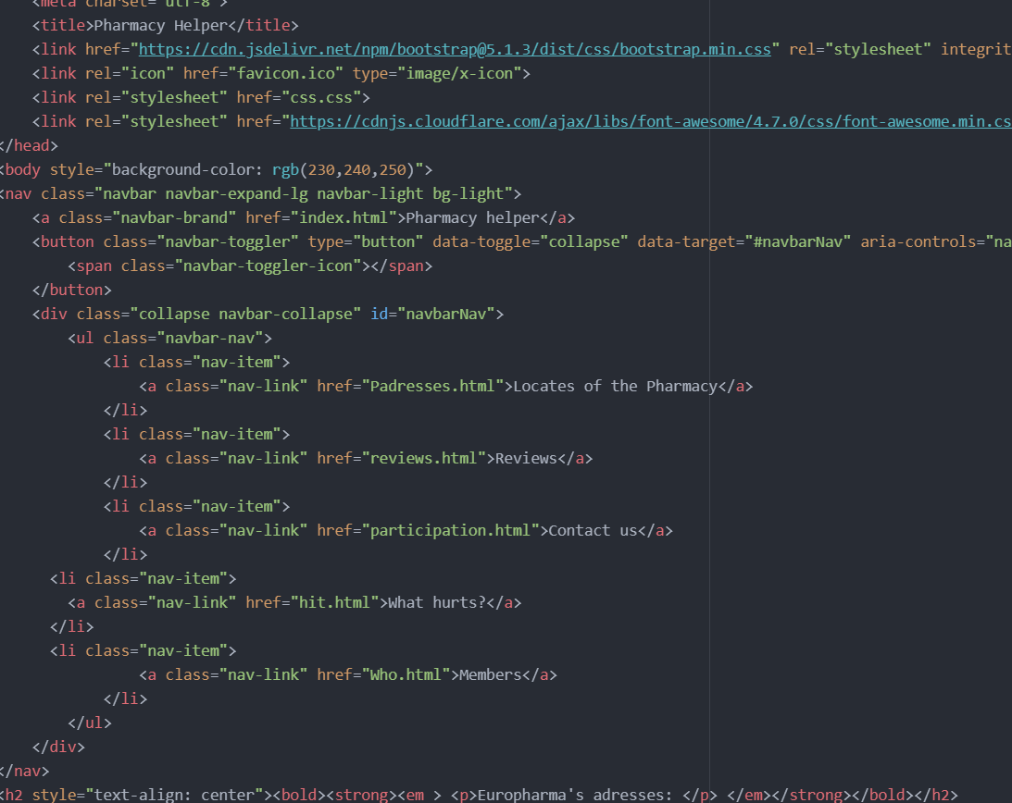

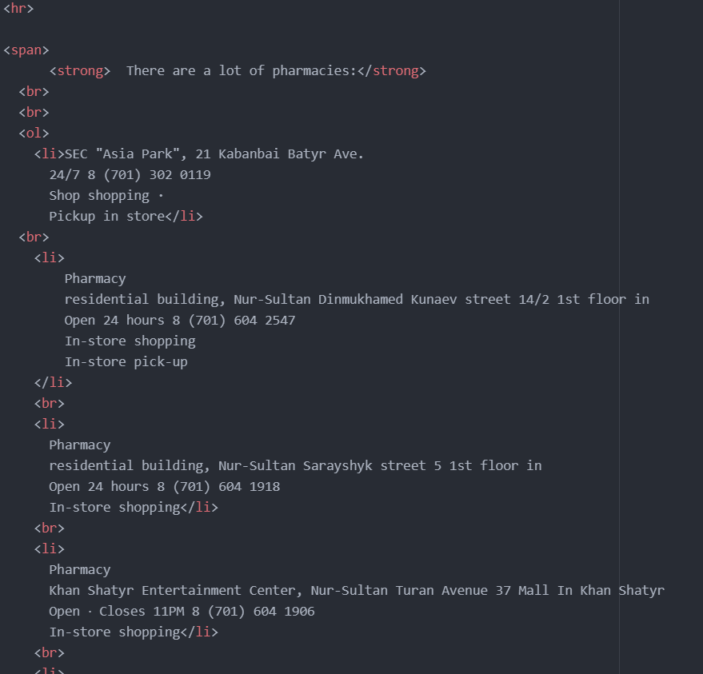

For example, we (Daniyar and Alina) added a **Navbar** to support site's header.

How it works?

1) Navbars require a wrapping .navbar with .navbar-expand{-sm|-md|-lg|-xl} for responsive collapsing and color scheme classes.

2) Navbars and their contents are fluid by default. Use optional containers to limit their horizontal width.

3) Use our spacing and flex utility classes for controlling spacing and alignment within navbars.

4) Navbars are responsive by default, but you can easily modify them to change that. Responsive behavior depends on our Collapse JavaScript plugin.

5) Navbars are hidden by default when printing. Force them to be printed by adding .d-print to the .navbar. See the display utility class.

6) Ensure accessibility by using a <nav> element or, if using a more generic element such as a <div>, add a role="navigation" to every navbar to explicitly identify it as a landmark region for users of assistive technologies.

Alina’s Responsibilities: CSS (css.css), some style sheets, table from home page (“Our partners”), navbar with Daniyar, reviews’ messages, favicon:

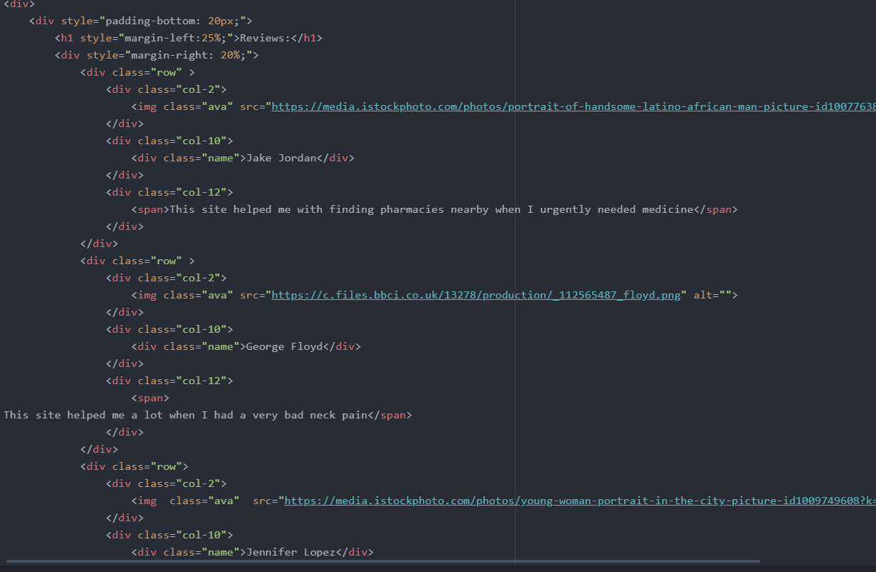

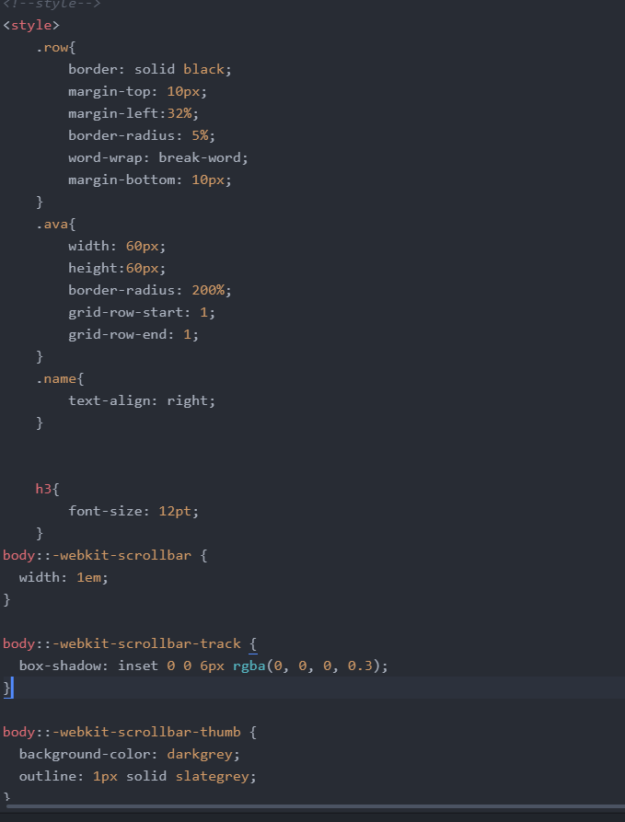

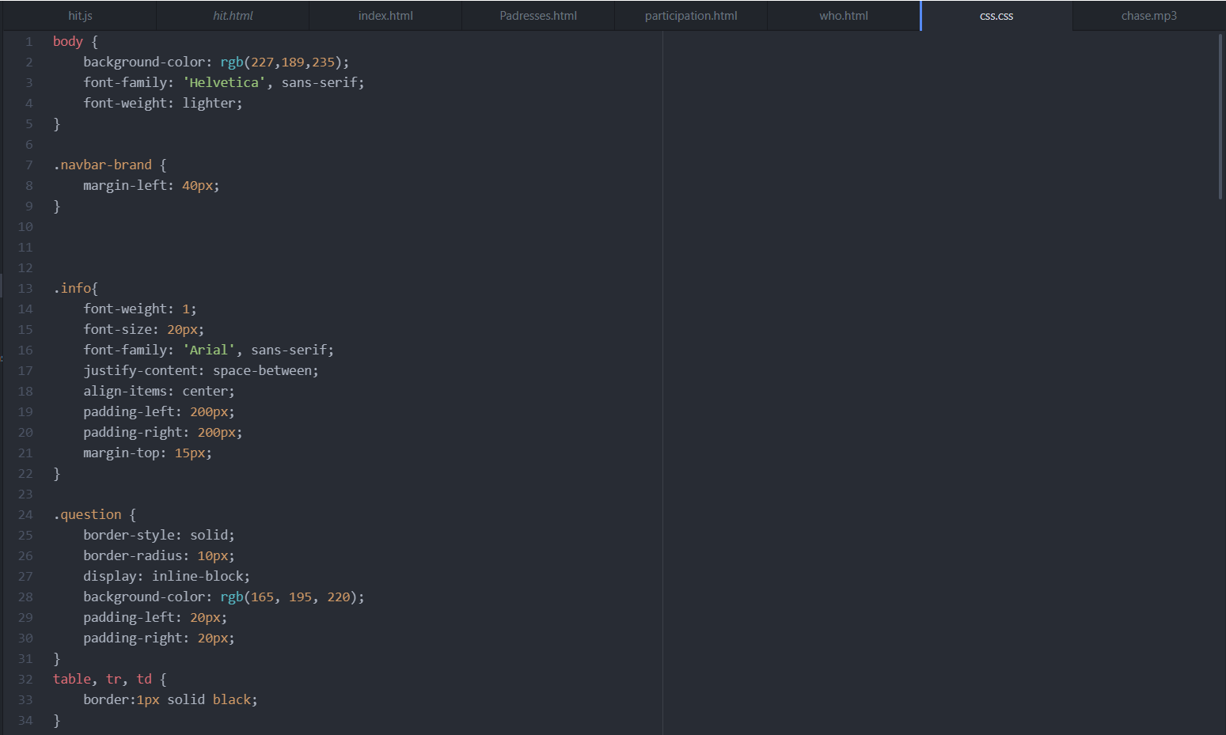

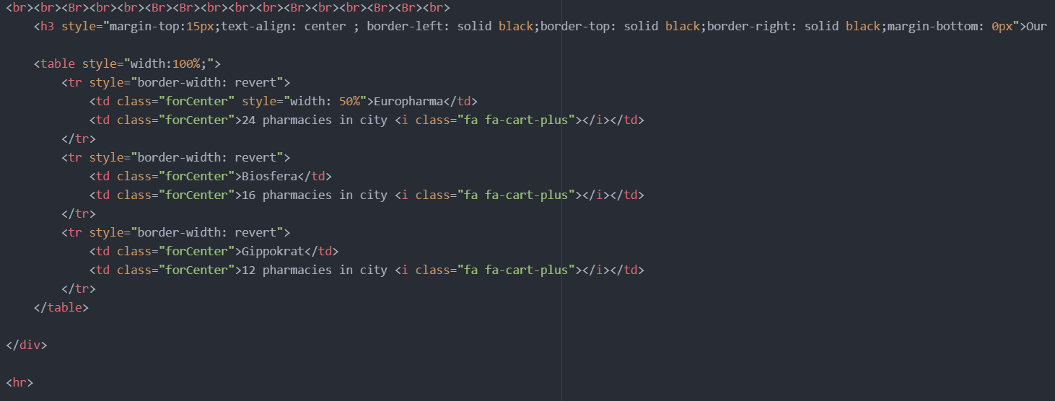

We would like to add that despite the fact that the first two assignments were made on the same topic, a lot has been corrected and revised. We have completely revised the design of the site itself, we have been more attentive to the fonts, favicon design, and color palette. Increasingly, hospital management and healthcare professionals are recognizing color and its uses for soothing, healing, and generally providing patients, staff, and visitors with a more pleasant experience while visiting the site. The tenderness and pleasant blueness of the blue color is associated with the universal harmony of the world. Blue symbolizes intelligence and self-improvement. Very often, the blue scale is associated with purity, silence, coolness, sincere and honest intentions. Thus, we believe that the blue color will evoke a sense of trust in our pharmacy.

Also, it was quite typical to make a medical cross as a favicon - in this way, the visitor will immediately understand that he has entered a medical site. Design elements familiar to every person give a feeling of comfort.

**PROGRESS [optional]**

|  |  |
| --- | --- |
| 09.02.2022 | JavaScript Algorithms and Data Structures (FreeCodeCamp) |
| 10.02.2022 | JavaScript Tutorial (lectures) |
| 11.02.2022 | JavaScript DOM Exercises 01 |
| 12.02.2022 | JS animation, AddeventListener with click, CSS style |
| 13.02.2022 | scrollbar style, contact information page, review.html |
| 16.02.2022 | Keypress, navbar editing |
| 17.02.2022 | Hit.js, hit.html |
| 18.02.2022 | Css.css, favicon, carousel |
| 19.02.2022 | Editing |
| 20.02.2022 | report |