Final Report - Lab #2 - Introduction to ROS

Daniel Engelsman - 300546173

Tom Smadar - 203374061

The Script is encapsulating the controller (enables us to give the robot multiple destinations and to plot its trail and heading) is given by:

rosshutdown

**%% Initialization**

close all

clear all

clc

rosinit

global robot_path robot_az rate runNum b c

**%% Topics**

Odom_topic = rossubscriber('/pioneer/odom');

Vel_topic = rospublisher('/pioneer/cmd_vel');

rate = 0.2;

**%% Goals**

Goal(1).loc = [-0.9 -0.2 0]';

Goal(1).Orien = deg2rad(2.4);

Goal(2).loc = [-0.9 1 0]';

Goal(2).Orien = deg2rad(0);

Goal(3).loc = [1 1 0]';

Goal(3).Orien = deg2rad(-90);

Goal(4).loc = [1 -1 0]';

Goal(4).Orien = deg2rad(90);

**%% Execute**

SafetyHalt(Vel_topic);

b = 1;

c = 1;

for k=1:length(Goal)

MyController(Goal(k),Odom_topic,Vel_topic);

end

**%% Plot**

figure(1)

hold on

box on

grid on

scatter(robot_path(1,:),robot_path(2,:))

set(gca,'FontSize',14)

title('Robot Path','FontSize',20)

xlabel('X [m]','FontSize',14)

ylabel('Y [m]','FontSize',14)

figure(2)

hold on

box on

grid on

plot(robot_az(2,:),rad2deg(robot_az(1,:)),'LineWidth',2)

set(gca,'FontSize',14)

title('Robot Azimuth','FontSize',20)

xlabel('Time [s]','FontSize',14)

ylabel('Azimuth [Deg]','FontSize',14)

And the functions in use are (given PD Block not included):

function [] = MyController(Goal,Odometry_Topic,Velocity_Topic)

**%% Initialization**

OdoSub = Odometry_Topic; % Odometry subscriber

VelPub = Velocity_Topic; % Velocity command publisher

epsLoc = 0.1; % Permitted location error [m]

step = 0.5; % Step length [m]

**%% Movement**

while(1)

odo = receive(OdoSub,2); % Recieve odometry data

r = odo.Pose.Pose.Position;

Rc = [r.X r.Y r.Z]'; % Current Position

LocErr = norm(Goal.loc - Rc); % Current distance from goal [m]

% Breaking Conditions

if LocErr < epsLoc

SetLOS(Goal.Orien,OdoSub,VelPub); % If we've reached goal, turn to requested azimuth and break

SafetyHalt(VelPub);

return;

end

% Movement

SetLOS(CalcLOS(Goal.loc,OdoSub),OdoSub,VelPub); % for each step, turn towards goal

StepFwd(min(step,LocErr),OdoSub,VelPub); % step forward

end

end

function [] = SafetyHalt(VelPub)

%SafetyHalt Safely halts the Pioneer

vCmd_msg = rosmessage(VelPub); % Create vel. cmd. message

vCmd_msg.Linear.X = 0;

vCmd_msg.Linear.Y = 0;

vCmd_msg.Linear.Z = 0;

vCmd_msg.Angular.X = 0;

vCmd_msg.Angular.Y = 0;

vCmd_msg.Angular.Z = 0;

send(VelPub,vCmd_msg)

end

function [Az1] = CalcLOS(R1,OdoSub)

% This function calculates the required LOS for the Pioneer robot

odo1 = receive(OdoSub,2); % Recieve odometry

r = odo1.Pose.Pose.Position;

R0 = [r.X r.Y r.Z]'; % Current position

Vec = R1-R0; % Delta to goal

Az1 = -atan2(Vec(2),Vec(1)); % Goal azimuth

end

function [] = SetLOS(Az1,OdoSub,VelPub)

% this function turns the Pioneer robot around to a required azimuth

global rate b c robot_path robot_az

odo = receive(OdoSub,2); % Recieve odometry

t0 = odo.Header.Stamp.Sec; % Initial time

a=1; % index

vCmd = 0; % Initial velocity command

maxAzErr = deg2rad(0.5); % Permitted angular error (epsilon)

while(1)

odo = receive(OdoSub,2); % Recieve odometry

pause(rate)

r = odo.Pose.Pose.Orientation;

ang = [r.X r.Y r.Z r.W]; % Current orientation

ang = ang./norm(ang);

ang = quat2eul(ang,'XYZ'); % Conver to Euler angles

Az0 = ang(1); % current azimuth

disp(rad2deg(Az0));

Err(a) = Az1-Az0; % Azimuth difference

disp(rad2deg(Err(a)))

%Recording:

rpos = odo.Pose.Pose.Position;

R1 = [r.X r.Y r.Z]'; % Current position

robot_path(:,b) = R1;

b=b+1;

robot_az(1,c) = Az0;

t1 = odo.Header.Stamp.Sec; % Current timestamp

robot_az(2,c) = t1;

c=c+1;

% /Recording

if abs(Err(a))>pi % Ensure shortest turn

if Err(a) > 0

Err(a) = Err(a) - 2*pi;

else

Err(a) = Err(a) + 2*pi;

end

end

if abs(Err(a)) < maxAzErr % if required azimuth reached, break

SafetyHalt(VelPub);

return;

end

dt = t1-t0; % Time step

if dt<1

dt=0.5;

end

t0=t1; % Remember previous timestamp

vCmd = PD_Block([0.5 0.001 200],dt,Err,vCmd); % Calculate angular velocity command

if abs(vCmd) > 0.7 % Verify angular velocity command does not exceed permitted maximum

vCmd = 0.7*sign(vCmd);

end

vCmd_msg = rosmessage(VelPub); % Create velocity command message

vCmd_msg.Angular.Z = -vCmd;

send(VelPub,vCmd_msg); % Send velocity command message to robot

a=a+1;

end

End

function [] = StepFwd(step,OdoSub,VelPub)

% This function makes the Pioneer robot mover forward, a specified distance

global rate robot_path b robot_az c

odo1 = receive(OdoSub,2); % Recieve odometry

t0 = odo1.Header.Stamp.Sec; % Initial time

a=1; % index

vCmd = 0; % Initial velocity command

maxErr = 0.01; % Permitted step error (epsilon)

r = odo1.Pose.Pose.Position;

R0 = [r.X r.Y r.Z]'; % Starting Position

while(1)

odo1 = receive(OdoSub,2); % Recieve odometry

pause(rate)

r = odo1.Pose.Pose.Position;

R1 = [r.X r.Y r.Z]'; % Current position

%Recording:

robot_path(:,b) = R1;

b=b+1;

r = odo1.Pose.Pose.Orientation;

ang = [r.X r.Y r.Z r.W]; % Current orientation

ang = ang./norm(ang);

ang = quat2eul(ang,'XYZ'); % Convert to Euler angles

robot_az(1,c) = ang(1);

t1 = odo1.Header.Stamp.Sec; % Current timestamp

robot_az(2,c) = t1;

c=c+1;

% /Recording

disp(R1);

Err(a) = step - norm(R1-R0); % Remaining distance to complete step

if abs(Err(a)) < maxErr

SafetyHalt(VelPub);

return; % If we've completed the step, break

end

t1 = odo1.Header.Stamp.Sec; % Current timestamp

dt = t1-t0; % Time step

if dt<1

dt=0.5;

end

t0=t1; % Remember previous timestamp

vCmd = PD_Block([0.6 0.05 100]',dt,Err,vCmd); % Calculate velocity command

if abs(vCmd) > 1 % Verify velocity command does not exceed permitted maximum

vCmd = 1*sign(vCmd);

end

vCmd_msg = rosmessage(VelPub); % Create vel. cmd. message

vCmd_msg.Linear.X = vCmd;

send(VelPub,vCmd_msg); % Send velocity cmd. message to robot

a=a+1;

end

end

**Results and conclusions**

The route is comprised of numerous “goal points”, that are predefined in the envelope script. We then launch it, and execution occurs in a for-loop (per goal point) all time that the desired approximation error has not been achieved.

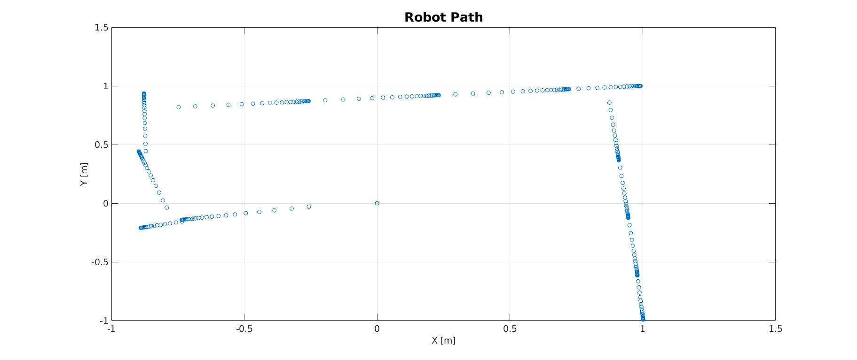  
Robot Path in the XY plane [m]

The 4 given goal points dictate the robot’s path, and are segmented as function of the desired “step” size (here: 0.5 [m]). The density of the sampling points are explained by the properties of the given PD block, whose intensity is influenced by the magnitude of the Error.

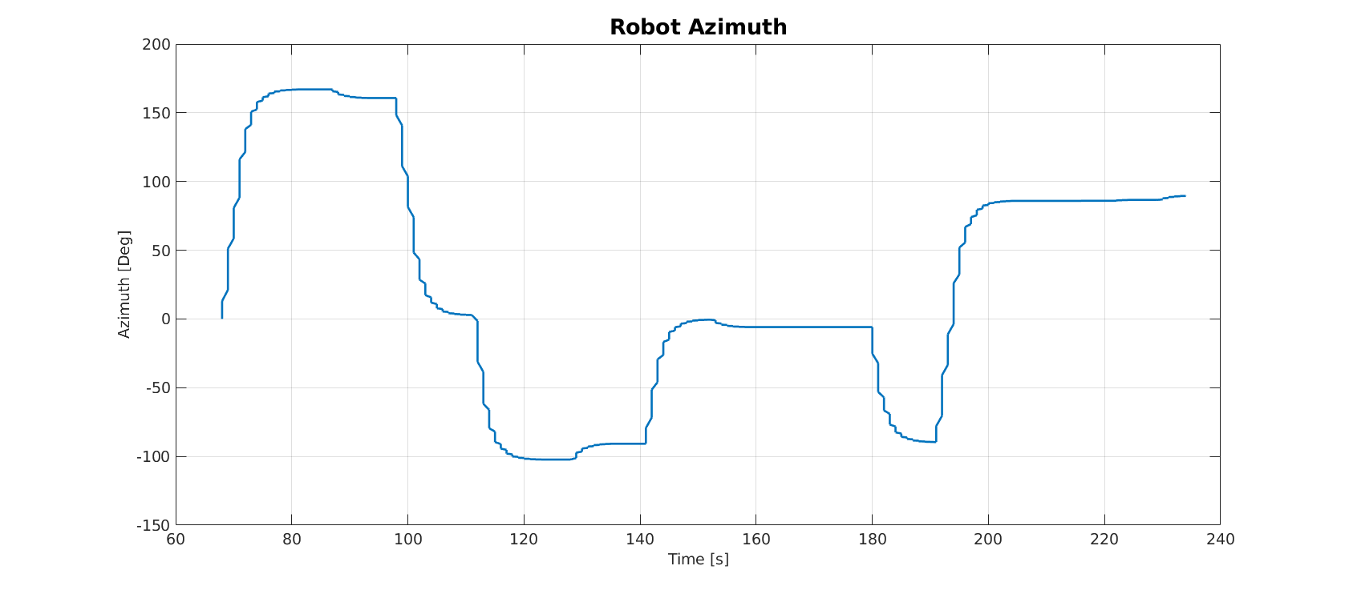  
Azimuth vs. Time [s]

The Second graph shows the currnet Robot’s Azimuth while seeking to reduce the Error. The curves are when error is big, and when parallelism is obtained, the robot is vacant to move on to the StepFwd function, that moves him forward towards the current goal point.