Question 2:

1)   
The image pair we choose:  
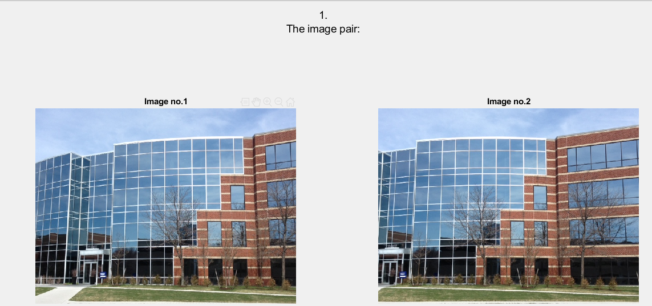  
  
2-3)  
I padded the images with zeros and then I searched for key-points:  
  
  
4-5)  
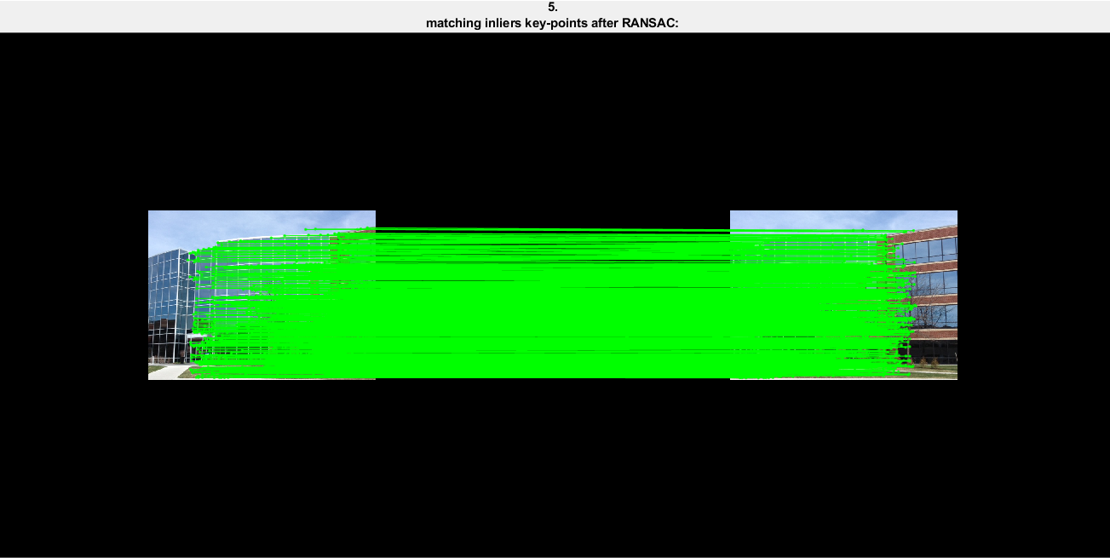  
  
The projective transformation that I found:  
  
The minimum number of points required for calculating the projective transform is 4 pairs of matching points.

Explanation:  
the relation between every pair of matching point and the projection matrix is:   
p'= 𝐻\*p   
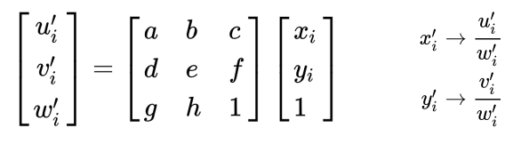  
<=>   
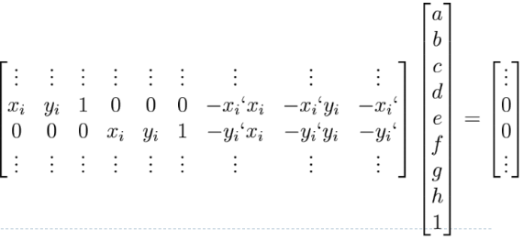  
From every pair of matching point 2 equations are obtained, for finding the 8 parameters we need 8 equations, so in order to be able to solve we need at least 4 pairs of matching points.

6-7)  
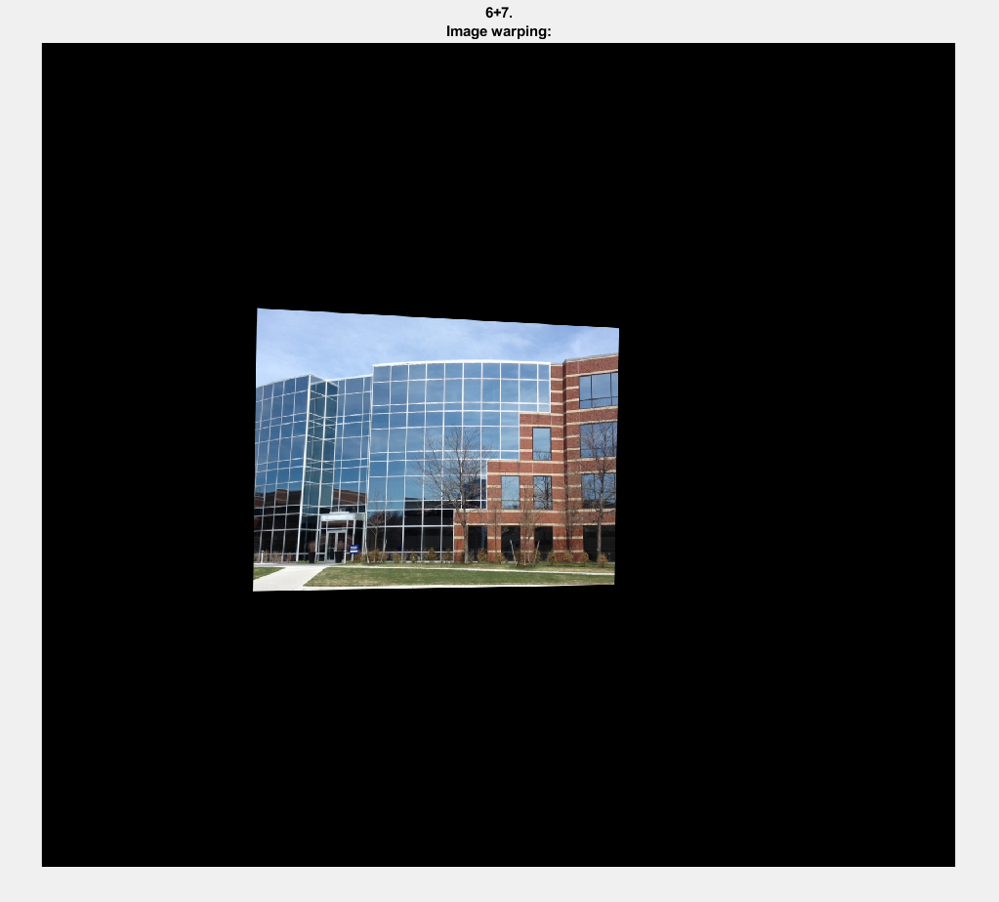  
image warping steps:  
- find from where each pixel in the projected image comes in the original image:   
 - finding the inverse transformation.

- create a vector of all the image 1 homogeneous coordinates

- apply the transformation we found on image 1 coordinates

- the values of where each pixel in the projected image comes in the original image aren't integers so we interpolated the value of inversed pixels and assign it to the pixels in the projected image.

8)

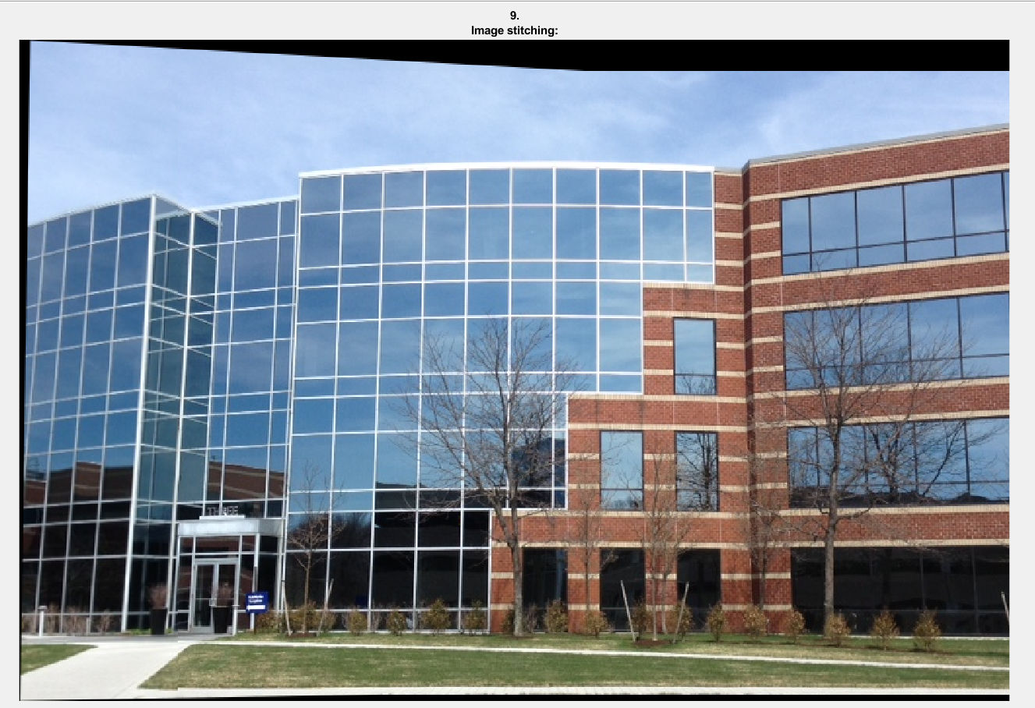  
We added the non-zero pixels in the warped image (created by image 1) to image2 and catted the zeros padding.