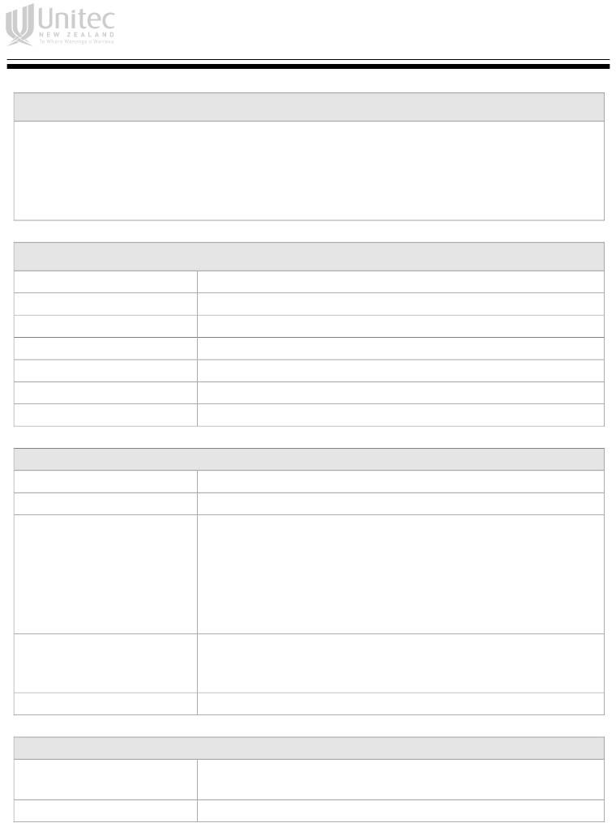

Assignment Cover Sheet

**Instructions**

* Complete this cover sheet and attach it to your assignment.
* Where applicable, show details of your workings.
* This is an individual assignment and must be your own work.
* Collusion, copying or plagiarism may result in disciplinary action.
* We advise that you keep a copy of this assignment.

**Assignment Details**

Course: ISCG6420 – Internet & Website Development

Assignment Number: 1

Assignment Due: 18 April 2022, Monday 11:59pm

Semester: Semester 1, 2022

Lecturer: Asra Rahimi

Class time: Wednesday, 6:00pm- 9:00pm

Student Signature:

Date of Signature: 17/04/2022

Student Declaration: I confirm that:

This is an original assignment and is entirely my own work.

Where I have used ideas, images etc of other writers, I have acknowledged the source in every case.

This assignment has not previously been submitted as assessed work for any academic course.

**Student Details**

Student Name: Danica Rose Montano

Student ID: 1538485

**Office Use**