Forecasting severe patient harm in the NHS
Dr Richard Wood and Dr Nick Howlett, Bristol NHS
Alex/Will – named here too?

1. Background
This competition is about forecasting severe harm resulting from delays in admitting patients from the Emergency Department (ED). Delays occur when it has been decided that a patient needs to be admitted from the ED but there are no available beds in the hospital. Recent research from the competition authors’ Bristol NHS healthcare system has shown that every four hours of ED admission delay associates with an 8% increase in the odds of 30-day mortality (link). Applied to recent data on ED admission delays, this corresponds to an estimated 25 deaths in Bristol per month which can be considered ‘avoidable’ were there no ED admission delays.

2. Objective
The objective of this competition is to develop an algorithm that can be applied ‘live’ to near-real-time data to forecast the number of avoidable deaths on each of the next 10 days. It is the competition authors’ intention to implement a winning entry within the Bristol NHS healthcare system, where the forecast will be scheduled to update each day with the latest data. The purpose is to provide managers with advance warning of severe patient harm such that pre-emptive action may be taken. All data in this project is ‘real’.

3. Key dates
The competition will run as follows.
- 11 February 2026. Competition launch, including the release of the development dataset. This includes the target outcome variable (daily estimated avoidable deaths) and all candidate explanatory variables over the period from March 2023 to September 2025. Competitors are free to use this data however they wish in training, validating and testing their algorithms.
- 5 April 2026. Deadline for competitors to submit their final algorithms which are not thereafter permitted to change (i.e., the code used to turn the ‘inputs’ into ‘outputs’ must stay the same).
- 6 April 2026. The assessment dataset is released, upon which competitors must apply their submitted algorithms in generating forecasts over the assessment period from October 2025 to March 2026.
- 20 April 2026. Deadline for competitors to submit their forecasts.
- 8 May 2026. Winners announced.

4. Development dataset
The target outcome variable is the daily estimated avoidable deaths, which has been pre-calculated based on the ED admission delays and patient attributes for all affected patients in the Bristol NHS healthcare system. There is no missing data for this variable.
The 220 candidate explanatory variables vary in time frequency of recording, from every day to every 15 minutes. Some have records for every time-point within the 16 March 2023 to 30 September 2025 period whilst others have only partial recordings and missing data-points.
Both the target outcome variable and the candidate explanatory variables are included within a single CSV dataset, which is available at the following GitHub page: XXXX.
See the Appendix for a glossary of terms used within this data, as well as a descriptive summary of the data items.

5. Assessment dataset
The assessment dataset will be of the same format to the development dataset, containing the target variable and 220 candidate explanatory variables over the period from 1 October 2025 to 31 March 2026. As with the development dataset, it is entirely possible (and expected) that some values for some explanatory variables will be missing. This data will be released to the aforementioned GitHub page.

6. Accuracy criteria
There are 182 days within the 1 October 2025 to 31 March 2026 range of the assessment dataset, meaning there are 173 sliding 10-day forecast periods. E.g., the first covers the 10 days from 1 to 10 October 2025 and the last covers the 10 days from 21 to 31 March 2026.
Using only the submitted algorithm, competitors must produce forecasts for each day within each of these 173 forecast periods. Mean Squared Error (MSE) will be calculated to measure forecast accuracy over the 1-to-5-day horizon and the 6-to-10-day horizon, as follows:
$${MSE}_{1to5d}=\frac{1}{173×5}\sum_{p=1}^{173}{\sum_{d=1}^{5}{{\left(Y_{p,d}-{\hat{Y}}_{p,d}\right)}^{2}}}$$
$${MSE}_{6to10d}=\frac{1}{173×5}\sum_{p=1}^{173}{\sum_{d=6}^{10}{{\left(Y_{p,d}-{\hat{Y}}_{p,d}\right)}^{2}}}$$

where $Y_{p,d}$ is the observed value of the target variable at day $d$ within forecast period $p$ and ${\hat{Y}}_{p,d}$ is the corresponding forecasted value. For example, $Y_{4,3}$ would relate to the third day within the fourth forecast period. The fourth forecast period is from 4 to 13 October 2025 and so the third day in this is the 6 October 2025, and hence $Y_{4,3}$ is the observed value on that day. Note, of course, that $Y_{4,3}=Y_{1,6}=Y_{2,5}=Y_{3,4}$.

7. Additional restrictions
Only data up to midday can be used for producing the forecasts on the coming 10 days. So, if today is day $D$ then the forecasts over days $D+1, …,D+10$ can only be based on data up to midday on day $D$.
Data on the target outcome variable is subject to a reporting lag of up to three days, and so (to ensure suitability for real-life operational use) any algorithms using past values of the target variable can only use data before three days past. Specifically, if today is day $D$ (Saturday) then only data up to and including day $D-3$ (Wednesday) can be used. This relates only to the target outcome variable.
The algorithm may be recalibrated based on the new data contained in the assessment dataset when generating forecasts. While the algorithm code is not permitted to change, any model structure or parameters may be dynamically updated according to the new inputs, provided any such changes are driven only by the new data applied to the existing code as submitted.
The computational running time to produce one set of 10-day forecasts must be under one hour on a standard desktop computer.
The algorithm must be coded in either R or Python.

8. Prizes
One prize will be given for the lowest ${MSE}_{1to5d}$.
One prize will be given for the lowest ${MSE}_{6to10d}$.
All winning teams will be assessed by the competition authors to ensure that the reported MSEs can be replicated with the submitted models, and to check all above restrictions are satisfied.

9. Beyond the competition
It is the competition authors’ intention to implement the winning algorithm for ‘live’ use within the Bristol NHS healthcare system. There is a Linux server within the healthcare system which can host the algorithm. The intention would be to schedule the algorithm to run at 12h00 midday each day, with the latest outputs available on a web-based user interface shortly after (so being accessible to afternoon operational planning meetings). The server has ready access to the latest data covering the explanatory variables and target outcome variable (excluding the most recent three-day period). Developing the user interface is not part of the project – that would be done within the healthcare system.
The competition authors would be pleased to co-author an academic paper covering the implementation of the algorithm. This can include model development, or that may be covered in a separate paper that the winning team are welcome to independently author.

10. Further details
Please raise any questions or matters of clarification on the aforementioned GitHub page as an ‘issue’. These will be answered and all competitors will be able to see the response.

Appendix
Description of development dataset
The development data is provided in a unified long format (features and outcome combined) with the following structure:
- dt: Date-time.
- metric_name: Name/description of metric.
- value: Measured value.
- coverage: Provider or geographic scope.
- coverage_label: Cleaned version of the coverage field.
- variable_type: Indicates if the metric is a feature or the outcome.

Metric time-ranges
The temporal coverage of each metric varies, as do their recording frequencies and calendar anchor points. These distinctions are summarised in figure 1.

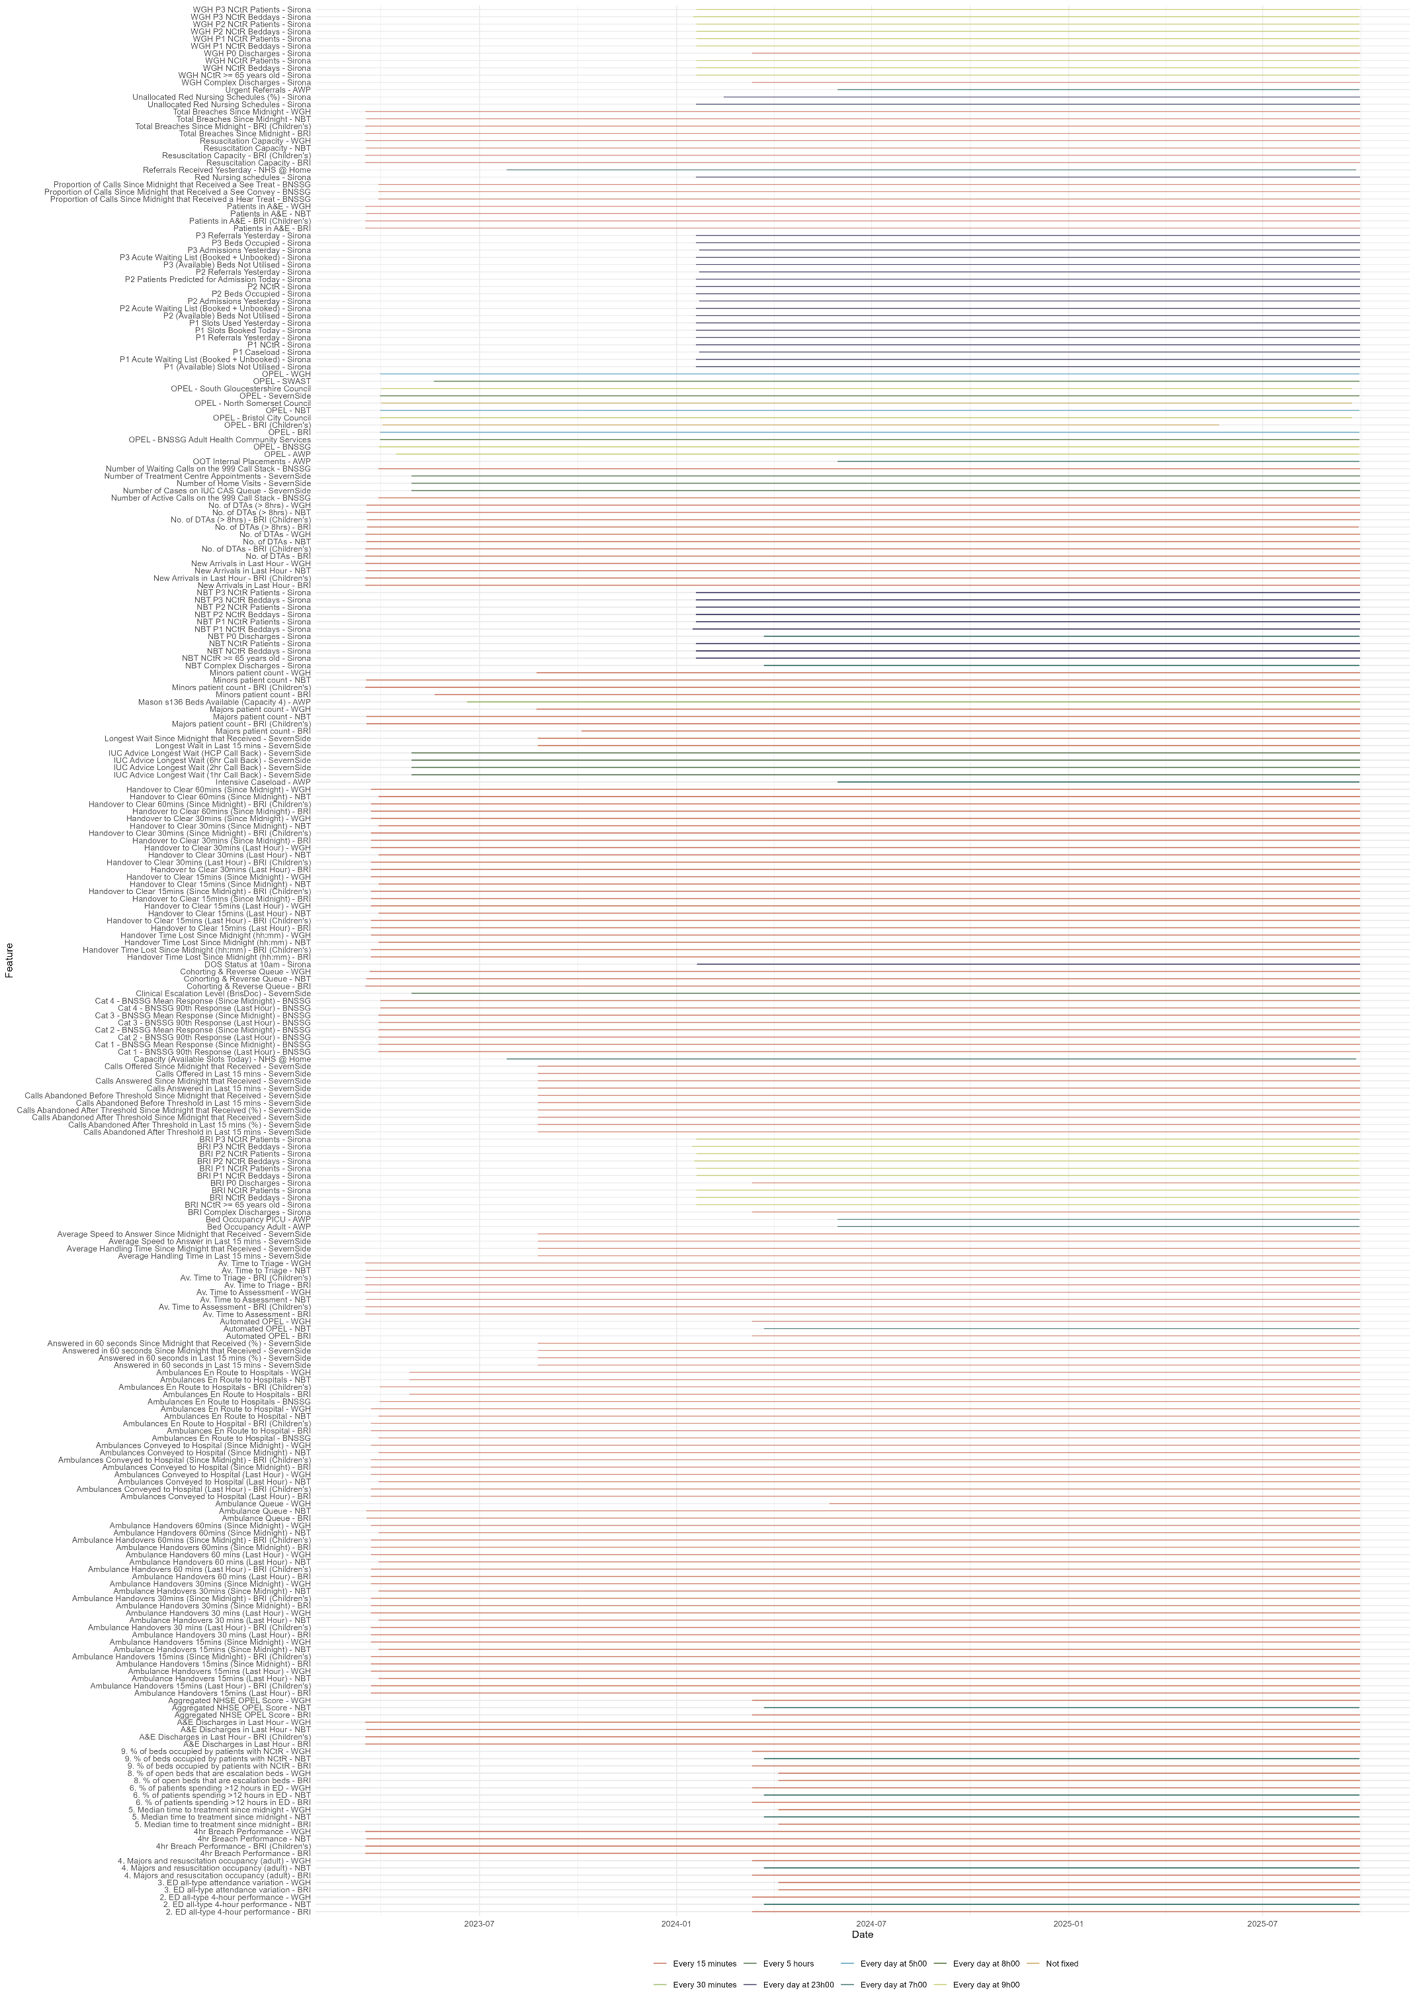
Figure 1: Temporal qualities of the explanatory feature set.

Outcome variable
Figure 2 visualises the Estimated avoidable deaths as a time series plot:
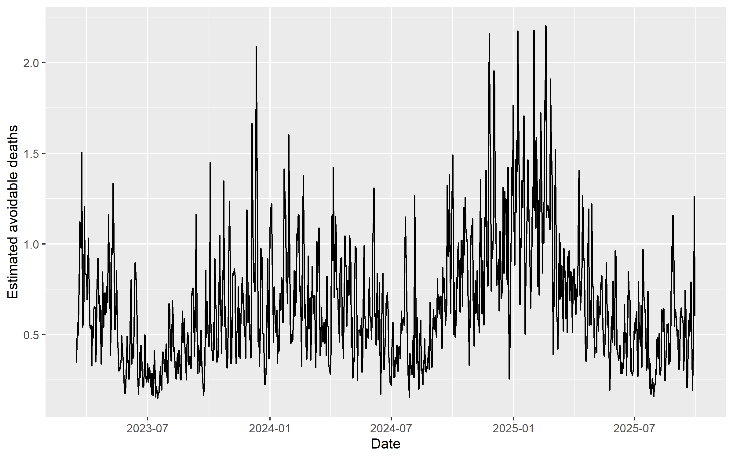
Figure 2:Time series of estimated avoidable deaths (outcome variable).

Glossary of terms
The metric names in the development dataset include various domain-specific terms and acronyms. Use the glossary below for definitions:
Term | Desciption
BNSSG | ‘Bristol, North Somerset & South Gloucestershire'.
SG | ‘South Gloucestershire’.
NS | ‘North Somerset’.
ICB | ‘Integrated Care Board'.
BRI | ‘Bristol Royal Infirmary’.
NBT | ‘North Bristol Trust’ (Southmead Hospital).
WGH | ‘Weston General Hospital’.
NCtR | ‘No Criteria to Reside', a status given to patients who are medically fit to leave their current clinical setting but are otherwise blocked.
MIU | ‘Minor Injury Unit’.
DtA | ‘Decision to Admit', a status given to a patient in A&E who has had the decision that they require an admitted bed, these are counted as they often queue inside A&E.
D2A | ‘Discharge to Assess', the name of the intermediate care service provided in BNSSG ICB.
P0, P1, P3, P4 | Pathways 0-4 are different levels of intermediate care settings, into which patients are discharged from acute beds.
ED | ‘Emergency Department'.
IUC | ‘Integrated Urgent Care'.
HCP | ‘Healthcare Professional'.
OPEL | ‘Operational Pressures Escalation Levels', a composite metric indicating system pressure.
G&A | ‘General & Acute’, a classification of bed type.
CAS | ‘Clinical Assessment Service'.
Majors | Patients who are seriously ill or injured and require a high level of nursing care and medical intervention.
Minors | Patients with injuries or illnesses that are urgent but not life-threatening.
SBRU | ‘South Bristol Community Hospital Rehabilitation Unit'
SWASFT | ‘South Western Ambulance Service Foundation Trust'.
TOC | ‘Transfer Of Care'.
C1, C2, C3, C4 | Categories 1-4 of ambulance response (from most to least critical).
DOS | ‘Directory Of Service'.
GP | ‘General Practice'.
ICE | ‘Inner City and East' locality.
OOT | ‘Out Of Trust'.
PICU | ‘Paediatric Intensive Care Unit.
SASS | ‘Specialist and Support Services'

