Introduction:
A fire on board a ship can have disastrous consequences, and as good as the evacuation plans may be now, they will need improvement to ensure that as many passengers as possible survives.

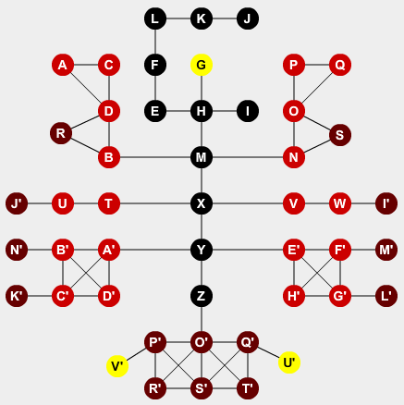
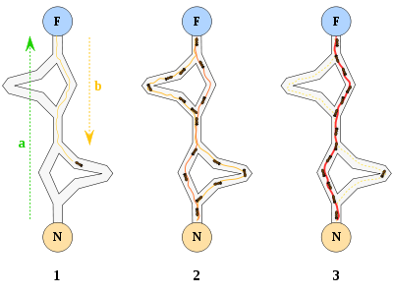
Step one shows that the first virtual ant finding one out of multiple paths from the start to the goal. Step two shows multiple ants exploring all paths and finally in step three the shortest path is established. [1]

We have worked on modifying existing algorithms; our main focus was the Ant Colony Optimization (ACO), a pathfinding algorithm which finds a path through the environment to the desired destination by mimicking the behavior of an ant colony.

Methods:
In our thesis we have compared Dijkstra's pathfinding algorithm to ACO, as Dijkstra's is one of the most commonly used pathfinding algorithms today. We modeled the ships as dynamic graphs with nodes and edges where the nodes could be rooms, hallways or other sections of the ships and the edges indicate that it were possible to transition from one node to another. The simulated passengers received directions on their smart phones and we assumed for that everyone had one.
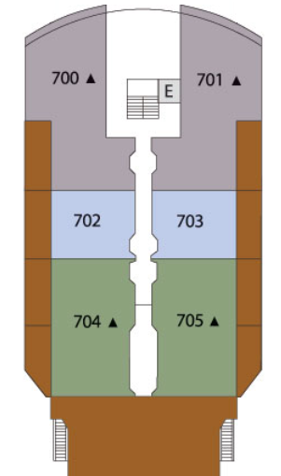

Real ship blueprints were converted into graphs, here color coded to show the process. [2]

Additionally, we have simulated human behavior during a crisis and observed how this affected the algorithms. Finally we looked into how high occupant density around exits slowed down the evacuation process and explored how to redirect passengers.
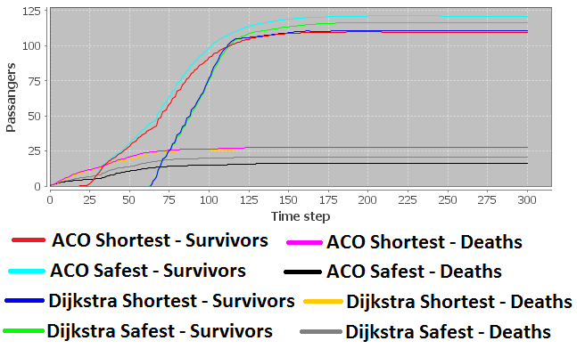
Results:
We simulated different scenarios and evacuations on two different ships. The algorithms were set to either search for the shortest distance to the exits or the safest.

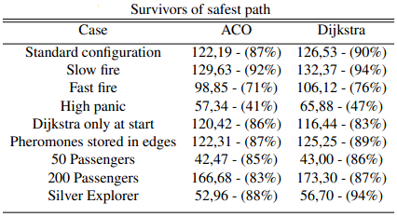
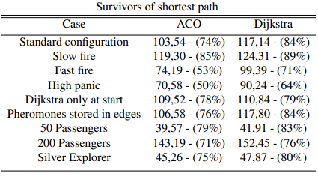The tables shows the results from different simulations with varying configurations like an evacuation in a ship with over the recommended passenger capacity.

Selecting the shortest path resulted in poor performance in almost all situations. This is natural as several passengers would be lead through dangerous areas regardless of there being a safer albeit longer path.
When Dijkstra's algorithm only calculated escape routes at the start, ACO found quicker and safer routes for the passengers.

Conclusion:
ACO always performed well but Dijkstra’s algorithm saved more simulated passengers in general, though by a slight margin. Considering performance as a combination of computational time and results there is a case to be made for ACO as a superior algorithm in this case. While we have only looked at the survivors in our simulations it is well known that ACO, correctly conﬁgured regarding amount of ants, is the faster algorithm. And there is no denying that getting the directions to the passengers quickly is of the utmost importance in an evacuation.

References:
[1]SaffLogic (n.d.) Ant Colony Optimizaton. [image online] Available at: http://upload.wikimedia.org/wikipedia/commons/thumb/a/af/Aco_branches.svg/400px-Aco_branches.svg.png [Accessed: 04 June 2013].
[2]Silversea (n.d.) Silver Explorer deck. [image online] Available at: http://www.silversea.com/uploadedFiles/silverseacom/Our_Fleet/Prince_Albert_II/RE12501_Explorer_Deck_PlansSuites2013.pdf [Accessed: 05 June 2013].

