**DANIEL CN**

**REG.NO:192211044**

**CSA1473-COMPILER DESIGN**

1. Write a LEX program to find the length of the longest word

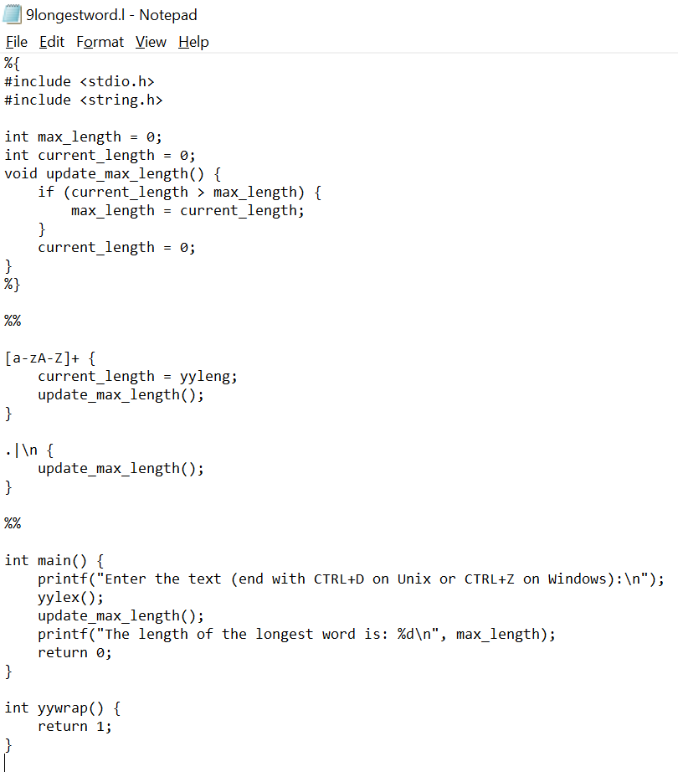

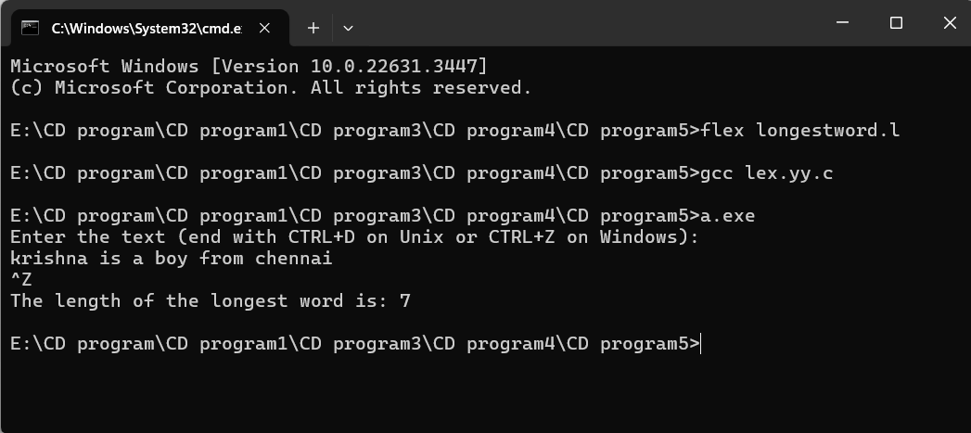

1. Write a LEX program to validate URL’s

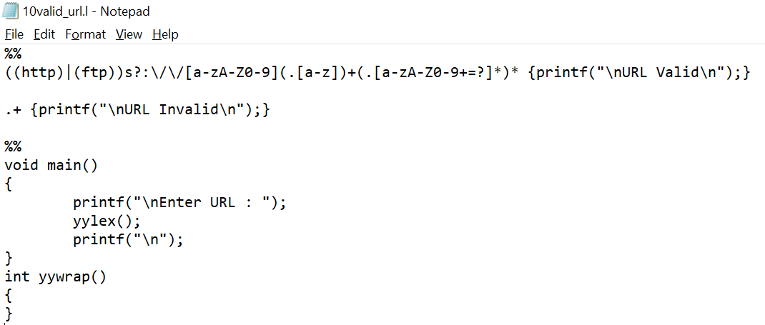

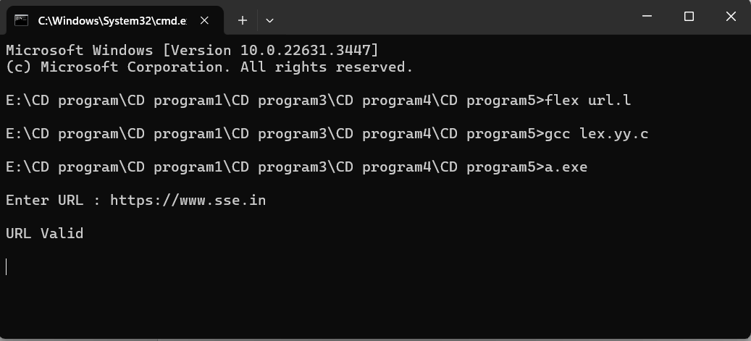

1. Write a LEX program to validate DOB of all students.

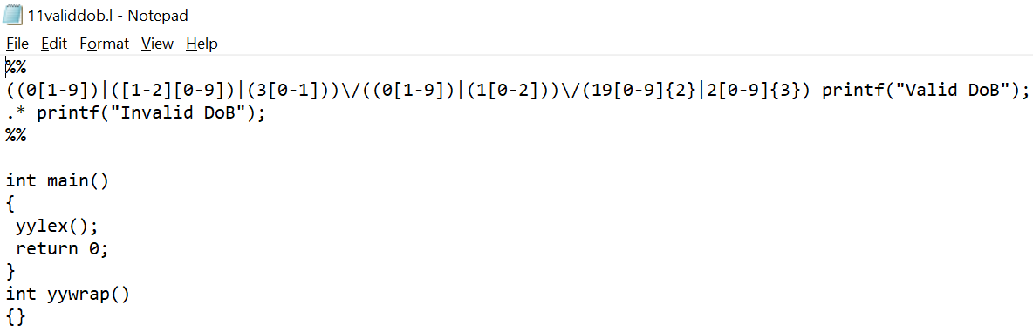

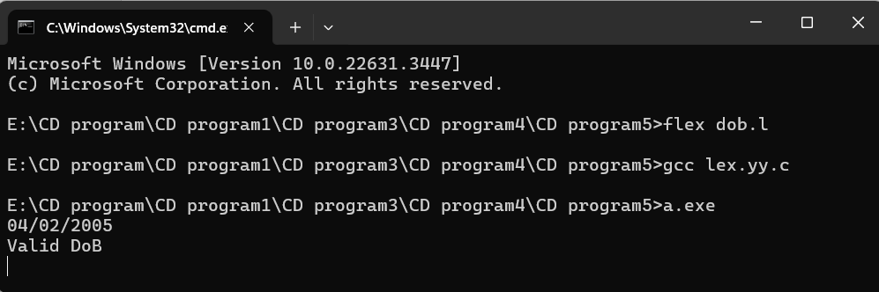

1. Write a LEX program to recognize a word and relational operator

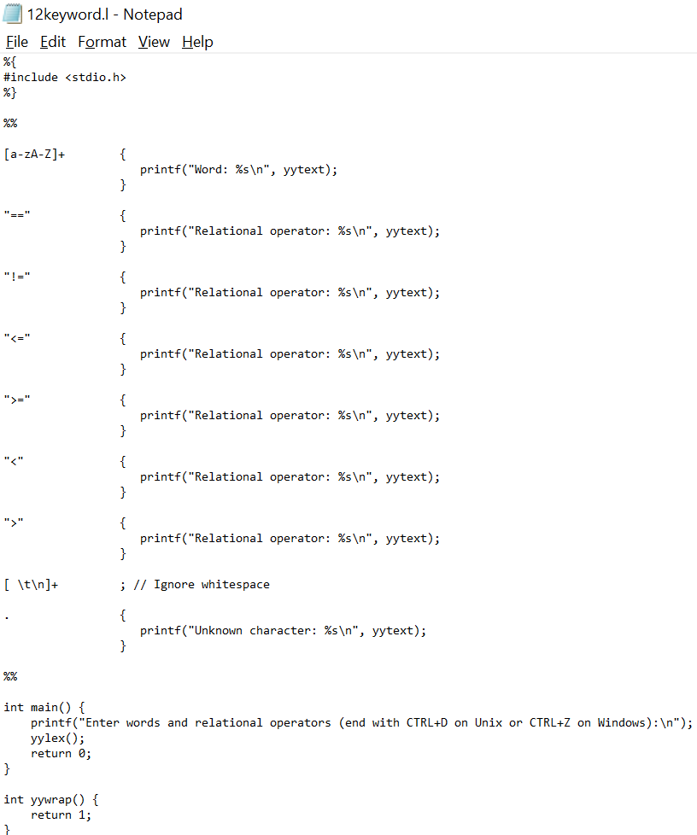

1. Write a LEX code to replace a word with another word in a file

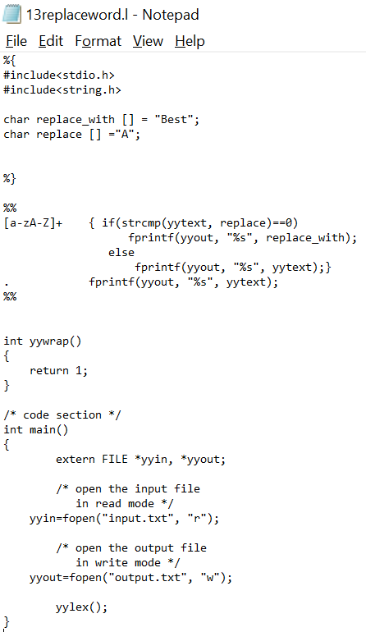

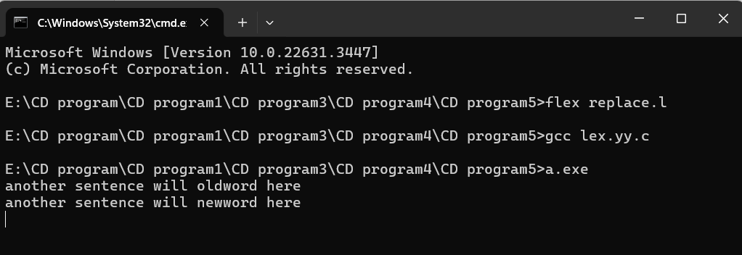

1. Implement a LEX program to implement basic mathematical operations

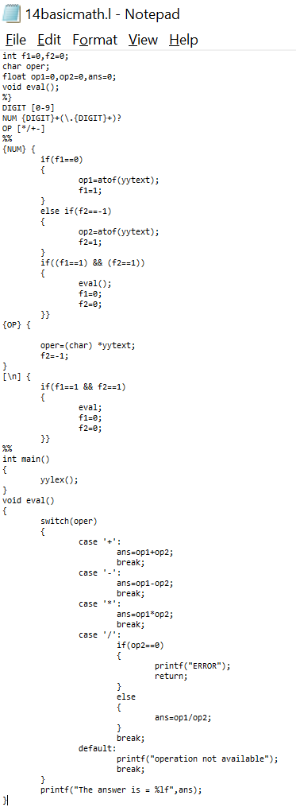

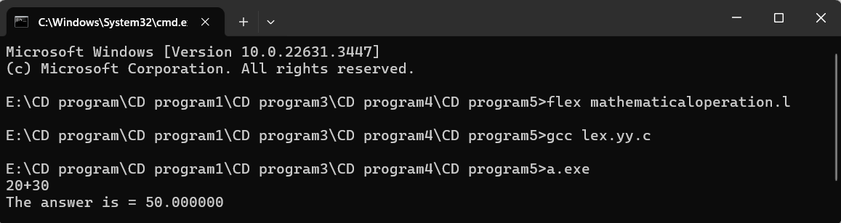

1. Write a LEX Program to check the email address is valid or not.

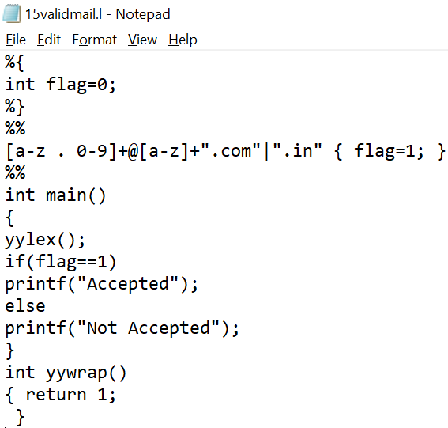

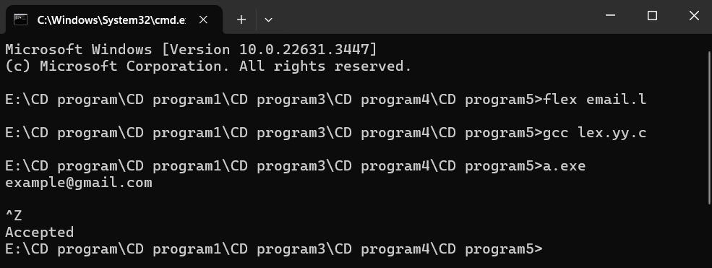

1. Write a LEX Program to convert the substring abc to ABC from the input string.

