Figure 14.1.1
Seroconversion by Analysis Visit and Treatment
Analysis Population

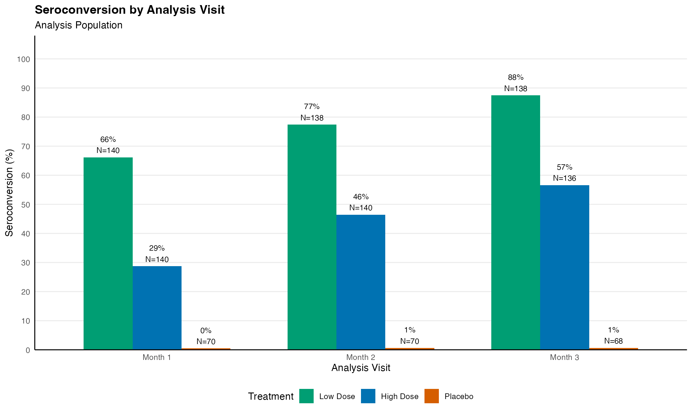
Note: Results are based on reproducibly simulated data with twice the original sample size.

