Figure 14.2.2
Cumulative Incidence of First Dermatologic Event
Safety Population

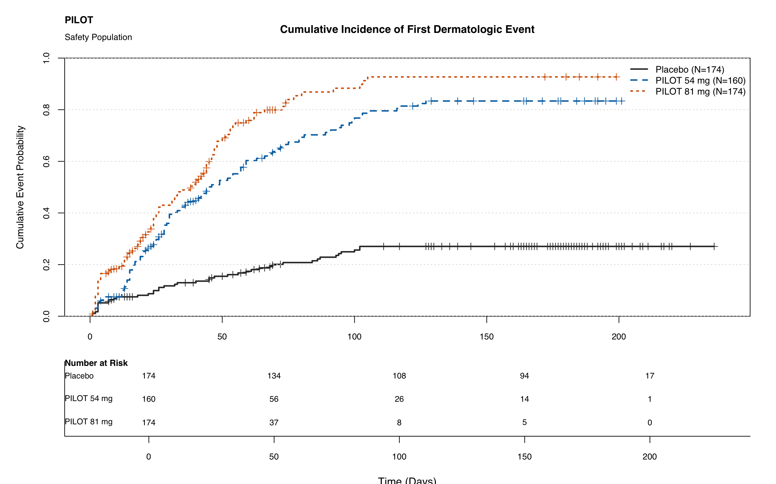
Note: Event is defined as CNSR=0; censoring is CNSR=1. Times are measured in days.
Log-rank p-value: <0.001.

