Figure 14.1.2
Forest Plot of Subgroup Analysis
Analysis Population

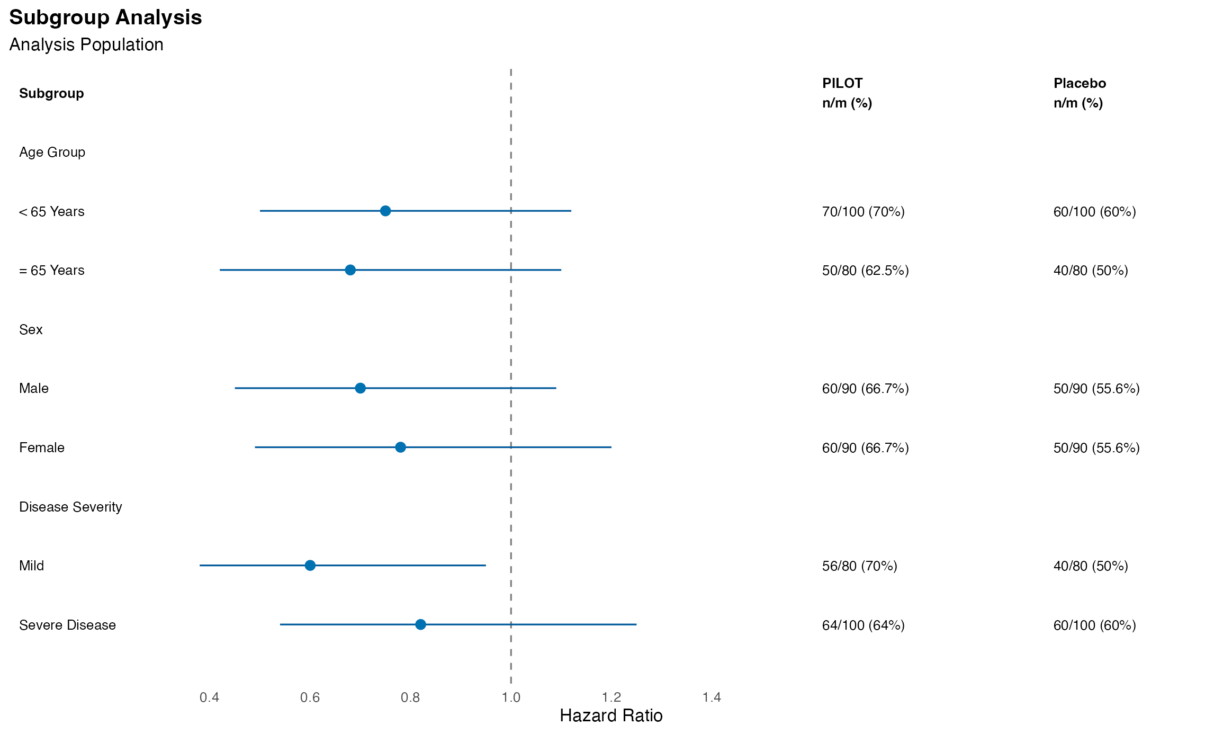
Note: Results are based on reproducibly simulated data with twice the original sample size.

