Figure 14.1.3
Mean Hemoglobin over Time with 95% Confidence Intervals
Analysis Population

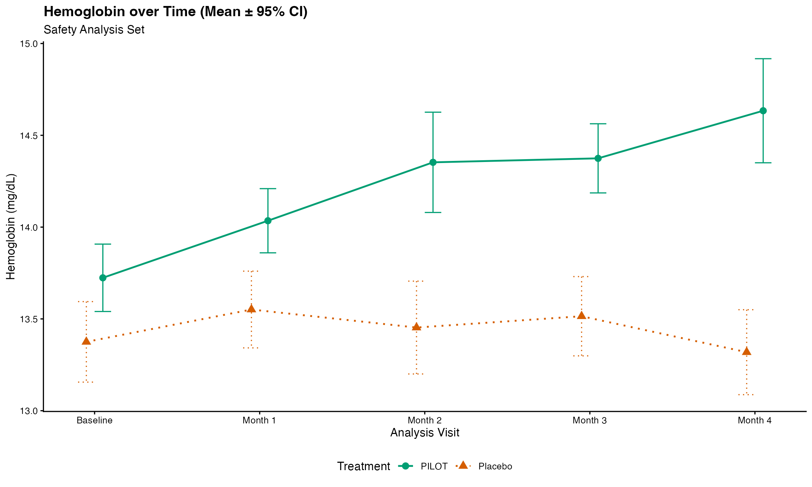
Note: Results are based on reproducibly simulated data with twice the original sample size.

