Figure 14.1.4
Individual Plasma Concentration-Time Profiles
Analysis Population

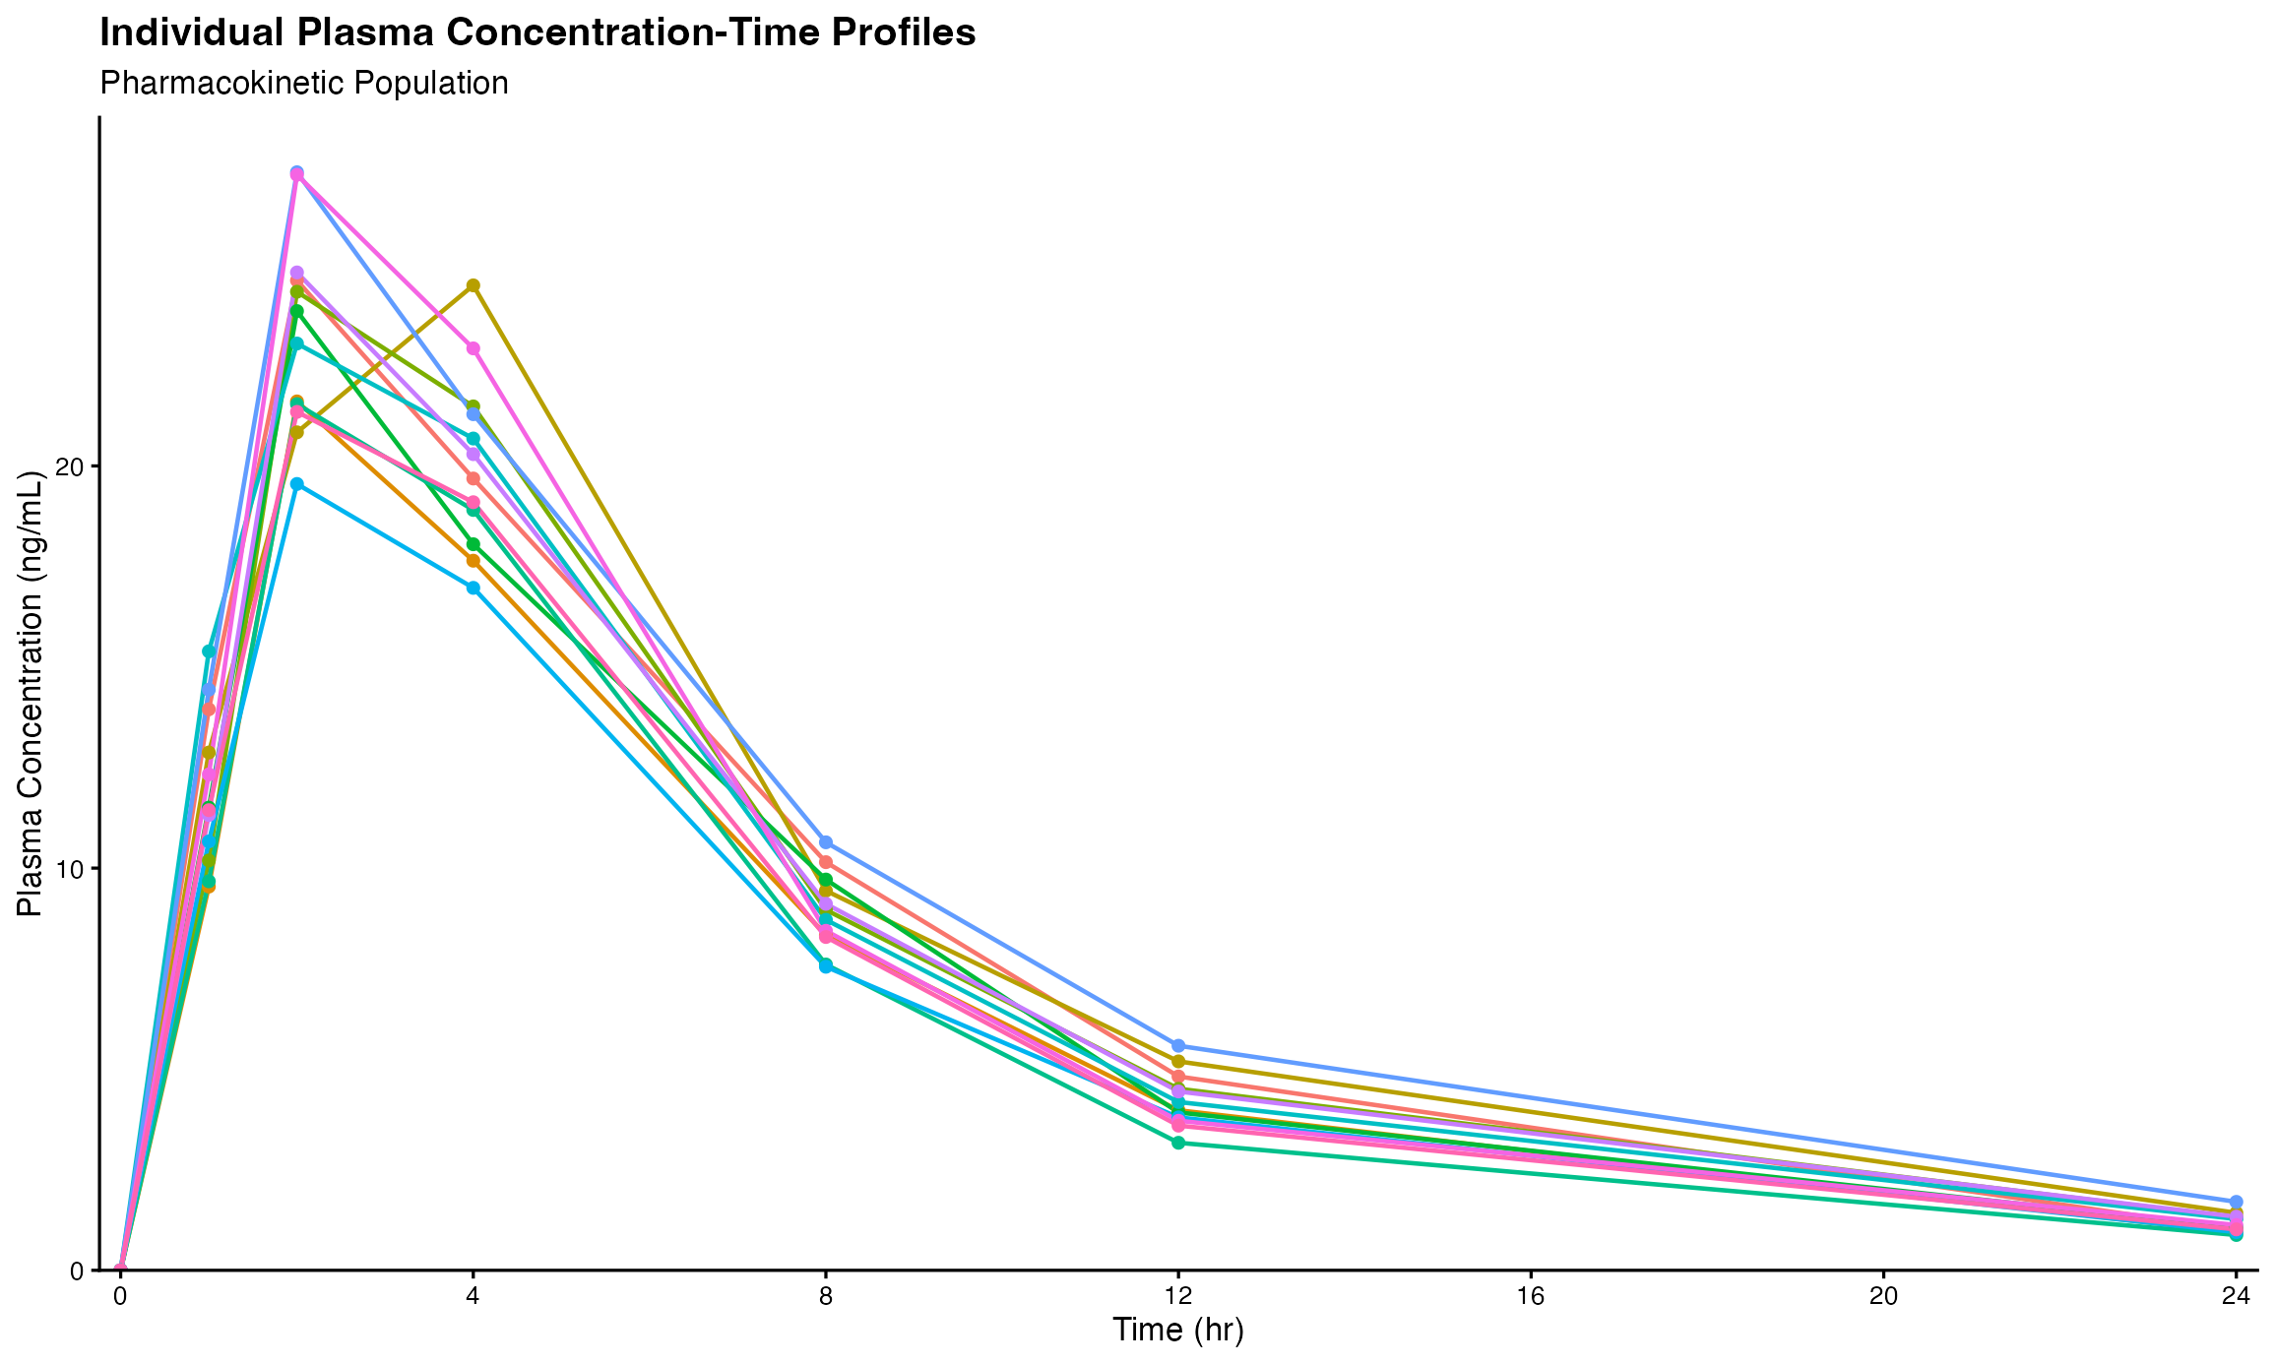
Note: Results are based on reproducibly simulated data with twice the original sample size.

