Figure 14.1.5
Mean Plasma Concentration-Time Profile with Standard Deviation
Analysis Population

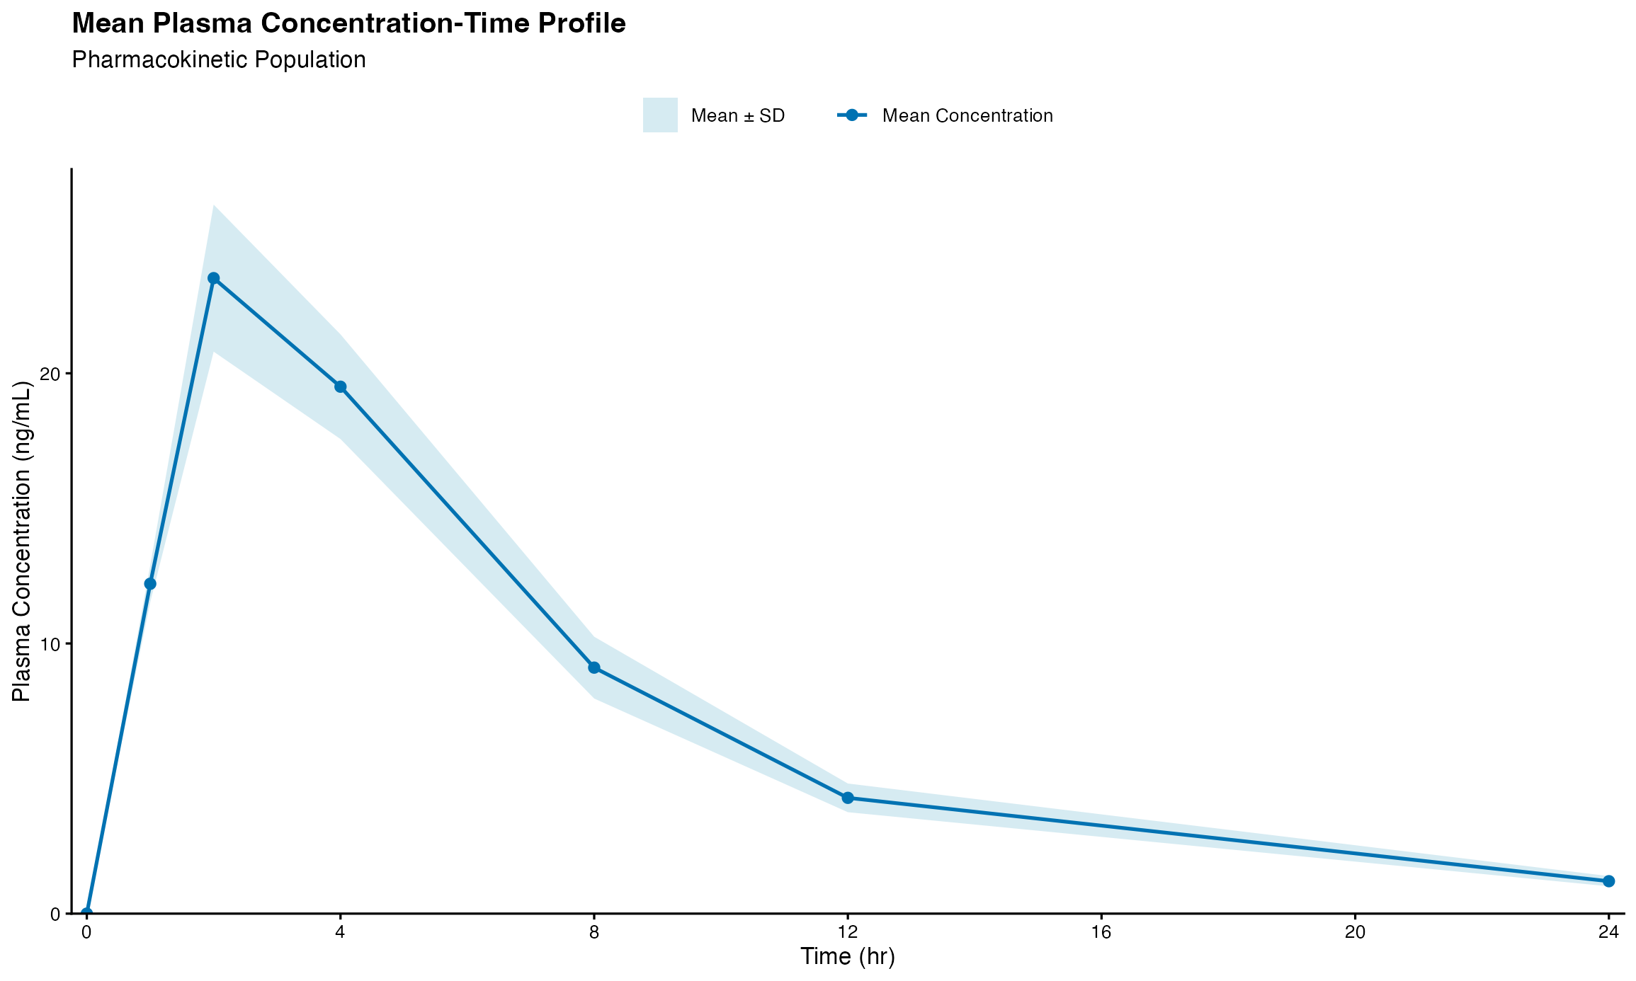
Note: Results are based on reproducibly simulated data with twice the original sample size.

