Figure 14.1.6
Baseline versus Postbaseline Maximum Hemoglobin
Analysis Population

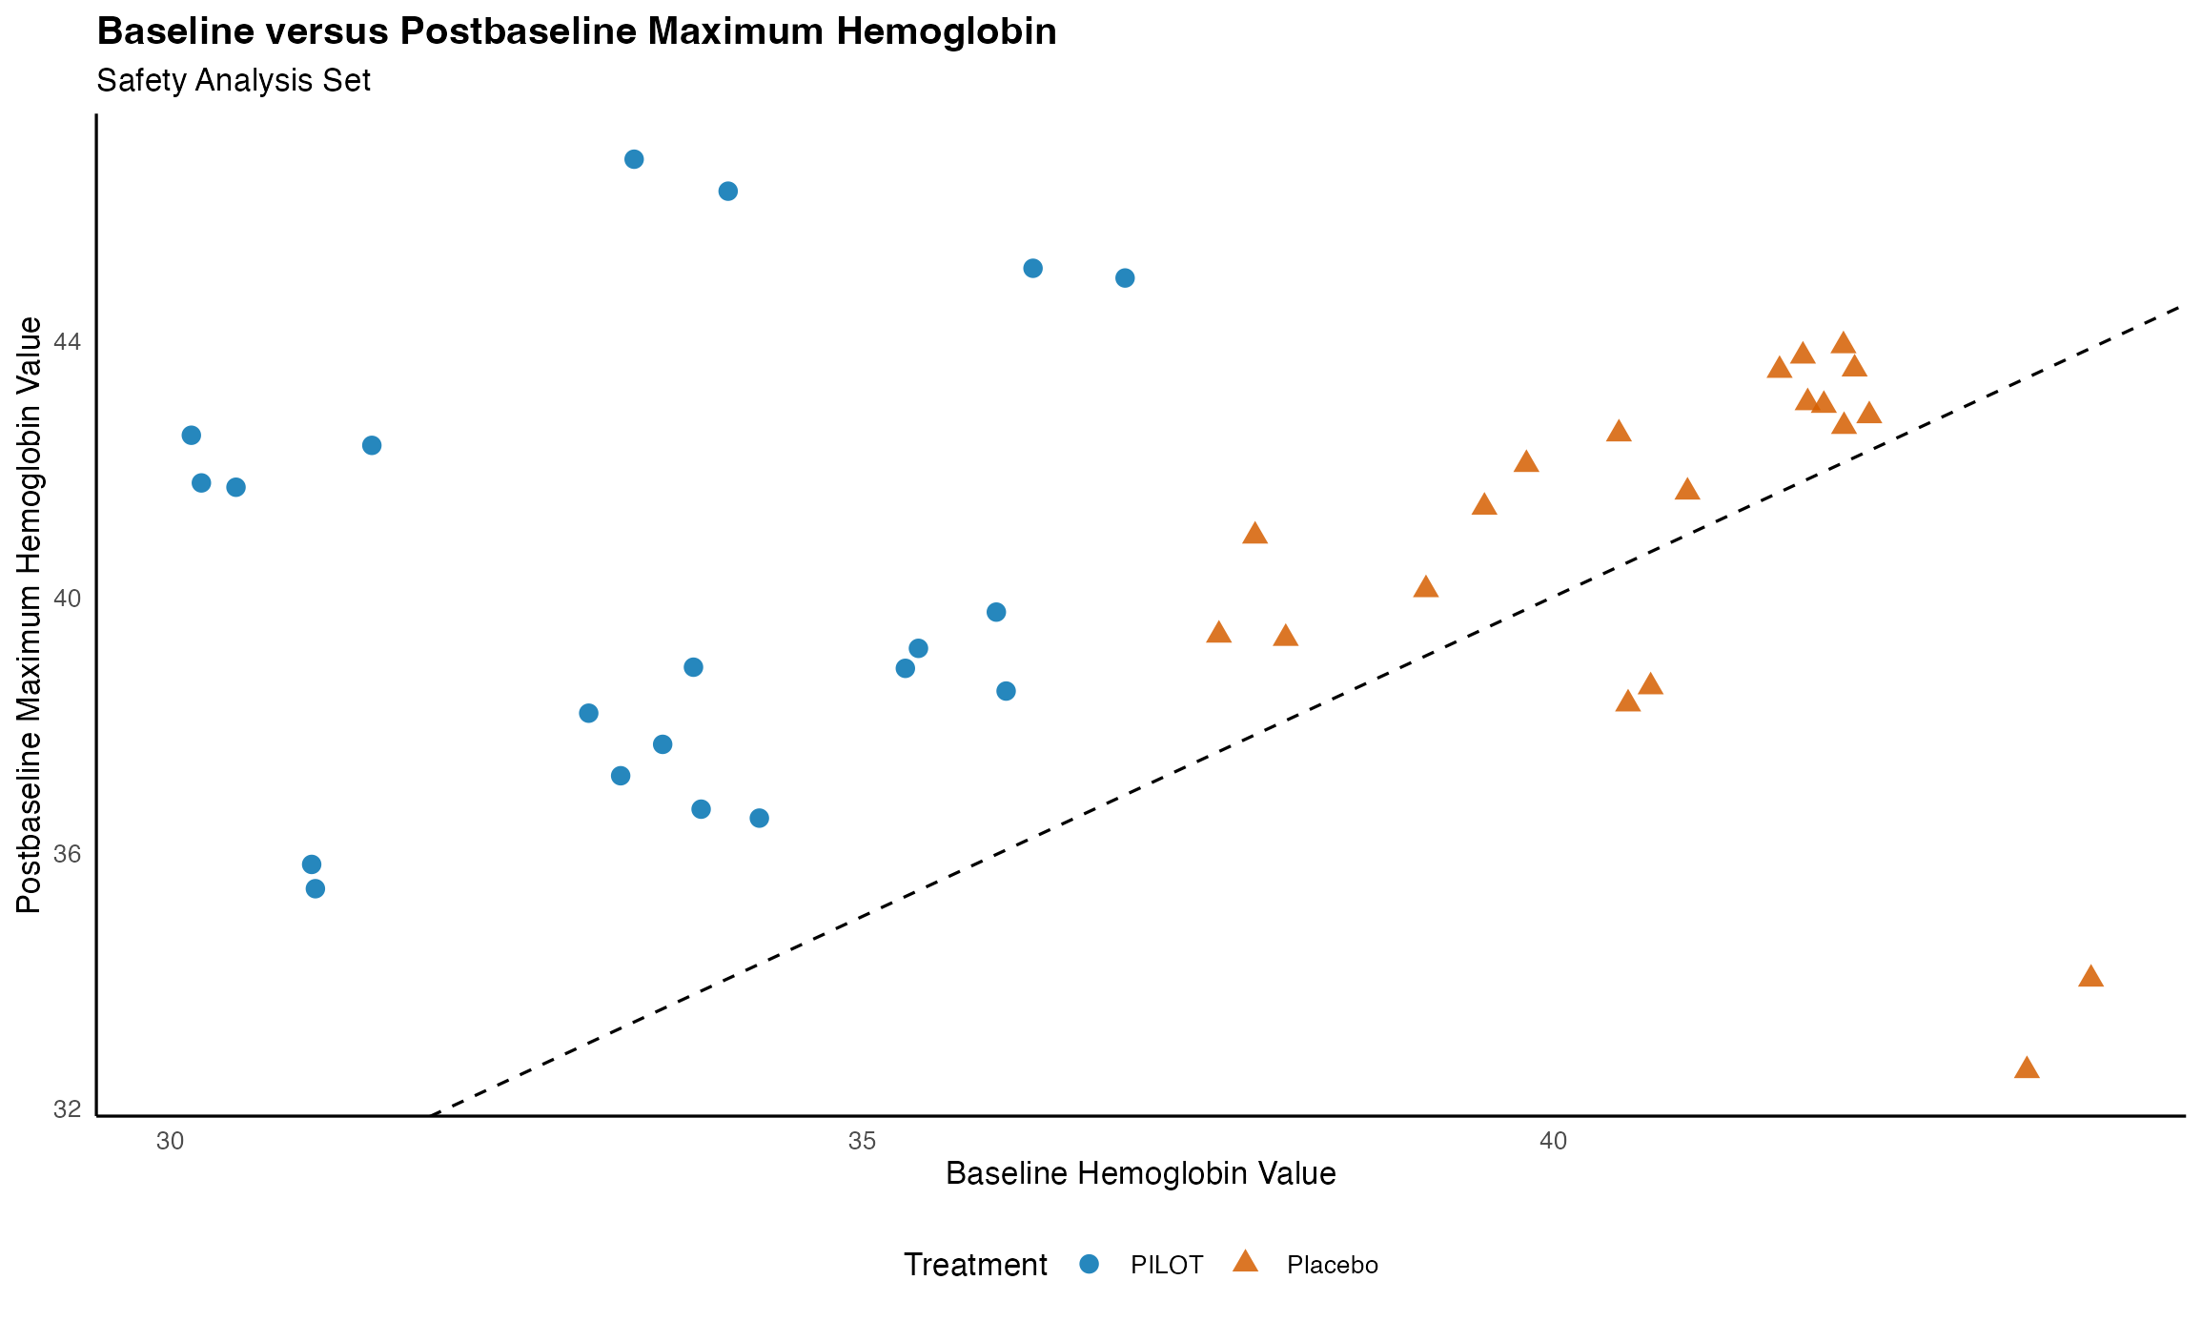
Note: Results are based on reproducibly simulated data with twice the original sample size.

