Figure 14.1.7
Subject-Level Percent Change in FEV1
Analysis Population

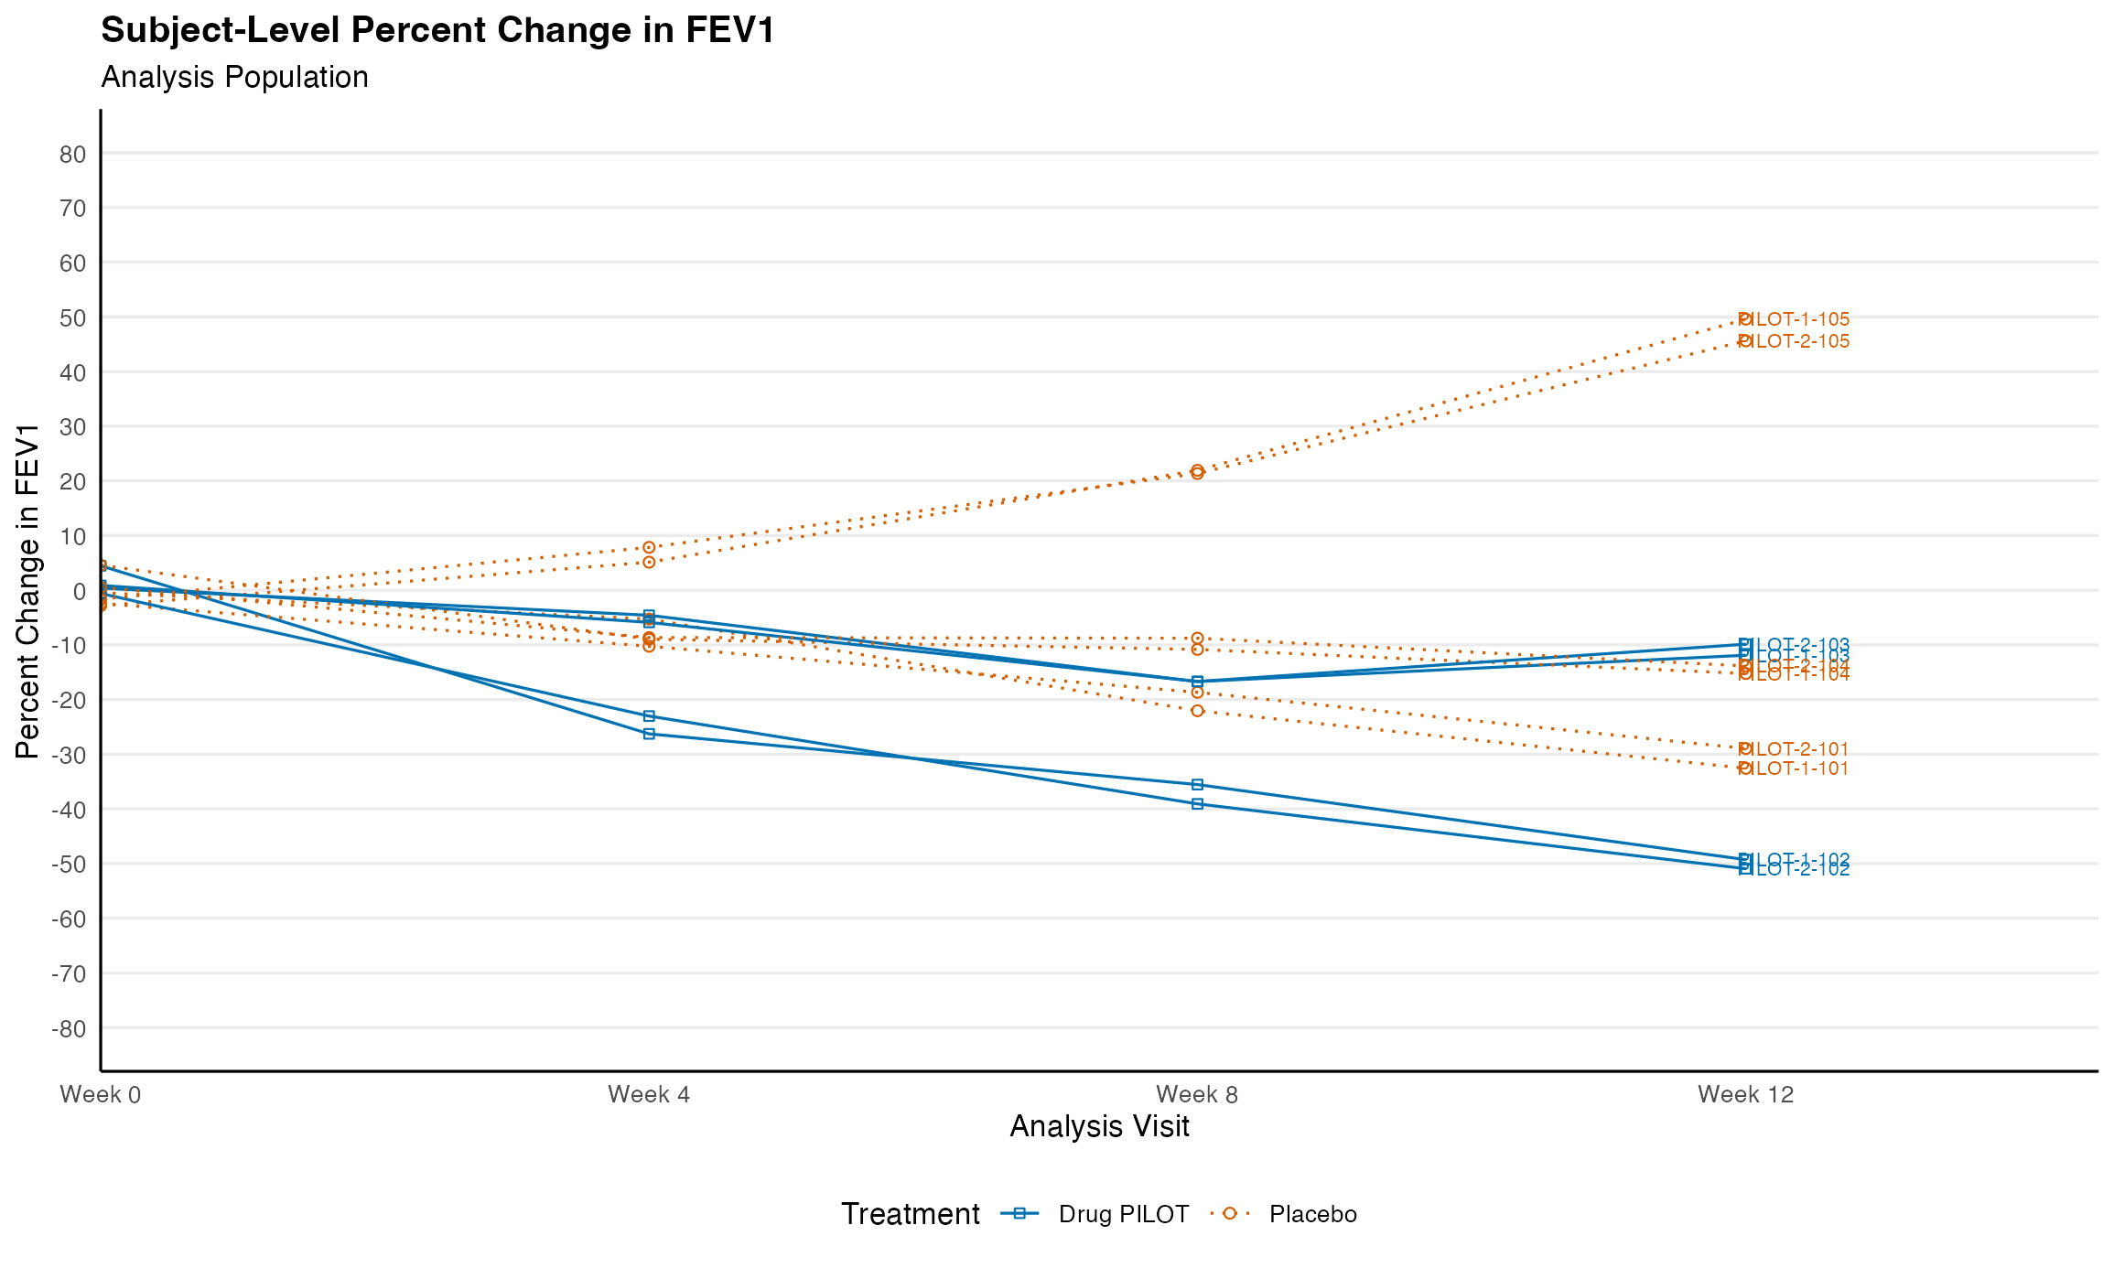
Note: Results are based on reproducibly simulated data with twice the original sample size.

