Figure 14.1.8
Waterfall Plot of Best Percent Change
Analysis Population

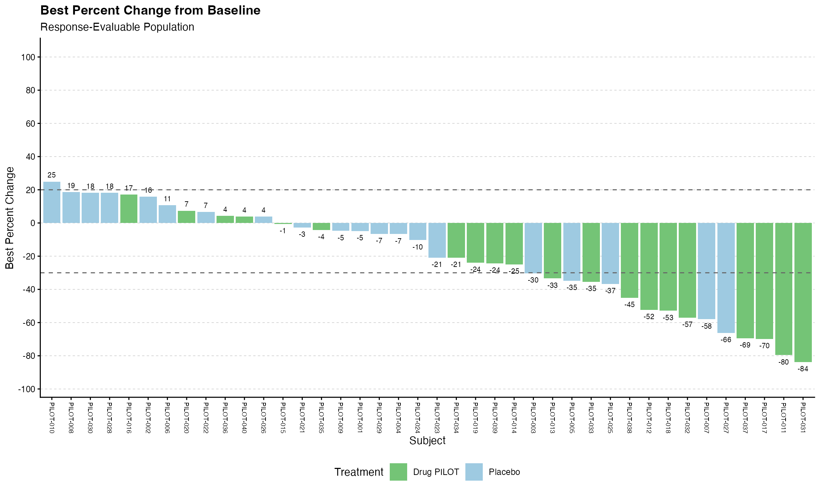
Note: Results are based on reproducibly simulated data with twice the original sample size.

