Oncology Registrational Study – Simulated Figures (English)

Subject Disposition Flow Diagram

Figure 1. Overall Survival (OS) Kaplan–Meier Curve
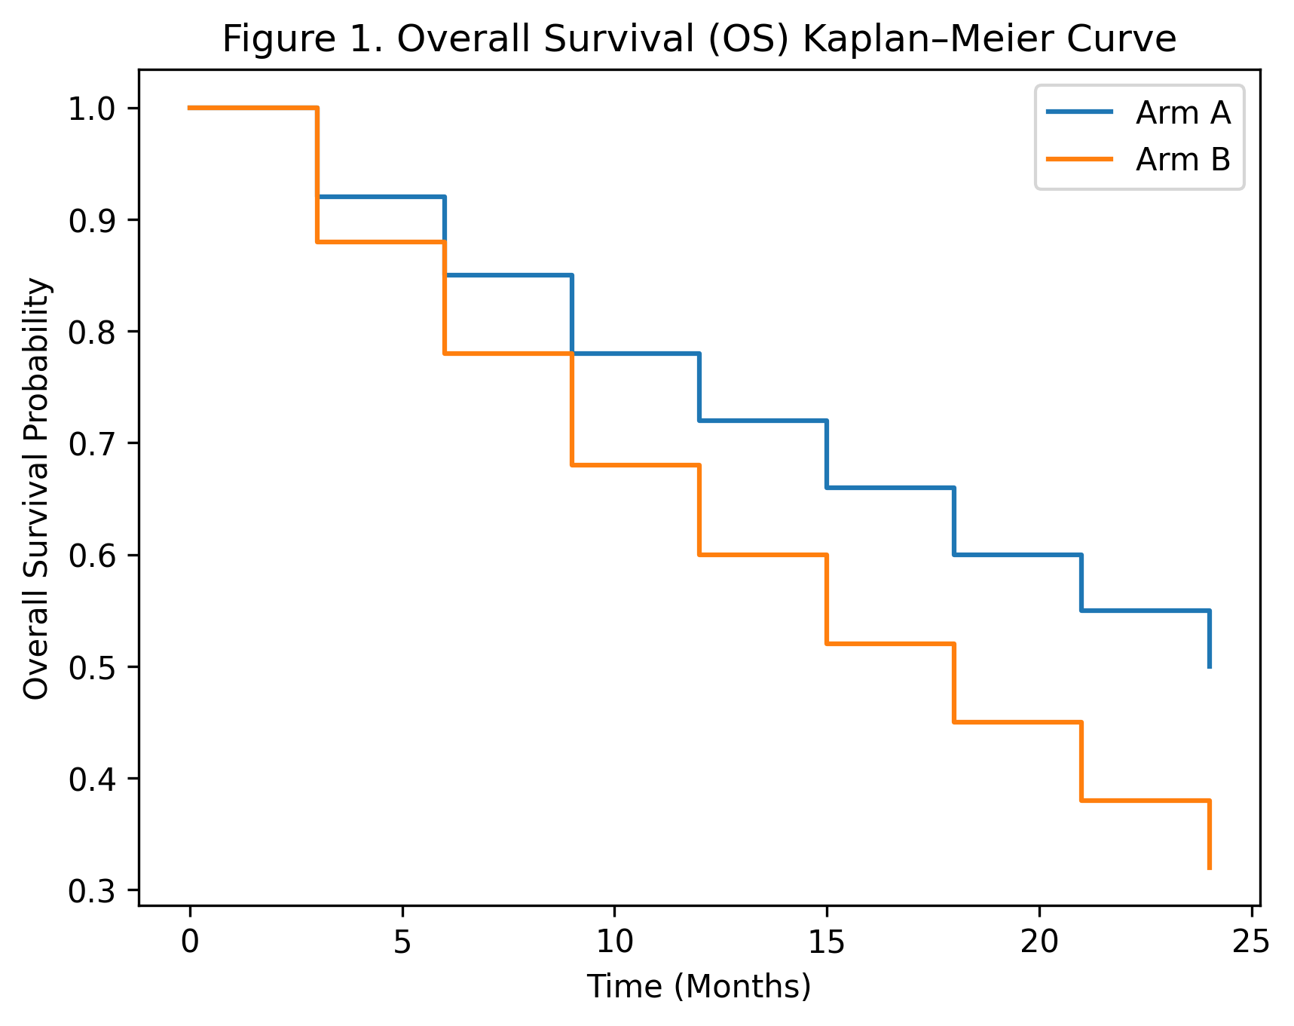

Figure 2. Progression-Free Survival (PFS) Kaplan–Meier Curve
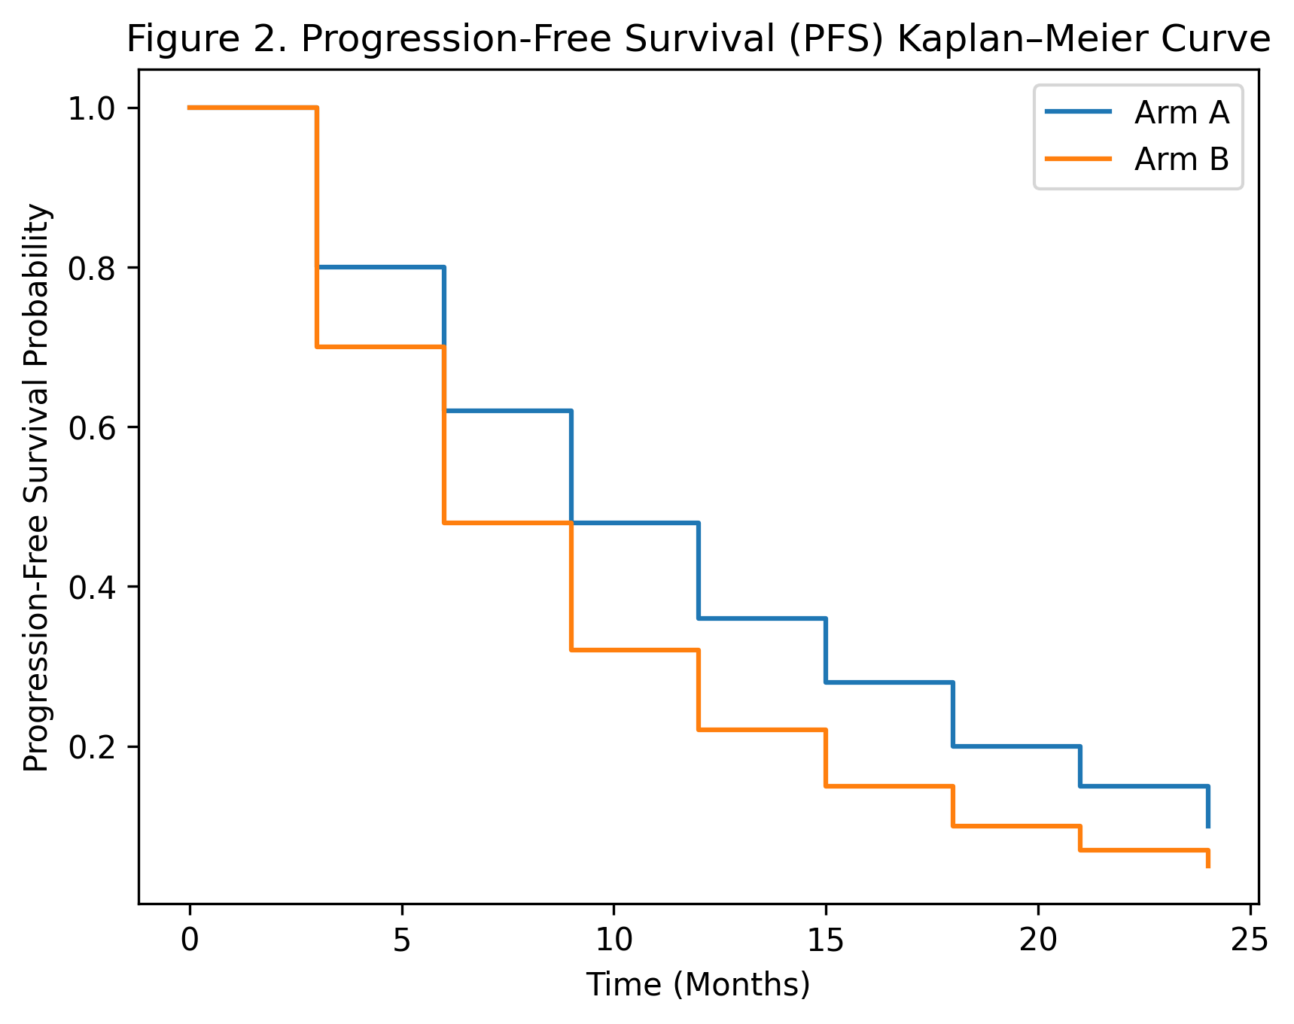

Figure 3. Waterfall Plot – Best Tumor Burden Change
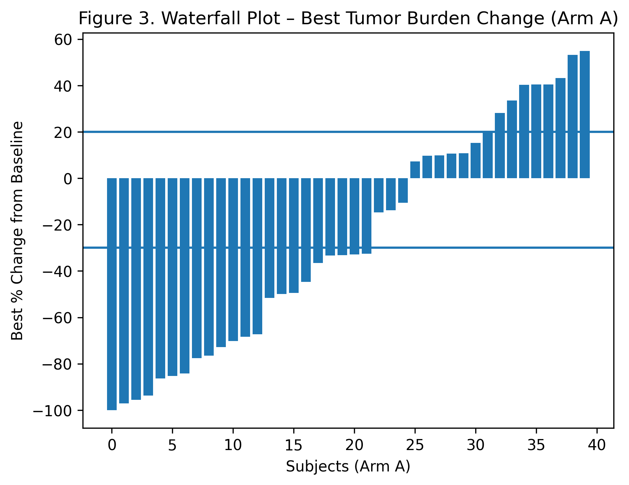

RECIST (Response Evaluation Criteria in Solid Tumors) – Summary Table
Term | Definition (RECIST 1.1)
Target Lesions | Selected measurable lesions (maximum 5 total, up to 2 per organ) used for quantitative assessment of tumor burden
Non-Target Lesions | All other lesions, including non-measurable disease (e.g., ascites, bone lesions)
CR (Complete Response) | Disappearance of all target lesions; all pathological lymph nodes must be <10 mm in short axis
PR (Partial Response) | At least a 30% decrease in the sum of diameters of target lesions, relative to baseline
SD (Stable Disease) | Neither sufficient shrinkage to qualify for PR nor sufficient increase to qualify for PD
PD (Progressive Disease) | At least a 20% increase in the sum of diameters of target lesions (minimum absolute increase of 5 mm) or appearance of new lesions
Best Overall Response (BOR) | The best response recorded from start of treatment until disease progression or start of new anti-cancer therapy
ORR (Objective Response Rate) | Proportion of patients with BOR of CR or PR
DCR (Disease Control Rate) | Proportion of patients with BOR of CR, PR, or SD
PFS (Progression-Free Survival) | Time from randomization or treatment start to disease progression or death
DoR (Duration of Response) | Time from first documented CR or PR to disease progression or death

Figure 4. Swimmer Plot – Time on Treatment and Response
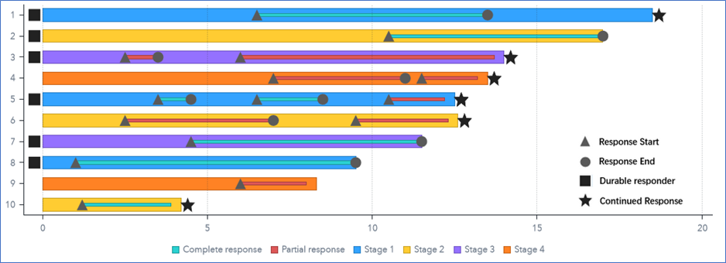
This swimmer plot depicts individual subject treatment duration and response dynamics. Colored bars represent time on treatment across different study stages. Triangles indicate the start of response, circles indicate the end of response, squares denote durable responders, and stars indicate ongoing responses at data cutoff. The plot demonstrates that responses occurred across multiple subjects and stages, with several durable and ongoing responses, supporting the consistency and durability of clinical benefit.

Status Transition | Considered End of Response
PR → SD | ❌ No
PR → PR | ❌ No
PR → PD | ✅ Yes
PR → Death | ✅ Yes
PR → SD → PD | ✅ Yes (at the time of PD)

Figure 5. Forest Plot – PFS by Subgroup
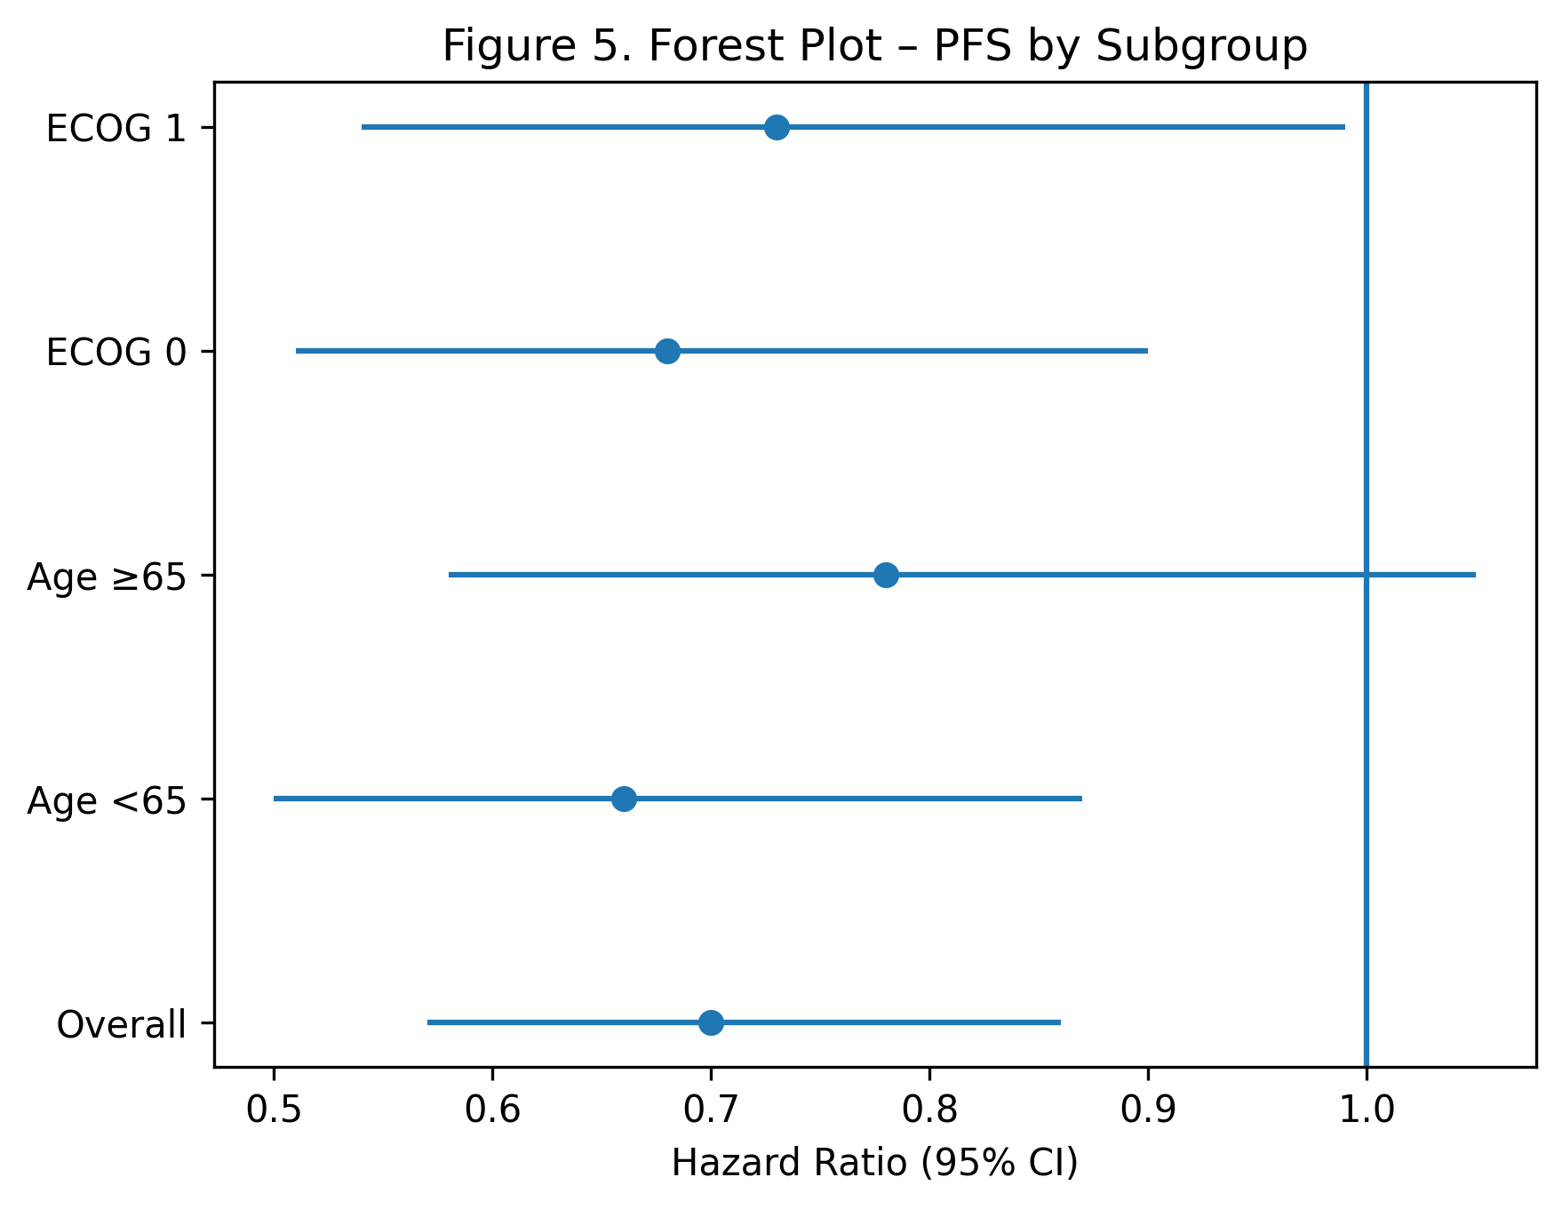

Figure 6. Summary of Treatment-Emergent Adverse Events
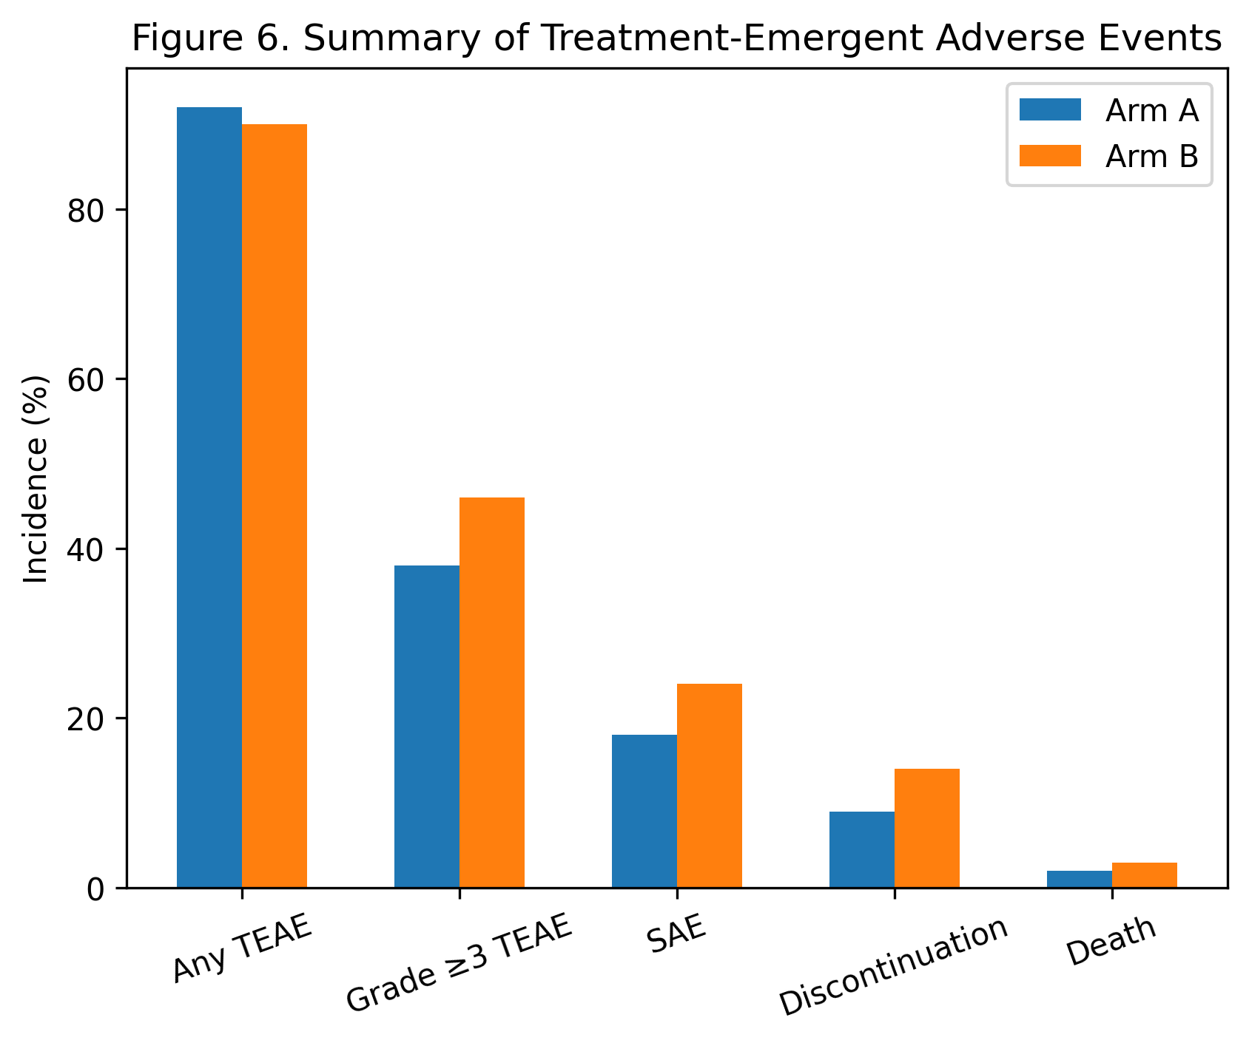

Figure → ADaM → Variable → SDTM

Audit Traceability Matrix (6 Core Figures)

Figure 1. Overall Survival (OS) Kaplan–Meier Curve
Figure | ADaM Dataset | ADaM Variable(s) | SDTM Source
OS KM | ADTTE | PARAMCD="OS", PARAM | Assigned (ADTTE parameterization)
 | ADTTE | STARTDT (e.g., RANDDT or TRTSDT) | DM.RFSTDTC and/or EX.EXSTDTC
 | ADTTE | ADT (event/censor date) | Derived from DTHDT / LSTALVDT
 | ADTTE | CNSR (0=event,1=censored) | Derived
 | ADTTE | AVAL (time-to-event, days) | Derived (ADT − STARTDT + 1)
 | ADTTE | DTHDT (if stored), LSTALVDT (if stored) | DM.DTHDTC and/or DS (survival/follow-up)
 | ADSL | TRT01A (treatment group) | EX (actual treatment derivation)

Figure 2. Progression-Free Survival (PFS) Kaplan–Meier Curve
Figure | ADaM Dataset | ADaM Variable(s) | SDTM Source
PFS KM | ADTTE | PARAMCD="PFS", PARAM | Assigned (ADTTE parameterization)
 | ADTTE | STARTDT (e.g., RANDDT or TRTSDT) | DM.RFSTDTC and/or EX.EXSTDTC
 | ADTTE | PDADT (if stored) | RS.RSDTC (progression assessment date)
 | ADTTE | DTHDT (if stored) | DM.DTHDTC and/or DS
 | ADTTE | ADT = min(PDADT, DTHDT) | Derived
 | ADTTE | CNSR, AVAL | Derived
 | ADTTE | EVNTDESC (Progression/Death/Censored) | Derived
 | ADSL | TRT01A | EX

Figure 3. Waterfall Plot – Best Tumor Burden Change
Figure | ADaM Dataset | ADaM Variable(s) | SDTM Source
Waterfall | ADTR (or equivalent Tumor Burden BDS) | TRT01A, USUBJID | EX (TRT01A derivation), DM.USUBJID
 | ADTR | PARAMCD (e.g., SLD), PARAM | Derived/assigned
 | ADTR | BASE (baseline tumor burden) | TR (baseline tumor measurement) (sometimes derived using TU+TR)
 | ADTR | AVAL (postbaseline tumor burden) | TR (tumor measurement results)
 | ADTR | PCHG (percent change from baseline) | Derived from BASE and AVAL
 | ADTR | BESTPCHG (if stored) or ANLxxFL to select best change | Derived
 | ADTR | ADT / ADY / AVISIT (timing/visit for best change) | TR/TRDTC (and visit variables)
 | ADRS (optional) | AVALC (CR/PR/SD/PD/NE) for labeling | RS (RECIST responses)
Typical SDTM note: Waterfall is usually anchored on tumor measurement results (often SDTM TR, sometimes TU+TR depending on sponsor implementation) rather than categorical response alone.

Figure 4. Swimmer Plot – Time on Treatment and Response
Figure | ADaM Dataset | ADaM Variable(s) | SDTM Source
Swimmer | ADSL | TRTSDT, TRTEDT, TRT01A, USUBJID | EX.EXSTDTC, EX.EXENDTC, EX; DM.USUBJID
 | ADRS | PARAMCD (OVR/BOR), AVALC (CR/PR/SD/PD/NE) | RS (RECIST responses)
 | ADRS | FRSTDRESPDT (first CR/PR date) | Derived from RS.RSDTC
 | ADTTE | PARAMCD="DOR" and/or PARAMCD="PFS" | Assigned
 | ADTTE | STARTDT (DoR start), ADT (end/censor), CNSR, AVAL | STARTDT derived from ADRS/RS; end from RS (PD) and/or DM/DS (death); derived CNSR/AVAL
 | ADTTE/ADRS (optional) | Flags for Durable / Ongoing (e.g., DURFL, ONGOFL if created) | Derived per SAP
Interpretation note: In registrational settings, Swimmer plots usually emphasize CR/PR timing and durability; SD is typically not highlighted as “response” (but can be reflected via time on treatment / PFS).

Figure 5. Forest Plot – PFS by Subgroup
Figure | ADaM Dataset | ADaM Variable(s) | SDTM Source
Forest (PFS HR by subgroup) | ADTTE | PARAMCD="PFS", AVAL, CNSR, TRT01A | AVAL/CNSR derived from RS+DM/DS; TRT01A from EX
 | ADSL | Subgroup variables (e.g., AGEGR1, SEX, ECOG, STAGE, METASTFL, region) | DM (AGE/SEX), SC/QS (ECOG, stage), MH/SC (metastasis), DM (region/country)
 | ADTTE/ADSL | Analysis flags (e.g., ANL01FL, population flags ITTFL) | Derived from DM/EX/DS rules
Stat note: The HR/CI itself is computed in the statistical procedure; the figure is driven by ADaM inputs (ADTTE + ADSL subgroups).

Figure 6. Summary of Treatment-Emergent Adverse Events
Figure | ADaM Dataset | ADaM Variable(s) | SDTM Source
TEAE Summary | ADAE | TRTEMFL/TEAEFL (treatment-emergent flag) | Derived using AE dates vs EX exposure window
 | ADAE | AESEV/AETOXGR (severity/grade) | AE.AESEV and/or supplemental grading
 | ADAE | AESER (SAE), AEACN (action taken), AEOUT (outcome) | AE.AESER, AE.AEACN, AE.AEOUT
 | ADAE | Derivation flags (e.g., G3PFL, DISCONFL, DEATHFL) | Derived from AE + DS (and protocol rules)
 | ADSL | TRT01A, SAFFL | EX (TRT01A), EX-derived (SAFFL)

