**Supplementary material**

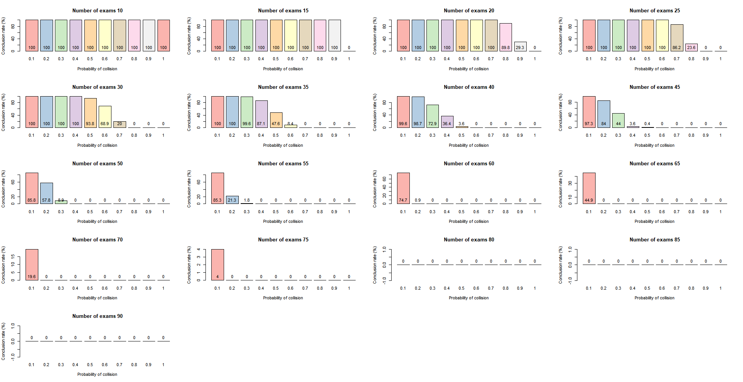

**Figure S1:** Analysis of conclusion rate (concluded cases) of code 1 for each set of probability of collision for all number of exams.

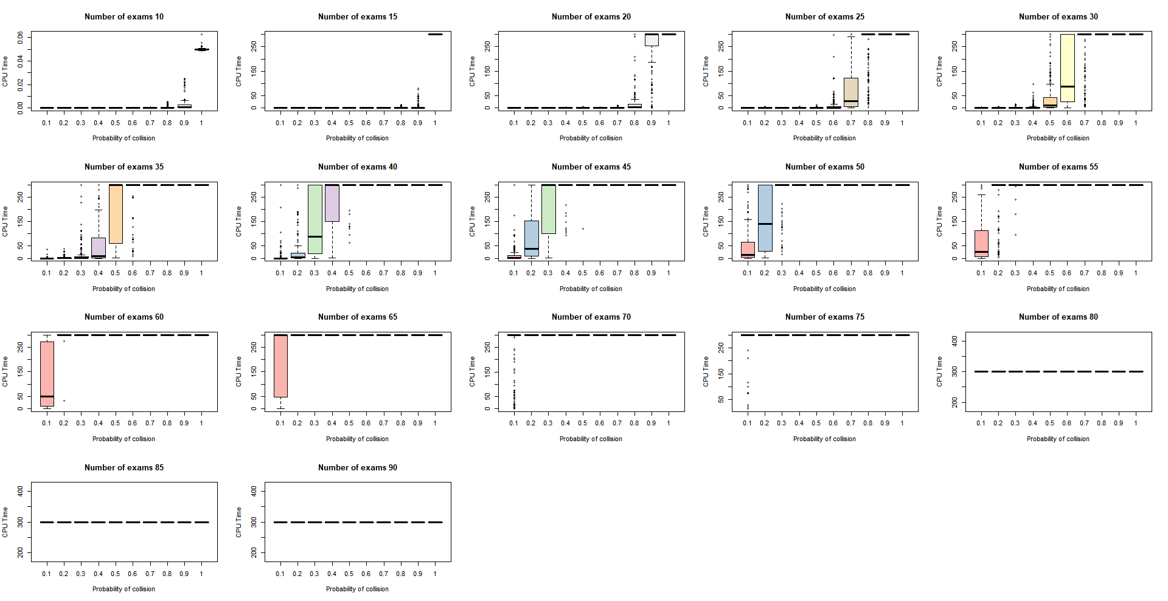

**Figure S2:** Relationship between dependent and independent variables (boxplots). Variation of the CPU time of code 2 with the probability of collision for each number of exams.

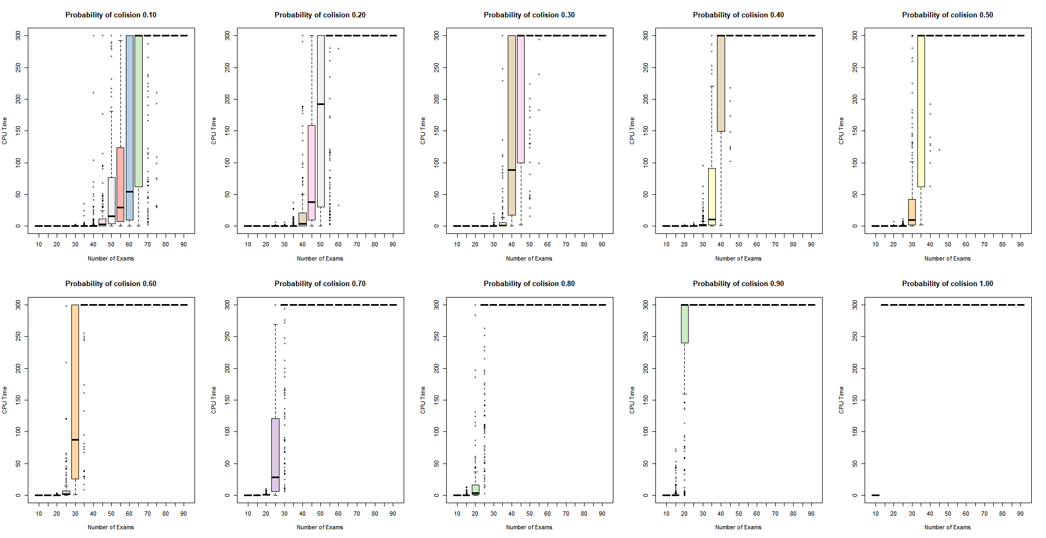**Figure S3:** Relationship between dependent and independent variables (boxplots). Variation of the CPU time of code 1 with the number of exams for each probability of collision.

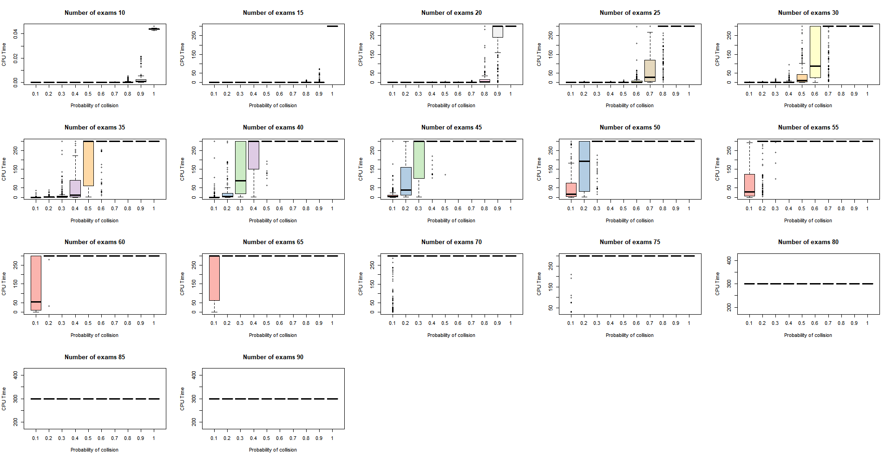

**Figure S4:** Relationship between dependent and independent variables (boxplots). Variation of the CPU time of code 1 with the probability of collision for each number of exams.

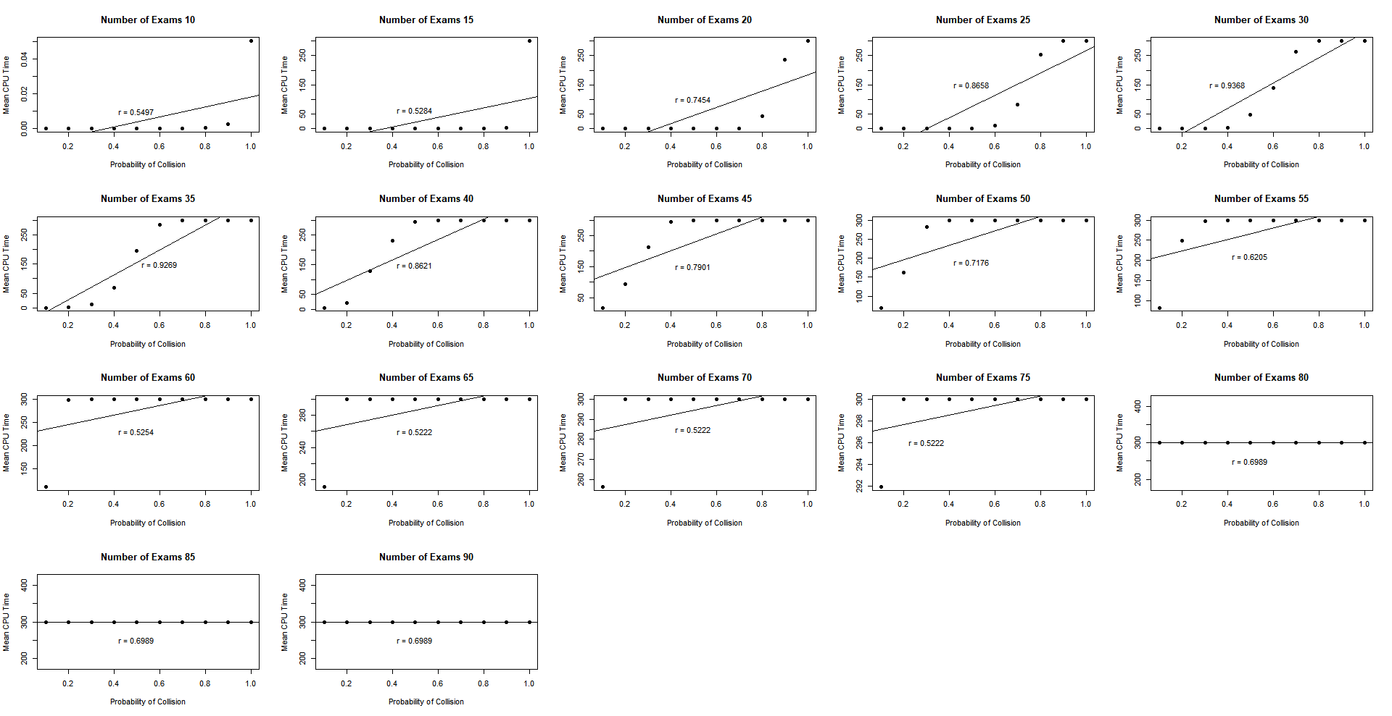

**Figure S5:** Linear regression fitted for variation of mean CPU time of code 2 in relation to the probability of collision for each number of exams.

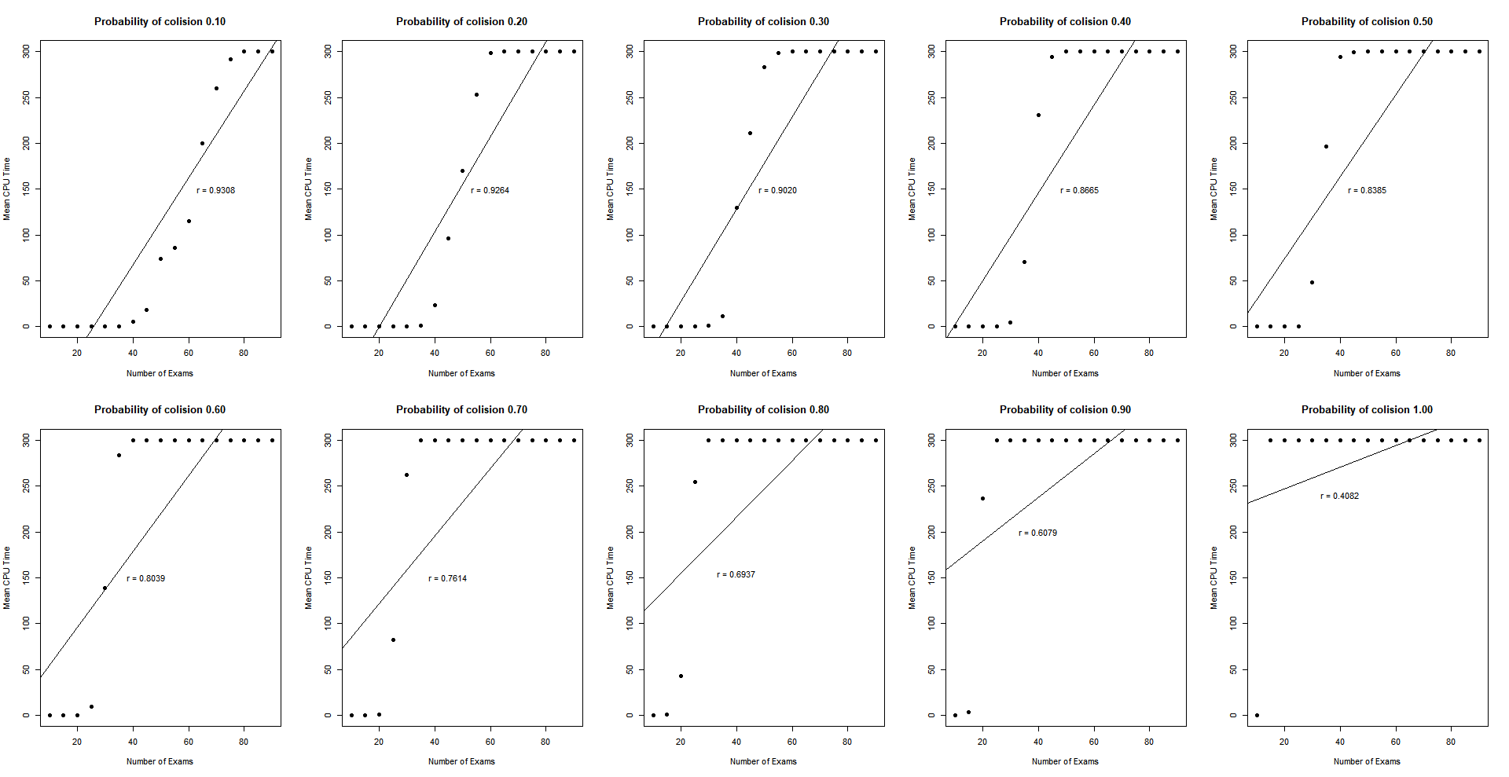

**Figure S6:** Linear regression fitted for variation of mean CPU time of code 1 in relation to the number of exams for each probability of collision.

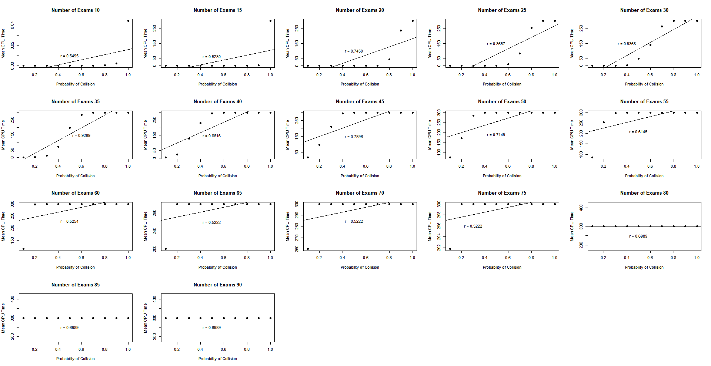

**Figure S7:** Linear regression fitted for variation of mean CPU time of code 1 in relation to the probability of collision for each number of exams.

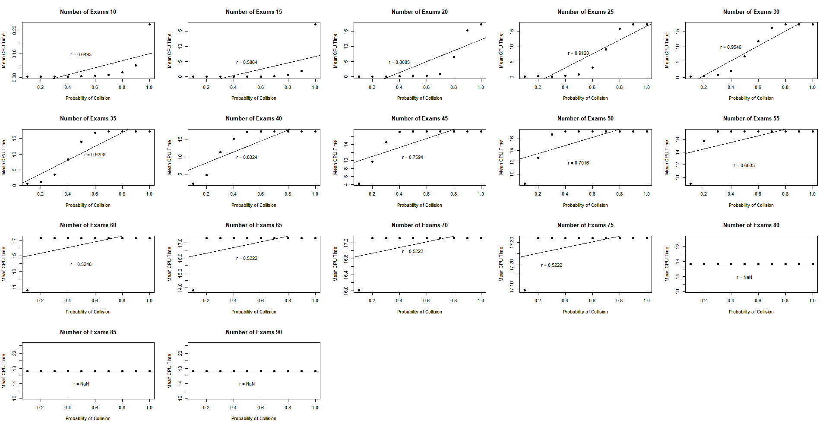

**Figure S8:** Linear regression fitted for the transformed variation of mean CPU time of code 2 in relation to the probability of collision for each number of exams.

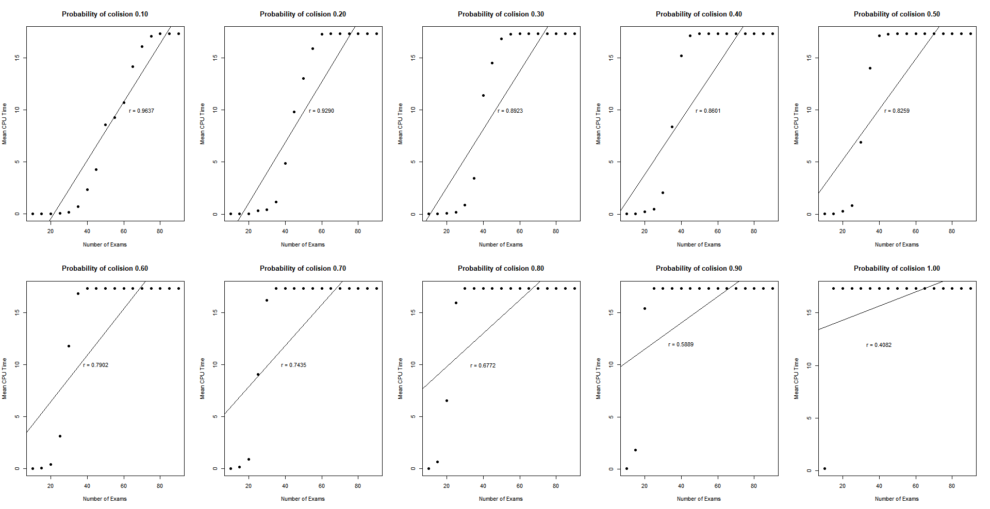

**Figure S9:** Linear regression fitted for variation of the transformed mean CPU time of code 1 in relation to the number of exams for each probability of collision.

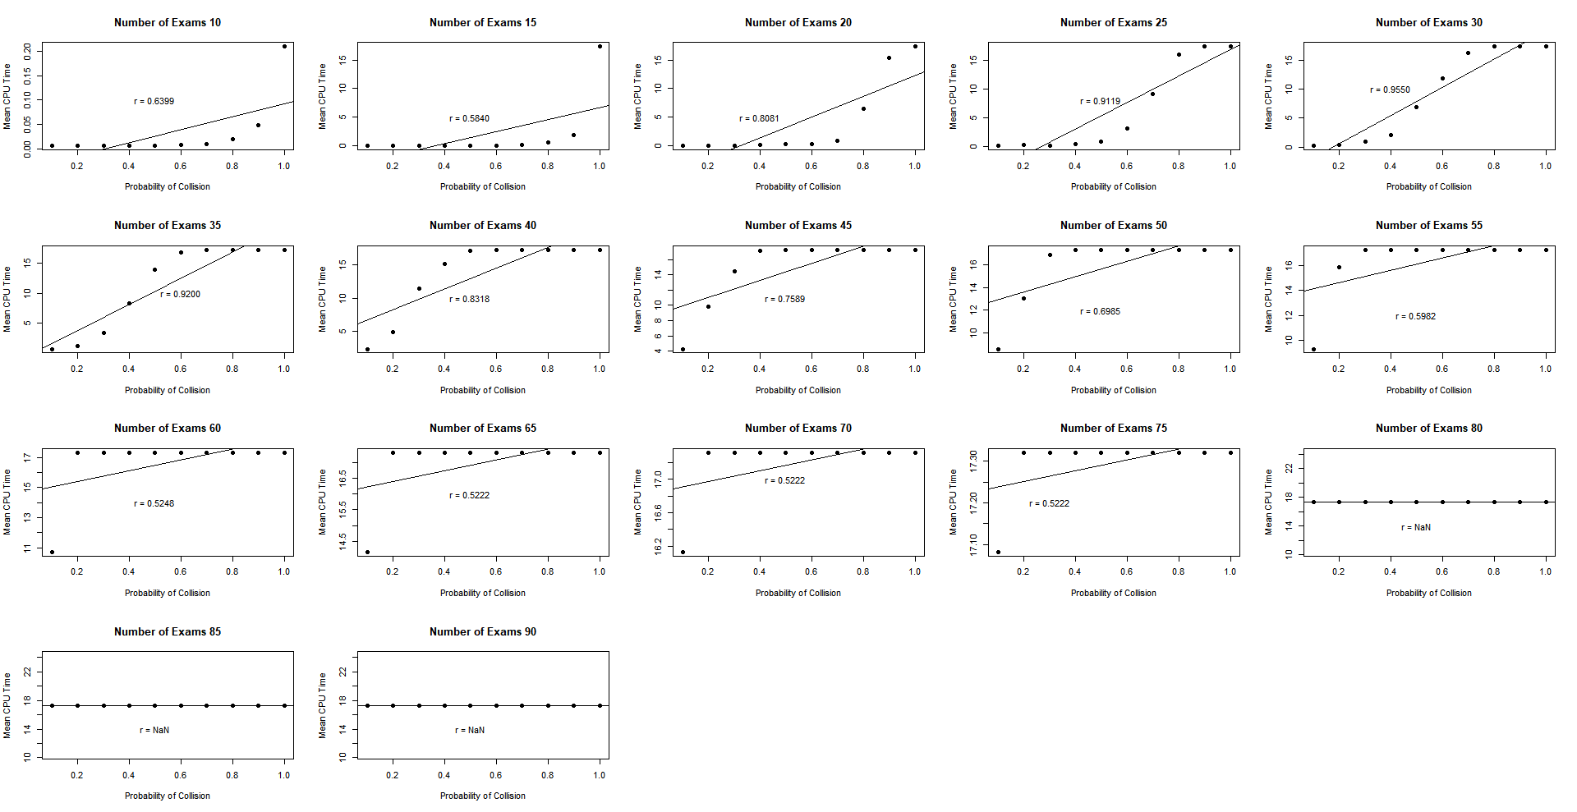

**Figure S10:** Linear regression fitted for the transformed variation of mean CPU time of code 1 in relation to the probability of collision for each number of exams.