SOFE 3490U - Software Project Management

Lab 1

Friday, January 19, 2024

11:10 AM - 2:00PM Eastern Time

CRN 74669

| Jeremy Mark Tubongbanua | 100849092 |
| --- | --- |
| Jonathan Hua | 100754458 |
| Daniel Amasowomwan | 100787640 |

Create a Git repository using the cheat sheet commands

Keep a word document named “Screenshots” open to put screenshots in

Edit the “Student” file to include your Student Name & Student ID

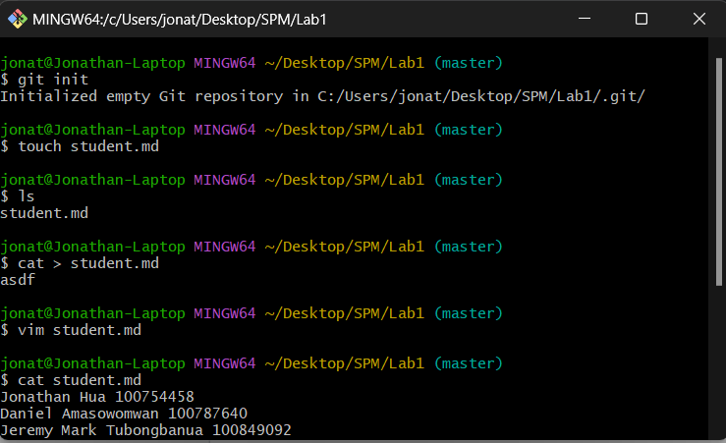

Commit changes

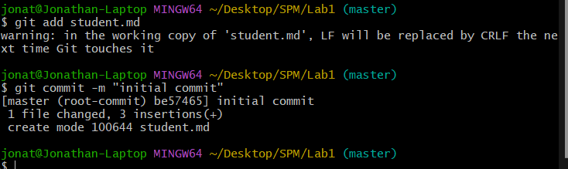

Create IgnoreExample.txt

Edit content of IgnoreExample.txt

Use git status and screenshot the outcome

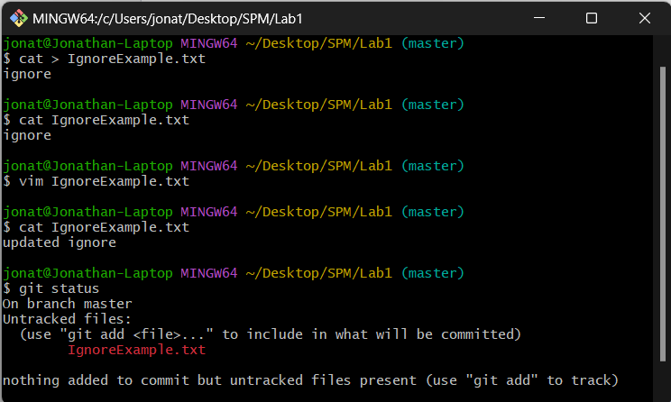

● Commit changes

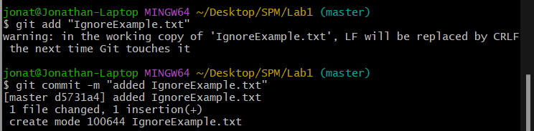

● Add IgnoreExample.txt to .gitignore file

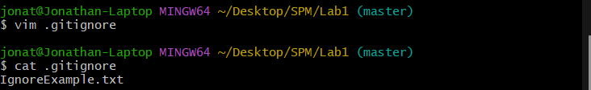

● Edit content of IgnoreExample.txt

● Use git status and screenshot the outcome

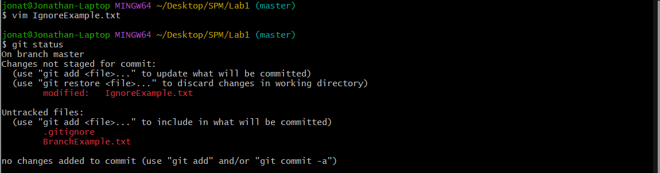

● Create a new branch using the git branch

● Switch to the new branch

● Edit BranchExample.txt (create this if not present) via the

notepad command

notepad BranchExample.txt

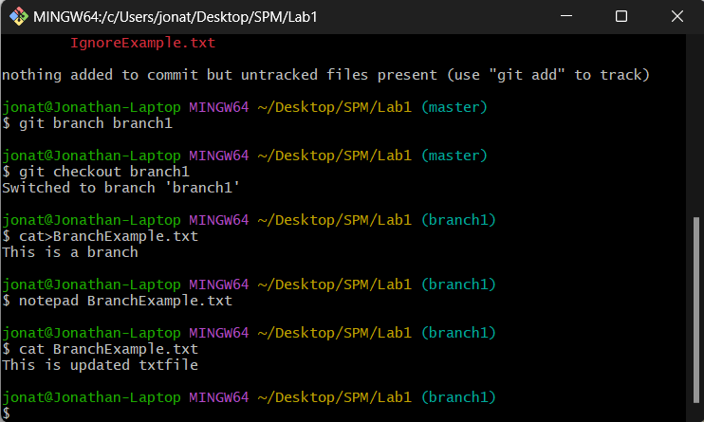

● Use git add to update branch example, commit and use the

notepad command again

● Screenshot content

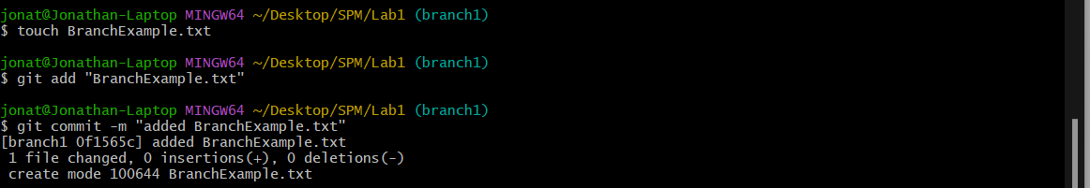

● Switch back to the master branchclea

● Use the same notepad command

● Screenshot the outcome

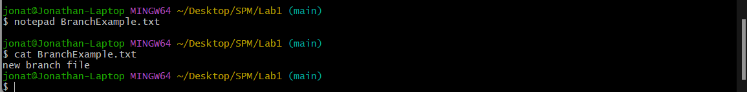

● Remove RemoveExample.txt (create one first if not present)

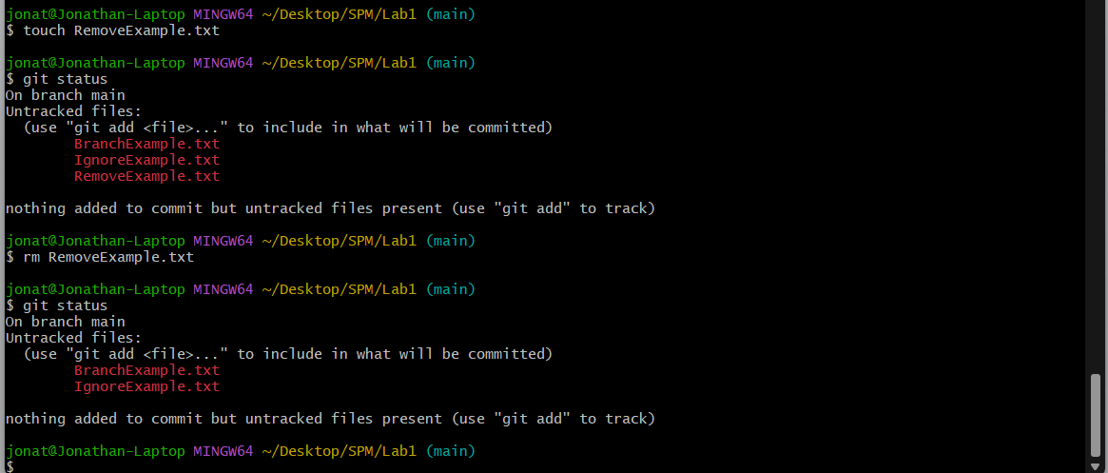

● Commit

● Use git status and screenshot outcome

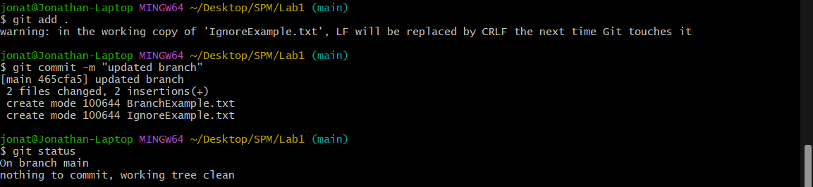

● Use the clean command to remove the file completely

● Use git status and screenshot outcome

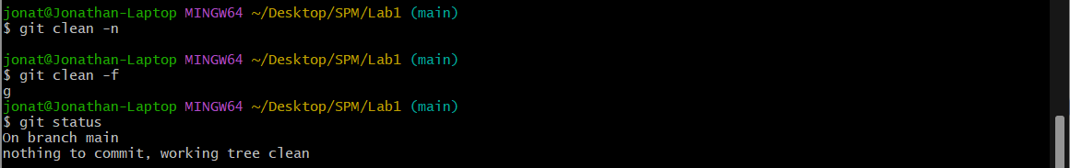

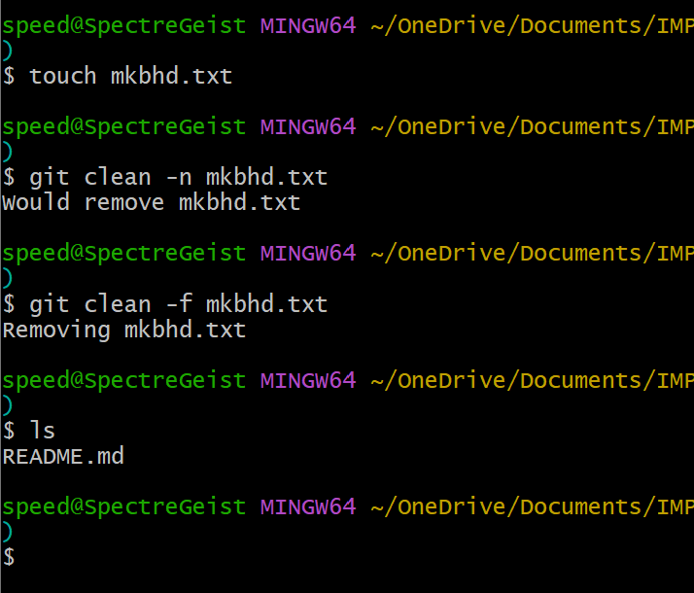

● Use git add to add your word document with the screenshots to the

repository; it should look something like this:

git add Screenshots.docx

● Commit