**NAME : UROOSA**

**FATHER NAME : AFZAAL MEHMOOD**

**BS : NI-F13-BS-00503**

**FIRST ASSIMENT OF INTRODUCTION OF SOFTWARE ENGINEER**

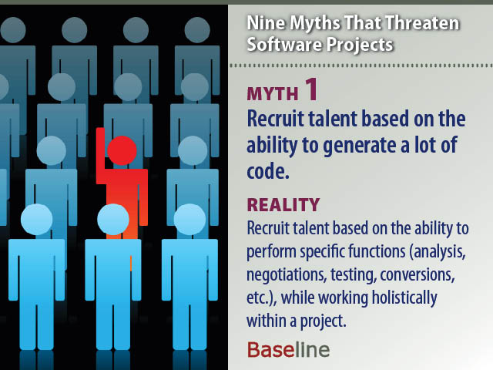

**SOFTWARE MYTHS:**

The development of software requires dedication and understanding on the developers' part. Many software problems arise due to myths that are formed during the initial stages of software development. Unlike ancient folklore that often provides valuable lessons, software myths propagate false beliefs and confusion in the minds of management, users and developers.

Managers, who own software development responsibility, are often under strain and pressure to maintain a software budget, time constraints, improved quality, and many other considerations.

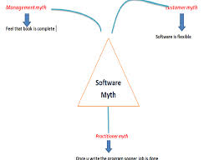

**CUSTOMER MYTHS:**

**Successful companies know that customer satisfaction is important, and they measure it often.**

However, if you believe any of these five persistent myths about customer satisfaction, you might not be getting enough insight from your customer experience data. You need to challenge these myths to create more engaged customers, who will in turn create revenue and success for your business.

**Myth #1: My Customer is satisfied and that is All I Need to Know**

A mistake many companies make is linking customer satisfaction directly to loyalty. They assume that satisfied customers are loyal customers, and vice versa.

The truth is that customer satisfaction is *not* a direct line to loyalty. Though loyal customers are in many cases also satisfied, there are many other reasons why they are loyal. Some of those reasons include values, brand, product and the customer’s feelings of engagement with the brand.

## Myth #2: Customer Satisfaction is Purely Dependent on Employees Who Have Customer-Facing Roles

Customer satisfaction will suffer if it isn’t on the agenda for the whole company. Though customer-facing roles are usually in the line of fire when customer satisfaction drops, everyone is responsible for how customers feel about the company and the products.

## Myth #3: Performing a Customer Satisfaction Survey Once a Year is enough

If you’re only measuring customer satisfaction once a year, your company will always be lagging behind. Data from eight months ago might be radically different from what you would discover in a survey today.

## Myth #4: Price and Customer Service Are the Only Factors That Matters to Customers

The [customer experience](http://www.questback.com/customer-experience) is multi-faceted and driven by many more elements than price and customer service. While price may have a clear effect on a customer’s initial decision to purchase your company’s product, every interaction the customer has with your brand affects their satisfaction.

## Myth #5: Customer Complaints Mean Customer Dissatisfaction

One of the benefits of conducting customer satisfaction surveys regularly and frequently is you get to hear what your customers really think of your company and products – and sometimes that will come in the form of complaints. Believe it or not, that can be a good thing.

## A Final Analysis

Customer experience is directly linked to whole-company performance – it’s not just the responsibility of customer-facing employees. Engaged employees, good leadership and operational performance keyed into real-time customer satisfaction data, create engaged customers. And engaged customers create revenue and success in business.

**Management Myths**  
Managers with software responsibility, like managers in most disciplines, are often under pressure to maintain budgets, keep schedules from slipping, and improve quality. Like a drowning person who grasps at a straw, a software manager often grasps at belief in a software myth, If the Belief will lessen the pressure.  
  
 Myth: We already have a book that's full of standards and procedures for building software; won't that provide my people with everything they need to know?  Reality: The book of standards may very well exist, but is it used? In many cases, the answer to the following questions is "no. “  Are software practitioners aware of its existence?  Does it reflect modern software engineering practice?  Is it complete?  Is it streamlined to improve time to delivery while still maintaining a focus on quality? 

Myth: If we get behind schedule, we can add more programmers and catch up  Reality: Software development is not a mechanistic process like manufacturing. In the words of Brooks [BRO75]: "adding people to a late software project makes it later“ 

Myth: If I decide to outsource the software project to a third party, I can just relax and let that firm build it.  Reality: If an organization does not understand how to manage and control software projects internally, it will invariably struggle when it outsources software projects.****

**Practitioner Practitioner’s Myths s Myths**

Myth: Once we write the program and get it to work, our job is done.  Reality: Someone once said that "the sooner you begin 'writing code', the longer it'll take you to get done." Industry data ([LIE80], [JON91], [PUT97]) indicate that between 60 and 80 percent of all effort expended on software will be expended after it is delivered to the customer for the first time.

 Myth: Until I get the program "running" I have no way of assessing its quality.  Reality: One of the most effective software quality assurance mechanisms can be applied from the inception of a project—the formal technical review. Software reviews are more effective than testing for finding certain classes of software defects. 

Myth: The only deliverable work product for a successful project is the working program.  Reality: A working program is only one part of a software configuration that includes many elements. Documentation provides a foundation for successful engineering and, more important, guidance for software support.

 Myth: Software engineering will make us create voluminous and unnecessary documentation and will invariably slow us down.  Reality: Software engineering is not about creating documents. It is about creating quality. Better quality leads to reduced rework. And reduced rework results in faster delivery times.