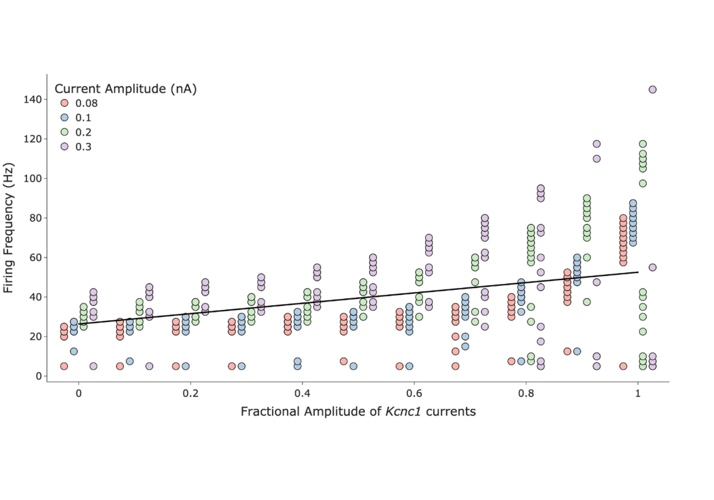

**Variation of the firing frequency with respect to the ɸKcnc1 for different current clamp stimuli surveyed.** An optimized best-fit (black line) indicate an increase of 2.62 Hz per 0.1 increase in fractional amplitude.