Medical Records PDF Compiler
User Manual
Version 1.0

Purpose
Medical Records PDF Compiler is an internal application designed to automate the creation of Medical Records packages for payer submissions. The application combines claim information, supporting documentation, SOAP notes, patient treatment documents, and payer correspondence into a single organized PDF package.

Before You Begin
Ensure all required documents have been received, PDFs open correctly, the Claims CSV contains the expected claims, SOAP documentation is complete, and you know where output files should be saved.

Launching the Application
Locate the executable, double-click it, and wait for the main window to appear. No installation is required when using the portable version.
In some cases, a warning window can appear depending on the user PC security settings, if that is your escenario, just clic on “More info” and then in the button that says “Run Anyways” and the application will run normally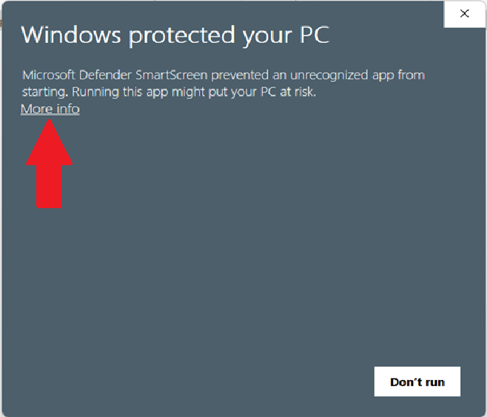

Creating your claim_list.csv
Before you start creating packages, you need to create this file, this is the core of the app and is necessary to create the packages correctly.
To do this, open a new excel file and create the following columns:
Make sure you create it exactly as the image above, if the column names are incorrect the app will not know where the information is located and will not create the packages corretly.
Once you have this, you can start putting the claims information like this example 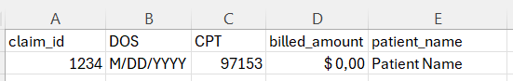
Make sure to select the date format to M/DD/YYYY, to do this, select the cells and ricght clic, then go to format cells
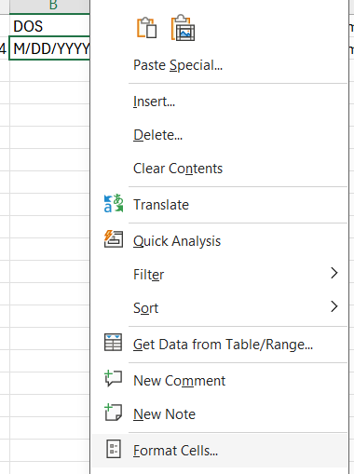
Then go to Date, on the location select “English (united States)” and select the type “3/14/2012” and clic “OK”
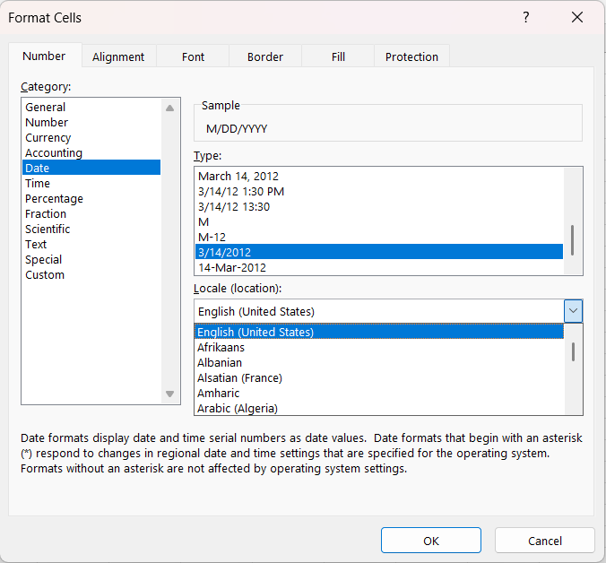
Once you finished completing the claims information, go to “File”, “Save As” and select this format and clic the save button.
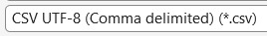
Once you save the file, you can upload it into the application.

Understanding the Interface
The application is divided into document selection sections and processing controls.
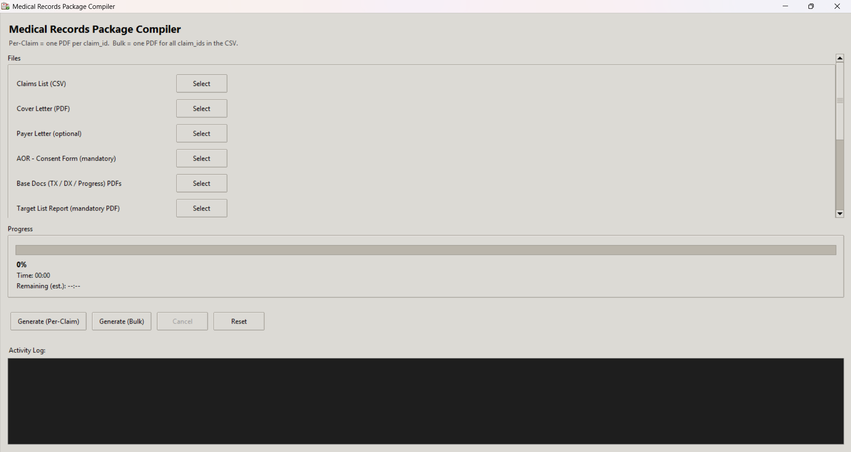
To select the document just click on the “Select” button at the right side of the file name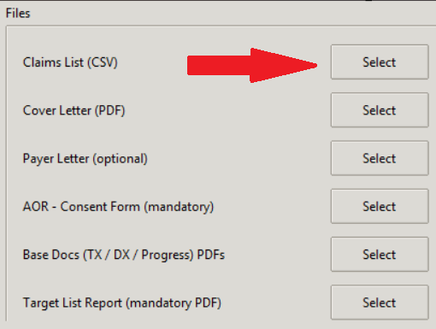
A new window will appear in which you can select the folder where your selected document is located 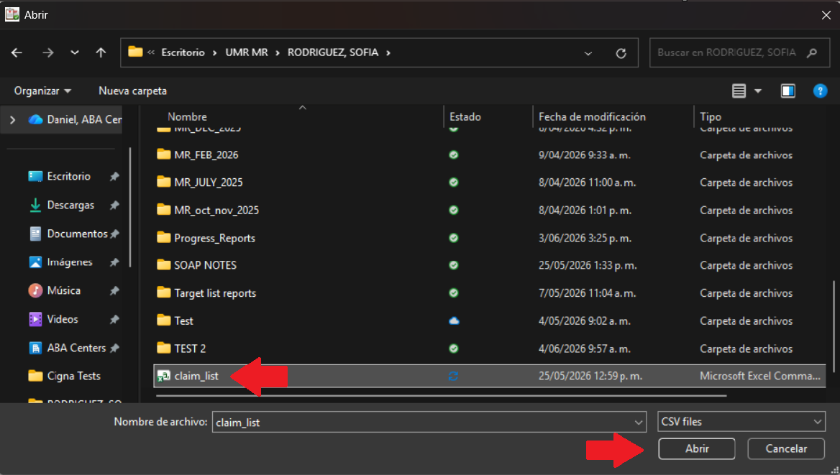
Clic on the selected document and then clic on “Abrir” or “Open” depending on your PC language.
Do the same for all the necessary documents, note that there is a scroll bar at the right side, if you don’t see the document you need to upload, just scroll down or up to find it.
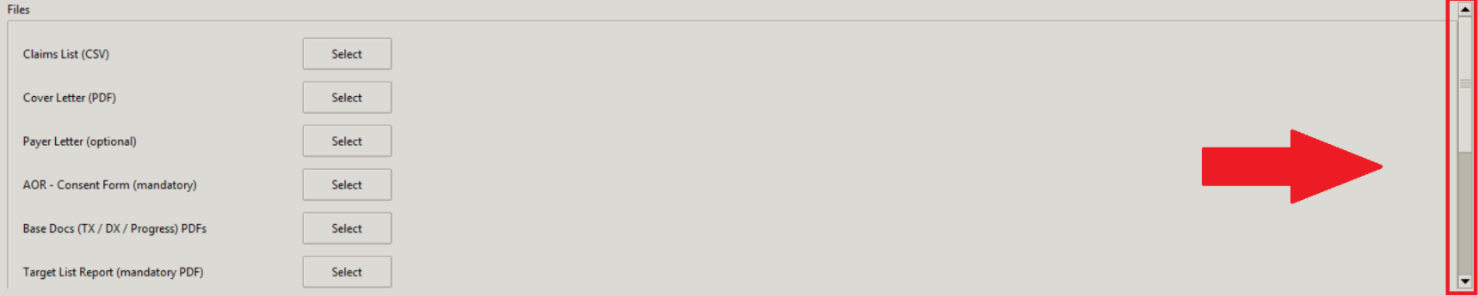
Once your document is selected, you will see the document name at the right side of the “select” button.
For some of the documents you will have to upload multiple files in one selection, for this case, from the selection folder press the key “Ctrl” on your keyboard and keep it pressed whlie you are clicing all the documents, if you need to scroll through the window you can unpress the “Ctrl” key, scroll and press it again to continue selecting documents, once you finished you will see something like this on the app with the amount of documents you selected.
In case you missed a file, clic the select button again and repeat the process.
Once you selected the files, now is time to selectwhere do you want so save the packages. At the bottom of the files selection section you will see an “Output Folder” option, just clic on select in the same way you selected your files and just select the folder you want.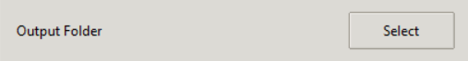
This aplication gives you the option to generate one single file or multiple files for the cases you need to create a bulk Medical Records package for multiple claims or single Medical Records packages for individual claims.
If you want to create a Bulk Medical Records package, use the button “Generate (Bulk)”, this option will generate one file for all the claims you put in the claim_list.csv file.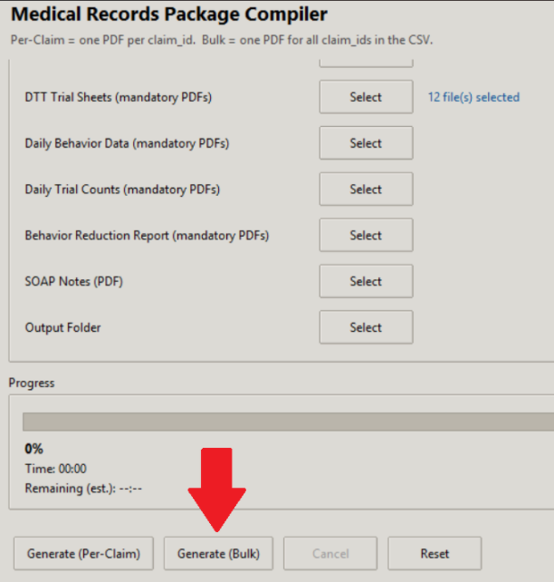
If you want to create a single file for each of the claims you are working, use the button “Generate (Per-Claim)”. This option will create one file for each claim, for example, if you are working on 10 claims, this option will create 10 Medical Records files, one for each of the claims in the claim_list.csv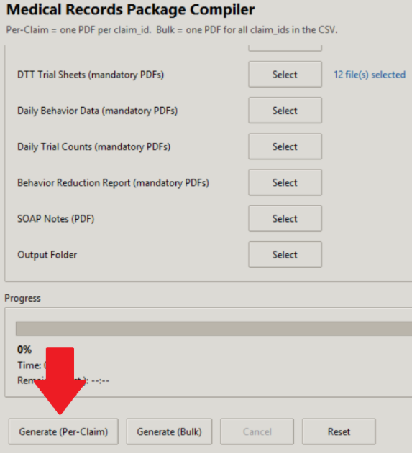
Once you selected the way you are going to create your Medical Records Packages, just clic on the button and the app will start generating the files, you will know that the app finished when the progress bar reach 100% and a pop up window will appear notifying you that the documents creation is complete.
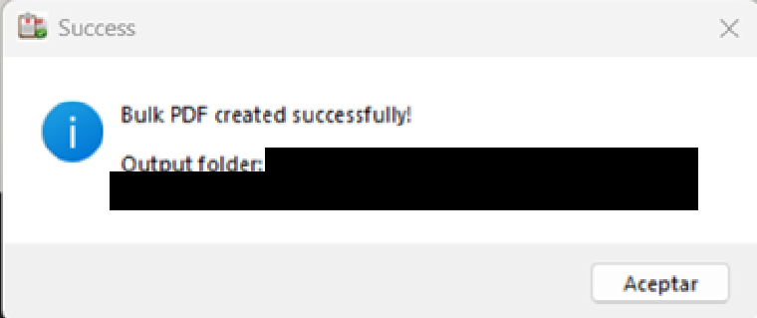
You will find the files on the folder you selected on the option “Output Folder”, remember checking the files before you send it to the payer.

Required Documents
- Claims CSV
- Cover Letter
- Payer Letter (Optional)
- AOR Document
- Base Documents (DX, TX, Progress Report)
- Target List Report
- DTT Trial Sheets
- Daily Behavior Data
- Daily Trial Counts
- Behavior Reduction Reports
- SOAP Notes for the claims DOS range
- Output Folder

Best Practices
Verify source documents before processing, use readable PDFs, review generated packages before submission, and maintain organized output folders.

Support
Save the application log, record the claim ID and error message, and provide screenshots when reporting issues.

System Requirements
- Windows 10 or Windows 11
- 8 GB RAM minimum
- 500 MB available disk space
- Supported file types: PDF and CSV

