MR Letters Automation
User Manual
ABA Centers of America
Version 1.0
Internal Use Only

Introduction
MR Letters Automation is an internal desktop application designed to reduce manual work associated with Medical Records request letters. The application processes PDF letters, extracts patient information, assigns documents to collectors, renames files, and generates processing logs automatically.

System Overview
The application reads PDF documents from an input folder, matches patient information against an assignment CSV file, and organizes documents into collector-specific folders. Unsupported or unmatched records are sent to an UNASSIGNED folder for review.

Required Files
Before processing, prepare:
(1) An Input Folder containing PDF letters.
(2) An Assignment CSV file containing patient-to-collector mappings, make sure that you are using this format:
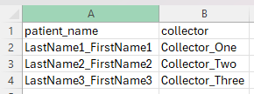
(3) An Output Folder where processed files will be saved.

Application Interface
The interface contains fields for Assignations CSV, Input Folder, and Output Folder, payer-specific tabs (UMR, Optum, Aetna, Cigna, BCBS TX, Florida Blue), a Start Processing button, a status indicator, and a processing log. 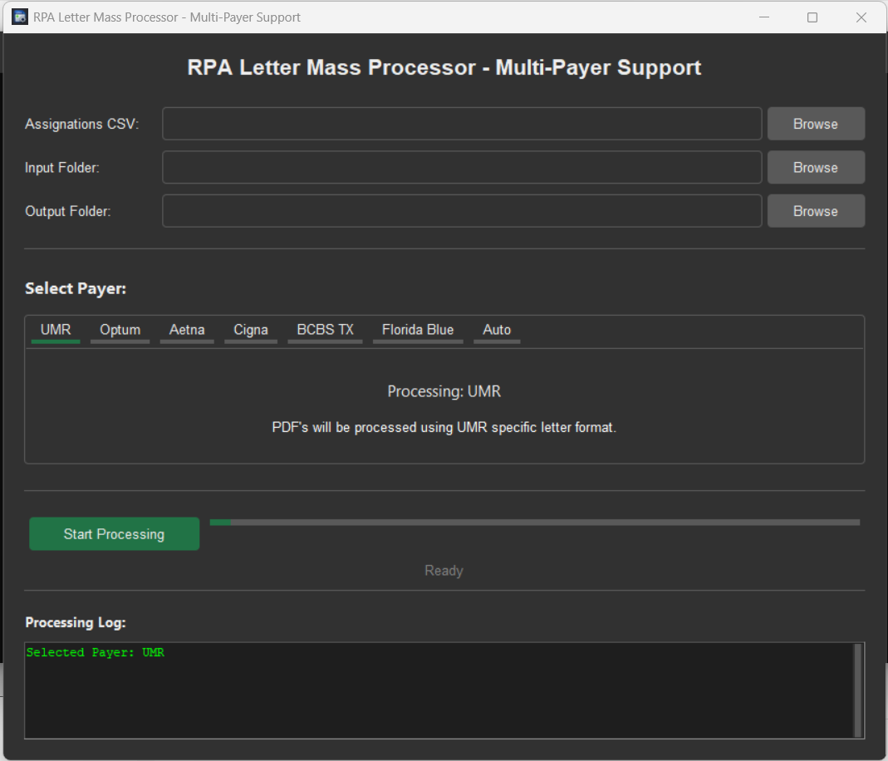

How to use the app
To select the Assignations file, go to the selection section, go to the “Browse” button at the right of the screen and click it, a new window will appear to select the file, go to the folder where your assignations.csv file is located and click on it, then click on “abrir” or “open depending on your PC language. 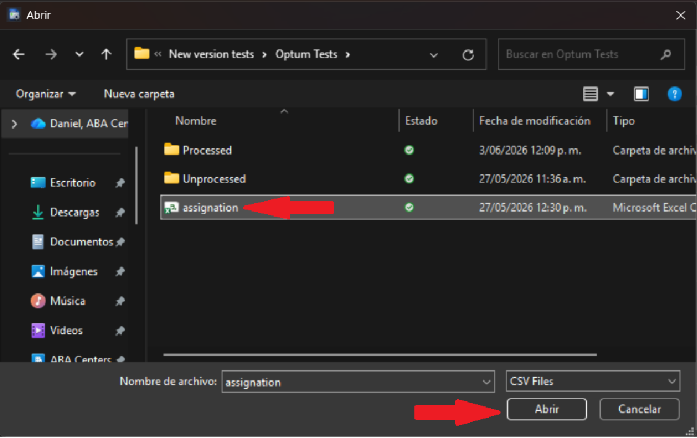
You will see the path where the file is located once the file is loaded into the application.
Now you must select the folder where the unprocessed letters are located, do the same process as with the assignations file. Click on the folder and then click on “Seleccionar Carpeta” or “Select folder” depending of your PC language.
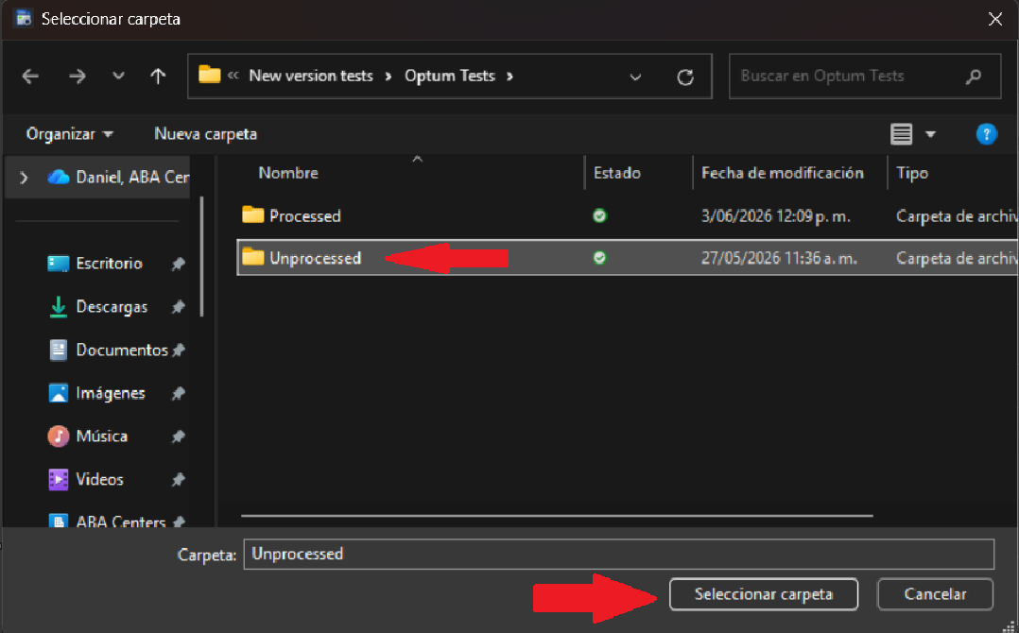
Repeat this procedure to select the folder where you want to save the processed letters, once you have finished selecting you will see this on the application. 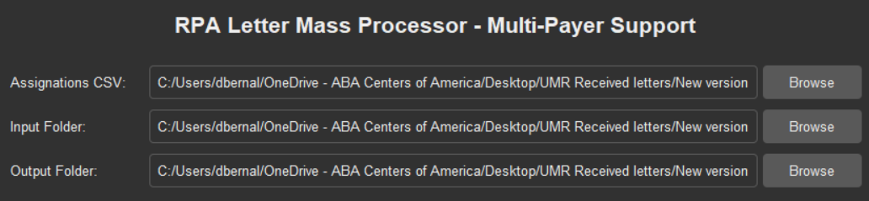
Now is time to select the specific payer to process, each payer have diferent letter formats so be sure you select the correct payer you are working with.
To do this, go to the Payer Selection section and clic on the payer name. 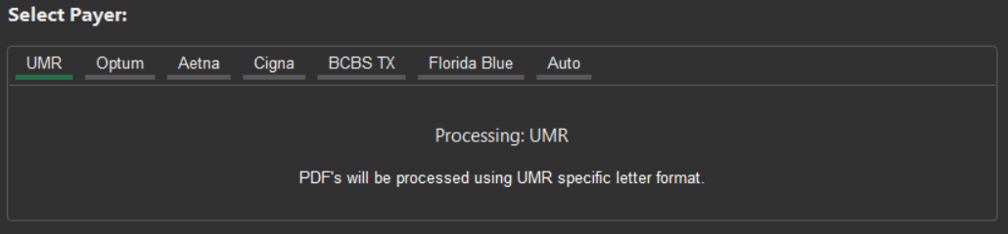
You will see a message on the app confirming the selected payer and the format that will be used to process the documents.
Once you have selected the payer, click on the green “Start Processing” button below and the app will start the process. 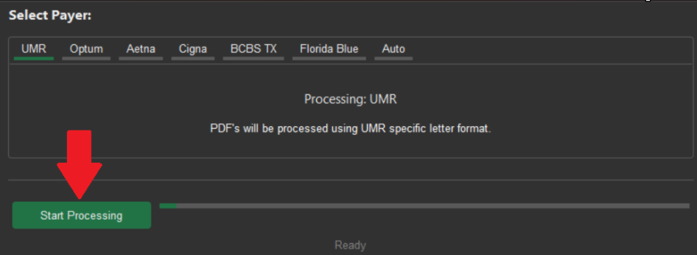
Once the app finished, a pop up message will appear with the successful processing confirmation.
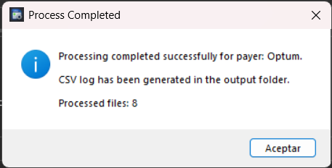
To review the documents, go to the output folder and you must see something like this: 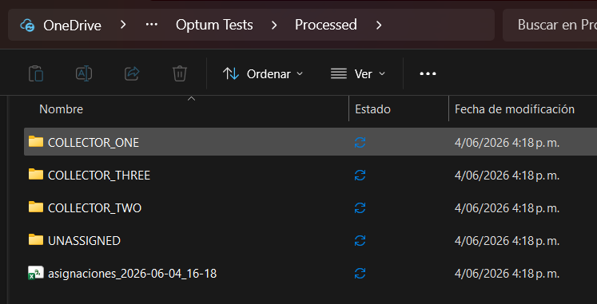
Open each folder to review the documents and start sending them to the asignated collector.
Inside the “UNASSIGNED” folder are the documents that couln’t being assigned to a collector, this could happened because the collector name or the patient were not on the assignations.csv, you can review these files manually or check the assignations.csv and run the aplication again if necessary.
You will also see a “.csv” file inside the processed folder, on this file you will find a report of the assignations that were made with the names and dates of the assignations.

Assignations log
This file contains the report of the assignations made each time you run the application, inside it you will find the information in this format: Original file name, patient name, DOS, assigned collector, exact time of the assignation (date and hour), payer. 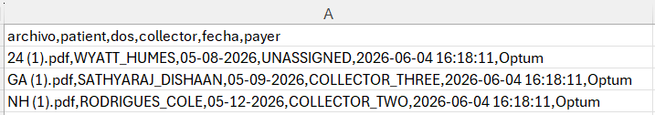

Output Structure
Processed documents are placed into collector folders. Documents that cannot be assigned are placed into the UNASSIGNED folder. Files are automatically renamed using extracted patient information and Date of Service when available.

Processing Logs
At the end of processing, the application generates a CSV log named asignaciones_YYYY-MM-DD_HH-MM.csv. The log contains file name, patient, DOS, collector, processing date, and payer information.

Supported Payers
Current supported payers include UMR, Optum, BCBS TX, Florida Blue, Aetna, and Cigna.

Common Issues
If files are routed to UNASSIGNED, verify that the patient exists in the Assignment CSV. Verify that all required folders were selected. Confirm that the PDF document is readable and contains the required patient information.

Best Practices
Validate the Assignment CSV before processing. Review the UNASSIGNED folder after every batch. Keep original source files until processing results have been verified.

Security and Confidentiality
This application process protected healthcare information and should only be used according to company policies and procedures.

System Requirements
Windows 10 or Windows 11. No installation is required. The application is distributed as a portable executable and can be run directly.

Copyright and License
Copyright (c) 2026 ABA Centers of America. All Rights Reserved. This software is proprietary and confidential. Unauthorized copying, distribution, modification, disclosure, or use outside ABA Centers of America is prohibited.

