Brief Overview

Opening up the CPI report and looking at overall CPI (CPI-U) for August one might be relieved to see .1% m/m inflation. Annualized this would come out to a 1.2% rate of inflation which is not a bad number, and more importantly below the highly coveted 2% that J-Pow so desperately aims at. Once one starts to look more deeply into the report though the numbers aren’t so rosy. Most notably we see that core-CPI rose .6% m/m and when we look at CPI-U we see that it was really only so low because of large decreases in the highly volatile energy sector. For this reason the report was to some extent mixed. Okay for the consumer inflation was not as bad, but going forward it might still be bad.

Where is inflation going?

The first topic to discuss is what this report says about current and future inflation. For a basis towards investigation we can start with the comparison of CPI-U and core-CPI. As previously stated CPI-U is more volatile due to energy prices so in some ways this might not be a good indicator of future inflation. At the same time energy prices are extremely important to many consumers and to tell them that overall inflation has not decreased when they no longer have to pay as high of prices on what is somewhat of an essential good would be wrong. Nonetheless when we look towards predicting long term inflation it is hard to make the argument that inflation will stay low just on decreases in the energy sector that is why many are looking at core-CPI. To understand though whether high core-CPI is a sign of things to come, like CPI-U one has to look at its specific components and where the rise in core-CPI is coming from.

A large amount of fear mongering about the rise in core-CPI comes from the idea of a wage-price spiral. In which higher prices lead to higher wages which then…. Lead to higher prices. Looking at subsectors of core-CPI I do think this report gives some support to this argument. Inflation among services was higher than that of commodities (.6% v. .5% m/m) and more labor intensive areas such as medical care and motor vehicle maintenance and repair did seem to see higher levels of inflation. (.8 medical care services 1.7 motor vehicle maintenance m/m) It is hard to really be precise on how much each sector uses labor and whether or not it should be considered labor intensive but just skimming through the report it does seem that labor played a large role in inflation. The question then becomes will wage hikes continue. When we think about the original sin, or in this case the original inflation that led to wage increases and subsequently large price hikes, it seemed to have come from three areas in particular, housing, food, and energy. To start, when looking at energy prices as already stated, prices saw major declines in the previous month and it is not unreasonable to believe that lower prices will continue. The main price hike was caused by uncertainty generated by the start of the Ukraine war and as time has gone on that uncertainty has slowly left the market. It is unlikely that any direct shock will occur to cause large price hikes in the energy sector in the near future. The only reasonable argument I can think of is high winter demand but I’m not really sure how much crediance this argument holds.[1] For both housing and food there is a strong case that both will continue going forward. Food prices have been caused by extreme weather and supply chain issues, better than expected crop yields in any number of areas could mitigate the extreme weather effects but this is only an if and large amounts of uncertainty still remain. In terms of supply chain issues and bottlenecks, they do not seem to be leaving us anytime soon. Shelter inflation also shows no signs of slowing down, housing starts in July were reportedly down to their lowest levels since February 2021 which will likely only make the issue worse. So will employees continue to ask for higher wages and push up other prices? I think whenever there is a large shock in the economy, whether it be decrease in supply, increase in demand, or any other shock, an economy and its participants need to find a new equilibrium. A new equilibrium of what goods and how much of those goods each participant will buy but also a new equilibrium of how much each will make from the services they provide to the economy. We currently are searching for that new equilibrium but I believe the longer we go the closer we get to a relatively steady state/equilibrium. (It is important to note here that the economy is always evolving and resource allocation is never truly in equilibrium but always changing. What we currently have is a situation in which a sudden shock has caused sharp change in our economy.) So do I think high inflation will continue in the economy, yes but overtime it will taper off as our economy moves closer to a steady state. I do not see a logical argument for it getting substantially worse unless the supply of essential goods (food, shelter, energy, etc.) gets substantially worse. Of course I could be wrong, for starters the future is unknown and there is so much uncertainty in the future. On top of that I’m kinda of an idiot so the likelihood of me being wrong is pretty high but if I had to make a sharp prediction this is the prediction I would make.

What Should J-Pow Do?

The next question I want to look into is how this report affects future federal reserve policies. Should they raise the F.F.R.? If so by how much. Again we can start with the base case of an increase of .75 points. As previously stated overall inflation was low in August but there is strong evidence that this might not last. Let's say future inflation given no action by the federal reserve would be something like .6 m/m. If this is the rate of inflation given no change in F.F.R. then a .75 point rate hike seems logical. Even if the future rate of inflation would be .6 m/m though we do not know that a .75 is the exact rate increase to take. The future is unknown, .75 might be too small, it might be too large but given a .6 rate of inflation it seems logical.

For starters however we do not know that inflation will increase to .6 m/m. I do not see any evidence that it will increase to any rate substantially higher than .6 m/m but could it be lower? Again I do not know the answer to this. I think there is a logical argument to be made that it could be lower, I think .3 m/m seems reasonable. Again both house and food inflation seem unlikely to cool down anytime soon but maybe the rest do? If this is the case maybe a lower rate of inflation is the proper measure and an increase of .25 would be better, maybe such a high rate increase of .75 is not only unnecessary but possibly detrimental to the economy, and subsequently the prosperity and peace of our nation! I don’t know but from an expected value standpoint at some level isn’t it more logical to air on the side of moderation? Maybe the value of the average outcome is better with a .75 rate hike than .5 but if we instead we look at the average expected value of all outcomes a .5 hike is more logical. I’m a moderate so I always think we should air on the side of moderation. We should always hedge because we actually do not know what is right, we only know what “might be right”. J-Pow is a “radical” however, he tends not to air on the side of caution and instead tends to go with sharper, more precise lines when enacting policy.

Before we even have this argument over what interest rate hike we should do though, or even where the future of inflation is going, there is a more fundamental question we should be asking, would rate hikes even be effective in taming inflation? And there is substantial evidence right now to say that they might not. Again if you look at core-CPI inflation it has been unchanged since J-Pow began raising interest rates. The only price decreases we have seen are in the energy sector. So the only real argument one could have that interest rate hikes are working is that they have had deflationary effects on the energy sector. The evidence for this is in my opinion… not very strong.

More notably though when we move over to the shelter sector, I think there is evidence that the rate hikes have caused a decrease in new housing starts which might actually be exacerbating the problem. As counterintuitive as it seems I think there is a legitimate argument that rate hikes are actually making inflation worse. I am not saying it is right, just that it might be true. Does this mean the Fed should not raise interest rates? Again I am a moderate and though I believe there is logic behind the argument that interest rate hikes are not working, I am not sure they aren’t, and if they are we should use them. For this reason I think we should hedge, raise interest rates but maybe less than we think. For this reason and the others previously provided I think the smartest thing to do in relation to the F.F.R. would be a .5 point increase.

How Should Markets Respond?

At the moment Wall Street really only seems to care about one thing, the F.F.R. and what J-Pow does with it. Our first question then becomes how does the report affect the expected change in F.F.R. compared to what was expected before the report.[2] It is important to note here the question is not what they “should do” but instead what they are “likely to do”. In Powell’s recent Jackson Hole speech, Powell signaled fairly strongly that he planned to take a hawkish approach towards taming inflation. The federal reserve has shown that they believe raising the F.F.R. is an effective solution for lowering inflation. These two factors combined lead most to believe coming into the report that F.F.R. increases would likely come in at a .75 point increase for the near future. So did this report give the federal reserve enough information about the current state of inflation to change their course on raising interest rates? One could say that the federal reserve does not care about sector specific inflation. Their goal is to maintain price stability in the economy. They do not care if one good or one sector of goods has inherently high inflation. At the same time the federal reserve’s main goal is to maintain price stability in the economy and energy prices are extremely volatile. When trying to gauge long term inflation, leaving out energy prices may be a smart strategy. Independently of if it is actually a better indicator of inflation the question really is what does the federal reserve think? The federal reserve is smart enough not to put all their eggs in one basket and will likely hedge their view. One measure shows that inflation is continuing to increase another that it might be cooling down. No one knows the truth but what we do know is that J-Pow has stated that the Fed plan to take a hawkish view towards inflation. Therefore, given the uncertainty of future inflation shown in this report it is highly likely that the federal reserve will air on the side of caution and continue to precede with F.F.R. increases as expected. Some might want to go more in-depth on the actual CPI report and look into more stratified sectors of inflation but for answering this question I do not think it is necessary. There is uncertainty over future inflation and under uncertainty I think the Fed is likely to proceed with previously stated plans.

Very quickly I’d like to talk about what this report doesn’t show and how that affects future policy. First, it did not show inflation getting substantly worse. A .6 m/m or higher would have been much worse and have raised the probability of higher rate increases. At the same time it also did not show a slowdown in inflation. It is unlikely that J-Pow was going to shift towards more dovish policies any time soon unless prices nose-dove in August and if that had happened we already would have known about it. So when we look at this report it dodged the main negative of supporting higher rate increases. So yes, this was a negative report but was it really that bad for markets? I’d argue no. Yes inflation was higher than expected .1% m/m compared to 0 predicted but really was it really that bad? The sp 500 fell 3% on Tuesday in response and from my estimations this is an overreaction. Maybe I am not looking deeply enough into this report maybe higher expected inflation came from specific sector based numbers that are worrying. I don’t know, normally these predictions really aren’t that in depth and my assumption is that what we saw on Tuesday was an overreaction, but what do I know?

Misleading the Masses with Y/y Comparisons

Last I wanted to talk a little bit about y/y vs. m/m increase. I have seen a lot of people reporting on and referencing y/y numbers for the most part to tell the story that inflation in the U.S. for August was really bad. Don’t get me wrong y/y are not bad in themselves, they play an important purpose in understanding how prices have increased from one year to the next. What they do a poor job in doing though is telling us about inflation in a given month. For example let's say an index was measured at 5.0 for 12 months straight starting in January-21, so January-21 through December-21 the index was 5.0, then in January-22 it shot up to 6. In January-22 inflation would have been really bad! Here both m/m and y/y would show 20% inflation. If then in February-22 the number stayed at 6, and then again in March so on.. all the way to August, y/y inflation in August would still be 20% even though prices had not increased since January. So saying that inflation in August was bad because y/y inflation was 20% would be downright wrong. For the year Aug-21 to Aug-22 was inflation bad, yes. But in Aug-22 was it bad, no. Even worst what if prices had fallen from 6 in July-22 to 5.5 in Aug-22. Y/y would still be reporting 10% inflation even though prices fell on the month. The point here being y/y inflation is not a good representation of monthly inflation! So when people report y/y inflation to describe inflation on the month they either do not know what they are reporting on well enough or are intentionally misleading readers. Either way you should be skeptical of anyone using these numbers to describe inflation on the month.

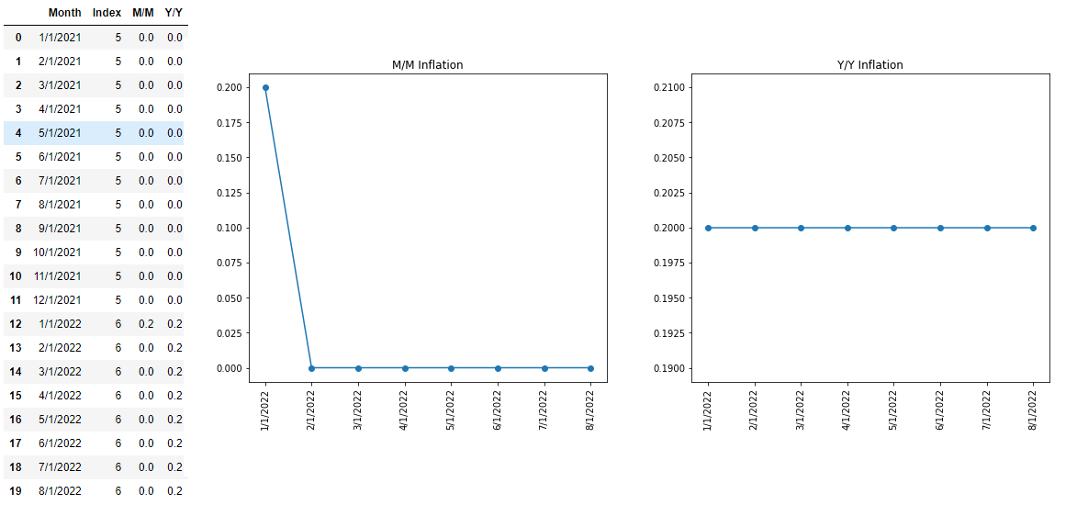

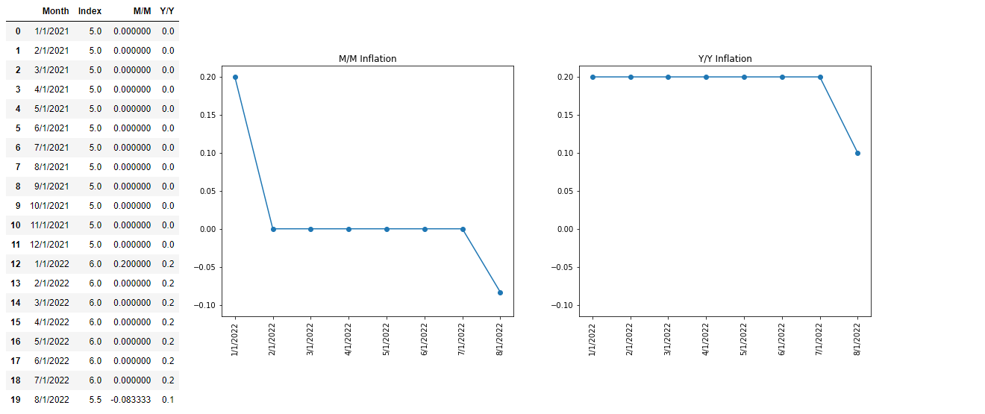

1. Really I do not know much about the energy sector but my assumption is future demand to some level should be factored into prices, whether that be suppliers reducing supply now so in winter months they can produce more when prices are higher or something else, my assumption is markets will have already factored seasonal demand into prices. I very much could be wrong here I am very much assuming.
2. Note this is not the exact question you would want to ask, you would want to take a more complex view such as taking the probability distribution of different F.F.R. occurring and then assign an expected value to each, then find the expected value of that!... Or at least this seems like a more precise method..