Unibody C-Ring Prototype Assembly Guide

Prototype V4.3

* "**Body**" refers to the flute body part, with six holes, printed by MJF.
  + 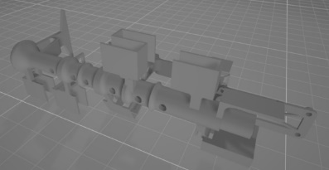
* In this guide, **ordinals start with zero**. 0th, 1st, etc.
* Here are the lab-printed parts:

|  |  |  |  |  |  |
| --- | --- | --- | --- | --- | --- |
| C-Ring | NanoClip | sensorBox adaptor | sensorBox grate | sensorBox muter | sensorBox ring |
|  |  |  |  |  |  |

1. Principles:
   1. When using hot glue, keep in mind that this is a modular, detachable design. You should be able to remove whatever hot glue there is and replace parts. i.e., don’t much too much hot glue and avoid nooks and crannies.
2. Install a PCA9685 onto Body with nuts and bolts.

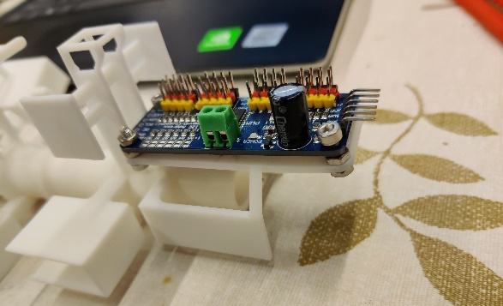

1. Stick pieces of the bronze tape onto Body.

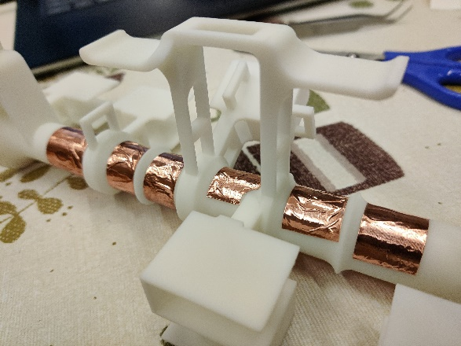

* 1. We will call one segment of tape “a tape”.
  2. Each tape should enclose both the top (hole area) and the bottom of Body as a “C” shape. The “C” should face against the servo shells, so that you have enough space for tools to move. (It’s ok for a tape to be too long.)
  3. Always cut out the left and right borders (making the segment less wide), since these borders are less sticky. (They are usually visibly worn out.)
  4. The tapes should not cover areas with too much curvature. In those cases, cut out some tape to avoid edges and curvatures.
  5. Press down on every corner of the tapes to ensure contact.

1. Use a box cutter (美工刀) to carve out the holes.

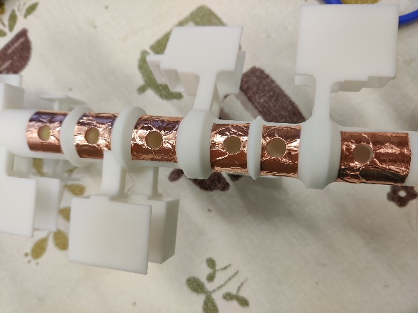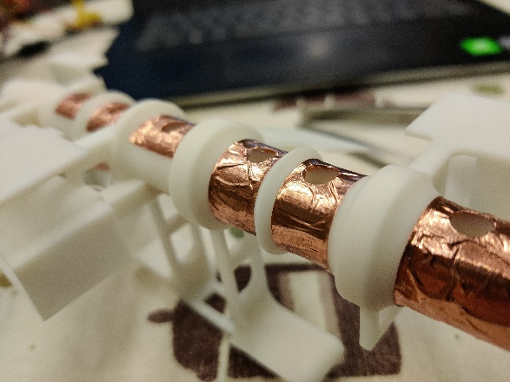

* 1. Use your fingers to press down on the holes. This makes the outline of the holes more visible.
  2. It’s ok to have some bronze left in the hole. Curve those bronze skirts inward and press them against the inside of the holes. Never cut away too much, otherwise the capacitor sensor may miss the player’s finger.
  3. I usually make six cuts forming a hexagon. This makes the process very fast.

1. Did you know? Bronze is bad for your health. Wash your hands NOW!
2. Install an Arduino Nano onto Body with a NanoClip.

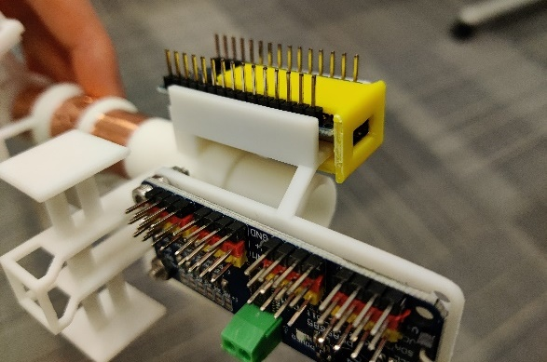

1. Use six jumper cables to connect the capacitor sensors (i.e., bronze tapes) with the Arduino pin 2, 3, 4, 5, 6, 7. (the 4, 5, 6, 7, 8, 9th pin on Arduino Nano counting from the left on the top row, when Body is placed on its stands.)

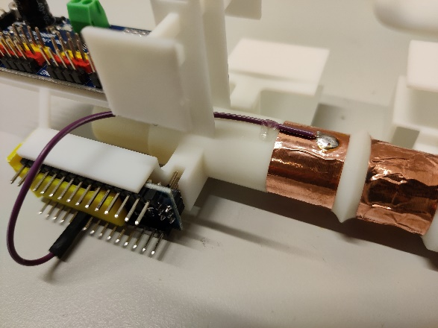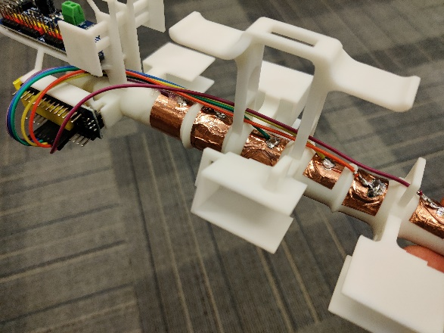

* 1. The jumper cables should be Female-Naked.
  2. Preferably, color code the cables as red-orange-yellow-green-blue-purple, from the farthest to the closest to the Arduino.
  3. Process one cable at a time, one after another, in the sequence: from purple to red. The red and the orange cables need to be longer than 19 cm.
  4. For each cable,
     1. Attach its Female lead to the Arduino.
     2. Make it go through the hole beneath the flute main cylinder.
     3. Cut it at a proper length. The cable heads should easily engage / eject from the pins, but meanwhile there shouldn’t be too much spare length wiggling around.
     4. Take the cable out into the open and expose the copper wires with a wire cutter / scissors. Put it back in again.
     5. Solder its Naked lead to the bottom of its corresponding piece of bronze tape. (Pin 2 is the 4th pin on Arduino Nano counting from the left on the top row, when Body is placed on its stands.)
     6. (Do not use hot glue to secure the solder. There won’t be stress on these cables, and hot glue does not attach to bronze well.)

1. Solder four cables onto the BMP085 sensor.

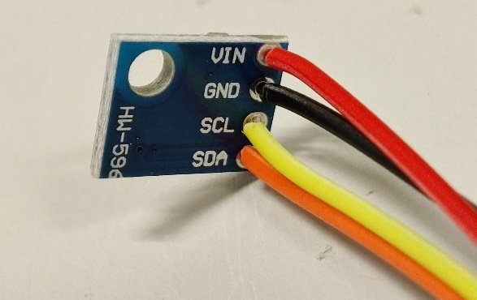

* 1. The exposed copper wire should be short, to avoid short circuiting.
  2. GND – black – Female.
  3. VCC – red – Female.
  4. I2C pins (i.e. CLK, DTA).
     1. For this, get two M-F jumper cables. Cut each into two parts at arbitrary proportion. Stash the Female parts (let’s call them “**Alice**”).
     2. Use the two Male parts. CLK – Male. DTA – Male.

1. Put the BMP085 sensor into the sensorBox adaptor
   1. Use a nut and a bolt to secure the sensor into the adaptor. Do not apply too much stress.

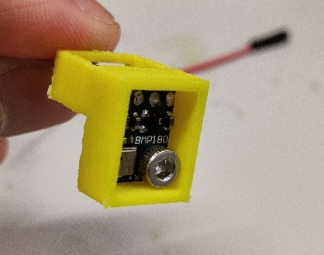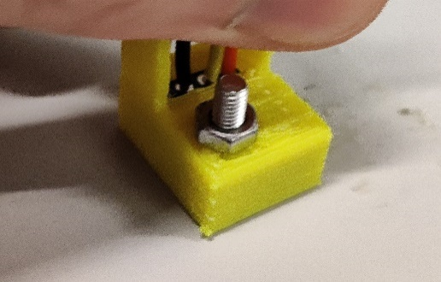

* 1. Use hot glue to secure the cables onto the extended cable ring on the adaptor. Secure both sides.

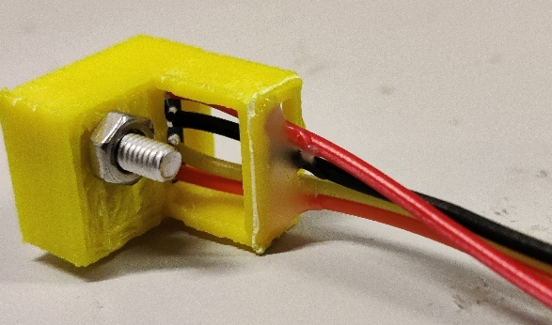

1. Make two 3-junctions.

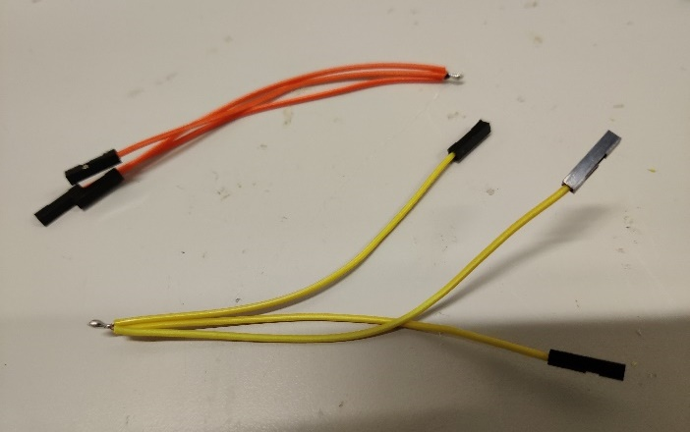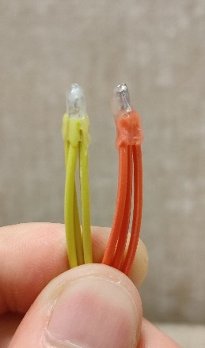

* 1. Retrieve **Alice**. Get two F-F jumper cables. Cut each F-F cable into two halves.
  2. Solder three half-cables together to get a F-F-F 3-junction.
  3. Use hot glue to cover the exposed wires.

1. Apply the 3-junctions.
   1. CLK: Arduino A5 – PCA9685 – floated.
   2. SDA: Arduino A4 – PCA9685 – floated.
   3. (Pin A5, A4 is the 6th, 7th pin on Arduino Nano counting from the left on the bottom row, when Body is placed on its stands.)
2. Initialize HC-05.

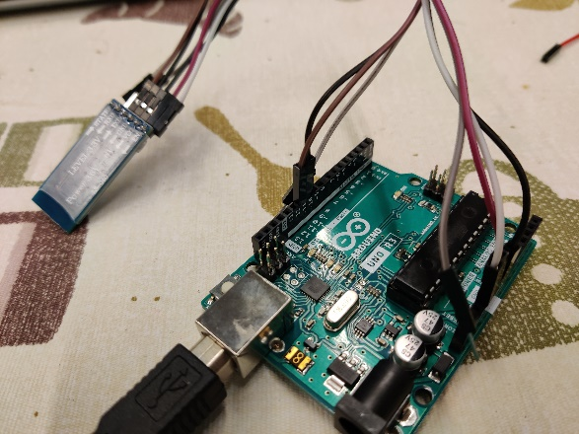

* 1. Optionally, get a spare Arduino Uno / Mega.
  2. Open “MAIN/ardu/setupBluetooth” Arduino script.
  3. Connect pin 10 with TXD, pin 11 with RXD, 5V with VCC, GND with GND, and 3V3 with EN.
  4. Make sure the constant `MODE` is `` and upload the script. Then, open Serial Monitor. Read everything – make sure the assertions are true. If everything checks out and the last line says “Arduino script exits”, we are good.
  5. Retrieve HC-05 from this circuit.

1. Install the HC-05 module onto Body with clear tape.

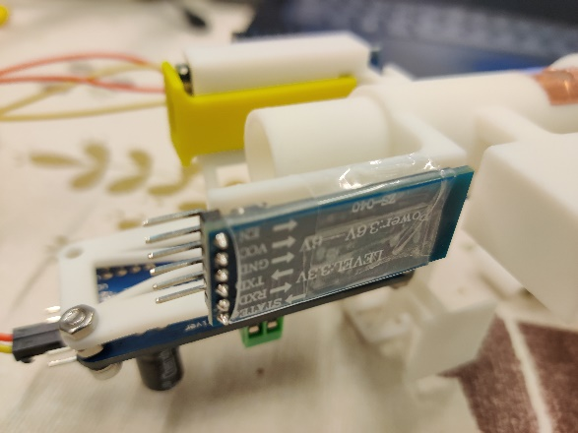

1. Assemble the sensorBox.
   1. Put the grates into the muter.

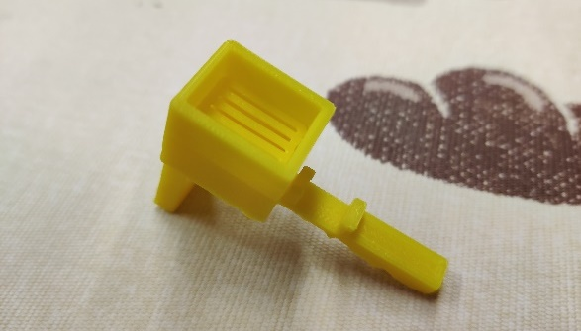

* 1. Add water absorbing beads into the muter chamber.

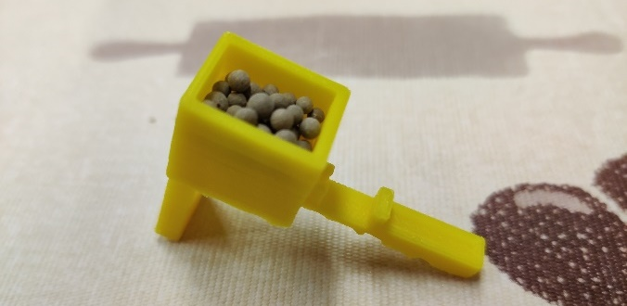

* + 1. They must fill the entire 2D cross section.
  1. Use clear tape to join the muter with the adaptor.

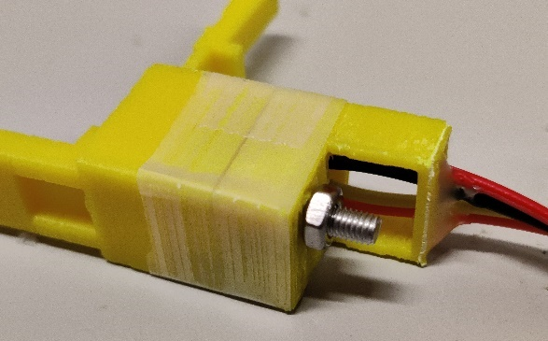

* + 1. It must be air-tight, otherwise the air pressure will be invalid.
    2. However, avoid the air hole on the side of the muter.

1. Hot-glue the servo wings into the wing-shaped holes on the C-Rings.

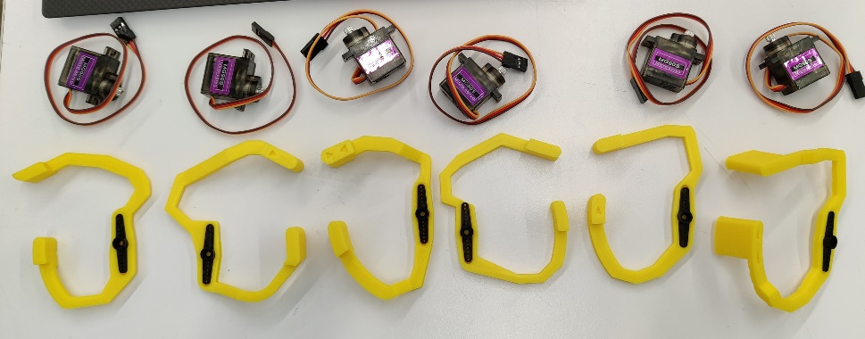

* 1. Be careful not to tilt the servo wing. They should lay flat – pressing them down in their center helps.
  2. Usually, the way they come off is via the hot glue losing contact with the C-Ring, so make sure the hot glue covers enough area on the C-Ring as shown below:

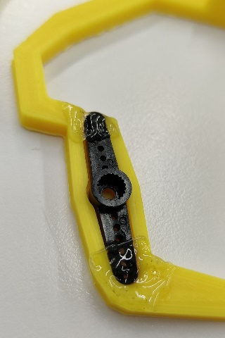

* 1. However, also keep the hot glue flat – too much bump may collide with adjacent C-Rings.

1. Insert the servos into Body.
   1. Sequence: right ring, middle, index, left ring, middle, and index finger. They should connect to servo pins 15, 14, 13, 12, 11, and 10 on the Arduino Nano. Differentiate the left middle finger and the left ring finger!
   2. For each servo, first make the servo cables go through the cable ring of the servo shell.

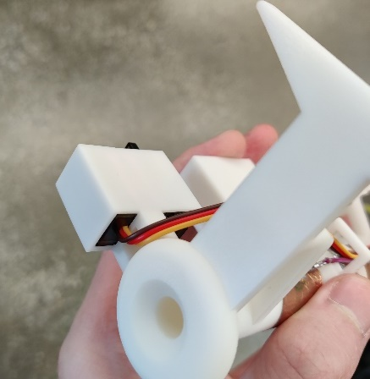

* 1. Use cable rings under Body as much you can. This prevents cables’ collision with C-Rings.

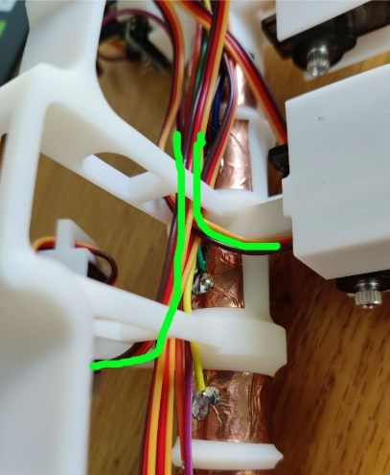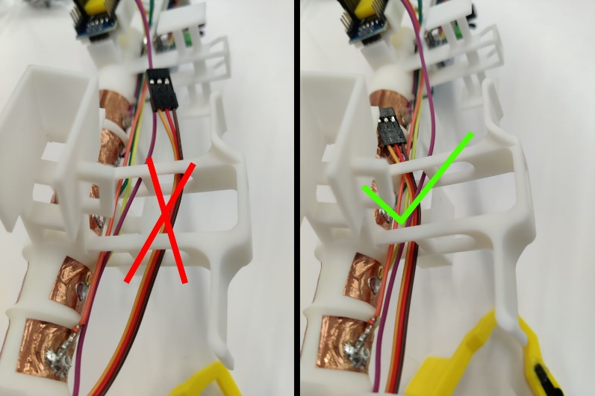

* 1. For the right index finger’s servo, there are two extra servo rings. Go through the side one, and then the bottom one, and then ***both*** thumb stands. This prevents collision with the left ring finger’s C-Ring.

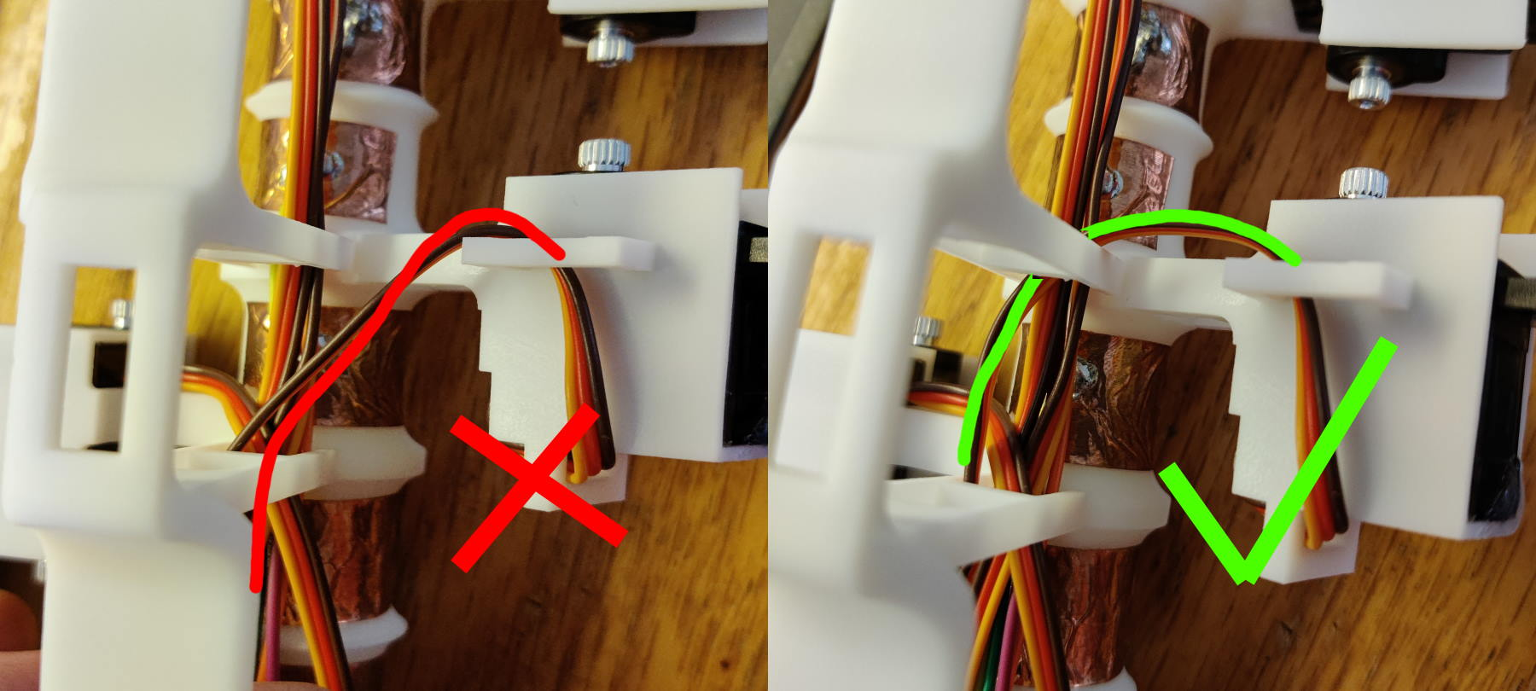

* 1. Use the cable coil on Body to use up extra cable length. Purpose: not to have cable loops dangling around.

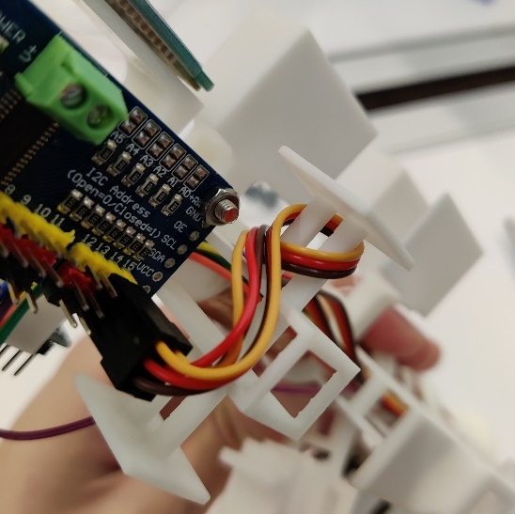

* + 1. Tips for wrapping cables around the cable coil: if wrapping one way (e.g. clockwise) turns our to leave 0.5 cycle unpreferred, try unwinding wrapping the other way (e.g. counter-clockwise). This solves the 0.5-cycle phase problem.
  1. Make sure to leave enough space for the battery:

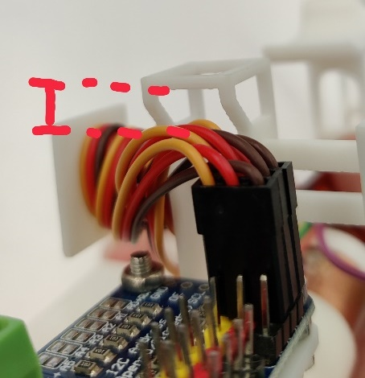

* 1. Use little hot glue to secure the servos.

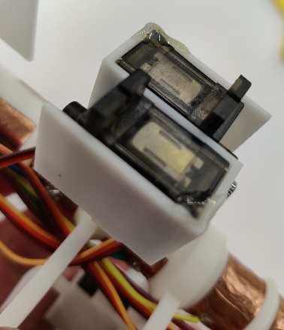

1. Install battery and switch.
   1. Get a short, thick piece of solid-wire cable. Expose its wire at both ends. At one end, curl it like this for maximal contact with PCA9685:

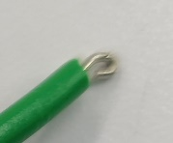

* 1. Solder its other end onto the middle pin of the switch.

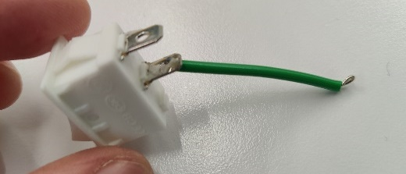

* 1. Strip the battery’s discharge cable. Be really careful! The inner wires are thin. Don’t impose any dents – 5V2A is suppose to go through them!
  2. Get another short, thick piece of solid-wire cable. Curl one end like before. Solder it onto the GND of battery discharge.
  3. Solder the VCC of battery discharge to the switch.

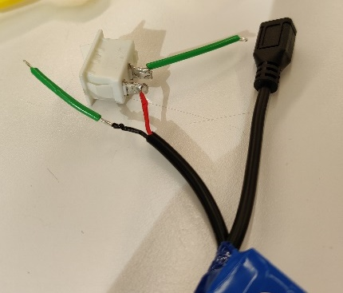

* 1. Solder is bad for your health. Wash your hands.
  2. Use duct tape (or cleat tape as shown in the photos) to strap the battery onto Body.
     1. Use tape to form an X in this part of Body.

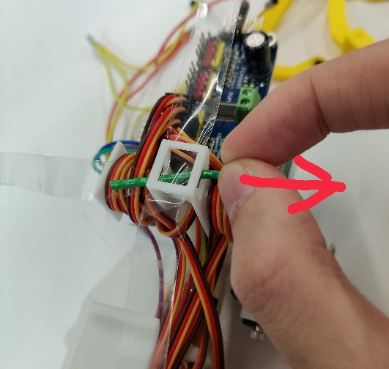

* + 1. Use a solid object (e.g. green wire, as shown in photo above) to lead the tape. Both pieces of tape should have their sticky side facing upwards (i.e. away from PCA9685). However, when inserting the second piece of tape, first face the sticky side downward (to avoid sticking to the other piece of tape), and then turn it 180°.
    2. The X should look like this.

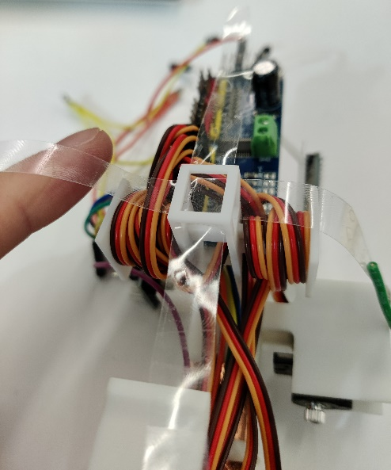

* + 1. Use the cross to strap the battery in place. The vertical space above the power supply terminal block of PCA9685 should be clear (so that a screwdriver won’t be blocked).

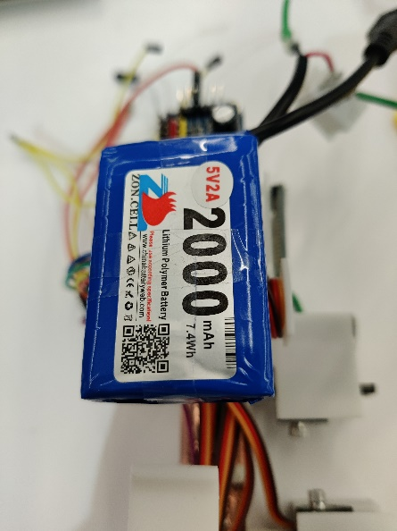 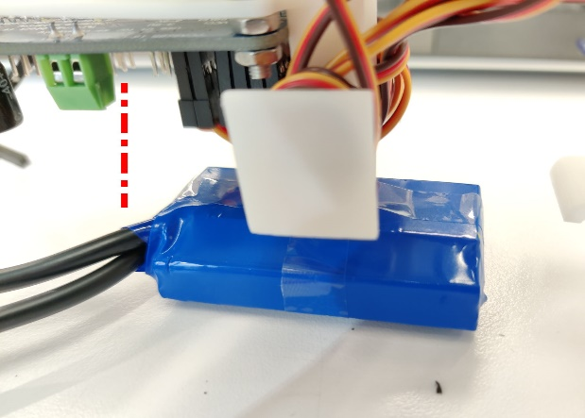

* 1. Hot-glue the switch onto Body.

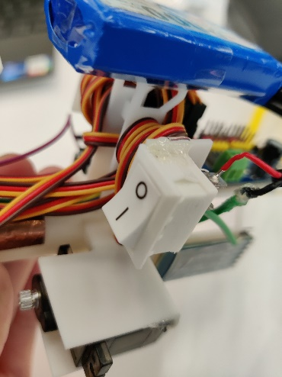

* 1. Insert the curled ends into PCA9685 power supply (i.e., terminal block). Make sure VCC - V+, and GND - GND. Use a screwdriver to secure the PCA9685 power supply, tightly.

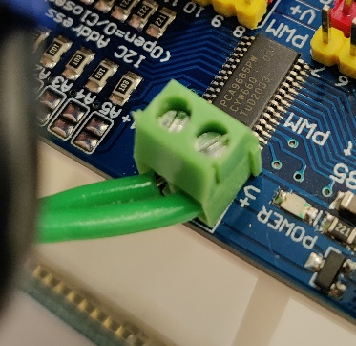

1. Use two 轧带 to constrain the cables. One above left index finger (i.e., first hole) and one below right ring finger (i.e., last hole).

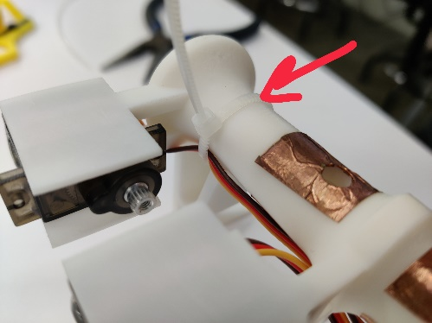

* 1. Cut away the extra strip. Then, rotate the strip until the cables snap into the 90-degree corner of the 轧带.

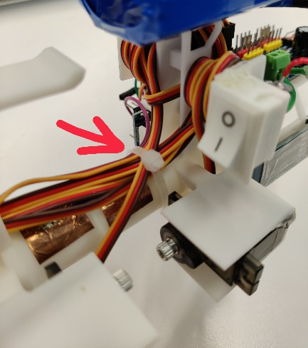

* 1. Applied a tiny bit of hot glue to the one above left index finger to prevent sliding.

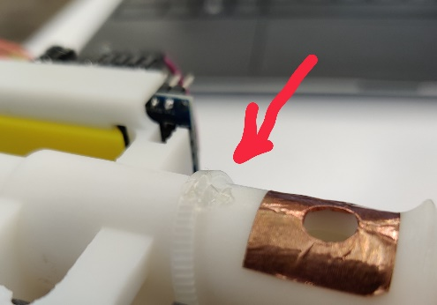

1. Finish cable connections.
   1. F-F 10cm: PCA9685 GND in – PCA9685 GND out.
      1. “PCA9685 GND in” is one of the six pins on the side. “PCA9685 GND out” refers to one of the black pins for servos.
   2. F-F 10cm: PCA9685 VCC in – PCA9685 5V out.
      1. “PCA9685 VCC in” is one of the six pins on the side. “PCA9685 5V out” refers to one of the red pins for servos.
      2. Maybe make a knot to further shrink the cable length.

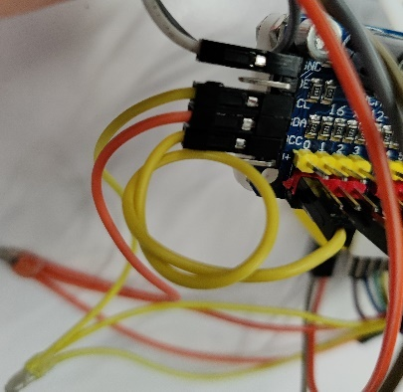

* 1. F-F 10cm: Arduino Nano GND – PCA9685 GND out.
     1. Nano GND pin is the 1st from the left, in the lower row.
  2. F-F 10cm: Arduino Nano 5V – PCA9685 5V out.
     1. Nano 5V pin is the 3rd from the left, in the lower row.
  3. F-F 20cm: Arduino Nano pin TX1 – HC05 RX.
     1. Nano pin TX1 is the 0st from the left, in the upper row.
     2. The cable should go below Body and PCA9685 – curve all the way around.
  4. F-F 20cm: Arduino Nano pin RX0 – HC05 TX.
     1. Nano pin RX0 is the 1st from the left, in the upper row.
     2. The cable should go below Body and PCA9685 – curve all the way around.
  5. F-F 10cm: HC05 GND – PCA9685 GND out.
  6. F-F 10cm: HC05 VCC – PCA9685 5V out.

1. Upload the Arduino script (“MAIN/ardu/ardu.ino”) to Arduino Nano. Then, disconnect the USB.
2. Recharge the battery. Follow the manual in order not to overcharge or undercharge it. After charging, disconnect the charging cable.
3. Apply sensorBox ring onto the mouthpiece. Insert the mouthpiece into Body. Insert the sensorBox into the mouthpiece. Rotate sensorBox ring to secure sensorBox.

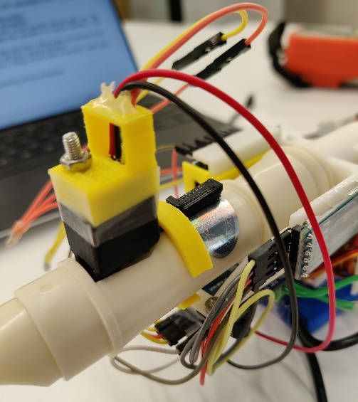

1. Connect sensorBox GND – PCA9685 GND out; sensorBox VCC – PCA9685 5V out; finally, 3-junction:
   1. CLK: Arduino A5 (–) PCA9685 – sensorBox.
   2. SDA: Arduino A4 (–) PCA9685 – sensorBox.
2. Flip the switch on! The LEDs on all three circuit boards should light up. The servos should make a sound and rotate the cylinders to neutral position. Flip the switch off.
3. Attach the C-Rings to the servos. Make sure the C-Ring ends are almost level, without rotating the servo cylinders off their neutral position.
4. Flip the switch on. Double check: the C-Rings should stay in position, with ends leveled. Flip the switch off.

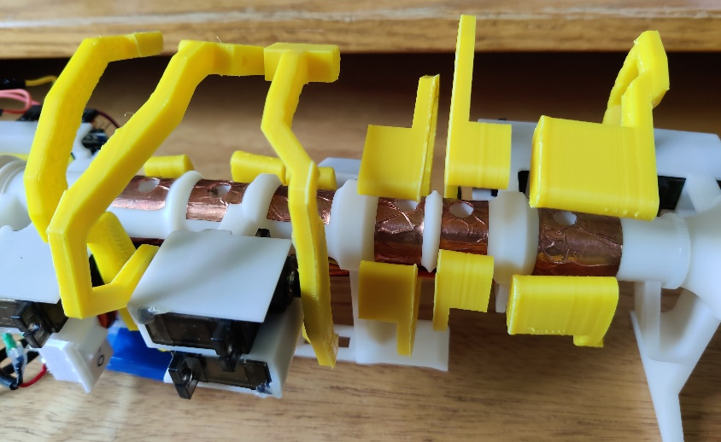

Congratulations. You completed the assembly of the prototype.

