ML HCI helps human acquire new modalities.

Take an example of muscle readings (Michael Zbyszyński, Balandino Di Donato, Atau Tanaka).

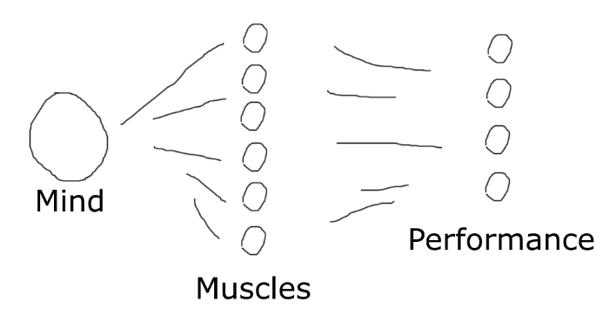

There are multiple ways to use muscles to perform the same motion. The middle layer has higher info entropy than the resulting motion. Because humans control muscles in a goal-oriented way, they are usually unaware of this middle layer. To illustrate that, imagine asking a human to distinguish between iso-motion muscle usages. The human would have to start to notice that and learn that.

Suppose we can only measure muscles. A naïve implementation of HCI would be to reconstruct the desired performance with ML. The desired performance then serves as the control interface.

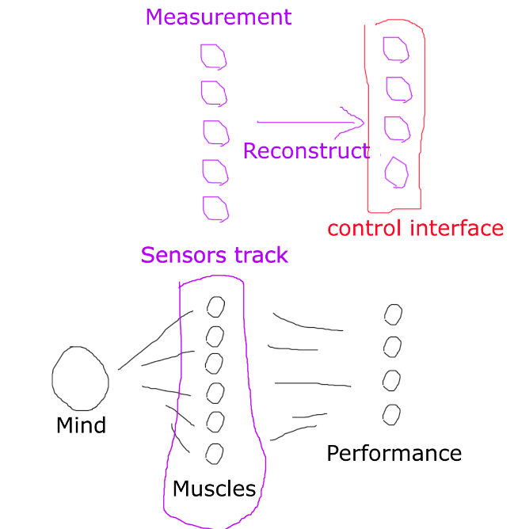

However, by providing feedback and making the human aware of the middle layer, the human can develop a new expression modality. We can achieve higher info throughput by using the middle layer, muscle readings, as the control interface.

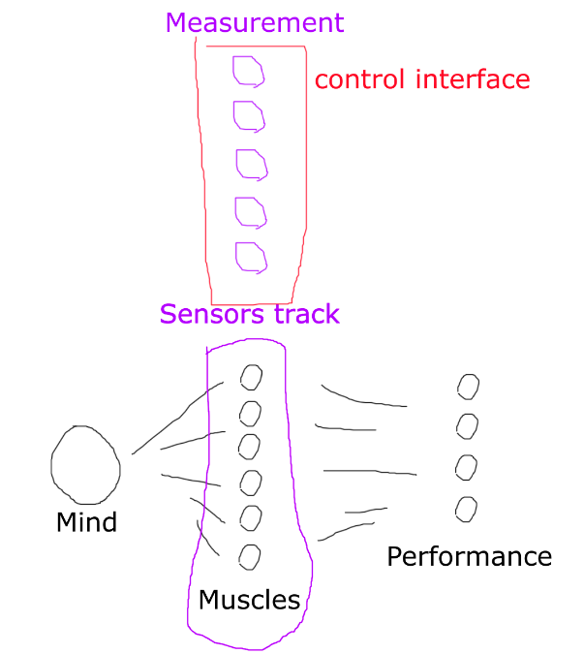

To reduce starting confusions, we can first use the naïve method to establish connection with the human. Then, employ the second method, and see what the human finds out about their muscles.

The plasticity of the human provides the possibility of acquiring a brand-new modality one can use to control machines.

Scaffolded co-adaptation.

Notes.

Wording: “performance” or “gesture”?

Other examples: voice timbre vs mouth+tongue+throat shape