A "counter example" to Picard–Lindelöf theorem

Of course, the title is a click bait. Picard Theorem is proved and the point here is to help me understand it.

Here is the “counter example”:

$$\frac{dy}{dx}=\left\{\begin{aligned}-\frac{x}{y-1}, x^{2}+{\left(y-1\right)}^{2}<1 \\ -\frac{x}{y+1}, x^{2}+{\left(y+1\right)}^{2}<1 \\ 0, y=0 \\ \frac{2xy}{x-y^{2}}, otherwise. \end{aligned}\right.$$

The first case and the second case describe some concentric circles with center $(0, 1)$ and $(0, -1)$. The last case describes all circles tangent to the x axis at $(0, 0)$ whose radius is larger than $1$.

The domain is $-0.9<y<0.9.$ Consider the initial value problem of $y\left(0\right)=0$. This problem apparently has a family of infinite solutions:

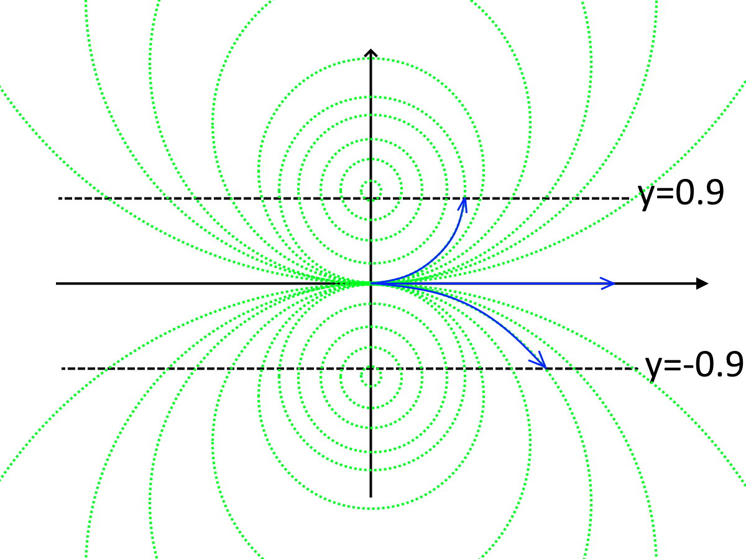

The setup is continuous and differentiable everywhere within the domain. Yet the IVP has non-unique solutions. Why?

(Usually when I read a proof with a counter example in mind I can see where I’m wrong, but for this I need help…)