Introduction:
We are trying to predict the G3 score of students and we have a dataset it’s data attributes include student grades, demographic, social and school related features and it was collected by using school reports and questionnaires.
The goal is to build a model to predict the G3 score using other information from the dataset; and find if there is a correlation between G3 and other features.

EDA:
Dataframe’s info:

RangeIndex: 649 entries, 0 to 648
Data columns (total 33 columns):
# Column Non-Null Count Dtype
--- ------ -------------- -----
0 school 649 non-null object
1 sex 649 non-null object
2 age 649 non-null int64
3 address 649 non-null object
4 famsize 649 non-null object
5 Pstatus 649 non-null object
6 Medu 649 non-null int64
7 Fedu 649 non-null int64
8 Mjob 649 non-null object
9 Fjob 649 non-null object
10 reason 649 non-null object
11 guardian 649 non-null object
12 traveltime 649 non-null int64
13 studytime 649 non-null int64
14 failures 649 non-null int64
15 schoolsup 649 non-null object
16 famsup 649 non-null object
17 paid 649 non-null object
18 activities 649 non-null object
19 nursery 649 non-null object
20 higher 649 non-null object
21 internet 649 non-null object
22 romantic 649 non-null object
23 famrel 649 non-null int64
24 freetime 649 non-null int64
25 goout 649 non-null int64
26 Dalc 649 non-null int64
27 Walc 649 non-null int64
28 health 649 non-null int64
29 absences 649 non-null int64
30 G1 649 non-null int64
31 G2 649 non-null int64
32 G3 649 non-null int64
dtypes: int64(16), object(17)
# we can see that there are no missing values.
# 16 features have numeric values(int) and 17 have non-numeric values : 33 total features.
# there are also 0 duplicates as we checked with <df.duplicated().sum()>

Univariate plots:
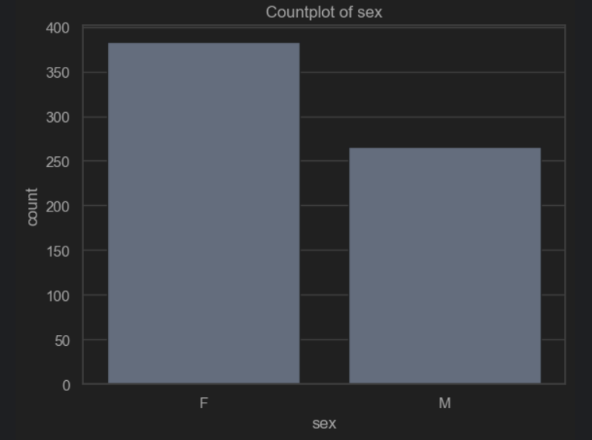
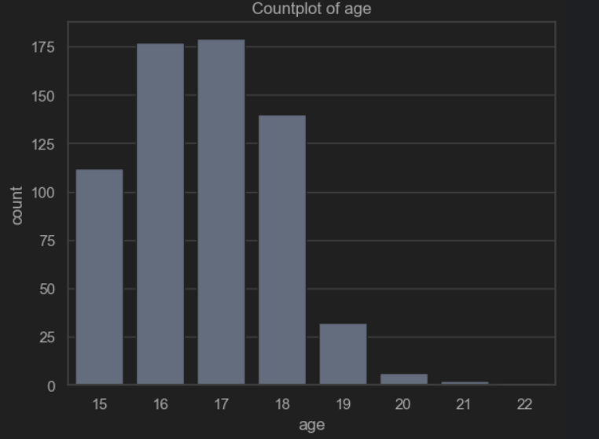
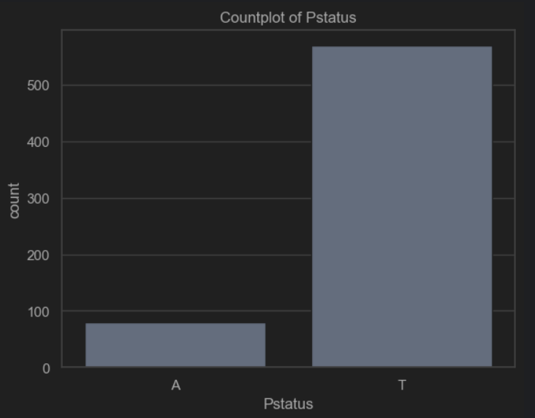
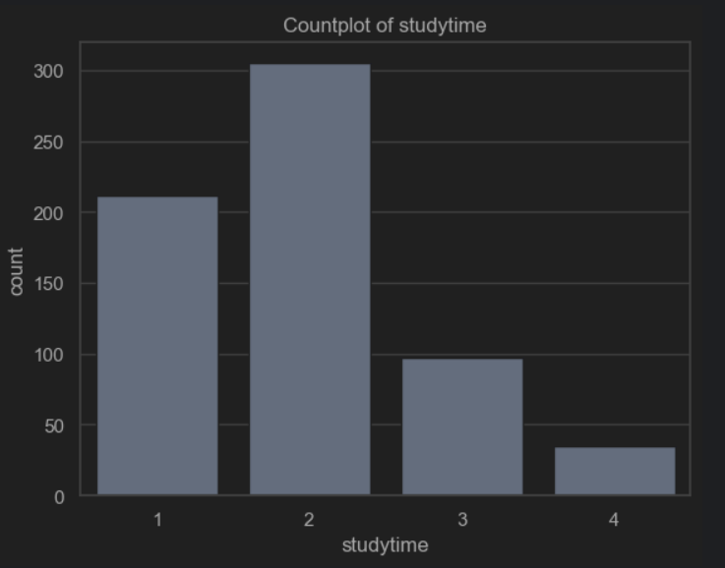
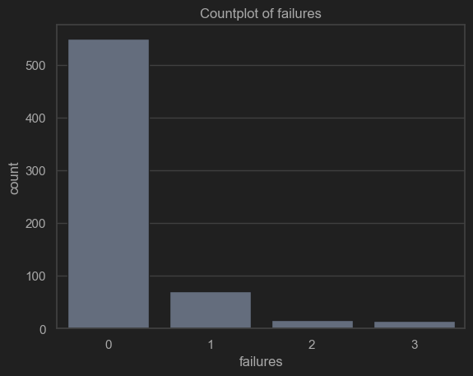
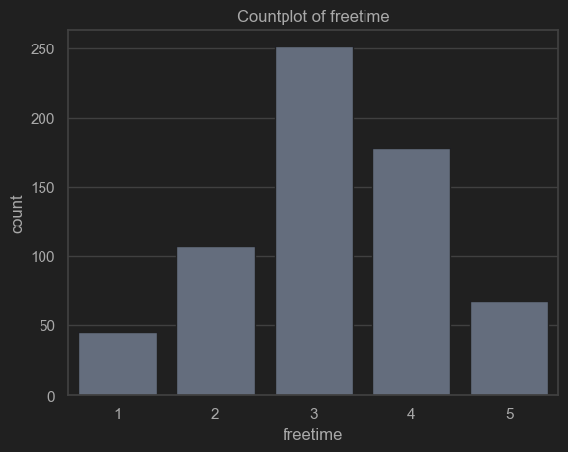
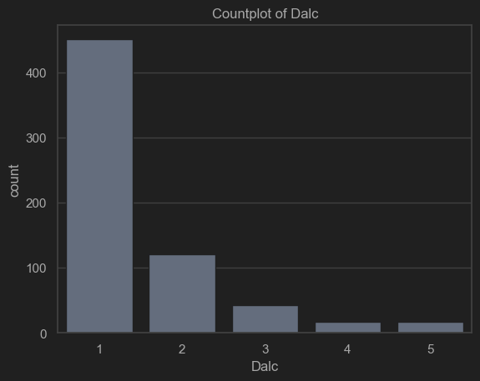
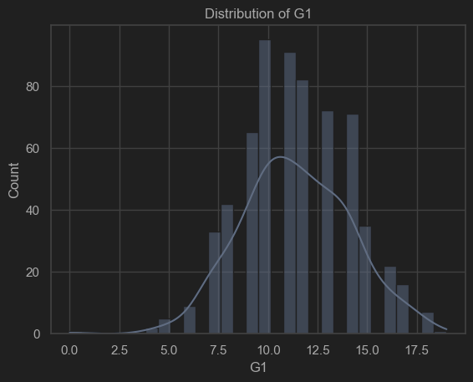
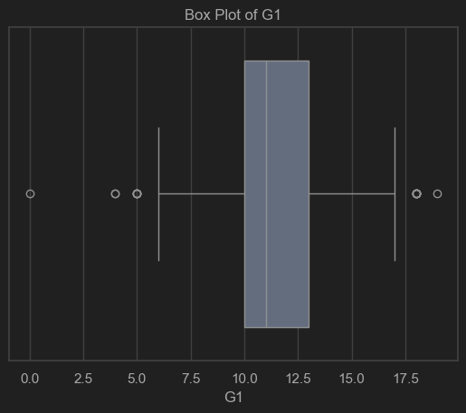
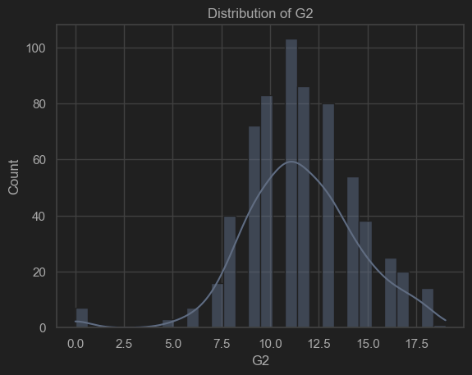
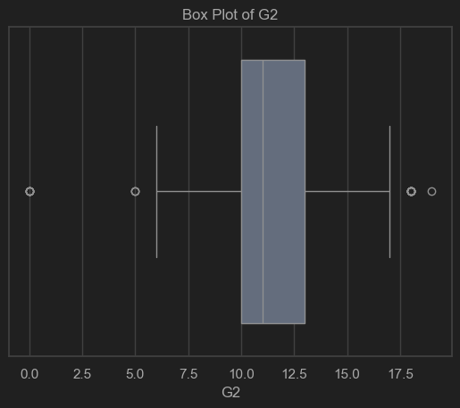
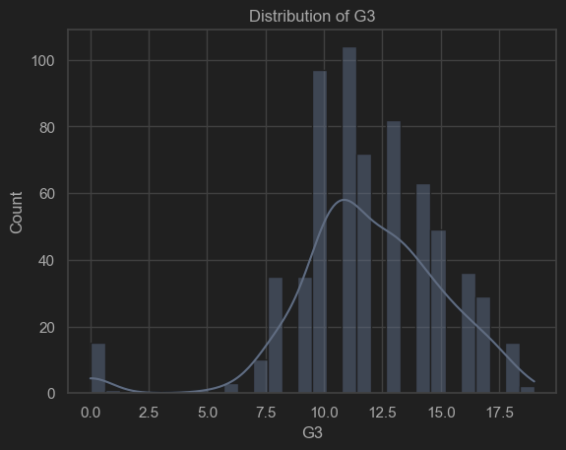
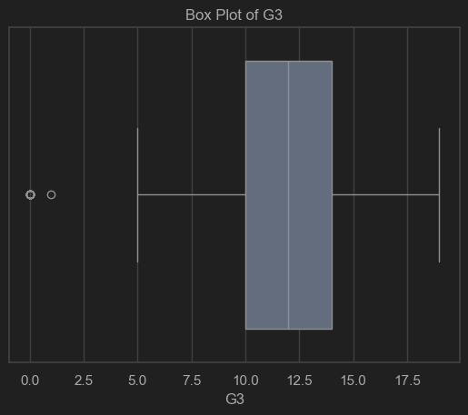
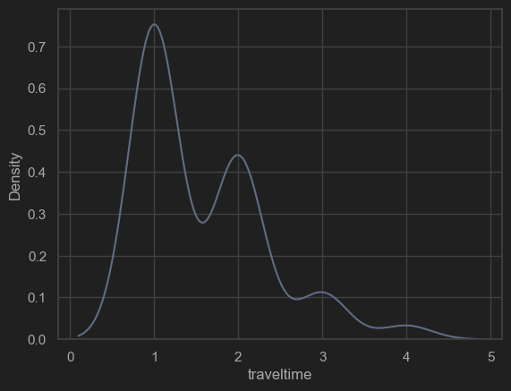
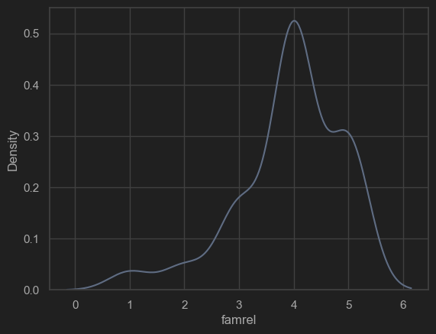
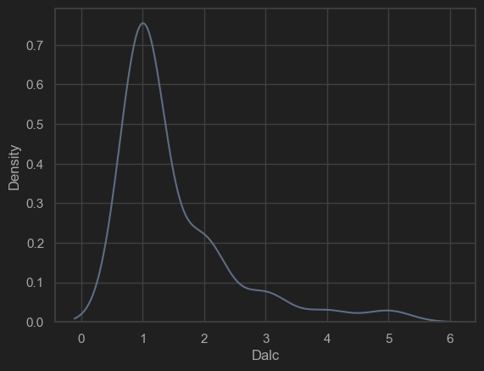
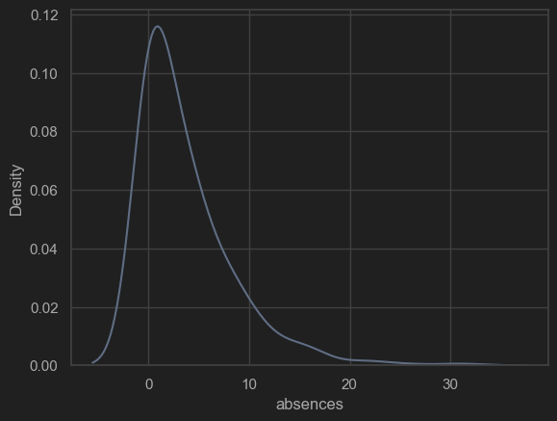
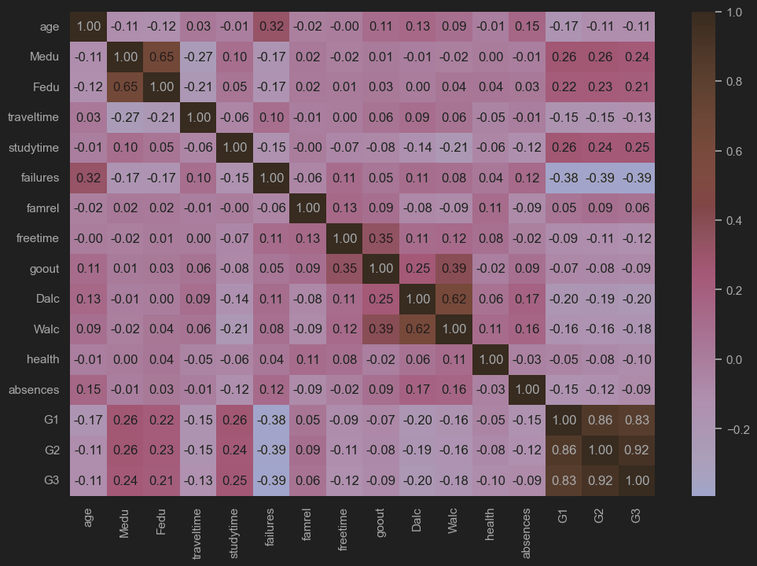
Findings summary:
the heatmap shows that the features with highest correlation with G3 are:
[G2, G1, -failures, studytime, Medu, Fedu]
Target: G3 distribution is close to normal.
Missing Data: The dataset is clean, no missing values to impute.
Categorical: school, sex, address, famsize, Pstatus, Mjob, Fjob, reason, guardian, schoolsup, famsup, paid, activities, nursery, higher, internet and romantic all need to be one-hot encoded.
Key Predictors: G2 and G1 are the strongest predictors by far. studytime , Medu and Fedu are also positively correlated with G3. failures is negatively correlated with G3.
Interactions: the heatmap shows that Medu and Fedu are correlated with each other, and Dalc is correlated with Walc.
Unbalanced: Pstatus, failures, schoolsup, paid and higher are unbalanced.
Skewed: famrel, Dalc and absences are skewed.
Action Plan:
Preprocessing: One-hot encode school, sex, address, famsize, Pstatus, Mjob, Fjob, reason, guardian, schoolsup, famsup, paid, activities, nursery, higher, internet and romantic. (one-hot encoding is the better option out of the methods for categorical feature encoding (Label Encoding, Ordinal Encoding, One-Hot Encoding, Count & Frequency Encoding and Target Encoding) because these methods do not perform well compared to one-hot encoding especially when there are outliers in the data)
Feature Engineering: calculate VIF and don't use features with high VIF.(dropping them one by one and recalculating VIF)
Model Selection: Since G1 and G2 effects are so strong a LinearRegression will probably do well but try multiple models for comparison.

Preprocessing:
First I One-hot encoded the non-numerical features.

Then I used train_test_split because it is a simple and reliable method.
Splitting the data into Train and Test sections:
Training set shape (X): (519, 41)
Testing set shape (X): (130, 41)

Then I used StandardScaler to scale the numeric data so the different scales of the features wont be a problem and they all have a standard-deviatoin of 1.
Here is a sample of the scaled data:

age Medu Fedu traveltime studytime \
count 5.190000e+02 5.190000e+02 5.190000e+02 5.190000e+02 5.190000e+02
mean -7.016438e-16 -1.009683e-16 -8.043234e-17 -1.266382e-16 6.845306e-18
std 1.000965e+00 1.000965e+00 1.000965e+00 1.000965e+00 1.000965e+00
min -1.444392e+00 -2.244250e+00 -2.117606e+00 -7.693894e-01 -1.144341e+00
25% -6.187979e-01 -4.646232e-01 -1.200212e+00 -7.693894e-01 -1.144341e+00
50% 2.067962e-01 -4.646232e-01 -2.828189e-01 -7.693894e-01 5.306418e-02
75% 1.032390e+00 1.315004e+00 6.345748e-01 5.796413e-01 5.306418e-02
max 4.334767e+00 1.315004e+00 1.551968e+00 3.277703e+00 2.447874e+00

Now I use VIF to drop features that are highly correlated with other features(not target).
I calculated VIF and dropped the feature with highest VIF if it’s is higher than the threshold and recalculated VIF and repeated the process until the highest VIF is lower than the threshold.
Threshold = 1.5 because with this threshold models performed better than others(5, 3, 2, 1.3)

Then we are left with 25 features.

And the heatmap of correlation of these features is:
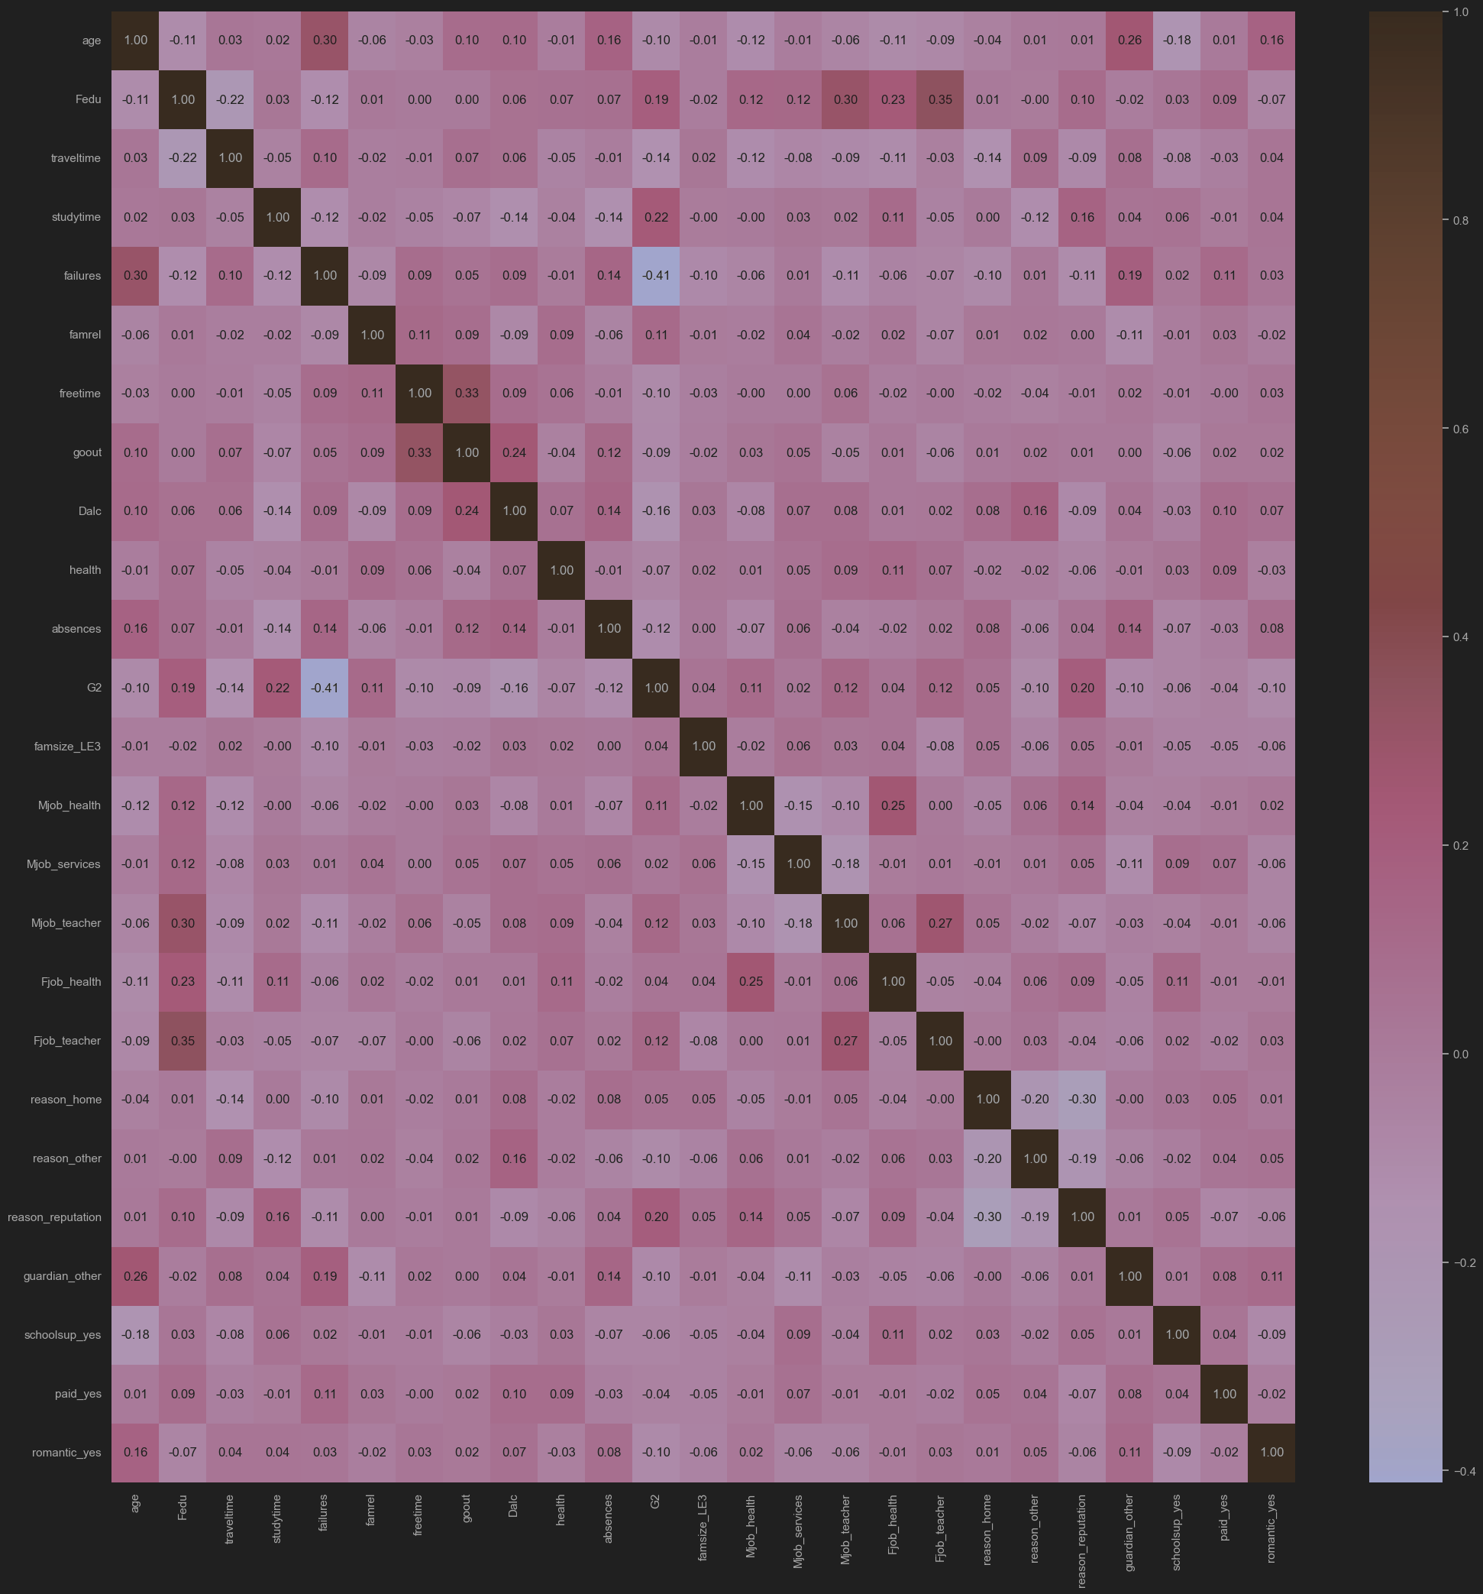

Modeling:
After training the Linear-Reagression model , it’s time to evaluate the model .
--- Model Evaluation ---
Test Set Performance:
R-squared (R²): 0.7450
Mean Absolute Error (MAE): 0.8656
Root Mean Squared Error (RMSE): 1.6440

Train Set Performance (for comparison):
R-squared (R²): 0.8782
Mean Absolute Error (MAE): 0.7595

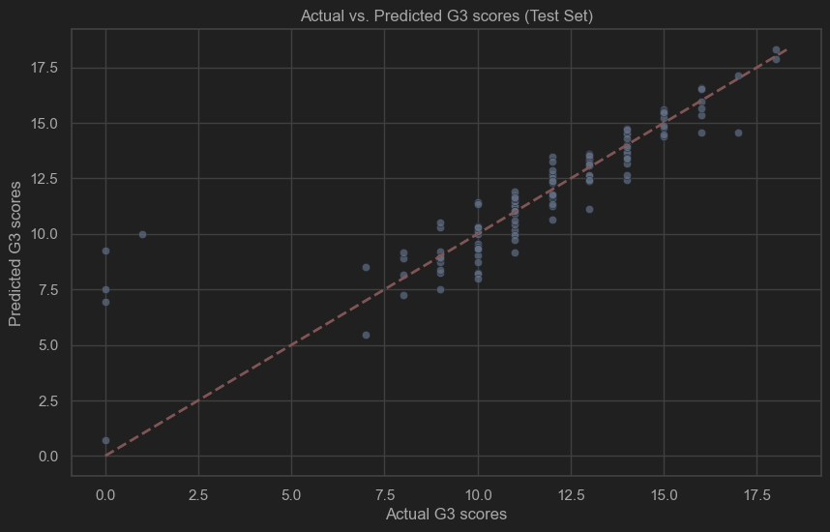
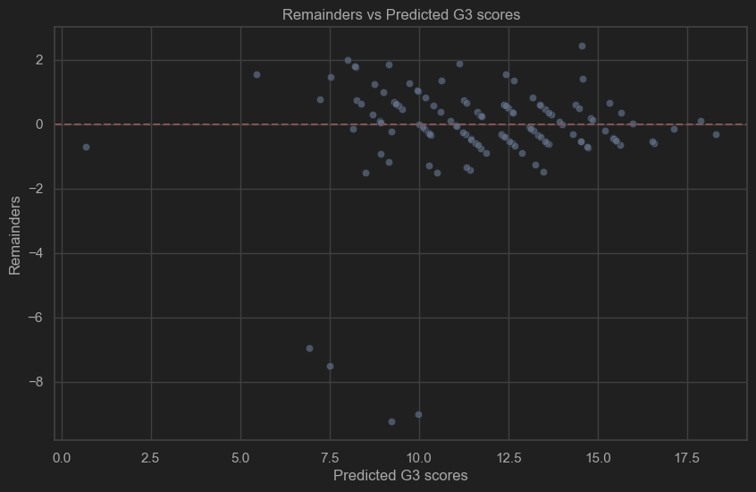
The remainders do not follow certain trend and increasing the predicted G3 score does not effect the remainders so the model is performing well.

Conclusion:
After comparing multiple models:
--- Final Model Comparison ---
R_squared Mean_Absolute_Error
Lasso_L1 0.745706 0.864660
Baseline_Linear 0.744969 0.865587
Ridge_L2 0.736335 0.857689
Polynomial_D4 0.449099 1.423411
Poly_Ridge 0.436051 1.616625

We can conclude that the Lasso_L1 model performed the best at predicting the G3 score but the Baseline_Linear model has performed very closely to Lasso_L1 model.

We can also conclude that G1 and G2 scores are the best predictors for the G3 score.

