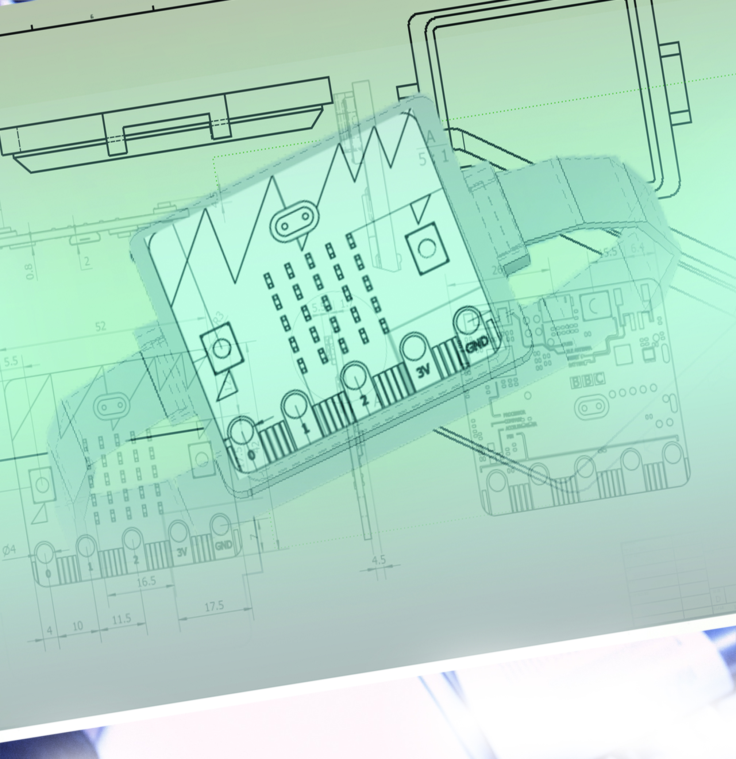

|  |
| --- |
| ASSESSMENT TASK 3  Embedded Systems Programming |

|  |  |  |
| --- | --- | --- |
| **Part 1: Embedded Systems Design: FITBIT** |  |  |
|  | Daniel Davaris |  |

TABLE OF CONTENTS

Project overview 2

OVerVIEW 3

PROJECT OVERVIEW

Name of game/project

FITBIT

Outline of premise

* The purpose of the project is to associate the concept of a modern-day fit-bit with the technology comprised within the BBC-Micro bit. The overall task is that of a project which features many individual functions, oppose to game type project. In terms of physicality, the devise will consist of a BBC Micro-bit mounted onto a 3D printed base designed for a strap to fix the device to the hand. The battery pack will also be fixed to the side. The capacity of the device is broken down into functions. The main function will be that of the step-ohmmeter as that is a quite predominant feature such devices. The Step-ohmmeter and many of the other features make use of the built-in accelerometer, while other features incorporate the built-in temperature sensor, LED display, input buttons and low-energy Bluetooth. These inclusive functions are listed below.

1. Scroll current time function
2. Step-ohmmeter function
3. Stopwatch function
4. Remote phone music control function
5. Remote phone picture capture function
6. Temperature display function
7. Battery usage display function
8. Compass function
9. Battery saver, timeout function

OVERVIEW

* The Fitbit will make use of readily evaluable buttons on the top of the micro-bit. When the battery is connected initially the device will remain idle until button A is pressed. This action will scroll the current time, digitally across the display. The action will repeat until button B is pressed. At this point the device will enter the stage known as the dashboard. Although this is comprised of a simple list of all the functions, by pressing either button A or button B the user can “scroll” up or down in that list to “select” different functions. This simulates a user-friendly interface. Once any in particular function is selected the user can press button A and B simultaneously to RUN that function. To exit or end a particular function and return to the dashboard the user can simply press button A and B simultaneously again. All inclusive talks that are performed within the device consist significantly of providing feedback and therefor the inbuilt buttons were appropriate and sufficient as input devices. A timeout function will also run in the background with the device checking constantly that the display has not been inactive for longer than 10 seconds. This saves battery.

|  |  |  |
| --- | --- | --- |
| Clock | Walk | Stopwatch |
| Music | Camera | Sun |

|  |  |  |
| --- | --- | --- |
| Empty Battery | Map compass | High Voltage |

# MAIN STATE MACHINE

FITBIT device state machine, excluding states of individual functions but including the timeout function

