Daniel Earle’s Storyboard, Web Programming Internal Assessment 2
Daniel Earle - 2404238 Faculty of Engineering and Computing,
University of Technology, Jamaica School of Computing and Information Technology (SCIT)
CIT2011: Web Programming
Mrs. C. Anuli
Date & Time of Class: Monday 3pm – 4:50pm
November 21, 2025

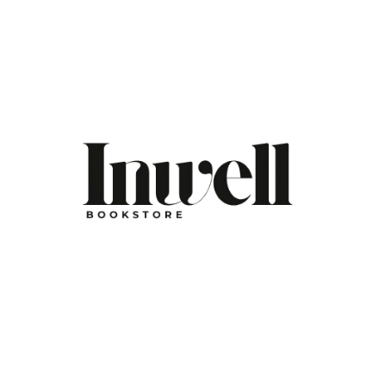

Business Description Inwell Bookstore is a beloved independent literary landmark established in 1992 in Kingston, Jamaica. Born from a deep love of storytelling, this community hub celebrates Jamaican and Caribbean authors while offering a diverse collection of global literature, ranging from novels and poetry to academic texts and rare finds. More than just a retail space, Inwell serves as a sanctuary that hosts monthly readings, children's story times, and literary workshops.
Mission Statement
At Inwell Bookstore, our mission is to foster a love for reading in our community by celebrating the power of the written word to connect us all. We strive to shape minds, spark imagination, and inspire personal growth through a carefully curated selection of local and international stories.
Vision Statement
To serve as a permanent sanctuary for readers, dreamers, and story-seekers, maintaining a warm, peaceful atmosphere where books, culture, and creativity come together to inspire the next generation of Jamaican literary lovers.
Slogan
“A sanctuary for readers, dreamers, story-seekers, and lovers of Jamaican literature.”
Color Palette
The website utilizes a sophisticated, vintage-inspired palette featuring Grainy Grey (#D6D3CD) and Cream (#F3F2EC) backgrounds paired with Deep Charcoal (#2f2f2f) for text. Accents of Warm Beige (#C5A992) and Classic Red (#CC3333) provide visual interest. This palette evokes the tactile feel of paper and ink, creating a nostalgic, intellectual, and inviting atmosphere suitable for a literary hub.
Intended Audience
Inwell Bookstore is designed for a diverse community of book lovers, including students, scholars, children, and adults seeking personal growth. The audience includes locals looking for Caribbean voices, students requiring a quiet place to study, and anyone seeking to discover new worlds between the pages of a book.

Sitemap Diagram
Home
About Us
Login
Register
Cart
Checkout

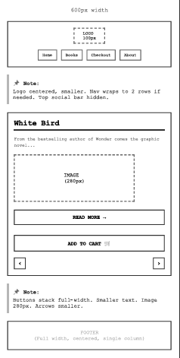
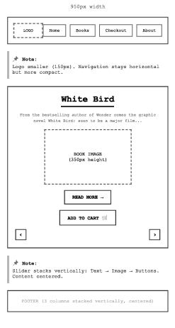
950 Pixel Wide Home Page 600 Pixel Wide Home Page

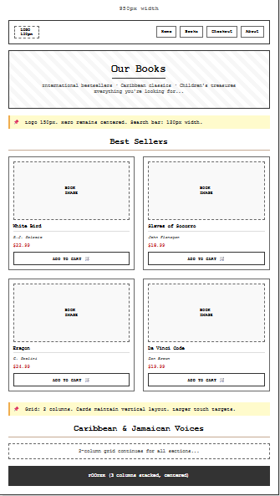
Both 950 and 600 Pixel Wide Products Page

950 Pixel Checkout Page 600 Pixel Checkout Page
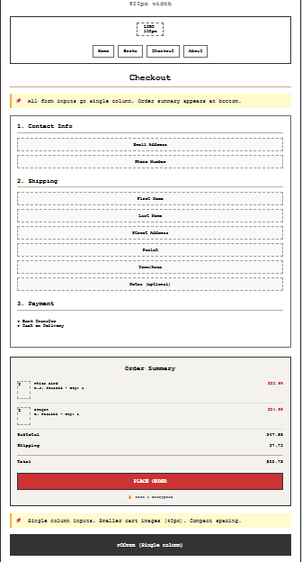
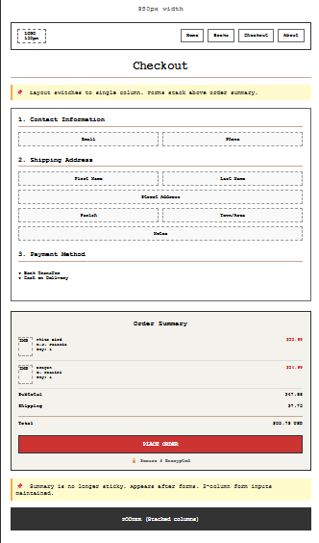

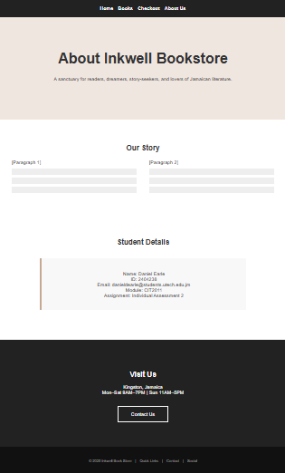
950 & 600 Pixels Wide About Us Page

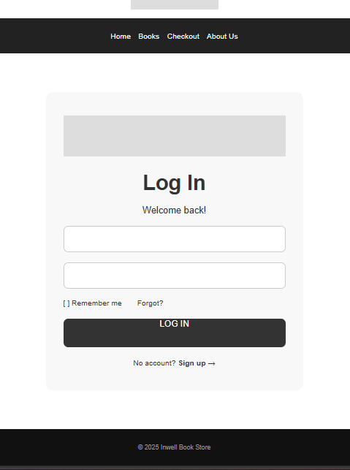
Both 950 & 600 Pixel Login Page

Both 950 & 600 Pixel Register Page
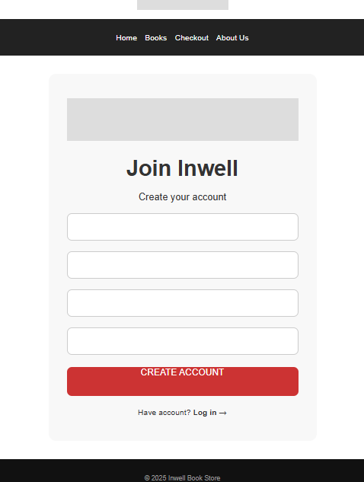

References

Brown, D. (2016). The Da Vinci code. Penguin Books.
Dennis-Benn, N. (2016). Here comes the sun : a novel. Liveright Publishing Corporation.
Flanagan, J. (2014). Slaves of Socorro. Penguin.
Goodison, L. (2007). Selected poems. University Of Michigan Press.
James, M. (2015). A brief history of seven killings : a novel. Riverhead Books, A Member Of Penguin Group (Usa.
James, M. (2020). Black leopard, red wolf. London] Penguin Books.
Kei Miller. (2018). Augustown. Vintage Books, A Division Of Penguin Random House Llc.
Mcdermott, G. (1993). Anansi the spider : a tale from the Ashanti. Scholastic, Inc.
Naidoo, B. (2025). The Other Side of Truth (A Puffin Book) : Naidoo, Beverley: Amazon.co.uk: Books. Amazon.co.uk. https://www.amazon.co.uk/Other-Side-Truth-Puffin-Book/dp/0141377356
Palacio, R. J. (2019). White Bird. Random House Children’s Books.
Paolini, C. (2005). Inheritance. Corgi.

