**Speed of Sound**

# Aim

This experiment aims to determine the velocity of sound by measuring the speed of propagation of a sound pulse in air. Emphasis is placed upon taking sufficient measurements to enable rigours uncertainty analysis. The speed of sound at room temperature should be determined and quoted along with its experimental uncertainty.

# Objectives

* Measure speed of sound in air.
* Understand statistical analysis of data, and uncertainty calculation.

# Learning Outcomes

* Demonstrate ability decide on appropriate amount of data to record.
* Demonstrate ability to conduct experimental work.
* Develop better understanding of uncertainty analysis in experimental context.

# Background Work (to be completed *before* lab starts)

1. Read all of the experimental notes for this experiment (this labsheet).
2. ‘Notes on Errors’ are available on Vision, and these may be helpful in your analysis.

# Safety

**This experiment uses low voltages that do not pose a safety risk. However, instruments are mains powered and *should not be used* if there are any signs of damage to the casing or power leads. Visually inspect before use.**

*In you lab-book you should provide a brief safety statement / Risk analysis for this experiments.*

# Understanding the Equipment

Before you start ensure you understand how all your equipment works:

* Ensure the experiment is set up as expected (see Appendix).
* Check operation of the software (see Appendix) and ensure you can save data in a format that you can read into MatLab/Excel/other software.

*You should make notes about any important aspects of the operation of the equipment in your lab-book.*

# Introduction

This experiment determines the speed of propagation of a sound pulse in air. The sound pulse is generated by "shaking" the membrane of a loudspeaker with a steep voltage edge; this motion causes the pressure variation in the air and an audible ‘click’. The sound pulse is registered by a microphone at a distance from the loudspeaker. The time between generation and receiving the pulse is measured.

In principle the velocity of sound *c* could be obtained by measuring the time taken for the pulse to travel from the loudspeaker to the microphone and using the relationship that $c=\frac{d}{t}$, where *d* is the distance between the loudspeaker and microphone.

However, the exact point of origin of the sound pulse in the loudspeaker and the exact point of detection in the microphone is not known therefore the distance *d* cannot be determined directly. However if we consider that the velocity is strictly given by the

change of distance in a change of time, i.e. $c=\frac{Δd}{Δt}$, then it is possible to determine the

velocity from a suitable plot of delay time as a function of the loudspeaker to microphone separation.

**4. Experiment – determine speed of sound.**

By varying the distance between the microphone and speaker obtain a set of results of

$Δt$ for various distances $Δd$.

You should take a suitable number of measurements at each distance to allow you to do a meaningful statistical analysis. You should transfer the data via USB memory pendrive. A suitable printout of your data should be included in your labbook.

You are expected to plot a histogram of the spread of the data for at least one value of *d*. For all values you should be able to state the average and 95% confidence interval.

Your analysis should allow you to determine the speed of sound from the slope of an appropriate graph. Including the 95% confident intervals (error bars) on this graph allows the uncertainty of the slope to be given.

In your discussion, you should consider possible sources of uncertainty, how significant they are, and how they could be reduced. Compare your experimental results with the expected value (include complete reference to the source of your information). Comment on any differences, giving possible reasons for any differences. Your conclusion should clearly state the value obtained for the speed of sound, and the uncertainty in this value.

# Appendix – Experimental Setup and Software

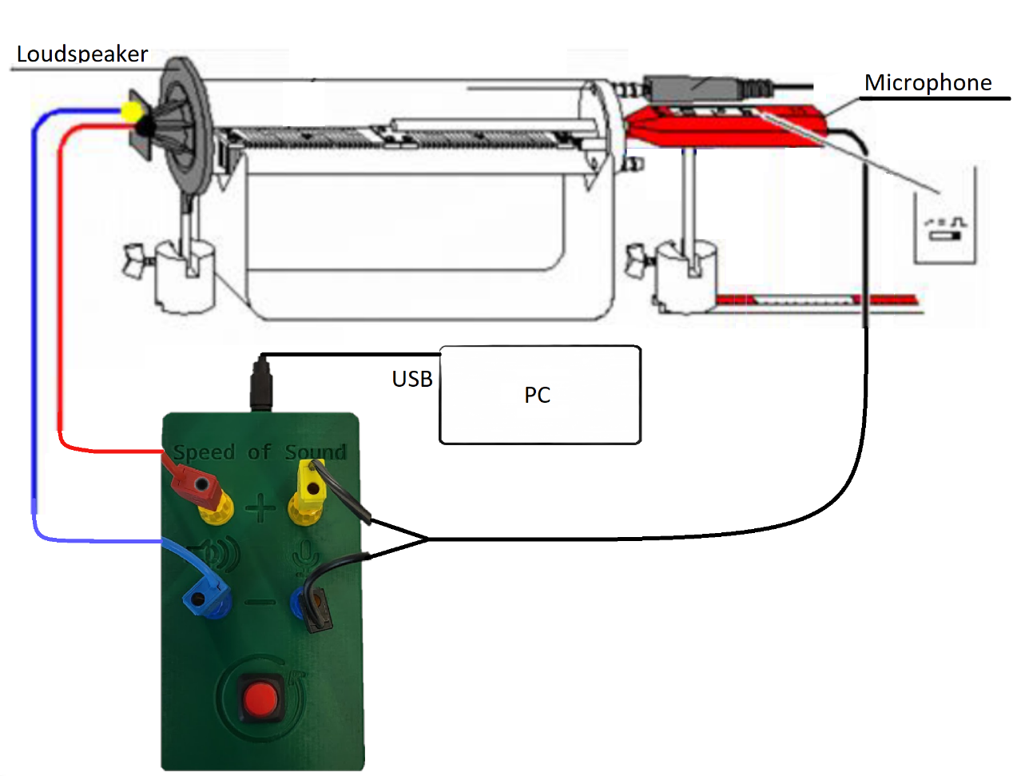

Figure A1: Experimental setup

If the experiment is not set up as shown above you should assemble the equipment:

* Attach the heater element to the plug pins on the end cover and insert into the plastic tube.
* Place the plastic tube on the stand and push the loudspeaker against it so that it seals the plastic tube as tightly as possible.
* Insert the multipurpose microphone approx. 1 cm deep into the middle hole of the cover and align it so that it moves parallel to the plastic tube when displaced. Set the multipurpose microphone to "Trigger" mode; don't forget to turn it on!
* Place the scaled metal rail directly beneath the base of the microphone.
* Connect the speaker and microphone wires to the Speed of Sound Control box
* As shown in Figure A1
* Connect the Speed of Sound control box to the PC via the USB cable.
* Press red square ‘on’ button to turn on the microphone.

|  |
| --- |
| **Safety note – *you are not expected to use heating feature of this experiment\***  The plastic tube of the apparatus for sound and velocity can be destroyed by excessive temperatures.   * Do not heat the apparatus above 80 °C. * Do not exceed the maximum permissible voltage of 25 V (approx. 5 A) for the heating filament. |

# Appendix Software Configuration

Run the “pc_speed_of_sound.pyw” python script to launch the GUI and establish communication with the Speed of Sound control box.

The source code and software installation instructions for this project can be found at: <https://github.com/Daniel-Forbes-HWU/speed-of-sound>