APPENDIX A
CORE PYTHON AND SVM SOURCE CODE
The complete implementation is available at https://github.com/Daniel-Godwin/typhoid-decision-support. The listings below reproduce the components central to the methodology described in Chapter Three. Full source, including the web application, the evaluation and the test suite, is in the repository.

A.1 Feature policy and exclusion of leakage-prone attributes
This configuration defines which attributes reach the model. The two leakage exclusions are the control described in Section 4.2.3, and the seven further exclusions are those directed at supervisory review and set out in the same section. Recording the reason for each exclusion in the configuration itself, rather than only in prose, keeps the implementation and the thesis in agreement.
# src/typhoid_ml/config.py

TARGET = "Typhoid Status"
RANDOM_STATE = 42
TEST_SIZE = 0.20
CV_FOLDS = 3

NEGATIVE_CLASS = "Normal or No Typhoid"
BINARY_LABELS = ["No Typhoid", "Typhoid"]
BINARY_POSITIVE = "Typhoid"

# `Blood Culture Result` is the confirmatory gold standard and
# `Complications` encodes post-diagnostic severity with 96.98%
# missingness. Both are excluded from every model so the system is
# evaluated as decision support, not as a restatement of a completed
# laboratory workup.
LEAKAGE_EXCLUDED = ["Blood Culture Result", "Complications"]

# Attributes dropped at supervisory review. Prediction must rest on
# what a clinician can obtain at the point of care, so laboratory and
# serological investigations are removed, together with two optional
# fields and one attribute describing the community rather than the
# patient.
DROPPED_AT_REVIEW = {
"White Blood Cell Count": "laboratory investigation",
"Platelet Count": "laboratory investigation",
"Widal Test": "serology; independent of the label (V = 0.0014)",
"Typhidot Test": "serology; independent of the label (V = 0.0065)",
"Typhoid Vaccination Status": "prophylaxis, not a presenting sign",
"Gastrointestinal Symptoms": "absent for 24.96% of records",
"Ongoing Infection in Society": "absent for 24.70%; not a patient sign",
}

# `Neurological Symptoms` is recoded as a binary headache indicator so
# that it carries the symptom named in Objective 1. No discriminative
# information is lost: P(typhoid) is 0.2972 to 0.3085 across the four
# levels, against an overall rate of 0.3019.
HEADACHE_SOURCE = "Neurological Symptoms"
HEADACHE_FEATURE = "Headache"

# The deployed feature space after the review.
SYMPTOM_NUMERIC = ["Age", "Fever Duration (Days)"]
SYMPTOM_CATEGORICAL = [
"Gender", "Location", "Socioeconomic Status",
"Water Source Type", "Sanitation Facilities", "Hand Hygiene",
"Consumption of Street Food", "Weather Condition",
"Skin Manifestations", HEADACHE_FEATURE,
"Previous History of Typhoid",
]

# The pre-review set, retained as the comparator reported in Chapter
# Four so that the cost of the reduction can be measured.
NUMERIC_FEATURES = [
"Age", "Fever Duration (Days)",
"White Blood Cell Count", "Platelet Count",
]
CATEGORICAL_FEATURES = [
"Gender", "Location", "Socioeconomic Status", "Water Source Type",
"Sanitation Facilities", "Hand Hygiene", "Consumption of Street Food",
"Gastrointestinal Symptoms", "Neurological Symptoms",
"Skin Manifestations", "Typhoid Vaccination Status",
"Previous History of Typhoid", "Weather Condition",
"Ongoing Infection in Society", "Widal Test", "Typhidot Test",
]

FEATURE_POLICIES = {
"symptom_based": {"numeric": SYMPTOM_NUMERIC,
"categorical": SYMPTOM_CATEGORICAL},
"routine": {"numeric": NUMERIC_FEATURES,
"categorical": CATEGORICAL_FEATURES},
}
DEFAULT_POLICY = "symptom_based"

# Kernel-specific grids. A single Cartesian product over
# kernel x C x gamma x degree wastes fits, because gamma is ignored by
# the linear kernel and degree by linear and RBF.
KERNEL_GRIDS = [
{"svc__kernel": ["linear"], "svc__C": [0.1, 1.0, 10.0]},
{"svc__kernel": ["rbf"], "svc__C": [0.1, 1.0, 10.0],
"svc__gamma": ["scale", 0.01, 0.1]},
{"svc__kernel": ["poly"], "svc__C": [0.1, 1.0, 10.0],
"svc__degree": [2, 3], "svc__gamma": ["scale", 0.1]},
]
SCORING = "f1_macro"

A.2 Derivation of the Headache indicator during preprocessing
The recoding directed at supervisory review is performed in the data layer, at the point the dataset is loaded, rather than in the modelling code. The training pipeline, the dataset audit and the deployed assessment form therefore all see an identical column, and the derivation cannot drift between them.
# src/typhoid_ml/data.py

def derive_features(df: pd.DataFrame) -> pd.DataFrame:
"""Add attributes derived during preprocessing.

`Headache` is a binary recoding of `Neurological Symptoms`,
directed at supervisory review so that the attribute carries the
symptom named in Objective 1. Confusion, Delirium and an absent
value all map to "No"; Headache maps to "Yes".
"""
if HEADACHE_SOURCE in df.columns and HEADACHE_FEATURE not in df.columns:
df = df.copy()
df[HEADACHE_FEATURE] = pd.Series(
["Yes" if v == "Headache" else "No" for v in df[HEADACHE_SOURCE]],
index=df.index, dtype=object,
)
return df

def load_dataset(path=DATA_PATH) -> pd.DataFrame:
df = pd.read_csv(path)
if TARGET not in df.columns:
raise ValueError(f"Target column '{TARGET}' not found in {path}")
return derive_features(df)

A.3 Preprocessing and SMOTENC applied within the pipeline
The ordering is the methodological control described in Section 3.2.1. SMOTENC requires a dense numeric matrix in which categorical columns are identifiable by index, so raw features are first imputed and ordinal-encoded. Resampling occurs inside the pipeline, which guarantees it only ever sees the training fold.
# src/typhoid_ml/preprocessing.py

class OrdinalPreprocessor(BaseEstimator, TransformerMixin):
"""Impute and ordinal-encode mixed raw features for SMOTENC."""

def __init__(self, numeric_features, categorical_features):
self.numeric_features = numeric_features
self.categorical_features = categorical_features

def fit(self, X, y=None):
self.numeric_features_ = list(self.numeric_features)
self.categorical_features_ = list(self.categorical_features)
self.num_imputer_ = SimpleImputer(strategy="median")
self.cat_imputer_ = SimpleImputer(strategy="most_frequent")
self.ordinal_ = OrdinalEncoder(
handle_unknown="use_encoded_value", unknown_value=-1)

self.num_imputer_.fit(X[self.numeric_features_])
cat_imputed = self.cat_imputer_.fit_transform(
X[self.categorical_features_].astype(object))
self.ordinal_.fit(cat_imputed)

self.n_numeric_ = len(self.numeric_features_)
self.n_categorical_ = len(self.categorical_features_)
return self

def transform(self, X):
num = self.num_imputer_.transform(X[self.numeric_features_])
cat = self.cat_imputer_.transform(
X[self.categorical_features_].astype(object))
cat = self.ordinal_.transform(cat)
return np.column_stack([num, cat]).astype(float)

@property
def categorical_indices_(self):
return list(range(self.n_numeric_,
self.n_numeric_ + self.n_categorical_))

A.4 SVM pipeline construction and cross-validated search
# src/typhoid_ml/model.py

def build_pipeline(numeric_features, categorical_features,
kernel="rbf", C=1.0, gamma="scale", degree=3,
probability=False, random_state=RANDOM_STATE):
"""Raw features -> impute/ordinal -> SMOTENC -> one-hot/scale -> SVC."""
n_num, n_cat = len(numeric_features), len(categorical_features)
svc = SVC(
kernel=kernel, C=C, gamma=gamma, degree=degree,
class_weight="balanced", cache_size=500,
random_state=random_state,
)
# An SVM is a maximum-margin classifier; its decision function is not
# a probability. Platt scaling fitted out of fold is what turns the
# margin into the confidence estimate the interface reports.
classifier = (
CalibratedClassifierCV(svc, method="sigmoid", ensemble=False, cv=3)
if probability else svc
)
return Pipeline([
("preprocess", OrdinalPreprocessor(numeric_features,
categorical_features)),
("smote", SmoteNCResampler(n_num, n_cat,
random_state=random_state)),
("encode_scale", PostSMOTEEncoder(n_num, n_cat,
categorical_names=categorical_features)),
("svc", classifier),
])

def build_search(numeric_features, categorical_features,
cv=CV_FOLDS, n_jobs=-1, verbose=1):
"""GridSearchCV over the kernel-specific search spaces."""
pipe = build_pipeline(numeric_features, categorical_features)
cv_obj = StratifiedKFold(n_splits=cv, shuffle=True,
random_state=RANDOM_STATE)
return GridSearchCV(pipe, KERNEL_GRIDS, scoring=SCORING,
cv=cv_obj, n_jobs=n_jobs, verbose=verbose,
refit=True, return_train_score=False)

A.5 Stratified partitioning and model training
# scripts/train_model.py (abridged)

df = load_dataset(DATA_PATH)
X, numeric, categorical = feature_frame(df, policy)
y = build_target(df, target_mode)

# 80:20 stratified split. The test partition is used once, for the
# final evaluation, and takes no part in model selection.
idx_train, idx_test = train_test_split(
df.index, test_size=TEST_SIZE, stratify=y,
random_state=RANDOM_STATE,
)

search = build_search(numeric, categorical)
search.fit(X.loc[idx_train], y.loc[idx_train])

best = search.best_params_
model = build_pipeline(
numeric, categorical,
kernel=best["svc__kernel"], C=best["svc__C"],
gamma=best.get("svc__gamma", "scale"),
degree=best.get("svc__degree", 3),
probability=True,
)
model.fit(X.loc[idx_train], y.loc[idx_train])
joblib.dump(model, model_path(target_mode, policy))

A.6 Evaluation metrics
# src/typhoid_ml/evaluate.py (abridged)

def core_metrics(y_true, y_pred, labels) -> dict:
cm = confusion_matrix(y_true, y_pred, labels=labels)
out = {
"accuracy": float(accuracy_score(y_true, y_pred)),
"balanced_accuracy": float(
balanced_accuracy_score(y_true, y_pred)),
"macro_precision": float(precision_score(
y_true, y_pred, average="macro", zero_division=0)),
"macro_recall": float(recall_score(
y_true, y_pred, average="macro", zero_division=0)),
"macro_f1": float(f1_score(
y_true, y_pred, average="macro", zero_division=0)),
"confusion_matrix": cm.tolist(),
}
if len(labels) == 2:
pos = labels.index(BINARY_POSITIVE)
neg = 1 - pos
tp, fn = int(cm[pos, pos]), int(cm[pos, neg])
fp, tn = int(cm[neg, pos]), int(cm[neg, neg])
out.update({
"sensitivity": tp / (tp + fn) if (tp + fn) else 0.0,
"specificity": tn / (tn + fp) if (tn + fp) else 0.0,
"false_positive_rate": fp / (fp + tn) if (fp + tn) else 0.0,
"false_negative_rate": fn / (fn + tp) if (fn + tp) else 0.0,
})
return out

A.7 Prediction service — the single boundary to the web application
No routing module in the web application imports the machine learning package. All access passes through this service, and an automated test enforces the constraint.
# src/webapp/services/prediction_service.py (abridged)

def validate_and_predict(record, target_mode=None, policy=None):
"""Validate a submitted record and return a prediction."""
cleaned = validate(record, policy=policy)
return run_prediction(cleaned, target_mode=target_mode,
policy=policy)

def triage_recommendation(probability, threshold):
"""Referral advice keyed to the configured cut-off."""
if probability >= threshold:
return ("Prioritise confirmatory testing",
"Blood culture is recommended before treatment.")
return ("Confirmatory testing not indicated by this assessment",
"Clinical judgement remains the deciding factor.")
APPENDIX B
DATA DICTIONARY AND FEATURE LIST
The dataset comprises 23 attributes as supplied. Thirteen form the modelling feature space after the exclusions set out in Section 4.2.3, nine are excluded, and one is the target. A fourteenth predictor, Headache, is derived during preprocessing from Neurological Symptoms and is described in Section B.1. Table B.1 gives the complete dictionary; the Role column states whether each attribute reaches the deployed model.
Table B.1: Data Dictionary
Attribute | Role | Values or range | Missing
Age | Retained (numeric) | 1 to 80 years (median 40) | 0%
Gender | Retained (categorical) | Female; Male | 0%
Location | Retained (categorical) | Endemic; Rural; Urban | 0%
Socioeconomic Status | Retained (categorical) | High; Low; Middle | 0%
Water Source Type | Retained (categorical) | River; Tap; Untreated Supply; Well | 0%
Sanitation Facilities | Retained (categorical) | Open Defecation; Proper | 0%
Hand Hygiene | Retained (categorical) | No; Yes | 0%
Consumption of Street Food | Retained (categorical) | No; Yes | 0%
Fever Duration (Days) | Retained (numeric) | 0 to 21 days (median 0) | 0%
Gastrointestinal Symptoms | Dropped at review | Abdominal Pain; Constipation; Diarrhea | 24.96%
Neurological Symptoms | Recoded as Headache | Confusion; Delirium; Headache | 24.91%
Skin Manifestations | Retained (categorical) | No; Yes | 0%
Headache (derived) | Retained (categorical) | No; Yes — derived from Neurological Symptoms | 0%
White Blood Cell Count | Dropped at review | 3,000 to 19,994 cells/µL (median 7,160) | 0%
Platelet Count | Dropped at review | 50,001 to 449,994 cells/µL (median 273,045) | 0%
Widal Test | Dropped at review | High O & H Antibody; Low O & H Antibody | 0%
Typhidot Test | Dropped at review | IgG Positive; IgM Positive; Negative | 0%
Typhoid Vaccination Status | Dropped at review | Not Received; Received | 0%
Previous History of Typhoid | Retained (categorical) | No; Yes | 0%
Weather Condition | Retained (categorical) | Cold & Humid; Hot & Dry; Moderate; Rainy & Wet | 0%
Ongoing Infection in Society | Dropped at review | COVID-19 Surge; Dengue Outbreak; Seasonal Flu | 24.70%
Complications | Withheld (leakage) | Intestinal Perforation; Meningitis; Sepsis | 96.98%
Blood Culture Result | Withheld (leakage) | Negative; Positive | 0%
Typhoid Status | Target | Normal or No Typhoid; Acute Typhoid Fever; Relapsing Typhoid; Complicated Typhoid | 0%
Note. Every attribute in the deployed feature space is complete for all 31,087 records, so the assessment form carries no optional field and no entry the clinician skips can move the result. The three attributes that were absent for approximately one quarter of records — Gastrointestinal Symptoms, Neurological Symptoms and Ongoing Infection in Society — were all dropped or recoded during preprocessing at supervisory review.

B.1 Derivation of the Headache indicator
Neurological Symptoms records one of Confusion, Delirium or Headache, or is absent. Supervisory review directed that the attribute be reduced to headache alone, so that it carries the symptom named in Objective 1 rather than a mixture of neurological presentations. It is recoded during preprocessing as a binary indicator, in the data layer rather than in the modelling code, so that the training pipeline, the dataset audit and the deployed assessment form all see an identical column.
Table B.2: Derivation of the Headache Indicator
Recorded value of Neurological Symptoms | Records | Headache | P(typhoid)
Headache | 7,614 | Yes | 0.3085
Confusion | 7,743 | No | 0.2972
Delirium | 7,986 | No | 0.3023
Absent | 7,744 | No | 0.2998
Note. The probability of typhoid ranges from 0.2972 to 0.3085 across the four levels, against an overall rate of 0.3019, so the recoding discards no discriminative information.

B.2 Derivation of the binary target
The four categories of Typhoid Status are collapsed to the binary diagnostic target as follows.
Table B.3: Derivation of the Binary Diagnostic Target
Source category | Records | Binary target
Normal or No Typhoid | 21,701 | No Typhoid
Acute Typhoid Fever | 5,649 | Typhoid
Relapsing Typhoid | 2,486 | Typhoid
Complicated Typhoid | 1,251 | Typhoid
APPENDIX C
DEPLOYMENT DETAILS

C.1 Live application
Table C.1: Deployment Particulars
Item | Detail
Live application URL | https://typhoid-decision-support.onrender.com
Health and readiness endpoint | https://typhoid-decision-support.onrender.com/health
Source repository | https://github.com/Daniel-Godwin/typhoid-decision-support
Application version | 2.0.0
Web framework | Flask 3.x, application factory with blueprint routing
WSGI server | Gunicorn, one worker and four threads
Hosting platform | Render web service, Frankfurt region
Compute allocation | 0.1 CPU, 512 MB RAM
Database | Managed PostgreSQL, accessed through SQLAlchemy 2.x
Deployed model artefact | svm_binary.joblib (353 KB), SHA-256 prefix 13b5620b
Referral threshold in production | 0.08
Process memory footprint | 240 MB
Transport security | HTTPS with HSTS; Content Security Policy; X-Frame-Options DENY
Password storage | PBKDF2-SHA256, 600,000 iterations

C.2 Programmatic interface
Table C.2: Application Programming Interface Endpoints
Endpoint | Method | Purpose
/health | GET | Liveness and readiness; reports database engine and model availability
/api/schema | GET | Field names, permitted values and numeric ranges
/api/models | GET | Model availability, kernel and training metadata
/api/predict | POST | Run a prediction on a submitted patient record
/api/assessments | GET | Recent assessments visible to the authenticated user
/api/assessments/<ref> | GET | One assessment with its inputs and explanation
A representative health check response from the deployed instance:
{
"status": "ok",
"environment": "production",
"version": "2.0.0",
"checks": {
"database": "ok",
"database_engine": "postgresql",
"models": {"binary": "available", "multiclass": "available"}
}
}

C.3 User interface
The screenshots below were captured from the application. Plate C.1 shows the authentication page, Plate C.2 the administrative system status page and Plate C.3 the interface at a mobile viewport width.
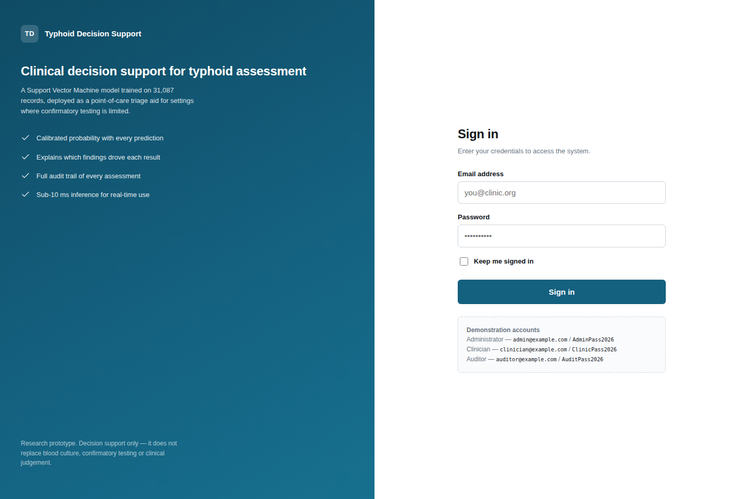
Plate C.1. Authentication page.
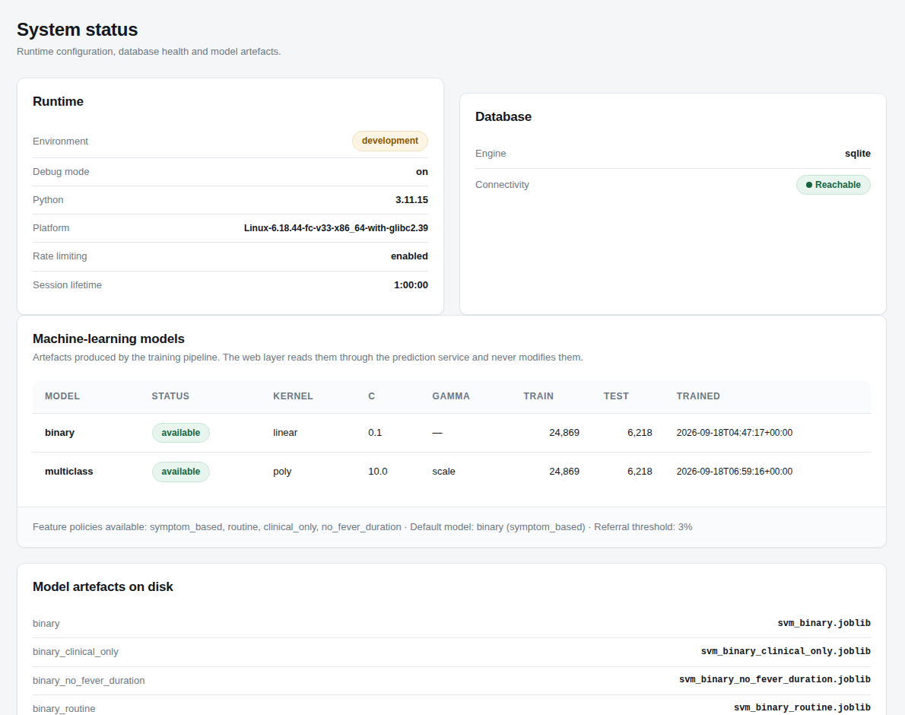
Plate C.2. Administrative system status page reporting model provenance and database health.
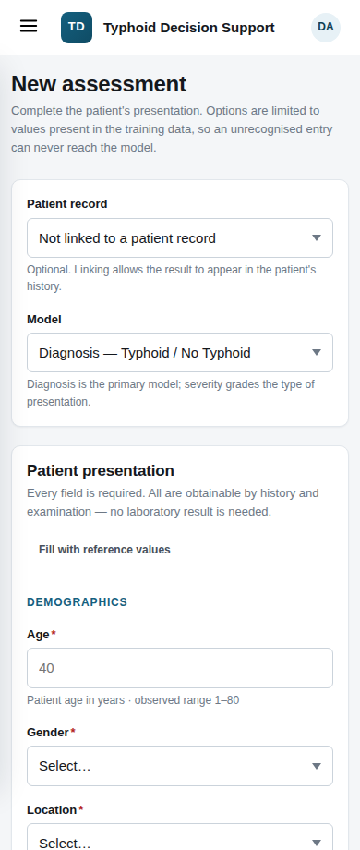
Plate C.3. Assessment form at a mobile viewport width of 390 pixels.
Note. Additional screenshots covering the clinician dashboard, patient register, activity log, validation errors and the 403 and 404 error pages are held in reports/screenshots/ in the source repository. Candidates preparing the bound copy should recapture these from the live instance on the date of submission.

C.4 Role-based access control
Table C.3: Roles and Permissions
Capability | Administrator | Clinician | Auditor
Register patients | Yes | Yes | No
Run assessments | Yes | Yes | No
View own assessments | Yes | Yes | Yes
View all assessments | Yes | No | Yes
Manage user accounts | Yes | No | No
View activity log | Yes | No | Yes
View system status | Yes | No | No

C.5 User acceptance test
Ten patient records were drawn from the held-out test partition, five typhoid and five disease-free, and entered into the deployed application through the clinician workflow. The expected output for each was computed in advance by running the record through the same prediction service the assessment form invokes. Table C.4 reports the outcome.
Table C.4: User Acceptance Test Results
Case | Recorded diagnosis | Expected and returned | Probability | Case type
1 | Typhoid | Typhoid | 1.0000 | Routine
2 | No Typhoid | No Typhoid | 0.0052 | Routine
3 | No Typhoid | No Typhoid | 0.0118 | Routine
4 | Typhoid | No Typhoid | 0.0053 | Known-difficult
5 | Typhoid | Typhoid | 0.9996 | Difficult, correctly identified
6 | No Typhoid | No Typhoid | 0.0147 | Routine
7 | Typhoid | Typhoid | 1.0000 | Routine
8 | Typhoid | No Typhoid | 0.0078 | Known-difficult
9 | No Typhoid | No Typhoid | 0.0186 | Routine
10 | No Typhoid | No Typhoid | 0.0260 | Routine
The deployed system reproduced the expected output in all ten cases, and its prediction agreed with the patient's recorded diagnosis in eight. Cases 4 and 8 are typhoid patients recorded with a fever duration of zero — the only patients in the dataset whose diagnosis cannot be read off a single attribute — and were included deliberately, with the expected disagreement declared in advance of the test. Case 5 is a third such patient whom the system identifies correctly, included so that the pack is not weighted towards failure.

C.6 Automated test coverage
Table C.5: Automated Test Suite by Module
Test module | Component under test | Cases
tests/test_data.py | Dataset loading, target construction, feature policy | 11
tests/test_pipeline.py | Preprocessing, SMOTENC, encoding, pipeline integrity | 10
tests/test_threshold.py | Threshold sweep, operating points, calibration | 12
tests/test_app.py | Prediction service and reference interface | 24
tests/test_webapp.py | Web application, security, database, deployment readiness | 77
tests/test_uat_pack.py | Acceptance pack agreement with the application | 24
Total |  | 158

C.7 Reproducing the study
The complete study can be reproduced from the repository with the following commands.
python -m venv .venv
.\.venv\Scripts\Activate.ps1 # Windows PowerShell
pip install -r requirements.txt

python scripts/audit_dataset.py # dataset integrity audit
python scripts/train_model.py --mode all --target binary
python scripts/baseline_rules.py # reference baselines
python scripts/threshold_analysis.py --policy all
python scripts/make_uat_samples.py # acceptance test pack
python -m pytest # 158 tests

$env:FLASK_APP = "run_dev.py"
python -m flask init-db
python run_dev.py # local server
Note. Training uses a fixed random seed of 42 and a stratified 80:20 partition, so every figure reported in Chapter Four is reproducible from these commands.

