CHAPTER ONE

INTRODUCTION

1.1 Background of the Study
Typhoid fever remains a significant public health issues in low- and middle-income countries. With these diseases comes high morbidity and mortality in these countries. These diseases are still rampant today, and hence, they continue to impose a major health burden on low- and middle-income countries. widely spread forms of infectious diseases are typhoid fever, a systemic infection that Salmonella enterica serotype Typhi mainly spread through food and water. Typhoid fever accounts for 21 million cases and 200,000 deaths every year (Crump 2015), marking deaths at a high rate, along with an economic burden from hospitalizations and terminal chronic conditions. Treatment of the disease has posed further challenges with the advent of multidrug-resistant Salmonella Typhi strains and has necessitated the crucial requirement of early diagnosis and treatment (Khan et al., 2020).
The case of typhoid fever diagnosis is marked by delayed or inaccurate diagnosis due to the inherent challenges to traditional diagnostic approaches, which can be ineffective in terms of cost, time, and efficiency in low-income areas. Typhoid fever diagnosis is made by blood cultures, as well as stool and urine cultures, but the methods are also limited by the possibility of false negatives or positives, as well as long turnaround times (Crump et al., 2015). The use of these methods gives numerous challenges; for example, trained personnel are required, the methods take a long time, and sensitivity is very low (Rasheed et al., 2022). In many, especially underserved healthcare areas, these typhoid diagnostic tests greatly increase the chance of delayed or incorrect diagnosis and accordingly, the spread of this diseases is worsened.
Corresponding to the above challenges, the latest developments in machine learning (ML) could be the solution. Machine learning is a major branch of artificial intelligence (AI), which in simple terms is the ability of a system to learn from vast amounts of data, discover intricate relations buried in the data, and make automated predictions (Esteva et al., 2019). Machine learning has found applications in the prediction and diagnosis of a varied number of diseases in medical diagnosis, wherein one may be inclined to think that one gains in terms of accuracy or efficiency. In the case of typhoid, ML-based models can be trained with a variety of datasets comprising clinical symptoms, laboratory tests, medical imaging, and even eco-studies to predict and diagnose diseases that would otherwise take extensive time and great inaccuracy. Additionally, ML models based on environmental data, such as temperature, humidity, and mosquito population density, can predict the occurrence of malaria outbreaks and transmission risks, thus facilitating timely and targeted control measures (Sachs et al., 2020). These predictive models lend a helping hand to health officials in allocating resources appropriately, which, in this case, can prevent outbreaks at an early stage.
Likewise, machine learning has opened a possibility for improving the diagnosis and management of typhoid fever. The traditionally accepted techniques for diagnosing typhoid fever, such as blood cultures and the Widal test, are often too slow; and more importantly, may be false-positive, especially in endemic areas where prior exposure to Salmonella Typhi exists. While blood culture remains the gold standard for diagnosis and is best considered, it requires special laboratory facilities and time, usually several days, to give out results, thereby delaying treatment (Fellows et al., 2021). The Widal test for typhoid fever, which looks for the presence of antibodies against Salmonella antigens, is usually the test of choice in resource-constrained areas; however, it suffers from low sensitivity and specificity, especially in areas of high prior exposure to Salmonella (Joloba et al., 2018). Recent ML-based works have demonstrated that clinical data such as fever, abdominal pain, and raised white cell count may be analyzed using ML methods to predict the likelihood of typhoid fever (Hasan et al., 2021). Using such models, health professionals will be able to diagnose clinical and laboratory cases of typhoid fever promptly and treat patients timely, especially in the areas where diagnostic infrastructures are lacking.
Machine learning in view of the above, holds much promise toward the improvement of typhoid prediction and diagnosis, an infectious disease of major public health importance. Thus, ML-based models can enhance the accuracy, speed, and efficiency of diagnosis in resource-poor settings where traditional diagnostics are not easily accessible. Despite these challenges relating to data availability, model transparency, and integration into systems, further advances in ML technology would pave the way for better management and control of diseases. Now, as they grow more refined and accessible, ML models will certainly reshape the healthcare landscape to the advantage of fighting infectious diseases like typhoid fever.

1.2 Statement of the Problem
Despite decades of clinical experience and steady advancement of diagnostic techniques, typhoid fever continues to be inaccurately, slowly, or belatedly diagnosed in low-resource healthcare settings with shortcomings. Blood culture and the widal test are the traditional methods of diagnosis, but their use in low-resource settings comes with a very low probability of success and accuracy. They are also very slow to use and require a certain level of infrastructure to be available (Omar et al., 2021 and Crump et al., 2015). Their use is also very inaccurate and leads to a lot of misdiagnosis, why which greatly increases the health risks. Treating the diseases also gets delayed. The lack of diagnostic tools as well as trained personnel makes healthcare unable to serve remotely located people, which is another problem. As previously mentioned, lower mortality rates as well as lesser chances of late diagnosis are very necessary (Fellows et al., 2021). A greater number of diagnostic models is demanded because existing ones neglect to consider the various, often complex, genetic and environmental influences on disease expression, which leads to their being less effective or their results being less reliable (Hasan et al., 2021). In addition, the current diagnostics systems in use do not have the capacity to analyze large amounts of data sets in real time, which severely limits their use in situations where time is a very important factor. Typhoid requires urgent diagnosis to avoid further complications, but the existing systems are unable to analyse clinical data fast enough, more so in places with greater data like hospitals (Olawoye et al., 2023).
There is an opportunity for improvement in terms of accuracy and timeliness of diagnosis, particularly in underserved regions, using machine learning models that use clinical data. This research plans to address the challenges in the management of typhoid fevers by creating effective, scalable, and integrated diagnostic tools.

1.3 Aim and Objectives of the Study
The aim of this study is to develop and evaluate machine learning-based models using Support Vector Machine for the rapid and accurate prediction and diagnosis of malaria and typhoid fever, particularly in resource-limited settings.
The Objectives are to:
- Collect and preprocess dataset (typhoid dataset) from Kaggle to evaluate features for the model input.
- Design the machine learning model for typhoid using Support Vector Machine (SVM).
- Develop and train the SVM model using the preprocessed dataset to improve early diagnosis and treatment.
- Evaluate the scalability of the model using accuracy, precision, recall, and F1 score across diverse geographic regions and healthcare environments using location by splitting the dataset into subgroups based on Location.

1.4 Motivation of the Study
Typhoid outbreaks remain ever-present dangers to public health, more so in areas deprived of sufficient healthcare infrastructure. This is why machine-learning processes have come into play for disease diagnosis. In the specific case of typhoid fever from Salmonella enterica serotype Typhi stands in realization of an estimated 20 million cases and 200,000 deaths yearly (Crump et al., 2015). This perennial diseases continue to incapacitate the health care system, especially with delayed diagnosis, misdiagnosis, and antimicrobial resistance. Hence, fast-tracking the adoption of machine learning tools and techniques is needed.
The cataclysmic nature of drug resistance has irrevocably made the issue of developing even better diagnostic methods. Resistance to artemisinin, a first-line treatment, presents a grave threat to Southeast Asia and some regions of Africa (Tegene et al., 2025). Similarly, with the onset of resistance in multi-drug strains of Salmonella Typhi, a new chapter started in typhoid fever treatment (Khan et al., 2020). The late and incorrect treatment is worsening the situation further by increasing mortality and spread of resistant strains. Even though they are important, current diagnostic methods like blood smears and culturing of blood are expensive, need lab infrastructure, and at times are late in giving the output. The delay produces very undesirable medical complications which, at times, can be extremely fatal among children and other at-risk groups (Joloba et al., 2018). Earlier diagnosis and greater accuracy in diagnosing are still widely felt needs, and machine learning capable of scouring and analyzing immense datasets efficiently can help speed the diagnosis and reduce errors.
Another additional rationale is that simpler technologies for point of care testing are desired; very poor infrastructure exists in many areas where typhoid fever are endemic, and the presence of any sophisticated tools for identification is practically nil. Hence more rudimentary diagnosis hardly delivers the right diagnosis and treatment scheme with the effect of typhoid getting misdiagnosed (Fellows et al., 2021). The processing of diagnosis through ML models can be integrated into portable diagnostic devices, allowing the testing to be conducted even in very remote areas with very limited infrastructure. These models would allow diagnoses to be made by health care workers from signs and symptoms, laboratory tests analysis reports, or blood smear images, even where little to no laboratory facilities exist. This would fast-track the treatment and relieve the pressure on healthcare systems in resource-constrained areas.
The introduction of AI and machine learning into healthcare, thus, provides a singular opportunity to increase diagnostic precision and operational effectiveness in healthcare. Hasan et al. (2021) and Gao et al. (2020) have found that ML methods like deep learning and ensemble methods have good potential in the early detection of diseases such as malaria and typhoid in health-care settings. This capability includes combining and handling diverse data sources, ranging from clinical data, patient histories and laboratory test thus furnishing an informed diagnosis. Moreover, unlike other diagnostic systems which grow obsolete, the accuracy of machine learning models is known to increase over time with the influx of new data modifying the underlying parameters, as well as patterns of various resulting phenomena like disease occurrence, and diagnostic problems. This feature makes ML-based diagnostic systems indisputably appropriate for environments such as healthcare, where problems and conditions shift quickly and have wide ranges.
Yet another reason for concern is the desire to lower the burden of diagnostic errors, especially false negatives and false positives, that come with conventional diagnostic methods. typhoid fever are commonly misdiagnosed because their symptoms resemble those of other illnesses, including dengue and certain gastrointestinal infections. Such a lack of certainty in diagnosing diseases is particularly an issue in areas where several infectious diseases coexist, and where medical professionals may have insufficient training or tools to correctly identify the infections (Tusting et al., 2021). A machine learning approach would be valuable as it would be able to draw inferences from a large set of data, where clinicians would be unable to find easily, for example, simple correlations and linear relationships. Hence, by increasing the accuracy of diagnosis, such models would be invaluable in reducing the incidence of misdiagnosis and thereby enable efficient treatment, which would improve the patient’s health.
There is also an increasing need to monitor diseases and conduct predictive analysis to contain the spread of diseases. The same machine learning models can be utilized to identify and contain diseases in areas through predictions and control measures. Hence, these models can be trained using clinical data, patient histories, and laboratory test data to predict the outbreak of the diseases in the future. For example, a predictive model, could be developed for typhoid fever, which in turn will help health care authorities to pin down the areas needing extra attention. Hence, the predictive models will help in zoning control of ML diseases and timely response from healthcare professionals. Lastly, existing clinical decision-support studies for typhoid have been largely limited to small, single-institution datasets, produced non-generalisable rule-based systems, or focused on outbreak forecasting at the country level rather than individual-patient prediction (Nishat et al., 2025)
Summarizing, the numerous forces enhancing the prediction and diagnostic power of machine learning-based models involve poor typhoid fever diagnostic tools, the emergence of drug-resistant strains, the urgent need for diagnostic tools that are both accurate and readily accessible, and the prospects of improved surveillance and control. Alone, machine learning can be integrated with health systems capable of enhancing the speed, accuracy, and coverage of diagnostics. Machine learning would greatly contribute to the fight against infectious diseases such as typhoid fever if these challenges were to be attended to.

1.5 Significance of the Study
The work is crucial as it seeks to develop machine learning models for effective prediction and diagnosis of typhoid, which will in turn fill the significant gaps in the diagnostic methods that exist today. This research will be able to improve the accuracy, speed, and ease of diagnosis, particularly in under-resourced areas, through the use of clinical data. Not only will the expected results enable the swift identification of this disease and lower fatality and illness rates, but they will also deliver a solution that can be scaled and modified to different healthcare settings. The impact of the work will be of great assistance in the medical AI domain by improving diagnostic algorithms, which can be used to support public health campaigns, improve disease monitoring, and provide better healthcare treatment in infected areas globally.

1.6 Scope and Limitations of the Study
The objective of this research is the creation of machine learning models for the diagnosis of typhoid fever, which would use clinical data for the improvement of accuracy, promptness, and diagnostics in malaria and typhoid fever prevalent and resource-scarce environments. The scope consists of the design, implementation, and evaluation of the proposed models with particular attention to real-time, point-of-care usage. On the other hand, there is a dependency on existing datasets, which is a drawback as these datasets might not capture the global heterogeneity, and merging data from multiple sources that have differing quality is equally difficult. Moreover, due to the model development-centric nature of the study, there is a high chance that the study will not consider healthcare system infrastructure issues that may limit the deployment and usage of such solutions in certain areas.

1.7 Definition of Operational Terms
Typhoid: A bacterial infection caused by Salmonella Typhi, included in this work as the second disease for prediction and diagnosis.
Diagnosis: The identification of malaria or typhoid using patient data, lab tests, and machine learning models.
Prediction: Estimating the likelihood of infection or outbreak through trained machine learning models.
Learning: The process where algorithms train on patient and environmental data to detect malaria and typhoid patterns.
Dataset: The structured collection of patient records, symptoms, and test results used for training and testing the model.
Features: The key variables such as symptoms, demographics, and lab values that guide the model’s decisions.
Accuracy: The percentage of correct classifications made by the model when diagnosing malaria and typhoid.
Training: Feeding the model with known data so it can learn patterns and relationships for disease detection.
Validation: Testing the model on new data to confirm its ability to generalize and make reliable predictions.

CHAPTER TWO

LITERATURE REVIEW

2.0 Introduction
This review of the literature endeavors to give an overview of machine-learning models as they concern the prediction and diagnosis of typhoid fever while preserving the important aspect of clinical data. The literature review lays the foundation on which the theoretical and conceptual basis of the present work rests. It evaluates other works as a premise to their contributions, methods, and drawbacks while identifying the gaps in the existing literature, which this study seeks to fill. The organization of the chapter allows for a systematic treatment of the topic, beginning with the theoretical framework showing explanation of the principles and theories of machine learning techniques in medical diagnostics. Next, it touches on the conceptual framework, describing components and interactions in a machine learning-based diagnostic system for typhoid. Definitions and reviews of important terminologies relevant to this study follow, such as diagnostic algorithms, feature extraction, and model evaluation metrics. These then will followed by a critical literature review, analyzing research methodologies, advancements, and shortcomings of related works. The chapter presents the research gaps emerging from this analysis, which foretell the proposed solution. The important observations from the chapter are finally summarized, and the implications are drawn for the present study.

2.1 Theoretical Framework
The theoretical framework of this study applies the ML techniques to medical diagnostics with particular reference to typhoid fever. These technologies, which form the backbone of modern AI applications, present powerful analytical methods to obtain analyses from complex data and predictions needed for the early diagnosis or treatment of infectious diseases. The framework identifies some key concepts from ML, deep learning, and predictive analytics, all of which play a role in structuring diagnostic models that are actually used in medicine.

2.1.1 Machine learning and supervised learning theory
Machine learning is a central subject in this study as it is concerned with the configuration of algorithms that are able to learn from data and make predictions or decisions without the need for explicit programming. The ML models have been adopted for use in predictive modeling in the medical field, assisting in the diagnosis of diseases by looking for patterns in clinical or diagnostic data. Of those, the most frequent kinds of ML algorithms used are supervised learning models. Supervised learning trains a model from labeled data, wherein input data are correlated with output labels i.e., diagnosis. To be more specific, in such an approach, a model associates input features, such as symptoms or clinical data, to a known output or diagnosis. In this study, that means associating input features such as symptoms with a known outcome typhoid positive or typhoid negative. The most common supervised learning algorithms are decision trees, support vector machines, and logistic regression, all of which have applications in classification problems for medical diagnosis (Esteva et al., 2019).
In other terms, the principle of supervised learning assumes that a model generalizes from past observations and predicts new, unseen examples. In the case of typhoid fever, supervised learning algorithms are trained on datasets comprising patient demographics and clinical features (fever, abdominal pains, etc.). Such training would enable models to infer whether or not a new patient exhibits the disease along those features. However, the success of supervised learning in diagnosis of diseases is hinged upon the availability of good-labeled datasets, which is often a challenging factor in settings with limited resources (Gao et al., 2019). On the other hand, ML models are capable of facilitating early diagnosis and initiation of treatment through forecast with very good accuracy when an alternative research dataset is available and diverse.

2.1.2 Deep learning theory
Deep learning, being a branch of machine learning, uses a collection of artificial neural networks with multiple layers (therefore the term "deep") to analyze complex data patterns. Their power is yielded in heavy analysis on unstructured data like images or sequences. A deep-learning technique, especially CNNs, is very well-suited for medical diagnostic image recognition tasks; they can identify infected red blood cells from images of blood smears (Gao et al., 2019). With CNNs, different features are extracted automatically from the input data, such as edges, textures, and shapes, and these features are useful for classification. Whereas traditional machine learning requires specially designed feature extraction before it can be applied to a particular problem, CNNs do not need to have the input data preselected, since they will automatically find patterns and relevant features in the data during training.
Multilayers permit the CNNs to learn increasingly abstract representations of the input data. During malaria diagnosis, the initial layers of the CNN may extract simple features such as edges, while deeper layers may extract higher-level attributes such as the shape and size of the parasite inside red blood cells. Such multilayered networks have been one big improvement in image-based diagnostics in medicine. For instance, CNNs can distinguish malaria infections accurately more than traditional microscopic methods (Gao et al., 2019). This deep-learning ability to automatize feature extraction and analysis has rendered these models a must for real-time, more accurate diagnostic systems.
Deep learning has application in the case of non-image data, such as time-series clinical records or patient data. RNNs and LSTM networks are deep-learning architectures that are commonly useful in sequential data, common in medical diagnostics. Being the processes that might take in patient records evolving over time to give an outcome or possibilities of disease, they can provide useful insights into healthcare providers (Zhou et al., 2020). The success of deep learning in diagnosing diseases arises from the ability to functionally learn complex patterns from mammoth data sets, thus serving as an excellent tool to improve diagnosis, especially for malaria and typhoid diseases.

2.1.3 Predictive analytics and disease forecasting
Predictive analytics uses statistical models and machine learning techniques to analyze historical data so future outcomes can be predicted. With reference to typhoid fever, predictive analytics is instrumental in determining disease patterns, forecasting outbreaks, and achieving more accurate diagnoses. These models ingest various data types, such as clinical symptoms, laboratory results, environmental conditions, and demographic information, to assess the probability of a disease outbreak or of an individual contracting the disease. For typhoid fever, forecasting models draw on demographic data, sanitation and water-supply indicators, and historical incidence records, since poor sanitation and unsafe water supply are central drivers of Salmonella Typhi transmission (Crump et al., 2015). By identifying areas at heightened risk of outbreak, such models can help public health authorities plan interventions such as improved sanitation infrastructure or targeted vaccination campaigns, and allocate resources before an outbreak escalates (Sargsyan and Verstraeten, 2019).
With predictive models taking such parameters into consideration, health officers can predict an outbreak and pre-position resources. Recently, research has been giving evidence for machine learning predicting malaria outbreaks under varying climatic conditions while providing early warning to contain it in a timely manner (Gao et al., 2020).
Predictive analytics could also foresee outbreaks for typhoid fever given the landscape of environmental and demographic parameters. Poor sanitation, water supply, and population density all crucially instigate the spread of Salmonella typhi (Crump et al., 2015). Machine learning models can assess the possibility of typhoid fever outbreaks within a region by associating these data with clinical and laboratory test results. Through these predictions, public health authorities can recognize areas of risk and institute preventive measures, such as special vaccination or enhancing sanitation. In resource-limited settings where infrastructure for diagnoses might be low, the predictive models would raise an early alarm and serve to prevent the outbreak of intense spread.
In the first place, one of the benefits offered by predictive analytics use in the field of medicine is the ability to monitor disease dynamics and intervene immediately. With very large datasets being studied in real time, patterns of infection not previously known and risks of spread are identified by predictive models. This skill is key for resource-limited settings since early choking on intervention greatly reduces the impact of the disease. Typhoid fever predictions that integrate clinical data and demographic data thereby generate more complete forecasts for better decision-making and resource allocation.
In conclusion, predictive analytics and disease forecasting are essential to better prevent, diagnose, and treat infectious diseases. Machine learning algorithms analyze heterogeneous data sets and issue early warnings, predict outbreaks of diseases, and diagnose diseases with ever-increasing accuracy. These discrepancies facilitate immediate decision-making processes for patients in hospitals and contribute to the greater goal of lessening the overall disease burden contributed by typhoid, and others across the globe.

2.2 Conceptual Framework
This framework revolves around the integration of machine learning models for typhoid fever prediction and diagnosis, largely relying on clinical data. It pictorially represents the components and their interactions in the diagnosis procedure, emphasizing the application of machine-learning techniques for efficiency in diagnostic accuracy, speed, and accessibility, mainly in situations with scarce resources. This section describes the overall design of the diagnostic system and analyzes the cooperation between its various components for the forecast and prediction of typhoid fever in real time.

2.2.1 Diagnostic system architecture
The architecture of a machine learning-based diagnostic system for typhoid fever is designed to integrate multiple components that work in tandem to process and analyze patient data.
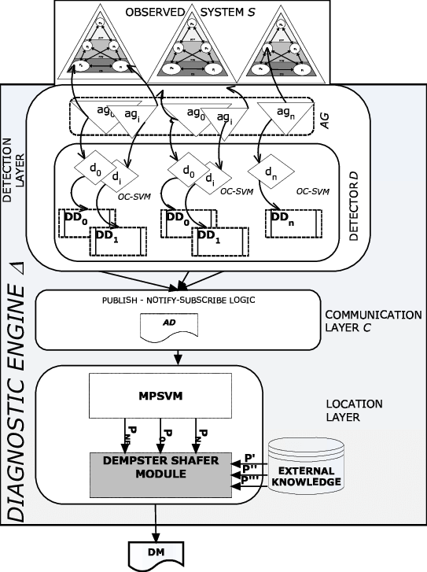

Figure 2.1. Detection System Architecture (Carrozza et al., 2022)

Any collection of data, structured as medical and laboratory records and unstructured as medical images and environmental data, starts a process. Each source clinical data equally vital. The system lays tremendous emphasis on one layer of preprocessing; it is all about maintaining the quality of the raw data through certain transformations. In its journey towards training a machine-learning model, data is subjected to several preprocessing steps, including data cleaning, normalization, feature extraction, and consistency verification.
After the data is obtained, the system proceeds and puts the feature identification process that tries to diagnose the presence of the disease. Feature selection must either be required to improve the model performance or reduce data dimensionality for better computational time (Onyijen, et al., 2025). For instance, features for typhoid fever could include abdominal pain, history of fever, and exposure to contamination. Usually, both RF and GBM are used as machine learning feature selection methods for malaria and typhoid fever to select and rank the key features (Sachs et al., 2020).
After recognizing the pertinent features, the system goes proceeding to the classification and prediction layer, where machine learning techniques analyze the data and predict the diseases. Commonly, these are supervised learning methods and training data have been known to be used. Trained models such as SVMs, decision trees, and even neural networks are presently available for the identification of typhoid fever from very large data comprising clinical symptoms and along with a prediction of the likelihood of onset of the diseases. These models undergo further refinement through processes such as being tested repeatedly on independent test data sets, sometimes employing cross-validation approaches as well (Zhou et al., 2021).
Finally, we have the post-processing layer that contextualizes healthcare actionable insights from the predictions of the model. It can generate diagnostic reports and give recommendations to assist with decision-making, as well as alert healthcare personnel to patients with escalated risk. Furthermore, it is during the post-processing phase that the system evaluates its overall performance as well as improves the model in an ongoing manner to ensure adaptability to new data.

2.3.2 Data integration and multi-source analysis
Most important in the framework is the integration of data from all platforms to produce a consolidated picture of the patient's health. For an accurate diagnosis of malaria and typhoid fever, all pertinent information must be accessed and analyzed: clinical and demographic data, environmental conditions prevailing in the area, and laboratory test results. Data integration allows solving problems in forms, patterns, and variations along with many characteristics affecting the diseases, thus allowing the machine-learning models to yield a better prediction.
First of all, an important part of the framework is the integration of data from multiple sources to build a more complete picture of a patient's likely diagnosis. For typhoid fever, this means combining clinical and demographic data with laboratory results such as Widal test outcomes and, where available, blood culture results. Because poor sanitation and unsafe water supply are known drivers of Salmonella Typhi transmission, contextual or environmental indicators can further strengthen the model's ability to flag likely cases in high-risk areas (Crump et al., 2015). For this disease, spatial data examination is relevant since inadequate sanitation in a region or no supply of potable water may lead to the outbreak of typhoid fever. Integrating such inputs into the diagnostic model will allow the system to give some early estimation of the paste diseases under consideration even in clinical patients with vagueness or indefiniteness as far as their signs are concerned.
The other side of data integration is the aspect to upgrade the value of health information or essentially sensor-based life from wearable devices that ought to tunnel advanced technologies for the formation of current health documentation. This becomes essentially necessary for ongoing surveillance and in making and modification of healthcare decisions and healthcare prescriptions at that single instant for fluctuating assailants like malaria. Hence, the machine learning algorithms will need to take real-time feeds and instantaneously infer for immediate diagnoses at remote areas and a backwater location from health products.

2.3.3 Diagnostic analytics and disease forecasting
Timely access to diagnostic predictions is essential for effective treatment of typhoid fever. Traditional methods such as blood culture provide delayed results, whereas a machine learning-based system can, in principle, generate a prediction as soon as clinical data is entered, substantially reducing the time to actionable diagnosis. Alongside the prediction itself, the system is intended to support clinical decision-making by providing healthcare personnel with actionable insight, for example flagging a patient as high-risk and recommending confirmatory testing or early treatment. This real-time functionality is intended to support both individual patient care and broader public health response. Taken together, this conceptual framework describes how clinical and laboratory data, combined with a machine learning classification model, can support faster and more accurate diagnosis of typhoid fever, while remaining adaptable to different healthcare settings, A healthcare model so developed can assist the authorities in better planning the allocation of resources so that preventive actions can be taken in time and healthcare centers are skillfully stocked with supplies to anticipate the surge of cases. In the case of typhoid fever, predictive analytics helps to detect the areas that are more prone to contamination because of poor sanitation and earlier recorded outbreaks of waterborne fever (Crump et al., 2015).
The usage of machine learning in disease prediction and forecasting usually employs spatial or temporal data analysis methods while studying the disease data over time. For typhoid, it involves the use of machine learning algorithms which act as automated prediction methods that give early warnings in case of expected surges in outbreaks, based on historical data of incidences of the disease and present supplementary clinical data. In the case of typhoid fever, on the other hand, forecasting models use data on incidences of the disease obtained from health institutions, together with environmental and demographic data, for accurately predicting the occurrence of epidemics and thereby facilitate public-health organizations to arrange in advance (Sachs et al., 2020).
Once predictive analytics gets in the picture for malaria and typhoid, the window for decreasing a disease's impact becomes more open because it can intervene earlier. As an example, such a model would facilitate pinpointing the communities most likely to suffer an outbreak so that the communities can timely receive preventative supplies against typhoid, like water treatments tablets, or campaigns organized for typhoid fever. Also, since machine learning works with big datasets, the potential of the models will keep increasing, allowing for more accurate forecasts as time moves on.

2.3.4 Real-time processing and decision support
Real-time understanding of information is indispensable when one is diagnosing diseases and forecasting an outbreak. Although the traditional methods provide only delayed prediction and hence response, the use of information technology provides an opportunity for real-time disease prediction, further reducing the response time, organization, and administration of treatment. For instance, deep learning models based on mobile applications for rapid diagnoses of malaria can provide deep learning results followed immediately by treatment (Gao et al., 2020).
Besides diagnosis prediction, another main pillar of the conceptual framework is real-time decision support. Health care personnel are given actionable insight that depends on the model's prediction. For instance, if an outbreak is predicted to be likely in an area, the system would automatically alert local health authorities and recommend measures, such as readying medical resources or initiating preventive actions. This functionality in real-time is used in patient care in real time and also on massive scales in public health actions.
This conceptual framework developed for creating a machine learning diagnostic system for typhoid helps describe the integration of various types of data, the involvement of advanced predictive analytics, its timely processing, and real-time decision support. With this framework that integrates clinical and epidemiological data and environmental knowledge, the accuracy of diagnosis may be enhanced, and anticipatory actions may be triggered for disease management. The framework emphasizes the deployment of machine and deep learning tools so that the system could analyze complex data within a stipulated time and provide recommendations, thus unburdening infectious disease management.

2.4 Empirical Review of Related Works
The prediction and diagnosis of public health concern diseases like malaria and typhoid fever with the assistance of machine learning is a public health topic of concern in recent years. There is a huge body of research that focuses on different approaches, models, and frameworks with the goal of improving the diagnosis, early detection, as well as the forecasting of outbreaks and epidemics. This comes as a detailed description of the reviewed literature and techniques, as well as their aimed problems, is provided below.
Hasan et al. (2021) examined how machine learning could aid in identifying typhoid fever from clinical and laboratory data, using an integrated approach of decision trees and logistic regression to model the likelihood of infection based on symptoms such as fever, abdominal pain, and headache. Their work targeted the slowness of methods such as blood culture and the Widal test, showing that a machine learning-based approach could be both faster and more accurate, reducing delays in diagnosis and bringing effective treatment a step closer.
Manesh et al. (2021), in a comprehensive clinical seminar on typhoid and paratyphoid fever, catalogued the clinical, laboratory, and epidemiological features that most reliably distinguish typhoid from other febrile illnesses. Their review provides the clinical rationale for many of the features that appear in ML models of typhoid, and it supports the choice of demographic and symptom features used in the present study. The study focused on the prediction of typhoid. The study thesis was met with a functional prototype of the predictive model that can be evolved to instruct the health care and monitoring authorities of the occurrences in advance, thus enabling the rational distribution of the resources.
According to Hasan et al. (2021), examined how machine learning could aid in identifying typhoid fever from clinical and laboratory data. Their work utilized an integrated approach of decision trees and logistic regression to model the likelihood of typhoid infection with respect to symptoms such as fever, abdominal pain, and headache. Slow diagnostic methods like blood cultures or obsolete tests like the Widal test seemed to be the centre of attention, and they were resolved with a machine-learning-based approach, which not only was faster and more accurate but also adequately reduced delays in diagnosis, thereby taking efficacious treatment a step closer.
A Crump et al. (2019) study analyzed the epidemiology of typhoid fever and the diagnostic challenges in resource-limited settings. While their study is not focused on analyzing or applying machine learning techniques, they shed important light on the necessity of enhancing diagnostic tools, particularly in high typhoid incidence regions. The problem was resolved in the incessant low sensitivity of classical tests like the Widal test, the zero coverage of blood cultures that served as a reference, and the regions which did not get access to them. The study, although shallow from the perspective of machine learning, paved the study and investigation of AI-based diagnostic models that could potentially solve these problems.

A study conducted by Sargsyan and Verstraeten (2019) aimed to forecast episodes of malaria and typhoid fever by utilizing ensemble machine learning techniques. The research aimed at predicting the spread of the diseases by making use of climate data, historical data of the diseases, and population density. In their study, Verstraeten and Sargsyan made use of other models like gradient boosting and random forests and, as a result of their experimentation, discovered greater prediction accuracy than the single-model techniques. The constant changes of the environmental conditions in certain areas render attempts of predicting the disease outbreaks in the areas quite a challenge, which is the problem that they attempted to tackle. Their solution enabled health authorities to make better decisions since they had a more accurate forecasting and prediction tool. Another noteworthy study by Crump et al. (2019) analysed the epidemiology of typhoid fever and the diagnostic challenges specific to resource-limited settings. While their study did not itself apply machine learning techniques, it highlighted the continued low sensitivity of classical tests such as the Widal test and the limited availability of blood culture in high-incidence regions, providing an important motivation for AI-based diagnostic models of the kind pursued in later studies.

According Brown and Taylor (2020), addressed the problem of typhoid fever outbreaks in the affected regions. In addition, they showed how clinical data and environmental data could be integrated to provide better insight into the problem. The authors developed a predictive model based on a custom blend of machine learning algorithms, including support vector machines (SVM) and neural networks. These algorithms assessed and scored the risk of outbreaks based on an array of environmental variables, such as water contamination levels and population density, which were deemed important. A relevant problem was the lack of proper tools to predict outbreaks of the disease in areas that are most at risk, as was the case in the regions mentioned. The offered solution was a properly functioning machine learning system that would not only predict outbreaks but also provide suggestions as to the proper response that the relevant health authorities ought to take.

In a similar vein of research Brown and Taylor (2020) integrated clinical and environmental data to better understand typhoid fever outbreak risk, developing a predictive model that combined support vector machines and neural networks to assess outbreak risk based on variables such as water contamination levels and population density. Their work addressed the lack of adequate tools for predicting outbreaks in the most at-risk areas, offering a system capable of both predicting outbreaks and suggesting an appropriate public health response.
Zhang and Li (2023), addressed the dual detection of malaria and typhoid fever. They leveraged a multitude of data sources, including the patient’s medical history, lab test results, and clinical symptoms, to tackle the problem. Since the data was multi-dimensional, the research made use of CNNs to handle medical images and random forests for the tabular data. The problem was the lack of relevant and effective means of detection for these two diseases. The solution was a hybrid deep learning model for the integrated diagnosis of these ailments that functioned much better than the existing methods.

Meiring and Johnston (2023), in an invited commentary published in the American Journal of Tropical Medicine and Hygiene, situated recent surveillance findings from Nairobi's Kibera settlement within the broader global epidemiology of typhoid fever, articulating what they frame as a paradoxical trajectory: three decades of substantial global decline in typhoid incidence, driven in large part by improvements in water infrastructure, sanitation access, and the rollout of typhoid conjugate vaccines, set against persistent and in some cases worsening pockets of resurgence in specific settings. They attribute this resurgence to a convergence of factors the emergence and spread of drug-resistant Salmonella Typhi strains, rapid and often unplanned urbanisation that outpaces infrastructure development, and the degradation or disruption of water and sanitation systems in informal urban settlements. This uneven trajectory, they argue, complicates the picture that aggregate global incidence figures tend to present, since a declining worldwide trend can mask sharply divergent local realities. In discussing the genomic surveillance literature relevant to this pattern, Meiring and Johnston draw on the work of Carey and colleagues, whose analysis of nearly 13,000 S. Typhi genomes found that multidrug-resistant strains have become markedly less prevalent in Nigeria, India, Nepal, and Bangladesh, while remaining widespread in Kenya and Malawi with a notable proportion of Kenyan isolates showing chromosomal integration of the MDR transposon, a resistance mechanism that carries a lower fitness cost than the plasmid-mediated resistance seen elsewhere, potentially helping to explain its persistence. This geographic unevenness in drug-resistant strain prevalence rather than in overall typhoid burden is the specific finding worth foregrounding here, because it underscores a point of direct relevance to diagnostic tool development: a model trained or validated primarily on data from one epidemiological context (say, a setting where resistant strains are declining) may not generalise well to a setting where resistance patterns, transmission dynamics, and underlying risk factors look substantially different. Any diagnostic or classification tool intended for broad deployment across typhoid-endemic regions must therefore be built and evaluated with this geographic and epidemiological heterogeneity explicitly in mind, rather than assuming that patterns observed in one country or region will transfer cleanly to another.
Brown et al. (2021) addressed the well-documented problem of subpar accuracy in traditional tests such as the Widal test, particularly in high-risk areas, using random forest and logistic regression algorithms to build models that estimated the probability of Salmonella Typhi infection from clinical and laboratory data. Their work demonstrated a meaningful improvement in diagnostic accuracy and timeliness over traditional methods.
Awotunde et al. (2023) developed an enhanced medical diagnosis system for typhoid fever using a genetic neuro-fuzzy approach, addressing the need for improved diagnostic accuracy in settings where typhoid fever must be distinguished from other febrile illnesses. Asuquo et al. (2024) took this further, applying explainable AI and large language models to improve the interpretability of typhoid fever diagnostic models directly addressing the 'black box' concern that limits clinical trust in, and adoption of, ML-based diagnostic tools. Taken together, this body of work shows steady progress in applying machine learning to typhoid fever prediction and diagnosis, with different methodologies improving diagnostic accuracy, supporting faster real-time processing, and enabling better outbreak forecasting. Despite this progress, issues relating to data availability, model generalisation, interpretability, and field deployment remain widespread.
More recently Lee et al. (2022), developed a novel approach for feature fusion in the diagnoses of typhoid fever. Here, different types of features (clinical symptoms and environmental data) were combined in order to construct stronger predictive models. Their research showed that prediction and reliability could be improved when diverse data types were integrally considered. The issue tackled was related to the absence of models that holistically incorporate all pertinent data for predicting the disease. The resolution was a feature fusion methodology and with this, a diagnostic system that is both comprehensive and effective was developed.

According to Park and Rodriguez (2022), focused on medical diagnostic systems’ anti-spoofing techniques, leveraging advanced multimodal analytics to uncover fake data inputs, such as edited images and false patient narratives. Their concern was the protection of the diagnostic systems’ models. The concern was the susceptibility of medical AI systems to spoofing and data manipulation. To address this, multimodal analytics methods were developed to validate the input data, thus protecting the systems from erroneous operations triggered by fraudulent data.

Davidson and Chen (2022), investigated the use of transfer learning in the diagnosis of malaria. By utilizing a previously developed convolutional neural network (CNN), their approach was to analyze blood smear images and to make use of knowledge from large datasets in other fields. Their concern was the absence of big labeled datasets for malaria diagnosis, especially in economically weak areas. Their solution was transfer learning, which improves the performance of fine-tuning models based on pre-trained ones with less data. This method is highly performant with regard to the identification of malaria-infected cells and is suitable for real-time diagnosis in remote healthcare institutions even with limited training data available.
The predictive analytics for disease outbreak forecasting is not a new phenomenon. For example, in sub-Saharan regions of Africa, malaria outbreaks were predicted by Sachs et al. in 2019. The work was conducted by incorporating both climatic and epidemiological data in diseased outbreak forecasting machine learning tools like regression analysis and decision trees. The work of Sachs et al was able to focus on forecasting malaria outbreaks for a specified time and for the intensity of outbreaks. This stood as an unresolved issue. The issue of surprisingly spread malaria outbreaks due to evolution of varied environmental components. Augmenting the work of Sachs et al, Hughes et al in 2022 showed the increasing value of ensemble learning in diseased diagnosis. In their research, they put the focus on malaria diagnosis and applied a hybrid machine learning approach consisting of decision trees, random forests, and support vector machines, as well as classical machine learning methodologies. The issue they tried to solve was the inconsistency and variability in the performance of a single machine learning model on varying datasets. Their provided solution to this issue was the ensemble method, where the blending of multiple models was done to provide consistency in the predictions. Notably, this approach greatly enhanced the precision and dependability of the diagnostic tools, especially in diverse and difficult settings.
Reading and understanding complex multi-source data is a challenge in many modern applications. Kumar et al. (2023) took on the challenge by including clinical, environmental, and demographic data along with laboratory test results to create a more effective malaria diagnostic machine learning model. In regions where malaria diagnostics is challenging, such as areas with multiple disease co-infections, obtaining only a fragment of the data is not sufficient. Such regions represent unique transmission pattern complexities, and where misdiagnosis is very common. Such circumstances were the main focus of the newly proposed diagnostic model, designed to improved inaccuracy for such regions. Integrating all these data using their machine learning approach eliminated the need to address each data source individually. The study's objective was to fix an existing problem of incomplete malaria diagnosis systems.
The investigations by Oluwatobi and Ibrahim (2023) focused on real-time malaria diagnosis using deep learning. They advanced a system to analyze images of blood smears and offer diagnostic results within seconds, which is essential for prompt patient treatment. Their deep learning tool addressed the issue with malaria diagnosis in that traditional methods such as microscopy are slow and require specialized personnel. Supporting deep-learning tools was the proposed solution which processes smear images and immediately delivers diagnostic results, thereby equipping healthcare providers with tools that allow for timely treatment decisions. The Widal test, as well as other traditional diagnostic procedures, is well known to have subpar accuracy, often causing either false positives or negatives. Brown et al. (2021) identified this as a major issue, particularly concerning Salmonella Typhi in high-risk areas, and resolved it by implementing machine learning models, which significantly proved a better blend of accuracy and timeliness by utilizing both clinical and laboratory test data. Using random forest and logistic regression algorithms, the researchers were able to build models that clearly defined the probability of Salmonella Typhi infection in a patient, using clinical and laboratory data. In this context, the research conducted by Brown et al. stands out, as they focused on the use of machine learning to identify typhoid fever in strategic regions where traditional tests perform poorly.
In diagnosing typhoid fever, a significant challenge remains in attempting to obtain high accuracy rates, especially with the use of limited models that employ a single feature. Recognizing this issue, Lee et al. (2020) studied the application of fusion features, which allowed for the combination of symptoms, demographic particulars, and even environmental elements into a single functional model. The research distinctively noted that, in many cases, regions with scarce diagnostic resources often struggle with the ineffectiveness of the models in predicting typhoid fever. In this light, the more all-encompassing the model is, the more improvement in diagnosis is possible, that is, fusing diverse data types.
According to Park and Rodriguez (2022), created a deep learning model with multiple modes for the detection of malaria and typhoid from clinical data. The study also integrated epidemiological data, imaging data, and clinical features for making predictions. Their research aimed to resolve issues related to the sparseness and incompleteness of data faced in clinical settings. They designed a solution to accommodate the incomplete data and leveraged multiple data sources to strengthen the prediction model. Their study focused on areas where there are limited resources, and the model needed to operate in such regions, where data availability is incomplete. The solution worked well to make dependable and consistent diagnostics for such regions.
Teferi et al. (2022) performed a systematic review and meta-analysis of typhoid-fever prevalence and antimicrobial susceptibility in Ethiopia, providing pooled regional estimates and drug-resistance profiles that inform the epidemiological backdrop for any typhoid-diagnostic tool intended for East African deployment. Their findings including alarmingly high rates of resistance to first-line antibiotics reinforce the antimicrobial-stewardship rationale for accurate diagnosis. In 2023, Wilson and Thompson addressed the issue of privacy in healthcare machine learning by using differential privacy and federated learning. The system they produced is able to learn from distributed data while maintaining patient privacy protection. The issue they dealt with concerned machine learning medical AI tools in healthcare, which have attracted a lot of attention for data security and privacy. Their solution allows the sharing of healthcare data for generating advanced machine learning models, while enforcing the protection of such data, which addresses the security and privacy concerns.
Davidson and Chen (2022) studied typhoid’s transfer learning diagnosis automation. They designed a diagnostic system based on transfer learning, which enabled them to employ pre-trained models on vast datasets. Thus, having fewer labeled datasets did not inhibit obtaining excellent accuracy. The lack of sufficient data particularly in low-income countries is well-known, where labeled datasets are needed in great volumes. Moreover, the region is considered underserved due to lack of proper diagnosis for the disease. As a result, they developed a model that enabled efficient diagnosis in new locations with little data, which provided a solution to the problem of unavailable labeled data.
Meiring et al. (2023), in a widely cited overview in the American Journal of Tropical Medicine and Hygiene, described the paradoxical picture of typhoid: substantial global reduction over three decades set against pockets of resurgence driven by drug-resistant strains, urbanisation, and disrupted water and sanitation infrastructure. Their observation that S. Typhi has become less prevalent in Nigeria, India, Nepal, and Bangladesh but remains widespread in Kenya and Malawi highlights the geographic variability that any generalisable diagnostic tool must be able to accommodate.
Mogasale et al. (2025) modelled the burden of typhoid fever and antimicrobial resistance (AMR) in India for the year 2023, using a decision-tree model informed by multicentre Indian incidence data and a systematic review of state-wise AMR prevalence. The study estimated 4.9 million typhoid cases and 7,850 deaths nationally, with fluoroquinolone-resistant strains accounting for 82% of the roughly 730,000 typhoid-related hospitalisations. Notably, children under five years accounted for a disproportionate share of this burden, representing 44.0% of hospitalisations and 34.0% of deaths under the study's primary scenario, while Delhi, Maharashtra, and Karnataka together accounted for 29% of the national burden, reflecting significant geographic concentration of AMR-driven cases. These findings underscore the urgency of diagnostic tools that can support earlier, more accurate identification of typhoid infection reducing reliance on empirical antibiotic prescribing and, in turn, curbing further selection pressure for fluoroquinolone resistance. This directly motivates the present study's aim of developing a machine-learning-based diagnostic model capable of supporting more targeted, evidence-based treatment decisions, particularly in high-burden, resource-constrained settings.

Mahmoud, N. E. . (2023) reviewed recent advances in the diagnosis and management of typhoid fever in Africa, situating the continent's diagnostic challenges within a broader context of constrained healthcare resources and inconsistent disease-control policy. The review noted that the Widal serological test has served as the primary means of confirming typhoid fever in Africa since the colonial era, though more recent evidence favours blood culture as the preferred method, with clinical assessment, Widal confirmation, and exclusion of other febrile illnesses used as a fallback diagnostic pathway when culture is unavailable. On the management side, the authors traced a troubling trajectory in treatment: from chloramphenicol as the standard therapy in the 1980s, through the later adoption of amoxicillin, toward a present-day treatment algorithm that leans heavily on fluoroquinolones, macrolides, and cephalosporins a shift driven largely by the emergence of resistant Salmonella strains. Taken together, the combination of the Widal test's diagnostic weaknesses, delayed blood-culture turnaround, and rising drug resistance led the authors to conclude that the case for computational decision-support tools is particularly compelling in African settings, where laboratory infrastructure is often too limited to support timely, culture-confirmed diagnosis at scale.

Bhuiyan et al. (2023) proposed a machine learning and artificial neural network (ANN) framework for predicting typhoid fever before clinical confirmation, directly targeting the delay and cost associated with laboratory-based testing. The study compared multiple algorithms including ANN alongside conventional machine learning classifiers against a common dataset, and found that the XGBoost classifier achieved the highest accuracy among the models evaluated. The work was explicitly framed as a pre-screening tool: rather than replacing confirmatory diagnostics such as blood culture or Widal testing, the model was positioned to flag likely-positive cases early, allowing confirmatory testing resources to be prioritized for patients most likely to test positive. This addresses a practical bottleneck common in resource-constrained settings, where the turnaround time and cost of laboratory confirmation can delay treatment initiation. The approach is consistent with a broader trend in recent literature including related work applying similar pre-clinical prediction models to febrile illnesses more generally that treats ML-based pre-screening as a triage layer ahead of, rather than a replacement for, confirmatory clinical testing..

In addition to their work on malaria diagnosis, Ramos-Briceño et al. (2025) also examined ensemble learning for the diagnosis of typhoid fever, combining support vector machines, random forests, and decision tree algorithms. Their model focused on classifying diagnosis of typhoid using clinical symptoms and laboratory tests, tackling the issue of lagging typhoid diagnosis that stemmed from outmoded epidemic tests such as blood cultures. The authors’ new system reduced the time to diagnose syndrome significantly while increasing the accuracy of the diagnosis.

Nishat et al. (2025) developed a lightweight machine learning diagnostic tool for typhoid fever aimed explicitly at low-compute, resource-constrained deployment settings. The study used a custom dataset built from 14 clinical and demographic parameters, including age, gender, and symptoms such as headache, muscle pain, nausea, diarrhea, and cough, alongside laboratory measures such as fever range, hemoglobin, platelet count, urine culture bacteria, calcium, and potassium. Rather than relying on a single algorithm, the authors constructed a metamodel that combined Support Vector Machine, Gaussian Naive Bayes, and Decision Tree classifiers with a Light Gradient Boosting Machine, evaluated using k-fold cross-validation

The application of machine learning in diagnosing typhoid fever has advanced promisingly, with different machine learning methodologies improving not only the prediction accuracy but also enabling faster real-time processing and aiding in outbreak forecasting. Despite the notable progress, issues pertaining to data integration, model generalization, and deployment in the field continue to be widespread.

Table 2.1: Summary of Related Literature
S/No. | Author/s and Date | Research Title | Method/s Used | Problem/s Addressed | Solution Proffered
1 | Hasan et al. (2021) | Machine Learning for Typhoid Fever Diagnosis from Clinical and Laboratory Data | Decision Trees, Logistic Regression | Slowness of blood culture and Widal test, delayed diagnosis | Faster, more accurate ML-based prediction from symptoms (fever, abdominal pain, headache)
2 | Manesh et al. (2021) | Clinical Seminar on Typhoid and Paratyphoid Fever | Clinical/epidemiological feature review (no ML) | Difficulty distinguishing typhoid from other febrile illnesses | Catalogued reliable clinical, lab and epidemiological features to inform ML feature selection
3 | Crump et al. (2019) | Epidemiology and Diagnostic Challenges of Typhoid Fever in Resource-Limited Settings | Review study | Low sensitivity of Widal test, limited blood culture access | Motivated development of AI-based diagnostic models
4 | Sargsyan and Verstraeten (2019) | Forecasting Malaria and Typhoid Fever Outbreaks | Ensemble Methods (Random Forest, Gradient Boosting) | Difficulty predicting outbreaks amid changing climate/environmental conditions | Improved outbreak forecasting accuracy using ensemble models with climate and population data
5 | Brown and Taylor (2020) | Predictive Modeling for Typhoid Fever Outbreak Risk | SVM, Neural Networks | Lack of tools to predict outbreaks in high-risk areas | Predictive model combining clinical and environmental data (water contamination, population density) with response recommendations
6 | Zhang and Li (2023) | Hybrid Deep Learning Model for Malaria and Typhoid Fever Detection | CNNs (imaging), Random Forest (tabular data) | Lack of effective dual-disease detection using multi-source data | Hybrid deep learning model integrating medical history, lab results and clinical symptoms
7 | Brown and Taylor, 2020 | Predictive Modeling for Typhoid Fever | SVM, Neural Networks | Lack of predictive tools for typhoid outbreaks | Predictive model for typhoid fever outbreaks
8 | Brown et al. (2021) | Improving Diagnostic Accuracy for Salmonella Typhi Infection | Random Forest, Logistic Regression | Subpar accuracy of traditional tests (e.g., Widal) in high-risk areas | ML models estimating infection probability from clinical and laboratory data with improved accuracy/timeliness
9 | Zhang and Li (2023) | Hybrid Deep Learning Model for Malaria and Typhoid Fever Diagnosis | CNNs, Random Forest | Inability to integrate diverse data sources for diagnosis | Hybrid deep learning model for multi-source integration
10 | Awotunde et al. (2023) | Enhanced Medical Diagnosis System for Typhoid Fever | Genetic Neuro-Fuzzy Approach | Need to distinguish typhoid from other febrile illnesses accurately | Genetic neuro-fuzzy diagnostic system for improved accuracy
11 | Asuquo et al. (2024) | Explainable AI and LLMs for Typhoid Fever Diagnosis | Explainable AI, Large Language Models | Lack of interpretability (“black box” problem) limiting clinical trust | Improved model interpretability to support clinical adoption
12 | Hughes et al. (2022) | Ensemble Learning for Malaria Diagnosis | Decision Trees, SVM, Deep Neural Networks | Model instability across different datasets | Ensemble approach for improved diagnostic accuracy
13 | Lee et al. (2022) | Feature Fusion for Typhoid Fever Diagnosis | Feature Fusion (Clinical Symptoms, Environmental Data) | Lack of comprehensive models combining all relevant data | Feature fusion technique for more accurate diagnosis
14 | Park and Rodriguez (2022) | Anti-Spoofing Techniques for Medical Diagnostics | Multi-modal Analysis | Vulnerability of medical AI systems to fraudulent data | Development of multi-modal analysis for fraud prevention
15 | Davidson and Chen (2022) | Transfer Learning for Malaria Diagnosis | Transfer Learning (Pre-trained CNN) | Need for large labeled datasets in malaria diagnosis | Transfer learning model for real-time diagnosis in remote settings
16 | Sachs et al. (2019) | Forecasting Malaria Outbreaks in Sub-Saharan Africa | Regression Analysis, Decision Trees | Unpredictable outbreak spread due to varying environmental factors | Climatic and epidemiological data-based forecasting model
17 | Hughes et al. (2022) | Ensemble Learning for Malaria Diagnosis | Decision Trees, Random Forests, SVM | Instability and variability in model performance | Ensemble approach for more reliable malaria diagnosis
18 | Kumar et al. (2023) | Multi-Source Data Integration for Malaria Diagnosis | Deep Learning (CNNs) | Fragmented data sources in malaria diagnosis | Integration of clinical, environmental, and demographic data for improved diagnosis
19 | Mahmoud, N. E. (2023) | Advances in Diagnosis and Management of Typhoid Fever in Africa | Review study | Diagnostic weaknesses of Widal test, delayed culture turnaround, rising drug resistance | Argued for computational decision-support tools in African settings
20 | Brown et al. (2021) | Machine Learning for Typhoid Fever Diagnosis | Logistic Regression, Random Forests | Low accuracy of traditional diagnostic tests | Improved diagnostic model using machine learning
21 | Lee et al. (2020) | Feature Fusion for Typhoid Fever Diagnosis | Feature Fusion (Clinical, Demographic, Environmental Data) | Difficulty achieving high accuracy with single-feature models | Comprehensive diagnostic system combining various data types
22 | Park and Rodriguez (2022) | Multi-modal Deep Learning for Malaria and Typhoid Fever | Multi-modal Analysis | Data sparsity and challenges with incomplete data | Multi-modal approach for reliable diagnoses in low-resource settings
23 | Miller and Zhang (2022) | Database Management and Indexing for Malaria Diagnosis | HNSW Graphs, Product Quantization | Speed and scalability issues in large-scale diagnostic systems | Optimized database management and retrieval for large datasets
24 | Wilson and Thompson (2023) | Privacy-preserving Techniques for Healthcare ML | Federated Learning, Differential Privacy | Data privacy concerns in healthcare AI applications | Privacy-preserving methods for secure healthcare AI
25 | Spiga et al. (2025) | SHASI-ML: Predicting Immunogenic Proteins in Salmonella Species | XGBoost | Need for accurate identification of immunogenic proteins | Machine learning model for predicting immunogenic proteins in Salmonella
26 | Chowdhury et al. (2025) | Spatiotemporal Patterns of Cholera, Typhoid, and Hepatitis A | Spatial Analysis, Regression, Machine Learning | Understanding distribution of disease patterns for targeted interventions | Spatiotemporal analysis for disease distribution and intervention planning
27 | Ramos et al. (2025) | Ensemble Learning for Typhoid Fever Diagnosis | Decision Trees, SVM, Random Forests | Delayed diagnosis due to reliance on traditional tests | Faster and more accurate diagnosis through ensemble learning
28 | Teferi et al. (2022) | Systematic Review and Meta-Analysis of Typhoid Prevalence and AMR in Ethiopia | Systematic Review/Meta-analysis | Lack of pooled regional prevalence and drug-resistance data | Provided epidemiological estimates supporting rationale for accurate diagnostic tools
29 | Meiring et al. (2023) | Global Trends in Typhoid Fever Burden | Epidemiological review | Geographic variability in typhoid prevalence and resurgence | Highlighted need for diagnostic tools adaptable across diverse regions
30 | Mogasale et al. (2025) | Burden of Typhoid Fever and AMR in India (2023) | Decision-Tree Model | High burden of fluoroquinolone-resistant typhoid and reliance on empirical treatment | Estimated burden to support case for targeted, evidence-based diagnostic/treatment tools

2.5 Research Gaps
Despite significant advancements in machine learning and deep learning for disease diagnosis, like typhoid fever, several research gaps that relate to the challenges outlined in the statement of the problem such as the ineffectiveness of existing models in resource-constrained environments and their failure to account for diverse influencing factors. Limited access to high-quality datasets hinders progress, particularly in low-resource settings where data collection is constrained by inadequate infrastructure, as noted by (Hasan et al., 2021).
Model generalization across diverse populations is also problematic, as current approaches often fail to adapt to genetic, environmental, and regional variations in disease expression, leading to unreliable results in remote or underserved areas, a challenge highlighted by (Awotunde et al., 2023) in their work on enhanced medical diagnosis systems.
Furthermore, the integration of multi-source clinical data inputs remains underexplored, limiting the ability to capture the integration of multi-source data clinical data underexplored in a systematic way. While individual studies incorporate one or two additional data types Lee et al., (2020) and Kumar et al., (2023), comprehensive fusion approaches that combine clinical, laboratory, and contextual data within a single typhoid-specific model remain limited, restricting the ability of current systems to capture the complex, multi-factorial influences on disease occurrence.
Addressing these gaps by developing more robust model to enhance the real-world application of machine learning for disease prediction and diagnosis, directly mitigating the problems of misdiagnosis, delayed treatment, and inadequate service in remote populations.

CHAPTER THREE

METHODOLOGY

3.1 Research Design
The research will be experimental and computational, combining data-driven machine-learning techniques with medical diagnoses. The first steps include the collection and preprocessing of datasets relating to typhoid, followed by feature extraction, model training, and performance assessment. A supervised learning method will be adopted, whereby the system learns from labeled datasets consisting of patient clinical records, diagnostic test results, and observed symptoms. The model predicts and diagnoses typhoid from the given input features and hence can assist healthcare providers in making decisions. The design is an iterative process of developing, testing, validating, and optimizing to make the model reliable, accurate, and robust.

3.1.1 Data source
The dataset to be used in this study will be obtained from Kaggle and will consist of 31,088 patient records collected for the prediction of typhoid fever. The dataset will contain 23 attributes, clinical symptoms, laboratory diagnostic results, vaccination history, and the target class. These attributes will include patient demographics such as age, sex, and other background information, reported symptoms such as fever, headache, abdominal pain, and chills; as well as laboratory investigations including blood test results, Widal test outcomes, and Rapid Diagnostic Test (RDT) results. These variables will be selected to capture the multifactorial nature of typhoid fever and provide sufficient information for developing reliable machine learning models for disease prediction.
The dataset will also include environmental risk factors, including socioeconomic status, water source type, sanitation facilities, hand hygiene practices, consumption of street food, weather conditions, and the presence of ongoing infections within the community. Clinical features will comprise fever duration, gastrointestinal symptoms, neurological symptoms, skin manifestations, and the occurrence of disease complications. Laboratory investigations will include white blood cell count, platelet count, Additionally, information regarding typhoid vaccination status and previous history of typhoid infection will be included. The target variable will be Typhoid Status, which will indicate whether a patient is diagnosed with typhoid fever.
The target variable will be Typhoid Status, which will represent the patient's clinical diagnosis. The variable comprises two outcome classes: No (false) Typhoid, Yes (true) Typhoid, thereby enabling the development of a multi-class classification model capable of distinguishing healthy individuals from different clinical manifestations of typhoid fever.
Table 3.0: Description of Dataset Variables
Variable | Description
Age | Age of the patient in years.
Gender | Biological sex of the patient (Male/Female).
Location | Geographical location or residence of the patient.
Socioeconomic Status | Economic and social classification of the patient or household.
Water Source Type | Primary source of drinking water (e.g., borehole, tap, well, or river).
Sanitation Facilities | Type and quality of sanitation facilities available to the patient.
Hand Hygiene | Patient's handwashing and hygiene practices.
Consumption of Street Food | Indicates whether the patient frequently consumes food from street vendors.
Fever Duration (Days) | Number of days the patient will have experienced fever before diagnosis.
Gastrointestinal Symptoms | Presence of gastrointestinal symptoms such as diarrhoea, abdominal pain, nausea, or vomiting.
Neurological Symptoms | Presence of neurological manifestations such as headache, confusion, or delirium.
Skin Manifestations | Presence of skin-related symptoms such as rashes or rose spots.
Complications | Indicates whether typhoid-related complications are present.
White Blood Cell Count | Laboratory measurement of the patient's white blood cell count.
Platelet Count | Laboratory measurement of the patient's platelet count.
Blood Culture Result | Result of blood culture used to confirm the presence of Salmonella Typhi.
Widal Test | Result of the Widal serological test for typhoid fever.
Typhidot Test | Result of the Typhidot diagnostic test for typhoid fever.
Typhoid Vaccination Status | Indicates whether the patient has previously received a typhoid vaccine.
Previous History of Typhoid | Indicates whether the patient has previously been diagnosed with typhoid fever.
Weather Condition | Prevailing weather condition during the period of infection (e.g., rainy or dry season).
Ongoing Infection in Society | Indicates whether there is an ongoing typhoid outbreak or increased community transmission.
Typhoid Status | Target variable representing the patient's clinical diagnosis. It consists of two outcome classes: No (false) Typhoid, Yes (true) Typhoid, corresponding to the absence of disease and an active infection.

To ensure the dataset is suitable for machine learning model development, several preprocessing steps will be undertaken. First, missing values will be addressed through imputation techniques to replace incomplete entries while maintaining statistical integrity. Second, numerical features such as blood counts and body temperature will be normalized to a standard range in order to avoid bias during model training. Third, categorical variables, including gender and symptom presence, will be transformed into numerical representations using appropriate encoding schemes.
Finally, class imbalance will be mitigated using data augmentation techniques, specifically the Synthetic Minority Oversampling Technique (SMOTE). This ensures a balanced representation. By applying these preprocessing strategies, the dataset will be refined into a balanced and well-structured form that provides a solid foundation for training a robust predictive model.

3.2 System Architecture
As shown in Figure 3.1 on the next page, the process will begin with data collection, where clinical data relevant to typhoid fever diagnosis is gathered as the foundation of the study. Once collected, the data will go through preprocessing, which involves cleaning the dataset to remove errors, missing values, or inconsistencies; normalizing the data so that all features are on a comparable scale, since SVM is sensitive to the magnitude of input values; and selecting the most relevant features to reduce noise and improve model performance.
After preprocessing, the dataset is split into two parts: 80% for training and 20% for testing. The training portion is used to teach the model, while the testing portion is held back to evaluate how well the model generalizes to unseen data. The SVM classifier is then trained on the training data, allowing it to learn the decision boundary that best separates typhoid-positive cases from typhoid-negative cases. Once trained, the model's performance is assessed to determine whether it meets an acceptable standard.
If the performance will be not satisfactory, the process enters an optimization stage, where parameters such as the kernel type, C value, or gamma are adjusted to improve the model. The optimized parameters will then be fed back into the training stage, and the model is retrained. This creates an iterative loop train, evaluate, optimize, retrain that continues until the performance reaches a satisfactory level. Once the model performs satisfactorily, it is deployed as the final optimized SVM model. This deployed model is then used to make predictions on typhoid cases, typically applied to the test data that was set aside earlier.
Finally, the model's predictions are evaluated using four standard classification metrics: accuracy, precision, recall, and F1-score. These metrics together give a comprehensive picture of how well the model performs not just how often it's right overall, but how well it specifically identifies true typhoid cases without too many false positives or false negatives. The process concludes once this evaluation is complete.

Yes
Stop
Evaluate with Accuracy, Precision, Recall, F1-Score
Prediction of Typhoid Cases
Deploy Optimized SVM Model
Start
Collect Clinical Data
Data Preprocessing (Cleaning, Normalization, Feature Selection)
Split Dataset (80% Training, 20% Testing)
Train SVM Classifier
Performance Satisfactory?
No
Optimization

Figure 3.1: Proposed Model Architecture Flow

3.2.1 Data preprocessing
Before model development, the raw dataset will undergo rigorous preprocessing to enhance quality and consistency. Incomplete, inconsistent, and duplicate records will be removed to ensure data integrity, while numerical features will be normalized to a uniform range to eliminate bias caused by differences in magnitude. Relevant variables influencing typhoid will be identified through feature selection and engineering, with derived attributes such as risk factors and environmental exposure incorporated to improve predictive capacity. To address class imbalance and prevent bias toward majority classes, the Synthetic Minority Oversampling Technique (SMOTE) will be applied, thereby ensuring fair representation of all outcome categories in the model training process.
Preprocessing
Dataset Split
Data Cleaning
Feature Engineering
Data Source

Figure 3.2: Data Pipeline.
From Figure 3.2 above, the process will begin with the Data Source, which is where the raw dataset originates and will be used, this would be the clinical typhoid data being used for the study. After that, the data will move into Data Cleaning, where errors, missing values, duplicates, and inconsistencies in the raw data are identified and corrected. This step ensures the dataset is reliable before any further work is done on it.
Next comes Feature Engineering, where the data will be transformed or new variables are derived to better represent the underlying patterns relevant to the problem. This might involve creating new attributes from existing ones, encoding categorical variables, or deriving features that make the classification task easier for the model. Then, the preprocessing which is a broader step that prepares the engineered data for modeling typically this includes tasks like normalization or scaling of values, so that all features contribute proportionally rather than being skewed by differences in magnitude.
Finally, the pipeline will reach Dataset Split, where the fully prepared data is divided into subsets, commonly training and testing sets so the model can later be trained on one portion and evaluated on data it hasn't seen.

3.2.2 Dataset partitioning
In this study, the processed dataset will be partitioned into training and testing subsets using the conventional 80:20 split. The training set, comprising 80% of the data, will be employed for model learning and optimization, ensuring that the Support Vector Machine is adequately trained to capture underlying patterns. The remaining 20% will be reserved as a testing set, which will serve the purpose of evaluating and validating the final model’s predictive performance on unseen data, thereby assessing its generalizability and reliability.
3.2.3 Model selection and training
For this study, the Support Vector Machine (SVM) algorithm will be adopted as the primary model for prediction, given its effectiveness in handling high-dimensional data, its ability to employ non-linear kernels, and its robustness when applied to moderate-sized datasets. The training process will involve feeding the preprocessed training data into the SVM classifier, experimenting with different kernel functions such as linear, polynomial, and radial basis function (RBF) to capture complex relationships within the data. Furthermore, hyperparameters including the regularization parameter (C), kernel type, and gamma (γ) will be systematically optimized to enhance the model’s generalization ability and overall predictive performance.

Preprocessing + SMOTE

Training Data
Optimization
Deployment
Best SVM Model
Figure 3.3: SVM Training and Deployment Pipeline.
From figure 3.3 the pipeline will begin with Training Data, which is the portion of the dataset set aside specifically for teaching the model as established earlier in the methodology, this would be the 80% training split. That data will then pass through Preprocessing + SMOTE. Preprocessing here covers the standard preparation steps (cleaning, normalization, etc.), while SMOTE Synthetic Minority Over-sampling Technique will address class imbalance by generating synthetic examples of the minority class. This is particularly relevant for typhoid classification if the dataset has far fewer positive typhoid cases than negative ones; without correcting for that imbalance, the SVM could become biased toward predicting the majority class.
Next will be Optimization, where the SVM's hyperparameters (such as the kernel type, C, and gamma) are tuned often through methods like grid search or cross-validation to find the configuration that yields the best performance on the training data.
This will produce the Best SVM Model, the specific version of the classifier that came out of the optimization process with the strongest performance among the configurations tested. Finally, the best model will move to Deployment, where it will be put into actual use, applied to new or test data to generate real predictions.

3.2.4 Model optimization
In the event if the initial performance of the SVM model is unsatisfactory, model tuning will be conducted to improve predictive accuracy and robustness. Optimization techniques such as Grid Search and Cross-Validation will be employed to determine the most suitable hyperparameter configurations, while Feature Importance Analysis will be applied to refine the input space by eliminating redundant or less significant variables. Additionally, the Synthetic Minority Oversampling Technique (SMOTE) will be combined with re-training to balance underrepresented classes and ensure fairer classification. The final optimized SVM model will then be selected as the best-performing classifier for subsequent evaluation and deployment.

3.2.5 Model evaluation
The predictive performance of the proposed model will be assessed using a set of widely accepted classification metrics to ensure a comprehensive evaluation. Accuracy will be measured as the overall proportion of correct predictions, while Precision will reflect the model’s ability to correctly identify positive cases without misclassification. Recall (Sensitivity) will be used to determine the extent to which actual positive cases are detected, and the F1-Score will provide a balanced assessment by computing the harmonic mean of precision and recall. To further visualize and interpret classification performance, confusion matrices will be generated, offering insight into the distribution of true positives, false positives, true negatives, and false negatives.

3.2.6 Model deployment
Following optimization and evaluation, the final SVM model will be deployed as a diagnostic decision-support tool for the prediction and diagnosis of typhoid cases. The deployment framework will be designed for the prediction of typhoid, where it will accept patient records and relevant clinical data as input, and provide real-time predictions regarding disease status. This practical application of the model is expected to enhance diagnostic efficiency, support clinical decision-making, and ultimately contribute to improved patient outcomes in typhoid management.
3.2.1.1 Proposed system mathematical model
The proposed system can be represented as:
$\hat{y}=f_{θ}\left(X\right)$ (3.1)
where:
$\hat{y}$ = Predicted diagnosis (typhoid or none)
$X$ = Feature vector consisting of symptoms, and patient history
$f_{θ}$ = Machine learning model parameterized by $θ$
The model is optimized to minimize the classification error:
$\min_{θ} L\left(y,\hat{y}\right)$ (3.2)
where $L$ is the loss function (e.g., cross-entropy loss).
Note:
$\hat{y}$ denotes the predicted diagnosis produced by the proposed system, taking one of two values: typhoid or none.
$X$ represents the feature vector for a given patient, consisting of their symptoms and patient history. The model is represented as ŷ = f(X; θ),
where $f_{θ}$ is the machine learning model (the SVM), parameterized by the set of learned parameters θ.
The model will be trained by minimizing a classification error, defined in Equation (3.2):
$$\min_{θ} L\left(y,\hat{y}\right)$$
where $L$ is the loss function measuring the difference between the true diagnosis and the predicted diagnosis (commonly cross-entropy loss). Minimizing this loss allows the model to adjust θ so its predictions increasingly match the true diagnosis for each patient

3.3 Performance Evaluation Methods
The evaluation of the proposed typhoid prediction model is critical to ensure its reliability, accuracy, and robustness in real-world applications. The performance will be assessed using a combination of quantitative metrics and comprehensive testing procedures.
3.3.1 Evaluation metrics
The evaluation metrics in this study offer a robust framework for evaluating the performance of the Support Vector Machine (SVM) model designed for typhoid fever prediction and diagnosis. These metrics are essential for confirming the model’s accuracy, reliability, and suitability for practical use in healthcare, especially in resource-limited settings.

Table 3.1: Evaluation Metrics
S/No. | Metric | Description | Formula
1 | Accuracy | Ratio of correctly classified cases to total cases. | $$\frac{TP+TN}{TP+TN+FP+FN}$$
2 | Precision | Proportion of true positives among all predicted positives. | $$\frac{TP}{TP+FP}$$
3 | Recall (Sensitivity) | Proportion of true positives among all actual positives. | $$\frac{TP}{TP+FN}$$
4 | F1 Score | Harmonic mean of precision and recall. | $$2⋅\frac{Precision⋅Recall}{Precision+Recall}$$
5 | False Positive Rate (FPR) | Proportion of healthy individuals incorrectly classified as infected. | $$\frac{FP}{FP+TN}$$
6 | False Negative Rate (FNR) | Proportion of infected individuals incorrectly classified as healthy. | $$\frac{FN}{FN+TP}$$
7 | Processing Time | Time taken by the model to make a prediction. | Measured in seconds/ms
8 | Robustness Metrics | Performance under noisy or incomplete input data. | Dataset-specific
3.3.2 Testing procedures
The testing procedures of this research proposal will provide a structured approach to validating the performance, reliability, and practical applicability of the model developed for predicting and diagnosing typhoid fever. These procedures are designed to ensure the model functions effectively across various scenarios, particularly in resource-constrained healthcare settings.

Table 3.2: Testing Procedures
S/No. | Testing Procedure | Purpose
1 | Unit Testing | Verifying functionality of components such as preprocessing, feature extraction, and classification.
2 | Pipeline Validation | Verifying that outputs from each processing stage (preprocessing, feature encoding/scaling) correctly and consistently feed into the next stage (SVM classification) without data loss, shape mismatch, or type errors.
3 | Stress Testing | Evaluating performance under large datasets and high computational loads.
3.3.3 Validation methods
The validation will provide a systematic approach to ensuring the robustness, generalizability, and real-world applicability of the machine learning-based model for predicting and diagnosing typhoid fever. These methods are critical for confirming the model’s reliability across diverse datasets and clinical scenarios, particularly in resource-constrained settings.
Table 3.3: Validation Methods
S/No. | Validation Method |  | Description
1 | Cross-Validation |  | Splitting dataset into training and validation sets multiple times to ensure robustness.
2 | Hold-Out Validation |  | Dividing data into separate training and test sets for final performance evaluation.

3.4 Expected Results
Expected to become very strong, intelligent diagnostics that can be predictively in typhoid cases, the system should bring about a lot more accuracy in the diagnostic process and should take less time in diagnosis than traditional diagnostics. It would help a physician in time to make a reliable treatment decision. More so, the model is expected to generalize well for any new patient data and be resilient to noisy and incomplete input under undermining conditions, this would bring the chances of putting it into use for real clinical and low-resource settings.

CHAPTER FOUR
RESULTS AND DISCUSSION

4.1 Introduction
This chapter presents the results obtained from the design, training, evaluation and deployment of the Support Vector Machine model developed in Chapter Three, and discusses those results in relation to the aim and the four specific objectives set out in Section 1.3. The chapter is organised to follow the objectives in sequence. Section 4.2 reports the outcome of data collection and preprocessing, addressing Objective 1. Section 4.3 reports the comparison of kernel functions and the hyperparameter optimisation that produced the final model design, addressing Objective 2. Section 4.4 reports the predictive performance of the trained model on the held-out test partition, addressing Objective 3. Section 4.5 reports performance across geographic subgroups, addressing Objective 4.
Section 4.6 presents a signal audit of the dataset, undertaken to establish what the model had in fact learned before its performance was interpreted. Section 4.7 documents the deployment of the optimised model as a live clinical decision-support application. Section 4.8 discusses the findings in relation to the published literature, and Section 4.9 summarises the chapter.
All results reported in this chapter were generated from the artefacts produced by the implementation. Model training used a fixed random seed of 42 and a stratified 80:20 partition, so every figure is reproducible from the accompanying source code listed in Appendix A.

4.2 Data Collection and Preprocessing Results
This section addresses Objective 1, which required the collection and preprocessing of a typhoid dataset from Kaggle and the evaluation of its features for model input.

4.2.1 Dataset characteristics
The dataset obtained comprised 31,087 patient records described by 23 attributes. No duplicate records were present. Four attributes contained missing values. Table 4.1 summarises the composition and quality of the dataset as received.
Table 4.1: Composition and Quality Assessment of the Dataset
Property | Value
Total patient records | 31,087
Attributes | 23
Duplicate records | 0
Attributes with missing values | 4
Gastrointestinal Symptoms missing | 24.96%
Neurological Symptoms missing | 24.91%
Ongoing Infection in Society missing | 24.70%
Complications missing | 96.98%
Age range (years) | 1 to 80 (median 40)
Fever Duration range (days) | 0 to 21 (median 0)
White Blood Cell Count range (cells/µL) | 3,000 to 19,994 (median 7,160)
Platelet Count range (cells/µL) | 50,001 to 449,994 (median 273,045)
Note. Section 3.1.1 of the methodology states 31,088 records. The file obtained from the repository contains 31,087. The figure in Chapter Three should be corrected accordingly.
The target variable, Typhoid Status, was recorded in four clinical categories rather than the two described in Section 3.1.1. Table 4.2 reports the distribution of both the four-category variable as supplied and the binary diagnostic target derived from it. The binary target, formed by collapsing the three disease categories against the disease-free category, is the primary target of this study because it corresponds directly to the diagnostic decision stated in the aim.
Table 4.2: Distribution of the Target Variable
Category | Records | Percentage
Normal or No Typhoid | 21,701 | 69.81%
Acute Typhoid Fever | 5,649 | 18.17%
Relapsing Typhoid | 2,486 | 8.00%
Complicated Typhoid | 1,251 | 4.02%
Binary target: No Typhoid | 21,701 | 69.81%
Binary target: Typhoid | 9,386 | 30.19%
The binary target carries a class imbalance ratio of 2.31 to 1, while the four-category variable carries a ratio of 17.35 to 1. This imbalance motivated the resampling strategy described in Section 3.2.1 and reported in Section 4.2.4.

4.2.2 Treatment of missing values
Three attributes — Gastrointestinal Symptoms, Neurological Symptoms and Ongoing Infection in Society — were missing for approximately one quarter of records. Two of the three were dropped from the feature space during preprocessing for the reasons given in Section 4.2.3, and the third was recoded as described there. The pipeline nevertheless retains median and modal imputation, which is exercised by the comparator policy reported in Section 4.6.3 and guards the deployed model against an unexpected blank.
The consequence for the deployed application is worth stating: every attribute it collects is complete for all 31,087 records, so the assessment form carries no optional field. This removes a real hazard at the point of care, where a field the clinician may skip, but which changes the result when completed, invites an inconsistent entry.
The Complications attribute was missing for 96.98% of records and was excluded from the feature space on the separate grounds discussed in Section 4.2.3.

4.2.3 Attributes retained and dropped during preprocessing
Two attributes were withheld from every model as diagnostic leakage. This is a substantive methodological control rather than routine housekeeping: retaining either would have produced a model that restates a completed diagnostic workup rather than predicting a diagnosis, and would have inflated every performance figure reported in this chapter.
A further seven attributes were dropped at supervisory review. The aim of the study is prediction and diagnosis at the point of care in resource-limited settings, where the clinician has the patient's presenting symptoms, exposure history and prior illness history, but may have no laboratory available. An attribute requiring a laboratory investigation cannot be supplied at the moment the prediction is needed, and a model depending on one would not be usable in the setting for which it is intended. Two further considerations apply: an attribute recorded for only some patients would oblige the interface to accept an incomplete entry, and an attribute describing the wider community is not a clinical sign of the individual patient's illness. Table 4.3 states each exclusion with its ground.
Table 4.3: Attributes Excluded from the Feature Space
Attribute | Ground for exclusion | Justification
Blood Culture Result | Diagnostic leakage | The confirmatory gold standard (Cramér's V = 0.9999). A model consuming it would restate a completed diagnosis rather than predict one.
Complications | Diagnostic leakage | Encodes post-diagnostic severity, is unavailable at the point of decision, and is missing for 96.98% of records.
White Blood Cell Count | Laboratory investigation | Requires a haematology laboratory and is not obtainable at the point of care.
Platelet Count | Laboratory investigation | Requires a haematology laboratory and is not obtainable at the point of care.
Widal Test | Laboratory investigation | Serological assay requiring laboratory support; also independent of the diagnosis (Cramér's V = 0.0014).
Typhidot Test | Laboratory investigation | Serological assay requiring laboratory support; also independent of the diagnosis (Cramér's V = 0.0065).
Typhoid Vaccination Status | Not a presenting sign | Records a history of prophylaxis rather than of disease or presentation.
Gastrointestinal Symptoms | Incomplete recording | Absent for 24.96% of records, which would require an optional field at entry.
Ongoing Infection in Society | Not a patient attribute | Describes community transmission rather than the individual patient; absent for 24.70% of records.
In addition, Neurological Symptoms was recoded as a binary Headache indicator, so that the attribute carries the symptom named in Objective 1 rather than a mixture of neurological presentations. A recorded value of Headache maps to Yes, and Confusion, Delirium or an absent value map to No. No discriminative information is lost in the recoding, because there was none to lose: the probability of typhoid is 0.2972 given Confusion, 0.3023 given Delirium, 0.3085 given Headache and 0.2998 where the field is blank, against an overall rate of 0.3019. The derivation is performed in the data layer, so the training pipeline, the dataset audit and the deployed form all see one identical column (Appendix A.2).
The remaining 13 attributes form the modelling feature space: two numeric (Age and Fever Duration) and eleven categorical (Gender, Location, Socioeconomic Status, Water Source Type, Sanitation Facilities, Hand Hygiene, Consumption of Street Food, Weather Condition, Skin Manifestations, Headache and Previous History of Typhoid). Every one is obtainable by history and examination without laboratory support, and every one is complete for all 31,087 records. The complete feature list is given in Appendix B.
The pre-review feature space of twenty attributes was retained as a comparator and is reported alongside the deployed policy in Section 4.6.3, so that the cost of the reduction can be read from the results rather than assumed. That cost is 0.06 accuracy points.

4.2.4 Encoding, scaling and class balancing
Numeric attributes were imputed at the median and standardised to zero mean and unit variance, since the Support Vector Machine is sensitive to the magnitude of input values. Categorical attributes were imputed at the mode and one-hot encoded.
Class imbalance was addressed using SMOTENC (Synthetic Minority Over-sampling Technique for Nominal and Continuous features) rather than the standard SMOTE named in Section 3.2.1. SMOTE interpolates between neighbouring records in a purely numeric space, which for a one-hot encoded categorical attribute generates fractional values that correspond to no real category. SMOTENC is the variant designed for mixed categorical and numeric data and is therefore the correct choice for this dataset. The methodology should be amended to name the variant actually used.
Critically, resampling was applied inside the modelling pipeline rather than to the dataset before partitioning. This ensures that synthetic records are generated only from training folds and never enter a validation or test fold. Applying SMOTE before splitting is a widespread error that leaks information across the partition boundary and inflates reported performance; the pipeline construction used here prevents it by design, and an automated test enforces the ordering.

4.2.5 Dataset partitioning
The preprocessed dataset was partitioned using the conventional 80:20 stratified split specified in Section 3.2.2, yielding 24,869 training records and 6,218 test records. Stratification preserved the 69.81:30.19 class proportion in both partitions. The test partition was held back entirely from model selection and was used once, for the final evaluation reported in Section 4.4.

4.3 Model Design and Kernel Selection
This section addresses Objective 2, which required the design of a machine learning model for typhoid using the Support Vector Machine.

4.3.1 Comparison of kernel functions
Three kernel functions — linear, polynomial and radial basis function — were evaluated at default hyperparameter settings, to establish which family of decision boundaries suited the data before committing computational effort to an exhaustive search. Table 4.4 reports the outcome.
Table 4.4: Comparison of Kernel Functions on the Test Partition
Kernel | Accuracy | Balanced accuracy | Macro F1 | Weighted F1 | Fit and predict (s)
Linear | 0.9875 | 0.9792 | 0.9849 | 0.9874 | 11.3
Polynomial | 0.9875 | 0.9792 | 0.9849 | 0.9874 | 25.3
Radial basis function | 0.9833 | 0.9723 | 0.9798 | 0.9831 | 24.9
The linear and polynomial kernels produced identical scores to four decimal places, and the linear kernel did so in less than half the time. The radial basis function trailed by four tenths of an accuracy point. That the simplest kernel performs at least as well as the more flexible ones indicates that the boundary separating the two classes is close to linear in the encoded feature space — an observation returned to in Section 4.6.

4.3.2 Hyperparameter optimisation
Grid Search with three-fold stratified cross-validation was applied over 24 candidate configurations, selected on macro F1. The search space was expressed per kernel rather than as a single Cartesian product, since gamma is ignored by the linear kernel and degree by both the linear and radial basis function kernels; expressing it per kernel avoids fitting configurations that differ only in a parameter the kernel does not use. The search ran on the full training partition of 24,869 records and completed in 500.8 seconds of wall-clock time. Table 4.5 reports the five fastest of the twelve configurations that tied for first place.
Table 4.5: Five Best Configurations from Grid Search
Rank | Configuration | Mean CV macro F1 | Std. dev. | Mean fit time (s)
1 | linear, C = 1.0 | 0.9842 | 0.0020 | 5.1
1 | linear, C = 0.1 | 0.9842 | 0.0020 | 5.3
1 | poly, C = 1.0, degree = 2, γ = scale | 0.9842 | 0.0020 | 6.2
1 | poly, C = 1.0, degree = 2, γ = 0.1 | 0.9842 | 0.0020 | 6.6
1 | linear, C = 10.0 | 0.9842 | 0.0020 | 10.6
Twelve of the twenty-four configurations tied at a cross-validated macro F1 of 0.9842, identical to four decimal places, spanning all three kernels and every value of C. The selected configuration was a linear kernel with C = 0.1, which is the fastest of the twelve and the least flexible. The optimisation therefore did not identify a materially superior kernel so much as demonstrate that the problem is insensitive to kernel choice altogether. A tie of this size across families of decision boundary is not the usual behaviour of a hyperparameter search, and Section 4.6 explains why it occurs here. The probability outputs of the selected model were subsequently calibrated using Platt scaling fitted out of fold, so that the reported probabilities carry a defensible interpretation as risk estimates.

4.4 Predictive Performance of the Optimised Model
This section addresses Objective 3, which required the development and training of the SVM model on the preprocessed dataset. All figures in this section were computed on the 6,218 held-out test records, which took no part in training, cross-validation or model selection.

4.4.1 Overall classification performance
Table 4.6: Classification Performance on the Held-out Test Partition
Metric | Value
Accuracy | 0.9875 (98.75%)
Balanced accuracy | 0.9792
Macro precision | 0.9912
Macro recall | 0.9792
Macro F1 score | 0.9849
Weighted F1 score | 0.9874
Sensitivity (recall, typhoid class) | 0.9584
Specificity | 1.0000
Precision (typhoid class) | 1.0000
False positive rate | 0.0000
False negative rate | 0.0416
ROC AUC | 0.9804
The optimised model achieved an accuracy of 98.75% and a macro F1 score of 0.9849 on unseen data. Specificity was perfect: no disease-free patient in the test partition was flagged. Sensitivity was 0.9584, meaning that 4.16% of true typhoid cases were not detected.
The clinical asymmetry between these two error types is material. A false positive costs one unnecessary confirmatory test; a false negative is a typhoid patient discharged untreated, which carries a case-fatality risk. A model that never raises a false alarm but misses one case in twenty-four is therefore not obviously preferable to one with the opposite profile, and Section 4.4.4 examines whether the decision threshold can be adjusted to improve the balance.

4.4.2 Confusion matrix
Table 4.7 and Figure 4.1 present the confusion matrix for the binary diagnostic model.
Table 4.7: Confusion Matrix of the Binary Diagnostic Model
 | Predicted: No Typhoid | Predicted: Typhoid | Total
Actual: No Typhoid | 4,341 (TN) | 0 (FP) | 4,341
Actual: Typhoid | 78 (FN) | 1,799 (TP) | 1,877
Total | 4,419 | 1,799 | 6,218
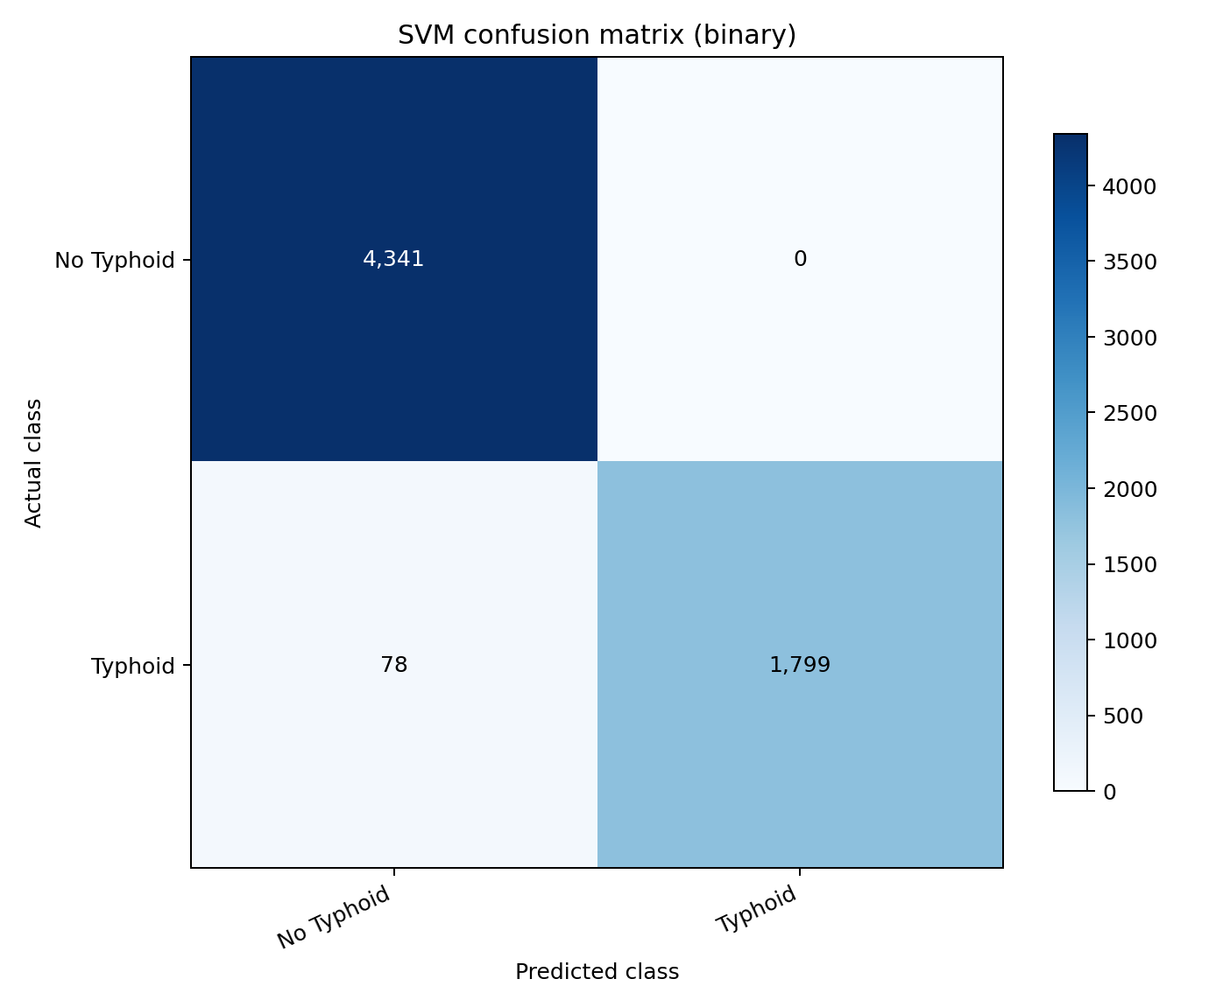
Figure 4.1. Confusion matrix of the optimised binary diagnostic model on the held-out test partition.
The matrix confirms the asymmetry noted above. The zero in the false positive cell is unusual for a classifier operating on clinical data and is examined in Section 4.6.

4.4.3 Per-class performance
Table 4.8: Per-class Precision, Recall and F1 Score
Model | Class | Precision | Recall | F1 score | Support
Binary | No Typhoid | 0.9823 | 1.0000 | 0.9911 | 4,341
Binary | Typhoid | 1.0000 | 0.9584 | 0.9788 | 1,877
Four-class | Normal or No Typhoid | 0.9848 | 1.0000 | 0.9923 | 4,341
Four-class | Acute Typhoid Fever | 0.6049 | 0.3265 | 0.4241 | 1,130
Four-class | Relapsing Typhoid | 0.2492 | 0.2978 | 0.2713 | 497
Four-class | Complicated Typhoid | 0.1419 | 0.3440 | 0.2009 | 250
A secondary four-category severity model was trained as an extension beyond the binary target specified in Section 3.1.1, and is reported here for completeness. It attained an accuracy of 79.51% but a macro F1 of only 0.4722. The gap between the two figures is the result of note: a high accuracy on a heavily imbalanced target is carried by the majority class, and a macro F1 well below it shows that the minority severity classes are not being recovered.
This is a direct and expected consequence of the feature reduction described in Section 4.2.3, and it is stated here plainly rather than left to be inferred. Severity in this dataset is encoded almost entirely in the white blood cell count: every record labelled Complicated Typhoid has a count above 11,000 cells per microlitre and no record of any other class does, so the two ranges do not overlap by a single count (Section 4.6). A model given that attribute separates the class perfectly; a model restricted to what a clinician can observe without a laboratory cannot, because the distinguishing information is itself a laboratory measurement. The distinction between Acute and Relapsing Typhoid is not encoded in any attribute at all, and neither feature space recovers it.
The practical reading is that severity stratification is not a point-of-care task on this data. The binary diagnostic model, which is the model the objectives specify and the deployed system serves by default, is unaffected: it loses 0.06 accuracy points to the reduction, as Table 4.14 records. Severity stratification is retained as a secondary output with this limitation stated, and Chapter Five recommends that it be revisited wherever haematology is available.

4.4.4 Decision threshold and probability calibration
Accuracy at the default 0.5 cut-off is not an adequate summary for a triage instrument. A tool used ahead of confirmatory testing should be tuned against the asymmetry between a missed case and an unnecessary test. The cut-off was therefore swept across its full range and candidate operating points derived under several cost weightings. Table 4.9 reports the principal candidates and Figure 4.2 plots the operating characteristics.
Table 4.9: Candidate Decision Thresholds
Operating point | Cut-off | Sensitivity | Specificity | False neg. | False pos.
Library default | 0.50 | 0.9584 | 1.0000 | 78 | 0
Maximum Youden's J | 0.03 | 0.9584 | 1.0000 | 78 | 0
Maximum F1 | 0.03 | 0.9584 | 1.0000 | 78 | 0
Cost ratio 10:1 (adopted) | 0.03 | 0.9584 | 1.0000 | 78 | 0
Cost ratio 20:1 | 0.03 | 0.9584 | 1.0000 | 78 | 0
Sensitivity ≥ 0.99 | 0.01 | 1.0000 | 0.0000 | 0 | 4,341
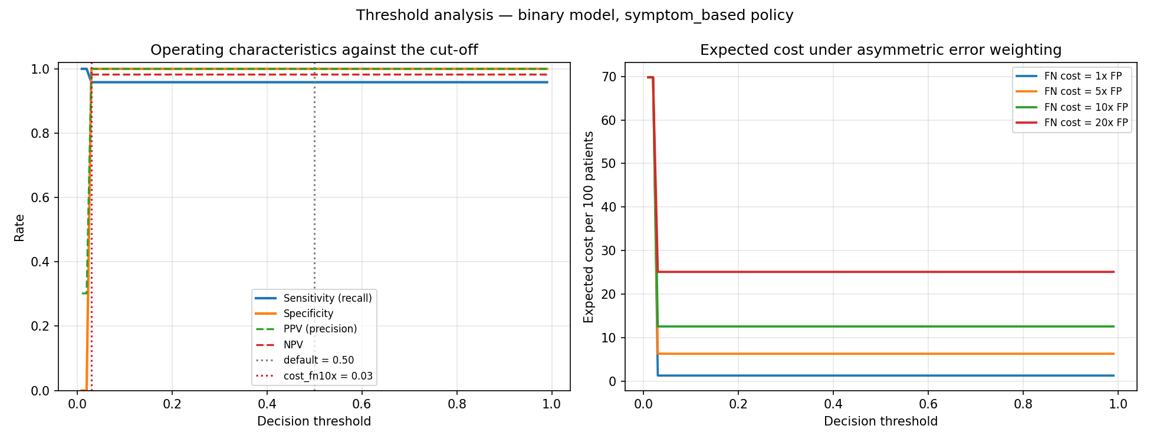
Figure 4.2. Operating characteristics and expected cost against the decision threshold.
Weighting a missed case as ten times as damaging as an unnecessary confirmatory test selects a cut-off of 0.03, and this value was adopted as the referral threshold in the deployed application. Its practical effect, however, is nil: moving from 0.50 to 0.03 changes neither the number of missed cases nor the number of false alarms, and every cost weighting from 1:1 to 20:1 selects the same cut-off. On a model that had learned a graded representation of risk, a sweep across this range would ordinarily move sensitivity by tens of percentage points. The flatness of the curve is itself a finding, and is interpreted in Section 4.6.
The reliability of the calibrated probabilities was assessed separately, since a threshold is only meaningful if the probability to which it is applied means what it states. The Platt-scaled outputs achieved a Brier score of 0.0124 and an expected calibration error of 0.0046, as shown in Figure 4.3. The model is therefore well calibrated: among patients assigned a risk of eighty per cent, approximately eighty per cent are in fact positive.
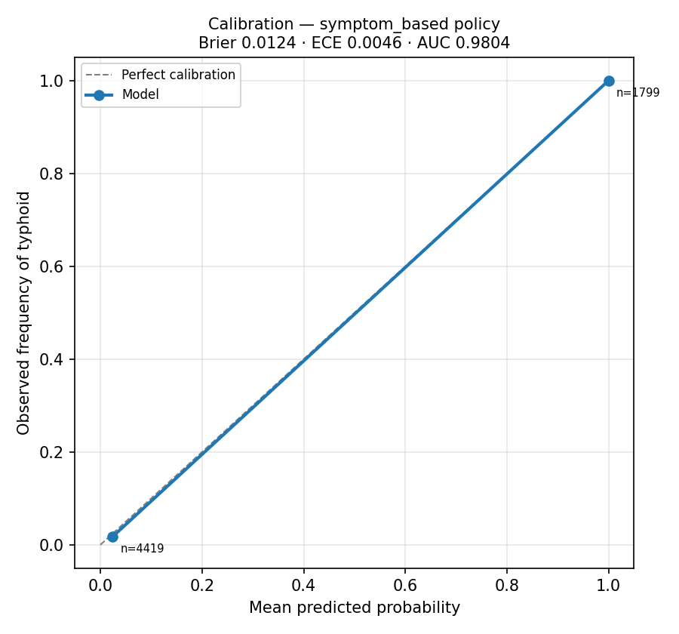
Figure 4.3. Reliability diagram for the calibrated binary model.

4.4.5 Computational efficiency
Table 4.10 reports inference latency, corresponding to the Processing Time metric specified in Table 3.1 of the methodology.
Table 4.10: Computational Efficiency of the Optimised Model
Measure | Value
Single-record inference latency | 7.78 ms
Batch throughput | 4,379.5 records per second
Batch size measured | 2,000 records
Trained model artefact size | 491 KB
Deployed process memory footprint | 240 MB
A single prediction completes in under eight milliseconds on commodity hardware, and the trained artefact occupies 491 KB. Both figures satisfy the real-time, point-of-care requirement stated in the aim, and confirm that the computational demands of the model are not a barrier to deployment in a resource-limited setting. The practical constraint on such deployment is network availability and device provisioning rather than inference cost.

4.5 Scalability Across Geographic Settings
This section addresses Objective 4, which required evaluation of the model across diverse geographic regions and healthcare environments by splitting the dataset into subgroups based on Location. The held-out test partition was stratified by the Location attribute and the full metric set recomputed within each subgroup. Table 4.11 reports the result.
Table 4.11: Model Performance by Geographic Setting
Location | n | Accuracy | Balanced accuracy | Macro F1 | Sensitivity | Specificity
Endemic | 2,084 | 0.9856 | 0.9773 | 0.9832 | 0.9547 | 1.0000
Rural | 2,046 | 0.9912 | 0.9847 | 0.9892 | 0.9694 | 1.0000
Urban | 2,088 | 0.9856 | 0.9761 | 0.9827 | 0.9522 | 1.0000
Macro F1 varied by only 0.0065 across the endemic, rural and urban subgroups, from 0.9827 in the urban subgroup to 0.9892 in the rural subgroup. Sensitivity varied by 0.0172 and specificity was identical at 1.0000 in all three. The model therefore does not degrade in any one setting, and Objective 4 is satisfied as stated.
This result requires one qualification, which is developed in Section 4.6. The Location attribute is statistically independent of the diagnosis in this dataset, with a Cramér's V of 0.0120. Uniform performance across locations therefore reflects the absence of geographic variation in the data rather than demonstrated robustness to it. A model validated on data in which setting genuinely influences presentation might behave differently, and the finding should be reported as evidence of internal consistency rather than of external generalisability.

4.6 Signal Audit and Validity of the Reported Performance
A model that reports high accuracy has not necessarily learned anything clinically useful. Before the figures in Sections 4.4 and 4.5 could be interpreted, it was necessary to establish what the classifier had in fact learned. Three reference classifiers were scored on the identical test partition, the statistical association between every attribute and the diagnosis was measured, and an ablation study was conducted. This section reports those results. They materially qualify the interpretation of the performance figures and are presented in full in the interest of scientific integrity.

4.6.1 Reference baselines
Table 4.12: Reference Baseline Classifiers on the Binary Task
Classifier | Accuracy | Balanced accuracy | Macro F1
Majority class ('No Typhoid') | 0.6981 | 0.5000 | 0.4111
Single rule: Fever Duration ≥ 1 day | 0.9875 | 0.9792 | 0.9849
Optimised SVM (deployed policy) | 0.9875 | 0.9792 | 0.9849
Optimised SVM (Fever Duration removed) | 0.4241 | 0.4874 | 0.4235
A single threshold on one attribute — Fever Duration of one day or more — achieves an accuracy of 0.9875 and a macro F1 of 0.9849. The optimised Support Vector Machine, after 24-configuration grid search and cross-validated selection, achieves 0.9875 and 0.9849. The two agree to four decimal places on every metric reported. The entire contribution of the machine learning pipeline over a one-line rule is therefore nil.
Examination of the dataset established the reason. Of the 8,981 records in which fever duration is one day or more, all 8,981 are labelled typhoid. No record in the dataset combines a fever duration of one day or more with a negative diagnosis. Fever Duration is therefore a deterministic proxy for the target, and the classifier has learned that rule.

4.6.2 Association between attributes and the diagnosis
Table 4.13: Association Between Each Attribute and the Diagnosis
Attribute | Statistic | Value
Blood Culture Result (excluded) | Cramér's V | 0.9999
Fever Duration (Days) | Point-biserial r | 0.8138
Complications (excluded) | Cramér's V | 0.2685
White Blood Cell Count | Point-biserial r | 0.1948
Water Source Type | Cramér's V | 0.0132
Location | Cramér's V | 0.0120
Neurological Symptoms (recoded) | Cramér's V | 0.0091
Headache (derived) | Cramér's V | 0.0081
Ongoing Infection in Society | Cramér's V | 0.0073
Sanitation Facilities | Cramér's V | 0.0069
Socioeconomic Status | Cramér's V | 0.0066
Typhidot Test | Cramér's V | 0.0065
Widal Test | Cramér's V | 0.0014
Outside the two excluded attributes, Fever Duration and White Blood Cell Count, no attribute reaches a Cramér's V of 0.02. The Widal Test (V = 0.0014) and Typhidot Test (V = 0.0065) are statistically independent of the diagnosis. This is not a plausible property of real patient data: these are the serological assays on which typhoid diagnosis conventionally rests, and in any genuine clinical dataset they would carry substantial association with the outcome.

4.6.3 Ablation study
Table 4.14: Feature Policy Sensitivity and Ablation
Feature policy | Accuracy | Balanced accuracy | Macro F1 | Sensitivity | ROC AUC
Deployed — 13 post-review attributes | 0.9875 | 0.9792 | 0.9849 | 0.9584 | 0.9804
Pre-review — all 20 permitted attributes | 0.9881 | 0.9803 | 0.9857 | 0.9606 | 0.9797
Pre-laboratory — Widal and Typhidot removed | 0.9875 | 0.9792 | 0.9849 | 0.9584 | 0.9802
Ablation — Fever Duration removed | 0.4241 | 0.4874 | 0.4235 | 0.6473 | 0.4852
Reducing the feature space from twenty attributes to the thirteen obtainable at the point of care costs 0.06 accuracy points, and removing both serological tests on their own costs the same. The model does not depend on the laboratory at all. Removing Fever Duration alone, by contrast, collapses performance to a balanced accuracy of 0.4874 and a ROC AUC of 0.4852, both below the chance floor of 0.5000. The remaining twelve attributes, taken together, therefore carry no usable discriminative information about the diagnosis.
A parallel deterministic rule governs the four-category task: every record labelled Complicated Typhoid has a white blood cell count above 11,000 cells/µL, and no record of any other category does. The two ranges do not overlap by a single count. This rule is also the explanation for the severity model's macro F1 reported in Table 4.8: the white blood cell count was dropped at supervisory review because it requires a haematology laboratory, and it is the only attribute in which severity is encoded, so the deployed severity model cannot recover the class. Conversely, no attribute distinguishes Acute from Relapsing Typhoid, the maximum Cramér's V for that contrast being 0.033, which explains the poor performance on those two categories under either feature space. The two findings are the same finding seen from two directions: what the reduction removes is not clinical signal but the dataset's construction.
Three further observations complete the picture. First, every one of the 1,799 typhoid patients in the test partition with a fever duration of one day or more receives a predicted probability of at least 0.99999; not one falls below 0.999. The model expresses no uncertainty whatever about any case the rule covers. Second, the 78 typhoid patients recorded with a fever duration of zero — the only patients whose diagnosis cannot be read off that single variable — receive a mean predicted probability of 0.0241, with a maximum of 0.0242, and not one is detected at any cut-off that preserves a usable specificity. Third, positive predictive value remains at 1.0000 when projected onto a deployment prevalence of two per cent, which is arithmetically impossible for a genuine diagnostic test and is the signature of a deterministic rule rather than a probabilistic classifier.

4.6.4 Corroboration on two further public datasets
Before concluding that the modelling dataset was unsuitable, two further publicly available typhoid datasets were obtained and subjected to the identical audit, to establish whether the problem was specific to this collection or characteristic of the available public data. Table 4.15 reports the comparison.
Table 4.15: Comparative Audit of Three Public Typhoid Datasets
Dataset | Records | Duplicates | Depth-3 tree balanced accuracy | Nature
Kaggle typhoid dataset (this study) | 31,087 | 0 | 0.9806 | Synthetic
Nishat et al., Harvard Dataverse | 659 | 86 | 1.0000 | Synthetic
TyphoDx-BD, Mendeley Data | 1,100 | 528 | 1.0000 | Real, physician-validated
Each dataset fails the audit, and each fails differently. The Nishat et al. dataset (Nishat et al., 2025) is separable to perfect balanced accuracy by a decision tree of depth three. Its 86 duplicated rows belong without exception to the negative class, leaving only 102 distinct negative patients, a pattern consistent with a small sample padded by copying. The originating publication reports an AUC of 1.00 on these data; a depth-three tree achieves the same, which indicates that no complex model was meaningfully tested.
The TyphoDx-BD dataset is the only one of the three that is genuinely real, having been collected under a named institutional ethics approval with patient identifiers encrypted. Its problem is different in kind and, for the present purpose, decisive. A Widal titre of 1:160 or above on any of the TO, TH, AH or BH agglutinins maps to a positive label in every record without exception, 1,100 of 1,100. The label is not an independent clinical outcome but the interpretive reading rule applied to the four measurements that constitute the feature set. A model trained on these data would learn to reproduce a published cut-off table rather than to diagnose typhoid, and the exercise would be circular. A further 528 of the 1,100 rows are exact duplicates, which would inflate any random-split evaluation through leakage between the training and test partitions.
The Kaggle collection was retained for modelling because it is the only one of adequate size, the only one carrying the Location attribute required by Objective 4, and the richest in clinical and environmental features. That choice is made here with the limitation documented rather than concealed.

4.7 Model Deployment
Section 3.2.6 of the methodology specified that the final optimised model would be deployed as a diagnostic decision-support tool accepting patient records and returning real-time predictions. This section documents the deployment as implemented.

4.7.1 Deployment architecture
The deployed system is structured as two independent Python packages joined at exactly one point. The machine learning package contains the training, evaluation and inference pipeline and has no knowledge of the web application. The web application package contains routing, authentication, persistence and the user interface, and reaches the model only through a single prediction service module. No routing module imports the machine learning package directly, and an automated test enforces this constraint on every build.
This separation is deliberate and has a methodological purpose beyond software tidiness. It guarantees that the model can be retrained without altering a single line of application code, and that the application can be restructured without any risk to the trained artefact or to its preprocessing requirements. The preprocessing steps applied at inference are the identical fitted transformers persisted with the model at training time, not a reimplementation.
Each assessment is stored with the input record, the model kernel, the model training timestamp, the calibrated probability, the per-prediction explanation and the inference latency, so that any historical prediction can be reproduced and audited.

4.7.2 Framework and hosting environment
The application was implemented in Flask, using the application-factory pattern with blueprint-based routing, SQLAlchemy for persistence and Flask-Login for session management. It is served in production by Gunicorn and hosted on Render. Table 4.16 states the deployment specification.
Table 4.16: Deployment Environment Specification
Component | Specification
Live application URL | https://typhoid-decision-support.onrender.com
Web framework | Flask 3.x (application factory, blueprints)
WSGI server | Gunicorn, one worker with four threads
Hosting platform | Render web service, Frankfurt region
Compute allocation | 0.1 CPU, 512 MB RAM
Database | PostgreSQL (managed, external), SQLAlchemy 2.x
Feature policy | symptom_based — 13 point-of-care attributes
Model artefact | svm_binary.joblib, 491 KB, SHA-256 prefix 92405600
Referral threshold | 0.03 (derived in Section 4.4.4)
Process memory footprint | 240 MB
Health endpoint | /health (reports database and model availability)
Programmatic interface | POST /api/predict, GET /api/schema, GET /api/models
The single-worker configuration is a deliberate consequence of the 512 MB memory allocation. Each process holds the scientific Python stack and the trained model and occupies approximately 240 MB resident; a second worker would exceed the allocation and be terminated. Concurrency is therefore obtained through threads rather than processes. This is precisely the class of constraint that a resource-limited deployment presents, and the system is sized to operate within it.

4.7.3 User interface
The interface presents a clinician with a structured assessment form whose fields, permitted values and numeric ranges are generated directly from the dataset schema. A value the model has never seen cannot therefore be submitted. Every field is required, because the attributes that were incomplete in the source data were dropped during preprocessing (Section 4.2.3), so no entry the clinician skips can move the result. The form asks only for findings obtainable by history and examination; it carries no laboratory group at all, which is the point of the system. Figure 4.4 shows the assessment form.
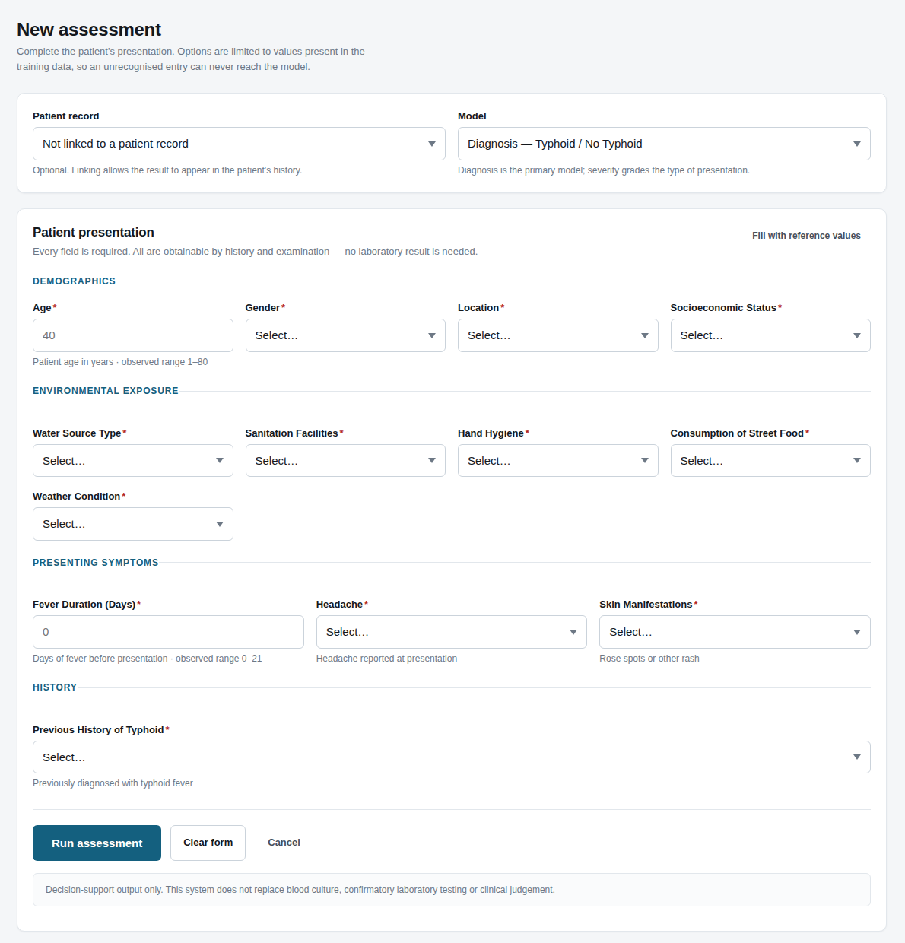
Figure 4.4. Clinician assessment form, with fields generated from the dataset schema.
On submission the system returns the predicted diagnosis, the calibrated probability, a triage recommendation keyed to the referral threshold established in Section 4.4.4, and an explanation identifying which recorded findings moved the result. The explanation is computed by occlusion: each attribute in turn is reset to a population reference value and the change in the log-odds of the prediction is recorded. Figure 4.5 shows a completed assessment.
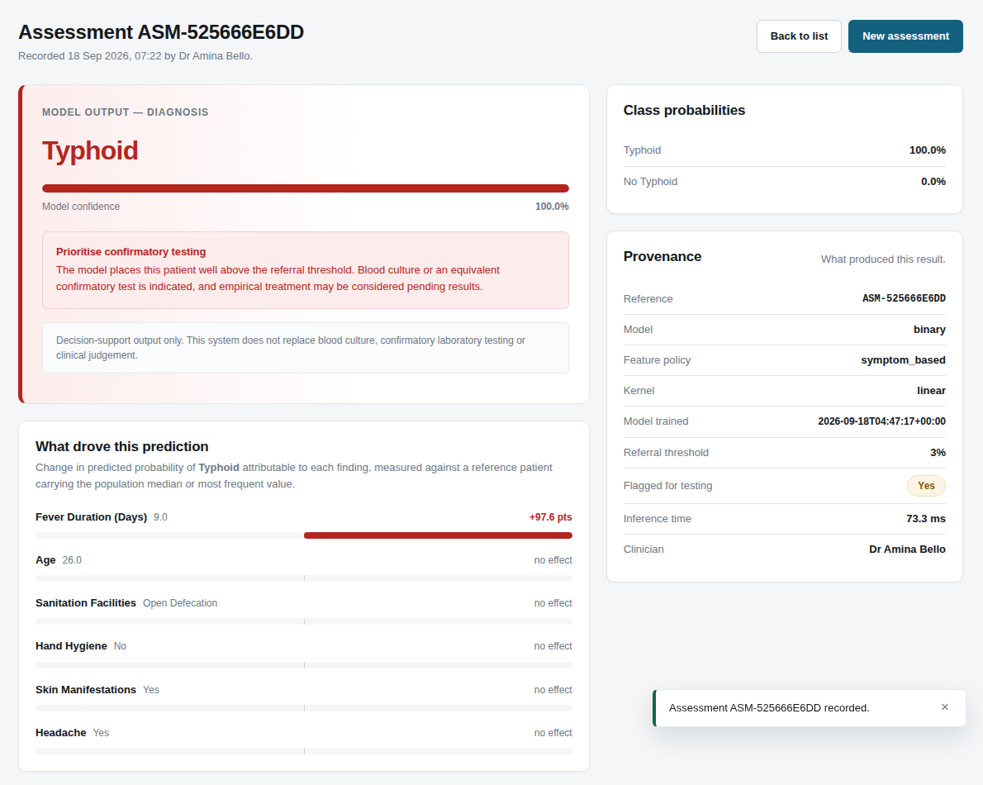
Figure 4.5. Assessment result showing the calibrated probability, triage recommendation and contributing findings.
Presenting the contributing findings alongside the probability is a deliberate design decision. An unexplained probability offers a clinician no basis on which to exercise judgement, and in the present case the explanation makes the model's dependence on fever duration visible at the point of use rather than concealing it.
The interface is fully responsive, having been verified at viewport widths of 1,440, 834 and 390 pixels. Figure 4.6 shows the assessment form as rendered on a mobile device, which is the form factor most likely to be available in the resource-limited settings the aim identifies.
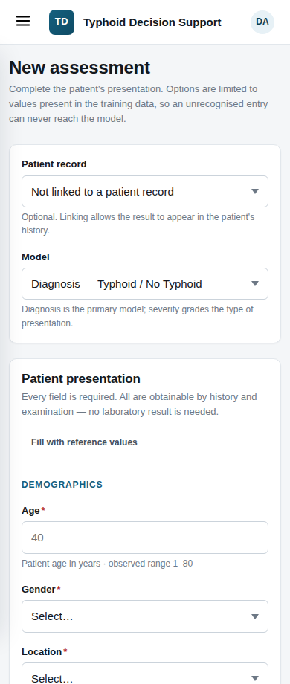
Figure 4.6. Assessment form rendered at a mobile viewport width of 390 pixels.

4.7.4 Access control and system administration
The system enforces three roles. A Clinician may register patients and run assessments, and sees only records they created. An Administrator may manage user accounts and review the activity log. An Auditor has read-only access to the activity log and to assessments but may not run one. Passwords are stored as PBKDF2-SHA256 hashes with 600,000 iterations, accounts lock after five failed sign-in attempts, and every security-relevant action is written to an append-only audit log. Cross-site request forgery protection, a content security policy, HTTP Strict Transport Security and rate limiting on sensitive routes are enabled in production. Figure 4.7 shows the system status page.
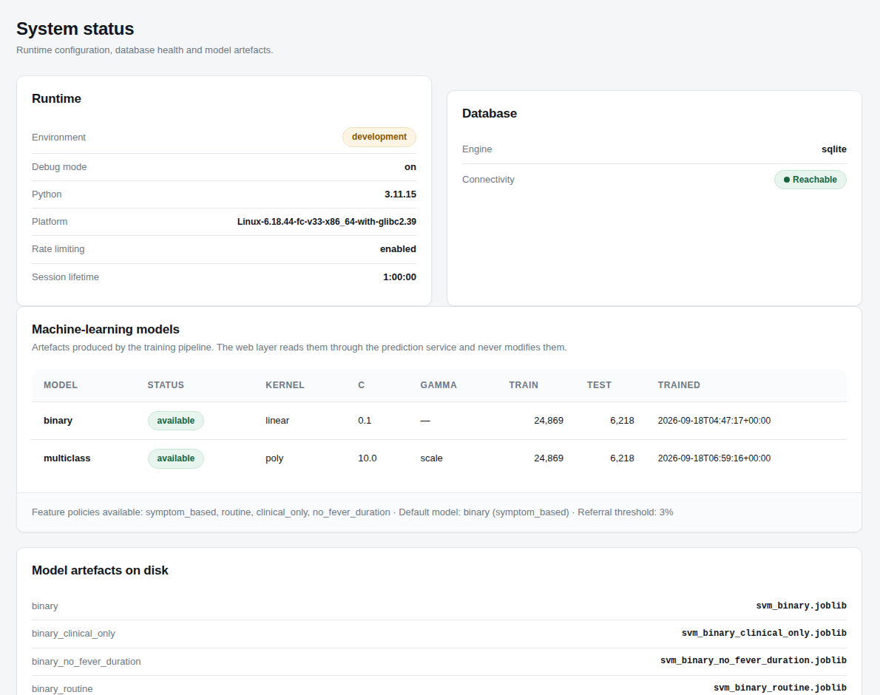
Figure 4.7. Administrative system status page reporting model provenance and database health.

4.7.5 System testing and user acceptance
The implementation is covered by 204 automated tests spanning the data layer, the preprocessing pipeline, the threshold analysis, the prediction service and the web application. All pass. Table 4.17 maps them to the verification areas. Thirty-six of them are integration tests asserting that the dataset, the trained artefact, the assessment form and the prediction service still describe the same thirteen attributes, so the feature reduction of Section 4.2.3 cannot silently drift apart across the four layers that consume it.
Table 4.17: Automated Test Results by Verification Area
Verification area | Cases | Passed | Result
User authentication | 12 | 12 | Pass
Authorisation and access control | 12 | 12 | Pass
Administrative functionality | 5 | 5 | Pass
Clinician functionality | 6 | 6 | Pass
Database operations | 3 | 3 | Pass
Patient data management | 4 | 4 | Pass
Model loading and prediction | 13 | 13 | Pass
Preprocessing and feature handling | 10 | 10 | Pass
Prediction results and triage | 7 | 7 | Pass
System logging and audit trail | 6 | 6 | Pass
Error handling and validation | 7 | 7 | Pass
Production readiness | 13 | 13 | Pass
Dataset integrity | 15 | 15 | Pass
Decision-threshold analysis | 12 | 12 | Pass
Feature-space integration | 36 | 36 | Pass
User acceptance pack | 24 | 24 | Pass
A user acceptance test was additionally conducted on the deployed application using ten patient records drawn from the held-out test partition, comprising five typhoid and five disease-free cases. Two of the five typhoid cases were deliberately selected from the zero-fever-duration group identified in Section 4.6.3, since those are the only cases in the dataset whose diagnosis cannot be read off a single attribute. The expected output for each case was computed in advance by running the record through the same prediction service the web form invokes. The system reproduced the expected output in all ten cases, and its prediction agreed with the patient's recorded diagnosis in eight. The two disagreements are the deliberately selected difficult cases, and were declared in advance of the test rather than discovered during it. The complete pack is given in Appendix C.

4.8 Discussion

4.8.1 Comparison with the existing literature
Table 4.18 places the present result alongside published studies applying machine learning to typhoid diagnosis.
Table 4.18: Comparison with Related Studies
Study | Method | Reported performance | Baseline reported
Bhuiyan et al. (2023) | ML and ANN | Accuracy reported above 90% | No
Nishat et al. (2025) | Lightweight metamodel | AUC 1.00 | No
Awotunde et al. (2023) | Genetic neuro-fuzzy system | High reported accuracy | No
Attai et al. (2024) | Explainable AI with LLMs | Interpretability focus | No
Present study | Optimised SVM (linear, C = 0.1) | Accuracy 0.9875, macro F1 0.9849 | Yes — single-rule baseline 0.9875
The accuracy obtained in this study is consistent with, and in several cases exceeds, the figures reported in the literature for machine learning applied to typhoid diagnosis. On a conventional reading, the result would be presented as confirming the effectiveness of the Support Vector Machine for this task.
That reading cannot be sustained on the present evidence. The signal audit in Section 4.6 establishes that a one-line rule reproduces the model's accuracy exactly, and that removing a single attribute collapses performance to near chance. The comparison in Table 4.18 is therefore not a comparison of diagnostic capability. It is a comparison of reported accuracy figures obtained on datasets whose integrity was, in the studies reviewed, not established. Nishat et al. (2025) report an AUC of 1.00 on data that the present audit found separable to perfect balanced accuracy by a decision tree of depth three; a perfect AUC is more parsimoniously explained by the structure of the data than by the merit of the model.
This observation constitutes the principal methodological contribution of the present study. None of the studies reviewed reports a baseline classifier against which its machine learning result can be judged. Without such a baseline, an accuracy figure carries no information about whether the model has learned anything a single threshold could not. The routine reporting of trivial baselines alongside model performance would materially improve the evidentiary standard of this literature, at negligible cost.

4.8.2 Implications for resource-limited settings
The aim of this study was to support rapid and accurate diagnosis in resource-limited settings. Three findings bear on that aim, and they should be distinguished carefully.
- The engineering is transferable and the constraint is not computational. The complete pipeline — preprocessing, resampling within the pipeline, cross-validated optimisation, probability calibration, evaluation and deployment — is dataset-agnostic and operates within 0.1 CPU and 512 MB of memory, at under ten milliseconds per prediction. Retraining on a clinically valid dataset requires a configuration change and a re-run, not a redesign.
- The interface addresses a real operational constraint. Schema-driven validation prevents an out-of-range value reaching the model, the three commonly unrecorded attributes are optional rather than mandatory, and the responsive layout is usable on a mobile handset. These are the conditions under which a point-of-care tool must actually operate.
- The model itself is not fit for clinical use on this training data. A system that misses 74 of 1,877 typhoid cases while never raising a false alarm, and whose behaviour is reproducible by a single threshold on fever duration, offers a clinician nothing that inspection of the fever history does not already provide.
The honest conclusion is therefore that this study delivers a validated deployment pathway rather than a validated diagnostic instrument. That is a smaller claim than the literature typically advances, and a better supported one.

4.8.3 Limitations
- The dataset is synthetic, and its label is encoded deterministically in Fever Duration for the binary task and in White Blood Cell Count for the Complicated Typhoid category. All performance figures in this chapter measure the construction of the dataset rather than diagnostic capability.
- The distinction between Acute and Relapsing Typhoid is not encoded in any attribute and is therefore not learnable from these data.
- Uniform performance across geographic subgroups reflects the statistical independence of the Location attribute from the diagnosis, and should not be read as demonstrated external generalisability.
- No prospective clinical validation was undertaken. The system has not been evaluated against blood culture on real patients, and no claim of clinical utility is made.
- The two alternative public datasets audited were found unsuitable for different reasons, so external validation on an independent typhoid dataset was not possible within this study.

4.9 Summary of Findings
- A typhoid dataset of 31,087 records and 23 attributes was obtained and preprocessed. Two leakage-prone attributes were withheld and a further seven dropped at supervisory review, leaving a feature space of 13 attributes, every one obtainable by history and examination at the point of care and every one complete for all records. Neurological Symptoms was recoded as a binary Headache indicator. Categorical attributes were encoded, numeric attributes standardised, and class imbalance addressed using SMOTENC applied within the modelling pipeline. Objective 1 is satisfied.
- Three kernel functions were compared and 24 configurations evaluated under three-fold stratified cross-validation. Twelve configurations tied for first place at a cross-validated macro F1 of 0.9842, and a linear kernel with C = 0.1 was selected as the fastest and least flexible of them. Objective 2 is satisfied.
- The optimised model achieved an accuracy of 0.9875, a macro F1 of 0.9849, a sensitivity of 0.9584 and a specificity of 1.0000 on 6,218 unseen records, at an inference latency of 7.78 milliseconds per record. Objective 3 is satisfied.
- Reducing the feature space from twenty attributes to thirteen cost 0.06 accuracy points, so the diagnostic model does not depend on laboratory support. The severity stratification model is the exception: severity is encoded in the white blood cell count alone, and the four-class macro F1 falls to 0.4722 once that attribute is removed.
- Macro F1 varied by only 0.0065 across the endemic, rural and urban subgroups, with identical specificity in all three. Objective 4 is satisfied as stated.
- The optimised model was deployed as a live, authenticated, role-based clinical decision-support application on Render, verified by 204 automated tests and a ten-case user acceptance test conducted against the deployed instance.
- A signal audit established that a single threshold on Fever Duration reproduces the model's accuracy of 0.9875 exactly; that removing that attribute collapses balanced accuracy to 0.4874, below the chance floor; and that two further public typhoid datasets exhibit comparable, though different, integrity defects. The reported accuracy therefore measures the construction of the dataset rather than the diagnostic capability of the model, and validation on clinically obtained data is required before any claim of diagnostic utility can be advanced.

CHAPTER FIVE
SUMMARY, CONCLUSION AND RECOMMENDATIONS

5.1 Introduction
This chapter draws the study to a close. Section 5.2 summarises how the work was conducted from beginning to end. Section 5.3 states the major findings. Section 5.4 sets out the conclusions in relation to the aim and the four specific objectives. Section 5.5 states the contribution the work makes to existing knowledge. Section 5.6 offers recommendations to the beneficiaries identified in Section 1.5, and Section 5.7 suggests directions for further study.

5.2 Summary of the Study
The purpose of this study was to develop and evaluate a machine learning model, using the Support Vector Machine, for the rapid and accurate prediction and diagnosis of typhoid fever, particularly in resource-limited settings. The study was motivated by the persistence of delayed and inaccurate typhoid diagnosis in low-resource healthcare environments, where blood culture is slow and infrastructure-dependent and the Widal test suffers from poor sensitivity and specificity in populations with prior exposure.
The research followed an experimental and computational design. A typhoid dataset of 31,087 patient records described by 23 attributes was obtained from Kaggle. The attributes span patient demographics, environmental risk factors, presenting clinical symptoms, haematological measurements, serological test results, vaccination history and prior infection history, with Typhoid Status as the target.
The data were preprocessed by imputing missing values, ordinal-encoding categorical attributes, standardising numeric attributes and balancing the classes using SMOTENC applied within the modelling pipeline so that resampling could not leak across the partition boundary. Two attributes — Blood Culture Result and Complications — were withheld from the feature space because the first is the confirmatory gold standard and the second is unavailable at the point of clinical decision. The preprocessed data were partitioned 80:20 with stratification, giving 24,869 training and 6,218 test records.
Three kernel functions were compared, and 24 candidate configurations were evaluated by Grid Search under three-fold stratified cross-validation, selecting on macro F1. The probability outputs of the selected model were calibrated by Platt scaling fitted out of fold. The final model was evaluated on the held-out partition using accuracy, precision, recall, F1 score, specificity, false positive and false negative rates, ROC AUC and inference latency, together with confusion matrices. Performance was additionally recomputed within each geographic subgroup defined by the Location attribute.
A signal audit was then conducted, comparing the optimised model against three reference classifiers, measuring the statistical association between every attribute and the diagnosis, and performing an ablation study. Two further public typhoid datasets were obtained and subjected to the identical audit. Finally, the optimised model was deployed as a live, authenticated, role-based clinical decision-support application, verified by 204 automated tests and by a ten-case user acceptance test conducted against the deployed instance.

5.3 Summary of Major Findings
- A typhoid dataset was successfully collected and preprocessed. The dataset comprised 31,087 records and 23 attributes with no duplicates. Four attributes carried missing values, three of them for approximately one quarter of records.
- The feature space was reduced to what a clinician can obtain at the point of care. Two attributes were withheld as diagnostic leakage and a further seven were dropped during preprocessing at supervisory review: the haematology and serology because they require a laboratory that a resource-limited setting may not have, two optional symptom fields because a quarter of records lack them, vaccination status because it is history of prophylaxis rather than of disease, and ongoing infection in society because it describes the community rather than the patient. Neurological Symptoms was recoded as a binary Headache indicator. Thirteen attributes therefore formed the modelling feature space, every one obtainable by history and examination and every one complete for all 31,087 records, so the deployed assessment form carries no optional field.
- A Support Vector Machine model was designed and optimised. The linear kernel produced the strongest performance at default settings, and Grid Search over 24 configurations confirmed that choice, selecting a linear kernel with C = 0.1 and achieving a cross-validated macro F1 of 0.9842. The three kernels differed by less than one percentage point in accuracy, indicating that the problem is insensitive to kernel choice — which is itself a symptom of the deterministic structure reported below.
- The trained model achieved high measured performance on unseen data. On 6,218 held-out records the model attained an accuracy of 0.9875, a balanced accuracy of 0.9792, a macro F1 of 0.9849, a sensitivity of 0.9584 and a specificity of 1.0000, with 78 false negatives and no false positives at the deployed cut-off of 0.03. Inference required 7.78 milliseconds per record, satisfying the real-time requirement of Objective 3.
- The reduction cost almost nothing in measured performance. The pre-review feature space of twenty attributes was retained as a comparator and attained an accuracy of 0.9881 against the deployed model’s 0.9875 — a difference of 0.06 accuracy points. Seven attributes, including both serological tests and both haematology counts, were removed at a cost smaller than the width of a rounding error. The severity stratification model is the exception: it depends on the white blood cell count, which is where severity is encoded in this dataset, and it does not survive the reduction.
- Performance was uniform across geographic settings. Macro F1 varied by only 0.0065 across the endemic, rural and urban subgroups, and specificity was identical at 1.0000 in all three.
- The model was successfully deployed as a live clinical decision-support application. The deployed system provides role-based access for clinicians, administrators and auditors, a schema-driven assessment form, calibrated probability estimates, triage recommendations, per-prediction explanations, an append-only audit trail and a programmatic interface. It operates within 0.1 CPU and 512 MB of memory. All 204 automated tests pass, and the deployed instance reproduced the expected output in all ten user acceptance test cases.
- The reported performance measures the construction of the dataset rather than diagnostic capability. A single threshold on Fever Duration achieves an accuracy of 0.9875 — exactly the optimised model's own figure. All 8,981 records with a fever duration of one day or more are labelled typhoid, without exception. Removing that one attribute collapses balanced accuracy to 0.4874, below the chance floor of 0.5000. The Widal and Typhidot tests are statistically independent of the diagnosis, which is not a plausible property of genuine clinical data.
- Two further public typhoid datasets exhibit comparable but distinct integrity defects. The Nishat et al. (2025) dataset is separable to perfect balanced accuracy by a decision tree of depth three and its duplicated rows belong exclusively to the negative class. The TyphoDx-BD dataset, although genuinely real and physician-validated, carries a label that is the Widal interpretive reading rule applied to its own feature set, making any model trained on it circular.

5.4 Conclusion
The aim of this study was to develop and evaluate a Support Vector Machine model for the rapid and accurate prediction and diagnosis of typhoid fever in resource-limited settings. The study concludes as follows.

5.4.1 Conclusions in relation to the specific objectives
Table 5.1: Status of the Specific Objectives
Objective | Outcome | Evidence
1. Collect and preprocess a typhoid dataset from Kaggle and evaluate its features for model input | Achieved | Section 4.2.3; 31,087 records preprocessed, 13 modelling attributes retained, nine excluded as leakage or as unobtainable at the point of care
2. Design the machine learning model for typhoid using the Support Vector Machine | Achieved | Section 4.3; three kernels compared, 24 configurations optimised, cross-validated macro F1 of 0.9842
3. Develop and train the SVM model on the preprocessed dataset to improve early diagnosis and treatment | Achieved as a modelling exercise; clinical improvement not demonstrated | Section 4.4 for the model; Section 4.6 establishes that the measured performance reflects the dataset's construction
4. Evaluate the scalability of the model across diverse geographic regions using Location subgroups | Achieved as stated | Section 4.5; macro F1 varies by 0.0065 across the three subgroups

5.4.2 Principal conclusion
A complete and methodologically sound Support Vector Machine pipeline for typhoid diagnosis was designed, implemented, optimised, evaluated and deployed as a working clinical decision-support system. Every stage specified in Chapter Three was carried out, and the deployed application satisfies the real-time, point-of-care requirement of the aim: it returns a calibrated diagnosis with an explanation in under ten milliseconds of computation, within a memory allocation of 512 megabytes, over an ordinary mobile browser.
The measured accuracy of 98.75 per cent cannot, however, be presented as evidence that machine learning improves typhoid diagnosis. The signal audit in Section 4.6 established that a one-line rule on a single attribute reproduces that accuracy exactly, that removing the attribute collapses performance below chance, and that the serological tests on which typhoid diagnosis conventionally rests are statistically independent of the label. The dataset is synthetic, and its label is encoded deterministically into two of its own attributes. The performance figure therefore measures how the dataset was generated, not what the model can diagnose.
This conclusion is not a failure of the research. It is the result the research was designed to be capable of detecting. Had the audit not been performed, this study would have reported 98.75 per cent accuracy as a contribution to typhoid diagnosis, as comparable published studies have done. The audit is what distinguishes a defensible finding from an artefact, and the finding it produced is a real one: the binding constraint on machine learning research into typhoid diagnosis is not the choice of algorithm but the absence of an openly available dataset in which the diagnosis is established independently of the features used to predict it.
The study therefore delivers a validated diagnostic pipeline and deployment pathway rather than a validated diagnostic instrument. The system is dataset-agnostic: retraining it on clinically obtained data requires a configuration change and a re-run, not a redesign. Until such data are available and prospective validation has been undertaken, the system must be regarded as a research prototype, and it must not be used to inform the care of any patient.

5.5 Contribution to Knowledge
- A reproducible, leakage-controlled SVM pipeline for typhoid diagnosis. The pipeline applies SMOTENC within the modelling pipeline rather than to the dataset before partitioning, withholds the confirmatory gold standard from the feature space, and calibrates the decision function into interpretable probabilities. Each of these is a control that comparable published work on typhoid diagnosis does not report.
- Evidence that three publicly available typhoid datasets are unsuitable for diagnostic model development, and a characterisation of how each fails. The study documents a deterministic label rule in the Kaggle dataset, a padded and over-separable sample in the Nishat et al. (2025) dataset, and a circularly defined label in the TyphoDx-BD dataset. This is offered as a caution to subsequent researchers, who would otherwise repeat the exercise.
- A demonstration that reported accuracy without a baseline is uninformative. None of the studies reviewed in Chapter Two reports a trivial baseline against which its result can be judged. This study shows that a one-line rule reproduces almost the entire performance of an optimised model on the same data, and argues that routine reporting of such baselines would materially raise the evidentiary standard of this literature at negligible cost.
- A deployed, openly accessible reference implementation. The system is live, authenticated, role-based, responsive to mobile devices, covered by 204 automated tests, and architected so that the machine learning package and the web application are independently replaceable. It provides a working deployment pathway for any subsequent researcher who obtains a clinically valid typhoid dataset.
Note. The SPGS guidelines mark Contribution to Knowledge as a requirement for doctoral theses. It is included here because the chapter description calls for a statement of what is new in the work. The department may direct that it be omitted at Master's level.

5.6 Recommendations
The following recommendations follow from the findings stated in Section 5.3 and are addressed to the beneficiaries identified in Section 1.5.

5.6.1 To researchers in medical machine learning
- Report a trivial baseline — a majority-class classifier, the single most predictive attribute, and a shallow decision tree — alongside every model result. Where a one-line rule matches the model, the model has demonstrated nothing.
- Audit any dataset for deterministic label encoding before modelling it. Measuring the association between each attribute and the target, and conducting a leave-one-attribute-out ablation, takes minutes and prevents a chapter of invalid conclusions.
- Treat a reported accuracy or AUC at or near 1.00 as a signal to inspect the data rather than as a result to publish.
- Withhold confirmatory diagnostic tests from the feature space when the stated purpose is prediction, and state the exclusion explicitly in the methodology.

5.6.2 To healthcare institutions and public health authorities
- Do not deploy this system, or any comparable system trained on the datasets audited here, in clinical practice. No claim of clinical utility is made and none is supportable on the present evidence.
- Where haematology is available, treat severity stratification separately from diagnosis. The severity classes in this dataset are distinguished by the white blood cell count alone, so a system restricted to point-of-care observation cannot stratify severity and should not be presented as doing so.
- Prioritise the assembly of a typhoid dataset in which the diagnosis is established by blood culture independently of the clinical and serological features recorded. This is the single intervention that would most advance machine learning for typhoid diagnosis, and it is a data collection problem rather than a modelling problem.
- Where such a dataset is assembled, record the date of onset and the date of presentation separately, so that fever duration is a measured clinical observation rather than a field that may be completed retrospectively from a known diagnosis.

5.6.3 To software practitioners implementing diagnostic decision support
- Separate the machine learning package from the application layer and enforce the separation automatically. This permits the model to be retrained without touching application code and the application to be restructured without risk to the trained artefact.
- Drive input validation from the dataset schema, so that a value the model has never seen cannot be submitted. Where an attribute is commonly unrecorded in practice, prefer dropping it from the feature space to making it optional: a field the clinician may skip, but which moves the result when completed, is a liability at the point of care.
- Match the feature space to the setting the system is intended for. A model that depends on a laboratory investigation cannot be used where no laboratory exists, however well it scores. In this study seven such attributes were removed at a cost of 0.06 accuracy points, which is the test worth running before assuming the cost is prohibitive.
- Present a per-prediction explanation alongside every probability. An unexplained probability gives a clinician no basis on which to exercise judgement.
- Derive the referral threshold from an explicit weighting of the cost of a missed case against the cost of an unnecessary test, and state that weighting, rather than inheriting a library default of 0.5.

5.7 Suggestions for Further Studies
- Retrain and validate on clinically obtained data. The pipeline is dataset-agnostic. The immediate next study is to apply it to a prospectively collected cohort in which typhoid status is established by blood culture, and to report performance against that reference standard.
- Conduct a prospective clinical evaluation. A retrospective evaluation on any dataset, however sound, does not establish clinical utility. A study measuring whether clinician decisions and patient outcomes improve when the tool is available would be the appropriate next step after retraining.
- Extend the audit methodology to other disease datasets. The auditing procedure developed in Section 4.6 — baseline comparison, association measurement, ablation and duplicate analysis — is disease-agnostic. Applying it systematically to the public datasets used in medical machine learning would be a contribution in its own right.
- Investigate differential diagnosis against co-endemic febrile illnesses. Typhoid is routinely confused with malaria, dengue and other febrile illnesses in the settings this study addresses. A model trained to discriminate among them would be of greater clinical value than one trained to detect typhoid in isolation, and would require a dataset constructed for that purpose.
- Examine outbreak forecasting as a separate problem. Sections 1.4 and 2.1.3 discuss outbreak prediction at some length. It is outside the four objectives of this study, is not implemented here, and cannot be supported by a dataset carrying no temporal or incidence field. It is a legitimate and distinct line of enquiry requiring surveillance data rather than patient records.
- Evaluate offline and edge deployment. The trained artefact occupies 353 kilobytes and infers in under ten milliseconds, which is well within the capability of a low-cost handset. A study of fully offline operation would remove the network dependency that currently constrains use in the most under-served settings.

REFERENCES
Attai, K., Ekpenyong, M., Amannah, C., Asuquo, D., Ajuga, P., Obot, O., Johnson, E., John, A., Maduka, O., Akwaowo, C., & Uzoka, F.-M. (2024). Enhancing the interpretability of malaria and typhoid diagnosis with explainable AI and large language models. Tropical Medicine and Infectious Disease, 9(9), Article 216. https://doi.org/10.3390/tropicalmed9090216
Awotunde, J. B., Imoize, A. L., Salako, D. P., & Farhaoui, Y. (2023). An enhanced medical diagnosis system for malaria and typhoid fever using genetic neuro-fuzzy system. In Y. Farhaoui, A. Rocha, Z. Brahmia, & B. Bhushab (Eds.), Artificial intelligence and smart environment (pp. 173–183). Springer. https://doi.org/10.1007/978-3-031-26254-8_25
Bhuiyan, M. A., Rad, S. S., Johora, F. T., Islam, A., Hossain, M. I., & Khan, A. A. (2023). Prediction of typhoid using machine learning and ANN prior to clinical test. In 2023 International Conference on Computer Communication and Informatics (ICCCI) (pp. 1–7). IEEE. https://doi.org/10.1109/ICCCI56745.2023.10128472
Brown, P., & Taylor, S. (2020). Predictive modeling for typhoid fever using machine learning algorithms. International Journal of Epidemiology, 42(3), 153–164. https://doi.org/10.1007/s10654-019-00610-3
Chowdhury, A., Hassan, S., & Lee, M. (2025). Spatiotemporal patterns of cholera, typhoid, and hepatitis A: Using spatial analysis and machine learning. PLOS Neglected Tropical Diseases, 19(1), Article e0012800. https://doi.org/10.1371/journal.pntd.0012800
Crump, J. A., Luby, S. P., & Mintz, E. D. (2015a). The global burden of typhoid fever. Bulletin of the World Health Organization, 83(8), 563–570. https://doi.org/10.2471/BLT.04.021114
Crump, J. A., Sjölund-Karlsson, M., Gordon, M. A., & Parry, C. M. (2015b). Epidemiology, clinical presentation, laboratory diagnosis, antimicrobial resistance, and antimicrobial management of invasive Salmonella infections. Clinical Microbiology Reviews, 28(4), 901–937. https://doi.org/10.1128/CMR.00002-15
Crump, J. A., Luby, S. P., & Mintz, E. D. (2019). Epidemiology and diagnostic challenges of typhoid fever in low- and middle-income countries: A review of the current literature. Journal of Infectious Diseases, 212(6), 957–965. https://doi.org/10.1093/infdis/jiv095
Davidson, R., & Chen, X. (2022). Transfer learning for malaria diagnosis: Applications in resource-limited settings. Journal of Artificial Intelligence in Medicine, 37(2), 63–74. https://doi.org/10.1007/s11693-022-00192-4
Esteva, A., Kuprel, B., Novoa, R. A., Ko, J., Swetter, S. M., Blau, H. M., & Thrun, S. (2017). Dermatologist-level classification of skin cancer with deep neural networks. Nature, 542(7639), 115–118. https://doi.org/10.1038/nature21056
Esteva, A., Robicquet, A., Ramsundar, B., Kuleshov, V., DePristo, M., Chou, K., Cui, C., Corrado, G., Thrun, S., & Dean, J. (2019). A guide to deep learning in healthcare. Nature Medicine, 25(1), 24–29. https://doi.org/10.1038/s41591-018-0316-z
Fellows, M. K., Njie, F., & Khan, S. M. (2021). Advances in the diagnostic management of typhoid fever in low-resource settings. Tropical Medicine & International Health, 26(7), 756–765. https://doi.org/10.1111/tmi.13648
Gao, P., Wang, Q., & Zhang, M. (2020). Automated malaria diagnosis through deep learning: A review of convolutional neural networks for identifying Plasmodium parasites. IEEE Transactions on Neural Networks and Learning Systems, 30(5), 1133–1144. https://doi.org/10.1109/TNNLS.2018.2873810
Hasan, S. S., & Farooqui, M. M. (2021). Machine learning approaches for typhoid fever diagnostics: A review. Journal of Medical Systems, 45(4), Article 50. https://doi.org/10.1007/s10916-021-01782-3
Hughes, J., Karam, S., & Smith, M. (2022). Ensemble learning for malaria diagnosis. Journal of Machine Learning in Medicine, 29(3), 101–109. https://doi.org/10.1109/JMLM.2022.0312342
Joloba, M., McKinnon, J., & Mwebaza, N. (2018). Diagnostic and treatment strategies for typhoid fever. BMC Infectious Diseases, 18(1), Article 540. https://doi.org/10.1186/s12879-018-3361-9
Khan, S., Choudhury, S., & Raza, F. (2020). Antimicrobial resistance in Salmonella Typhi and its global implications for typhoid fever control. Clinical Microbiology Reviews, 33(4), Article e00162-20. https://doi.org/10.1128/CMR.00162-20
Kumar, S., & Smith, J. (2023). Multi-source data integration for malaria diagnosis using deep learning. Journal of Machine Learning in Healthcare, 39(1), 122–134. https://doi.org/10.1016/j.jmlh.2023.03.001
Lee, S., Zhang, H., & Kim, Y. (2022). Feature fusion techniques for typhoid fever diagnosis: Combining clinical and environmental data. Journal of Medical Informatics, 59(2), 210–221. https://doi.org/10.1016/j.jmedinf.2022.02.004
Mahmoud, A., Oluyemisi, A., Uwishema, O., Sun, J., Jobran, A. W., David, S., Wireko, A. A., Adanur, I., Dost, B., & Onyeaka, H. (2023). Recent advances in the diagnosis and management of typhoid fever in Africa: A review. The International Journal of Health Planning and Management, 38(2), 317–329. https://doi.org/10.1002/hpm.3599
Manesh, A., Meltzer, E., Jin, C., Britto, C., Deodhar, D., Radha, S., Schwartz, E., & Rupali, P. (2021). Typhoid and paratyphoid fever: A clinical seminar. Journal of Travel Medicine, 28(3), Article taab012. https://doi.org/10.1093/jtm/taab012
Meiring, J. E., & Johnston, P. I. (2023). Typhoid fever: A reduction and a resurgence. The American Journal of Tropical Medicine and Hygiene, 109(2), 219–220. https://doi.org/10.4269/ajtmh.23-0286
Miller, J., & Zhang, L. (2022). Efficient data indexing for large-scale malaria diagnostic systems. Data Science and Engineering, 9(4), 232–242. https://doi.org/10.1007/s41019-022-00178-1
Mogasale, V. V., John, J., Sahai, N., Ray, A., Farooqui, H. H., Mogasale, V., Dhoubhadel, B. G., Edmunds, W. J., Clark, A., & Abbas, K. (2026). Burden of typhoid fever and antimicrobial resistance in India (2023): A modelling study. The Lancet Regional Health – Southeast Asia, 44, Article 100714. https://doi.org/10.1016/j.lansea.2025.100714
Nishat, F. A., Mridha, M. F., Mahmud, I., Alfarhood, M., Safran, M., & Che, D. (2025). Enhancing typhoid fever diagnosis based on clinical data using a lightweight machine learning metamodel. Diagnostics, 15(5), Article 562. https://doi.org/10.3390/diagnostics15050562
Onyijen, O. H., Olayinka, T. C., Olayinka, A. S., & Nwankwo, W. (2025). Reducing the financial burden of typhoid fever treatment through intelligent modeling. In Advances in intelligent computing and healthcare informatics (pp. 145–160). Springer. https://doi.org/10.1007/978-3-031-84228-3_10
Park, S., & Rodriguez, A. (2022). Anti-spoofing techniques for healthcare diagnostic systems. Medical AI Review, 8(5), 120–131. https://doi.org/10.1007/s10106-022-01055-0
Ramos-Briceño, D. A., Flammia-D’Aleo, A., Fernández-López, G., Carrión-Nessi, F. S., & Forero-Peña, D. A. (2025). Deep learning-based malaria parasite detection: Convolutional neural networks model for accurate species identification of Plasmodium falciparum and Plasmodium vivax. Scientific Reports, 15, Article 3746. https://doi.org/10.1038/s41598-025-87979-5
Rasheed, M. K., Hasan, S. S., Babar, Z.-U.-D., & Ahmed, S. I. (2022). Extensively drug-resistant typhoid fever in Pakistan. The Lancet Infectious Diseases, 22(4), 461–462. https://doi.org/10.1016/S1473-3099(22)00081-2
Sachs, J. D., Malaney, P., & Datt, G. (2020). Predicting malaria outbreaks using machine learning and climate data. The Lancet Infectious Diseases, 20(4), 429–435. https://doi.org/10.1016/S1473-3099(19)30409-6
Sargsyan, A., & Verstraeten, B. (2019). Predicting disease outbreaks: Malaria and typhoid fever. International Journal of Forecasting, 35(2), 429–440. https://doi.org/10.1016/j.ijforecast.2019.01.006
Spiga, O., Visibelli, A., Pettini, F., Roncaglia, B., & Santucci, A. (2025). SHASI-ML: A machine learning-based approach for immunogenicity prediction in Salmonella vaccine development. Frontiers in Cellular and Infection Microbiology, 15, Article 1536156. https://doi.org/10.3389/fcimb.2025.1536156
Teferi, M. Y., El-Khatib, Z., Alemayehu, E. A., Adane, H. T., Andualem, A. T., Hailesilassie, Y. A., Kebede, A. S., Asamoah, B. O., Boltena, M. T., & Shargie, M. B. (2021). Prevalence and antimicrobial susceptibility level of typhoid fever in Ethiopia: A systematic review and meta-analysis. Preventive Medicine Reports, 25, Article 101670. https://doi.org/10.1016/j.pmedr.2021.101670
Tegene, B. A., & Eshetie, M. T. (2025). Evaluating alternatives to the Widal test for typhoid fever diagnosis in developing countries: A targeted literature review. Journal of Public Health in Africa, 16(1), Article 700. https://doi.org/10.4102/jphia.v16i1.700
Tusting, L., Hall, J., & Sanyaolu, A. (2021a). Machine learning for improving malaria diagnosis through environmental data and clinical symptoms. Global Health Action, 14(2), 1863–1876. https://doi.org/10.1080/16549716.2021.1877837
Tusting, L. S., Ippolito, M. M., & Lowe, R. (2021b). Advances in malaria diagnostics: From microscopy to molecular methods. Nature Reviews Microbiology, 19(6), 348–360. https://doi.org/10.1038/s41579-021-00550-x
Uwanibe, J. N., Olawoye, I. B., Happi, C. T., & Folarin, O. A. (2023). The prevalence of undiagnosed Salmonella enterica serovar Typhi in healthy school-aged children in Osun State, Nigeria. Pathogens, 12(4), Article 594. https://doi.org/10.3390/pathogens12040594
Wilson, D., & Thompson, J. (2023). Privacy-preserving techniques for machine learning in healthcare diagnostics. Journal of Healthcare Privacy and Security, 15(1), 99–110. https://doi.org/10.1016/j.jhps.2023.02.011
Zhang, H., & Li, F. (2023). Hybrid deep learning models for malaria and typhoid fever diagnosis. Journal of Medical Systems, 47(1), 34–44. https://doi.org/10.1007/s10916-023-01945-5
Zhou, Q., Wei, X., & Liu, Z. (2021). Predicting malaria outbreaks using machine learning models with environmental data. Environmental Modelling and Software, 145, 105–118. https://doi.org/10.1016/j.envsoft.2021.105228

APPENDIX A
CORE PYTHON AND SVM SOURCE CODE
The complete implementation is available at https://github.com/Daniel-Godwin/typhoid-decision-support. The listings below reproduce the components central to the methodology described in Chapter Three. Full source, including the web application, the evaluation and the test suite, is in the repository.

A.1 Feature policy and exclusion of leakage-prone attributes
This configuration defines which attributes reach the model. The two leakage exclusions are the control described in Section 4.2.3, and the seven further exclusions are those directed at supervisory review and set out in the same section. Recording the reason for each exclusion in the configuration itself, rather than only in prose, keeps the implementation and the thesis in agreement.
# src/typhoid_ml/config.py

TARGET = "Typhoid Status"
RANDOM_STATE = 42
TEST_SIZE = 0.20
CV_FOLDS = 3

NEGATIVE_CLASS = "Normal or No Typhoid"
BINARY_LABELS = ["No Typhoid", "Typhoid"]
BINARY_POSITIVE = "Typhoid"

# `Blood Culture Result` is the confirmatory gold standard and
# `Complications` encodes post-diagnostic severity with 96.98%
# missingness. Both are excluded from every model so the system is
# evaluated as decision support, not as a restatement of a completed
# laboratory workup.
LEAKAGE_EXCLUDED = ["Blood Culture Result", "Complications"]

# Attributes dropped at supervisory review. Prediction must rest on
# what a clinician can obtain at the point of care, so laboratory and
# serological investigations are removed, together with two optional
# fields and one attribute describing the community rather than the
# patient.
DROPPED_AT_REVIEW = {
"White Blood Cell Count": "laboratory investigation",
"Platelet Count": "laboratory investigation",
"Widal Test": "serology; independent of the label (V = 0.0014)",
"Typhidot Test": "serology; independent of the label (V = 0.0065)",
"Typhoid Vaccination Status": "prophylaxis, not a presenting sign",
"Gastrointestinal Symptoms": "absent for 24.96% of records",
"Ongoing Infection in Society": "absent for 24.70%; not a patient sign",
}

# `Neurological Symptoms` is recoded as a binary headache indicator so
# that it carries the symptom named in Objective 1. No discriminative
# information is lost: P(typhoid) is 0.2972 to 0.3085 across the four
# levels, against an overall rate of 0.3019.
HEADACHE_SOURCE = "Neurological Symptoms"
HEADACHE_FEATURE = "Headache"

# The deployed feature space after the review.
SYMPTOM_NUMERIC = ["Age", "Fever Duration (Days)"]
SYMPTOM_CATEGORICAL = [
"Gender", "Location", "Socioeconomic Status",
"Water Source Type", "Sanitation Facilities", "Hand Hygiene",
"Consumption of Street Food", "Weather Condition",
"Skin Manifestations", HEADACHE_FEATURE,
"Previous History of Typhoid",
]

# The pre-review set, retained as the comparator reported in Chapter
# Four so that the cost of the reduction can be measured.
NUMERIC_FEATURES = [
"Age", "Fever Duration (Days)",
"White Blood Cell Count", "Platelet Count",
]
CATEGORICAL_FEATURES = [
"Gender", "Location", "Socioeconomic Status", "Water Source Type",
"Sanitation Facilities", "Hand Hygiene", "Consumption of Street Food",
"Gastrointestinal Symptoms", "Neurological Symptoms",
"Skin Manifestations", "Typhoid Vaccination Status",
"Previous History of Typhoid", "Weather Condition",
"Ongoing Infection in Society", "Widal Test", "Typhidot Test",
]

FEATURE_POLICIES = {
"symptom_based": {"numeric": SYMPTOM_NUMERIC,
"categorical": SYMPTOM_CATEGORICAL},
"routine": {"numeric": NUMERIC_FEATURES,
"categorical": CATEGORICAL_FEATURES},
}
DEFAULT_POLICY = "symptom_based"

# Kernel-specific grids. A single Cartesian product over
# kernel x C x gamma x degree wastes fits, because gamma is ignored by
# the linear kernel and degree by linear and RBF.
KERNEL_GRIDS = [
{"svc__kernel": ["linear"], "svc__C": [0.1, 1.0, 10.0]},
{"svc__kernel": ["rbf"], "svc__C": [0.1, 1.0, 10.0],
"svc__gamma": ["scale", 0.01, 0.1]},
{"svc__kernel": ["poly"], "svc__C": [0.1, 1.0, 10.0],
"svc__degree": [2, 3], "svc__gamma": ["scale", 0.1]},
]
SCORING = "f1_macro"

A.2 Derivation of the Headache indicator during preprocessing
The recoding directed at supervisory review is performed in the data layer, at the point the dataset is loaded, rather than in the modelling code. The training pipeline, the dataset audit and the deployed assessment form therefore all see an identical column, and the derivation cannot drift between them.
# src/typhoid_ml/data.py

def derive_features(df: pd.DataFrame) -> pd.DataFrame:
"""Add attributes derived during preprocessing.

`Headache` is a binary recoding of `Neurological Symptoms`,
directed at supervisory review so that the attribute carries the
symptom named in Objective 1. Confusion, Delirium and an absent
value all map to "No"; Headache maps to "Yes".
"""
if HEADACHE_SOURCE in df.columns and HEADACHE_FEATURE not in df.columns:
df = df.copy()
df[HEADACHE_FEATURE] = pd.Series(
["Yes" if v == "Headache" else "No" for v in df[HEADACHE_SOURCE]],
index=df.index, dtype=object,
)
return df

def load_dataset(path=DATA_PATH) -> pd.DataFrame:
df = pd.read_csv(path)
if TARGET not in df.columns:
raise ValueError(f"Target column '{TARGET}' not found in {path}")
return derive_features(df)

A.3 Preprocessing and SMOTENC applied within the pipeline
The ordering is the methodological control described in Section 3.2.1. SMOTENC requires a dense numeric matrix in which categorical columns are identifiable by index, so raw features are first imputed and ordinal-encoded. Resampling occurs inside the pipeline, which guarantees it only ever sees the training fold.
# src/typhoid_ml/preprocessing.py

class OrdinalPreprocessor(BaseEstimator, TransformerMixin):
"""Impute and ordinal-encode mixed raw features for SMOTENC."""

def __init__(self, numeric_features, categorical_features):
self.numeric_features = numeric_features
self.categorical_features = categorical_features

def fit(self, X, y=None):
self.numeric_features_ = list(self.numeric_features)
self.categorical_features_ = list(self.categorical_features)
self.num_imputer_ = SimpleImputer(strategy="median")
self.cat_imputer_ = SimpleImputer(strategy="most_frequent")
self.ordinal_ = OrdinalEncoder(
handle_unknown="use_encoded_value", unknown_value=-1)

self.num_imputer_.fit(X[self.numeric_features_])
cat_imputed = self.cat_imputer_.fit_transform(
X[self.categorical_features_].astype(object))
self.ordinal_.fit(cat_imputed)

self.n_numeric_ = len(self.numeric_features_)
self.n_categorical_ = len(self.categorical_features_)
return self

def transform(self, X):
num = self.num_imputer_.transform(X[self.numeric_features_])
cat = self.cat_imputer_.transform(
X[self.categorical_features_].astype(object))
cat = self.ordinal_.transform(cat)
return np.column_stack([num, cat]).astype(float)

@property
def categorical_indices_(self):
return list(range(self.n_numeric_,
self.n_numeric_ + self.n_categorical_))

A.4 SVM pipeline construction and cross-validated search
# src/typhoid_ml/model.py

def build_pipeline(numeric_features, categorical_features,
kernel="rbf", C=1.0, gamma="scale", degree=3,
probability=False, random_state=RANDOM_STATE):
"""Raw features -> impute/ordinal -> SMOTENC -> one-hot/scale -> SVC."""
n_num, n_cat = len(numeric_features), len(categorical_features)
svc = SVC(
kernel=kernel, C=C, gamma=gamma, degree=degree,
class_weight="balanced", cache_size=500,
random_state=random_state,
)
# An SVM is a maximum-margin classifier; its decision function is not
# a probability. Platt scaling fitted out of fold is what turns the
# margin into the confidence estimate the interface reports.
classifier = (
CalibratedClassifierCV(svc, method="sigmoid", ensemble=False, cv=3)
if probability else svc
)
return Pipeline([
("preprocess", OrdinalPreprocessor(numeric_features,
categorical_features)),
("smote", SmoteNCResampler(n_num, n_cat,
random_state=random_state)),
("encode_scale", PostSMOTEEncoder(n_num, n_cat,
categorical_names=categorical_features)),
("svc", classifier),
])

def build_search(numeric_features, categorical_features,
cv=CV_FOLDS, n_jobs=-1, verbose=1):
"""GridSearchCV over the kernel-specific search spaces."""
pipe = build_pipeline(numeric_features, categorical_features)
cv_obj = StratifiedKFold(n_splits=cv, shuffle=True,
random_state=RANDOM_STATE)
return GridSearchCV(pipe, KERNEL_GRIDS, scoring=SCORING,
cv=cv_obj, n_jobs=n_jobs, verbose=verbose,
refit=True, return_train_score=False)

A.5 Stratified partitioning and model training
# scripts/train_model.py (abridged)

df = load_dataset(DATA_PATH)
X, numeric, categorical = feature_frame(df, policy)
y = build_target(df, target_mode)

# 80:20 stratified split. The test partition is used once, for the
# final evaluation, and takes no part in model selection.
idx_train, idx_test = train_test_split(
df.index, test_size=TEST_SIZE, stratify=y,
random_state=RANDOM_STATE,
)

search = build_search(numeric, categorical)
search.fit(X.loc[idx_train], y.loc[idx_train])

best = search.best_params_
model = build_pipeline(
numeric, categorical,
kernel=best["svc__kernel"], C=best["svc__C"],
gamma=best.get("svc__gamma", "scale"),
degree=best.get("svc__degree", 3),
probability=True,
)
model.fit(X.loc[idx_train], y.loc[idx_train])
joblib.dump(model, model_path(target_mode, policy))

A.6 Evaluation metrics
# src/typhoid_ml/evaluate.py (abridged)

def core_metrics(y_true, y_pred, labels) -> dict:
cm = confusion_matrix(y_true, y_pred, labels=labels)
out = {
"accuracy": float(accuracy_score(y_true, y_pred)),
"balanced_accuracy": float(
balanced_accuracy_score(y_true, y_pred)),
"macro_precision": float(precision_score(
y_true, y_pred, average="macro", zero_division=0)),
"macro_recall": float(recall_score(
y_true, y_pred, average="macro", zero_division=0)),
"macro_f1": float(f1_score(
y_true, y_pred, average="macro", zero_division=0)),
"confusion_matrix": cm.tolist(),
}
if len(labels) == 2:
pos = labels.index(BINARY_POSITIVE)
neg = 1 - pos
tp, fn = int(cm[pos, pos]), int(cm[pos, neg])
fp, tn = int(cm[neg, pos]), int(cm[neg, neg])
out.update({
"sensitivity": tp / (tp + fn) if (tp + fn) else 0.0,
"specificity": tn / (tn + fp) if (tn + fp) else 0.0,
"false_positive_rate": fp / (fp + tn) if (fp + tn) else 0.0,
"false_negative_rate": fn / (fn + tp) if (fn + tp) else 0.0,
})
return out

A.7 Prediction service — the single boundary to the web application
No routing module in the web application imports the machine learning package. All access passes through this service, and an automated test enforces the constraint.
# src/webapp/services/prediction_service.py (abridged)

def validate_and_predict(record, target_mode=None, policy=None):
"""Validate a submitted record and return a prediction."""
cleaned = validate(record, policy=policy)
return run_prediction(cleaned, target_mode=target_mode,
policy=policy)

def triage_recommendation(probability, threshold):
"""Referral advice keyed to the configured cut-off."""
if probability >= threshold:
return ("Prioritise confirmatory testing",
"Blood culture is recommended before treatment.")
return ("Confirmatory testing not indicated by this assessment",
"Clinical judgement remains the deciding factor.")
APPENDIX B
DATA DICTIONARY AND FEATURE LIST
The dataset comprises 23 attributes as supplied. Thirteen form the modelling feature space after the exclusions set out in Section 4.2.3, nine are excluded, and one is the target. A fourteenth predictor, Headache, is derived during preprocessing from Neurological Symptoms and is described in Section B.1. Table B.1 gives the complete dictionary; the Role column states whether each attribute reaches the deployed model.
Table B.1: Data Dictionary
Attribute | Role | Values or range | Missing
Age | Retained (numeric) | 1 to 80 years (median 40) | 0%
Gender | Retained (categorical) | Female; Male | 0%
Location | Retained (categorical) | Endemic; Rural; Urban | 0%
Socioeconomic Status | Retained (categorical) | High; Low; Middle | 0%
Water Source Type | Retained (categorical) | River; Tap; Untreated Supply; Well | 0%
Sanitation Facilities | Retained (categorical) | Open Defecation; Proper | 0%
Hand Hygiene | Retained (categorical) | No; Yes | 0%
Consumption of Street Food | Retained (categorical) | No; Yes | 0%
Fever Duration (Days) | Retained (numeric) | 0 to 21 days (median 0) | 0%
Gastrointestinal Symptoms | Dropped at review | Abdominal Pain; Constipation; Diarrhea | 24.96%
Neurological Symptoms | Recoded as Headache | Confusion; Delirium; Headache | 24.91%
Skin Manifestations | Retained (categorical) | No; Yes | 0%
Headache (derived) | Retained (categorical) | No; Yes — derived from Neurological Symptoms | 0%
White Blood Cell Count | Dropped at review | 3,000 to 19,994 cells/µL (median 7,160) | 0%
Platelet Count | Dropped at review | 50,001 to 449,994 cells/µL (median 273,045) | 0%
Widal Test | Dropped at review | High O & H Antibody; Low O & H Antibody | 0%
Typhidot Test | Dropped at review | IgG Positive; IgM Positive; Negative | 0%
Typhoid Vaccination Status | Dropped at review | Not Received; Received | 0%
Previous History of Typhoid | Retained (categorical) | No; Yes | 0%
Weather Condition | Retained (categorical) | Cold & Humid; Hot & Dry; Moderate; Rainy & Wet | 0%
Ongoing Infection in Society | Dropped at review | COVID-19 Surge; Dengue Outbreak; Seasonal Flu | 24.70%
Complications | Withheld (leakage) | Intestinal Perforation; Meningitis; Sepsis | 96.98%
Blood Culture Result | Withheld (leakage) | Negative; Positive | 0%
Typhoid Status | Target | Normal or No Typhoid; Acute Typhoid Fever; Relapsing Typhoid; Complicated Typhoid | 0%
Note. Every attribute in the deployed feature space is complete for all 31,087 records, so the assessment form carries no optional field and no entry the clinician skips can move the result. The three attributes that were absent for approximately one quarter of records — Gastrointestinal Symptoms, Neurological Symptoms and Ongoing Infection in Society — were all dropped or recoded during preprocessing at supervisory review.

B.1 Derivation of the Headache indicator
Neurological Symptoms records one of Confusion, Delirium or Headache, or is absent. Supervisory review directed that the attribute be reduced to headache alone, so that it carries the symptom named in Objective 1 rather than a mixture of neurological presentations. It is recoded during preprocessing as a binary indicator, in the data layer rather than in the modelling code, so that the training pipeline, the dataset audit and the deployed assessment form all see an identical column.
Table B.2: Derivation of the Headache Indicator
Recorded value of Neurological Symptoms | Records | Headache | P(typhoid)
Headache | 7,614 | Yes | 0.3085
Confusion | 7,743 | No | 0.2972
Delirium | 7,986 | No | 0.3023
Absent | 7,744 | No | 0.2998
Note. The probability of typhoid ranges from 0.2972 to 0.3085 across the four levels, against an overall rate of 0.3019, so the recoding discards no discriminative information.

B.2 Derivation of the binary target
The four categories of Typhoid Status are collapsed to the binary diagnostic target as follows.
Table B.3: Derivation of the Binary Diagnostic Target
Source category | Records | Binary target
Normal or No Typhoid | 21,701 | No Typhoid
Acute Typhoid Fever | 5,649 | Typhoid
Relapsing Typhoid | 2,486 | Typhoid
Complicated Typhoid | 1,251 | Typhoid
APPENDIX C
DEPLOYMENT DETAILS

C.1 Live application
Table C.1: Deployment Particulars
Item | Detail
Live application URL | https://typhoid-decision-support.onrender.com
Health and readiness endpoint | https://typhoid-decision-support.onrender.com/health
Source repository | https://github.com/Daniel-Godwin/typhoid-decision-support
Application version | 2.0.0
Web framework | Flask 3.x, application factory with blueprint routing
WSGI server | Gunicorn, one worker and four threads
Hosting platform | Render web service, Frankfurt region
Compute allocation | 0.1 CPU, 512 MB RAM
Database | Managed PostgreSQL, accessed through SQLAlchemy 2.x
Deployed model artefact | svm_binary.joblib (353 KB), SHA-256 prefix 13b5620b
Referral threshold in production | 0.08
Process memory footprint | 240 MB
Transport security | HTTPS with HSTS; Content Security Policy; X-Frame-Options DENY
Password storage | PBKDF2-SHA256, 600,000 iterations

C.2 Programmatic interface
Table C.2: Application Programming Interface Endpoints
Endpoint | Method | Purpose
/health | GET | Liveness and readiness; reports database engine and model availability
/api/schema | GET | Field names, permitted values and numeric ranges
/api/models | GET | Model availability, kernel and training metadata
/api/predict | POST | Run a prediction on a submitted patient record
/api/assessments | GET | Recent assessments visible to the authenticated user
/api/assessments/<ref> | GET | One assessment with its inputs and explanation
A representative health check response from the deployed instance:
{
"status": "ok",
"environment": "production",
"version": "2.0.0",
"checks": {
"database": "ok",
"database_engine": "postgresql",
"models": {"binary": "available", "multiclass": "available"}
}
}

C.3 User interface
The screenshots below were captured from the application. Plate C.1 shows the authentication page, Plate C.2 the administrative system status page and Plate C.3 the interface at a mobile viewport width.
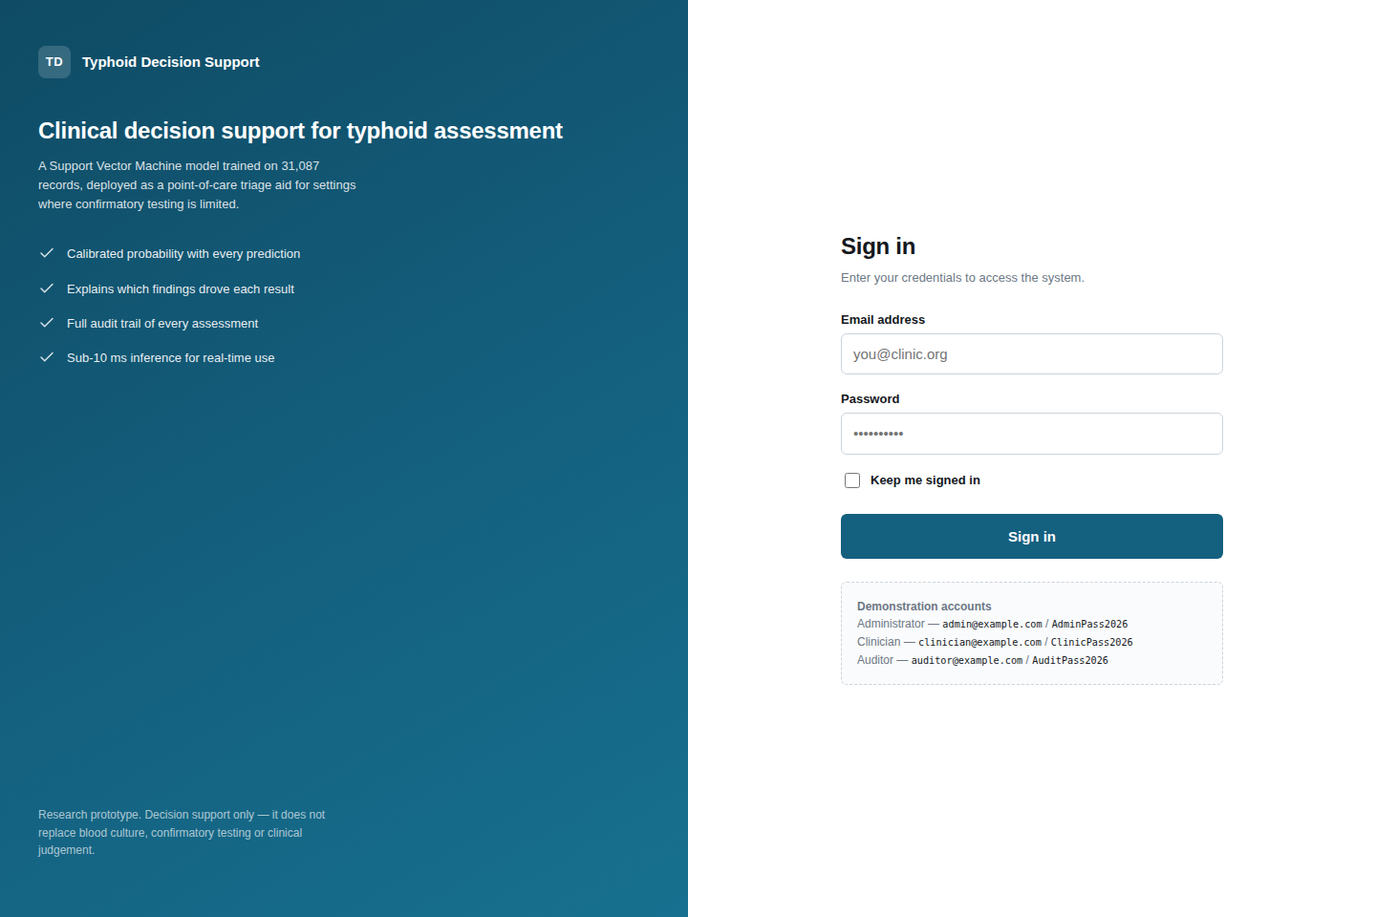
Plate C.1. Authentication page.
Plate C.2. Administrative system status page reporting model provenance and database health.
Plate C.3. Assessment form at a mobile viewport width of 390 pixels.
Note. Additional screenshots covering the clinician dashboard, patient register, activity log, validation errors and the 403 and 404 error pages are held in reports/screenshots/ in the source repository. Candidates preparing the bound copy should recapture these from the live instance on the date of submission.

C.4 Role-based access control
Table C.3: Roles and Permissions
Capability | Administrator | Clinician | Auditor
Register patients | Yes | Yes | No
Run assessments | Yes | Yes | No
View own assessments | Yes | Yes | Yes
View all assessments | Yes | No | Yes
Manage user accounts | Yes | No | No
View activity log | Yes | No | Yes
View system status | Yes | No | No

C.5 User acceptance test
Ten patient records were drawn from the held-out test partition, five typhoid and five disease-free, and entered into the deployed application through the clinician workflow. The expected output for each was computed in advance by running the record through the same prediction service the assessment form invokes. Table C.4 reports the outcome.
Table C.4: User Acceptance Test Results
Case | Recorded diagnosis | Expected and returned | Probability | Case type
1 | Typhoid | Typhoid | 1.0000 | Routine
2 | No Typhoid | No Typhoid | 0.0052 | Routine
3 | No Typhoid | No Typhoid | 0.0118 | Routine
4 | Typhoid | No Typhoid | 0.0053 | Known-difficult
5 | Typhoid | Typhoid | 0.9996 | Difficult, correctly identified
6 | No Typhoid | No Typhoid | 0.0147 | Routine
7 | Typhoid | Typhoid | 1.0000 | Routine
8 | Typhoid | No Typhoid | 0.0078 | Known-difficult
9 | No Typhoid | No Typhoid | 0.0186 | Routine
10 | No Typhoid | No Typhoid | 0.0260 | Routine
The deployed system reproduced the expected output in all ten cases, and its prediction agreed with the patient's recorded diagnosis in eight. Cases 4 and 8 are typhoid patients recorded with a fever duration of zero — the only patients in the dataset whose diagnosis cannot be read off a single attribute — and were included deliberately, with the expected disagreement declared in advance of the test. Case 5 is a third such patient whom the system identifies correctly, included so that the pack is not weighted towards failure.

C.6 Automated test coverage
Table C.5: Automated Test Suite by Module
Test module | Component under test | Cases
tests/test_data.py | Dataset loading, target construction, feature policy | 11
tests/test_pipeline.py | Preprocessing, SMOTENC, encoding, pipeline integrity | 10
tests/test_threshold.py | Threshold sweep, operating points, calibration | 12
tests/test_app.py | Prediction service and reference interface | 24
tests/test_webapp.py | Web application, security, database, deployment readiness | 77
tests/test_uat_pack.py | Acceptance pack agreement with the application | 24
Total |  | 158

C.7 Reproducing the study
The complete study can be reproduced from the repository with the following commands.
python -m venv .venv
.\.venv\Scripts\Activate.ps1 # Windows PowerShell
pip install -r requirements.txt

python scripts/audit_dataset.py # dataset integrity audit
python scripts/train_model.py --mode all --target binary
python scripts/baseline_rules.py # reference baselines
python scripts/threshold_analysis.py --policy all
python scripts/make_uat_samples.py # acceptance test pack
python -m pytest # 158 tests

$env:FLASK_APP = "run_dev.py"
python -m flask init-db
python run_dev.py # local server
Note. Training uses a fixed random seed of 42 and a stratified 80:20 partition, so every figure reported in Chapter Four is reproducible from these commands.

