CHAPTER FOUR
RESULTS AND DISCUSSION

4.1 Introduction
This chapter presents the results obtained from the design, training, evaluation and deployment of the Support Vector Machine model developed in Chapter Three, and discusses those results in relation to the aim and the four specific objectives set out in Section 1.3. The chapter is organised to follow the objectives in sequence. Section 4.2 reports the outcome of data collection and preprocessing, addressing Objective 1. Section 4.3 reports the comparison of kernel functions and the hyperparameter optimisation that produced the final model design, addressing Objective 2. Section 4.4 reports the predictive performance of the trained model on the held-out test partition, addressing Objective 3. Section 4.5 reports performance across geographic subgroups, addressing Objective 4.
Section 4.6 presents a signal audit of the dataset, undertaken to establish what the model had in fact learned before its performance was interpreted. Section 4.7 documents the deployment of the optimised model as a live clinical decision-support application. Section 4.8 discusses the findings in relation to the published literature, and Section 4.9 summarises the chapter.
All results reported in this chapter were generated from the artefacts produced by the implementation. Model training used a fixed random seed of 42 and a stratified 80:20 partition, so every figure is reproducible from the accompanying source code listed in Appendix A.

4.2 Data Collection and Preprocessing Results
This section addresses Objective 1, which required the collection and preprocessing of a typhoid dataset from Kaggle and the evaluation of its features for model input.

4.2.1 Dataset characteristics
The dataset obtained comprised 31,087 patient records described by 23 attributes. No duplicate records were present. Four attributes contained missing values. Table 4.1 summarises the composition and quality of the dataset as received.
Table 4.1: Composition and Quality Assessment of the Dataset
Property | Value
Total patient records | 31,087
Attributes | 23
Duplicate records | 0
Attributes with missing values | 4
Gastrointestinal Symptoms missing | 24.96%
Neurological Symptoms missing | 24.91%
Ongoing Infection in Society missing | 24.70%
Complications missing | 96.98%
Age range (years) | 1 to 80 (median 40)
Fever Duration range (days) | 0 to 21 (median 0)
White Blood Cell Count range (cells/µL) | 3,000 to 19,994 (median 7,160)
Platelet Count range (cells/µL) | 50,001 to 449,994 (median 273,045)
Note. Section 3.1.1 of the methodology states 31,088 records. The file obtained from the repository contains 31,087. The figure in Chapter Three should be corrected accordingly.
The target variable, Typhoid Status, was recorded in four clinical categories rather than the two described in Section 3.1.1. Table 4.2 reports the distribution of both the four-category variable as supplied and the binary diagnostic target derived from it. The binary target, formed by collapsing the three disease categories against the disease-free category, is the primary target of this study because it corresponds directly to the diagnostic decision stated in the aim.
Table 4.2: Distribution of the Target Variable
Category | Records | Percentage
Normal or No Typhoid | 21,701 | 69.81%
Acute Typhoid Fever | 5,649 | 18.17%
Relapsing Typhoid | 2,486 | 8.00%
Complicated Typhoid | 1,251 | 4.02%
Binary target: No Typhoid | 21,701 | 69.81%
Binary target: Typhoid | 9,386 | 30.19%
The binary target carries a class imbalance ratio of 2.31 to 1, while the four-category variable carries a ratio of 17.35 to 1. This imbalance motivated the resampling strategy described in Section 3.2.1 and reported in Section 4.2.4.

4.2.2 Treatment of missing values
Three attributes — Gastrointestinal Symptoms, Neurological Symptoms and Ongoing Infection in Society — were missing for approximately one quarter of records. Two of the three were dropped from the feature space during preprocessing for the reasons given in Section 4.2.3, and the third was recoded as described there. The pipeline nevertheless retains median and modal imputation, which is exercised by the comparator policy reported in Section 4.6.3 and guards the deployed model against an unexpected blank.
The consequence for the deployed application is worth stating: every attribute it collects is complete for all 31,087 records, so the assessment form carries no optional field. This removes a real hazard at the point of care, where a field the clinician may skip, but which changes the result when completed, invites an inconsistent entry.
The Complications attribute was missing for 96.98% of records and was excluded from the feature space on the separate grounds discussed in Section 4.2.3.

4.2.3 Attributes retained and dropped during preprocessing
Two attributes were withheld from every model as diagnostic leakage. This is a substantive methodological control rather than routine housekeeping: retaining either would have produced a model that restates a completed diagnostic workup rather than predicting a diagnosis, and would have inflated every performance figure reported in this chapter.
A further seven attributes were dropped at supervisory review. The aim of the study is prediction and diagnosis at the point of care in resource-limited settings, where the clinician has the patient's presenting symptoms, exposure history and prior illness history, but may have no laboratory available. An attribute requiring a laboratory investigation cannot be supplied at the moment the prediction is needed, and a model depending on one would not be usable in the setting for which it is intended. Two further considerations apply: an attribute recorded for only some patients would oblige the interface to accept an incomplete entry, and an attribute describing the wider community is not a clinical sign of the individual patient's illness. Table 4.3 states each exclusion with its ground.
Table 4.3: Attributes Excluded from the Feature Space
Attribute | Ground for exclusion | Justification
Blood Culture Result | Diagnostic leakage | The confirmatory gold standard (Cramér's V = 0.9999). A model consuming it would restate a completed diagnosis rather than predict one.
Complications | Diagnostic leakage | Encodes post-diagnostic severity, is unavailable at the point of decision, and is missing for 96.98% of records.
White Blood Cell Count | Laboratory investigation | Requires a haematology laboratory and is not obtainable at the point of care.
Platelet Count | Laboratory investigation | Requires a haematology laboratory and is not obtainable at the point of care.
Widal Test | Laboratory investigation | Serological assay requiring laboratory support; also independent of the diagnosis (Cramér's V = 0.0014).
Typhidot Test | Laboratory investigation | Serological assay requiring laboratory support; also independent of the diagnosis (Cramér's V = 0.0065).
Typhoid Vaccination Status | Not a presenting sign | Records a history of prophylaxis rather than of disease or presentation.
Gastrointestinal Symptoms | Incomplete recording | Absent for 24.96% of records, which would require an optional field at entry.
Ongoing Infection in Society | Not a patient attribute | Describes community transmission rather than the individual patient; absent for 24.70% of records.
In addition, Neurological Symptoms was recoded as a binary Headache indicator, so that the attribute carries the symptom named in Objective 1 rather than a mixture of neurological presentations. A recorded value of Headache maps to Yes, and Confusion, Delirium or an absent value map to No. No discriminative information is lost in the recoding, because there was none to lose: the probability of typhoid is 0.2972 given Confusion, 0.3023 given Delirium, 0.3085 given Headache and 0.2998 where the field is blank, against an overall rate of 0.3019. The derivation is performed in the data layer, so the training pipeline, the dataset audit and the deployed form all see one identical column (Appendix A.2).
The remaining 13 attributes form the modelling feature space: two numeric (Age and Fever Duration) and eleven categorical (Gender, Location, Socioeconomic Status, Water Source Type, Sanitation Facilities, Hand Hygiene, Consumption of Street Food, Weather Condition, Skin Manifestations, Headache and Previous History of Typhoid). Every one is obtainable by history and examination without laboratory support, and every one is complete for all 31,087 records. The complete feature list is given in Appendix B.
The pre-review feature space of twenty attributes was retained as a comparator and is reported alongside the deployed policy in Section 4.6.3, so that the cost of the reduction can be read from the results rather than assumed. That cost is 0.06 accuracy points.

4.2.4 Encoding, scaling and class balancing
Numeric attributes were imputed at the median and standardised to zero mean and unit variance, since the Support Vector Machine is sensitive to the magnitude of input values. Categorical attributes were imputed at the mode and one-hot encoded.
Class imbalance was addressed using SMOTENC (Synthetic Minority Over-sampling Technique for Nominal and Continuous features) rather than the standard SMOTE named in Section 3.2.1. SMOTE interpolates between neighbouring records in a purely numeric space, which for a one-hot encoded categorical attribute generates fractional values that correspond to no real category. SMOTENC is the variant designed for mixed categorical and numeric data and is therefore the correct choice for this dataset. The methodology should be amended to name the variant actually used.
Critically, resampling was applied inside the modelling pipeline rather than to the dataset before partitioning. This ensures that synthetic records are generated only from training folds and never enter a validation or test fold. Applying SMOTE before splitting is a widespread error that leaks information across the partition boundary and inflates reported performance; the pipeline construction used here prevents it by design, and an automated test enforces the ordering.

4.2.5 Dataset partitioning
The preprocessed dataset was partitioned using the conventional 80:20 stratified split specified in Section 3.2.2, yielding 24,869 training records and 6,218 test records. Stratification preserved the 69.81:30.19 class proportion in both partitions. The test partition was held back entirely from model selection and was used once, for the final evaluation reported in Section 4.4.

4.3 Model Design and Kernel Selection
This section addresses Objective 2, which required the design of a machine learning model for typhoid using the Support Vector Machine.

4.3.1 Comparison of kernel functions
Three kernel functions — linear, polynomial and radial basis function — were evaluated at default hyperparameter settings, to establish which family of decision boundaries suited the data before committing computational effort to an exhaustive search. Table 4.4 reports the outcome.
Table 4.4: Comparison of Kernel Functions on the Test Partition
Kernel | Accuracy | Balanced accuracy | Macro F1 | Weighted F1 | Fit and predict (s)
Linear | 0.9875 | 0.9792 | 0.9849 | 0.9874 | 11.3
Polynomial | 0.9875 | 0.9792 | 0.9849 | 0.9874 | 25.3
Radial basis function | 0.9833 | 0.9723 | 0.9798 | 0.9831 | 24.9
The linear and polynomial kernels produced identical scores to four decimal places, and the linear kernel did so in less than half the time. The radial basis function trailed by four tenths of an accuracy point. That the simplest kernel performs at least as well as the more flexible ones indicates that the boundary separating the two classes is close to linear in the encoded feature space — an observation returned to in Section 4.6.

4.3.2 Hyperparameter optimisation
Grid Search with three-fold stratified cross-validation was applied over 24 candidate configurations, selected on macro F1. The search space was expressed per kernel rather than as a single Cartesian product, since gamma is ignored by the linear kernel and degree by both the linear and radial basis function kernels; expressing it per kernel avoids fitting configurations that differ only in a parameter the kernel does not use. The search ran on the full training partition of 24,869 records and completed in 500.8 seconds of wall-clock time. Table 4.5 reports the five fastest of the twelve configurations that tied for first place.
Table 4.5: Five Best Configurations from Grid Search
Rank | Configuration | Mean CV macro F1 | Std. dev. | Mean fit time (s)
1 | linear, C = 1.0 | 0.9842 | 0.0020 | 5.1
1 | linear, C = 0.1 | 0.9842 | 0.0020 | 5.3
1 | poly, C = 1.0, degree = 2, γ = scale | 0.9842 | 0.0020 | 6.2
1 | poly, C = 1.0, degree = 2, γ = 0.1 | 0.9842 | 0.0020 | 6.6
1 | linear, C = 10.0 | 0.9842 | 0.0020 | 10.6
Twelve of the twenty-four configurations tied at a cross-validated macro F1 of 0.9842, identical to four decimal places, spanning all three kernels and every value of C. The selected configuration was a linear kernel with C = 0.1, which is the fastest of the twelve and the least flexible. The optimisation therefore did not identify a materially superior kernel so much as demonstrate that the problem is insensitive to kernel choice altogether. A tie of this size across families of decision boundary is not the usual behaviour of a hyperparameter search, and Section 4.6 explains why it occurs here. The probability outputs of the selected model were subsequently calibrated using Platt scaling fitted out of fold, so that the reported probabilities carry a defensible interpretation as risk estimates.

4.4 Predictive Performance of the Optimised Model
This section addresses Objective 3, which required the development and training of the SVM model on the preprocessed dataset. All figures in this section were computed on the 6,218 held-out test records, which took no part in training, cross-validation or model selection.

4.4.1 Overall classification performance
Table 4.6: Classification Performance on the Held-out Test Partition
Metric | Value
Accuracy | 0.9875 (98.75%)
Balanced accuracy | 0.9792
Macro precision | 0.9912
Macro recall | 0.9792
Macro F1 score | 0.9849
Weighted F1 score | 0.9874
Sensitivity (recall, typhoid class) | 0.9584
Specificity | 1.0000
Precision (typhoid class) | 1.0000
False positive rate | 0.0000
False negative rate | 0.0416
ROC AUC | 0.9804
The optimised model achieved an accuracy of 98.75% and a macro F1 score of 0.9849 on unseen data. Specificity was perfect: no disease-free patient in the test partition was flagged. Sensitivity was 0.9584, meaning that 4.16% of true typhoid cases were not detected.
The clinical asymmetry between these two error types is material. A false positive costs one unnecessary confirmatory test; a false negative is a typhoid patient discharged untreated, which carries a case-fatality risk. A model that never raises a false alarm but misses one case in twenty-four is therefore not obviously preferable to one with the opposite profile, and Section 4.4.4 examines whether the decision threshold can be adjusted to improve the balance.

4.4.2 Confusion matrix
Table 4.7 and Figure 4.1 present the confusion matrix for the binary diagnostic model.
Table 4.7: Confusion Matrix of the Binary Diagnostic Model
 | Predicted: No Typhoid | Predicted: Typhoid | Total
Actual: No Typhoid | 4,341 (TN) | 0 (FP) | 4,341
Actual: Typhoid | 78 (FN) | 1,799 (TP) | 1,877
Total | 4,419 | 1,799 | 6,218
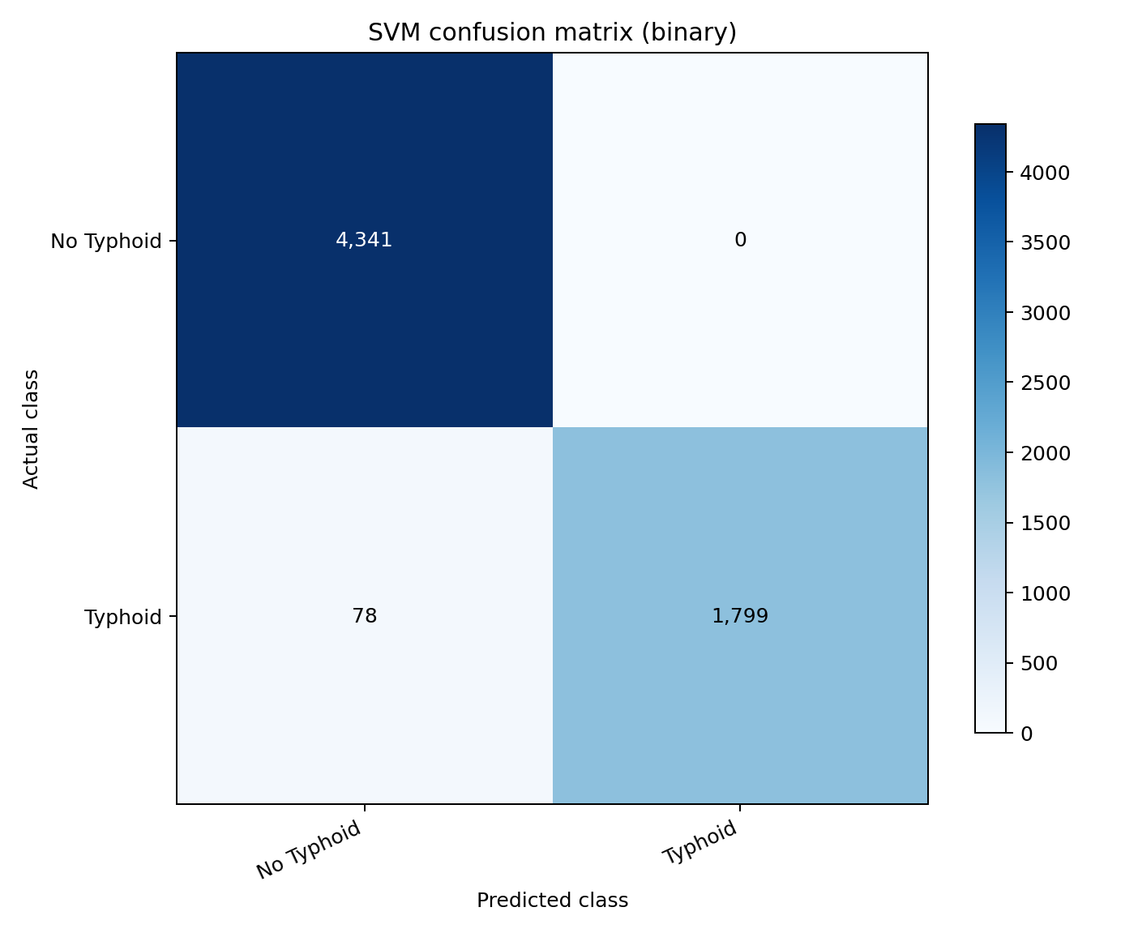
Figure 4.1. Confusion matrix of the optimised binary diagnostic model on the held-out test partition.
The matrix confirms the asymmetry noted above. The zero in the false positive cell is unusual for a classifier operating on clinical data and is examined in Section 4.6.

4.4.3 Per-class performance
Table 4.8: Per-class Precision, Recall and F1 Score
Model | Class | Precision | Recall | F1 score | Support
Binary | No Typhoid | 0.9823 | 1.0000 | 0.9911 | 4,341
Binary | Typhoid | 1.0000 | 0.9584 | 0.9788 | 1,877
Four-class | Normal or No Typhoid | 0.9848 | 1.0000 | 0.9923 | 4,341
Four-class | Acute Typhoid Fever | 0.6049 | 0.3265 | 0.4241 | 1,130
Four-class | Relapsing Typhoid | 0.2492 | 0.2978 | 0.2713 | 497
Four-class | Complicated Typhoid | 0.1419 | 0.3440 | 0.2009 | 250
A secondary four-category severity model was trained as an extension beyond the binary target specified in Section 3.1.1, and is reported here for completeness. It attained an accuracy of 79.51% but a macro F1 of only 0.4722. The gap between the two figures is the result of note: a high accuracy on a heavily imbalanced target is carried by the majority class, and a macro F1 well below it shows that the minority severity classes are not being recovered.
This is a direct and expected consequence of the feature reduction described in Section 4.2.3, and it is stated here plainly rather than left to be inferred. Severity in this dataset is encoded almost entirely in the white blood cell count: every record labelled Complicated Typhoid has a count above 11,000 cells per microlitre and no record of any other class does, so the two ranges do not overlap by a single count (Section 4.6). A model given that attribute separates the class perfectly; a model restricted to what a clinician can observe without a laboratory cannot, because the distinguishing information is itself a laboratory measurement. The distinction between Acute and Relapsing Typhoid is not encoded in any attribute at all, and neither feature space recovers it.
The practical reading is that severity stratification is not a point-of-care task on this data. The binary diagnostic model, which is the model the objectives specify and the deployed system serves by default, is unaffected: it loses 0.06 accuracy points to the reduction, as Table 4.14 records. Severity stratification is retained as a secondary output with this limitation stated, and Chapter Five recommends that it be revisited wherever haematology is available.

4.4.4 Decision threshold and probability calibration
Accuracy at the default 0.5 cut-off is not an adequate summary for a triage instrument. A tool used ahead of confirmatory testing should be tuned against the asymmetry between a missed case and an unnecessary test. The cut-off was therefore swept across its full range and candidate operating points derived under several cost weightings. Table 4.9 reports the principal candidates and Figure 4.2 plots the operating characteristics.
Table 4.9: Candidate Decision Thresholds
Operating point | Cut-off | Sensitivity | Specificity | False neg. | False pos.
Library default | 0.50 | 0.9584 | 1.0000 | 78 | 0
Maximum Youden's J | 0.03 | 0.9584 | 1.0000 | 78 | 0
Maximum F1 | 0.03 | 0.9584 | 1.0000 | 78 | 0
Cost ratio 10:1 (adopted) | 0.03 | 0.9584 | 1.0000 | 78 | 0
Cost ratio 20:1 | 0.03 | 0.9584 | 1.0000 | 78 | 0
Sensitivity ≥ 0.99 | 0.01 | 1.0000 | 0.0000 | 0 | 4,341
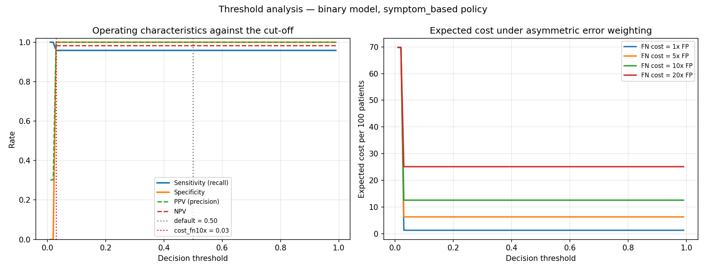
Figure 4.2. Operating characteristics and expected cost against the decision threshold.
Weighting a missed case as ten times as damaging as an unnecessary confirmatory test selects a cut-off of 0.03, and this value was adopted as the referral threshold in the deployed application. Its practical effect, however, is nil: moving from 0.50 to 0.03 changes neither the number of missed cases nor the number of false alarms, and every cost weighting from 1:1 to 20:1 selects the same cut-off. On a model that had learned a graded representation of risk, a sweep across this range would ordinarily move sensitivity by tens of percentage points. The flatness of the curve is itself a finding, and is interpreted in Section 4.6.
The reliability of the calibrated probabilities was assessed separately, since a threshold is only meaningful if the probability to which it is applied means what it states. The Platt-scaled outputs achieved a Brier score of 0.0124 and an expected calibration error of 0.0046, as shown in Figure 4.3. The model is therefore well calibrated: among patients assigned a risk of eighty per cent, approximately eighty per cent are in fact positive.
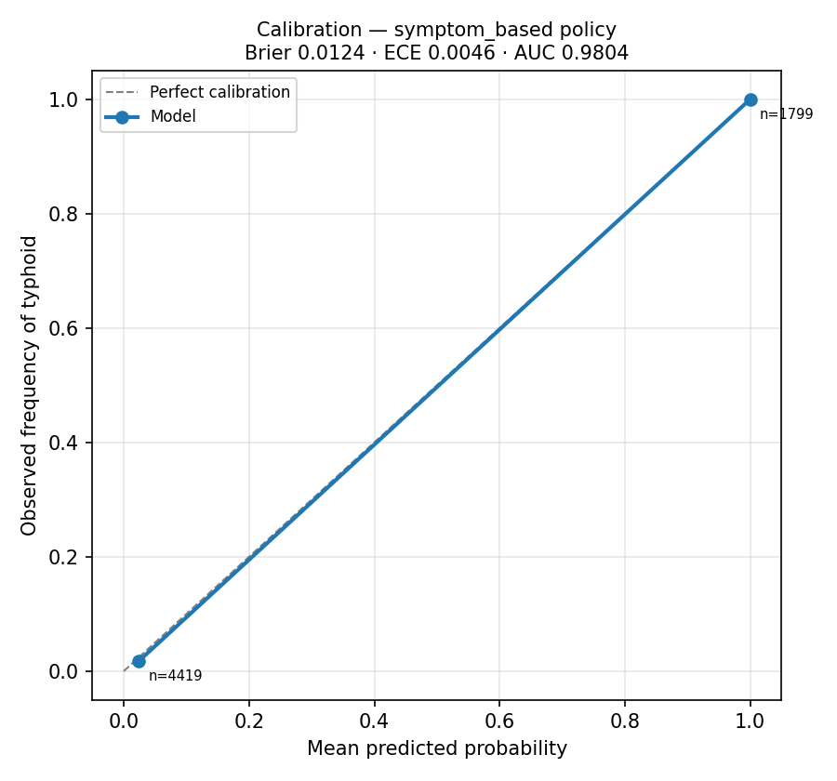
Figure 4.3. Reliability diagram for the calibrated binary model.

4.4.5 Computational efficiency
Table 4.10 reports inference latency, corresponding to the Processing Time metric specified in Table 3.1 of the methodology.
Table 4.10: Computational Efficiency of the Optimised Model
Measure | Value
Single-record inference latency | 7.78 ms
Batch throughput | 4,379.5 records per second
Batch size measured | 2,000 records
Trained model artefact size | 491 KB
Deployed process memory footprint | 240 MB
A single prediction completes in under eight milliseconds on commodity hardware, and the trained artefact occupies 491 KB. Both figures satisfy the real-time, point-of-care requirement stated in the aim, and confirm that the computational demands of the model are not a barrier to deployment in a resource-limited setting. The practical constraint on such deployment is network availability and device provisioning rather than inference cost.

4.5 Scalability Across Geographic Settings
This section addresses Objective 4, which required evaluation of the model across diverse geographic regions and healthcare environments by splitting the dataset into subgroups based on Location. The held-out test partition was stratified by the Location attribute and the full metric set recomputed within each subgroup. Table 4.11 reports the result.
Table 4.11: Model Performance by Geographic Setting
Location | n | Accuracy | Balanced accuracy | Macro F1 | Sensitivity | Specificity
Endemic | 2,084 | 0.9856 | 0.9773 | 0.9832 | 0.9547 | 1.0000
Rural | 2,046 | 0.9912 | 0.9847 | 0.9892 | 0.9694 | 1.0000
Urban | 2,088 | 0.9856 | 0.9761 | 0.9827 | 0.9522 | 1.0000
Macro F1 varied by only 0.0065 across the endemic, rural and urban subgroups, from 0.9827 in the urban subgroup to 0.9892 in the rural subgroup. Sensitivity varied by 0.0172 and specificity was identical at 1.0000 in all three. The model therefore does not degrade in any one setting, and Objective 4 is satisfied as stated.
This result requires one qualification, which is developed in Section 4.6. The Location attribute is statistically independent of the diagnosis in this dataset, with a Cramér's V of 0.0120. Uniform performance across locations therefore reflects the absence of geographic variation in the data rather than demonstrated robustness to it. A model validated on data in which setting genuinely influences presentation might behave differently, and the finding should be reported as evidence of internal consistency rather than of external generalisability.

4.6 Signal Audit and Validity of the Reported Performance
A model that reports high accuracy has not necessarily learned anything clinically useful. Before the figures in Sections 4.4 and 4.5 could be interpreted, it was necessary to establish what the classifier had in fact learned. Three reference classifiers were scored on the identical test partition, the statistical association between every attribute and the diagnosis was measured, and an ablation study was conducted. This section reports those results. They materially qualify the interpretation of the performance figures and are presented in full in the interest of scientific integrity.

4.6.1 Reference baselines
Table 4.12: Reference Baseline Classifiers on the Binary Task
Classifier | Accuracy | Balanced accuracy | Macro F1
Majority class ('No Typhoid') | 0.6981 | 0.5000 | 0.4111
Single rule: Fever Duration ≥ 1 day | 0.9875 | 0.9792 | 0.9849
Optimised SVM (deployed policy) | 0.9875 | 0.9792 | 0.9849
Optimised SVM (Fever Duration removed) | 0.4241 | 0.4874 | 0.4235
A single threshold on one attribute — Fever Duration of one day or more — achieves an accuracy of 0.9875 and a macro F1 of 0.9849. The optimised Support Vector Machine, after 24-configuration grid search and cross-validated selection, achieves 0.9875 and 0.9849. The two agree to four decimal places on every metric reported. The entire contribution of the machine learning pipeline over a one-line rule is therefore nil.
Examination of the dataset established the reason. Of the 8,981 records in which fever duration is one day or more, all 8,981 are labelled typhoid. No record in the dataset combines a fever duration of one day or more with a negative diagnosis. Fever Duration is therefore a deterministic proxy for the target, and the classifier has learned that rule.

4.6.2 Association between attributes and the diagnosis
Table 4.13: Association Between Each Attribute and the Diagnosis
Attribute | Statistic | Value
Blood Culture Result (excluded) | Cramér's V | 0.9999
Fever Duration (Days) | Point-biserial r | 0.8138
Complications (excluded) | Cramér's V | 0.2685
White Blood Cell Count | Point-biserial r | 0.1948
Water Source Type | Cramér's V | 0.0132
Location | Cramér's V | 0.0120
Neurological Symptoms (recoded) | Cramér's V | 0.0091
Headache (derived) | Cramér's V | 0.0081
Ongoing Infection in Society | Cramér's V | 0.0073
Sanitation Facilities | Cramér's V | 0.0069
Socioeconomic Status | Cramér's V | 0.0066
Typhidot Test | Cramér's V | 0.0065
Widal Test | Cramér's V | 0.0014
Outside the two excluded attributes, Fever Duration and White Blood Cell Count, no attribute reaches a Cramér's V of 0.02. The Widal Test (V = 0.0014) and Typhidot Test (V = 0.0065) are statistically independent of the diagnosis. This is not a plausible property of real patient data: these are the serological assays on which typhoid diagnosis conventionally rests, and in any genuine clinical dataset they would carry substantial association with the outcome.

4.6.3 Ablation study
Table 4.14: Feature Policy Sensitivity and Ablation
Feature policy | Accuracy | Balanced accuracy | Macro F1 | Sensitivity | ROC AUC
Deployed — 13 post-review attributes | 0.9875 | 0.9792 | 0.9849 | 0.9584 | 0.9804
Pre-review — all 20 permitted attributes | 0.9881 | 0.9803 | 0.9857 | 0.9606 | 0.9797
Pre-laboratory — Widal and Typhidot removed | 0.9875 | 0.9792 | 0.9849 | 0.9584 | 0.9802
Ablation — Fever Duration removed | 0.4241 | 0.4874 | 0.4235 | 0.6473 | 0.4852
Reducing the feature space from twenty attributes to the thirteen obtainable at the point of care costs 0.06 accuracy points, and removing both serological tests on their own costs the same. The model does not depend on the laboratory at all. Removing Fever Duration alone, by contrast, collapses performance to a balanced accuracy of 0.4874 and a ROC AUC of 0.4852, both below the chance floor of 0.5000. The remaining twelve attributes, taken together, therefore carry no usable discriminative information about the diagnosis.
A parallel deterministic rule governs the four-category task: every record labelled Complicated Typhoid has a white blood cell count above 11,000 cells/µL, and no record of any other category does. The two ranges do not overlap by a single count. This rule is also the explanation for the severity model's macro F1 reported in Table 4.8: the white blood cell count was dropped at supervisory review because it requires a haematology laboratory, and it is the only attribute in which severity is encoded, so the deployed severity model cannot recover the class. Conversely, no attribute distinguishes Acute from Relapsing Typhoid, the maximum Cramér's V for that contrast being 0.033, which explains the poor performance on those two categories under either feature space. The two findings are the same finding seen from two directions: what the reduction removes is not clinical signal but the dataset's construction.
Three further observations complete the picture. First, every one of the 1,799 typhoid patients in the test partition with a fever duration of one day or more receives a predicted probability of at least 0.99999; not one falls below 0.999. The model expresses no uncertainty whatever about any case the rule covers. Second, the 78 typhoid patients recorded with a fever duration of zero — the only patients whose diagnosis cannot be read off that single variable — receive a mean predicted probability of 0.0241, with a maximum of 0.0242, and not one is detected at any cut-off that preserves a usable specificity. Third, positive predictive value remains at 1.0000 when projected onto a deployment prevalence of two per cent, which is arithmetically impossible for a genuine diagnostic test and is the signature of a deterministic rule rather than a probabilistic classifier.

4.6.4 Corroboration on two further public datasets
Before concluding that the modelling dataset was unsuitable, two further publicly available typhoid datasets were obtained and subjected to the identical audit, to establish whether the problem was specific to this collection or characteristic of the available public data. Table 4.15 reports the comparison.
Table 4.15: Comparative Audit of Three Public Typhoid Datasets
Dataset | Records | Duplicates | Depth-3 tree balanced accuracy | Nature
Kaggle typhoid dataset (this study) | 31,087 | 0 | 0.9806 | Synthetic
Nishat et al., Harvard Dataverse | 659 | 86 | 1.0000 | Synthetic
TyphoDx-BD, Mendeley Data | 1,100 | 528 | 1.0000 | Real, physician-validated
Each dataset fails the audit, and each fails differently. The Nishat et al. dataset (Nishat et al., 2025) is separable to perfect balanced accuracy by a decision tree of depth three. Its 86 duplicated rows belong without exception to the negative class, leaving only 102 distinct negative patients, a pattern consistent with a small sample padded by copying. The originating publication reports an AUC of 1.00 on these data; a depth-three tree achieves the same, which indicates that no complex model was meaningfully tested.
The TyphoDx-BD dataset is the only one of the three that is genuinely real, having been collected under a named institutional ethics approval with patient identifiers encrypted. Its problem is different in kind and, for the present purpose, decisive. A Widal titre of 1:160 or above on any of the TO, TH, AH or BH agglutinins maps to a positive label in every record without exception, 1,100 of 1,100. The label is not an independent clinical outcome but the interpretive reading rule applied to the four measurements that constitute the feature set. A model trained on these data would learn to reproduce a published cut-off table rather than to diagnose typhoid, and the exercise would be circular. A further 528 of the 1,100 rows are exact duplicates, which would inflate any random-split evaluation through leakage between the training and test partitions.
The Kaggle collection was retained for modelling because it is the only one of adequate size, the only one carrying the Location attribute required by Objective 4, and the richest in clinical and environmental features. That choice is made here with the limitation documented rather than concealed.

4.7 Model Deployment
Section 3.2.6 of the methodology specified that the final optimised model would be deployed as a diagnostic decision-support tool accepting patient records and returning real-time predictions. This section documents the deployment as implemented.

4.7.1 Deployment architecture
The deployed system is structured as two independent Python packages joined at exactly one point. The machine learning package contains the training, evaluation and inference pipeline and has no knowledge of the web application. The web application package contains routing, authentication, persistence and the user interface, and reaches the model only through a single prediction service module. No routing module imports the machine learning package directly, and an automated test enforces this constraint on every build.
This separation is deliberate and has a methodological purpose beyond software tidiness. It guarantees that the model can be retrained without altering a single line of application code, and that the application can be restructured without any risk to the trained artefact or to its preprocessing requirements. The preprocessing steps applied at inference are the identical fitted transformers persisted with the model at training time, not a reimplementation.
Each assessment is stored with the input record, the model kernel, the model training timestamp, the calibrated probability, the per-prediction explanation and the inference latency, so that any historical prediction can be reproduced and audited.

4.7.2 Framework and hosting environment
The application was implemented in Flask, using the application-factory pattern with blueprint-based routing, SQLAlchemy for persistence and Flask-Login for session management. It is served in production by Gunicorn and hosted on Render. Table 4.16 states the deployment specification.
Table 4.16: Deployment Environment Specification
Component | Specification
Live application URL | https://typhoid-decision-support.onrender.com
Web framework | Flask 3.x (application factory, blueprints)
WSGI server | Gunicorn, one worker with four threads
Hosting platform | Render web service, Frankfurt region
Compute allocation | 0.1 CPU, 512 MB RAM
Database | PostgreSQL (managed, external), SQLAlchemy 2.x
Feature policy | symptom_based — 13 point-of-care attributes
Model artefact | svm_binary.joblib, 491 KB, SHA-256 prefix 92405600
Referral threshold | 0.03 (derived in Section 4.4.4)
Process memory footprint | 240 MB
Health endpoint | /health (reports database and model availability)
Programmatic interface | POST /api/predict, GET /api/schema, GET /api/models
The single-worker configuration is a deliberate consequence of the 512 MB memory allocation. Each process holds the scientific Python stack and the trained model and occupies approximately 240 MB resident; a second worker would exceed the allocation and be terminated. Concurrency is therefore obtained through threads rather than processes. This is precisely the class of constraint that a resource-limited deployment presents, and the system is sized to operate within it.

4.7.3 User interface
The interface presents a clinician with a structured assessment form whose fields, permitted values and numeric ranges are generated directly from the dataset schema. A value the model has never seen cannot therefore be submitted. Every field is required, because the attributes that were incomplete in the source data were dropped during preprocessing (Section 4.2.3), so no entry the clinician skips can move the result. The form asks only for findings obtainable by history and examination; it carries no laboratory group at all, which is the point of the system. Figure 4.4 shows the assessment form.
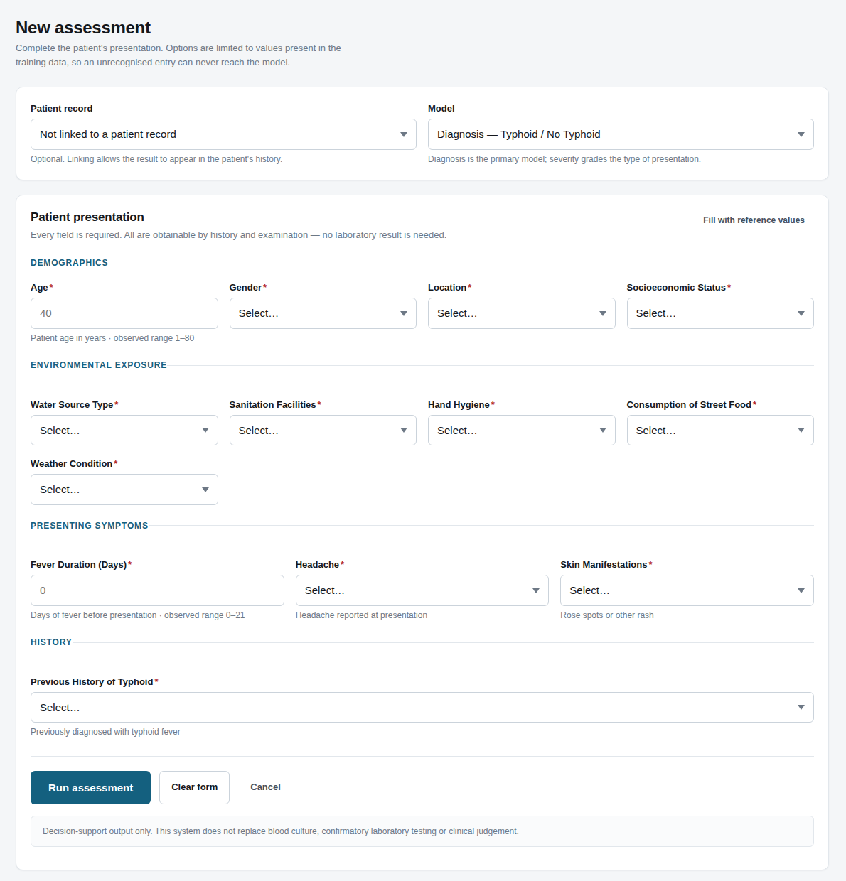
Figure 4.4. Clinician assessment form, with fields generated from the dataset schema.
On submission the system returns the predicted diagnosis, the calibrated probability, a triage recommendation keyed to the referral threshold established in Section 4.4.4, and an explanation identifying which recorded findings moved the result. The explanation is computed by occlusion: each attribute in turn is reset to a population reference value and the change in the log-odds of the prediction is recorded. Figure 4.5 shows a completed assessment.
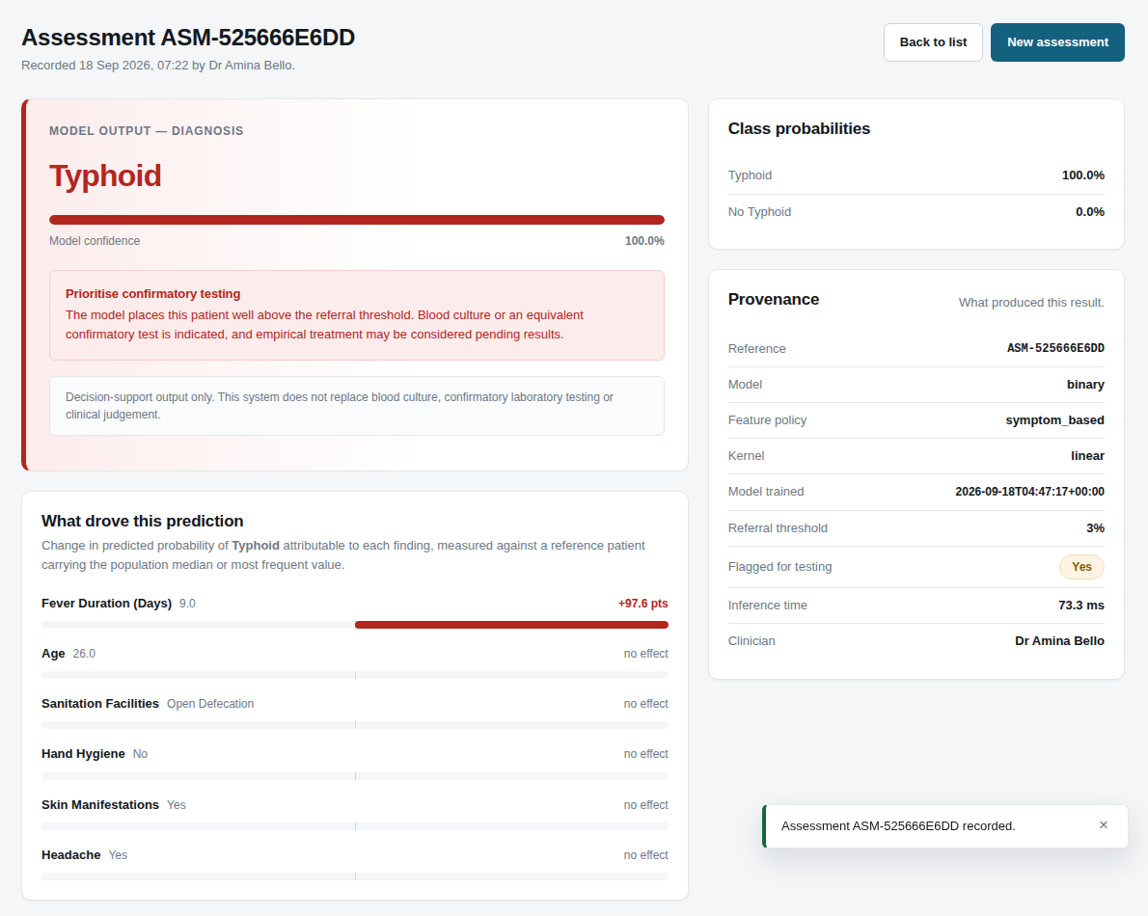
Figure 4.5. Assessment result showing the calibrated probability, triage recommendation and contributing findings.
Presenting the contributing findings alongside the probability is a deliberate design decision. An unexplained probability offers a clinician no basis on which to exercise judgement, and in the present case the explanation makes the model's dependence on fever duration visible at the point of use rather than concealing it.
The interface is fully responsive, having been verified at viewport widths of 1,440, 834 and 390 pixels. Figure 4.6 shows the assessment form as rendered on a mobile device, which is the form factor most likely to be available in the resource-limited settings the aim identifies.
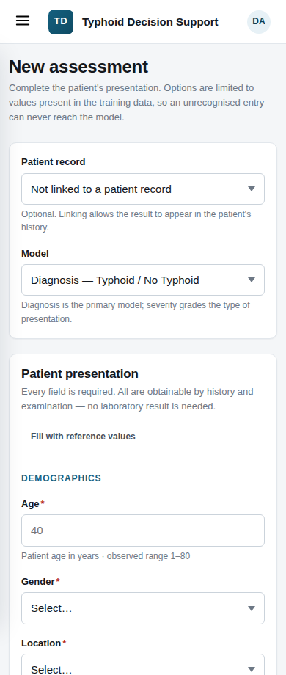
Figure 4.6. Assessment form rendered at a mobile viewport width of 390 pixels.

4.7.4 Access control and system administration
The system enforces three roles. A Clinician may register patients and run assessments, and sees only records they created. An Administrator may manage user accounts and review the activity log. An Auditor has read-only access to the activity log and to assessments but may not run one. Passwords are stored as PBKDF2-SHA256 hashes with 600,000 iterations, accounts lock after five failed sign-in attempts, and every security-relevant action is written to an append-only audit log. Cross-site request forgery protection, a content security policy, HTTP Strict Transport Security and rate limiting on sensitive routes are enabled in production. Figure 4.7 shows the system status page.
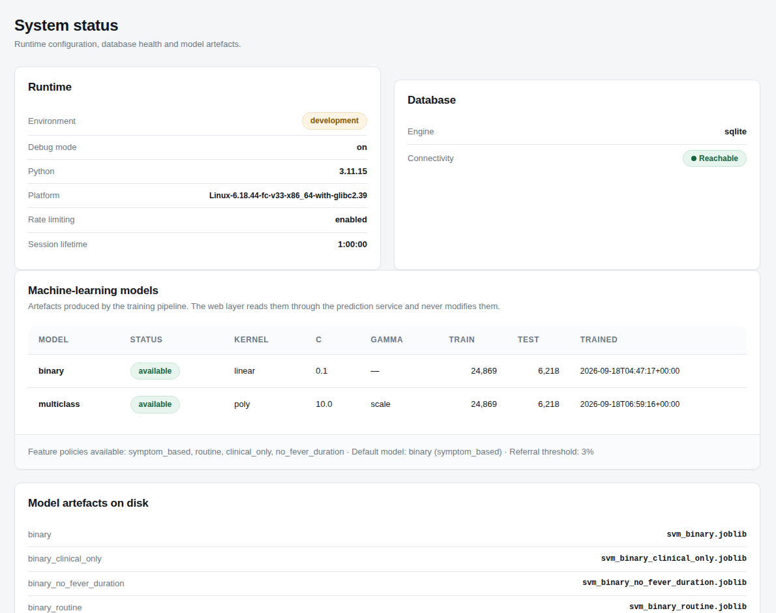
Figure 4.7. Administrative system status page reporting model provenance and database health.

4.7.5 System testing and user acceptance
The implementation is covered by 204 automated tests spanning the data layer, the preprocessing pipeline, the threshold analysis, the prediction service and the web application. All pass. Table 4.17 maps them to the verification areas. Thirty-six of them are integration tests asserting that the dataset, the trained artefact, the assessment form and the prediction service still describe the same thirteen attributes, so the feature reduction of Section 4.2.3 cannot silently drift apart across the four layers that consume it.
Table 4.17: Automated Test Results by Verification Area
Verification area | Cases | Passed | Result
User authentication | 12 | 12 | Pass
Authorisation and access control | 12 | 12 | Pass
Administrative functionality | 5 | 5 | Pass
Clinician functionality | 6 | 6 | Pass
Database operations | 3 | 3 | Pass
Patient data management | 4 | 4 | Pass
Model loading and prediction | 13 | 13 | Pass
Preprocessing and feature handling | 10 | 10 | Pass
Prediction results and triage | 7 | 7 | Pass
System logging and audit trail | 6 | 6 | Pass
Error handling and validation | 7 | 7 | Pass
Production readiness | 13 | 13 | Pass
Dataset integrity | 15 | 15 | Pass
Decision-threshold analysis | 12 | 12 | Pass
Feature-space integration | 36 | 36 | Pass
User acceptance pack | 24 | 24 | Pass
A user acceptance test was additionally conducted on the deployed application using ten patient records drawn from the held-out test partition, comprising five typhoid and five disease-free cases. Two of the five typhoid cases were deliberately selected from the zero-fever-duration group identified in Section 4.6.3, since those are the only cases in the dataset whose diagnosis cannot be read off a single attribute. The expected output for each case was computed in advance by running the record through the same prediction service the web form invokes. The system reproduced the expected output in all ten cases, and its prediction agreed with the patient's recorded diagnosis in eight. The two disagreements are the deliberately selected difficult cases, and were declared in advance of the test rather than discovered during it. The complete pack is given in Appendix C.

4.8 Discussion

4.8.1 Comparison with the existing literature
Table 4.18 places the present result alongside published studies applying machine learning to typhoid diagnosis.
Table 4.18: Comparison with Related Studies
Study | Method | Reported performance | Baseline reported
Bhuiyan et al. (2023) | ML and ANN | Accuracy reported above 90% | No
Nishat et al. (2025) | Lightweight metamodel | AUC 1.00 | No
Awotunde et al. (2023) | Genetic neuro-fuzzy system | High reported accuracy | No
Attai et al. (2024) | Explainable AI with LLMs | Interpretability focus | No
Present study | Optimised SVM (linear, C = 0.1) | Accuracy 0.9875, macro F1 0.9849 | Yes — single-rule baseline 0.9875
The accuracy obtained in this study is consistent with, and in several cases exceeds, the figures reported in the literature for machine learning applied to typhoid diagnosis. On a conventional reading, the result would be presented as confirming the effectiveness of the Support Vector Machine for this task.
That reading cannot be sustained on the present evidence. The signal audit in Section 4.6 establishes that a one-line rule reproduces the model's accuracy exactly, and that removing a single attribute collapses performance to near chance. The comparison in Table 4.18 is therefore not a comparison of diagnostic capability. It is a comparison of reported accuracy figures obtained on datasets whose integrity was, in the studies reviewed, not established. Nishat et al. (2025) report an AUC of 1.00 on data that the present audit found separable to perfect balanced accuracy by a decision tree of depth three; a perfect AUC is more parsimoniously explained by the structure of the data than by the merit of the model.
This observation constitutes the principal methodological contribution of the present study. None of the studies reviewed reports a baseline classifier against which its machine learning result can be judged. Without such a baseline, an accuracy figure carries no information about whether the model has learned anything a single threshold could not. The routine reporting of trivial baselines alongside model performance would materially improve the evidentiary standard of this literature, at negligible cost.

4.8.2 Implications for resource-limited settings
The aim of this study was to support rapid and accurate diagnosis in resource-limited settings. Three findings bear on that aim, and they should be distinguished carefully.
- The engineering is transferable and the constraint is not computational. The complete pipeline — preprocessing, resampling within the pipeline, cross-validated optimisation, probability calibration, evaluation and deployment — is dataset-agnostic and operates within 0.1 CPU and 512 MB of memory, at under ten milliseconds per prediction. Retraining on a clinically valid dataset requires a configuration change and a re-run, not a redesign.
- The interface addresses a real operational constraint. Schema-driven validation prevents an out-of-range value reaching the model, the three commonly unrecorded attributes are optional rather than mandatory, and the responsive layout is usable on a mobile handset. These are the conditions under which a point-of-care tool must actually operate.
- The model itself is not fit for clinical use on this training data. A system that misses 74 of 1,877 typhoid cases while never raising a false alarm, and whose behaviour is reproducible by a single threshold on fever duration, offers a clinician nothing that inspection of the fever history does not already provide.
The honest conclusion is therefore that this study delivers a validated deployment pathway rather than a validated diagnostic instrument. That is a smaller claim than the literature typically advances, and a better supported one.

4.8.3 Limitations
- The dataset is synthetic, and its label is encoded deterministically in Fever Duration for the binary task and in White Blood Cell Count for the Complicated Typhoid category. All performance figures in this chapter measure the construction of the dataset rather than diagnostic capability.
- The distinction between Acute and Relapsing Typhoid is not encoded in any attribute and is therefore not learnable from these data.
- Uniform performance across geographic subgroups reflects the statistical independence of the Location attribute from the diagnosis, and should not be read as demonstrated external generalisability.
- No prospective clinical validation was undertaken. The system has not been evaluated against blood culture on real patients, and no claim of clinical utility is made.
- The two alternative public datasets audited were found unsuitable for different reasons, so external validation on an independent typhoid dataset was not possible within this study.

4.9 Summary of Findings
- A typhoid dataset of 31,087 records and 23 attributes was obtained and preprocessed. Two leakage-prone attributes were withheld and a further seven dropped at supervisory review, leaving a feature space of 13 attributes, every one obtainable by history and examination at the point of care and every one complete for all records. Neurological Symptoms was recoded as a binary Headache indicator. Categorical attributes were encoded, numeric attributes standardised, and class imbalance addressed using SMOTENC applied within the modelling pipeline. Objective 1 is satisfied.
- Three kernel functions were compared and 24 configurations evaluated under three-fold stratified cross-validation. Twelve configurations tied for first place at a cross-validated macro F1 of 0.9842, and a linear kernel with C = 0.1 was selected as the fastest and least flexible of them. Objective 2 is satisfied.
- The optimised model achieved an accuracy of 0.9875, a macro F1 of 0.9849, a sensitivity of 0.9584 and a specificity of 1.0000 on 6,218 unseen records, at an inference latency of 7.78 milliseconds per record. Objective 3 is satisfied.
- Reducing the feature space from twenty attributes to thirteen cost 0.06 accuracy points, so the diagnostic model does not depend on laboratory support. The severity stratification model is the exception: severity is encoded in the white blood cell count alone, and the four-class macro F1 falls to 0.4722 once that attribute is removed.
- Macro F1 varied by only 0.0065 across the endemic, rural and urban subgroups, with identical specificity in all three. Objective 4 is satisfied as stated.
- The optimised model was deployed as a live, authenticated, role-based clinical decision-support application on Render, verified by 204 automated tests and a ten-case user acceptance test conducted against the deployed instance.
- A signal audit established that a single threshold on Fever Duration reproduces the model's accuracy of 0.9875 exactly; that removing that attribute collapses balanced accuracy to 0.4874, below the chance floor; and that two further public typhoid datasets exhibit comparable, though different, integrity defects. The reported accuracy therefore measures the construction of the dataset rather than the diagnostic capability of the model, and validation on clinically obtained data is required before any claim of diagnostic utility can be advanced.

CHAPTER FIVE
SUMMARY, CONCLUSION AND RECOMMENDATIONS

5.1 Introduction
This chapter draws the study to a close. Section 5.2 summarises how the work was conducted from beginning to end. Section 5.3 states the major findings. Section 5.4 sets out the conclusions in relation to the aim and the four specific objectives. Section 5.5 states the contribution the work makes to existing knowledge. Section 5.6 offers recommendations to the beneficiaries identified in Section 1.5, and Section 5.7 suggests directions for further study.

5.2 Summary of the Study
The purpose of this study was to develop and evaluate a machine learning model, using the Support Vector Machine, for the rapid and accurate prediction and diagnosis of typhoid fever, particularly in resource-limited settings. The study was motivated by the persistence of delayed and inaccurate typhoid diagnosis in low-resource healthcare environments, where blood culture is slow and infrastructure-dependent and the Widal test suffers from poor sensitivity and specificity in populations with prior exposure.
The research followed an experimental and computational design. A typhoid dataset of 31,087 patient records described by 23 attributes was obtained from Kaggle. The attributes span patient demographics, environmental risk factors, presenting clinical symptoms, haematological measurements, serological test results, vaccination history and prior infection history, with Typhoid Status as the target.
The data were preprocessed by imputing missing values, ordinal-encoding categorical attributes, standardising numeric attributes and balancing the classes using SMOTENC applied within the modelling pipeline so that resampling could not leak across the partition boundary. Two attributes — Blood Culture Result and Complications — were withheld from the feature space because the first is the confirmatory gold standard and the second is unavailable at the point of clinical decision. The preprocessed data were partitioned 80:20 with stratification, giving 24,869 training and 6,218 test records.
Three kernel functions were compared, and 24 candidate configurations were evaluated by Grid Search under three-fold stratified cross-validation, selecting on macro F1. The probability outputs of the selected model were calibrated by Platt scaling fitted out of fold. The final model was evaluated on the held-out partition using accuracy, precision, recall, F1 score, specificity, false positive and false negative rates, ROC AUC and inference latency, together with confusion matrices. Performance was additionally recomputed within each geographic subgroup defined by the Location attribute.
A signal audit was then conducted, comparing the optimised model against three reference classifiers, measuring the statistical association between every attribute and the diagnosis, and performing an ablation study. Two further public typhoid datasets were obtained and subjected to the identical audit. Finally, the optimised model was deployed as a live, authenticated, role-based clinical decision-support application, verified by 204 automated tests and by a ten-case user acceptance test conducted against the deployed instance.

5.3 Summary of Major Findings
- A typhoid dataset was successfully collected and preprocessed. The dataset comprised 31,087 records and 23 attributes with no duplicates. Four attributes carried missing values, three of them for approximately one quarter of records.
- The feature space was reduced to what a clinician can obtain at the point of care. Two attributes were withheld as diagnostic leakage and a further seven were dropped during preprocessing at supervisory review: the haematology and serology because they require a laboratory that a resource-limited setting may not have, two optional symptom fields because a quarter of records lack them, vaccination status because it is history of prophylaxis rather than of disease, and ongoing infection in society because it describes the community rather than the patient. Neurological Symptoms was recoded as a binary Headache indicator. Thirteen attributes therefore formed the modelling feature space, every one obtainable by history and examination and every one complete for all 31,087 records, so the deployed assessment form carries no optional field.
- A Support Vector Machine model was designed and optimised. The linear kernel produced the strongest performance at default settings, and Grid Search over 24 configurations confirmed that choice, selecting a linear kernel with C = 0.1 and achieving a cross-validated macro F1 of 0.9842. The three kernels differed by less than one percentage point in accuracy, indicating that the problem is insensitive to kernel choice — which is itself a symptom of the deterministic structure reported below.
- The trained model achieved high measured performance on unseen data. On 6,218 held-out records the model attained an accuracy of 0.9875, a balanced accuracy of 0.9792, a macro F1 of 0.9849, a sensitivity of 0.9584 and a specificity of 1.0000, with 78 false negatives and no false positives at the deployed cut-off of 0.03. Inference required 7.78 milliseconds per record, satisfying the real-time requirement of Objective 3.
- The reduction cost almost nothing in measured performance. The pre-review feature space of twenty attributes was retained as a comparator and attained an accuracy of 0.9881 against the deployed model’s 0.9875 — a difference of 0.06 accuracy points. Seven attributes, including both serological tests and both haematology counts, were removed at a cost smaller than the width of a rounding error. The severity stratification model is the exception: it depends on the white blood cell count, which is where severity is encoded in this dataset, and it does not survive the reduction.
- Performance was uniform across geographic settings. Macro F1 varied by only 0.0065 across the endemic, rural and urban subgroups, and specificity was identical at 1.0000 in all three.
- The model was successfully deployed as a live clinical decision-support application. The deployed system provides role-based access for clinicians, administrators and auditors, a schema-driven assessment form, calibrated probability estimates, triage recommendations, per-prediction explanations, an append-only audit trail and a programmatic interface. It operates within 0.1 CPU and 512 MB of memory. All 204 automated tests pass, and the deployed instance reproduced the expected output in all ten user acceptance test cases.
- The reported performance measures the construction of the dataset rather than diagnostic capability. A single threshold on Fever Duration achieves an accuracy of 0.9875 — exactly the optimised model's own figure. All 8,981 records with a fever duration of one day or more are labelled typhoid, without exception. Removing that one attribute collapses balanced accuracy to 0.4874, below the chance floor of 0.5000. The Widal and Typhidot tests are statistically independent of the diagnosis, which is not a plausible property of genuine clinical data.
- Two further public typhoid datasets exhibit comparable but distinct integrity defects. The Nishat et al. (2025) dataset is separable to perfect balanced accuracy by a decision tree of depth three and its duplicated rows belong exclusively to the negative class. The TyphoDx-BD dataset, although genuinely real and physician-validated, carries a label that is the Widal interpretive reading rule applied to its own feature set, making any model trained on it circular.

5.4 Conclusion
The aim of this study was to develop and evaluate a Support Vector Machine model for the rapid and accurate prediction and diagnosis of typhoid fever in resource-limited settings. The study concludes as follows.

5.4.1 Conclusions in relation to the specific objectives
Table 5.1: Status of the Specific Objectives
Objective | Outcome | Evidence
1. Collect and preprocess a typhoid dataset from Kaggle and evaluate its features for model input | Achieved | Section 4.2.3; 31,087 records preprocessed, 13 modelling attributes retained, nine excluded as leakage or as unobtainable at the point of care
2. Design the machine learning model for typhoid using the Support Vector Machine | Achieved | Section 4.3; three kernels compared, 24 configurations optimised, cross-validated macro F1 of 0.9842
3. Develop and train the SVM model on the preprocessed dataset to improve early diagnosis and treatment | Achieved as a modelling exercise; clinical improvement not demonstrated | Section 4.4 for the model; Section 4.6 establishes that the measured performance reflects the dataset's construction
4. Evaluate the scalability of the model across diverse geographic regions using Location subgroups | Achieved as stated | Section 4.5; macro F1 varies by 0.0065 across the three subgroups

5.4.2 Principal conclusion
A complete and methodologically sound Support Vector Machine pipeline for typhoid diagnosis was designed, implemented, optimised, evaluated and deployed as a working clinical decision-support system. Every stage specified in Chapter Three was carried out, and the deployed application satisfies the real-time, point-of-care requirement of the aim: it returns a calibrated diagnosis with an explanation in under ten milliseconds of computation, within a memory allocation of 512 megabytes, over an ordinary mobile browser.
The measured accuracy of 98.75 per cent cannot, however, be presented as evidence that machine learning improves typhoid diagnosis. The signal audit in Section 4.6 established that a one-line rule on a single attribute reproduces that accuracy exactly, that removing the attribute collapses performance below chance, and that the serological tests on which typhoid diagnosis conventionally rests are statistically independent of the label. The dataset is synthetic, and its label is encoded deterministically into two of its own attributes. The performance figure therefore measures how the dataset was generated, not what the model can diagnose.
This conclusion is not a failure of the research. It is the result the research was designed to be capable of detecting. Had the audit not been performed, this study would have reported 98.75 per cent accuracy as a contribution to typhoid diagnosis, as comparable published studies have done. The audit is what distinguishes a defensible finding from an artefact, and the finding it produced is a real one: the binding constraint on machine learning research into typhoid diagnosis is not the choice of algorithm but the absence of an openly available dataset in which the diagnosis is established independently of the features used to predict it.
The study therefore delivers a validated diagnostic pipeline and deployment pathway rather than a validated diagnostic instrument. The system is dataset-agnostic: retraining it on clinically obtained data requires a configuration change and a re-run, not a redesign. Until such data are available and prospective validation has been undertaken, the system must be regarded as a research prototype, and it must not be used to inform the care of any patient.

5.5 Contribution to Knowledge
- A reproducible, leakage-controlled SVM pipeline for typhoid diagnosis. The pipeline applies SMOTENC within the modelling pipeline rather than to the dataset before partitioning, withholds the confirmatory gold standard from the feature space, and calibrates the decision function into interpretable probabilities. Each of these is a control that comparable published work on typhoid diagnosis does not report.
- Evidence that three publicly available typhoid datasets are unsuitable for diagnostic model development, and a characterisation of how each fails. The study documents a deterministic label rule in the Kaggle dataset, a padded and over-separable sample in the Nishat et al. (2025) dataset, and a circularly defined label in the TyphoDx-BD dataset. This is offered as a caution to subsequent researchers, who would otherwise repeat the exercise.
- A demonstration that reported accuracy without a baseline is uninformative. None of the studies reviewed in Chapter Two reports a trivial baseline against which its result can be judged. This study shows that a one-line rule reproduces almost the entire performance of an optimised model on the same data, and argues that routine reporting of such baselines would materially raise the evidentiary standard of this literature at negligible cost.
- A deployed, openly accessible reference implementation. The system is live, authenticated, role-based, responsive to mobile devices, covered by 204 automated tests, and architected so that the machine learning package and the web application are independently replaceable. It provides a working deployment pathway for any subsequent researcher who obtains a clinically valid typhoid dataset.
Note. The SPGS guidelines mark Contribution to Knowledge as a requirement for doctoral theses. It is included here because the chapter description calls for a statement of what is new in the work. The department may direct that it be omitted at Master's level.

5.6 Recommendations
The following recommendations follow from the findings stated in Section 5.3 and are addressed to the beneficiaries identified in Section 1.5.

5.6.1 To researchers in medical machine learning
- Report a trivial baseline — a majority-class classifier, the single most predictive attribute, and a shallow decision tree — alongside every model result. Where a one-line rule matches the model, the model has demonstrated nothing.
- Audit any dataset for deterministic label encoding before modelling it. Measuring the association between each attribute and the target, and conducting a leave-one-attribute-out ablation, takes minutes and prevents a chapter of invalid conclusions.
- Treat a reported accuracy or AUC at or near 1.00 as a signal to inspect the data rather than as a result to publish.
- Withhold confirmatory diagnostic tests from the feature space when the stated purpose is prediction, and state the exclusion explicitly in the methodology.

5.6.2 To healthcare institutions and public health authorities
- Do not deploy this system, or any comparable system trained on the datasets audited here, in clinical practice. No claim of clinical utility is made and none is supportable on the present evidence.
- Where haematology is available, treat severity stratification separately from diagnosis. The severity classes in this dataset are distinguished by the white blood cell count alone, so a system restricted to point-of-care observation cannot stratify severity and should not be presented as doing so.
- Prioritise the assembly of a typhoid dataset in which the diagnosis is established by blood culture independently of the clinical and serological features recorded. This is the single intervention that would most advance machine learning for typhoid diagnosis, and it is a data collection problem rather than a modelling problem.
- Where such a dataset is assembled, record the date of onset and the date of presentation separately, so that fever duration is a measured clinical observation rather than a field that may be completed retrospectively from a known diagnosis.

5.6.3 To software practitioners implementing diagnostic decision support
- Separate the machine learning package from the application layer and enforce the separation automatically. This permits the model to be retrained without touching application code and the application to be restructured without risk to the trained artefact.
- Drive input validation from the dataset schema, so that a value the model has never seen cannot be submitted. Where an attribute is commonly unrecorded in practice, prefer dropping it from the feature space to making it optional: a field the clinician may skip, but which moves the result when completed, is a liability at the point of care.
- Match the feature space to the setting the system is intended for. A model that depends on a laboratory investigation cannot be used where no laboratory exists, however well it scores. In this study seven such attributes were removed at a cost of 0.06 accuracy points, which is the test worth running before assuming the cost is prohibitive.
- Present a per-prediction explanation alongside every probability. An unexplained probability gives a clinician no basis on which to exercise judgement.
- Derive the referral threshold from an explicit weighting of the cost of a missed case against the cost of an unnecessary test, and state that weighting, rather than inheriting a library default of 0.5.

5.7 Suggestions for Further Studies
- Retrain and validate on clinically obtained data. The pipeline is dataset-agnostic. The immediate next study is to apply it to a prospectively collected cohort in which typhoid status is established by blood culture, and to report performance against that reference standard.
- Conduct a prospective clinical evaluation. A retrospective evaluation on any dataset, however sound, does not establish clinical utility. A study measuring whether clinician decisions and patient outcomes improve when the tool is available would be the appropriate next step after retraining.
- Extend the audit methodology to other disease datasets. The auditing procedure developed in Section 4.6 — baseline comparison, association measurement, ablation and duplicate analysis — is disease-agnostic. Applying it systematically to the public datasets used in medical machine learning would be a contribution in its own right.
- Investigate differential diagnosis against co-endemic febrile illnesses. Typhoid is routinely confused with malaria, dengue and other febrile illnesses in the settings this study addresses. A model trained to discriminate among them would be of greater clinical value than one trained to detect typhoid in isolation, and would require a dataset constructed for that purpose.
- Examine outbreak forecasting as a separate problem. Sections 1.4 and 2.1.3 discuss outbreak prediction at some length. It is outside the four objectives of this study, is not implemented here, and cannot be supported by a dataset carrying no temporal or incidence field. It is a legitimate and distinct line of enquiry requiring surveillance data rather than patient records.
- Evaluate offline and edge deployment. The trained artefact occupies 353 kilobytes and infers in under ten milliseconds, which is well within the capability of a low-cost handset. A study of fully offline operation would remove the network dependency that currently constrains use in the most under-served settings.
APPENDIX A
CORE PYTHON AND SVM SOURCE CODE
The complete implementation is available at https://github.com/Daniel-Godwin/typhoid-decision-support. The listings below reproduce the components central to the methodology described in Chapter Three. Full source, including the web application, the evaluation and the test suite, is in the repository.

A.1 Feature policy and exclusion of leakage-prone attributes
This configuration defines which attributes reach the model. The two leakage exclusions are the control described in Section 4.2.3, and the seven further exclusions are those directed at supervisory review and set out in the same section. Recording the reason for each exclusion in the configuration itself, rather than only in prose, keeps the implementation and the thesis in agreement.
# src/typhoid_ml/config.py

TARGET = "Typhoid Status"
RANDOM_STATE = 42
TEST_SIZE = 0.20
CV_FOLDS = 3

NEGATIVE_CLASS = "Normal or No Typhoid"
BINARY_LABELS = ["No Typhoid", "Typhoid"]
BINARY_POSITIVE = "Typhoid"

# `Blood Culture Result` is the confirmatory gold standard and
# `Complications` encodes post-diagnostic severity with 96.98%
# missingness. Both are excluded from every model so the system is
# evaluated as decision support, not as a restatement of a completed
# laboratory workup.
LEAKAGE_EXCLUDED = ["Blood Culture Result", "Complications"]

# Attributes dropped at supervisory review. Prediction must rest on
# what a clinician can obtain at the point of care, so laboratory and
# serological investigations are removed, together with two optional
# fields and one attribute describing the community rather than the
# patient.
DROPPED_AT_REVIEW = {
"White Blood Cell Count": "laboratory investigation",
"Platelet Count": "laboratory investigation",
"Widal Test": "serology; independent of the label (V = 0.0014)",
"Typhidot Test": "serology; independent of the label (V = 0.0065)",
"Typhoid Vaccination Status": "prophylaxis, not a presenting sign",
"Gastrointestinal Symptoms": "absent for 24.96% of records",
"Ongoing Infection in Society": "absent for 24.70%; not a patient sign",
}

# `Neurological Symptoms` is recoded as a binary headache indicator so
# that it carries the symptom named in Objective 1. No discriminative
# information is lost: P(typhoid) is 0.2972 to 0.3085 across the four
# levels, against an overall rate of 0.3019.
HEADACHE_SOURCE = "Neurological Symptoms"
HEADACHE_FEATURE = "Headache"

# The deployed feature space after the review.
SYMPTOM_NUMERIC = ["Age", "Fever Duration (Days)"]
SYMPTOM_CATEGORICAL = [
"Gender", "Location", "Socioeconomic Status",
"Water Source Type", "Sanitation Facilities", "Hand Hygiene",
"Consumption of Street Food", "Weather Condition",
"Skin Manifestations", HEADACHE_FEATURE,
"Previous History of Typhoid",
]

# The pre-review set, retained as the comparator reported in Chapter
# Four so that the cost of the reduction can be measured.
NUMERIC_FEATURES = [
"Age", "Fever Duration (Days)",
"White Blood Cell Count", "Platelet Count",
]
CATEGORICAL_FEATURES = [
"Gender", "Location", "Socioeconomic Status", "Water Source Type",
"Sanitation Facilities", "Hand Hygiene", "Consumption of Street Food",
"Gastrointestinal Symptoms", "Neurological Symptoms",
"Skin Manifestations", "Typhoid Vaccination Status",
"Previous History of Typhoid", "Weather Condition",
"Ongoing Infection in Society", "Widal Test", "Typhidot Test",
]

FEATURE_POLICIES = {
"symptom_based": {"numeric": SYMPTOM_NUMERIC,
"categorical": SYMPTOM_CATEGORICAL},
"routine": {"numeric": NUMERIC_FEATURES,
"categorical": CATEGORICAL_FEATURES},
}
DEFAULT_POLICY = "symptom_based"

# Kernel-specific grids. A single Cartesian product over
# kernel x C x gamma x degree wastes fits, because gamma is ignored by
# the linear kernel and degree by linear and RBF.
KERNEL_GRIDS = [
{"svc__kernel": ["linear"], "svc__C": [0.1, 1.0, 10.0]},
{"svc__kernel": ["rbf"], "svc__C": [0.1, 1.0, 10.0],
"svc__gamma": ["scale", 0.01, 0.1]},
{"svc__kernel": ["poly"], "svc__C": [0.1, 1.0, 10.0],
"svc__degree": [2, 3], "svc__gamma": ["scale", 0.1]},
]
SCORING = "f1_macro"

A.2 Derivation of the Headache indicator during preprocessing
The recoding directed at supervisory review is performed in the data layer, at the point the dataset is loaded, rather than in the modelling code. The training pipeline, the dataset audit and the deployed assessment form therefore all see an identical column, and the derivation cannot drift between them.
# src/typhoid_ml/data.py

def derive_features(df: pd.DataFrame) -> pd.DataFrame:
"""Add attributes derived during preprocessing.

`Headache` is a binary recoding of `Neurological Symptoms`,
directed at supervisory review so that the attribute carries the
symptom named in Objective 1. Confusion, Delirium and an absent
value all map to "No"; Headache maps to "Yes".
"""
if HEADACHE_SOURCE in df.columns and HEADACHE_FEATURE not in df.columns:
df = df.copy()
df[HEADACHE_FEATURE] = pd.Series(
["Yes" if v == "Headache" else "No" for v in df[HEADACHE_SOURCE]],
index=df.index, dtype=object,
)
return df

def load_dataset(path=DATA_PATH) -> pd.DataFrame:
df = pd.read_csv(path)
if TARGET not in df.columns:
raise ValueError(f"Target column '{TARGET}' not found in {path}")
return derive_features(df)

A.3 Preprocessing and SMOTENC applied within the pipeline
The ordering is the methodological control described in Section 3.2.1. SMOTENC requires a dense numeric matrix in which categorical columns are identifiable by index, so raw features are first imputed and ordinal-encoded. Resampling occurs inside the pipeline, which guarantees it only ever sees the training fold.
# src/typhoid_ml/preprocessing.py

class OrdinalPreprocessor(BaseEstimator, TransformerMixin):
"""Impute and ordinal-encode mixed raw features for SMOTENC."""

def __init__(self, numeric_features, categorical_features):
self.numeric_features = numeric_features
self.categorical_features = categorical_features

def fit(self, X, y=None):
self.numeric_features_ = list(self.numeric_features)
self.categorical_features_ = list(self.categorical_features)
self.num_imputer_ = SimpleImputer(strategy="median")
self.cat_imputer_ = SimpleImputer(strategy="most_frequent")
self.ordinal_ = OrdinalEncoder(
handle_unknown="use_encoded_value", unknown_value=-1)

self.num_imputer_.fit(X[self.numeric_features_])
cat_imputed = self.cat_imputer_.fit_transform(
X[self.categorical_features_].astype(object))
self.ordinal_.fit(cat_imputed)

self.n_numeric_ = len(self.numeric_features_)
self.n_categorical_ = len(self.categorical_features_)
return self

def transform(self, X):
num = self.num_imputer_.transform(X[self.numeric_features_])
cat = self.cat_imputer_.transform(
X[self.categorical_features_].astype(object))
cat = self.ordinal_.transform(cat)
return np.column_stack([num, cat]).astype(float)

@property
def categorical_indices_(self):
return list(range(self.n_numeric_,
self.n_numeric_ + self.n_categorical_))

A.4 SVM pipeline construction and cross-validated search
# src/typhoid_ml/model.py

def build_pipeline(numeric_features, categorical_features,
kernel="rbf", C=1.0, gamma="scale", degree=3,
probability=False, random_state=RANDOM_STATE):
"""Raw features -> impute/ordinal -> SMOTENC -> one-hot/scale -> SVC."""
n_num, n_cat = len(numeric_features), len(categorical_features)
svc = SVC(
kernel=kernel, C=C, gamma=gamma, degree=degree,
class_weight="balanced", cache_size=500,
random_state=random_state,
)
# An SVM is a maximum-margin classifier; its decision function is not
# a probability. Platt scaling fitted out of fold is what turns the
# margin into the confidence estimate the interface reports.
classifier = (
CalibratedClassifierCV(svc, method="sigmoid", ensemble=False, cv=3)
if probability else svc
)
return Pipeline([
("preprocess", OrdinalPreprocessor(numeric_features,
categorical_features)),
("smote", SmoteNCResampler(n_num, n_cat,
random_state=random_state)),
("encode_scale", PostSMOTEEncoder(n_num, n_cat,
categorical_names=categorical_features)),
("svc", classifier),
])

def build_search(numeric_features, categorical_features,
cv=CV_FOLDS, n_jobs=-1, verbose=1):
"""GridSearchCV over the kernel-specific search spaces."""
pipe = build_pipeline(numeric_features, categorical_features)
cv_obj = StratifiedKFold(n_splits=cv, shuffle=True,
random_state=RANDOM_STATE)
return GridSearchCV(pipe, KERNEL_GRIDS, scoring=SCORING,
cv=cv_obj, n_jobs=n_jobs, verbose=verbose,
refit=True, return_train_score=False)

A.5 Stratified partitioning and model training
# scripts/train_model.py (abridged)

df = load_dataset(DATA_PATH)
X, numeric, categorical = feature_frame(df, policy)
y = build_target(df, target_mode)

# 80:20 stratified split. The test partition is used once, for the
# final evaluation, and takes no part in model selection.
idx_train, idx_test = train_test_split(
df.index, test_size=TEST_SIZE, stratify=y,
random_state=RANDOM_STATE,
)

search = build_search(numeric, categorical)
search.fit(X.loc[idx_train], y.loc[idx_train])

best = search.best_params_
model = build_pipeline(
numeric, categorical,
kernel=best["svc__kernel"], C=best["svc__C"],
gamma=best.get("svc__gamma", "scale"),
degree=best.get("svc__degree", 3),
probability=True,
)
model.fit(X.loc[idx_train], y.loc[idx_train])
joblib.dump(model, model_path(target_mode, policy))

A.6 Evaluation metrics
# src/typhoid_ml/evaluate.py (abridged)

def core_metrics(y_true, y_pred, labels) -> dict:
cm = confusion_matrix(y_true, y_pred, labels=labels)
out = {
"accuracy": float(accuracy_score(y_true, y_pred)),
"balanced_accuracy": float(
balanced_accuracy_score(y_true, y_pred)),
"macro_precision": float(precision_score(
y_true, y_pred, average="macro", zero_division=0)),
"macro_recall": float(recall_score(
y_true, y_pred, average="macro", zero_division=0)),
"macro_f1": float(f1_score(
y_true, y_pred, average="macro", zero_division=0)),
"confusion_matrix": cm.tolist(),
}
if len(labels) == 2:
pos = labels.index(BINARY_POSITIVE)
neg = 1 - pos
tp, fn = int(cm[pos, pos]), int(cm[pos, neg])
fp, tn = int(cm[neg, pos]), int(cm[neg, neg])
out.update({
"sensitivity": tp / (tp + fn) if (tp + fn) else 0.0,
"specificity": tn / (tn + fp) if (tn + fp) else 0.0,
"false_positive_rate": fp / (fp + tn) if (fp + tn) else 0.0,
"false_negative_rate": fn / (fn + tp) if (fn + tp) else 0.0,
})
return out

A.7 Prediction service — the single boundary to the web application
No routing module in the web application imports the machine learning package. All access passes through this service, and an automated test enforces the constraint.
# src/webapp/services/prediction_service.py (abridged)

def validate_and_predict(record, target_mode=None, policy=None):
"""Validate a submitted record and return a prediction."""
cleaned = validate(record, policy=policy)
return run_prediction(cleaned, target_mode=target_mode,
policy=policy)

def triage_recommendation(probability, threshold):
"""Referral advice keyed to the configured cut-off."""
if probability >= threshold:
return ("Prioritise confirmatory testing",
"Blood culture is recommended before treatment.")
return ("Confirmatory testing not indicated by this assessment",
"Clinical judgement remains the deciding factor.")
APPENDIX B
DATA DICTIONARY AND FEATURE LIST
The dataset comprises 23 attributes as supplied. Thirteen form the modelling feature space after the exclusions set out in Section 4.2.3, nine are excluded, and one is the target. A fourteenth predictor, Headache, is derived during preprocessing from Neurological Symptoms and is described in Section B.1. Table B.1 gives the complete dictionary; the Role column states whether each attribute reaches the deployed model.
Table B.1: Data Dictionary
Attribute | Role | Values or range | Missing
Age | Retained (numeric) | 1 to 80 years (median 40) | 0%
Gender | Retained (categorical) | Female; Male | 0%
Location | Retained (categorical) | Endemic; Rural; Urban | 0%
Socioeconomic Status | Retained (categorical) | High; Low; Middle | 0%
Water Source Type | Retained (categorical) | River; Tap; Untreated Supply; Well | 0%
Sanitation Facilities | Retained (categorical) | Open Defecation; Proper | 0%
Hand Hygiene | Retained (categorical) | No; Yes | 0%
Consumption of Street Food | Retained (categorical) | No; Yes | 0%
Fever Duration (Days) | Retained (numeric) | 0 to 21 days (median 0) | 0%
Gastrointestinal Symptoms | Dropped at review | Abdominal Pain; Constipation; Diarrhea | 24.96%
Neurological Symptoms | Recoded as Headache | Confusion; Delirium; Headache | 24.91%
Skin Manifestations | Retained (categorical) | No; Yes | 0%
Headache (derived) | Retained (categorical) | No; Yes — derived from Neurological Symptoms | 0%
White Blood Cell Count | Dropped at review | 3,000 to 19,994 cells/µL (median 7,160) | 0%
Platelet Count | Dropped at review | 50,001 to 449,994 cells/µL (median 273,045) | 0%
Widal Test | Dropped at review | High O & H Antibody; Low O & H Antibody | 0%
Typhidot Test | Dropped at review | IgG Positive; IgM Positive; Negative | 0%
Typhoid Vaccination Status | Dropped at review | Not Received; Received | 0%
Previous History of Typhoid | Retained (categorical) | No; Yes | 0%
Weather Condition | Retained (categorical) | Cold & Humid; Hot & Dry; Moderate; Rainy & Wet | 0%
Ongoing Infection in Society | Dropped at review | COVID-19 Surge; Dengue Outbreak; Seasonal Flu | 24.70%
Complications | Withheld (leakage) | Intestinal Perforation; Meningitis; Sepsis | 96.98%
Blood Culture Result | Withheld (leakage) | Negative; Positive | 0%
Typhoid Status | Target | Normal or No Typhoid; Acute Typhoid Fever; Relapsing Typhoid; Complicated Typhoid | 0%
Note. Every attribute in the deployed feature space is complete for all 31,087 records, so the assessment form carries no optional field and no entry the clinician skips can move the result. The three attributes that were absent for approximately one quarter of records — Gastrointestinal Symptoms, Neurological Symptoms and Ongoing Infection in Society — were all dropped or recoded during preprocessing at supervisory review.

B.1 Derivation of the Headache indicator
Neurological Symptoms records one of Confusion, Delirium or Headache, or is absent. Supervisory review directed that the attribute be reduced to headache alone, so that it carries the symptom named in Objective 1 rather than a mixture of neurological presentations. It is recoded during preprocessing as a binary indicator, in the data layer rather than in the modelling code, so that the training pipeline, the dataset audit and the deployed assessment form all see an identical column.
Table B.2: Derivation of the Headache Indicator
Recorded value of Neurological Symptoms | Records | Headache | P(typhoid)
Headache | 7,614 | Yes | 0.3085
Confusion | 7,743 | No | 0.2972
Delirium | 7,986 | No | 0.3023
Absent | 7,744 | No | 0.2998
Note. The probability of typhoid ranges from 0.2972 to 0.3085 across the four levels, against an overall rate of 0.3019, so the recoding discards no discriminative information.

B.2 Derivation of the binary target
The four categories of Typhoid Status are collapsed to the binary diagnostic target as follows.
Table B.3: Derivation of the Binary Diagnostic Target
Source category | Records | Binary target
Normal or No Typhoid | 21,701 | No Typhoid
Acute Typhoid Fever | 5,649 | Typhoid
Relapsing Typhoid | 2,486 | Typhoid
Complicated Typhoid | 1,251 | Typhoid
APPENDIX C
DEPLOYMENT DETAILS

C.1 Live application
Table C.1: Deployment Particulars
Item | Detail
Live application URL | https://typhoid-decision-support.onrender.com
Health and readiness endpoint | https://typhoid-decision-support.onrender.com/health
Source repository | https://github.com/Daniel-Godwin/typhoid-decision-support
Application version | 2.0.0
Web framework | Flask 3.x, application factory with blueprint routing
WSGI server | Gunicorn, one worker and four threads
Hosting platform | Render web service, Frankfurt region
Compute allocation | 0.1 CPU, 512 MB RAM
Database | Managed PostgreSQL, accessed through SQLAlchemy 2.x
Deployed model artefact | svm_binary.joblib (353 KB), SHA-256 prefix 13b5620b
Referral threshold in production | 0.08
Process memory footprint | 240 MB
Transport security | HTTPS with HSTS; Content Security Policy; X-Frame-Options DENY
Password storage | PBKDF2-SHA256, 600,000 iterations

C.2 Programmatic interface
Table C.2: Application Programming Interface Endpoints
Endpoint | Method | Purpose
/health | GET | Liveness and readiness; reports database engine and model availability
/api/schema | GET | Field names, permitted values and numeric ranges
/api/models | GET | Model availability, kernel and training metadata
/api/predict | POST | Run a prediction on a submitted patient record
/api/assessments | GET | Recent assessments visible to the authenticated user
/api/assessments/<ref> | GET | One assessment with its inputs and explanation
A representative health check response from the deployed instance:
{
"status": "ok",
"environment": "production",
"version": "2.0.0",
"checks": {
"database": "ok",
"database_engine": "postgresql",
"models": {"binary": "available", "multiclass": "available"}
}
}

C.3 User interface
The screenshots below were captured from the application. Plate C.1 shows the authentication page, Plate C.2 the administrative system status page and Plate C.3 the interface at a mobile viewport width.
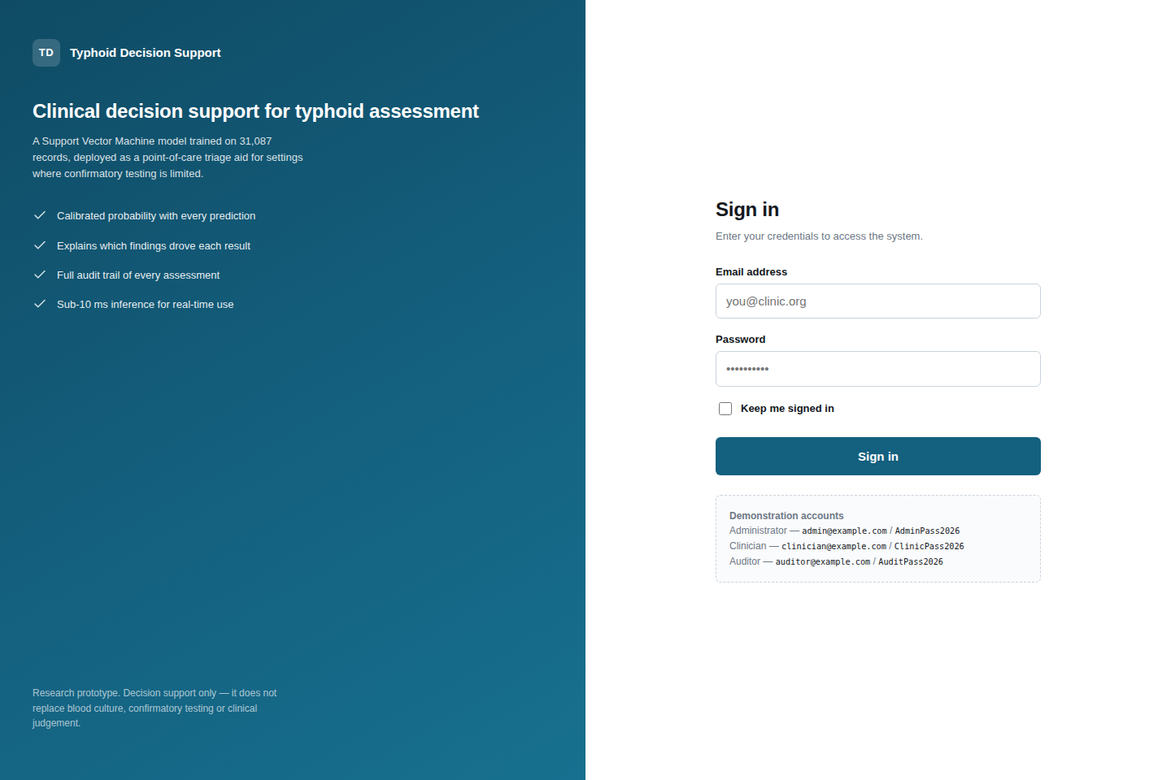
Plate C.1. Authentication page.
Plate C.2. Administrative system status page reporting model provenance and database health.
Plate C.3. Assessment form at a mobile viewport width of 390 pixels.
Note. Additional screenshots covering the clinician dashboard, patient register, activity log, validation errors and the 403 and 404 error pages are held in reports/screenshots/ in the source repository. Candidates preparing the bound copy should recapture these from the live instance on the date of submission.

C.4 Role-based access control
Table C.3: Roles and Permissions
Capability | Administrator | Clinician | Auditor
Register patients | Yes | Yes | No
Run assessments | Yes | Yes | No
View own assessments | Yes | Yes | Yes
View all assessments | Yes | No | Yes
Manage user accounts | Yes | No | No
View activity log | Yes | No | Yes
View system status | Yes | No | No

C.5 User acceptance test
Ten patient records were drawn from the held-out test partition, five typhoid and five disease-free, and entered into the deployed application through the clinician workflow. The expected output for each was computed in advance by running the record through the same prediction service the assessment form invokes. Table C.4 reports the outcome.
Table C.4: User Acceptance Test Results
Case | Recorded diagnosis | Expected and returned | Probability | Case type
1 | Typhoid | Typhoid | 1.0000 | Routine
2 | No Typhoid | No Typhoid | 0.0052 | Routine
3 | No Typhoid | No Typhoid | 0.0118 | Routine
4 | Typhoid | No Typhoid | 0.0053 | Known-difficult
5 | Typhoid | Typhoid | 0.9996 | Difficult, correctly identified
6 | No Typhoid | No Typhoid | 0.0147 | Routine
7 | Typhoid | Typhoid | 1.0000 | Routine
8 | Typhoid | No Typhoid | 0.0078 | Known-difficult
9 | No Typhoid | No Typhoid | 0.0186 | Routine
10 | No Typhoid | No Typhoid | 0.0260 | Routine
The deployed system reproduced the expected output in all ten cases, and its prediction agreed with the patient's recorded diagnosis in eight. Cases 4 and 8 are typhoid patients recorded with a fever duration of zero — the only patients in the dataset whose diagnosis cannot be read off a single attribute — and were included deliberately, with the expected disagreement declared in advance of the test. Case 5 is a third such patient whom the system identifies correctly, included so that the pack is not weighted towards failure.

C.6 Automated test coverage
Table C.5: Automated Test Suite by Module
Test module | Component under test | Cases
tests/test_data.py | Dataset loading, target construction, feature policy | 11
tests/test_pipeline.py | Preprocessing, SMOTENC, encoding, pipeline integrity | 10
tests/test_threshold.py | Threshold sweep, operating points, calibration | 12
tests/test_app.py | Prediction service and reference interface | 24
tests/test_webapp.py | Web application, security, database, deployment readiness | 77
tests/test_uat_pack.py | Acceptance pack agreement with the application | 24
Total |  | 158

C.7 Reproducing the study
The complete study can be reproduced from the repository with the following commands.
python -m venv .venv
.\.venv\Scripts\Activate.ps1 # Windows PowerShell
pip install -r requirements.txt

python scripts/audit_dataset.py # dataset integrity audit
python scripts/train_model.py --mode all --target binary
python scripts/baseline_rules.py # reference baselines
python scripts/threshold_analysis.py --policy all
python scripts/make_uat_samples.py # acceptance test pack
python -m pytest # 158 tests

$env:FLASK_APP = "run_dev.py"
python -m flask init-db
python run_dev.py # local server
Note. Training uses a fixed random seed of 42 and a stratified 80:20 partition, so every figure reported in Chapter Four is reproducible from these commands.

