02/02/2024

* Talked to Lisa about entering code talk
* Struggled to think about ideas

03/02/2024

* Came up with idea around getting notified for trains

04/02/2024

* Installed latest Android Studio
* Found page on getting Wear OS app going in emulator <https://developer.android.com/training/wearables/get-started/creating>
* Tried setting up emulator with Tiramisu, but laptop too poos to install (didn’t meet system requirements)
* Set up physical watch for debugging
  + adb pair *IP_ADDRESS*:*PORT*
  + adb connect 192.168.1.100:5555
* Used Bing image generator to make an icon
* Added icon into app
* Set up Metlink API
* Hit endpoints to get initial information

22/02/2024

* IRL testing with Herm

24/02/2022

* Began trying to understand how the base app works in more detail.
* Activity
  + What is an activity, seem to be quite important? Is it a class? Generally, one activity implements one screen in an app. <https://developer.android.com/guide/components/activities/intro-activities>
* Composable
  + A function within activities which can take a parameter and be responsible for rendering components. When a composable is executed, it is immutable and needs to be recalled with different parameter values to be updated.
* Frontend
  + Tried to make a button appear on screen. App was initially made with Compose, so buttons and stuff are defined in the activity. I then looked at tutorial (see linked) to add a button and that used a XML approach. **Began getting confused as I was struggling to see how this compose stuff feed into the XML part! This will be a good talking point in presentation**
    - Tutorial: <https://www.youtube.com/watch?v=r1P7slDbtd4>
    - Compose vs XML: <https://www.reddit.com/r/Kotlin/comments/11vm9o8/compose_ui_or_layouts/>
  + Google seems to recommend compose going forward, although I got button working with XML :’(
  + 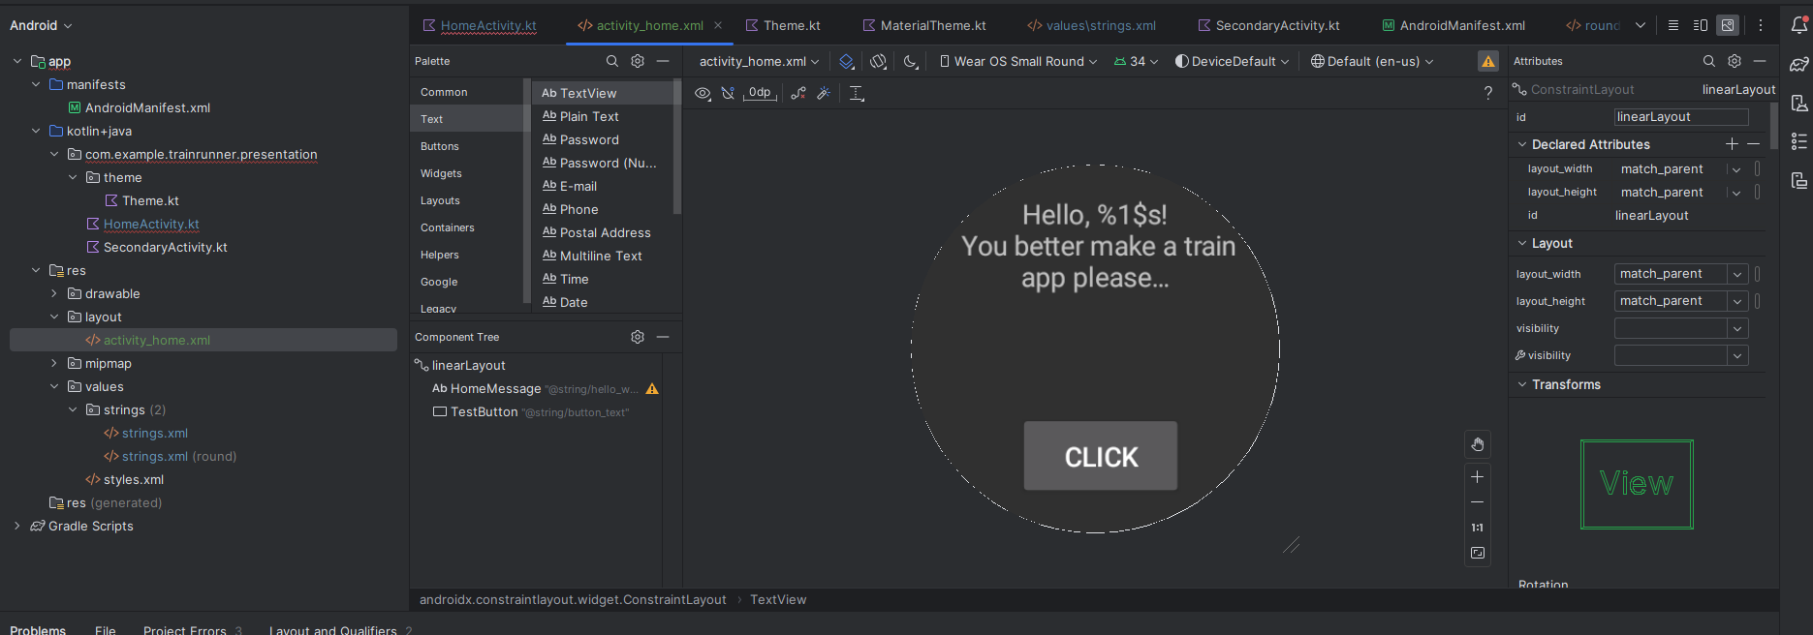
* Networking
  + Seeing if you can hit metlink api directly from app
  + <https://developer.android.com/training/wearables/data/network-access>
  + Also can traffic be proxied through phone viua bluetooth as my watch does not have 5G/data?