**CHAPTER 3: METHODOLOGY**

**3.1 Introduction**

This chapter explains how the facial recognition system was developed. Since deep learning models need a lot of computing power and accuracy, a well-organized approach was used. The process includes collecting data, preparing it, designing the system, building the model, and putting everything together for real-world use. Unlike regular software, which follows set rules, machine learning learns from patterns in data. Because of this, the development process was repeated multiple times to improve the model through training, testing, and fine-tuning.

**3.2 System Development Methodology**

The earliest systematic studies on the development of face recognition abilities were conducted by Goldstein and Chance, who tested school children across different age groups (as cited in Johnston & Ellis, 1995). In these experiments, children were first shown unfamiliar faces and later asked to identify them from a larger set. This aligns with the common observation that young children often make category-inclusive errors in facial recognition, much to their parents' embarrassment.

Johnston and Ellis (1995) explain that the origin of the multidimensional face space lies in the central tendency of its dimensions, with facial features varying normally around this point. To quantify distinctiveness, correlation coefficients were calculated between each face’s linear distinctiveness rating and its distance from the origin in the dimensional space. The authors argue that an exemplar-based model best explains the development of this face space.

This understanding of facial recognition development parallels modern deep learning approaches. Unlike traditional software development methods (e.g., waterfall or agile models), training neural networks is highly experimental. Therefore, a flexible, data-driven process structured around six key phases, was adopted to refine the facial recognition system.

**Phase 1: Data Collection and Preprocessing**

First, we gathered facial image data from an available dataset. (labelled faces in the wild) Since we didn’t have unlimited data, we made sure to include a variety of images so the model could recognize different faces accurately. The images were resized to a fixed size to keep things consistent during training. We also normalized pixel values (scaling them between 0 and 1) to help the model learn better. To make up for limited data, we used data augmentation techniques like rotating, flipping, and adjusting brightness to artificially increase the dataset and improve accuracy.

**Phase 2: System Design and Architecture Setup**

Before training the model, we planned the system’s structure. We chose TensorFlow as the deep learning framework and designed a recognition pipeline that could work in real-time and batch processing. We also decided on how to store and retrieve face data, using a simple file system instead of a full database. Another important step was designing the neural network’s feature extraction layers to help recognize faces more effectively.

**Phase 3: Model Development and Training**

Once the system was set up, we built the model using TensorFlow. We used a   
convolutional neural network (CNN) and trained it with the preprocessed dataset. To improve accuracy, we fine-tuned hyperparameters like batch size, learning rate, and the number of epochs (we ended up training for 50 epochs). We also added dropout layers and regularization techniques to prevent overfitting. The loss function used was categorical cross-entropy, optimized with Adam.

**Phase 4: Front-End and Back-End Integration**

After training the model, we connected it to a front-end and back-end system. The front-end provided a user interface where a group member could upload or capture images for recognition in real time. The back end processed the images, passed them through the trained model, and returned the results. We also used a second pre-trained model in the back end to verify users for added accuracy.

**Phase 5: Testing and Evaluation in Real-World Scenarios**

Once everything was integrated, we tested the system in real-life situations. We checked how well the model handled different lighting conditions, face angles, and image qualities. Standard evaluation metrics like accuracy, precision, recall, and confusion matrices were used to measure performance. Real-world testing also helped us identify challenges, such as false positives or difficulty recognizing faces in poor conditions.

**Phase 6: Final Deployment and Optimization**

Finally, we optimized the system for deployment. To make it run faster, we used   
techniques like model quantization and pruning. The model was then deployed to a suitable environment, such as a local server or cloud platform. Continuous monitoring and improvements were planned to keep the facial recognition system efficient and accurate over time.

**3.3 Crystallization of the Problem**

Facial recognition is a challenging task because faces can look different under various lighting conditions, angles, and image qualities. Unlike simple classification problems (like telling a cat from a dog), human faces have subtle differences that require deep learning to extract important features. This project tackled several key challenges:

•**Limited Data** – Deep learning models need a large and diverse dataset. Since we had limited resources, we used data augmentation (like flipping and rotating images) to create more variations.

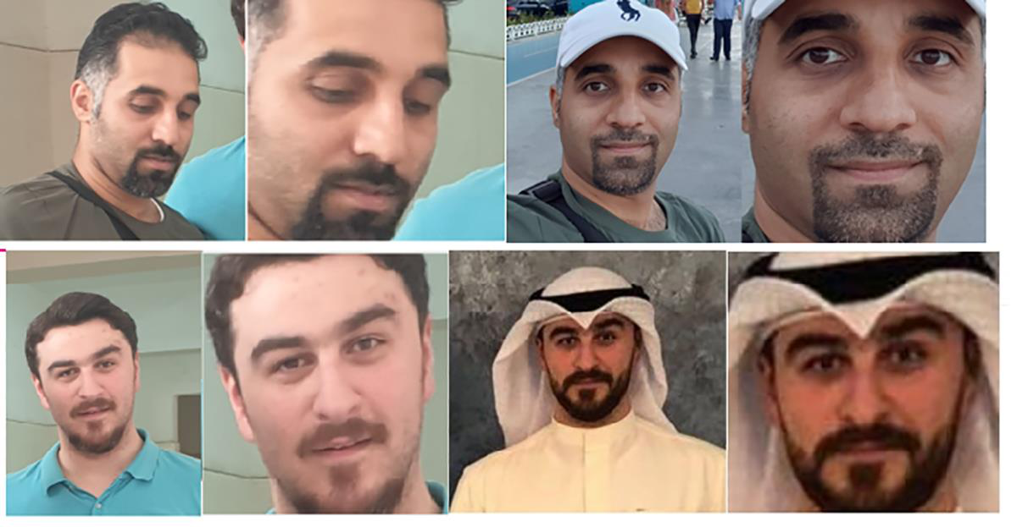

•**Preprocessing Complexity** – Faces had to be resized, normalized, and formatted consistently while keeping important details intact.

The study employed Deep Convolutional Neural Networks (DCNN) for robust facial representations, though performance was influenced by occlusions, expressions, lighting variations, and pose (AbdELminaam et al., 2020).

•**Computational Limits** – Training deep learning models requires a powerful GPU, which wasn’t always available. We used techniques like batch processing and model quantization to improve efficiency.

•**Real-Time Performance** – Unlike classifying static images, facial recognition needs to work quickly. We adjusted the model to reduce delay while keeping accuracy high.

•**Security and Privacy** – Since facial recognition involves sensitive data, we considered ethical issues related to storing and handling biometric information.

By overcoming these challenges, we aimed to build a reliable and efficient facial recognition system, even with some limitations.

**3.4 Requirements of the Proposed System**

A system is only as good as its foundation, and for this facial recognition model, the requirements set the limits and goals for what it should achieve. These requirements make sure the system is not just working in theory but also useful in real-world situations. Since deep learning models can be complex and facial recognition needs to work in real-time, the system must meet certain functional and non-functional requirements to be effective.

The system is designed to process facial images, extract key features, compare them to a trained dataset, and identify faces accurately. But it’s not just about recognition—it also needs to be fast, scalable, and secure. The requirements are divided into two categories:

•**Functional Requirements** – What the system must do (like detecting and recognizing faces).

•**Non-Functional Requirements** – How well the system must perform (like speed, accuracy, and security).

**3.4.1 Functional Requirements**

Functional requirements outline the key tasks the system must perform to achieve accurate and reliable facial recognition. These tasks ensure the model works as expected. The main functional aspects include:

**Image Acquisition and Input Handling**

The system should accept images from different sources, like live camera feeds and existing image datasets.

It must support common image formats (JPEG, PNG, BMP) and ensure they are compatible with processing.

**Preprocessing and Feature Extraction**

Input images should be resized, normalized, and, when needed, augmented to improve model performance.

The system must use Convolutional Neural Networks (CNNs) to extract facial features and convert them into numerical representations.

**Model Training and Learning**

The model should be trained using deep learning (TensorFlow/Keras) on a labeled dataset while reducing overfitting.

Data augmentation should be supported to help the model generalize better, especially when data is limited.

**Face Detection and Recognition**

The system must detect and identify faces in images or video feeds using an optimized classification algorithm.

It should handle tricky cases like poor lighting, different head angles, and partially hidden faces.

**Database and Storage Management**

A structured database (SQL or NoSQL) should store facial data and related metadata for easy access.

The system should retrieve stored data quickly to support real-time or near-real-time recognition.

**Integration with Front-End and Back-End**

The system should provide APIs or direct integration for front-end applications. A web or desktop interface should allow users to upload images, see recognition results, and manage records.

**Security and Access Control**

Strict authentication and authorization must be in place to prevent unauthorized access.

Stored facial data should follow ethical and legal standards, with encryption if needed for extra security.

**3.4.2 Non-Functional Requirements**

Aside from functionality, the system also needs to meet performance, usability, and scalability requirements to work well in real-world situations. These non-functional requirements determine how efficiently and effectively the system operates.

**Performance and Accuracy**

•The system should achieve at least **90% accuracy** on benchmark datasets. •It should process images quickly, ideally within **500ms per recognition task**. •False positives and false negatives should be minimized through proper model tuning.

**Scalability and Extensibility**

•The system should handle **larger datasets** and more users over time without slowing down.

•It should be flexible enough to support **future improvements**, like combining facial recognition with fingerprint or voice authentication.

**Usability and User Experience**

•The **interface should be simple and easy to use**, even for first-time users. •If errors occur (e.g., low-quality images), the system should give **clear feedback** so users know how to fix them.

**Security and Data Privacy**

•Stored facial data should be **encrypted** to prevent unauthorized access.

•The system must follow **legal guidelines** like GDPR when handling biometric data.

**Reliability and Availability**

•The system should be available **99.9% of the time** under normal conditions. •It should have backup options, like **cloud storage**, to prevent data loss from hardware failures.

**Compatibility and Integration**

•It should work on different platforms, including **Windows, Linux, and cloud-based**  **systems**.

•APIs should follow **standard RESTful formats** so they can easily connect with other applications.

**Ethical Considerations and Bias Mitigation**

•The model should be tested on **diverse datasets** to avoid racial, gender, or age bias.

•Ethical AI principles should be followed to **prevent misuse**, such as unethical surveillance.

These requirements help create a **reliable, secure, and fair** facial recognition system. By balancing strong functional features with well-defined non-functional goals, the system can perform efficiently and be ready for real-world use.

**3.4.3 Software Requirements**

•The effectiveness of a facial recognition system depends a lot on the software stack behind it. Every part from the machine learning framework to the back-end API needs to be carefully selected to ensure good performance, scalability, and easy maintenance. The software requirements outline the key technologies used to make the system work smoothly.

•**1. Programming Languages and Frameworks**

•**Python** – The main programming language, chosen for its powerful libraries and ease of use in deep learning.

•**TensorFlow/Keras** – Used for training and deploying the neural network, with GPU support when available.

•**OpenCV** – Helps with image processing, face detection, and handling video frames in real time.

•**Flask / FastAPI** – Runs the back-end API to process requests and return recognition results.

•**JavaScript (React / Vanilla JS)** – Used for front-end development to create an interactive and responsive UI.

•

**2. Development and Execution Environments**

•**Jupyter Notebook**: Primary environment for model experimentation, debugging, and visualization.

•**Google Colab**: Used for cloud-based training, leveraging free GPU resources to accelerate computation.

•**Local Development (VS Code / PyCharm)**: For integrating the trained model with the full system stack.

**3. Dependencies and Libraries**

•**NumPy, Pandas**: For handling numerical operations and dataset manipulation. •**Matplotlib, Seaborn**: Used for visualizing training progress, loss curves, and data distributions.

•**Dlib / Mediapipe**: Alternative face detection libraries in case OpenCV performance needs enhancement.

•**SQLite / PostgreSQL / Firebase**: Database options for storing user facial embeddings and metadata.

**4. Version Control and Deployment Tools**

•**GitHub / GitLab**: For version control, ensuring collaborative development and code backup.

•**Heroku / AWS / GCP**: Potential cloud deployment platforms for scaling the recognition service.

**5. Security Considerations**

•**SSL/TLS Encryption**: Ensures secure communication between the client, server, and database.

•**OAuth / JWT Authentication**: Provides role-based access control for managing user permissions.

By leveraging these technologies, the system remains **scalable, and efficient**, ensuring smooth development and deployment.

**3.5 Design of the System**

The design phase is where ideas are put together to build a working system. Everything, from how data moves to how users interact with the system, needs to be planned properly to avoid problems. A good design makes sure all parts of the system work well together for smooth facial recognition.

The system is built in separate parts, each handling a specific task but still working together as a whole.

**3.5.1 System Architecture**

The architecture follows a **three-layered design**, ensuring separation of concerns:

1.**Data Processing Layer** (Model Training & Preprocessing)   
a.Handles image preprocessing, data augmentation, and transformation. b.Facilitates model training, evaluation, and storage.

2.**Application Layer** (Face Recognition & API)   
a.Receives image input, processes embeddings, and performs classification. b.Exposes endpoints for front-end interaction (e.g., API call for face matching).

3.**Presentation Layer** (Front-End & User Interface)   
a.Provides a UI for users to upload images, view results, and manage data. b.Displays system feedback, such as recognition success/failure messages.

**3.5.2 Data Flow & Processing Pipeline**

The system follows a structured pipeline to ensure efficient face recognition:

**1.User uploads an image (or video frame is captured in real-time).**

**2.Image undergoes preprocessing:**   
 a.**Resizing & Normalization:** Converts input to a uniform format.

b.**Face Detection:** Identifies face(s) using OpenCV/Dlib.

c.**Feature Extraction:** Converts facial features into embeddings.

**3.Extracted features are passed through the trained deep learning model. 4.The model predicts the identity (or returns "unknown" for unregistered faces). 5.Results are returned via the API and displayed on the front-end.**

This **structured data flow** ensures that processing remains efficient, whether handling a **single image, batch processing, or real-time detection.**

**3.5.3 User Interaction & Interface Design**

•The user interface (UI) is designed for **efficiency, clarity, and ease of use**. The front-end must:   
 . Allow users to **upload an image** and receive instant recognition feedback.

. Display **real-time webcam recognition**, showing matched identities. . Provide an **admin panel** for managing stored faces and dataset updates. . Offer a **responsive design**, adapting to both desktop and mobile screens.

**3.5.4 Security & Performance Considerations**

**Data Privacy Measures:**

•Facial embeddings are stored in an **encrypted format** to prevent unauthorized access.

•The system avoids **sending raw facial data over networks**, instead using hashed representations.

**Performance Optimization:**

•Model inference is optimized for **low latency (<500ms per recognition request)**. •**GPU acceleration (TensorFlow/Keras)** ensures that the recognition system remains **scalable and efficient**.

**3.5.5 Flowchart**

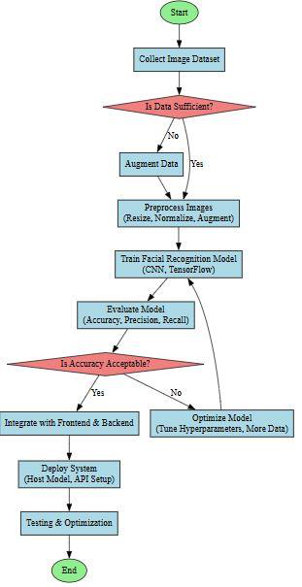

3.5.6 Entity Relationships

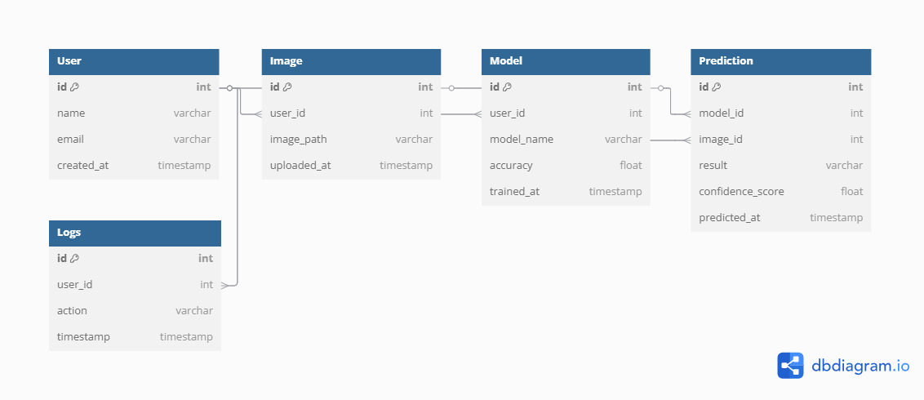

3.5.6 Data Flow

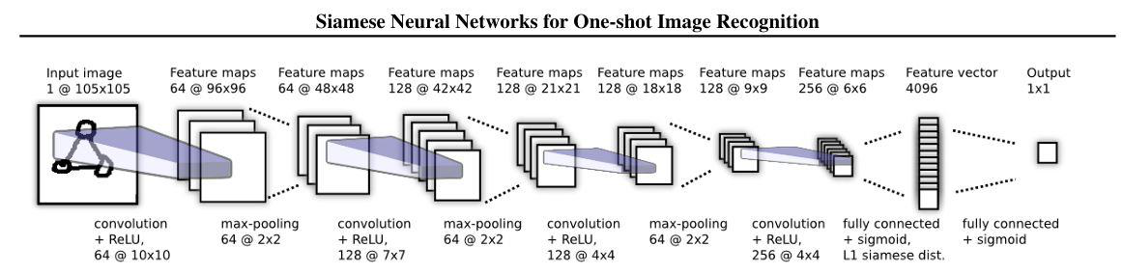

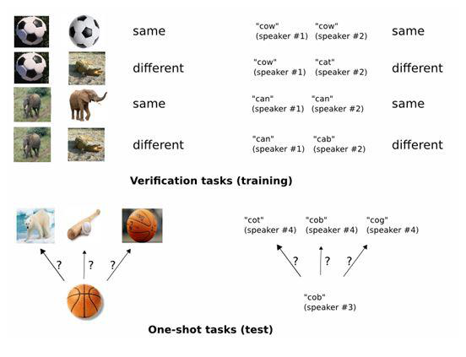

3..5.7 Use Cases

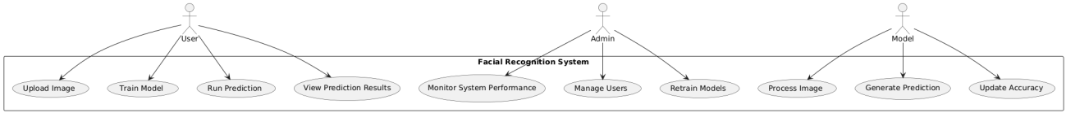

This chapter explained the step-by-step process of building the facial recognition system, from planning to implementation.

We started with collecting and preparing images by resizing, normalizing, and adding variations to improve the model. The system design covered how the front-end, back-end, and machine learning parts work together. Model training was done using TensorFlow, where the facial recognition model was built and improved. The next step was connecting the model to an easy-to-use interface so it could work in real-world situations. After that, we tested the system to find and fix any issues, making sure it was accurate and reliable. Finally, we worked on deploying and optimizing it for smooth performance.

This chapter also included diagrams like flowcharts, ERDs, DFDs, context diagrams, and use case diagrams to visually explain how the system works and how its parts connect.

Overall, the approach was well-planned and flexible, allowing each stage to be completed carefully, resulting in a working facial recognition system.