* Understand the data:

The Final cleaned dataset that has:

- 8248 observations

- 18 variables

- Variable type: Numeric

- Target column: “ForcastDemand”

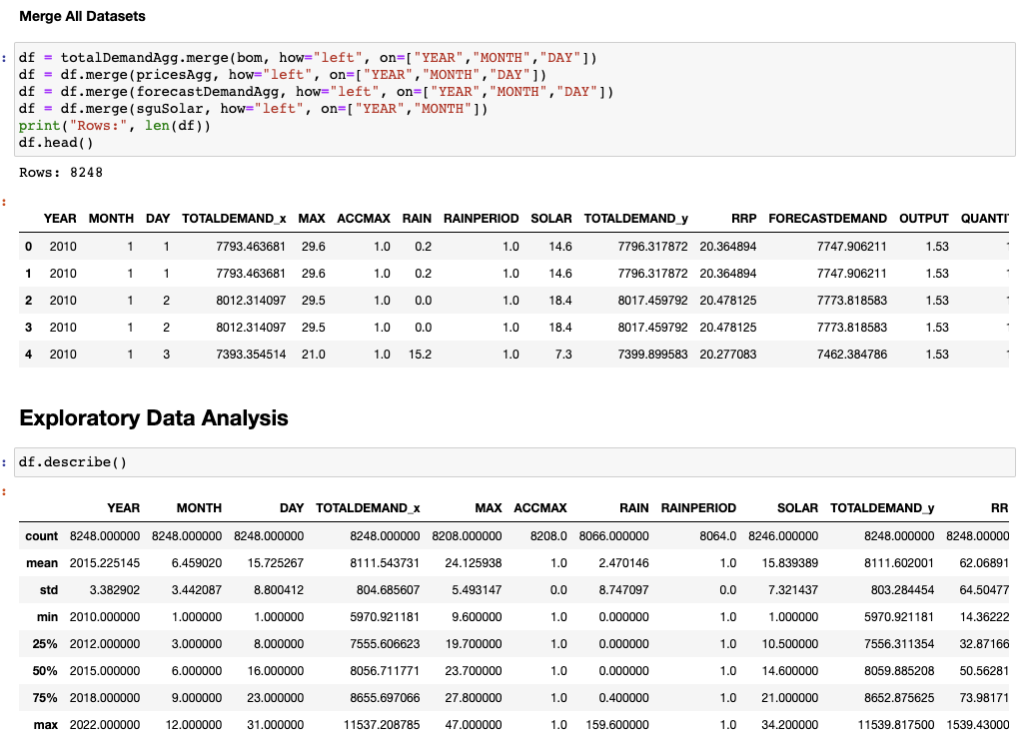

* Prepare data for modelling:

Max (Temperature) is directly related to the demand of electricity consumption as people tend to turn on air con/heater devices when temperature is too hot or too cold.

Solar OutputTotal has a definite impact on energy consumption as the more solar power generated, the electricity load is reduced

RRP Price should have a clear relationship with electricity consumption, saving when electricity price is high should be an understandable trend.

Rain should not have some effect on electricity consumption as well since because the weather dry or wet, people’s electricity demand is also fluctuated.

* Methodology: Ensemble method