From Zero to FEM
The Finite Element Method and the Tissue-Stiffness Simulation
Behind the Arthroscopy POC
A self-contained explainer — assumes no prior knowledge
Prepared for Daniel · Thesis POC
Arthroscopic Tissue Stiffness Estimation

Contents

0. How to read this document
This document explains two things from the ground up: (1) what the Finite Element Method (FEM) is and how it is implemented in your code, and (2) how the simulation works — the physics, the forces, and every calculation that turns a probe poke into the sensor numbers your model will learn from. It assumes you know basic algebra and a little calculus, but nothing about mechanics or FEM.
The structure mirrors the actual code in sim/. Each concept is introduced intuitively first, then formalized with the exact equations the code computes, and finally tied to the specific function and line that implements it. Wherever you see a grey box, that is real code or a real formula from your project.
The one-sentence summary
FEM turns a continuous, deformable object into a mesh of triangles, writes down the elastic energy stored when those triangles stretch, and the simulation finds the shape that minimizes total energy — that equilibrium shape is the physical answer, and the contact forces read off it become your training data.

1. The Finite Element Method (FEM)

1.1 The problem FEM solves
Imagine a block of soft rubber. Push a finger into it and it deforms: the material near the finger moves a lot, material far away barely moves, and everything in between settles into a smooth, continuous shape. Physically, the rubber arranges itself so that it is in mechanical equilibrium — every tiny piece of material has balanced forces acting on it.
We would like to predict that deformed shape. The honest description of the material is a continuum: infinitely many points, each able to move. The governing physics is a set of partial differential equations (the equations of elasticity) that hold at every one of those infinitely many points. We cannot solve that on a computer directly — a computer only handles finitely many numbers.
The core idea of FEM: replace the infinite continuum with a finite number of representative points (nodes), connected into simple shapes (elements — here, triangles). We only track how the nodes move. Inside each triangle, we assume the deformation varies in the simplest possible way (linearly). With finitely many node positions as our unknowns, the problem becomes solvable numerically.
Why "finite element"
"Element" = one of the small simple pieces (a triangle). "Finite" = there is a finite number of them, as opposed to the infinite continuum. The method is essentially: divide a hard continuous problem into many small easy ones, then stitch the answers back together.

1.2 The mesh: nodes, elements, and connectivity
The first step is to cover the object with a mesh. In your project the tissue is a 2-D rectangle, so the mesh is a set of points (nodes) joined into triangles. Each node has an (x, y) position. Each triangle is defined by which three nodes are its corners — this list of corner indices is called the connectivity.
In your code, two steps build this:
First, build_rectangle_mesh() in sim/tissue.py lays out a regular grid of points spaced grid_size apart (default 0.08) across a rectangle of width 2.0 and height 0.4. It separates them into boundary points (on the perimeter) and interior points.
xs = np.arange(0.0, width + grid_size*0.5, grid_size)
ys = np.arange(0.0, height + grid_size*0.5, grid_size)
# each (x, y) is classified as boundary or interior
Second, scipy.spatial.Delaunay (called in SoftShapeFiniteElement.__init__, sim/shapes.py) connects those points into triangles. Delaunay triangulation is a standard recipe that produces "well-shaped" triangles — it avoids long, thin slivers by maximizing the smallest angle in every triangle. Good triangle shape matters because skinny triangles make the numerical solution inaccurate and unstable.
tri = Delaunay(vertices)
self.triangles = tri.simplices # (n_tri, 3) array of node indices
From the triangles, the code also builds an edge list (self.links) — every unique pair of connected nodes. Edges are not used for the elastic energy in this FEM model (energy is computed per triangle), but they are kept for visualization and were inherited from the original spring-mass code.

1.3 Degrees of freedom and the displacement field
Each node can move in x and y, so it carries two degrees of freedom (DOF). If the mesh has N nodes, the entire state of the deformed object is a vector of 2N numbers. That vector is the single unknown we are solving for.
We distinguish two configurations of every node:
- Reference (rest) position, written X — where the node sits with no forces applied. In code: original_positions.
- Current (deformed) position, written x — where the node sits right now. In code: vertices (a PyTorch tensor with requires_grad=True).
The displacement of a node is simply u = x − X. When u = 0 everywhere, the object is undeformed and stores no energy. The whole job of FEM is to find the displacement of every node.
Where this lives in code
In SoftShape.__init__ (sim/shapes.py): self.vertices = torch.tensor(vertices, requires_grad=True) holds the current positions, and self.initial_vertices / original_positions hold the rest positions. Because vertices has requires_grad=True, PyTorch can differentiate the energy with respect to every node position — this is what makes the whole simulation work (Section 2.4).

1.4 Strain: deriving the measure of stretch
Energy is stored when material is stretched or sheared, not when it is merely moved. So we need a measure of local stretching that ignores rigid translation. That measure is strain. This section derives it, rather than just quoting it.

Step 1 — strain of a 1-D bar
Take a bar lying along x. A point originally at position x moves to x + u(x), where u(x) is the displacement. Consider a tiny segment from x to x + dx. Its two ends move by u(x) and u(x + dx). The new length is:
L_new = [ (x+dx) + u(x+dx) ] − [ x + u(x) ] = dx + [u(x+dx) − u(x)]
The fractional change in length — the definition of strain — is therefore
ε = (L_new − dx) / dx = [u(x+dx) − u(x)] / dx → du/dx (as dx→0)
So strain is the spatial derivative of displacement. A constant displacement (rigid shift) has zero derivative → zero strain, exactly as we want.

Step 2 — the three 2-D strain components
In 2-D the displacement has two components u = (u_x, u_y), each varying in both x and y. Repeating the line-element argument along x gives the normal strain ε_xx = ∂u_x/∂x; along y it gives ε_yy = ∂u_y/∂y. The third component is shear: how much an originally right angle between an x-line and a y-line closes. A small x-line tilts by the angle ∂u_y/∂x and a small y-line tilts by ∂u_x/∂y; the total loss of the right angle is their sum. Collecting all three:
ε_xx = ∂u_x/∂x ε_yy = ∂u_y/∂y γ_xy = ∂u_x/∂y + ∂u_y/∂x
These are stacked into the strain vector ε = [ε_xx, ε_yy, γ_xy]ᵀ. The shear term γ_xy here is the engineering shear strain (the full angle change), which is twice the tensor shear ε_xy = ½(∂u_x/∂y + ∂u_y/∂x). This "factor of 2" convention matters later when we write energy as ½ σᵀε (Step in 1.7), so keep it in mind.
The one approximation hiding in Step 1
We kept only the first derivative of u and dropped squared terms like (du/dx)². That is the small-strain (linear) assumption: valid when displacements gradients are small. The full nonlinear (Green–Lagrange) strain keeps those squares. Your code uses the linear form — accurate for the shallow ~4% pokes here, and the reason the whole energy ends up a clean quadratic. The CLAUDE.md flags this as a deliberate POC simplification.

1.5 Deriving the B-matrix from shape functions
Strain needs derivatives of displacement, but we only store displacement at the three corner nodes. The bridge is an interpolation rule: assume the displacement varies linearly inside the triangle. This section derives, from that single assumption, the exact matrix your code builds.

Step 1 — linear interpolation and shape functions
Write the x-displacement field inside the triangle as a general linear function of position:
u_x(x, y) = a + b·x + c·y
We have three knowns: the displacement equals u_x1, u_x2, u_x3 at the three corners (x₁,y₁), (x₂,y₂), (x₃,y₃). Three equations, three unknowns (a, b, c). Rather than solve for a, b, c directly, we re-express the result as a weighted sum of the nodal values:
u_x(x, y) = N₁(x,y)·u_x1 + N₂(x,y)·u_x2 + N₃(x,y)·u_x3
The weights N_i(x,y) are the shape functions. Each is the linear function that equals 1 at its own node and 0 at the other two (so the formula reproduces the nodal values exactly). Solving the 3×3 system gives the closed form, for nodes in cyclic order (i, j, k):
N_i(x,y) = ( α_i + β_i·x + γ_i·y ) / (2A)
with the geometric coefficients:
β_i = y_j − y_k γ_i = x_k − x_j α_i = x_j·y_k − x_k·y_j
and 2A = det( [[1, x₁, y₁], [1, x₂, y₂], [1, x₃, y₃]] ) — twice the signed triangle area. (You can verify N_i = 1 at node i and 0 at the others by substituting the coordinates.) The same shape functions interpolate u_y with the same weights.

Step 2 — differentiate to get strain
Because each N_i is linear, its derivatives are constant over the whole triangle:
∂N_i/∂x = β_i / (2A) = (y_j − y_k)/(2A) ∂N_i/∂y = γ_i / (2A) = (x_k − x_j)/(2A)
Now plug the interpolation into the strain definitions from 1.4:
ε_xx = ∂u_x/∂x = Σ_i (∂N_i/∂x)·u_xi = Σ_i (y_j − y_k)/(2A) · u_xi
ε_yy = ∂u_y/∂y = Σ_i (∂N_i/∂y)·u_yi = Σ_i (x_k − x_j)/(2A) · u_yi
γ_xy = ∂u_x/∂y + ∂u_y/∂x = Σ_i [ (x_k − x_j)·u_xi + (y_j − y_k)·u_yi ] / (2A)
Since the strain came out constant, this element is the Constant Strain Triangle (CST) — the simplest 2-D finite element.

Step 3 — package as ε = B·d
Stack the three node displacements into d = [u_x1, u_y1, u_x2, u_y2, u_x3, u_y3]ᵀ and read the coefficients above off into a 3×6 matrix B so that ε = B·d. For each corner i (block of two columns 2i, 2i+1):
row 0 (ε_xx): B[0, 2i] = (y_j − y_k)/2A
row 1 (ε_yy): B[1, 2i+1] = (x_k − x_j)/2A
row 2 (γ_xy): B[2, 2i] = (x_k − x_j)/2A , B[2, 2i+1] = (y_j − y_k)/2A
That is exactly the code in _strain_energy (sim/shapes.py), which builds the numerators first and divides by 2*area at the end:
area = 0.5 * |det([[1, x1, y1],
[1, x2, y2],
[1, x3, y3]])| # = A (true area)

for i in range(3): # j = i+1, k = i+2 (cyclic)
B[0, 2i] = y_j - y_k # β_i → ε_xx
B[1, 2i+1] = x_k - x_j # γ_i → ε_yy
B[2, 2i] = x_k - x_j # γ_i → shear (u_x part)
B[2, 2i+1] = y_j - y_k # β_i → shear (u_y part)
B = B / (2 * area) # divide by 2A
The takeaway
B is pure rest-geometry — it depends only on the triangle's reference corner coordinates, never on the current deformation. So the code computes it from original_positions and it is effectively constant per triangle. Multiply B by the live displacement and you get strain; that is the only place node motion enters the elastic energy.

1.6 Deriving the material matrix D (plane stress)
Stress (symbol σ) is internal force per unit area — how hard the material pushes back when strained. The law linking stress to strain is the constitutive law, and it carries the material properties. We derive the exact matrix the code uses.

Step 1 — the two material constants
- Young's modulus E — stiffness. Pull a bar with stress σ and it strains ε = σ/E; large E means stiff. This is the per-zone quantity the whole project recovers. Range here: [0.002, 0.02].
- Poisson's ratio ν — when you stretch a material along one axis it contracts on the other by a fraction ν. Default 0.45, near-incompressible (soft tissue/rubber; 0.5 = perfectly incompressible).

Step 2 — Hooke's law, written strain-from-stress
The experimental facts above, superposed for a 2-D state of stress (σ_xx, σ_yy, σ_xy), give strain as a function of stress. Stretching along x adds σ_xx/E to ε_xx; the perpendicular stress σ_yy contracts x by −ν·σ_yy/E; and shear obeys γ_xy = σ_xy/G with shear modulus G = E / [2(1+ν)]. This is the plane-stress assumption (a thin sheet free to thin out through its thickness, so σ_zz = 0):
ε_xx = (σ_xx − ν·σ_yy) / E
ε_yy = (σ_yy − ν·σ_xx) / E
γ_xy = σ_xy / G = 2(1+ν)·σ_xy / E

Step 3 — invert to get stress-from-strain
The energy formula needs stress from strain, i.e. σ = D·ε, so we invert the system above. The first two equations form a 2×2 system in (σ_xx, σ_yy); solving (multiply, add, eliminate) gives
σ_xx = E/(1−ν²) · (ε_xx + ν·ε_yy)
σ_yy = E/(1−ν²) · (ε_yy + ν·ε_xx)
and the shear equation inverts directly to σ_xy = G·γ_xy = E/[2(1+ν)] · γ_xy. To match the E/(1−ν²) prefactor of the other two rows, rewrite 1/[2(1+ν)] = (1−ν) / [2(1−ν²)] (since 1−ν² = (1−ν)(1+ν)). Then all three rows share the same prefactor and assemble into one matrix:
D = E / (1 − ν²) · [ [1, ν, 0], [ν, 1, 0], [0, 0, (1−ν)/2] ]
which is precisely the code (sim/shapes.py):
D = (E / (1 - nu**2)) * torch.tensor([
[1, nu, 0],
[nu, 1, 0],
[0, 0, (1 - nu) / 2],
])
Why E sits out front as a multiplier
E multiplies the entire D matrix, so the strain energy of every triangle (next section) is directly proportional to its Young's modulus. A stiff zone stores more energy for the same deformation, so at equilibrium it deforms less under the same probe push. That difference in deformation is what produces different contact forces — and therefore what makes stiffness learnable from the sensor signal.

1.7 Deriving the strain energy and stiffness matrix
A stretched spring stores energy ½ k x². The elastic continuum generalizes this. We derive the triangle's energy from scratch, then connect it to the code — and find an instructive factor-of-2.

Step 1 — energy density
For a 1-D spring, energy is the area under the force–extension line, ½ (force)(extension). Per unit volume, the analogue is ½ × stress × strain. In 2-D with all components, the strain energy density (energy per unit volume) is the sum over components:
w = ½ ( σ_xx·ε_xx + σ_yy·ε_yy + σ_xy·γ_xy ) = ½ · σᵀε
The single dot product σᵀε equals that sum precisely because we used the engineering shear γ_xy (from 1.4): the tensor form would read σ_xx ε_xx + σ_yy ε_yy + 2σ_xy ε_xy, and 2ε_xy = γ_xy absorbs the 2. This is why the convention was worth tracking.

Step 2 — integrate over one triangle
Total energy is the density integrated over the body, U = ∫ w dV. For one CST triangle, ε and σ are constant (Section 1.5), so the integral is just the density times the triangle's volume = area A × thickness t. Taking unit thickness t = 1:
U_e = ½ · σᵀε · A = ½ · (D·ε)ᵀ ε · A
Substituting ε = B·d and using the symmetry of D gives the compact quadratic form
U_e = ½ · dᵀ ( Bᵀ D B · A ) d = ½ · dᵀ K d , K = Bᵀ D B · A
K is the element stiffness matrix. Summed over all triangles, the whole tissue energy is one big quadratic U(d) = ½ dᵀ K_global d — and minimizing a quadratic is the entire mathematical content of linear-elastic FEM.

Step 3 — match the code, and a factor-of-2
The code (_strain_energy) computes exactly the Step-1/2 chain:
disp = v_cur.flatten() - v_ref.flatten() # d (6-vector)
strain = B @ disp # ε = B d
stress = D @ strain # σ = D ε
energy += 0.5 * dot(stress, strain) * 2 * area
Here area is the true area A, and B already includes the 1/(2A) factor. So dot(stress, strain) is σᵀε, and the code evaluates ½ · σᵀε · (2A) = σᵀε · A. The derivation in Step 2 gives ½ · σᵀε · A. The code is therefore exactly twice the textbook strain energy (with unit thickness).
Does the factor-of-2 matter? (worth a line in the thesis)
It is a single global constant multiplying all strain energy. On its own it would not move the energy minimum. But the total energy also contains the collision penalty k·p² (Section 2.3), which is not scaled. So the practical effect is that the tissue behaves as if every Young's modulus were doubled relative to the contact stiffness k — equivalently, the simulated tissue is ~2× stiffer than the labeled E suggests.
For the POC this is benign: the same factor applies to every experiment, so the forces→stiffness map the network learns is still well-defined and the relative stiffness profile is unaffected. It only means the absolute E values are not physically calibrated (and k is a free knob anyway). If you ever want physically meaningful moduli, change 2 * area to area. Note the original code comment claiming “the two cancel” is not correct — they do not.

1.8 Equilibrium = minimum energy (and where K d = f comes from)
The principle that ties it together is the principle of minimum total potential energy: a stable elastic system at rest settles into the configuration that minimizes its total potential energy
Π(d) = U(d) − Wₑₓₜ = ½ dᵀ K d − fᵀd
where U = ½ dᵀKd is the stored strain energy (1.7) and Wₑₓₜ = fᵀd is the work done by external/applied forces f (here, contact).

Deriving the equilibrium condition
A minimum of Π occurs where its gradient with respect to the free displacements vanishes. Differentiating the quadratic (using ∂(½dᵀKd)/∂d = Kd for symmetric K, and ∂(fᵀd)/∂d = f):
∂Π/∂d = K d − f = 0 ⟹ K d = f
This is the classical FEM linear system: stiffness × displacement = force. Classical solvers form K and solve it directly with linear algebra. The ∂U/∂d = Kd term is itself the vector of internal elastic forces on the nodes — so “gradient of energy” and “force” are literally the same thing, a fact the sensor model reuses (Section 2.5).
Why this project minimizes instead of solving K d = f
Your code never assembles K. It keeps the energy as a Python function and slides the node positions downhill with gradient descent (Adam), letting PyTorch autodiff supply ∂E/∂d (Section 2.4). Both routes reach the same equilibrium. The optimization route is chosen because (a) contact is a conditional, nonlinear force that does not fit a fixed linear K cleanly, (b) PyTorch gives all gradients for free, and (c) per the CLAUDE.md it leaves the door open to differentiating through the whole simulation later (e.g. to fit material parameters by autodiff).

1.9 Boundary conditions
A minimization needs constraints, or the object would just float away or collapse. The constraint here is a Dirichlet boundary condition: the bottom edge of the tissue is pinned in place (it models tissue anchored to bone). Those nodes are not allowed to move.
In code this is done with fixed_vertices_idx (the bottom-edge nodes, where y ≈ 0) and a frozen_mask. The mask is 0 for fixed DOF and 1 for free DOF:
self.frozen_mask = torch.ones_like(self.vertices)
self.frozen_mask[self.fixed_vertices_idx] = 0
# ... later, during optimization:
s.vertices.grad *= s.frozen_mask # zero out gradient on fixed nodes
Zeroing the gradient on the fixed nodes means the optimizer never moves them — they stay welded to their rest position while the rest of the tissue deforms around the probe. The probe's own nodes are similarly frozen (it is treated as rigid; Section 2.2).
FEM in one paragraph (recap)
Cover the object in triangles. Each triangle's stretch (strain ε = B d) and internal force (stress σ = D ε) follow from its node displacements through pure-geometry matrix B and material matrix D (which carries Young's modulus E). Each triangle stores energy ½ σ·ε·A; sum over all triangles for the total energy U(d). Pin the fixed nodes. The physical deformed shape is the one that minimizes U. Recover forces from that shape.

2. The simulation
Part 1 covered a single static deformation. The simulation wraps that in time: it moves a probe step by step, re-solves the equilibrium at every step, and reads off the contact forces. This section walks through every moving part and every calculation, in the order the code performs them.

2.1 The cast: tissue and probe
A simulation is created from exactly two bodies (SoftObjectSimulation asserts len(shapes) == 2):
- shapes[0] — the tissue: a SoftShapeFiniteElement, the deformable FEM body from Part 1. Rectangle 2.0 × 0.4, bottom edge fixed, divided into 5 stiffness zones.
- shapes[1] — the probe: a SoftShapeSpringMass, a small circle of 8 vertices (radius 0.05), treated as a rigid body. It is the simplified arthroscope tip.

The tissue's stiffness zones — the labels
The rectangle is split along x into n_zones (=5) equal columns. Each zone gets one Young's modulus sampled uniformly in [E_min, E_max] = [0.002, 0.02] (sample_zone_stiffness). set_zone_stiffness then assigns each triangle the E of whichever zone its centroid falls into:
for i, tri in enumerate(self.triangles):
centroid_x = vertices_np[tri, 0].mean()
# find which zone [x_lo, x_hi) the centroid is in
self.young_modulus[i] = zone_young_moduli[that_zone]
A small per-triangle random variation (young_modulus_var = 0.0002) and Poisson variation are added so the material is not perfectly uniform within a zone — mild realism / regularization. The 5 zone moduli are the ground-truth label vector the model must predict.

2.2 The probe: a rigid body driven by a trajectory
The probe is built by create_circular_probe: 8 points evenly spaced on a circle, and crucially all of its vertices are fixed (fixed_vertices_idx = all indices). "Fixed" here means the energy optimizer cannot deform it — it has no internal squishiness that matters. Instead its position is driven externally by a trajectory.
A trajectory (sim/trajectory.py) returns a velocity (v_x, v_y) at each time. Each simulation step advances the probe's fixed nodes by velocity × dt (update_positions):
vel = self.trajectory.step(dt) # (vx, vy)
self.vertices[fixed_idx] += dt * vel # rigid translation
For a poke, the code uses two TwoPointTrajectory segments: one driving the probe straight down from a hover point to tissue_top − penetration_depth, and one driving it back up (generate_dataset.py). A constant velocity over time T means the probe descends smoothly across the frames of the poke.
Hover and penetration geometry
From generate_dataset.py: hover_height = radius * 3 = 0.15 (start above the surface) and penetration_depth = radius * 0.8 = 0.04 (target depth below the surface). The probe begins clear of the tissue, descends into contact, presses to the target depth, then withdraws — one full poke.

2.3 Contact: the collision penalty
Nothing in the strain energy of Part 1 stops the probe from passing straight through the tissue — they are two independent bodies. Contact is enforced by adding a collision penalty energy: whenever a probe vertex dips below the tissue's (deformed) top surface, we add an energy that grows with how far it has penetrated. The optimizer, trying to minimize total energy, then pushes the surface down/out of the way and the probe up, until they reach a contact equilibrium.
The penalty, per penetrating probe vertex (inside _minimize_energy):
E_collision = k · (penetration)² penetration = surface_y − probe_y
top_edge_verts = tissue.vertices[self._top_edge_idx] # tensor, keeps grad
for v in probe.vertices[probe.boundary_idx]:
vx = v[0].item()
if not (tissue_x_min <= vx <= tissue_x_max):
continue
nearest = (top_edge_verts[:,0] - vx).abs().argmin() # closest surface node
surface_y = top_edge_verts[nearest, 1] # deformed surface height
penetration = surface_y - v[1]
if penetration.item() > 0:
energy = energy + k_collision * penetration**2
Three things to notice. First, k_collision (=0.02) is a penalty stiffness — like a very stiff spring that only activates on overlap. It is the classic penalty method for contact: instead of a hard non-penetration constraint, you allow a tiny overlap and pay a quadratic energy price for it. Second, surface_y is taken from the live tissue tensor (not detached), so the penalty's gradient flows back into the tissue nodes — pushing the surface down realistically. Third, the comparison uses the deformed top-edge height, re-sliced fresh each optimizer call so the contact tracks the surface as it sinks.

Deriving the contact force from the penalty energy
Force is minus the gradient of energy (a ball rolls down the steepest energy slope). The probe vertex sits at height y_probe, and penetration is p = y_surface − y_probe. The contact energy for that vertex is E = k·p². The vertical force on the probe is
F_y = −∂E/∂y_probe = −(dE/dp)·(∂p/∂y_probe) = −(2k·p)·(−1) = +2k·p
The chain rule supplies two factors: dE/dp = 2k·p, and ∂p/∂y_probe = −1 (pushing the probe up reduces penetration). The two minus signs make the force positive (upward) — the tissue pushes the probe out. This is exactly the value the sensor model reports, Fy = 2 * k_collision * penetration. So the measured force is the true gradient of the energy that was minimized: physics and measurement are one and the same, by construction.
This is also why the units/scale are coupled to k
Because F_y = 2k·p, the absolute force scale is set jointly by the penalty stiffness k_collision (=0.02) and the equilibrium penetration p. Combined with the strain-energy factor-of-2 from Section 1.7, the absolute forces are not physically calibrated — but they are perfectly consistent across the dataset, which is what learning needs.

2.4 Solving for equilibrium: energy minimization with Adam
At each frame, after the probe moves, the code finds the new equilibrium by minimizing the total energy
E_total(positions) = U_strain(tissue) + Σ E_collision
over all free node positions. Rather than solving K d = f directly, it uses gradient descent via PyTorch's Adam optimizer (_minimize_energy). This is the heart of the engine:
optimizer = torch.optim.Adam([s.vertices for s in shapes],
lr=learning_rate,
betas=(beta1, beta2))
def closure():
optimizer.zero_grad()
energy = sum(s.internal_energy() for s in shapes) # strain energy
energy = energy + collision_penalty # contact
energy.backward() # autodiff gradient
# freeze fixed DOF and kill NaNs
s.vertices.grad[isnan] = 0
s.vertices.grad *= s.frozen_mask
return energy
for _ in range(steps):
energy = optimizer.step(closure)
# early stop when improvement < 0.1% for 5 steps
Step by step, what happens each optimizer iteration:
- zero_grad() clears old gradients.
- Total energy is computed: strain energy of the tissue (Part 1) plus the collision penalty (2.3).
- energy.backward() — PyTorch automatic differentiation computes ∂E/∂(every node position) for free. This is why vertices needed requires_grad=True; the gradient is the elastic+contact force on each node.
- The gradient on fixed nodes (bottom of tissue, all of the probe) is multiplied by 0 via frozen_mask, so they never move. NaNs are zeroed for stability.
- optimizer.step() nudges every free node a little way downhill in energy. Repeat.
After enough steps, the nodes stop moving (energy stops dropping) — that is the equilibrium shape. The code detects this with an early-stopping rule: if the energy improves by less than 0.1% for 5 consecutive steps, it returns early. Otherwise it runs up to steps (=500) iterations and warns if it never converged.
Adam settings and the warm-up
Defaults: learning_rate=0.001, beta1=0.2, beta2=0.999. The unusually low beta1 (vs. the typical 0.9) means less momentum — appropriate here because we want the positions to settle precisely, not overshoot. With warmup=True the optimizer first runs 5 steps at double the learning rate to move quickly out of the initial overlap, then drops back to the normal rate to settle.
Why optimization instead of solving K d = f?
For pure linear elasticity, the direct solve is faster and exact. But contact is a nonlinear, conditional force (it only acts when penetration > 0 and only on the surface that happens to be in contact). Phrasing everything as "minimize this energy" handles that conditional contact gracefully, lets PyTorch supply all gradients automatically, and — per the CLAUDE.md — keeps the door open to differentiating through the whole simulation later (e.g. for learning material parameters by autodiff).

2.5 The sensor model: from shape to (Fx, Fy, Mz)
Once the frame is at equilibrium, the simulation reads a force/torque measurement. This mimics a sensor on the probe handle. get_sensor_reading() computes a 3-vector per probe vertex; get_aggregated_sensor() sums them into one (Fx, Fy, Mz) per frame.
Per probe vertex:
- Find the tissue surface height directly above the vertex (nearest top-edge node in x), and compute penetration = surface_y − vertex_y.
- If the vertex is in contact (penetration > 0), the tissue pushes it up:
F_x = 0 F_y = 2 · k_collision · penetration
- Add small Gaussian sensor noise (probe_force_noise_std = 1e-4) to Fx and Fy.
- Compute the moment about the probe center from the vertex's offset (dx, dy):
M_z = F_x · dy − F_y · dx
penetration = surface_y - vy
if penetration > 0:
fx = 0.0
fy = 2.0 * k_collision * penetration
fx += randn() * noise_std
fy += randn() * noise_std
dx, dy = v - probe_center
mz = fx*dy - fy*dx
# aggregated: readings.sum(axis=0) -> (Fx_total, Fy_total, Mz_total)
Why F_y = 2k·p: as derived in 2.3, this is exactly −∂E/∂y of the contact energy k·p² — the real reaction force. F_x ≈ 0 because a vertical poke on a roughly horizontal surface produces almost no sideways force (only the noise term makes it nonzero).

Deriving the moment Mz, and the lever arm
A moment (torque) is force times perpendicular distance: M = r × F, which in 2-D for a force (F_x, F_y) applied at offset (dx, dy) from the reference point is the scalar
M_z = dx·F_y − dy·F_x (code writes the equivalent F_x·dy − F_y·dx)
Here (dx, dy) = vertex − probe_center is each contact vertex's offset from the point the moment is taken about — the probe center. So the lever arm in this model is the distance from the probe center to the contact vertex. Since the probe is a circle of radius 0.05 with 8 vertices, that distance is at most one radius: |dx|, |dy| ≤ 0.05. The torque magnitude is therefore on the order F_y × 0.05 — which is why the Mz traces in the figures sit around 1e-5 while Fy is around 1e-3.
The moment Mz is the informative part
On uniform tissue the contact is left-right symmetric about the probe center: the +dx and −dx vertices carry equal upward Fy, their dx·F_y contributions cancel, and Mz ≈ 0. But when the probe straddles a stiff/soft zone boundary, the soft side sinks deeper → larger penetration → larger upward Fy on that side → the cancellation breaks → net torque. A non-zero Mz is thus a direct signal that the probe sits over a stiffness transition, helping the model localize zone boundaries.

Distance between the sensor and the touching point
This deserves emphasis because it is the biggest gap between the simulation and the real instrument.
In the simulation: the "sensor" is taken at the probe_center — the centre of the little 8-vertex circle. The tissue is touched by the lowest probe vertices, about one radius below that centre. So the distance between the sensor point and the contact point is roughly one probe radius ≈ 0.05 sim-units (the same number that serves as the moment lever arm above). The contact point itself is reported by get_contact_point() as the centroid of the probe vertices currently inside the tissue.
In the real device: the force/torque sensor is mounted on the external, non-sterile handle of the probe, while the tip touches tissue deep inside the joint. The sensor-to-contact distance is the whole shaft length (~10–20 cm), not one tip radius. To get what such a sensor reads, you transform the tip contact wrench (force + moment) up to the handle. Two rules govern that transform, and only one of them involves distance:
- Force is unchanged by distance. For a rigid shaft in quasi-static equilibrium the force balance ΣF = 0 gives F_sensor = F_contact = Σ fₙ — no length term. The handle feels the same net (Fx, Fy) as the tip; the shaft just transmits it (push a rigid rod with 10 N, it pushes back with 10 N). So a sensor relocation must not scale or spread the forces.
- Only the moment shifts, via the lever arm. Mz_sensor = Σ[(pxₙ−sx)·fyₙ − (pyₙ−sy)·fxₙ]. For a vertical shaft with the sensor at s ≈ (cx, cy+L) this is Mz ≈ Σ(pxₙ−cx)·fyₙ + L·Σfxₙ. The shaft length L multiplies only the lateral force Fx — the axial force Fy still acts through the small lateral offset, not L.
The catch, and the fix
Because the current model is frictionless and vertical, Fx ≈ 0, so the L·Fx term vanishes and moving the sensor up the shaft changes Mz by almost nothing. So the fix is two coupled changes: (1) add a tangential friction force (Coulomb Ft = −μ·Fn, config friction_coeff, default 0) so Fx is physically nonzero; (2) add a shaft_length L and compute Mz about the sensor (cx, cy+L) with the formula above, leaving forces unchanged. With both off it reproduces today's output exactly. (The portal/cannula reaction — a sideways force on the shaft that would break F_sensor = F_contact — is left as later work.)

2.6 One frame, one poke, one experiment, one dataset
The pieces nest like Russian dolls. From innermost to outermost:

A frame — SoftObjectSimulation.step()
Move the probe one dt along its trajectory, then re-minimize energy to equilibrium. One frame = one probe position fully resolved.
def step(self):
for s in self.shapes: s.update_positions(self.dt) # move probe
self._minimize_energy(steps=self.config.steps) # re-solve

A poke — descend then withdraw
In generate_dataset.py, each poke at position x is two trajectory segments — frames_per_poke // 2 frames going down and the same number coming back up. Before each poke the tissue is reset to its rest shape with tissue.reset_positions(), so pokes are independent measurements. The sensor reading from every frame is collected into a (frames_per_poke, 3) array.

An experiment — a full scan
One experiment = one tissue (one random stiffness profile) scanned at num_scan_positions (=10) evenly-spaced x-positions across the width (scan_probe_positions, avoiding the edges by a margin). Stacking the pokes gives the experiment's input tensor:
sensor_array shape = (n_positions, frames_per_poke, 3)
Saved to disk per experiment: sensor_log.pkl (the input), label.npy (the 5 zone moduli — the target), x_positions.npy, and config.yaml. A done.txt marker lets generation resume without redoing finished experiments.

A dataset — many experiments in parallel
generate_dataset() runs num_experiments of these across a multiprocessing pool (num_processes workers). Each worker seeds its own RNG from the experiment index (np.random.default_rng(start_index + exp_idx) and matching torch/np seeds) so the dataset is reproducible and every experiment gets a different random stiffness profile. The result is a folder of experiments later compiled to HDF5 by data/preprocess.py for training.
The full pipeline in one line
random stiffness profile → build FEM tissue → for each of 10 scan x's: reset, poke down+up (re-solving FEM contact equilibrium every frame) → record (Fx, Fy, Mz) per frame → stack into (10, frames, 3) input with the 5 moduli as label → repeat for thousands of tissues → HDF5 → train encoder–decoder to invert the map (forces → stiffness).

2.7 What a poke actually looks like
Your visualize_sim.py script already renders pokes as dashboards (saved in output/sim/). The frames below are taken from those runs. Top-left: the tissue mesh, colored by Young's modulus per zone (brighter = stiffer), with the probe (red circle) descending. Right: the live sensor traces — exactly the (Fy, Mz) curves described in Section 2.5. Bottom-left: the ground-truth zone stiffness profile (the label).
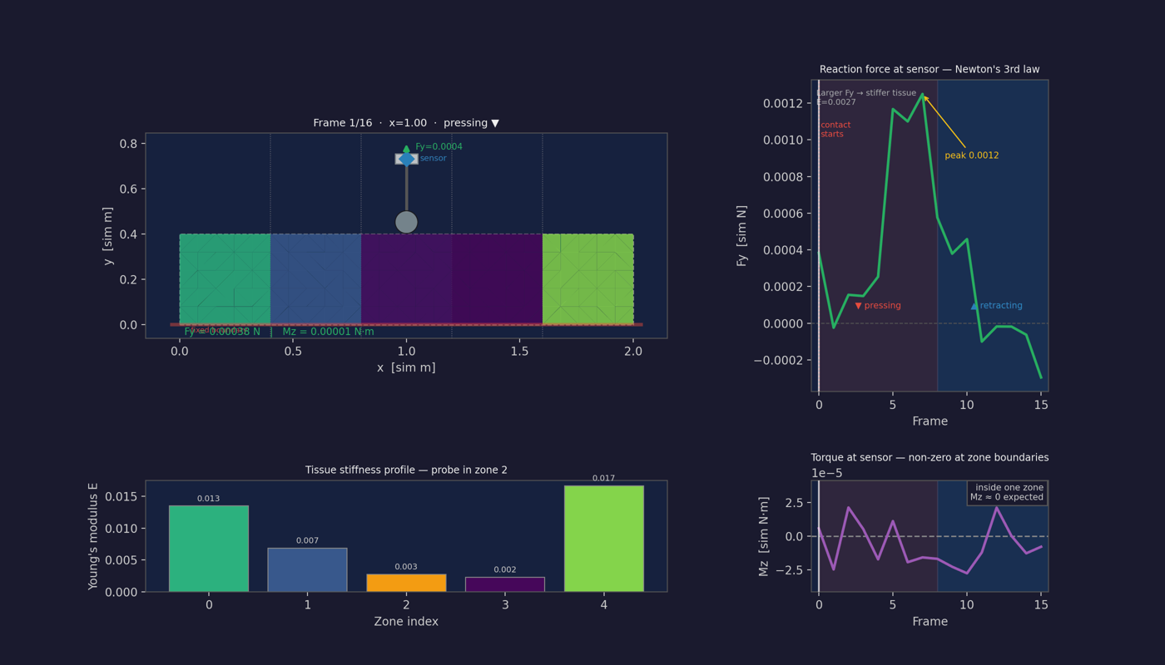
Figure 1 — Poke at x = 1.00 (zone 2), first frame: probe hovering above the surface, no contact yet (the trace panels on the right show the whole poke for reference).
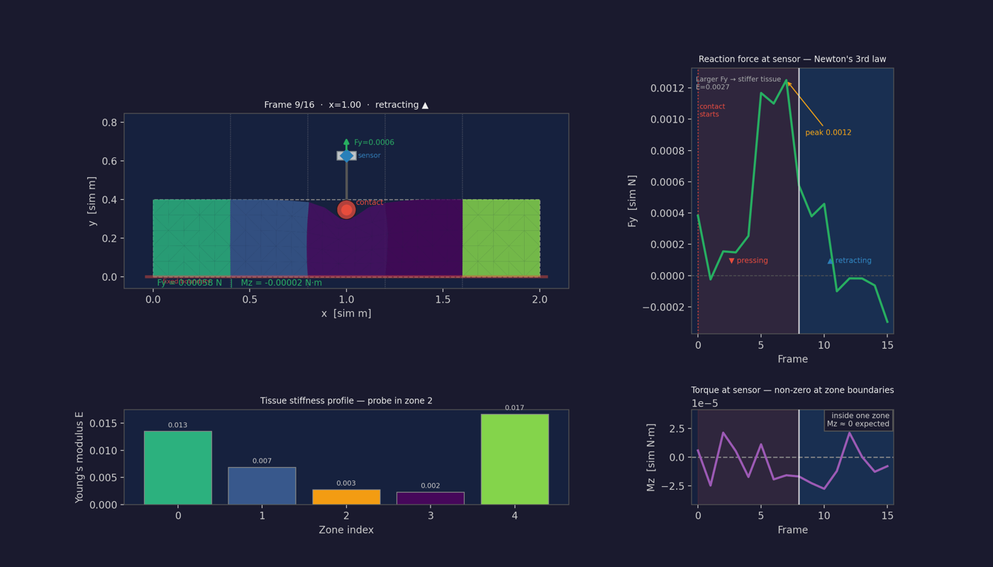
Figure 2 — Same poke, mid-retraction: Fy rose while pressing, peaked at maximum depth (~0.0012), and falls as the probe withdraws. Mz hovers near zero because the probe sits well inside a single zone — symmetric contact, no net torque.
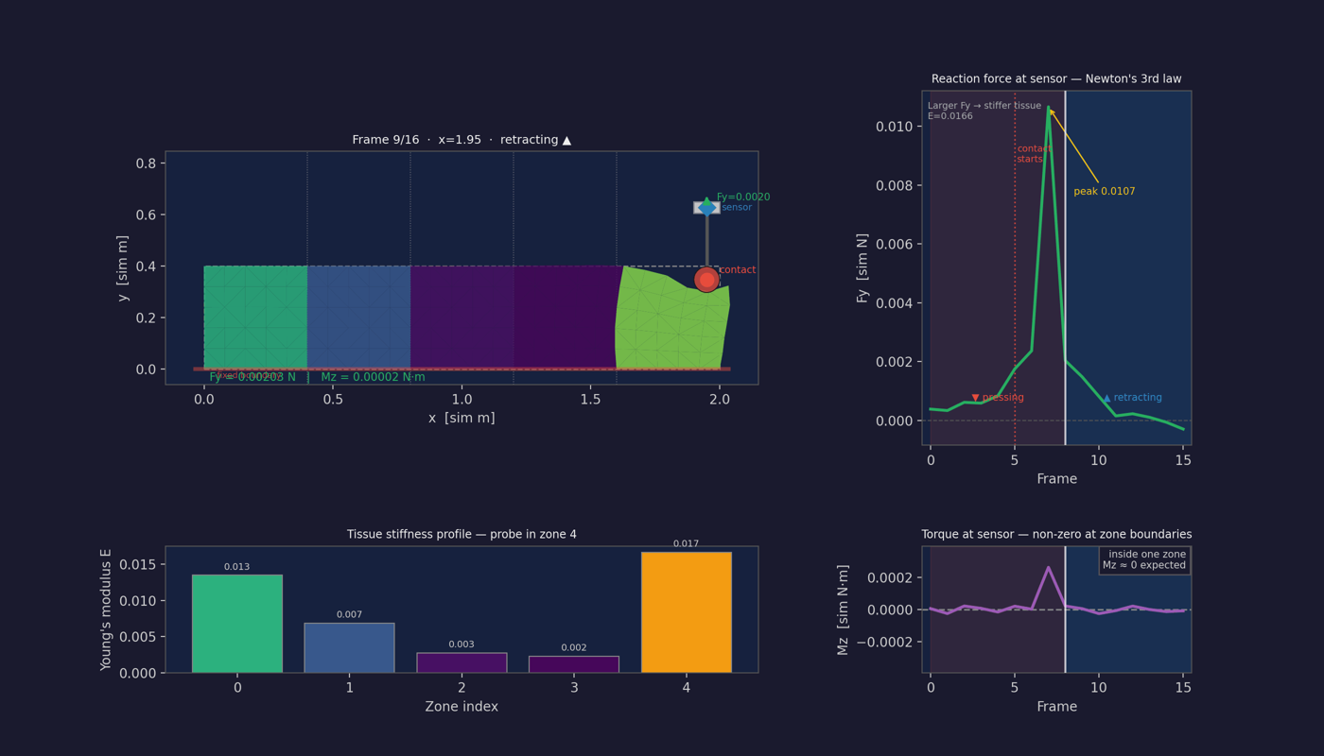
Figure 3 — Poke at x = 1.95, at the stiff edge zone (zone 4, E = 0.017): contact with a stiffer zone produces a different force curve than Figure 2. Comparing such curves across the 10 scan positions is precisely the signal the encoder learns from.
Read Figure 2's Fy plot against the intuition in Section 4.4: pressing → penetration grows → force ramps up; retracting → force decays. A stiffer zone gives a higher peak for the same probe motion. The per-frame samples of that curve are the 10 numbers per channel your dataset stores for this poke.

2.8 Dimensions and geometry: every length in the model
All lengths are in dimensionless "sim units" (the plots label them "sim m"). They are internally consistent; only relative sizes matter for the physics. This section collects every dimension so nothing is left implicit.

Tissue
Quantity | Value | Notes / how derived
Width (x) | 2.0 | Long axis, scanned by the probe
Height (y) | 0.4 | Short axis; aspect ratio 5:1
Mesh spacing (grid_size) | 0.08 | Node-to-node distance of the regular grid
Nodes in x | 26 | = width/grid + 1 = 2.0/0.08 + 1
Nodes in y | 6 | = height/grid + 1 = 0.4/0.08 + 1
Total nodes | 156 | = 26 × 6 (each has 2 DOF → 312 DOF)
Boundary nodes | 60 | perimeter; interior = 96
Fixed nodes (bottom, y≈0) | 26 | Dirichlet BC — the pinned edge
Triangles | 250 | from scipy Delaunay on the 156 nodes
Stiffness zones | 5 | equal columns along x
Zone width | 0.4 | = width / n_zones = 2.0/5
Zone boundaries (x) | 0, 0.4, 0.8, 1.2, 1.6, 2.0 | n_zones + 1 = 6 edges
Young's modulus E | 0.002 – 0.02 | sampled uniformly per zone (the label)
Per-element E jitter | ±0.0002 | small within-zone variation
Poisson ratio ν | 0.45 (±0.005) | near-incompressible soft tissue

Probe
Quantity | Value | Notes / how derived
Tip radius | 0.05 | = 1/8 of tissue height; ~1/40 of width
Vertices | 8 | octagon, spaced 45° apart
Sensor↔contact distance | ≈ 0.05 | = one radius (sim); see Section 2.5
Moment lever arm |dx|,|dy| | ≤ 0.05 | vertex offset from probe center
Hover height above surface | 0.15 | = radius × 3
Penetration depth | 0.04 | = radius × 0.8 (~4% of tissue height)
Probe start y (hover) | 0.55 | = tissue_top (0.4) + hover (0.15)
Probe bottom y (deepest) | 0.36 | = tissue_top (0.4) − pen (0.04)
Total descent travel | 0.19 | = 0.55 − 0.36

Scan & timing
Quantity | Value | Notes / how derived
Scan positions | 10 | evenly spaced across the width
First / last x | 0.1 / 1.9 | margin = 0.1 keeps off the edges
Scan spacing | 0.2 | = (1.9 − 0.1) / 9
Frames per poke | 10 | 5 descending + 5 ascending
Time step dt | 0.1 | paces the probe (not true dynamics)
Poke duration T | 1.0 | = frames × dt; down T/2, up T/2
Descent speed |vy| | 0.38 | = travel 0.19 / (T/2 = 0.5)
Per-frame descent | 0.038 | = |vy| × dt
Input tensor per experiment | (10, 10, 3) | (positions, frames, [Fx,Fy,Mz])
Sanity-check on relative sizes
The probe tip (radius 0.05) is small next to a zone (width 0.4) — about 1/8 of a zone — so most pokes sit cleanly inside one zone and only the few near a boundary straddle two (that is exactly when Mz fires). Penetration (0.04) is shallow versus tissue height (0.4), ~10%, keeping the linear small-strain model honest. And scan spacing (0.2) is half a zone width, so each 0.4-wide zone is sampled by about two pokes.

3. From forces to stiffness: the ML side
The simulation defines a forward map: stiffness profile → force recordings. The model's job is the inverse map: force recordings → stiffness profile. This part walks the data path from raw experiment folders to a trained network.

3.1 Data packaging and normalization
data/preprocess.py packs every experiment folder into one HDF5 file: per experiment, sensor_log (n_positions, frames, 3), label (n_zones,) and x_positions. Experiments listed in failed_experiments.txt are skipped.
data/dataset.py wraps the HDF5 in a PyTorch ArthroscopyDataset. One important transformation happens here: labels are normalized to [0, 1] using the min/max Young's modulus found across the whole dataset:
label_norm = (E − E_min) / (E_max − E_min)
This matters because the decoder ends in a Sigmoid, which can only output values in (0, 1) — the normalization and the output activation are a matched pair. To recover physical units at inference time you must keep label_min/label_max from training.
Subtlety worth knowing: normalization stats and the split
The min/max are computed over the full dataset before the train/val/test split (make_dataloaders splits afterwards with a seeded random_split). Strictly speaking that lets test-set statistics leak into preprocessing. With labels drawn uniformly from a known fixed range it is practically harmless — but for the thesis, the cleaner statement is to normalize with the known simulation range [E_min, E_max] = [0.002, 0.02] from the config, which involves no data at all.

3.2 Encoder: 1D-CNN per poke, pooled across positions
The encoder (model/encoder.py) works in two stages, mirroring the data's structure:
Stage 1 — PokeEncoder. Each poke is a short multichannel time series: (frames, 3) with channels (Fx, Fy, Mz). A stack of num_layers (=3) blocks of [Conv1d → BatchNorm → ReLU → Dropout] slides a kernel (size 3) along the time axis, then an AdaptiveAvgPool1d averages over time, producing one hidden_dim (=64) vector per poke. A 1D-CNN is a good fit because the signal is short and the informative pattern (rise rate, peak height, decay) is local in time and roughly shift-invariant.
Stage 2 — ScanEncoder. The same PokeEncoder (shared weights) runs on all 10 pokes, giving a (n_positions, 64) sequence of embeddings, which is then mean-pooled across positions into a single 64-vector latent z for the whole scan.
x: (B, P, F, 3) -> view (B*P, F, 3) -> PokeEncoder -> (B*P, 64)
-> view (B, P, 64) -> mean over P -> z: (B, 64)
Design caveat: mean-pooling forgets where each poke was
Averaging across positions makes the latent permutation-invariant: the model cannot tell which poke came from which x-location, yet the target (zone profile) is ordered in x. The information survives only weakly (e.g., edge pokes feel boundary effects, Mz marks transitions). If training stalls, the natural fixes are: concatenate the per-position embeddings instead of averaging, add x-position as an input feature, or use encode_positions() (already provided, unpooled) with a sequence decoder. The CLAUDE.md's open question about replacing the CNN with a Transformer fits here too.

3.3 Decoder and the full model
StiffnessDecoder (model/decoder.py) is a small MLP: Linear layers with LayerNorm+ReLU between them, ending in a Linear to output_dim (= n_zones = 5) and a Sigmoid. ArthroscopyModel (model/model.py) just chains the two: z = encoder(sensor); stiffness = decoder(z). It also exposes encode() so you can inspect the latent space later (e.g., t-SNE of z colored by mean stiffness — a good "what did the encoder learn" analysis for the thesis).

3.4 Training loop and losses
training/train.py is a standard supervised regression loop: AdamW (lr 1e-3, weight decay 1e-4), cosine learning-rate annealing over 100 epochs, gradient clipping at norm 1.0, 75/15/10 train/val/test split, and checkpointing of the best-validation model to best_model.pt with a history.json log.
Three losses are implemented in training/losses.py:
- MSELoss — plain mean squared error on the normalized profiles.
- HuberLoss (the default used in train.py, δ=0.1) — quadratic for small errors, linear for large ones; robust to occasional bad experiments (e.g., non-converged pokes from Section 4.3).
- RankingLoss — α·MSE + (1−α)·pairwise ranking penalty that rewards getting the ordering of zones right ("zone 3 is stiffer than zone 1") even when absolute values are off. Clinically sensible: surgeons care about relative stiffness. Implemented but not currently wired into train.py — switching criterion is a one-line change worth an ablation.
Sensible evaluation metrics beyond the loss: per-zone MAE in physical units (denormalized), Spearman rank correlation per experiment (does the predicted ordering match?), and error vs. zone index (are edge zones easier because of boundary effects?).

4. Things worth knowing (assumptions, limits, gotchas)
These are not bugs — they are modeling choices and simplifications you should be able to defend or revisit in a thesis. Several are flagged in your own CLAUDE.md.

4.1 Modeling assumptions baked into the physics
- Linear, small-strain elasticity. Stress ∝ strain, strain ∝ displacement. Only valid for small deformations. Real tissue is nonlinear and hyperelastic; with a 4% penetration depth the linear model is a reasonable POC approximation but will under-model large pokes.
- Constant-strain triangles (CST). The simplest element; strain is constant per triangle. Accurate enough on a fine mesh but stiff ("locking") on coarse meshes, especially near-incompressible (ν=0.45). Finer grid_size or higher-order elements would improve fidelity.
- 2-D plane stress. The joint is modeled as a thin 2-D slice. The real problem is 3-D; this is a deliberate POC reduction.
- Rigid probe. The probe stores no strain energy; it only translates. Fine, since a metal arthroscope tip is far stiffer than tissue.
- Quasi-static, not dynamic. Each frame solves for static equilibrium — no mass, inertia, velocity, or damping in the tissue. dt only paces the probe's motion; it is not a true dynamics time-step. Good for slow palpation; would miss rate-dependent (viscoelastic) effects.

4.2 Sensor model caveats
- Aggregation by summation. The per-vertex forces are summed into one (Fx, Fy, Mz). The CLAUDE.md flags this as "a crude approximation of a real 6-DOF sensor." It is a reasonable proxy for a handle-mounted sensor but discards spatial detail.
- Fx is hard-coded to ~0. Only the noise makes it nonzero. A vertical poke on a flat surface genuinely produces little lateral force, but tilted contact or sloped surfaces would in reality generate Fx — not captured.
- Force model is consistent with the energy, by construction. Fy = 2k·p is the analytic gradient of k·p². This is a strength (self-consistent) but also means the "measurement" is essentially reading back the penalty, not an independently modeled contact mechanics.

4.3 Numerical / implementation gotchas (from CLAUDE.md & code)
- Slow Python loops. _strain_energy loops over triangles in Python, and _closest_edge_tensor is a slow per-edge loop. Vectorizing with batched torch ops would speed up generation substantially. This is the main performance bottleneck for scaling the dataset.
- Convergence is not guaranteed. The optimizer early-stops on a 0.1% improvement heuristic, or prints a warning after 500 steps. Pokes that fail to converge could inject noise into the dataset; worth logging/checking the warning rate.
- output_dim must equal n_zones. The decoder's output_dim (5) must match TissueConfig.n_zones. Currently set manually — the CLAUDE.md flags adding an auto-check.
- Contact uses nearest-node-in-x, not true surface projection. Penetration is measured against the nearest top-edge node, not the interpolated surface. On a coarse mesh this slightly quantizes contact; finer meshes reduce the effect.
- Boundary vertices are not stored in perimeter order, which is why get_contact_point uses a bounding-box test instead of the ray-casting polygon test. A latent footgun if you later rely on polygon traversal.

4.4 Where the learning signal actually comes from
It is worth being explicit about why this is learnable at all. Under the same probe displacement, a stiff zone (large E) resists more — at equilibrium it deforms less, so the probe meets it sooner and penetration-driven Fy is larger and rises faster through the poke. A soft zone yields, giving smaller, slower-rising Fy. Across the 10 scan positions, the profile of these force curves encodes the stiffness profile, and Mz sharpens the localization of zone boundaries. The encoder–decoder model's job is to invert this forward map: from the (10, frames, 3) force record back to the 5 moduli.

4.5 Quick reference — key parameters
Parameter | Default | Meaning
width × height | 2.0 × 0.4 | Tissue rectangle dimensions
grid_size | 0.08 | Mesh spacing (smaller = finer, slower)
n_zones | 5 | Stiffness zones along x = label length
E_min..E_max | 0.002..0.02 | Young's modulus range (the labels)
poisson_ratio | 0.45 | Near-incompressible soft tissue
k_collision | 0.02 | Contact penalty stiffness
steps | 500 | Max optimizer iterations per frame
learning_rate | 0.001 | Adam step size for energy minimization
probe radius | 0.05 | Probe tip size (8 vertices)
penetration_depth | 0.04 | = radius × 0.8, how deep a poke goes
num_scan_positions | 10 | Poke locations across the width
frames_per_poke | 10 | Frames per poke (down + up)
force_noise_std | 1e-4 | Gaussian sensor noise
End of document. All equations, figures and code excerpts are drawn directly from the project: sim/, model/, data/, training/ and output/sim/.

