In this project, your mission is to build a minimal BASIC interpreter. You need to accomplish the following objectives:

* To increase your familiarity with ***expression trees and class inheritance***.
* To give you a better sense of how programming languages work. ***Learning how an interpreter operates***—particularly one that you build yourself—provides useful insights into the programming process.
* To offer you the chance to adapt an existing program into one that solves a different but related task. The majority of programming that people do in the industry consists of modifying existing systems rather than creating them from scratch.

**What is BASIC?**

The programming language BASIC—the name is an acronym for Beginner’s All-purpose Symbolic Instruction Code—was developed in the mid-1960s at Dartmouth College by John Kemeny and Thomas Kurtz. It was one of the first languages designed to be easy to use and learn. Although BASIC has now pretty much disappeared as a teaching language, its ideas live on in Microsoft’s Visual Basic system, which remains in widespread use.

In BASIC, a program consists of a sequence of numbered statements, as illustrated by the simple program below:

10 REM Program to add two numbers

20 INPUT n1

30 INPUT n2

40 LET total = n1 + n2

50 PRINT total

60 END

The line numbers at the beginning of the line establish the sequence of operations in a program. In the absence of any control statements to the contrary, the statements in a program are executed in ascending numerical order starting at the lowest number. Here, for example, program execution begins at line 10, which is simply a ***comment (the keyword REM is short for REMARK)*** indicating that the purpose of the program is to add two numbers. Lines 20 and 30 request two values from the user, which are stored in the variables n1 and n2, respectively. The LET statement in line 40 is an example of an assignment in BASIC and sets the variable total to be the sum of n1 and n2. Line 50 displays the value of total on the console, and line 60 indicates the end of execution. A sample run of the program therefore looks like this:

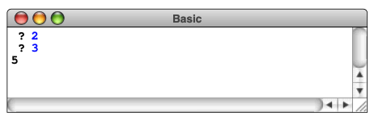

Figure 1

Line numbers are also used to provide a simple editing mechanism. ***Statements need not be entered in order, because the line numbers indicate their relative position.*** Moreover, as long as the user has left gaps in the number sequence, new statements can be added in between other statements. For example, to change the program that adds two numbers into one that adds three numbers, you would need to make the following changes:

1. Add a new line to read in the third value by typing in the command

*35 INPUT n3*

1. This statement is inserted into the program between line 30 and line 40. Replace the old line 40 with an update version by typing

*40 LET total = n1 + n2 + n3*

In classical implementations of BASIC, ***the standard mechanism for deleting lines was to type in a line number with nothing after it on the line***. Note that this operation actually deleted the line and did not simply replace it with a blank line that would appear in program listings.

**Expressions in BASIC**

The **LET** statement illustrated by line 40 of the addition program has the general form

LET variable = expression

and has the effect of assigning the result of the expression to the variable. In Minimal BASIC, **the assignment operator is no longer part of the expression structure**. The simplest expressions are variables and integer constants. These may be combined into larger expressions by enclosing an expression in **parentheses** or by joining two expressions with the operators **+**, **-**, **\***, and **/**. ***You only need to support +,-, *, /, (, ) operators with signed integers (at least 32-bit) in expressions. (Be aware of negative integers.)***

Additionally, you need to support the exponentiation operator in expressions:

exp1 ** exp2

The exponentiation operator returns the result of exp1exp2, where exp1 and exp2 are expressions. ***The exponentiation operator is right associative***, i.e., a ** b ** c is equal to a ** (b ** c). ***The operator has higher precedence than * and /***.

***For all expressions and statements, you need to handle extra spaces***. For example, LET a = b + 4 * (-5 + 4 ).

**Control statements in BASIC**

The statements in the addition program illustrate how to use BASIC for simple, sequential programs. If you want to express loops or conditional execution in a BASIC program, you have to use the **GOTO** and **IF** statements. The statement

GOTO *n*

transfers control unconditionally to line *n* in the program. If line *n* does not exist, your BASIC interpreter should generate an error message informing the user of that fact.

The statement

IF condition THEN n

performs a conditional transfer of control. On encountering such a statement, the BASIC interpreter begins by evaluating *condition,* which in the minimal version of BASIC consists of ***two arithmetic expressions joined by one of the operators <, >, or =***. If the result of the comparison is true, ***control passes to line n, just as in the GOTO statement***; if not, the program continues with the next line in sequence.

For example, the following BASIC program simulates a countdown from 10 to 0:

10 REM Program to simulate a countdown

20 LET T = 10

30 IF T < 0 THEN 70

40 PRINT T

50 LET T = T - 1

60 GOTO 30

70 END

Even though **GOTO** and **IF** are sufficient to express any loop structure, they represent a much lower level control facility than that available in C++ and tend to make BASIC programs harder to read. The replacement of these low-level forms with higher level constructs like **if**/**else**, **while**, and **for** represented a significant advance in software technology, allowing programs to represent much more closely the programmer’s mental model of the control structure.

**Summary of statements available in the minimal BASIC interpreter**

The minimal BASIC interpreter implements only six statement forms, which appear in Table 1. ***The LET, PRINT, and INPUT statements can be executed directly by typing them without a line number, in which case they are evaluated immediately.*** Thus, if you type in (as Microsoft cofounder Paul Allen did on the first demonstration of BASIC for the Altair)

PRINT 2 + 2

your program should respond immediately with 4. ***The statements GOTO, IF, REM, and END are legal only if they appear as part of a program, which means that they must be given a line number.***

**Commands recognized by the BASIC interpreter**

In addition to the statements listed in Table 1, BASIC accepts the commands shown in Table 2. These commands cannot be part of a program and must therefore be entered without a line number.

***Table 1. Statements implemented in the minimal version of BASIC***

|  |  |
| --- | --- |
| **REM** | This statement is used for comments. Any text on the line after the keyword **REM** is ignored. |
| **LET** | This statement is BASIC’s assignment statement. The **LET** keyword is followed by a variable name, an equal sign, and an expression. As in C++, the effect of this statement is to assign the value of the expression to the variable, replacing any previous value. In BASIC, assignment is not an operator and may not be nested inside other expressions. |
| **PRINT** | In minimal BASIC, the **PRINT** statement has the form:  PRINT *exp*  where *exp* is an expression. The effect of this statement is to print the value of the expression on the console and then print a newline character so that the output from the next **PRINT** statement begins on a new line. |
| **INPUT** | In the minimal version of the BASIC interpreter, the **INPUT** statement has the form:  INPUT *var*  where *var* is a variable read in from the user. The effect of this statement is to print a prompt consisting of the string **" ? "** and then to read in a value to be stored in the variable. (The string " ? " should display in the command input edit box in GUI.) |
| **GOTO** | This statement has the syntax  GOTO *n*  and forces an unconditional change in the control flow of the program. When the program hits this statement, the program continues from line *n* instead of continuing with the next statement. Your program should report an error if line *n* does not exist. |
| **IF** | This statement provides conditional control. The syntax for this statement is:  IF *exp*1 *op exp*2 THEN *n*  where *exp*1 and *exp*2 are expressions and *op* is one of the conditional operators **=**, **<**, or **>**. If the condition holds, the program should continue from line *n* just as in the **GOTO** statement. If not, the program continues on to the next line.  Note that the conditional operators (=, <, >) are not parts of expressions. |
| **END** | Marks the end of the program. Execution halts when this line is reached. This statement is usually optional in BASIC programs because execution also stops if the program continues past the last numbered line. |

page5image40557568

***page5image40552416Table 2. Commands to control the BASIC interpreter***

|  |  |
| --- | --- |
| **RUN** | This command starts program execution beginning at the lowest-numbered line. Unless the flow is changed by **GOTO** and **IF** commands, statements are executed in line-number order. Execution ends when the program hits the **END** statement or continues past the last statement in the program. |
| **LOAD** | This command loads a file containing statements and commands. Statements and commands should be stored (also displayed in GUI) and executed respectively, as if they were entered into input box in order. A prompt window should be displayed when this command is entered. The window asks users to choose the file to load. |
| **LIST** | This command lists the steps in the program in numerical sequence. It has been required to be implemented in the previous version of this project. In the new version, your interpreter should be able to display all the codes that have been entered in real time, so there is no need to implement this command. |
| **CLEAR** | This command deletes the program so the user can start entering a new one. |
| **HELP** | This command provides a simple help message describing your interpreter. |
| **QUIT** | Typing **QUIT** exits from the BASIC interpreter. |

**Example of use**

Figure 2 shows a complete session with the BASIC interpreter. The program is intended to display the terms in the Fibonacci series less than or equal to 10000. The three output windows are used to the current program, the standard output (and errors) of program, and the syntax tree of each line of statements. User can enter statements or commands into command input box, or load a file to be executed through LOAD button. The syntax tree is displayed only when RUN is called. CLEAR will clears the content of all three windows. The RUN and CLEAR buttons are used to execute and clear statements entered respectively.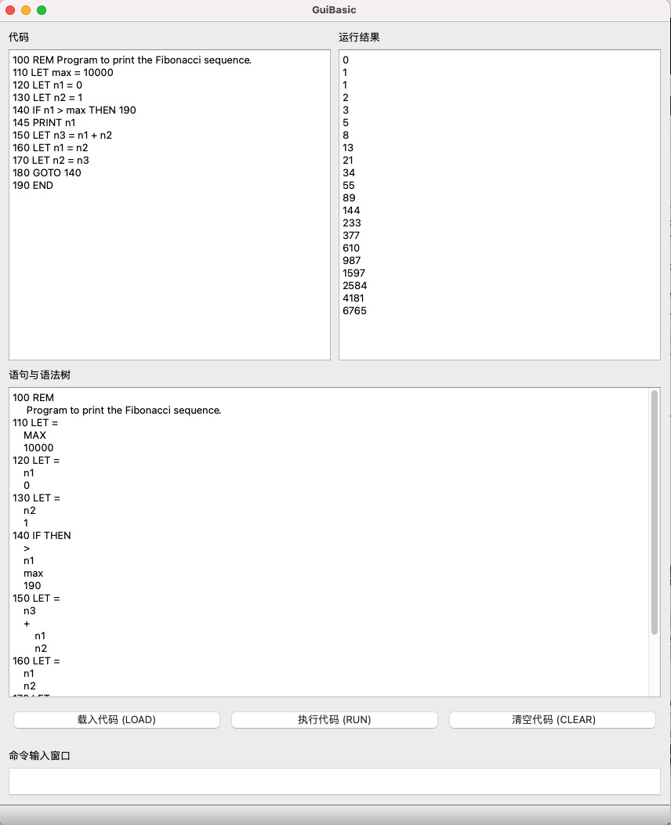

Figure 2

***Syntax tree display***

Conceptually, syntax tree is one abstract representation of program. More specifically, every **statement** in the program can be represented as a tree. The structure of the syntax tree can be seen as the steps of the computation of the **expression** in the statement.

As you have learnt from previous programming course, some statements have side effects, in our mini basic language, the side effects include assignment and branch. And these side effects should also be displayed in the syntax tree.

The node of the tree can be identifier definition, assignment, function call (You need not to implement function call in this project), expression computation and conditional or unconditional branch. In your interpreter implementation, you can make the computation along the syntax tree from leaf node to root. Because the connection structures of the tree are determined by the computation rules, e.g. operator priority and association.

In your implementation, you should construct the syntax tree in **infix notation**.

For displaying the syntax tree structure in your GUI window easily, you don’t need to plot the real tree. Instead, you should use indentation to display the syntax tree of each statement.

Followings are some concrete examples. Structure in the red border is expression of that statement.

1. LET m = p + q*t

The syntax tree of this statement:

|  |  |
| --- | --- |
|  | LET =  m  +  p  *  q  t |

Figure 3

1. IF m > max THEN n

The syntax tree of this statement:

|  |  |
| --- | --- |
|  | IF THEN  m  >  max  n |

Figure 4

1. GOTO n

The syntax tree of this statement:

|  |  |
| --- | --- |
|  | GOTO n |

Figure 5

1. PRINT p + q*t

The syntax tree of this statement:

|  |  |
| --- | --- |
|  | PRINT  +  p  *  q  t |

Figure 6

As what you can observe, the nodes at the same level in the tree are at the same vertical line in the indentation notation.

Each indent contains 4 spaces to make the structure of the syntax tree clear enough.

***Storing the program***

The first task you need to undertake is making it so your BASIC interpreter can store programs. Whenever you type in a line that begins with a line number, such as

100 REM Program to print the Fibonacci sequence

your interpreter has to store that line in its internal data structure so that it becomes part of the current program. As you type the rest of the lines from the program in Figure 2, the data structure inside your implementation must add the new lines and keep track of the sequence. In particular, when you correct the program by typing

145 PRINT n1

your data structure must know that this line goes between lines 140 and 150 in the existing program.

**Hints on the statement class hierarchy**

***The primary class for expressions should be Expression, which is the abstract superclass for a hierarchy that includes three concrete subclasses for the three different expression types***, as follows:

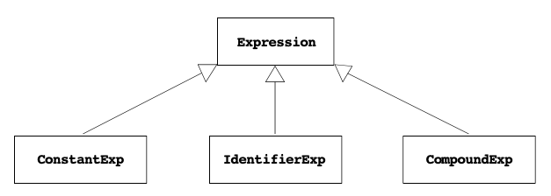

The structure of the statements is quite similar. ***The primary class should be Statement, which is the abstract superclass for a set of subclasses corresponding to each of the statement types***, as illustrated in the following diagram:

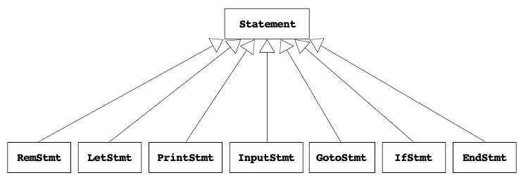Even though there are more subclasses in the **Statement** hierarchy, it is still somewhat easier to implement than the **Expression** hierarchy. One of the things that makes the **Expression** hierarchy complex—but also powerful—is that it is recursive. ***Compound expressions contain other expressions, which makes it possible to create expression trees of arbitrary complexity.*** Although statements in modern languages like C++ *are* recursive, statements in BASIC are not.

**Exception handling**

Crashing the whole interpreter because your BASIC program has a syntax error would be incredibly frustrating, since you would lose everything you’d typed in up to that point. Thus, ***you need to use try/catch so that your interpreter responds to errors much more gracefully.***

**Strategy and tactics**

As you work through this project, you might want to keep in mind the following bits of advice:

* The last line of the fictional memo from Bill Gates encourages his team to “get going on this project as soon as possible.” I encourage you to adopt that same strategy.
* You need to first create a project and initialize the GUI. You can use the UI editor of Qt Creator or place the UI widgets by C++ code. To finish the Minimal BASIC project, you need to proceed strategically by making carefully staged edits. To whatever extent you can, you should make sure that the BASIC project continues to run at the completion of each stage in the implementation.
* Make sure you get the project working before you embark on extensions. It’s easy to get too ambitious at the beginning and end up with a mass of code that proves impossible to debug.

***Grading***

* **(10’)** Your interpreter should be able to present a GUI and interact with user input.
  + GUI should contain the input and output interfaces shown in Figure 2.
* **(20’)** Your interpreter should be able to load and edit basic programs.
  + Users can add, update or delete statements through input box or LOAD button.
  + The statements entered by user can be stored and displayed in the correct order.
* **(50’)** Your interpreter should be able to interpret basic programs correctly.
  + Expression parsing (display the syntax tree, although this should be done when you store the programs);
  + Expression evaluation and statement execution (display the result of print if exists);
  + Runtime context maintenance (e.g., the current line to be executed, all variables and their values).
* **(10’)** Your interpreter should be robust and correctly handle errors in the input.
* **(10’)** You should finish the project with object-oriented design and implementation; your code should be clear and easy to read with appropriate comments.

**Hints:**

You could learn something from this article (<https://doc.qt.io/archives/qq/qq27-responsive-guis.html>). But there are always other ways to achieve the same goal, and you are not restricted by the article.