“Launchpath - Internship Tracking System”

Web Programming : Prof. Nashwa Mohamed Abdelghaffar
: TA: Eng.Alaa Mahmoud

Team Members:

Daniel Adel Lamie 241004035

Mehrail Adel Lamie 241004034

Alaa Ahmed 241004885

Abdelmaged Nour 241004867

Judy Ahmed Mohamed 241006767

Introduction

Launchpath is a web-based internship tracking system designed to connect students with companies offering internship opportunities. The website helps students search for internships, apply easily, build their CV, and track their application status.

At the same time, it allows companies to create profiles, post internship opportunities, manage applicants, and update application statuses. The main goal of Launchpath is to make the internship process easier, more organized, and more accessible for both students and companies.

Problem Definition

Many students face difficulties when searching for internships because opportunities are often scattered across different platforms, social media pages, and company websites. Students may also struggle with preparing a proper CV or tracking the internships they applied for.

Companies also face challenges in managing applications manually, reviewing student information, and organizing applicants for different internship positions.

Launchpath solves this gap by providing one centralized platform where students and companies can interact in a simple and organized way.

Project Functionality

Launchpath provides different services depending on the user role.

For Students:
Students can create an account, log in, browse available internships, apply for internships, build a CV, and track their application status.

For Companies:
Companies can create accounts , post internship opportunities, view applicants, manage posted internships, and update the status of student applications.

Main Website Functionalities:
- User registration and login
-Role selection: Student or Company
-Company profile creation
-Internship posting
-Browse latest internships
-Apply for internships
-CV Builder
-Track application status
- Manage applicants
-Update application status

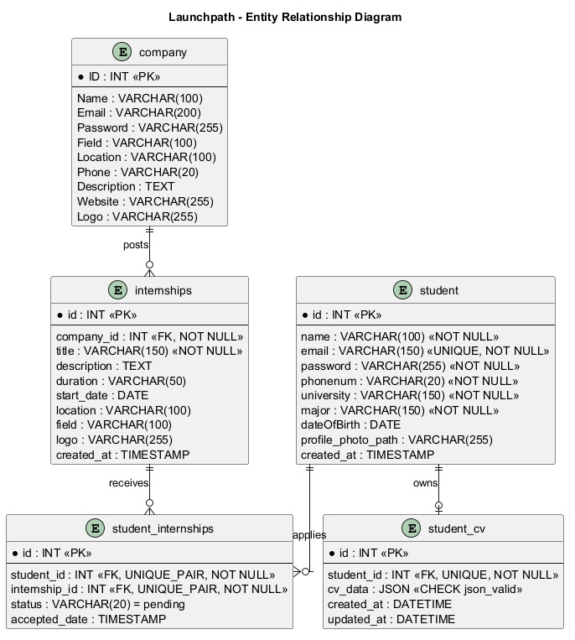
ERD Diagram:

Our Website:
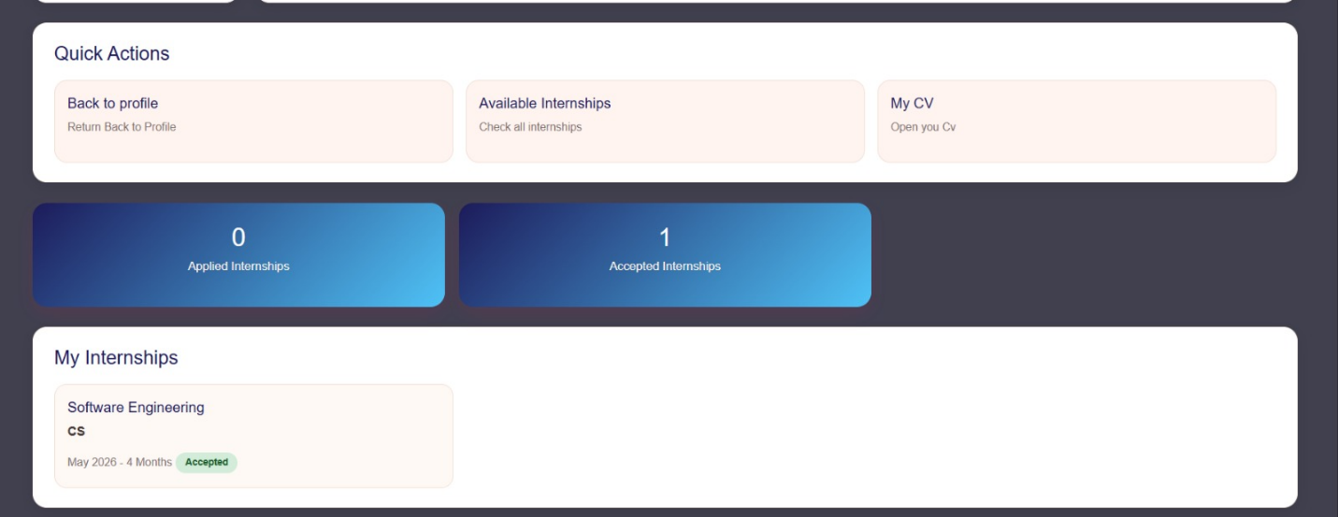
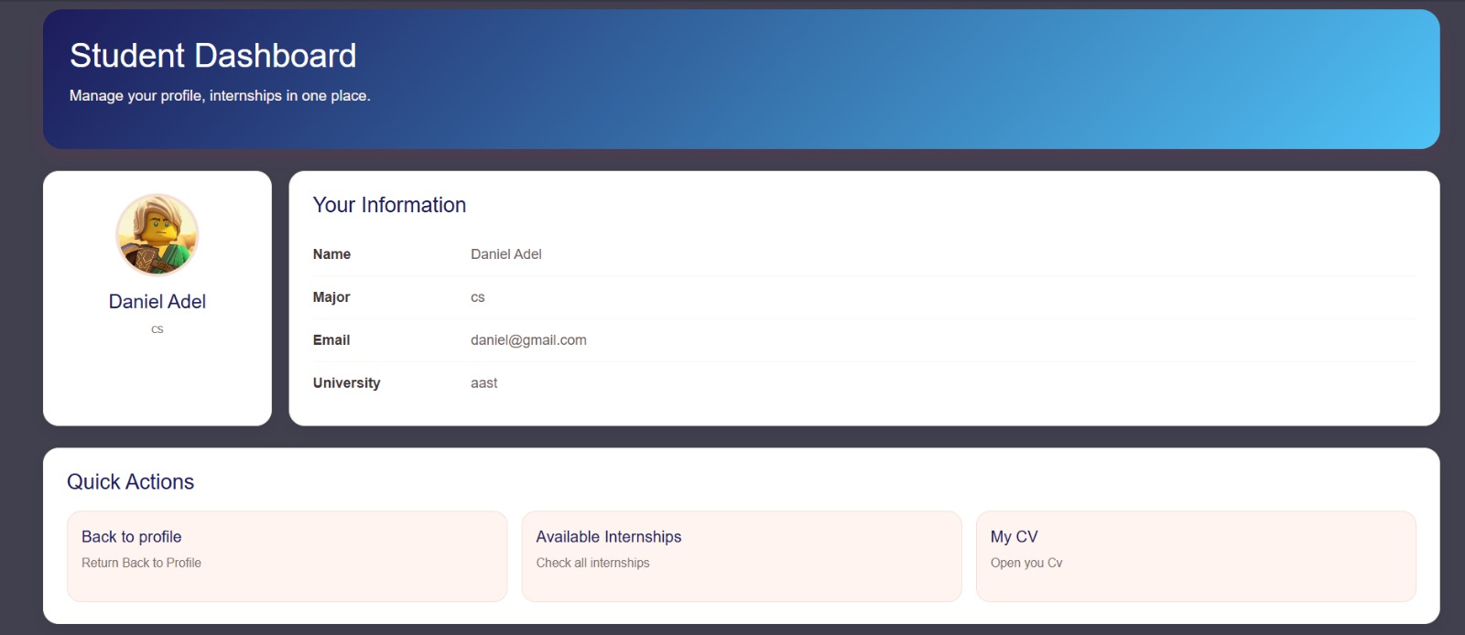
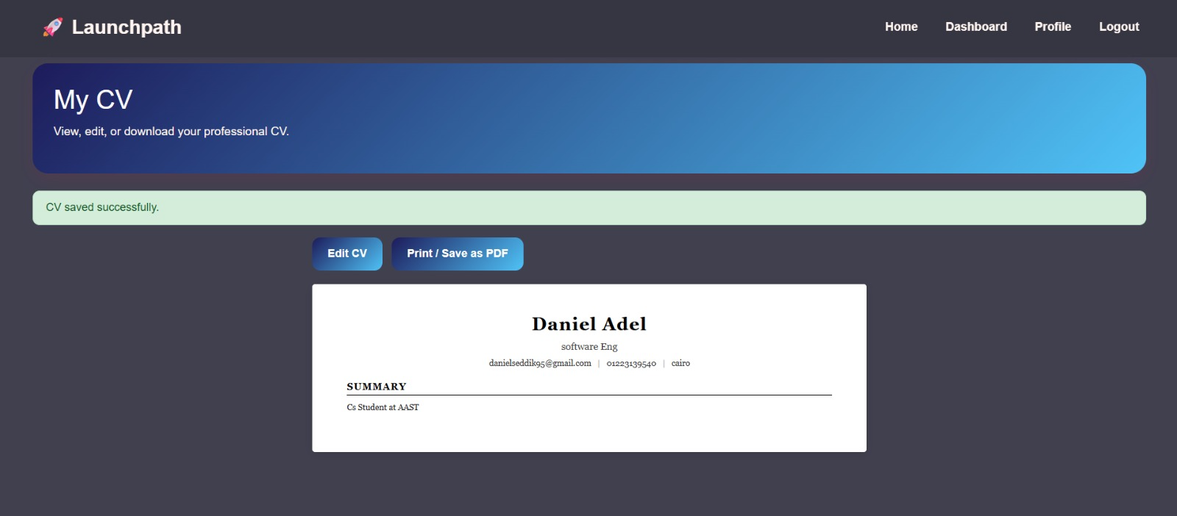

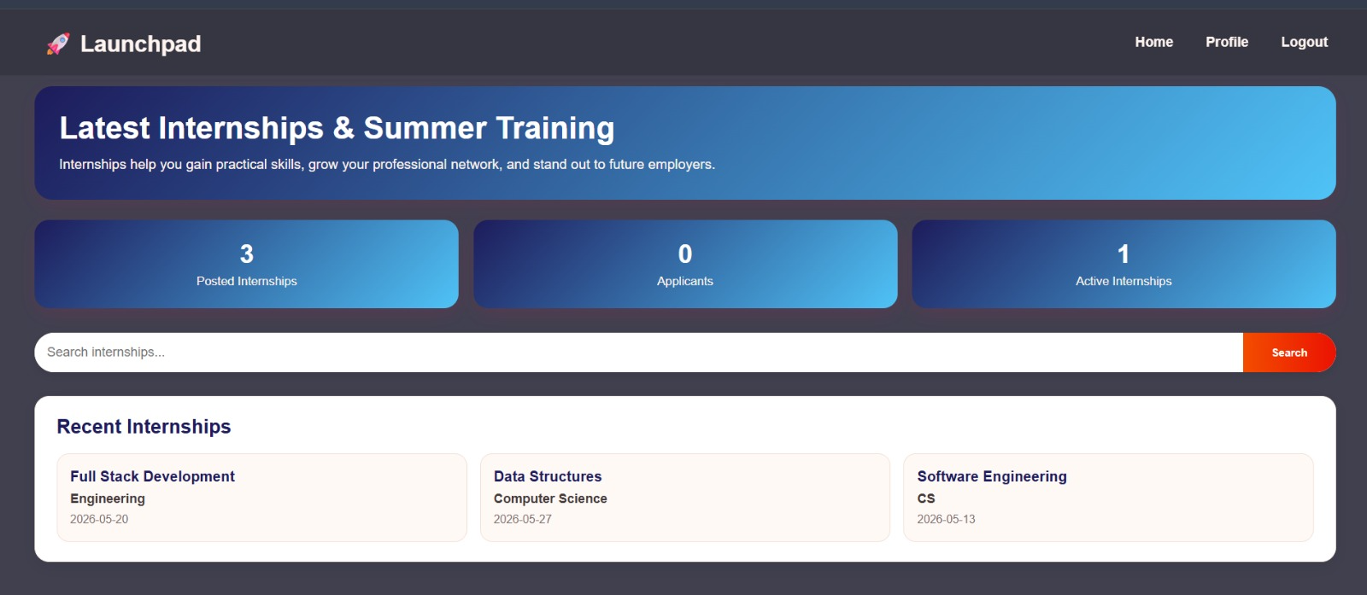
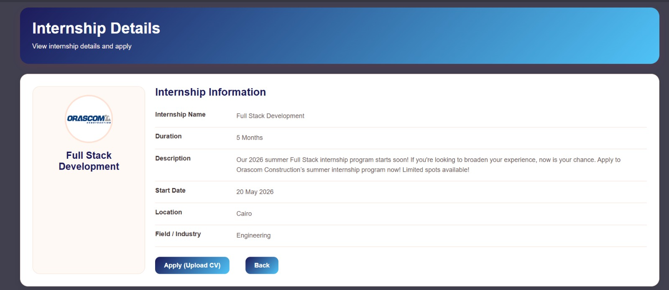

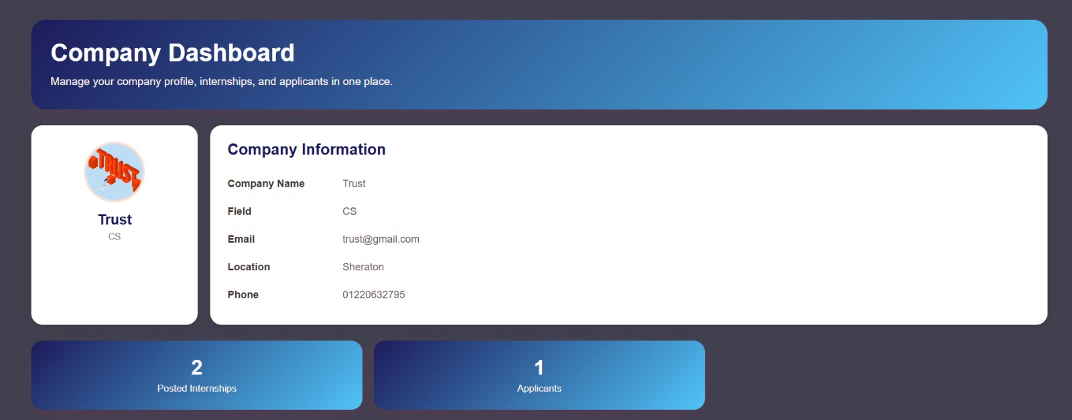

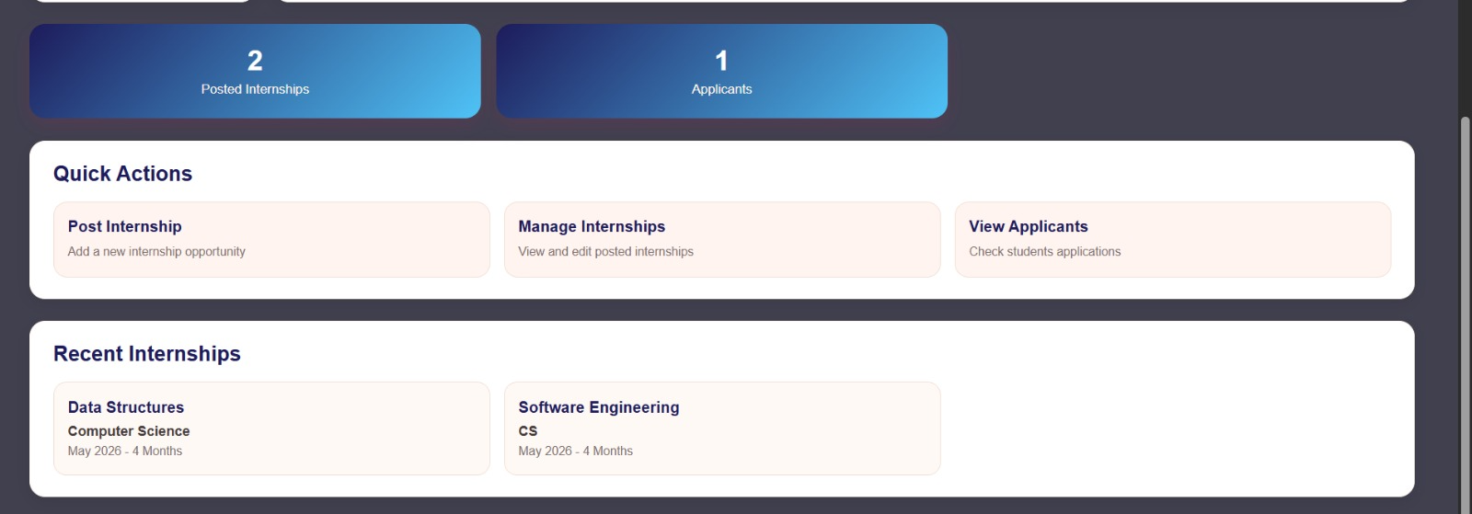

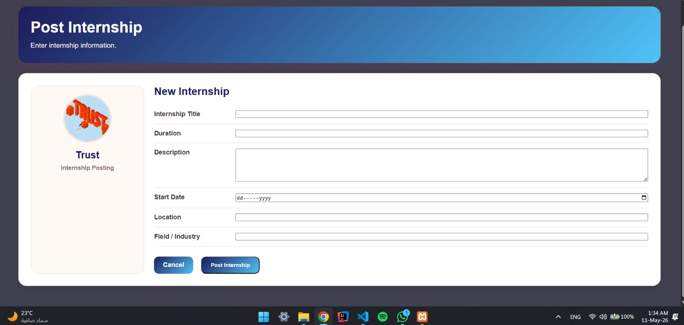
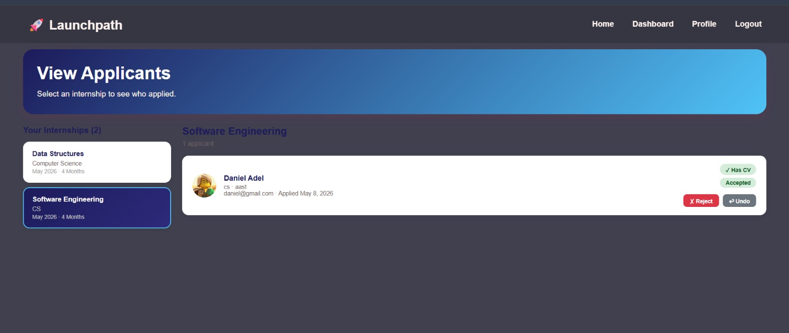

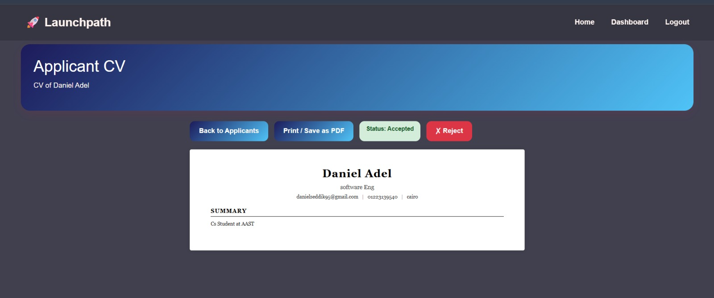

Conclusion
Launchpath is a useful platform that simplifies the internship process for students and companies. It reduces confusion, saves time, and keeps all internship-related activities in one organized system. By offering features such as internship browsing, application tracking, company management, and CV building, Launchpath helps students become more prepared for their career journey.

