Finite Difference Code
CVEN 5838: Computational Multi-Physics Production Software Development
Colorado University at Boulder
Professor: Scott R. Runnels, Ph.D.

Author : Daniel Lindberg

Overview:
There are 3 classes within this project and a class tester.
The code has classes inside of it to simulate the finite differences, which is intended to form a linear system representing a 2D finite difference approximation to Laplace’s equation on a square.
Then with the finite difference approximation , a Gauss-Seidel iteration is performed on that linear system up to a specified number of iterations or a specified tolerance to refine the potential solutions.
There is also a class tester, to test all of the various functionality and determine if the class has its intended outcomes, essentially performing unit testing/verification testing.

Class1: Finite Difference
The first chunk of code is for the actual finite differences. The header for this class is fd.h, however the header for this class doesn’t have the typical function definitions as other C/C++ headers typically do. However this header has a number of variables and macro definitions to use as utilities within the actual class.
The actual class and all of its methods are written and defined in the fd.cpp file. The description of the class is: the finite difference code , intended to form a linear system representing a 2D finite difference approximation to Laplace's equation on a square.
How it performs this is creating a matrix of the number of cells that are specified to it within the Constructor. As seen below:
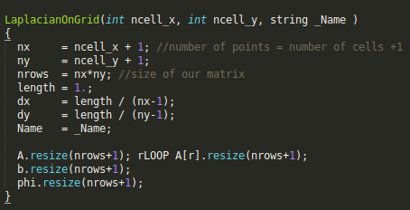
This constructor is called in each one of our base tests. The linear system is created by calling the constructor for this class. The constructor creates a matrix and the linear system is created within the matrix of values.
The linear system is then formed by producing the interior grid points that are determined based on the number of cells. The more cells the smaller the interior grid points values are. Then once the interior grid points are produced, the outer grid points are produced in relation to the interior grid points.
However there is a Manufactured Method of Solution applied to these outer grid points, if that option is chosen by the user.
The Manufactured Method of Solution is when you have a differential function:
Differential operator*source values = solution
and then uses methods from mathematics, inverts the operator to solve for the existing solution.
So with the manufactured method of solution applied to the outer grid points. The outer grid points inverts the operator to solve for the existing solution.

Class2: Gauss Seidel
The second class is the Gauss-Seidel class. Gauss-Seidel is a member function of the LaplacianOnGrid class. Gauss-Seidel methods are an iterative method used to solve a linear system of equations.
So we call the Gauss Seidel, to solve our function through an iterative process. We can specify a limit for this solver, so that it doesn’t take too long, either by setting a set number of computations to be made, or a specified tolerance. Note that some tolerances cannot be reached if too small. The number of iterations can be great, however may not give the intended tolerance that you are looking for.
By giving an overzealous tolerance, the program may take a while to run. We always print how many iterations the Gauss-Seidel takes. For a 10x10 Laplacian Grid, our Gauss-Seidel takes 76 iterations of the Guass-Seidel systematic solver to meet the specified tolerance. By default our tolerance is 0.0004.
What it looks for is looping over the Laplacian Grid’s inner and outer grid points. It computes a guess for the row based off of : A*solution = RHS . Where RHS is the convergence state. A is the base grid points. So the solution is what is going to get refined over the various iterations of Gauss-Seidel.
So it loops through all of the values and multiplies the grid points times what they believe to be the solution, they see it converge to the real solution. And as it moves closer to the real solution we will see more iterative calls to the Gauss-Seidel method. Sometimes more iterations can be applied to create a solution, however the resultant can only go down to a finite number.

Class3: Plotter
The final class is the Plotter function. What plotter takes in is a descriptor and a field value. It will take the name of the Laplacian grid, and the field value to be printed.
It iterates over the matrix and prints out the values into a .plt file (GNU Plot).

Class tester

With this finite difference code there is a tester for this class. The tester is test.cpp class that utilizes CppUnit to create test fixtures.

Test Fixtures are a way to write tests, that have a setup() and teardown() method.
The Setup() method is called before each test, to initialize all variables for a test. For our setup, we just initialize a base LaplacianGrid, we don’t form the linear system, or perform GaussSeidel upon the linear system. The tear down function will delete our Laplacian Grid at the very end.
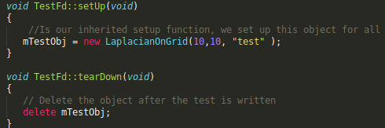

There are six tests within the test.cpp class. One for the various functions:
GridSize: Prove that when the LaplacianGrid Constructor is called that the grid size is created correctly. For an example of 5 passed on in, we expect a 6x6 grid. 10 is passed on in, we expect the grid size to be an 11x11 grid.
ValidData: Validate the data that is produced on a 10x10 grid for the linear solver using a Gauss Seidel method at a max limit of 100 times. Checking some of the various in-depth values are the same as how they were computed on paper.
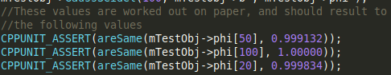
ErrorHandling: Calling some of the various functions, constructors with poor parameters to have an intended failure. Make sure that it doesn’t continue with poor values. Some of the poor values are negative values. We send in negative values into the class , this should get an intended failure as you cannot create a matrix of negative dimensions.
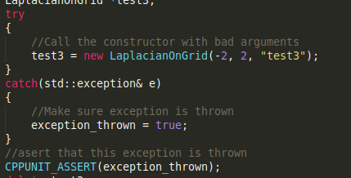
GaussSeidel: Check out the Gauss-Seidel method with various max iterations versions and that no error is thrown when called upon. Given 50 max iterations . Also given 200 max iterations in the GridSize test. When we specify a 10x10 grid to be created, the max number of iterations it will perform to be within the tolerance is 76, so by specifying a 50, that is less than tolerance.
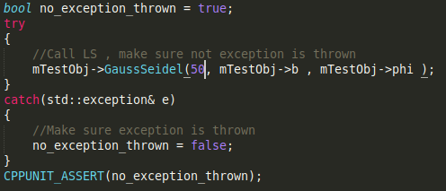

FormLS: Test the linear system former, make sure that no error is thrown when called. We put a simple try-catch block around the class to FormLS() to ensure that the linear system is correctly formed.
Plotter: Ensure that when the plotter is called, it actually forms the files that it intends to. We do a check on the filesystem to make sure that the .plt files are created for both the b and phi values in our linear system.
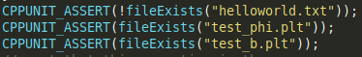

Once the test is ran via : make, and a ./test

A cppTestFd.xml is produced with the results of all successful tests and failed tests. There should be no failed tests when changes to this class is made.

Dependencies
The compiler for our class is g++ (GNU C++ compiler).
Specific version:
g++ --version
g++ (Ubuntu 7.4.0-1ubuntu1~18.04.1) 7.4.0

It involves CppUnit as a testing framework.

To install CppUnit on your system :
Ubuntu/Debian: sudo apt-get install libcppunit-doc libcppunit-dev
CentOS/RHEL: yum install cppunit

In our make file, you also need to link the cppunit.

Execution of the program
to run the program:
1)make
2)./tests

Interpreting the Results
Checkout the results that are produced in :
cppTestFd.xml
They give a result like this:
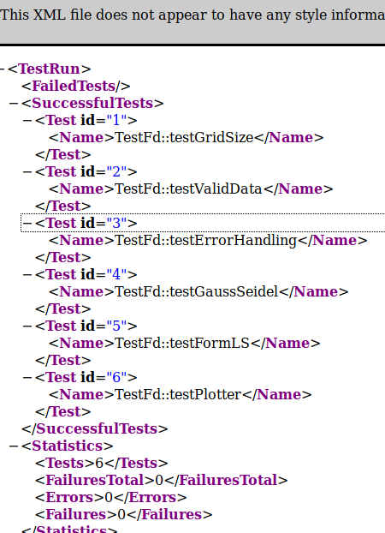
You will see all six tests are successful and there are not test failures.
After the test is ran, you can open the plotter files of the various GNU plots produced:
test_b.plt
test_phi.plt

You can view these values through the linear solver.
By performing a “sh run.sh”.
This will map the data points for the test_phi.plt
Will produce similar results to this:
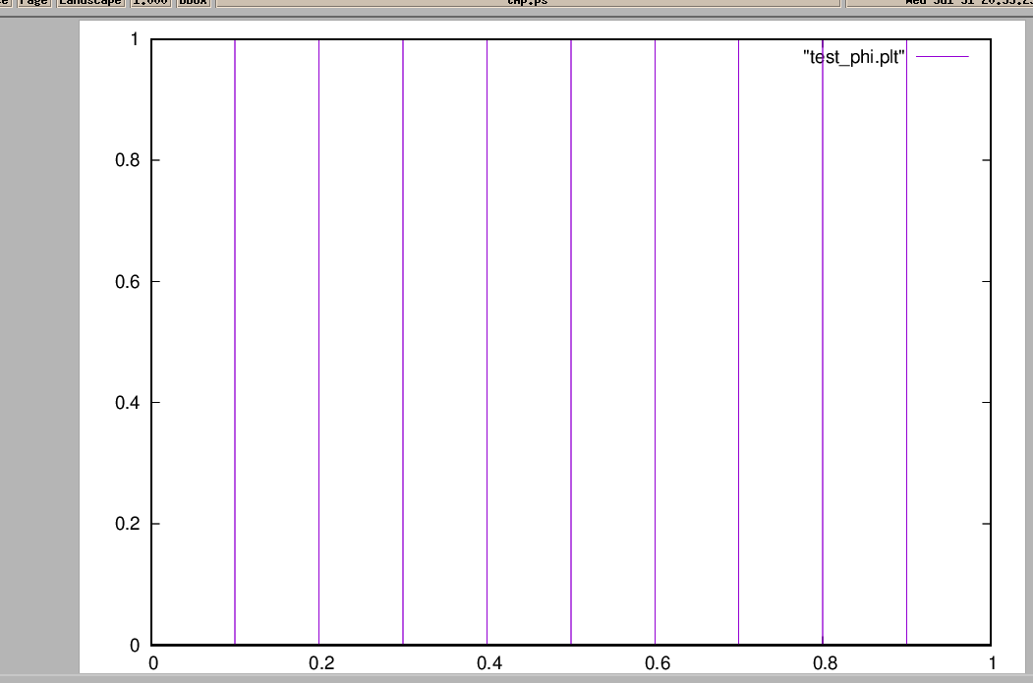

Regression_Tester
The regression tester was added to ensure that the functionality of the code is not regressed in any way between days. This way we can see if any functionality or tests have been broken inbetween days of updating code.
To run this regression, simply type “sh run.sh”.

What the regression tester does is compiles all of the classes, along with the tester. Runs all of the tests. Gets the resultant cppTestFd.xml , adds a date signature to the end; i.e. cppTestFd_YYYY-MM-DD.xml
Where YYYY is the four digit year number, the MM is for the two digit month code and the DD stands for the two digit day number. The results get put into the RegressionResults folder. Then a comparison is done by analyzing the statistics of the xml.

The comparison is between the two most recent files within the RegressionResults folder. So it will, if scheduled daily, will compare yesterday’s test results with todays. It makes sure that the amount of tests, failures, errors and failed tests stays the same. If there is any difference it will output a result similar to this:

It will also tell you if nothing has changed at all, and you get to save the results of tests for each day, so you can potentially write some scripts to view the results over the past couple of weeks, months or even years.

