CSCI 5229 Computer Graphics
Project: Final Project
Author: Daniel Lindberg

To run the program, you can either:
1) Perform a "make", then execute the binary via "./final"
2) do a simple "./run.sh"

Homework took me most every single one of my evenings for the week, from previous sunday to following sunday. I work full time as an engineer.

I had to look up how to use the vast majority of the functions
in my code from khronos.org

Pages like this: https://www.khronos.org/registry/OpenGL-Refpages/gl2.1/xhtml/glTranslate.xml

really helped me understand what the functions were performing.

I created my own textures using the ubuntu library imagemagick.

The photos for the chair, rose, and the dinosaur are just default photos
from google when doing a search for "chair, rose and dinosaur."

How to play the game:
The light swings from left to right. The portraits get displayed with an
image on them when the light swings in that direction. Some portraits do not have photos. What you will see at the bottom of the scene is an object: a flower, dinosaur or chair. Depending on the object, you have
to guess how many portraits have paintings of said object. So if it shows a flower, you have to guess how many roses there are. You change
your guessing number by moving up and down on the arrow key, and you can see it displayed in the string at the bottom of the room. Once you have the guess number to your designated level, you need to hit the
'Enter' key. If you guess correctly, you extend your 'timer'. The game
ends when the timer reaches 0. The timer goes down whenever the light
changes direction, or the guess number is incorrect.

The guessing number and camera viewpoint can be changed:

x_viewpoint, y_viewpoint
Value | Up | Down
--------------------------------
x_camera | a | d
y_camera | w | s

guess_number
Value | Up | Down
--------------------------------
guess_number | Up arrow | Down Arrow

Computer Graphics Concepts:

Collision detection is a computer graphics concept. It is used when attempting to determine if a collision occurs between two objects. This is a highly complicated thing to check for in the fact, that in opengl we generally do not use the data of the objects, since these objects are quite complicated. We then check for collisions based on simple shapes. One of the easiest ways to detect collisions is through a concept of “Axis-Aligned-bounding box”. This is generally applied to 2D scenes, in which you can see if objects overlay on a 2D plane. You could generally see if a rectangle takes up 4 coordinates such as this one: ([1,0] [1, 1] [0, 1] [0,0]), we could see that if a new object comes into the spot [0.5,0.05], we would see that this interacts with the rectangle object, and we would detect a collision. Now this would requiring you to keep track of the locations of objects and the spaces inbetween them.
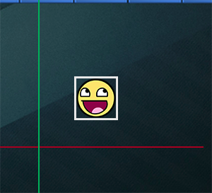

AABB is a concept that doesn’t work well in the 3D space because objects can take up more than just 2D coordinates.

So for this game, FlashPaint, described above. We needed to determine how to do collision detection, in the form of , when the light is directed towards a portrait, we would want to generate a painting on the portrait. What we are looking for is the collision of light to the portrait. But to understand this concept we need to understand another computer graphics concept called ray tracing.

Let’s first define a ray. A ray is a line with an endpoint that extends infinitely in one direction. So in the game Flashpaint, the ray is the light sources associated with the swinging light. We see that the angle in which the ray takes changes, as the ray swings back and forth. The light will extend infinitely just as ray does. We need to trace where the ray is directed towards and then determine if the angle in which it is facing is touching an object in that direction.

So in computer graphics, ray tracing is a rendering technique for generating an image by tracing the path of light as pixels in an image plane and simulating the effects of its encounters with virtual objects.
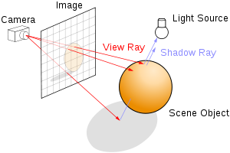

For raytracing, you need to trace the secondary rays and test for intersection with geometry. Therefore, you need access to the geometry of the light, and generally where the objects are where in which the light will be “colliding”.

Now I want to put a little disclaimer here, ray tracing is mainly a concept for simulating the effects of the ray , and its encounters past the virtual object. Typically they are used in the concept of shadow determination. If interested in shadows, you would need to determine the size of the object, the ray that hits it, and where the next object is that it will interact with. In the photo above we can see the light ray interacting with a ball, and a much larger ball shadow being drawn. Some of these determinations are hard to find out in computer graphics because as I said the location of these objects are sometimes ambiguous in computer graphics. So I obtained some of this information described below.

For Flashpaint, what I needed to determine is, in which direction the angle of the light was rotated to.
I used the following code snippet:
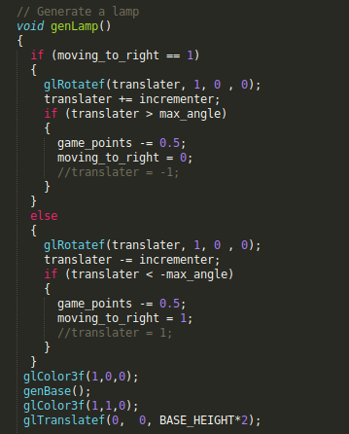

In here you can see that I “rotate” the light by the variable of translater. It moves the light by the degree amount every time the display function gets called. When it gets to the max angle limit it turns the incrementer into a negative amount, and it starts rotating in the other direction until it gets to the negative amount for the max angle. The direction in which the light was moving was the translater. We could then determine if the translater was within the range of certain degree segments it logically be lighting up the portraits in that direction.

Through this code segment, I was able to determine a logical “collision”, and a the concept of “ray tracing”.
Sources:

https://learnopengl.com/In-Practice/2D-Game/Collisions/Collision-detection

https://tutorialedge.net/gamedev/aabb-collision-detection-tutorial/

