To add front covers to your document use Generate Cover pages function in Pubsy
If your publication will be disseminated with identifiers (ISBN, ISSN, doi, etc.), please generate the covers after the identifiers have been assigned.
See: PUBSY: Automated Generate cover pages – Easier.Simpler.Faster
Please check the steps to format your report on p. 23 and the steps to make your publication accessible on p. 25.

Contents
Table of contents is generated automatically; simply click on it and press F9 key, then select to update entire table.
Contents 1
Abstract <mandatory element> 3
Foreword <optional element> 4
Acknowledgements <optional element> 5
Authors 5
Executive summary (mandatory element only for science for policy reports) 6
Policy context 6
Key conclusions 6
Main findings 7
Related and future Joint Research Centre work 7
Quick guide 7
1. Introduction <mandatory element> 9
2. Second heading of body of report 12
2.1. Subheading 1 13
2.1.1. Subheading 2 13
2.1.1.1. Subheading 3 14
2.1.1.1.1. Subheading 4 14
2.1.1.1.2. Second subheading 4 15
2.1.1.2. Second subheading 3 16
3. Methodology 19
3.1. Materials 19
3.2. Preparation of the modified-SNF Leachate 19
3.3. Batch adsorption experiments 20
3.4. Characterization techniques 21
3.5. Radioactivity characterization 22
4. Results 23
4.1. Cs removal of the SNF leachate 23
4.2. Adsorption experiments 24
4.3. Radioactivity characterization 34
4.4. To be used in case of need, otherwise removed :P 35
5. Conclusions <mandatory element> 36
References <mandatory element> 38
List of abbreviations and definitions <mandatory when report contains abbreviations and definitions> 46
List of boxes <mandatory when report contains boxed text> 47
List of figures <mandatory when report contains figures> 48
List of tables <mandatory when report contains tables> 49
Annexes <optional> 50
Annex 1. Title of annex <numbering of annexes is mandatory, if there is more than one> 50
Steps to format your report 51
Steps to make your publication accessible 53
Write clear and structured content 53
Text formatting 53
Add alternative text to images 53
Use of colour and sufficient colour contrast 54
Accessibility checker integrated with Microsoft Word 54
Exporting to PDF 54
Final actions and checks in PDF 55

Abstract <mandatory element>
Max. 1 550 characters with spaces.
Give, in up to five sentences, the most important conclusions, key facts and figures.
Also include a sentence or two on the policy relevance of the work.
It is to be used for eye-catching, newspaper-type headlines to attract the reader.
Deep geological disposal (DGD) stands out as the most promising and globally accepted solution to dispose the high-level radioactive waste (HLW). Bentonite is proposed as the last engineered barrier of DGD due to its low hydraulic conductivity, its self-sealing ability and its long-term stability. Furthermore, its sorption property could play an additional role for the long-term safety of the disposal.
In this project the adsorption properties of bentonites on DGD conditions have been studied for the first time by performing batch adsorption experiments using UO₂ spent nuclear fuel (SNF) leachates. The radioactive Cs of the leachate was removed and replaced by stable Cs to conduct the experiments inside a glove box. Actinides, lanthanides and Cs present in the modified SNF leachate were successfully retained by the bentonite, with a sorption that decreased with increasing elemental concentration for all the elements except for Np and Cs. Pre- and post-experimental characterization of the bentonite did not reveal significant structural or morphological changes, except for indications of slight amorphization. Alpha spectrometry analyses further confirmed the retention of radionuclides by bentonite.
#1214 characters, 9 sentences, 177 words.

Please consult the Interinstitutional Style Guide for guidance in drafting your report. It contains uniform stylistic rules and conventions that must be used by all the institutions, bodies, offices and agencies of the European Union. It is available in 24 EU languages, and is obligatory for all those involved in document production.

Foreword <optional element>
Nunc vestibulum condimentum nisi. Nam erat diam, suscipit vitae nisl eget, tempus tempus eros. Proin vel diam convallis, bibendum mi id, faucibus eros. Donec mi nisl, auctor quis aliquet a, ultricies vel metus. Ut rhoncus nulla augue, in egestas metus fringilla non. Sed sit amet felis dignissim, ornare elit vel, mattis augue. In adipiscing euismod purus id rutrum. Nulla facilisi. Nulla vitae dui lectus.

Acknowledgements <optional element>
The experimental data used in this research were generated through access to the ActUsLab/HC-KA under the Framework of access to the Joint Research Centre Physical Research Infrastructures of the European Commission (BAGSFUL, Research Infrastructure Access Agreement N° 36926/01).

Authors
Daniel López Aires
Esperanza Pavón González
Stefaan Van Winckel

Executive summary (mandatory element only for science for policy reports)
Nunc vestibulum condimentum nisi. Nam erat diam, suscipit vitae nisl eget, tempus tempus eros. Proin vel diam convallis, bibendum mi id, faucibus eros. Donec mi nisl, auctor quis aliquet a, ultricies vel metus. Ut rhoncus nulla augue, in egestas metus fringilla non. Sed sit amet felis dignissim, ornare elit vel, mattis augue. In adipiscing euismod purus id rutrum. Nulla facilisi. Nulla vitae dui lectus.

Policy context
Typically around 130 words – up to a maximum of 800 characters with spaces, reduced pro rata when graphics used.
- What broader and then specific EU (ongoing) policy issue does the report address? For example, does it support a specific directive or regulation, or does it support EU industrial policy and then specifically advanced manufacturing? This is essential to ensure that policy colleagues can straightaway determine its relevance to them.
- For whom was the report done and, if applicable, with whom (e.g. external collaborators)?
- Is it relevant to a possible new policy or a current policy measure that has been proposed or to the implementation of a current policy?
- What is/are the issue(s) at stake? Are the stakes high?
- What does the report add (added value) to previous policy support work?
- Why is the report relevant now? For example, is it to inform an upcoming or ongoing political (or media) debate or issue?
- Is it relevant to policies other than the one it was carried out to support? In other words, are there conclusions of more general application to several policies? If so, indicate which ones.

Key conclusions
Typically 350 words – maximum 2 200 characters with spaces, excluding any graphics.
- What are the main policy-relevant consequences of, or recommendations arising from, your findings about the policy/measure in question?
- What policy options could be proposed arising from your analysis?
- Have the main assumptions behind the existing policy or measures been confirmed or overturned?
- Has a new problem been identified? Should new policy measures be considered?
- Does the problem statement need to be adjusted?
- Have some additional impacts or alternative options been identified?
- Do the costs and benefits of the existing options need to be reassessed?
- Are there potential innovations that could arise? What potential risks could there be if such innovations are (not) undertaken?
- What significant knowledge gaps and uncertainties still remain that are relevant to policy in this field?
- Has the report served to change the level of uncertainties?

Main findings
Typically 300 words – maximum 1 850 characters with spaces, excluding any graphics.
- Summarise the main findings from and results of the work, including relevant data. Use (question) subheadings for specific (sub)topics.
- Use images, infographics, tables and graphs as much as possible.

Related and future Joint Research Centre work
Typically 50 words – maximum 300 characters with spaces, excluding any graphics.
- What other work by the Joint Research Centre (JRC) is relevant to this topic?
- What will be the follow-up or next steps from this report, including from a policy perspective (e.g. in regard to an upcoming new legislative proposal)?

Quick guide
Typically 100 words – maximum 700 characters with spaces, excluding any graphics.
Give non-experts a brief introduction to the topic being addressed, plus the key terms and concepts used, with a very brief explanation, and outline the main assumptions used, approach (methodology) and uncertainties. For highly sensitive and/or controversial topics you may need to expand some more on the main assumptions, uncertainties and/or approach used.

Recommendations for drafting an executive summary
- The main target audience for an executive summary is (senior) policy colleagues across the Commission.
- Picture a commissioner or director-general having 10 minutes to read only the executive summary before discussing the topic at a meeting. They will want the main policy-relevant outcomes very concisely and do not want the details of how you came to your results/conclusions (they will trust that the JRC does this correctly).
- The executive summary should ‘tell a story’, that is, have a clear and relevant narrative.
- Use the questions in each section to guide you in your drafting to develop a narrative. Do not answer each question consecutively.
- Do not be overly technical. Use language that a non-specialist reader would understand and would want to read. For example, do not use technical terms or acronyms excessively and, if you use any, define them in the overview section.
- Write it with the view that, if a (non-expert) reader wishes to learn more, they can go to the (relevant section of the) report.
- When drafting, follow the ‘keep it short and simple’ (KISS) and ‘less is more’ approaches and put yourself in the shoes of the reader.
- Use (question) subheadings to break up the text.
- Ask yourself, would the target audience reader find the information relevant and understandable?
- Ask a colleague with no knowledge of the report’s content to read a draft; then question them to see if they received the messages you want to convey.
- Use bullet points plus bold (sparsely!) to highlight key words, facts and figures.
- The total number of words in the abstract and executive summary should be around 950 words. It should never exceed 6 200 characters with spaces.
- The headings in this section and their order must not be changed, although you may modify the text of the subheadings.

- Introduction <mandatory element>
The introduction must contain at least the elements presented in the list below. The author is free to organise the body text under subheadings in order to improve the presentation and readability.
- General introduction to the issue – policy context and background
- Purpose of the report – why was the study undertaken?
- What is the policy problem/question addressed? Why is it important/significant?
- What are the main objectives of the report? How can they be applied in addressing the policy problem/question?

There is a renewed interest in nuclear energy and the role it can play in achieving the climate goals of the Green Deal (reducing 55% greenhouse gas emissions by 2030; reaching climate neutrality by 2050) (European Commission, n.d.; S et al., 2021). However, nuclear energy produces radioactive waste that must be safely disposed of, not to be harmful for people and the environment. The IAEA classifies nuclear waste depending on its activity and its half-life in: Very Low Level Waste, Low Level Waste, Intermediate Level Waste and High Level Waste (HLW) (IAEA, 2009). Although HLW (half-life > 30 y and specific activity > 10⁸ Bq/g) contributes the least to the total volume of radioactive waste (0.13 %) (IAEA, 2022), it is the most challenging to manage because it is the most radioactive.
There is a global scientific consensus that DGD is the best disposal strategy for HLW (Apted et al., 2017). In this scenario, the nuclear waste will be stored and sealed underground with a multi-barrier system so that the radionuclides can further decay in safe and secure conditions for people and the environment (Figure 1). Up to present, there is no operational disposal facility for HLW. However, Finland and Sweden will be the first countries to have one, as both countries are currently in the commissioning stage of their DGD.
Figure 1. Scheme of a deep geological repository.
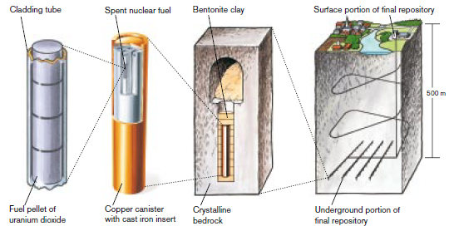
Source: (SKB, 2022a).

Bentonite, a type of swelling clay, is planned to be used as the last engineered barrier in most DGD concepts (Apted et al., 2017; Enresa, 1995; Nagra, 2021; SKB et al., 2017; SKB, 2022b) mainly due to its low hydraulic conductivity, swelling ability, and its long- term mineral stability (Galunin et al., 2010; Sellin et al., 2014). Furthermore, this type of clay also present adsorption properties (Bergaya et al., 2013; Meunier, 2005) which would enhance the long-term safety of this disposal strategy by retaining the radionuclides in case of water penetration into the fuel element and subsequent transport to the biosphere.
Bentonite clay is primarily made of Montmorillonite, a 2:1 phyllosilicate consisting of a central octahedral sheet containing sandwiched between two tetrahedral silica sheets. The region between these layered structures, known as interlayer space (Figure 2). The sheets are usually charged because of substitutions; in the tetrahedral layer alumina for silica, and in the octahedral layers iron or magnesium for alumina. To counterbalance this charge imbalance, the interlayer space holds a variety of hydrated cations.
Figure 2. Structure of Montmorillonite, the main constituent mineral of bentonite.
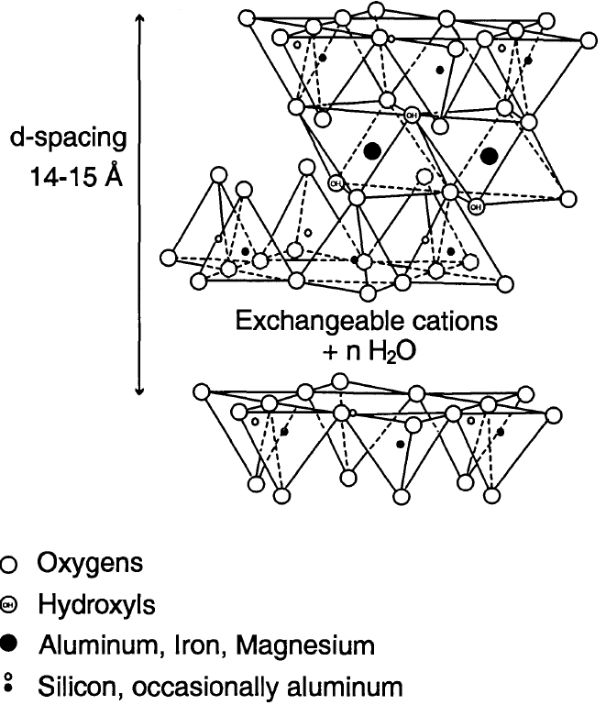
Source: (Pusch et al., 1996).
The sorption properties of bentonites have been studied using non-radioactive analogues of the radioactive nuclides present in SNF leachates (Coppin et al., 2002; Galunin et al., 2010; Gu et al., 2018; Hu et al., 2010; Murali et al., 2002; P. Wang et al., 2024; Yadav et al., 2019; Zhang et al., 2021), as well as using some of the radioactive elements present in SNF leachates (Begg et al., 2013; Degueldre et al., 1994; Turner et al., 1998; J. Wang et al., 2017). Diffusion experiments have been conducted using SNF leachates (Ramebäck et al., 2000) and non-radioactive analogues (Marimon, 2002). However, to our knowledge there is no literature concerning the sorption using actual SNF leachates, a more realistic scenario in terms of the long-term evolution of a DGD facility (H. Liu et al., 2023; Novikau et al., 2022).
The purpose of this report is to present the outcomes of the BAGSFUL project, which was undertaken to address this knowledge gap. The project aimed to quantify and understand radionuclide retention mechanisms in bentonites when exposed to SNF leachates generated at the JRC Karlsruhe (JRC-KA) facilities. This project serves as an extension of previous work conducted under the Collaborative Doctoral Partnership (CDP) program with the University of Seville (agreement No. 35582). In that preceding project, the kinetic of the adsorption process was investigated and the adsorption properties of bentonites were studied using non-radioactive solutions simulating SNF leachates. The results of both the previous work and this project will be included in a PhD thesis.

Lorem ipsum dolor sit amet, consectetur adipiscing elit. Sed quis metus dolor. Nam congue cursus ligula sed faucibus. Fusce ligula est, mattis ut ullamcorper id, vulputate nec urna. Curabitur sit amet nisi eget urna ornare ultrices . Cras eget facilisis dolor. Sed id velit sit amet dui ornare dapibus at et lorem. Donec erat lacus, dapibus a massa at, euismod hendrerit leo. Etiam volutpat dapibus dui a laoreet. Mauris gravida lobortis hendrerit. Integer at risus erat. Ut luctus lectus lorem, sit amet molestie lacus dictum id. Donec dolor lacus, aliquam et urna quis, cursus convallis nisi. Cras aliquet convallis urna, ac elementum leo accumsan ut. Nunc accumsan dolor dolor, vitae iaculis libero tempus non .
- Second heading of body of report
The author is free to organise the body of the report under suitable headings and subheadings (five levels of headings are available). The whole report should, however, broadly follow the usual logic for a scientific report: introduction (mandatory element) → methodology → results/findings → conclusions (mandatory element).
In relevant parts of the body of the report, please ensure the following.
- The methodology used is clearly explained/reported. (What were the methods used and why are they useful in addressing the policy problem/question and/or the objectives of the study/research?)
- The report refers appropriately to prior studies/work.
- Assumptions made are clearly explained and justified.
- Uncertainties having an impact on results and conclusions are fully explained.
- There is a copyright warning. (Images should be not used without permission. Copyright should always be mentioned.)
Lorem ipsum dolor sit amet, consectetur adipiscing elit. Sed quis metus dolor. Nam congue cursus ligula sed faucibus. Fusce ligula est, mattis ut ullamcorper id, vulputate nec urna. Curabitur sit amet nisi eget urna ornare ultrices. Cras eget facilisis dolor. Sed id velit sit amet dui ornare dapibus at et lorem. Donec erat lacus, dapibus a massa at, euismod hendrerit leo.
Etiam volutpat dapibus dui a laoreet. Mauris gravida lobortis hendrerit. Integer at risus erat. Ut luctus lectus lorem, sit amet molestie lacus dictum id. Donec dolor lacus, aliquam et urna quis, cursus convallis nisi. Cras aliquet convallis urna, ac elementum leo accumsan ut. Nunc accumsan dolor dolor, vitae iaculis libero tempus non.
- The first level of a bulleted list always uses em-dashes.
- Etiam volutpat dapibus dui a laoreet.
- Mauris gravida lobortis hendrerit. Integer at risus erat.
- Ut luctus lectus lorem, sit amet molestie lacus dictum id.
- Donec dolor lacus, aliquam et urna quis, cursus convallis nisi. Cras aliquet convallis urna, ac elementum leo accumsan ut. Nunc accumsan dolor dolor, vitae iaculis libero tempus non:
  - the second level of a bulleted list uses bullet points;
  - lorem ipsum dolor sit amet, consectetur adipiscing elit;
  - sed quis metus dolor;
  - nam congue cursus ligula sed faucibus.
Avoid creating very complex lists with list items consisting of multiple paragraphs, as the additional paragraphs will split the list. Should you need more paragraphs for the same list item, consider using a forced line break character before each additional paragraph. Another possibility is manually editing PDF tags of the additional paragraphs in post-processing after the export to PDF.
  - Subheading 1
Nunc vestibulum condimentum nisi. Nam erat diam, suscipit vitae nisl eget, tempus tempus eros. Proin vel diam convallis, bibendum mi id, faucibus eros. Donec mi nisl, auctor quis aliquet a, ultricies vel metus. Ut rhoncus nulla augue, in egestas metus fringilla non. Sed sit amet felis dignissim, ornare elit vel, mattis augue. In adipiscing euismod purus id rutrum. Nulla facilisi. Nulla vitae dui lectus.
- This is a numbered list.
- Etiam volutpat dapibus dui a laoreet:
  - this list can have two levels;
  - nunc accumsan dolor dolor.
- Mauris gravida lobortis hendrerit.
- Integer at risus erat.
Ut luctus lectus lorem, sit amet molestie lacus dictum id. Donec dolor lacus, aliquam et urna quis, cursus convallis nisi. Cras aliquet convallis urna, ac elementum leo accumsan ut. Nunc accumsan dolor dolor, vitae iaculis libero tempus non.
    - Subheading 2
Nunc vestibulum condimentum nisi. Nam erat diam, suscipit vitae nisl eget, tempus tempus eros. Proin vel diam convallis, bibendum mi id, faucibus eros. Donec mi nisl, auctor quis aliquet a, ultricies vel metus. Ut rhoncus nulla augue, in egestas metus fringilla non. Sed sit amet felis dignissim, ornare elit vel, mattis augue. In adipiscing euismod purus id rutrum. Nulla facilisi. Nulla vitae dui lectus.
Table 1. Nunc vestibulum condimentum nisi Table title is inserted above the table.
Nunc | Nunc 1 | Nunc | Nunc | Nunc
Nulla | Nulla | Nulla | Nulla | Nulla
Nulla | Nulla | Nulla 2 | Nulla | Nulla
1 This is a table note. Table notes are regular text and go directly below the table – do not use the built-in Word function for footnotes.
2 And this is another table note.
Source: All tables should have a source.
These are the accessibility rules for tables.
- Additional information like the table title, table notes and source information should be separated from the table structure and added as text paragraphs.
- If tables have different header cells, keep them separate from each other.
- Avoid placing other header cells or heading rows in the middle of a table.
- Do not leave the header cells empty.
- For header cells that appear at the top of a table, activate the option for the header rows to repeat on the next pages. Do it even if the table appears on a single page. This setting also tells assistive technology that marked cells are header cells.
- If the cells in the first column act as row headers, activate the First Column checkbox under the Table Design menu. This setting also tells assistive technology that the cells in the first column are header cells. Unfortunately, an additional fix is needed for row header cells after the export to PDF. Using Adobe Acrobat Pro, set the row header cell scope to ‘row’.
- Do not apply justified alignment to paragraphs in the table cells.
- Consider adding alternative text for complex tables. Please note that the alternative text added to tables in Microsoft Word is lost on exporting to PDF. However, the alternative text for a table can be entered as a table summary in PDF using Adobe Acrobat Pro.
      - Subheading 3
Vestibulum condimentum nisi. Nam erat diam, suscipit vitae nisl eget, tempus tempus eros. Proin vel diam convallis, bibendum mi id, faucibus eros. Donec mi nisl, auctor quis aliquet a, ultricies vel metus. Ut rhoncus nulla augue, in egestas metus fringilla non. Sed sit amet felis dignissim, ornare elit vel, mattis augue. In adipiscing euismod purus id rutrum. Nulla facilisi. Nulla vitae dui lectus.
        - Subheading 4
Nunc vestibulum condimentum nisi. Nam erat diam, suscipit vitae nisl eget, tempus tempus eros. Proin vel diam convallis, bibendum mi id, faucibus eros. Donec mi nisl, auctor quis aliquet a, ultricies vel metus. Ut rhoncus nulla augue, in egestas metus fringilla non. Sed sit amet felis dignissim, ornare elit vel, mattis augue. In adipiscing euismod purus id rutrum. Nulla facilisi. Nulla vitae dui lectus.
Figure 1. Simplified diagram of the convergence model Figure title is inserted above the figure.
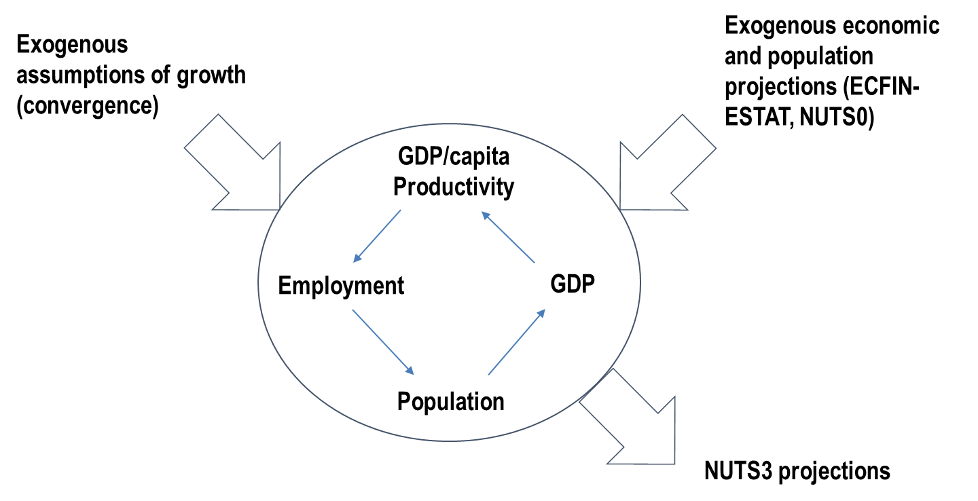
Source: All figures should have a source as well.
These are the general accessibility requirements for pictures:
- Add alternative text to the meaningful pictures.
- For publications published as Microsoft (MS) Word files, pictures are accessible only if they are inserted in line with the text. Alternative text for anchored pictures is supported only by the MS Office 365 update released in 2022 and later updates.
- For publications published as PDF files (exported from MS Word), pictures can be inserted in line with the text or with different text-wrapping options.
- To set the reading order for a picture with the text wrapping, lock the anchor in front of the paragraph preceding where the image’s alternative text should appear in the reading order. The alternative text is read out after that paragraph.
- Picture title, subtitle, copyrights, source and caption text must be separated from the graphic and appear as text.
- Each picture should be a single object. If a picture consists of several elements (e.g. a chart combined with text boxes and drawings), such a picture should be created in another document. A good solution is to create an infographic or a complex chart in PowerPoint, then save the picture as an enhanced metafile and insert it as a single object in the working MS Word file.
- Ensure sufficient colour contrast (Web Content Accessibility Guidelines 2.1 level AA) for the picture elements. This does not include logos, photos and decorative images.
- Ensure that the text size in the pictures is equivalent to a minimum of 8 points after inserting and resizing the picture.
- The resolution of pictures should be 150 pixels per inch or higher. If a publication is also being printed, the resolution of pictures should be 200–300 pixels per inch.
        - Second subheading 4
Nunc vestibulum condimentum nisi. Nam erat diam, suscipit vitae nisl eget, tempus tempus eros. Proin vel diam convallis, bibendum mi id, faucibus eros. Donec mi nisl, auctor quis aliquet a, ultricies vel metus. Ut rhoncus nulla augue, in egestas metus fringilla non. Sed sit amet felis dignissim, ornare elit vel, mattis augue. In adipiscing euismod purus id rutrum. Nulla facilisi.
Add an equation as a single image, for example copied and pasted as a picture enhanced metafile, and add alternative text to it.

Equation 1. Title of the equation
      - Second subheading 3
Nunc vestibulum condimentum nisi. Nam erat diam, suscipit vitae nisl eget, tempus tempus eros. Proin vel diam convallis, bibendum mi id, faucibus eros. Donec mi nisl, auctor quis aliquet a, ultricies vel metus. Ut rhoncus nulla augue, in egestas metus fringilla non. Sed sit amet felis dignissim, ornare elit vel, mattis augue. In adipiscing euismod purus id rutrum. Nulla facilisi. Nulla vitae dui lectus. (Please set space after to 12 pt as direct formatting to increase the space between the text and the following box.)
Box 1. This is a box title (manually add ‘Strong’ character style to the numbering)
This is a box text … Nunc vestibulum condimentum nisi. Nam erat diam, suscipit vitae nisl eget, tempus tempus eros. Proin vel diam convallis, bibendum mi id, faucibus eros. Donec mi nisl, auctor quis aliquet a, ultricies vel metus. Ut rhoncus nulla augue, in egestas metus fringilla non. Sed sit amet felis dignissim, ornare elit vel, mattis augue. In adipiscing euismod purus id rutrum. Nulla facilisi. Nulla vitae dui lectus.
If the box like this (which is constructed based on a paragraph style) is split between two pages, the box border towards the edge of a page is not added. You may try to insert a larger white space before the box to force it to move onto a single page, or you can use a single cell table with table style JRC_Table_Box for long boxes (see Box 2 as an example).
- And sometimes you may want to make a list inside a box.
- This bulleted list style with em-dashes is specifically made for this box.
Sed sit amet felis dignissim, ornare elit vel, mattis augue. In adipiscing euismod purus id rutrum. Nulla facilisi. Nulla vitae dui lectus.
Donec mi nisl, auctor quis aliquet a, ultricies vel metus. (Please set space before and space after to 12 pt as direct formatting to increase the space between text and boxes.)
Box 2. This is a box title (manually add ‘Strong’ character style to the numbering)
This is a box text … Nunc vestibulum condimentum nisi. Nam erat diam, suscipit vitae nisl eget, tempus tempus eros. Proin vel diam convallis, bibendum mi id, faucibus eros. Donec mi nisl, auctor quis aliquet a, ultricies vel metus. Ut rhoncus nulla augue, in egestas metus fringilla non. Sed sit amet felis dignissim, ornare elit vel, mattis augue. In adipiscing euismod purus id rutrum. Nulla facilisi. Nulla vitae dui lectus.
Only use a single cell table structure for a box if you need it to contain elements that are not possible to format using just a paragraph style. Afterwards, to make the PDF file completely accessible, the table tags should be removed manually in the PDF tags structure using Acrobat Pro software.
- And sometimes you may want to make a list inside a box.
- This bulleted list is the same as used elsewhere in the document:
  - the second level of a bulleted list uses bullet points;
  - lorem ipsum dolor sit amet, consectetur adipiscing elit.
Sed sit amet felis dignissim, ornare elit vel, mattis augue. In adipiscing euismod purus id rutrum. Nulla facilisi. Nulla vitae dui lectus.
(Format the following paragraph after a table by setting space before to 12 pt to increase the space between the text and the preceding box.) Proin vel diam convallis, bibendum mi id, faucibus eros. Donec mi nisl, auctor quis aliquet a, ultricies vel metus. Ut rhoncus nulla augue, in egestas metus fringilla non. Sed sit amet felis dignissim, ornare elit vel, mattis augue. In adipiscing euismod purus id rutrum. Nulla facilisi. Nulla vitae dui lectus.
Nunc vestibulum condimentum nisi. Nam erat diam, suscipit vitae nisl eget, tempus tempus eros. Proin vel diam convallis, bibendum mi id, faucibus eros. Donec mi nisl, auctor quis aliquet a, ultricies vel metus. Ut rhoncus nulla augue, in egestas metus fringilla non. Sed sit amet felis dignissim, ornare elit vel, mattis augue. In adipiscing euismod purus id rutrum. Nulla facilisi. Nulla vitae dui lectus.
This is a new section with a horizontal page layout. This should mainly be used for the insertion of large, complex tables or graphics.
Insert two section breaks (Next Page), and then change the page orientation for this section only. Remember to change the page numbering format, so that it is continuous from the previous section (this has to be done twice: for the new, horizontal section and for the section that follows it).
Table 2. Large table in horizontal layout
Column 1 | Column 2 | Column 3 | Column 4 | Column 5 | Column 6 | Column 7 | Column 8 | Column 9 | Column 10
First column | Data | Data | Data | Data | Data | Data | Data | Data | Data
First column | Data | Data | Data | Data | Data | Data | Data | Data | Data
First column | Data | Data | Data | Data | Data | Data | Data | Data | Data
First column | Data | Data | Data | Data | Data | Data | Data | Data | Data
Source: xxxxxxxxxxxxx.
- Methodology
  - Materials
Three SNF samples were used to generate the leachate under oxidizing conditions in a hot cell. The leachate was prepared with bicarbonated (BIC) water, a reference solution employed in SNF leaching experiments at JRC-KA (Kokinda et al., 2025; Martínez-Torrents et al., 2018; Serrano-Purroy et al., 2012). This leachant simulates the groundwater composition in a granitic environment, which is the candidate host rock for the repositories of Finland, Spain and Sweden (SKB et al., 2017; SKB, 2022c; Villar et al., 2006). Its composition was:
- 19 mM NaCl,
- 1.1 mM NaHCO₃.
The leaching time was 165 days. The SNF was originated from a commercial pressurized water reactor and irradiated at a linear power density of 255 W/cm. The average burnup of the fuel rod was 63 MWd/kgU. The irradiation ended in March 2001.
The bentonite used in the adsorption experiments is a candidate buffer material for the Swedish DGD concept (Svensson et al., 2019). It is a red bentonite from Sardinia, supplied by the Swedish company SKB in granular form (1-3 mm size). The material was quartered, milled and sieved to obtain a particle size fraction below 200 μm.

  - Preparation of the modified-SNF Leachate
For technical and time efficiency reasons, the experiments were conducted in a glove box. This required a radioactive dose reduction of the SNF leachate, which was prepared in a hot cell. The dose reduction was achieved using a Cs-selective sorbent column to remove the radioactive Cs, after which stable Cs was added to restore the chemical characteristics of the SNF leachate. Cs is one of the major contributors to the radioactive dose of the SNF during the first century after irradiation (Ewing et al., 1995; NEA, 2011; S et al., 2021). A closed-system column (Figure 1 a), filled with AMP-PAN resin (Treskim, France) was used to remove the radioactive Cs from the SNF leachate. The resin had a particle size of 100–600 μm. Given the high Cs-removal efficiency of AMP-PAN resin (Brewer et al., 1999; Todd et al., 2002; Tranter et al., 2002) and the relatively low Cs concentration in the leachate (ppm range), the column was designed with a bed volume of 0.4 mL. The closed-system column was connected to a peristaltic pump, allowing the leachate to pass through the resin and be collected. The flow rate was fixed at 1 mL/min to prevent pressure build-up in the column. After column preparation, the resin was equilibrated with BIC water by passing 4 mL (10 bed volumes) of BIC water through the column.
Firstly, the performance of the system was evaluated in cold (non-active) conditions using a solution of BIC water spiked with U, Cs, La, Eu and Sr (ppm-ppb range). After validation the column was rinsed, refilled with fresh resin, equilibrated with BIC water and installed in a hot cell. Figure 1 b) shows the set-up at a hot cell, consisting of a bottle containing the initial solution (left), a peristaltic pump, the column (right side) and a collection bottle for the filtered solution (right). Three aliquots were taken before and after the filtration for elemental analysis.
After the Cs removal, the modified-SNF leachate was transferred to a glove box. Stable Cs was added by using a CsCl solution (1.27 g/L) to restore the initial Cs concentration without introducing additional complexing agents or significantly altering the pH of the solution.
Figure 3. Closed-system column for Cs separation a) and Cs removal set-up in a hot cell b). The set-up consists of two bottles, one containing the initial leachate (left) and another to collect the filtered leachate (right)- as well as a peristaltic pump and the filtration column (located on the right side).
a)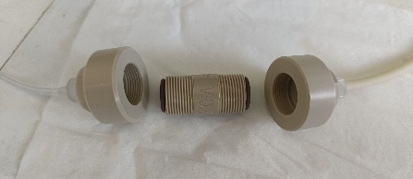b) 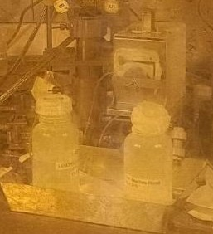
Source: JRC analysis.

  - Batch adsorption experiments
Batch adsorption experiments were conducted under oxidizing conditions in a glove box using a solid-to-liquid ratio of 5 g/L. Temperature and pH were not controlled during the experiments. Dilutions of the modified-SNF leachate were prepared using BIC water as dilutant, with dilutions factors (Df) ranging from 100 to 1 (undiluted).
For each experiment, 50 mL of solution were mixed with 250 mg of bentonite in polypropylene tubes and agitated horizontally at 500 rpm using a VKR basic Vibrax shaker (IKA, Germany) for 10 days. The equilibration time was set to 10 days based on kinetic experiments performed in the preceding CDP project. After equilibration, the solid and liquid phases were separated by centrifugation at 6000 rpm for 25 min using a D-78532 centrifuge (Hettlich, Germany). The supernatants were filtered through 0.8 μm syringe filters, and aliquots were taken, further filtered to 0.2 μm and acidified with 1 M HNO₃ for elemental analysis. The solid phase was collected, dried and homogenised using an agate mortar for analysis. All experiments were performed in triplicate.
From the initial solute concentration $C_{0}$ and the supernatant concentration after equilibration $C_{e}$, the removal percentage, the sorbed quantity at the equilibrium $Q_{e}$ and the equilibrium distribution coefficient $K_{d}$ were computed as follows:
Equation 2. Adsorption magnitudes.
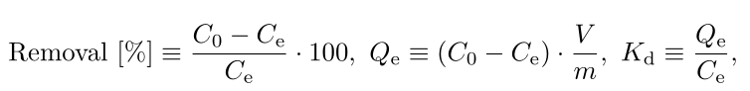

where $m$ is the mass of bentonite and $V$ the supernatant volume.
Adsorption isotherms were constructed and fitted to the Langmuir and Freundlich models. The Langmuir model (J. Wang et al., 2020) assumes monolayer adsorption on a homogeneous surface with identical sorption sites and without interactions between the adsorbed particles:
Equation 3. Langmuir isotherm model, including its linearization.


where $K_{L}$ is the Langmuir distribution coefficient and $Q_{max}$ is the maximum sorbed quantity. A key feature of this model is the prediction of a saturation limit: as $C_{e}$ increases, the available sorption sites become progressively occupied until a maximum coverage is reached. At this point, the sorbent is saturated and no further uptake occurs, such that $Q_{e}=Q_{max}$.
In contrast, the Freundlich isotherm model is an empirical model used to describe multilayer adsorption on a heterogeneous surface (Al-Ghouti et al., 2020; Saadi et al., 2015):
Equation 4. Freundlich isotherm model, including its linearization.
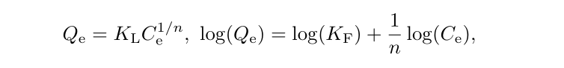

where $n$ is a positive dimensionless constant, and $K_{F}$ the Freundlich distribution coefficient. J. Wang et al showed that this model could as well be derived from the Langmuir theory by assuming a coverage fraction of active sites at the equilibrium of 50 % (J. Wang et al., 2020). The Freundlich model does not predict any saturation point; $Q_{e}$ increase as $C_{e}$ without any bound. The exponent $n$ controls the shape of its increase. For $n=1$, a linear equation is obtained, which correspond to the case of an adsorbent with many adsorption sites so that the coverage fraction is always low. For $n<1$ (unfavourable sorption), $Q_{e}$ increases exponentially with $C_{e}$. For $n>1$ (favourable sorption), $Q_{e}$ increases with $C_{e}$ but at a decreasing rate, indicating that the adsorption becomes less favourable as the adsorption sites get filled, but without reaching a true saturation state.
For the isotherm fitting, both linear and non-linear equations of the Langmuir and Freundlich models were used. Potential wall sorption was evaluated using control samples without bentonite. The effect was tested with a solution containing U, La, Eu, Cs and Sr at ppm to pbb levels, without detecting any significant concentration loss.

  - Characterization techniques
The elemental composition of the solutions was characterized by inductively coupled plasma mass spectrometry (ICP-MS) using a Thermo Element XP instrument (Thermo Electron Corporation, Germany). Calibration curves were produced using a series of certified multi-elemental standard solutions in the concentration range of the major elements in the solution. Co, In, Ho and Th were used as internal standards in the sample measurements. The concentration of the elements was calculated considering all the isotopes of each radionuclide. Isobaric interferences were corrected based on isotopic ratios previously calculated using the ORIGEN2 code. The pH was measured with a SG2 pH metter (Mettler Toledo, USA) with an Inlab expert pro electrode (Mettler Toledo, USA).
The solid samples were dried and ground using a mortar with a few drops of acetone. Fourier-transform infrarred (FTIR) spectroscopy was performed using a Bruker Alpha I spectrometer (Bruker, Germany) equipped with a diamond crystal. For each measurement, 64 scans were collected with a resolution of 2 cm⁻¹ and a range from 4000 to 350 cm⁻¹. X-Ray diffraction (XRD) was performed with a Bruker AXS D8 advanced diffractometer with a Platinum filament (Bruker, Germany) using the K_{α} Cu emission, operated at a voltage of 40 kV and an intensity of 15 mA. XRD measurements were conducted inside a glovebox under N₂ atmosphere. The sample preparation involved further grounding with isopropanol and mounting that mix into the Platinum filament of the diffractometer. Diffractograms were obtained within the 2θ range from 4 to 70 ° with a step size of 0.01 ° and a step time of 10 s. Scanning electron microscopy (SEM) was performed to uncoated bentonite samples using a Thermo Scientific Quattro SEM (Thermo Electron Corporation, USA) with a field emission gun (FEG) source, equipped with EDS XFlash 6/30 and EBSD e-Flash HD detectors. It was operated at a voltage up to 40 kV and a working distance of 10 mm.

  - Radioactivity characterization
Alpha spectrometry was performed to both the leachate dilutions and the supernatants using an Alpha duo detector (Ortec, Germany). The detector was calibrated using a standard planchet containing ²³⁹Pu, ²⁴¹Am and ²⁴⁴Cm (Eckert & Ziegler, Germany). A volume of 0.1 mL of solution was deposited in a metallic planchet, evaporated to dryness, and counted for 10 h. The total alpha activity was calculated by integrating the peaks and correcting for the detector efficiency (13 %). With the alpha activity of the dilutions and the supernatants the relative alpha activity reduction was computed.

- Results
Uncertainties of all derived quantities were calculated by quadratic (quadrature) error propagation. Uncertainties are reported with one significant figure when their leading digit is 3 or higher, and with two significant figures otherwise. The significant figures of each uncertainty determine the number of significant figures of the corresponding value. Each reported value is the mean of three replicate measurements, with uncertainty expressed as the standard deviation of those replicates.
  - Cs removal of the SNF leachate
Prior to the SNF leachate filtration in a hot cell, the fitness of the filtration setup was evaluated in cold conditions. These first tests revealed an almost complete Cs retention, around 99 %. Minor leaching of resin constituents, namely P and Mo, was detected at trace levels (ppm). Moderate retention was also observed for lanthanides (~ 30 %) and U (~ 20 %). U retention has also been reported in the literature. Reynier et al. reported ~ 10 % U retention, with a pH of 1.5-2, using a BV of 50 mL and a U concentration of 58.24 mg/L (Reynier et al., 2022). The higher U retention observed in the present study may be attributed to the formation of U complexes under the neutral pH conditions used.
Following setup validation, the setup was installed in a hot cell and the SNF leachate filtration was performed. The average ICP-MS concentrations measured before and after the Cs filtration in the hot cell, together with the corresponding removal percentages and the concentration after stable Cs addition are reported in Table 1. Cs removal was nearly complete (~ 100 %), with the final concentration approaching the analytical uncertainty of the measurements. Actinides were also removed from solution, with the highest removal for Pu (~ 48 %), followed by Am and Cm (~ 28 % each) and U (~ 21 %). Lanthanides were removed to a similar extent, between 20 and 30 %. For clarity, Table 1 shows only La and Sm as representative lanthanides. Mo concentration increased by approximately three orders of magnitude, while P concentration increased by a factor of approximately three. The solution pH remained neutral throughout the process, at $7.6±0.2$.

Table 1. Leachate elemental concentration before and after the Cs removal, and after natural Cs addition, including the removal percentage. Mo and P concentrations are also included, as these elements are present in both the leachate and the AMP-PAN resin.
Element | Initial concentration [μM] | Concentration after Cs removal [μM] | Concentration after stable Cs addition [μM] | Removal [%]
Cs | $$21.5±1.2$$ | $$0.104±0.004$$ | $$22.6±0.3$$ | $$100±8$$
La | $$0.195±0.010$$ | $$0.1359±0.0005$$ | $$0.147±0.006$$ | $$30±5$$
Sm | $$0.165±0.006$$ | $$0.1260±0.0017$$ | $$0.1205±0.0029$$ | $$24±4$$
U | $$12.5±0.8$$ | $$9.79±0.21$$ | $$10.39±0.12$$ | $$21±7$$
Pu | $$0.052±0.004$$ | $$0.0268±0.0007$$ | $$0.0279±0.0003$$ | $$48±8$$
Np | $$0.00424±0.00020$$ | $$0.00304±0.00003$$ | $$0.00326±0.00022$$ | $$28±5$$
Am | $$0.069±0.006$$ | $$0.0497±0.0010$$ | $$0.0539±0.0017$$ | $$28±10$$
Cm | $$0.0086±0.0007$$ | $$0.00617±0.00010$$ | $$0.0065±0.0003$$ | $$28±9$$
P | $$12.6±1.2$$ | $$31.4±0.8$$ | $$32.8±0.7$$ | ----
Mo | $$0.241±0.019$$ | $$265.0±2.3$$ | $$264.3±2.2$$ | ----
Source: JRC analysis.

  - Adsorption experiments
The pH of the leachate dilutions used for the batch adsorption experiments ranged between $7.8±0.2$ and $8.0±0.2$. After the equilibration, the supernatants exhibited slightly higher pH, ranging from $8.2±0.2$ to $8.8±0.2$.
Figure 4 shows the removal percentage as a function of the initial concentration for non-actinides and actinides. Adsorption isotherms based on $K_{d}$ are presented in Figure 5, whereas those based on $Q_{e}$ are included in Figure 6. For all the elements studied, $Q_{e}$ increased with $C_{e}$. All isotherms could be fitted using the Freundlich model, also included in Figure 6, with the fit parameters included in Table 2. Some isotherms could as well be fitted using the Langmuir model, included in Figure 7, with the fit parameters in Table 3.
The adsorption results are discussed below.

Figure 4. Removal percentage as a function of its initial concentration for a) non-actinides and for b) actinides. Values represent the average of the three replicates.
a)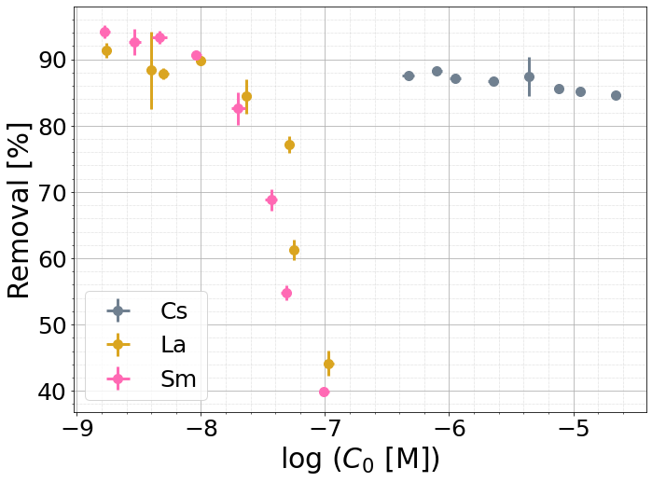
b)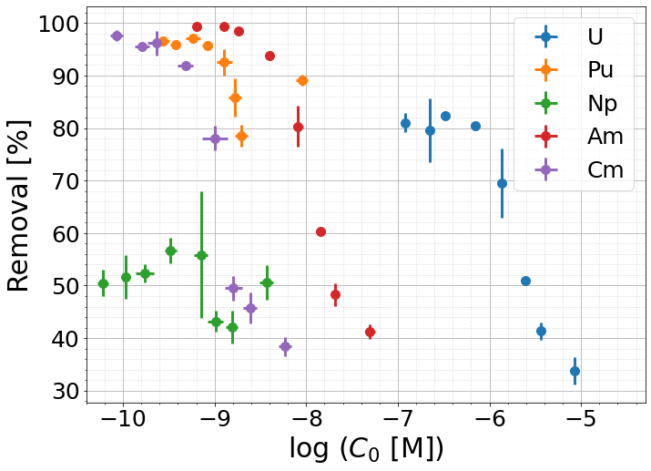
Source: JRC analysis.
Figure 5. Adsorption isotherms based on the equilibrium distribution coefficient for a) non-actinides and for b) actinides. Values represent the average of the three replicates.
- 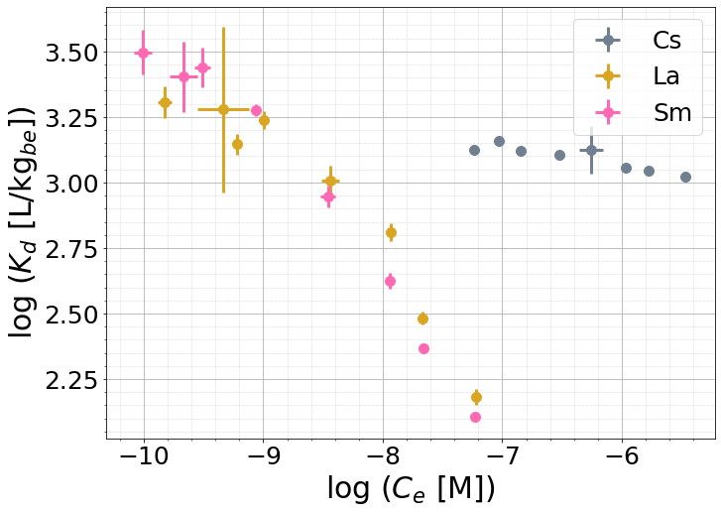
- 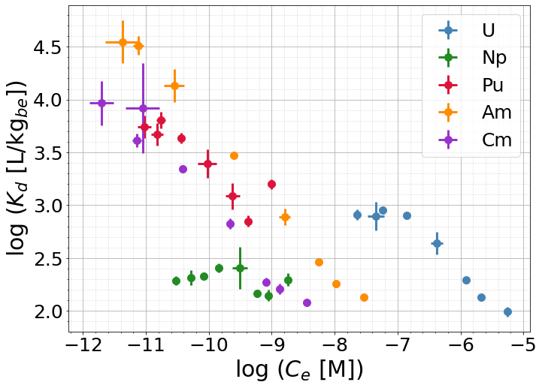
Source: JRC analysis.

Figure 6. Adsorption isotherms based on the sorbed quantity for a) non-actinides and for b) actinides. The best fits using the Freundlich model are included (discontinuous lines). For Pu, the last sample was excluded for the fit. Values represent the average of the three replicates.
- 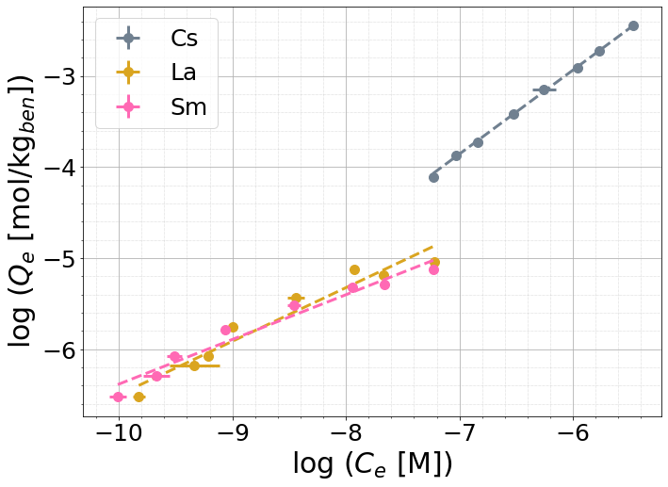
- 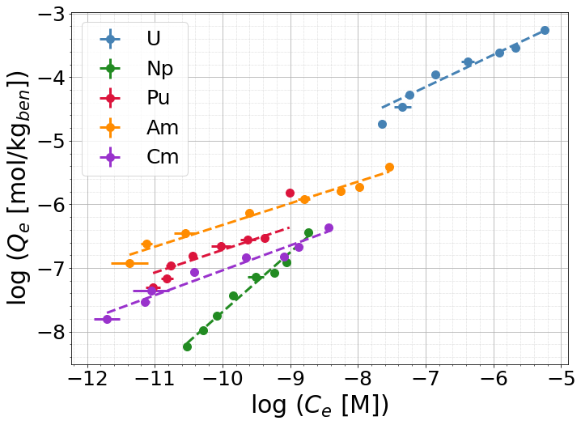
Source: JRC analysis.
Table 2. Parameters of the best fits using the Freundlich model, including the correlation coefficient r. The relatively high uncertainties obtained for the Freundlich equilibrium distribution coefficient K_F arise from the low intercept values b obtained in the fits. $K_{F}$ is proportional to $b^{-1}$, while its standard deviation $σ\left(K_{F}\right)$ is proportional to $b^{-2}$. Hence, small b could lead to relatively high $σ\left(K_{F}\right)$ that may be comparable to, or even exceed, the fitted parameter $K_{F}$ itself.
Element | $$r$$ | $$n$$ | $K_{F}$ [L^{n} mol^{1-n} / kg_{be}]
Cs | $$0.9998$$ | $$1.086±0.010$$ | $$(39±4)⋅10$$
La | $$0.94$$ | $$1.70±0.18$$ | $$(2.4±2.9)⋅{10}^{-1}$$
Sm | $$0.98$$ | $$2.71±0.23$$ | $$(3.3±2.5)⋅{10}^{-3}$$
U | $$0.98$$ | $$1.98±0.16$$ | $$(2.4±1.2)⋅{10}^{-1}$$
Np | $$0.98$$ | $$1.07±0.06$$ | $$(5±6)⋅10$$
Pu | $$0.93$$ | $$2.8±0.4$$ | $$(7±8)⋅{10}^{-4}$$
Am | $$0.97$$ | $$2.94±0.20$$ | $$(1.2±0.6)⋅{10}^{-3}$$
Cm | $$0.96$$ | $$2.56±0.22$$ | $$(7±6)⋅{10}^{-4}$$
Source: JRC analysis.
Figure 7. Adsorption isotherms based on the sorbed quantity including the best fits using the Langmuir model (discontinuous lines) for La, Sm, U and Pu. For Pu, the last sample was excluded for the fit. Values represent the average of the three replicates.
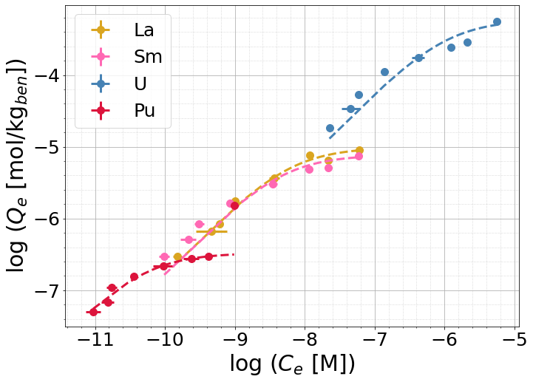
Source: JRC analysis.
Table 3. Parameters of the best fits using the Langmuir model, including the correlation coefficient $r$.
Element | $$r$$ | $Q_{max}$ [mol / kg_{be}] | $K_{L}$ [M⁻¹]
La | $$0.99$$ | $$(9.8±0.4)⋅{10}^{-6}$$ | $$(1.7±0.3)⋅{10}^{8}$$
Sm | $$0.98$$ | $$(7.7±0.5)⋅{10}^{-6}$$ | $$(2.3±0.7)⋅{10}^{8}$$
U | $$0.9$$ | $$(5.9±0.8)⋅{10}^{-4}$$ | $$(9±3)⋅{10}^{5}$$
Pu | $$0.998$$ | $$(3.30±0.07)⋅{10}^{-7}$$ | $$(2.12±0.18)⋅{10}^{10}$$
Source: JRC analysis.
Cs adsorption
Cs removal rate was constant at ~ 85 % over the whole concentration range. High removal efficiencies can also be found in the literature, ranging from 60 to 95 % depending on the experimental conditions (Galamboš et al., 2009, 2010; H.-J. Liu et al., 2016).
The $K_{d}$ isotherm was nearly flat at log (K_{d} [ L·kg⁻¹]) ~ 3 meaning that the bentonite holds about 1000 times more Cs per kg than the solution holds per litre. This overall weak concentration dependence suggest that Cs uptake is dominated by site types that remain far for saturation over the investigated range. The values obtained are consistent with Cs sorption studies (H.-J. Liu et al., 2016; Missana et al., 2004, 2014; Tsai et al., 2001; Yildiz et al., 2011).
$Q_{e}$ reached the highest value of all elements studied, with a maximum of log ($Q_{e}$ [mol/kg_{be}.]) ~ -2.5. The isotherm data was well fitted using the Freundlich model, with a correlation coefficient
$r$ of 0.997 and $n$ ~ 1, indicating an almost linear isotherm. Hence, this suggests that no site-saturation has been reached within the studied concentration interval. Thus, the Langmuir model did not provide a good fit for the data. In the literature, Cs sorption has been successfully described using both Freundlich (Atun et al., 2002; H.-J. Liu et al., 2016; Tsai et al., 2001; Yildiz et al., 2011) and Langmuir (Galamboš et al., 2010; Yang et al., 2014) models, depending on the experimental conditions. The parameters of this study are comparable to those of (Atun et al., 2002), who also found the Freundlich model to better describe Cs adsorption.
U adsorption
U removal showed two regions, a first one where the removal rate had an approximately constant value at ~ 80 %; and a second one where the removal rate decreased with increasing $C_{0}$, reaching a value of ~ 35 % for the highest $C_{0}$ explored. In the literature studies with a wide variety of removal rates can be found depending on the experimental conditions, ranging from 20 to 60 % (Aytas et al., 2009; Bachmaf et al., 2011; Joseph et al., 2013; J. Wang et al., 2017; Xiao et al., 2013; S. Yu et al., 2020).
The $K_{d}$ isotherm remained nearly constant at log ($K_{d}$ [ L·kg⁻¹]) ~ 3.0 at low $C_{e}$, and then decreased progressively with increasing $C_{e}$, reaching ~ 2.0 at the maximum $C_{e}$ investigated. This pattern is consistent with adsorption on sites of different affinity. At low $C_{e}$, the higher-affinity sites are far from occupied, so $K_{d}$, is flat. At higher $C_{e}$, these sites fill and U uptake is shifted toward lower-affinity sites. Multi-site sorption mechanisms have already been reported for elements such as Cs or Eu in literature, having similar adsorption isotherms (T. Missana et al. 2004; Tiziana Missana et al. 2014; M. H. Bradbury et al. 2005; M. H. Bradbury and Baeyens 2002). The $K_{d}$ values obtained are comparable to the ones reported in the literature (Missana et al., 2004; Pabalan et al., 1997; Xiao et al., 2013).
$Q_{e}$ reached a maximum value of log ($Q_{e}$ [mol/kg_{be}.]) ~ -3.2. The isotherm data could be fitted by both the Freundlich and Langmuir model. The Freundlich model provided a more suitable fit considering its higher correlation coefficient; 0.98 for the Freundlich fit compared to 0.9 for the Langmuir fit, consistent with heterogeneity in the U adsorption. The $n$ coefficient ~ 2 indicates a favourable sorption that become less favourable as the sorption sites fill, but without reaching a saturation point. Studies fitting U sorption data to both Langmuir and Freundlich models can be found in the literature (J. Wang et al., 2017; Xiao et al., 2013).
Pu adsorption
Pu removal had a similar trend to U, but with higher initial removal rate, ~ 90 %, and milder decrease with initial concentration, reaching ~ 80 % at the highest concentration explored. Pu removal rates close to 90 % have also been reported in the literature (Begg et al., 2013, 2015, 2018).
The $K_{d}$ isotherm exhibited a similar shape to U but with higher values. Log ($K_{d}$ [ L·kg⁻¹]) stayed at ~ 3.7 at low $C_{e}$ and for high $C_{e}$ it decreased with increasing $C_{e}$ to ~ 2.7 for the highest $C_{e}$ explored. The most concentrated sample showed an abrupt increase in $K_{d}$, also visible in the removal rate and in $Q_{e}$. This could be due to Pu precipitation, which is likely at nM - μM concentrations range under neutral to slightly alkaline pH (Kokinda et al., 2025; P. Wang et al., 2017). The $K_{d}$ values obtained are in line with results from published literature (Begg et al., 2018; Leng et al., 2016).
$Q_{e}$ reached a maximum value of log ($Q_{e}$ [mol/kg_{be}.]) ~ -6.6 excluding the outlier, which had log ($Q_{e}$ [mol/kg_{be}.]) ~ -6.2. These values are comparable to those in the literature (Begg et al., 2018; Missana et al., 2008). Excluding the outlier, the data could be fitted by both the Freundlich and Langmuir models, with Langmuir providing the better fit (correlation coefficient of 0.998 vs. 0.93 for Freundlich model). This suggests a saturation point would be reached at sufficiently high concentrations, with a predicted maximum sorbed quantity of (3.30 ± 0.07) ·10⁻⁷ mol/kg_{be}. No published studies using these adsorption models could be found for Pu.
Np adsorption
Np removal rate was approximately constant for all the concentrations explored, with values scattering around 50 %. Similar removal rates can be found in the literature (Kasar et al., 2014; Li et al., 2015).
The $K_{d}$ isotherm was nearly flat at log (K_{d} [ L·kg⁻¹]) ~ 2.2. These are the lowest values of all the elements studied, which indicates that the bentonite holds about 160 times more mol per kg than the solution holds per litre. Several Np sorption studies report $K_{d}$ values of the same order of magnitude (Bradbury et al., 2005; Fröhlich, 2015; Li et al., 2015; Turner et al., 1998).
The similarities between Cs and Np adsorption isotherms could be explained by speciation. Under the experimental conditions, Np is expected to occur as the monovalent cation NpO₂⁺, a linear molecule with limited hydrolysis tendency (Benedicto et al., 2014; Grenthe et al., 2020; Zavarin et al., 2012). Cs⁺ is also a monovalent cation with negligible hydrolysis tendency, so both elements are expected to behave in a similar way.
$Q_{e}$ reached a maximum value of log ($Q_{e}$ [mol/kg_{be}.]) ~ -6.4. As for Cs, the Freundlich model gave the best fit (r = 0.98). The $n$ coefficient was close to unity as well, indicating an almost linear isotherm and no site saturation within the concentration range studied. Li et al. also found that the Freundlich model described Np sorption successfully, with a $n$ coefficient of 0.86 (Li et al., 2015).
Am adsorption
Am removal followed a similar trend to U and Pu, but it had the highest initial removal rate of all the studied elements, close to 100 %. For high $C_{0}$, the removal decreased with $C_{0}$ up to ~ 40 % for the highest $C_{0}$ explored. T. Yu et al reported removal rate of 90 % for pH 8 (T. Yu et al., 2012).
The $K_{d}$ isotherm displayed a similar pattern as U and Pu. In the first region, log ($K_{d}$ [ L·kg⁻¹]) stayed constant at ~ 4.5, the highest value obtained for all the elements. In the second region, $K_{d}$ decreases with increasing $C_{e}$ down to ~ 2.1 in log units for the highest $C_{e}$. The $K_{d}$ values obtained here are in line with the results from published studies (Bradbury et al., 2005; Degueldre et al., 1994; Nagasaki et al., 1997).
Log ($Q_{e}$ [mol/kg_{be}.]) reached a maximum of ~ -5.4, comparable with the values reported by Yu et al (T. Yu et al., 2012). The sorption data could be fitted with the Freundlich model (r = 0.97) and $n$ ~ 2.9, the highest $n$ obtained among the studied elements, indicating favourable sorption. Fitting Am sorption data to the Freundlich model can also be found in the literature (Konishi et al., 1988; T. Yu et al., 2012).

Cm adsorption
Cm removal followed similar trend to Am, with an initial removal of ~ 95 % that decreased to ~ 40 % at the highest $C_{0}$ explored. No Cm removal data have been found in the literature.
The $K_{d}$ isotherm showed a similar pattern to Am, with slightly lower values. In the first region, log ($K_{d}$ [ L·kg⁻¹]) ~ 4.0 and it decreased to ~ 2.1 at high $C_{e}$. Higher $K_{d}$ values, ~ 4.5 in log units, have been reported in the literature at neutral to basic pH (Grambow et al., 2006; Rabung et al., 2005). The lower values observed here may be attributed to competition for the sorption sites with other elements, particularly Am and lanthanides. Lanthanides are commonly used as non-radioactive analogues of both Am and Cm due to their chemical similarities (Chapman et al., 1986; Coppin et al., 2002; Galunin et al., 2010).
Log ($Q_{e}$ [mol/kg_{be}.]) reached a maximum of ~ -6.4. The Freundlich model provided a good fit of the data, with r = 0.96 and a $n$ parameter ~ 2.6, indicating favourable sorption. No published studies using these adsorption models could be found for Cm.
Lanthanides adsorption
A wide range of lanthanides was present in the leachate and sorbed by the bentonite. For clarity, only La and Sm are presented here. Lanthanides removal followed a similar trend to Am and Cm, but with slightly lower maximum removal rates; it started at ~ 90 % and decreased to ~ 40 % at the highest $C_{0}$ explored. Removal rates ~ 90 %, have also been reported in the literature (Chen et al., 2012a; Hurel et al., 2010; Missana et al., 2021).
The $K_{d}$ isotherm of both lanthanides followed a similar trend to Am and Cm but with lower values. In the first region, log ($K_{d}$ [ L·kg⁻¹]) was ~ 3.3 for both La and Sm, decreasing to ~ 2.1 at high $C_{e}$ for both lanthanides. Similar $K_{d}$values can be found in the literature (Abass et al., 2022; Coppin et al., 2002).
Log ($Q_{e}$ [mol/kg_{be}.]) reached a maximum of ~ -5.2 for both La and Sm. The isotherms could be fitted using both Langmuir and Freundlich model, but the Langmuir provided the better fit for both lanthanides based on the correlation coefficients. The Langmuir model predicted a maximum sorbed capacity of $(7.7±0.5)⋅{10}^{-6}$ mol/kg_{be} for La and $(6.4±1.1)⋅{10}^{-6}$ mol/kg_{be} for Sm. The Langmuir model is commonly used to describe lanthanide adsorption (Abass et al., 2022; Chen et al., 2012b; Coppin et al., 2002; Hu et al., 2010; Zhou et al., 2024), which is consistent with the results obtained in this study.
Bentonite characterization before and after the experiment
The XRD diffractograms of the initial bentonite, the bentonite after contact with BIC water and the bentonite after contact with the undiluted modified-SNF leachate are shown in Figure 8. The peaks marked with * correspond to the characteristic reflections of the Pt filament of the spectrometer. The diffraction pattern of the initial bentonite is consistent with the pattern reported by SKB (Svensson et al., 2019). According to that report, Montmorillonite is the dominant component of the bentonite (85 %), followed by Mica (8 %) and Feldspar (5%). However, the diffractograms shown in Figure 6 do not exhibit the {001} reflection peak of Montmorillonites, typically located at 2θ around 5 °, which correspond to the interlayer spacing of Montmorillonite. The absence of this peak is attributed to the vacuum conditions under which the XRD measurements were conducted. XRD measurements of the initial bentonite performed under air conditions revealed that reflection. Kelch et al. also reported the disappearance of the {001} peak at relative humidity values of approximately 10 %, consistent with our findings (Kelch et al., 2021).
Comparison of the diffractograms indicates that the main peaks are largely preserved across all samples, suggesting that the chemical structure of the bentonite remained unchanged. Nevertheless, slight indications of amorphization can be observed for the sample exposed to the leachate, which may be attributed to radiation-induced structural damage, particularly to the alpha radiation present in the leachate (Allard et al., 2009; Bergaya et al., 2013; Ewing et al., 1995). Studies in the literature can be found reporting changes in the interlaminar space after gamma irradiation (⁶⁰Co) (Cheng et al., 2022; H. Wang et al., 2023), but as commented above, due to the absence of the {001} peak, the interlaminar distance could not be calculated.
FTIR spectra of the initial bentonite, the bentonite after contact with BIC water and the bentonite after contact with the undiluted modified-SNF leachate are shown in Figure 9. The overall spectra remain largely unchanged, indicating that the bentonite structure was not significantly altered during the experiments, in line with the findings of Chen et al. (Cheng et al., 2022). The broad band at approximately 3500 cm⁻¹ correspond to H₂O stretching vibrations, while the band near 1600 cm⁻¹ correspond to H₂O bending vibrations. The bands at approximately 500 and 600 cm⁻¹ correspond to Al-O and Si-O bending vibrations respectively (Madejová et al., 2002; Sheng et al., 2009). A band at approximately 1500 cm⁻¹, assigned to CO₃ stretching vibration (Roonasi et al., 2010; Wijnja et al., 2001) is observed only in the initial sample. This suggests that carbonate phases present in the bentonite dissolved upon contact with the leachant solutions.
Finally, two SEM images of the initial bentonite are shown in Figure 10. The bentonite exhibits a granular morphology composed of plate-like structures, consistent with observations reported in the literature (H.-J. Liu et al., 2016; J. Wang et al., 2017). SEM characterization of the bentonite after the sorption experiments did not reveal any significant morphological changes.
Figure 8. XRD spectra of the initial bentonite, the bentonite after contact with BIC water and the bentonite after contact with the undiluted modified-SNF leachate. * = Pt background from the spectrometer.
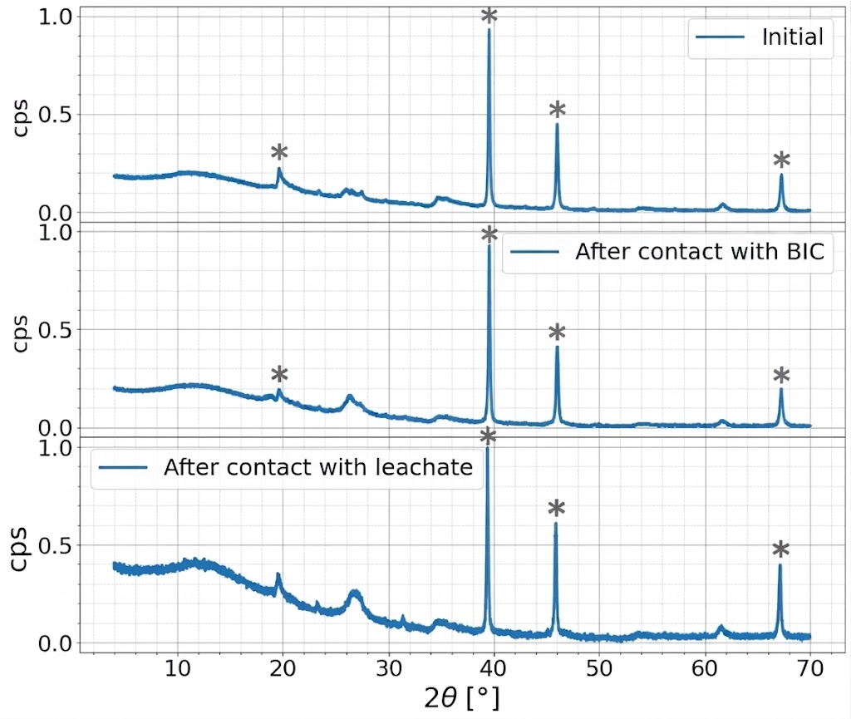
Source: JRC analysis.
Figure 9. FTIR spectra of the initial bentonite, the bentonite after contact with BIC water and the bentonite after contact with the undiluted modified-SNF leachate.
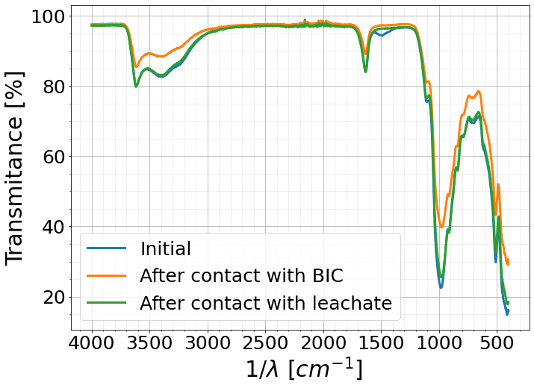
Source: JRC analysis.

Figure 10. SEM images of the initial bentonite.
Source: JRC analysis.

  - Radioactivity characterization
The alpha spectra of the undiluted modified-SNF leachate exhibited two main peaks, as can be seen in Figure 11. The peak at ~ 5470 keV is attributed to the combined contribution of ²³⁸Pu and ²⁴¹Am, while the peak at ~ 5795 keV is attributed to the combined emissions of ²⁴³Cm and ²⁴⁴Cm.
Three leachant solutions and their corresponding supernatants were analysed by alpha spectrometry. The alpha activity removal as a function of the initial alpha activity of the leachant is summarized in Table 4. In this table, the leachant solutions are identified by their Df: the undiluted modified-SNF leachate (Df = 1), the most diluted sample (Df = 100) and an intermediate dilution (Df = 20). For the most diluted sample, alpha activity removal was nearly complete, whereas for the undiluted leachate a removal around 20 % was obtained. This trend agrees with the elemental analyses, which showed that removal of Pu, Am and Cm decreased with increasing concentration. One possible explanation is progressive saturation of the available sorption sites, since the undiluted leachate contains the most actinides.
Radiation damage offers a second possible explanation: the radiation dose may have damaged the bentonite structure and thereby reduced its sorption capability, as reported by Cheng et al for gamma irradiation (Cheng et al., 2022). The presented results do not allow us to determine which explanation, or combination of explanations, is responsible for the observed trend.
Figure 11. Alpha spectra of the modified SNF leachate.
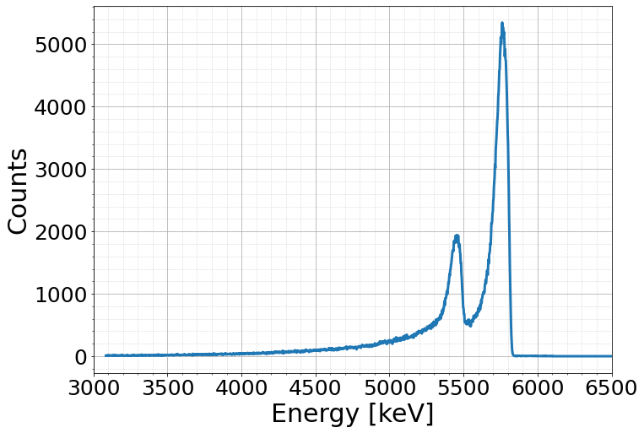
Source: JRC analysis.
Table 4. Alpha activity removal as a function of the initial activity of the leachant for the undiluted modified-SNF leachate (Df = 1), the most diluted sample (Df = 100) and an intermediate dilution (Df = 20).
Df of the leachant | Initial alpha activity [kBq/L] | Alpha activity removal [%]
$$100$$ | $$2.55±0.15$$ | $$98±8$$
$$20$$ | $$22.0±0.4$$ | $$93.9±2.5$$
$$1$$ | $$548.9±2.0$$ | $$22.3±0.5$$
Source: JRC analysis.

  - To be used in case of need, otherwise removed :P
- Conclusions <mandatory element>
This chapter discusses and interprets the study/research results and findings in the light of the policy question and the objectives of the study/research presented in the introduction. It should also present the recommendations when appropriate. The author is free to organise the body text under subheadings in order to improve the presentation and readability.
This work evaluated the radionuclide retention properties of bentonite using batch adsorption experiments with a SNF leachate. Prior to the experiments, the radioactive Cs was removed with an AMP-PAN-based filtration system and replaced with stable Cs. The Cs removal was almost complete (~ 100 %). Moderate actinides removal was also observed (20 – 50 %), attributed to the neutral pH condition of the leachate.
Bentonite sorbed all actinides, as well as lanthanides and Cs. For lanthanides and all actinides except Np, adsorption decreased as the initial concentration increased, which points to progressive saturation of the sorption sites of the bentonite. In contrast, for Cs and Np did not follow this trend, suggesting that their adsorption occur through different mechanisms. Isotherm fittings showed that the Langmuir model best describes the adsorption of lanthanides and Pu, while the Freundlich model better represents the remaining elements.
XRD, FTIR and SEM showed no major structural or morphological changes in the bentonite after contact with the leachate. XRD did indicate slight amorphization in the sample exposed to the undiluted modified-SNF leachate. Alpha spectrometry confirmed a decrease in solution activity after contact with bentonite. The removal rate also declined with increasing initial alpha activity. This could reflect saturation of sorption sites, but it could also result from alpha-radiation damage that reduces the number of available sites. This study cannot distinguish between these two causes. Further work is needed to assess the effect of alpha radiation on the sorption properties of bentonite.
More evaluations will be performed to gain a better understanding on the adsorption process. Nevertheless, based on the results obtained in this study, it can be stated that bentonite is able to retain most of the radionuclides present in modified SNF leachates without undergoing significant structural and morphological changes. Since adsorption is primarily a chemical process, the use of actual SNF leachates (without radioactive Cs removal) would not be expected to affect the adsorption performance. However, the higher gamma radiation associated with untreated SNF leachates could potentially affect the bentonite structure and its adsorption properties. That said, such high gamma radiation doses are not expected under DGD conditions, given the relatively short half-lives of Cs radioactive isotopes present in SNF leachates (2.1 y for ¹³⁴Cs and 30.1 y for ¹³⁷Cs).

Lorem ipsum dolor sit amet, consectetur adipiscing elit. Sed quis metus dolor. Nam congue cursus ligula sed faucibus. Fusce ligula est, mattis ut ullamcorper id, vulputate nec urna. Curabitur sit amet nisi eget urna ornare ultrices. Cras eget facilisis dolor. Sed id velit sit amet dui ornare dapibus at et lorem. Donec erat lacus, dapibus a massa at, euismod hendrerit leo.
Etiam volutpat dapibus dui a laoreet. Mauris gravida lobortis hendrerit. Integer at risus erat. Ut luctus lectus lorem, sit amet molestie lacus dictum id. Donec dolor lacus, aliquam et urna quis, cursus convallis nisi. Cras aliquet convallis urna, ac elementum leo accumsan ut. Nunc accumsan dolor dolor, vitae iaculis libero tempus non.
Nunc vestibulum condimentum nisi. Nam erat diam, suscipit vitae nisl eget, tempus tempus eros. Proin vel diam convallis, bibendum mi id, faucibus eros. Donec mi nisl, auctor quis aliquet a, ultricies vel metus. Ut rhoncus nulla augue, in egestas metus fringilla non. Sed sit amet felis dignissim, ornare elit vel, mattis augue. In adipiscing euismod purus id rutrum. Nulla facilisi. Nulla vitae dui lectus.

References <mandatory element>
This section should contain a complete list of works cited in the report. Please see the rules of the Interinstitutional Style Guide at https://style-guide.europa.eu/en/content/-/isg/topic?identifier=5.9.4-bibliographic-references.

Abass, M. R., Ibrahim, A. B. and Abou-Mesalam, M. M. (2022), ‘Sorption and Selectivity Behavior of Some Rare Earth Elements on Bentonite–Dolomite Composites as Natural Materials’, Radiochemistry, Vol. 64, pp. 349–359, https://doi.org/10.1134/S1066362222030122.
Al-Ghouti, M. A. and Da’ana, D. A. (2020), ‘Guidelines for the use and interpretation of adsorption isotherm models: A review’, Journal of Hazardous Materials, Vol. 393, p. 122383, https://doi.org/10.1016/j.jhazmat.2020.122383.
Allard, T. and Calas, G. (2009), ‘Radiation effects on clay mineral properties’, Applied Clay Science, Vol. 43, Issue 2, pp. 143–149, https://doi.org/10.1016/j.clay.2008.07.032.
Apted, M. J. and Ahn, J. (2017), Geological Repository Systems for Safe Disposal of Spent Nuclear Fuels and Radioactive Waste, Woodhead Publishing.
Atun, G. and Bodur, N. (2002), ‘Retention of Cs on zeolite, bentonite and their mixtures’, Journal of Radioanalytical and Nuclear Chemistry, Vol. 253, Issue 2, Akadémiai Kiadó, co-published with Springer Science+Business Media B.V., Formerly Kluwer Academic Publishers B.V., Budapest, Hungary, pp. 275–279, https://doi.org/10.1023/a:1019658011221.
Aytas, S., Yurtlu, M. and Donat, R. (2009), ‘Adsorption characteristic of U(VI) ion onto thermally activated bentonite’, Journal of Hazardous Materials, Vol. 172, Issue 2, pp. 667–674, https://doi.org/10.1016/j.jhazmat.2009.07.049.
Bachmaf, S. and Merkel, B. J. (2011), ‘Sorption of uranium(VI) at the clay mineral–water interface’, Environmental Earth Sciences, Vol. 63, pp. 925–934, https://doi.org/10.1007/s12665-010-0761-6.
Begg, J. D., Edelman, C., Zavarin, M. and Kersting, A. B. (2018), ‘Sorption kinetics of plutonium (V)/(VI) to three montmorillonite clays’, Applied Geochemistry, Vol. 96, pp. 131–137, https://doi.org/10.1016/j.apgeochem.2018.06.001.
Begg, J. D., Zavarin, M., Tumey, S. J. and Kersting, A. B. (2015), ‘Plutonium sorption and desorption behavior on bentonite’, Journal of Environmental Radioactivity, Vol. 141, pp. 106–114, https://doi.org/10.1016/j.jenvrad.2014.12.002.
Begg, J. D., Zavarin, M., Zhao, P., Tumey, S. J., Powell, B. et al. (2013), ‘Pu(V) and Pu(IV) Sorption to Montmorillonite’, Environmental Science & Technology, Vol. 47, Issue 10, pp. 5146–5153, https://doi.org/10.1021/es305257s.
Benedicto, A., Begg, J. D., Zhao, P., Kersting, A. B., Missana, T. et al. (2014), ‘Effect of major cation water composition on the ion exchange of Np(V) on montmorillonite: NpO2+–Na+–K+–Ca2+–Mg2+ selectivity coefficients’, Applied Geochemistry, Vol. 47, pp. 177–185, https://doi.org/10.1016/j.apgeochem.2014.06.003.
Bergaya, F. and Lagaly, G. (2013), Handbook of Clay Science, Elsevier.
Bradbury, M. H. and Baeyens, B. (2005), ‘Modelling the sorption of Mn(II), Co(II), Ni(II), Zn(II), Cd(II), Eu(III), Am(III), Sn(IV), Th(IV), Np(V) and U(VI) on montmorillonite: Linear free energy relationships and estimates of surface binding constants for some selected heavy metals and actinides’, Geochimica et Cosmochimica Acta, Vol. 69, Issue 4, pp. 875–892, https://doi.org/https://doi.org/10.1016/j.gca.2004.07.020.
Brewer, K. N., Todd, T. A., Wood, D. J., Tullock, P. A., Sebesta, F. et al. (1999), ‘AMP-PAN column tests for the removal of 137Cs from actual and simulated INEEL high-activity wastes’, Czech J Phys, Vol. 49, pp. 959–964, https://doi.org/10.1007/s10582-999-1024-1.
Chapman, N. A. and Smellie, J. A. T. (1986), ‘Introduction and summary of the workshop’, Chemical Geology, Vol. 55, Issue 3, pp. 167–173, https://doi.org/10.1016/0009-2541(86)90021-5.
Chen, Y., Zhu, C., Sun, Y., Duan, H., Ye, W. et al. (2012a), ‘Adsorption of La(III) onto GMZ bentonite: effect of contact time, bentonite content, pH value and ionic strength’, Journal of Radioanalytical and Nuclear Chemistry, Vol. 292, Issue 3, Akadémiai Kiadó, co-published with Springer Science+Business Media B.V., Formerly Kluwer Academic Publishers B.V., Budapest, Hungary, pp. 1339–1347, https://doi.org/10.1007/s10967-012-1612-6.
Chen, Y., Zhu, C., Sun, Y., Duan, H., Ye, W. et al. (2012b), ‘Adsorption of La(III) onto GMZ bentonite: effect of contact time, bentonite content, pH value and ionic strength’, Journal of Radioanalytical and Nuclear Chemistry, Vol. 292, Issue 3, Akadémiai Kiadó, co-published with Springer Science+Business Media B.V., Formerly Kluwer Academic Publishers B.V., Budapest, Hungary, pp. 1339–1347, https://doi.org/10.1007/s10967-012-1612-6.
Cheng, J., Gu, R., He, P., Pan, Y., Leng, Y. et al. (2022), ‘Effect of high-dose γ-ray irradiation on the structural stability and U(VI) adsorption ability of bentonite’, Journal of Radioanalytical and Nuclear Chemistry, Vol. 331, Issue 2, pp. 339–352, https://doi.org/10.1007/s10967-021-08117-9.
Coppin, F., Berger, G., Bauer, A., Castet, S. and Loubet, M. (2002), ‘Sorption of lanthanides on smectite and kaolinite’, Chemical Geology, Vol. 182, Issue 1, pp. 57–68, https://doi.org/10.1016/S0009-2541(01)00283-2.
Degueldre, C., Ulrich, H. J. and Silby, H. (1994), ‘Sorption of Am241 onto Montmorillonite, Illite and Hematite Colloid’, Radiochimica Acta, Vol. 65, pp. 173–179, https://doi.org/10.1524/ract.1994.65.3.173.
Enresa (1995), ‘TR-11/95: Almacenamiento geológico profundo de residuos radioactivos de alta actividad (AGP). Disenos conceptuales genéricos’, Enresa, https://www.osti.gov/etdeweb/servlets/purl/10103662.
European Commission (n.d.), https://commission.europa.eu/strategy-and-policy/priorities-2019-2024/european-green-deal_en.
Ewing, R. C., Weber, W. J. and Clinard, F. W. (1995), ‘Radiation effects in nuclear waste forms for high-level radioactive waste’, Progress in Nuclear Energy, Vol. 29, Issue 2, pp. 63–127, https://doi.org/10.1016/0149-1970(94)00016-Y.
Fröhlich, D. R. (2015), ‘Sorption of neptunium on clays and clay minerals - A review’, Clay and Clay Minerals, Vol. 63, Issue 4, pp. 262–276, https://doi.org/10.1346/CCMN.2015.0630402.
Galamboš, M., Kufčáková, J. and Rajec, P. (2009), ‘Adsorption of cesium on domestic bentonites’, Journal of Radioanalytical and Nuclear Chemistry, Vol. 281, Issue 3, Akadémiai Kiadó, co-published with Springer Science+Business Media B.V., Formerly Kluwer Academic Publishers B.V., Budapest, Hungary, pp. 485–492, https://doi.org/10.1007/s10967-009-0026-6.
Galamboš, M., Paučová, V., Kufčáková, J., Rosskopfová, O., Rajec, P. et al. (2010), ‘Cesium sorption on bentonites and montmorillonite K10’, Journal of Radioanalytical and Nuclear Chemistry, Vol. 284, Issue 1, Akadémiai Kiadó, co-published with Springer Science+Business Media B.V., Formerly Kluwer Academic Publishers B.V., Budapest, Hungary, pp. 55–64, https://doi.org/10.1007/s10967-010-0480-1.
Galunin, E., Alba, M. D., Santos, M. J., Abrao, T. and Vidal, M. (2010), ‘Lanthanide sorption on smectitic clays in presence of cement leachates’, Geochimica et Cosmochimica Acta, Vol. 74, Issue 3, pp. 862–875, https://doi.org/10.1016/j.gca.2009.11.003.
Grambow, B., Fattahi, M., Montavon, G., Moisan, C. and Giffaut, E. (2006), ‘Sorption of Cs, Ni, Pb, Eu(III), Am(III), Cm, Ac(III), Tc(IV), Th, Zr, and U(IV) on MX 80 bentonite: An experimental approach to assess model uncertainty’, Radiochim. Acta, Vol. 94, pp. 627–636, https://doi.org/10.1524/ract.2006.94.9.627.
Grenthe, I. and Gaona, X. (2020), Second update on the Chemical Thermodynamics of Uranium, Neptunium, Plutonium, Americium And Technetium, OECD.
Gu, S., Kang, X., Wang, L., Lichtfouse, E. and Wang, C. (2018), ‘Clay mineral adsorbents for heavy metal removal from wastewater: a review’, Environmental Chemistry Letters, Vol. 17, p. 114685, https://doi.org/10.1007/s10311-018-0813-9.
Hu, J., Xie, Z., He, B., Sheng, G., Chen, C. et al. (2010), ‘Sorption of Eu(III) on GMZ bentonite in the absence/presence of humic acid studied by batch and XAFS techniques’, Science China Chemistry, Vol. 53, pp. 1420–1428, https://doi.org/10.1007/s11426-010-3064-6.
Hurel, C. and Marmier, N. (2010), ‘Sorption of europium on a mX-80 bentonite sample: experimental and modelling results’, Journal of radioanalytical and nuclear chemistry, Vol. 284, pp. 225–230, https://doi.org/10.1007/s10967-010-0476-x.
IAEA (2009), ‘Classification of Radioactive Waste’, IAEA, https://www-pub.iaea.org/MTCD/Publications/PDF/Pub1419_web.pdf.
IAEA (2022), ‘IAEA Nuclear Safety and Securtiy Glossary’, IAEA, https://www-pub.iaea.org/MTCD/Publications/PDF/IAEA-NSS-GLOweb.pdf.
Joseph, C., Stockmann, M., Schmeide, K., Sachs, S., Brendler, V. et al. (2013), ‘Sorption of U(VI) onto Opalinus Clay: Effects of pH and humic acid’, Applied Geochemistry, Vol. 36, pp. 104–117, https://doi.org/10.1016/j.apgeochem.2013.06.016.
Kasar, S., Umar, S., Kar, A., Bajpai, R. B., Kaushik, C. P. et al. (2014), ‘Retention behaviour of Cs(I), Sr(II), Tc(VII) and Np(V) on smectite-rich clay’, Journal of Radioanalytical and Nuclear Chemistry, Vol. 300, pp. 71–75, https://doi.org/10.1007/s10967-014-2943-2.
Kelch, S. E., Youngman, R. E., Ferrage, E., Basinski, J. J., Wang, J. et al. (2021), ‘Quantitative Spectroscopic Analysis of Water Populations in the Hydrated Nanopore Environments of a Natural Montmorillonite’, The Journal of Physical Chemistry C, Vol. 125, Issue 48, pp. 26552–26565, https://doi.org/10.1021/acs.jpcc.1c05462.
Kokinda, J., Serrano-Purroy, D., Martínez-Torrents, A., Pablo, J. D., Clarens, F. et al. (2025), ‘Dissolution of low burn-up (33 GWd/t) spent nuclear fuel at alkaline and hyperalkaline pH’, Nuclear Engineering and Technology, Vol. 57, Issue 11, p. 103783, https://doi.org/10.1016/j.net.2025.103783.
Konishi, M., Yamamoto, K., Yanagi, T. and Okajima, Y. (1988), ‘Sorption Behavior of Cesium, Strontium and Americium Ions on Clay Materials’, Journal of Nuclear Science and Technology, Vol. 25, Issue 12, pp. 929–933, https://doi.org/10.3327/jnst.25.929.
Leng, Y., Henderson, M. J., Courtois, J., Li, H., Xiong, K. et al. (2016), ‘Sorption of plutonium on geological materials associated with a Chinese radioactive waste repository: influence of pH’, Journal of Radioanalytical and Nuclear Chemistry, Vol. 308, pp. 895–903, https://doi.org/10.1007/s10967-015-4594-.
Li, P., Liu, Z., Ma, F., Shi, Q., Guo, Z. et al. (2015), ‘Effects of pH, ionic strength and humic acid on the sorption of neptunium(V) to Na-bentonite’, Journal of Molecular Liquids, Vol. 206, pp. 285–292, https://doi.org/10.1016/j.molliq.2015.02.014.
Liu, H., Fu, T., Sarwar, M. T. and Yang, H. (2023), ‘Recent progress in radionuclides adsorption by bentonite-based materials as ideal adsorbents and buffer/backfill materials’, Applied Clay Science, Vol. 232, p. 106796, https://doi.org/10.1016/j.clay.2022.106796.
Liu, H.-J., Xie, S.-B., Xia, L.-S., Tang, Q., Kang, X. et al. (2016), ‘Sorption and diffusion behavior of Cs and Sr on Jih-Hsing bentonite’, Environmental Earth Sciences, Vol. 75, Issue 148, https://doi.org/10.1007/s12665-015-4941-2.
Madejová, J., Janek, M., Komadel, P., Herbert, H.-J. and Moog, H. C. (2002), ‘FTIR analyses of water in MX-80 bentonite compacted from high salinary salt solution systems’, Applied Clay Science, Vol. 20, Issue 6, pp. 255–271, https://doi.org/10.1016/S0169-1317(01)00067-9.
Marimon, M. M. (2002), ‘On the sorption and difussion of radionuclides in bentonite clay’, PhD Thesis, Kungl Tekniska Högskolan.
Martínez-Torrents, A., Serrano-Purroy, D., Casas, I. and Pablo, J. D. (2018), ‘Influence of the interpellet space to the Instant Release Fraction determination of a commercial UO2 Boiling Water Reactor Spent Nuclear Fuel’, Journal of Nuclear Materials, Vol. 499, pp. 9–17, https://doi.org/10.1016/j.jnucmat.2017.10.064.
Meunier, A. (2005), Clays, Springer.
Missana, T., Alonso, U. and García-Gutiérrez, M. (2021), ‘Evaluation of component additive modelling approach for europium adsorption on 2:1 clays: Experimental, thermodynamic databases, and models’, Chemosphere, Vol. 272, p. 129877, https://doi.org/https://doi.org/10.1016/j.chemosphere.2021.129877.
Missana, T., Alonso, U., García-Gutiérrez, M. and Mingarro, M. (2008), ‘Role of bentonite colloids on europium and plutonium migration in a granite fracture’, Applied Geochemistry, Vol. 23, Issue 6, pp. 1484–1497, https://doi.org/10.1016/j.apgeochem.2008.01.008.
Missana, T., Benedicto, A., García-Gutiérrez, M. and Alonso, U. (2014), ‘Modeling cesium retention onto Na-, K- and Ca-smectite: Effects of ionic strength, exchange and competing cations on the determination of selectivity coefficients’, Geochimica et Cosmochimica Acta, Vol. 128, pp. 266–277, https://doi.org/10.1016/j.gca.2013.10.007.
Missana, T., Garcı́a-Gutiérrez, M. and Alonso, Ú. (2004), ‘Kinetics and irreversibility of cesium and uranium sorption onto bentonite colloids in a deep granitic environment’, Applied Clay Science, Vol. 26, Issue 1, pp. 137–150, https://doi.org/10.1016/j.clay.2003.09.008.
Murali, M. S. and Mathur, J. N. (2002), ‘Sorption characteristics of Am(III), Sr(II) and Cs(I) on bentonite and granite’, Journal of Radioanalytical and Nuclear Chemistry, Vol. 254, Issue 1, pp. 129–136, https://doi.org/10.1023/A:1020858001845.
Nagasaki, S., Tanaka, S. and Suzuki, A. (1997), ‘Affinity of finely dispersed montmorillonite colloidal particles for americium and lanthanides’, Journal of Nuclear Materials, Vol. 244, Issue 1, pp. 29–35, https://doi.org/https://doi.org/10.1016/S0022-3115(96)00727-1.
Nagra (2021), ‘NTB-21-02: The Nagra Research, Development and Demonstration Plan for the Disposal of Radioactive Waste in Switzerland’, Nagra, https://nagra.ch/wp-content/uploads/2022/08/NTB-21-02.pdf.
NEA (2011), ‘Spent Nuclear Fuel Assay Data for Isotopic Validation’, OECD, https://www.oecd-nea.org/jcms/pl_23061/spent-nuclear-fuel-assay-data-for-isotopic-validation-state-of-the-art-report?details=true.
Novikau, R. and Lujaniene, G. (2022), ‘Adsorption behaviour of pollutants: Heavy metals, radionuclides, organic pollutants, on clays and their minerals (raw, modified and treated): A review’, Journal of Environmental Management, Vol. 309, p. 114685, https://doi.org/10.1016/j.jenvman.2022.114685.
Pabalan, R. T. and Turner, D. R. (1997), ‘Uranium(6+) sorption on montmorillonite: Experimental and surface complexation modeling study’, Aquatic Geochemistry, Vol. 2, pp. 203–226, https://doi.org/10.1007/BF01160043.
Pusch, R. and Karnland, O. (1996), ‘Physico/chemical stability of smectite clays’, Engineering Geology, Vol. 41, Issue 1, pp. 73–85, https://doi.org/10.1016/0013-7952(95)00027-5.
Rabung, T., Pierret, M. C., Bauer, A., Geckeis, H., Bradbury, M. H. et al. (2005), ‘Sorption of Eu(III)/Cm(III) on Ca-montmorillonite and Na-illite. Part 1: Batch sorption and time-resolved laser fluorescence spectroscopy experiments’, Geochimica et Cosmochimica Acta, Vol. 69, Issue 23, pp. 5393–5402, https://doi.org/10.1016/j.gca.2005.06.030.
Ramebäck, H., Albinsson, Y., Skålberg, M., Eklund, U. B., Kjellberg, L. et al. (2000), ‘Transport and leaching of technetium and uranium from spent UO2 fuel in compacted bentonite clay’, Journal of Nuclear Materials, Vol. 277, Issue 2, pp. 288–294, https://doi.org/10.1016/S0022-3115(99)00152-X.
Reynier, N., Courchesne, M., Anderson, J., Williams, K. and Schinnour, K. (2022), ‘Pilot Scale Validation of a Chemical Process for Uranium, Cesium, and Mercury Recovery from Cemented Radioactive Wastes’, Minerals, Vol. 12, Issue 5, p. 594, https://doi.org/10.3390/min12050594.
Roonasi, P. and Holmgren, A. (2010), ‘An ATR–FTIR study of carbonate sorption onto magnetite’, Surface and Interface Analysis, Vol. 42, Issue 6–7, pp. 1118–1121, https://doi.org/10.1002/sia.3382.
S, A., P, C., B, F., H, G., R, K. et al. (2021), ‘Technical assessment of nuclear energy with respect to the “do no significant harm” criteria of Regulation (EU) 2020/852 (“Taxonomy Regulation”)’, Scientific analysis or review, KJ-NA-30777-EN-N (online), KJ-NA-30777-EN-C (print), Publications Office of the European Union, Luxembourg (Luxembourg), https://doi.org/10.2760/665806%20(online),10.2760/207251%20(print).
Saadi, R., Saadi, Z., Fazaeli, R. and Fard, N. E. (2015), ‘Monolayer and multilayer adsorption isotherm models for sorption from aqueous media’, Korean Journal of Chemical Engineering, Vol. 32, pp. 787–799, https://doi.org/10.1007/s11814-015-0053-7.
Sellin, P. and Leupin, O. (2014), ‘The Use of Clay as an Engineered Barrier in Radioactive-Waste Management – A Review’, Clays and Clay Minerals, Vol. 61, March, pp. 477–498, https://doi.org/10.1346/CCMN.2013.0610601.
Serrano-Purroy, D., Clarens, F., González-Robles, E., Glatz, J. P., Wegen, D. H. et al. (2012), ‘Instant release fraction and matrix release of high burn-up UO2 spent nuclear fuel: Effect of high burn-up structure and leaching solution composition’, Journal of Nuclear Materials, Vol. 427, Issue 1, pp. 249–258, https://doi.org/10.1016/j.jnucmat.2012.04.036.
Sheng, G. D., Shao, D. D., Fan, Q. H., Xu, D., Chen, Y. X. et al. (2009), ‘Effect of pH and ionic strength on sorption of Eu(III) to MX-80 bentonite: batch and XAFS study’, Radiochim Acta, Vol. 97, pp. 621–630, https://doi.org/10.1524/ract.2009.1656.
SKB (2022a), ‘TR-21-01: Post-closure safety for the finnal repository for spent nuclear fuel at Fosmark’, SKB, https://skb.com/publication/2506409/TR-21-01.pdf.
SKB (2022b), ‘TR-22-11: Programme for research, development and demonstration of methods for the management and disposal of nuclear waste’, SKB, https://skb.com/publication/2506485/TR-22-11.pdf.
SKB (2022c), ‘TR-22-11: Programme for research, development and demonstration of methods for the management and disposal of nuclear waste’, SKB, https://skb.com/publication/2506485/TR-22-11.pdf.
SKB and OY, P. (2017), ‘Safey functions. performance targets and technical design requirements for a KBS-3V repository’, SKB, Posiva OY, https://skb.com/publication/2485568/Posiva+SKB+Report+01.pdf.
Svensson, D., Eriksson, P., Johannesson, L.-E., Lundgren, C. and Bladström, T. (2019), ‘TR-19-25: Development and testing of methods suitable for quality control of bentonite as KBS-3 buffer and backfill’, Svensk Kärnbränslehantering AB, https://skb.com/publication/2495032/TR-19-25.pdf.
Todd, T., Mann, N., Tranter, T., Šebesta, F., John, J. et al. (2002), ‘Cesium sorption from concentrated acidic tank wastes using ammonium molybdophosphate-polyacrylonitrile composite sorbents’, Journal of Radioanalytical and Nuclear Chemistry, Vol. 254, Issue 1, Akadémiai Kiadó, co-published with Springer Science+Business Media B.V., Formerly Kluwer Academic Publishers B.V., Budapest, Hungary, pp. 47–52, https://doi.org/10.1023/a:1020881212323.
Tranter, T. J., Herbst, R. S., Todd, T. A., Olson, A. L. and Eldredge, H. B. (2002), ‘Evaluation of ammonium molybdophosphate-polyacrylonitrile (AMP-PAN) as a cesium selective sorbent for the removal of 137Cs from acidic nuclear waste solutions’, Advances in Environmental Research, Vol. 6, Issue 2, pp. 107–121, https://doi.org/10.1016/S1093-0191(00)00073-3.
Tsai, S.-C., Ouyang, S. and Hsu, C.-N. (2001), ‘Sorption and diffusion behavior of Cs and Sr on Jih-Hsing bentonite’, Applied Radiation and Isotopes, Vol. 54, Issue 2, pp. 209–215, https://doi.org/10.1016/S0969-8043(00)00292-X.
Turner, D. R., Pabalan, R. T. and Bertetti, F. P. (1998), ‘Neptunium(V) Sorption on Montmorillonite: An Experimental and Surface Complexation Modeling Study’, Clays and Clay Minerals, Vol. 46, Issue 3, pp. 256–269, https://doi.org/10.1346/CCMN.1998.0460305.
Villar, M. V., Villar, L. P. del, Martín, P. L., Pelayo1, M., Fernández, A. M. et al. (2006), ‘The study of Spanish clays for their use as sealing materials in nuclear waste repositories: 20 years of progress’, Journal of Iberian Geology, Vol. 32, Issue 1, pp. 15–36.
Wang, H., Sun, Z., Xia, F., Yang, C., Wang, X. et al. (2023), ‘An exploration of lattice transformation mechanism of muscovite single crystal under EB irradiation at 0–1000 kGy’, Journal of the American Ceramic Society, Vol. 107, Issue 1, pp. 300–320, https://doi.org/10.1111/jace.19453.
Wang, J., Chen, Z., Shao, D., Li, Y., Xu, Z. et al. (2017), ‘Adsorption of U(VI) on bentonite in simulation environmental conditions’, Journal of Molecular Liquids, Vol. 242, pp. 678–684, https://doi.org/10.1016/j.molliq.2017.07.048.
Wang, J. and Guo, X. (2020), ‘Adsorption isotherm models: Classification, physical meaning, application and solving method’, Chemosphere, Vol. 258, p. 127279, https://doi.org/10.1016/j.chemosphere.2020.127279.
Wang, P., Anderko, A. and Kosinski, J. J. (2017), ‘Modeling Speciation and Solubility in Aqueous Systems Containing U(IV, VI), Np(IV, V, VI), Pu(III, IV, V, VI), Am(III), and Cm(III)’, Journal of Solution Chemistry, Vol. 46, pp. 521–588, https://doi.org/10.1007/s10953-017-0587-x.
Wang, P., Shen, X., Qiu, S., Zhang, L., Ma, Y. et al. (2024), ‘Clay-Based Materials for Heavy Metals Adsorption: Mechanisms, Advancements, and Future Prospects in Environmental Remediation’, Crystals, Vol. 14, p. 1046, https://doi.org/10.3390/cryst14121046.
Wijnja, H. and Schulthess, C. P. (2001), ‘Carbonate Adsorption Mechanism on Goethite Studied with ATR–FTIR, DRIFT, and Proton Coadsorption Measurements’, Soil Science Society of America Journal, Vol. 65, Issue 2, pp. 324–330, https://doi.org/10.2136/sssaj2001.652324x.
Xiao, J., Chen, Y., Zhao, W. and Xu, J. (2013), ‘Sorption behavior of U(VI) onto Chinese bentonite: Effect of pH, ionic strength, temperature and humic acid’, Journal of Molecular Liquids, Vol. 188, pp. 178–185, https://doi.org/10.1016/j.molliq.2013.10.008.
Yadav, V. B., Gadi, R. and Kalra, S. (2019), ‘Clay based nanocomposites for removal of heavy metals from water: A review’, Journal of Environmental Management, Vol. 232, pp. 803–817, https://doi.org/10.1016/j.jenvman.2018.11.120.
Yang, S., Han, C., Wang, X. and Nagatsu, M. (2014), ‘Characteristics of cesium ion sorption from aqueous solution on bentonite- and carbon nanotube-based composites’, Journal of Hazardous Materials, Vol. 274, pp. 46–52, https://doi.org/10.1016/j.jhazmat.2014.04.001.
Yildiz, B., Erten, H. and Kış, M. (2011), ‘The sorption behavior of Cs+ ion on clay minerals and zeolite in radioactive waste management: sorption kinetics and thermodynamics’, Journal of Radioanalytical and Nuclear Chemistry, Vol. 288, Issue 2, Akadémiai Kiadó, co-published with Springer Science+Business Media B.V., Formerly Kluwer Academic Publishers B.V., Budapest, Hungary, pp. 475–483, https://doi.org/10.1007/s10967-011-0990-5.
Yu, S., Ma, J., Shi, Y., Du, Z., Zhao, Y. et al. (2020), ‘Uranium(VI) adsorption on montmorillonite colloid’, Journal of radioanalytical and nuclear chemistry, Vol. 324, pp. 541–549, https://doi.org/10.1007/s10967-020-07083-y.
Yu, T., Wu, W. S. and Fan, Q. H. (2012), ‘Sorption of Am(III) on Na-bentonite: Effect of pH, ionic strength, temperature and humic acid’, Chinese Chemical Letters, Vol. 23, Issue 10, pp. 1189–1192, https://doi.org/10.1016/j.cclet.2012.07.011.
Zavarin, M., Powell, B. A., Bourbin, M., Zhao, P. and Kersting, A. B. (2012), ‘Np(V) and Pu(V) Ion Exchange and Surface-Mediated Reduction Mechanisms on Montmorillonite’, Environmental Science & Technology, Vol. 46, Issue 5, pp. 2692–2698, https://doi.org/10.1021/es203505g.
Zhang, T., Wang, W., Zhao, Y., Bai, H., Wen, T. et al. (2021), ‘Removal of heavy metals and dyes by clay-based adsorbents: From natural clays to 1D and 2D nano-composites’, Chemical Engineering Journal, Vol. 420, p. 127574, https://doi.org/10.1016/j.cej.2020.127574.
Zhou, Z., Wan, Q., Yu, W., Nie, X., Yang, S. et al. (2024), ‘Influence of Sulfate and Nitrate for Lanthanum (III) Adsorption on Bentonite: Implications for Rare Earth Wastewater Disposal’, Minerals, Vol. 14, Issue 3, https://doi.org/10.3390/min14030268.

List of abbreviations and definitions <mandatory when report contains abbreviations and definitions>
Abbreviations | Definitions
BAGSFUL | Bentonite adsorption experiments using genuine spent nuclear fuel leachate
BIC | Bicarbonated
CDP | Collaborative Doctoral Partnership
Df | Dilution factor
DGD | Deep geological disposal
FTIR | Fourier-transform Infrared
JRC-KA | JRC Karlsruhe
ICP-MS | Inductively coupled plasma mass spectrometry
SNF | Spent nuclear fuel
XRD | X-Ray diffraction

List of boxes <mandatory when report contains boxed text>
Use the built-in function to generate a table of figures (References > Captions > Insert Table of Figures), or simply use the example in the template and update it (click on table field and press F9) when the report is complete.
Box 1. This is a box title (manually add ‘Strong’ character style to the numbering)
Box 2. This is a box title (manually add ‘Strong’ character style to the numbering)

List of figures <mandatory when report contains figures>
Use the built-in function to generate a table of figures (References > Captions > Insert Table of Figures), or simply use the example in the template and update it (click on table field and press F9) when the report is complete.
Note: Word does not distinguish between these tables; therefore, when it asks if you want to replace the already inserted table (for boxes or tables), answer No.
Figure 1. Scheme of a deep geological repository. 9
Figure 2. Structure of Montmorillonite, the main constituent mineral of bentonite. 10
Figure 1. Simplified diagram of the convergence model Figure title is inserted above the figure. 15
Figure 3. Closed-system column for Cs separation a) and Cs removal set-up in a hot cell b). The set-up consists of two bottles, one containing the initial leachate (left) and another to collect the filtered leachate (right)- as well as a peristaltic pump and the filtration column (located on the right side). 20
Figure 4. Removal percentage as a function of its initial concentration for a) non-actinides and for b) actinides. Values represent the average of the three replicates. 25
Figure 5. Adsorption isotherms based on the equilibrium distribution coefficient for a) non-actinides and for b) actinides. Values represent the average of the three replicates. 26
Figure 6. Adsorption isotherms based on the sorbed quantity for a) non-actinides and for b) actinides. The best fits using the Freundlich model are included (discontinuous lines). For Pu, the last sample was excluded for the fit. Values represent the average of the three replicates. 27
Figure 7. Adsorption isotherms based on the sorbed quantity including the best fits using the Langmuir model (discontinuous lines) for La, Sm, U and Pu. For Pu, the last sample was excluded for the fit. Values represent the average of the three replicates. 28
Figure 8. XRD spectra of the initial bentonite, the bentonite after contact with BIC water and the bentonite after contact with the undiluted modified-SNF leachate. * = Pt background from the spectrometer. 33
Figure 9. FTIR spectra of the initial bentonite, the bentonite after contact with BIC water and the bentonite after contact with the undiluted modified-SNF leachate. 33
Figure 10. SEM images of the initial bentonite. 34
Figure 11. Alpha spectra of the modified SNF leachate. 35

List of tables <mandatory when report contains tables>
Use the built-in function to generate a table of figures (References > Captions > Insert Table of Figures), or simply use the example in the template and update it (click on table field, press F9, update entire table) when the report is complete.
Note: Word does not distinguish between these tables; therefore, when it asks if you want to replace the already inserted table (for boxes or figures), answer No.
Table 1. Nunc vestibulum condimentum nisi Table title is inserted above the table. 13
Table 2. Large table in horizontal layout 18
Table 1. Leachate elemental concentration before and after the Cs removal, and after natural Cs addition, including the removal percentage. Mo and P concentrations are also included, as these elements are present in both the leachate and the AMP-PAN resin. 23
Table 2. Parameters of the best fits using the Freundlich model, including the correlation coefficient r. The relatively high uncertainties obtained for the Freundlich equilibrium distribution coefficient K_F arise from the low intercept values b obtained in the fits. $KF$ is proportional to $b-1$, while its standard deviation $σKF$ is proportional to $b-2$. Hence, small b could lead to relatively high $σKF$ that may be comparable to, or even exceed, the fitted parameter $KF$ itself. 27
Table 3. Parameters of the best fits using the Langmuir model, including the correlation coefficient $r$. 28
Table 4. Alpha activity removal as a function of the initial activity of the leachant for the undiluted modified-SNF leachate (Df = 1), the most diluted sample (Df = 100) and an intermediate dilution (Df = 20). 35

Annexes <optional>

Annex 1. Title of annex <numbering of annexes is mandatory, if there is more than one>
Each annex has a numbered title. They do not start on new pages.

Steps to format your report
For the branding of JRC outputs, it is essential that each JRC report has the same look and feel, in accordance with the following specifications.
- Use EN (United Kingdom) spelling for reports written in English.
- Styles to be used in these reports are preceded by ‘JRC_’. They are available from the quick style gallery on the Home banner, or you can click on the small arrow in the bottom right corner of the Styles panel to open the Styles window, which can be displayed to the right of your document.
- Please do not modify the styles.
- In this template the character style ‘Strong’ is formatted bold. The character style ‘Emphasis’ is formatted italic. Bold italic formatting is available with the character style ‘Intense Emphasis’.
- Do not add empty paragraphs – spacing is set in the definition of the styles. Only add page breaks when necessary to keep elements together that will otherwise be separated.
- On the front cover, use line breaks (SHIFT + Enter) to break titles that are too long for one line.
- Each main section (Level-1 heading) starts on a new page (this is included in the style definition, so it is not necessary to add a page break).
- The template provides for five levels of heading. It should not be necessary to divide the text further.
- Use the style ‘JRC_Text’ for regular paragraphs (EC Square Sans Pro font size 11, 8 pt spacing before and after, 1.1 line spacing).
- The template provides for two list types – bulleted and numbered – both with two levels (styles ‘JRC_Text_bulleted_list1/2’ and ‘JRC_Text_numbered_list1/2’). Do not use the built-in function in Word to create lists.
- Use the built-in function in Word to insert footnotes (References > Insert Footnote). Footnotes appear at the bottom of the page, and the text should be preceded by a tab in order to align it properly; see the examples in this document. Footnote markers are formatted in accordance with rules in the Interinstitutional Style Guide (preceded by a non-breaking space in the text.
- References should be listed at the end of the document in alphabetical and chronological order; please see Section 5.9.4 of the Interinstutional Style Guide for examples of how to cite references’.
- If formulae are needed, but they cannot be written using Word, then they should instead be copied and pasted (e.g. as an image) from the programme (e.g. LaTeX) that you usually use to write them. Use the ‘JRC_Equation’ style for both Word-generated formulae and inserted images.
- Table titles should be inserted above the table, aligned to the left (use the style ‘JRC_Table_title’; manually add bold to the numbering ‘Table #.’ only).
- Tables should be inserted using the Word function Insert > Table. Tables should be aligned to the left, even if they do not fill up the entire text width.
- Table notes should be added manually below the table (use the style ‘JRC_Table_note’; do not use the built-in Word function for this).
- Figure captions should be inserted above the figure (use the style ‘JRC_Figure_caption’; manually add bold to the numbering ‘Figure #.’ only).
- Each figure, table, infographic and graph should list the source(s) underneath and note if it is a JRC analysis (e.g. ‘Sources: Eurostat, World Bank, JRC analysis’).
- Only use section breaks if pages with landscape orientation are needed. Add a section break (Next Page) before and after the landscape page(s) and make sure pagination is included and is continuous from the previous section.
- Page numbers appear at the bottom of the page, in the middle of the footer. The cover pages (the front cover, bibliographical information page, Europe Direct page and back cover) have no numbering. Pages are numbered with Arabic numerals starting at the contents page from 1. This is all already applied in the template.
- If photos from third parties are used, make sure to respect copyright rules and list the copyright/credit/source on the second page as requested. The so-called 'royalty free' images or photos found on the internet or purchased on CD-ROM are not public domain. They are copyright protected. Therefore, it is essential to respect all terms of use specified. For more info see http://ec.europa.eu/ipg/basics/legal/notice_copyright/index_en.htm and/or write to op-info-copyright@publications.europa.eu.

Steps to make your publication accessible

Write clear and structured content
The accessibility of the publication is also evaluated by how easy it is to understand it. There is no actual standard on how to do this, but the World Wide Web Consortium gives the following tips for writing for accessibility.
- Use simple and straightforward language and formatting.
- Write in short, clear sentences and paragraphs without complex grammar.
- Avoid using unnecessarily complex words and phrases. Consider providing a glossary for terms readers may not know.
- Expand acronyms on first use.
- Consider providing a glossary for terms readers may not know.
- Use list formatting as appropriate.
- Consider using images, illustrations, video, audio and symbols to help clarify meaning.
- Check out the Commission’s Clear Writing Guide available on the writer’s toolbox page on the intranet and the older edition published by the Publications Office.
To ensure that the publication is easily operable by assistive technology, write the structured content and apply proper heading paragraph styles without skipping heading levels. Use paragraph styles consistently and apply list and table styles, considering the requirements for accessibility.

Text formatting
Left alignment of the text and wide white space between lines, paragraphs and layout elements are recommended for better accessibility.
Underlined text is usually understood as a hyperlink. Therefore, it is recommended to emphasise the text using the bold font effect. In this template the character style ‘Strong’ is formatted bold.
Text in italics is considered hard to read. Therefore, do not format large parts of a text with the italic font effect. In this template the character style ‘Emphasis’ is formatted italic.
Bold italic formatting is available with the character style ‘Intense Emphasis’.
Avoid adding empty paragraphs. Apply the correct language for text and text styles.
You also need to add a non-breaking space before the opening footnote number in the text and a tab character after the number in the footnote. The same applies to endnotes.

Add alternative text to images
Alternative text provides a textual alternative to an image. It is needed for those who cannot read but rely on assistive technology, such as screen readers.
Not all images need alternative text, because some are added purely for decorative purposes. With Office 365, we can mark such images as decorative instead of writing the alt text.
For more information, watch the video on how to design a good alternative text and see the handout with tips and tricks.

Use of colour and sufficient colour contrast
Make sure that colour is not the only means used to convey information.
Check that the colour contrast for text, charts and infographics is sufficient and in accordance with Web Content Accessibility Guidelines 2.1 requirements.
Recommended tool for colour contrast check: Adobe Color Contrast Checker.

Accessibility checker integrated with Microsoft Word
Please check your document for potential accessibility issues before exporting to PDF:
- in the Microsoft (MS) Word document, select the File tab;
- select Info from the left-hand menu;
- click the ‘Check for Issues’ button;
- select Check Accessibility from the drop-down menu and review the list of potential errors in the Accessibility Checker panel.
Try to fix as many errors as possible. However, remember that not all errors are critical for accessibility if the final format for publishing is PDF.
For example:
- alternative text for tables is not exported to PDF; it has to be added manually after the PDF export, using Adobe Acrobat Pro;
- if a single-cell table is used as a container for box content, it cannot have a header row;
- objects with text wrapping can be used if the publishing format is PDF;
- MS Office 2016 will bring up the ‘Missing Alt Text’ error for decorative images marked as such with MS Office 365.

Exporting to PDF
If you have Adobe Acrobat (professional version), you just need to click on ‘Save as Adobe PDF’, embedded into your MS Word:
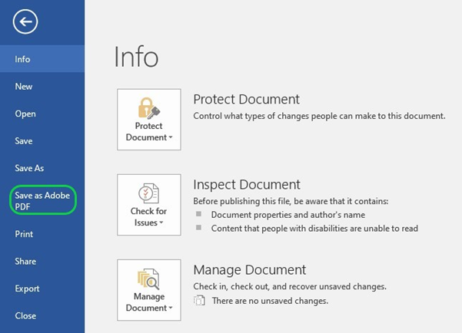
Otherwise, PDF CoDe is a central PDF conversion service powered by the Directorate-General for Digital Services. It allows you to convert Office documents into PDF format by just sending them to a special mailbox. The service is open to everyone within the Commission.
If you wish to use this service, please send an email with the file you wish to convert as an attachment to EC-PDF-CODE-WEB@ec.europa.eu to optimise it for viewing on screen. No explanation is needed in the email.
Please avoid other conversion options (Print > PDF / Save as > PDF / Export > PDF) because they lose some accessibility features and/or the European Commission font.

Final actions and checks in PDF
The primary tool to check the accessibility of PDF files is Adobe Acrobat Pro. Use its automatic accessibility checker to detect accessibility issues.
You may check the primary reading order using the Acrobat Pro tags panel.
Additional tools to check accessibility are the Callas pdfGoHTML2 plug-in for Adobe Acrobat Pro and PDF Accessibility Checker 2021. The recommended screen reader to test the accessibility is Non-visual Desktop Access (NVDA).
Carry out the following actions and checks in PDF:
- add document title and author metadata;
- set the correct document language;
- check if the navigation with bookmarks and table of contents works properly;
- check if the reading order is accurate;
- check if the alternative text is added to all meaningful images;
- check if all decorative objects are tagged as artefacts;
- if necessary, set the table header cells as header cells and fix their scope (row headers or column headers);
- add table summary to complex tables if necessary;
- check the primary reading order (used by the most popular screen readers) using the Acrobat Pro tags panel and pdfGoHTML2 plug-in;
- check the secondary reading order (used by less popular screen readers) using the Acrobat Pro order panel;
- check semantic tagging and the heading hierarchy;
- check the colour contrast (if not already checked while working in MS Word);
- fix errors reported by the Acrobat Accessibility Checker.
To add back covers to your document use Generate Cover pages function in Pubsy
If your publication will be disseminated with identifiers (ISBN, ISSN, doi, etc.), please generate the covers after the identifiers have been assigned.
See: PUBSY: Automated Generate cover pages – Easier.Simpler.Faster

Footnote text (please always insert <tab> at the beginning).
Footnote text (please always insert <tab> at the beginning). When the text is longer than one line, it is indented for a more reader-friendly layout.

