To add front covers to your document use Generate Cover pages function in Pubsy
If your publication will be disseminated with identifiers (ISBN, ISSN, doi, etc.), please generate the covers after the identifiers have been assigned.
See: PUBSY: Automated Generate cover pages – Easier.Simpler.Faster
Please check the steps to format your report on p. 23 and the steps to make your publication accessible on p. 25.

Contents
Table of contents is generated automatically; simply click on it and press F9 key, then select to update entire table.
Contents 1
Abstract <mandatory element> 4
Abstract <mandatory element> 4
Foreword <optional element> 5
Foreword <optional element> 5
Acknowledgements <optional element> 6
Acknowledgements <optional element> 6
Authors 6
Executive summary (mandatory element only for science for policy reports) 7
Executive summary (mandatory element only for science for policy reports) 7
Policy context 7
Key conclusions 7
Main findings 8
Related and future Joint Research Centre work 8
Quick guide 8
1. Introduction <mandatory element> 10
1. Introduction <mandatory element> 10
2. Second heading of body of report 12
2. Second heading of body of report 12
2.1. Subheading 1 13
2.1.1. Subheading 2 13
2.1.1.1. Subheading 3 14
2.1.1.1.1. Subheading 4 14
2.1.1.1.2. Second subheading 4 15
2.1.1.2. Second subheading 3 16
3. Methodology 20
3. Methodology 20
4. Findings 24
4. Findings 24
5. Conclusions <mandatory element> 38
5. Conclusions <mandatory element> 38
References <mandatory element> 39
References <mandatory element> 39
List of abbreviations and definitions <mandatory when report contains abbreviations and definitions> 41
List of abbreviations and definitions <mandatory when report contains abbreviations and definitions> 41
List of boxes <mandatory when report contains boxed text> 42
List of boxes <mandatory when report contains boxed text> 42
List of figures <mandatory when report contains figures> 43
List of figures <mandatory when report contains figures> 43
List of tables <mandatory when report contains tables> 44
List of tables <mandatory when report contains tables> 44
Annexes <optional> 45
Annexes <optional> 45
Annex 1. Title of annex <numbering of annexes is mandatory, if there is more than one> 45
Steps to format your report 46
Steps to format your report 46
Steps to make your publication accessible 48
Steps to make your publication accessible 48
Write clear and structured content 48
Text formatting 48
Add alternative text to images 49
Use of colour and sufficient colour contrast 49
Accessibility checker integrated with Microsoft Word 49
Exporting to PDF 50
Final actions and checks in PDF 50

Abstract <mandatory element>
Max. 1 550 characters with spaces.
Give, in up to five sentences, the most important conclusions, key facts and figures.
Also include a sentence or two on the policy relevance of the work.
It is to be used for eye-catching, newspaper-type headlines to attract the reader.
Lorem ipsum dolor sit amet, coadipiscing elit. Sed quis metus dolor. Nam congue cursus ligula sed faucibus. Fusce ligula est, mattis ut ullamcorper id, vulputate nec urna. Curabitur sit amet nisi eget urna ornare ult rices.
Please consult the Interinstitutional Style Guide for guidance in drafting your report. It contains uniform stylistic rules and conventions that must be used by all the institutions, bodies, offices and agencies of the European Union. It is available in 24 EU languages, and is obligatory for all those involved in document production.

Foreword <optional element>
Nunc vestibulum condimentum nisi. Nam erat diam, suscipit vitae nisl eget, tempus tempus eros. Proin vel diam convallis, bibendum mi id, faucibus eros. Donec mi nisl, auctor quis aliquet a, ultricies vel metus. Ut rhoncus nulla augue, in egestas metus fringilla non. Sed sit amet felis dignissim, ornare elit vel, mattis augue. In adipiscing euismod purus id rutrum. Nulla facilisi. Nulla vitae dui lectus.

Acknowledgements <optional element>
Nunc vestibulum condimentum nisi. Nam erat diam, suscipit vitae nisl eget, tempus tempus eros. Proin vel diam convallis, bibendum mi id, faucibus eros. Donec mi nisl, auctor quis aliquet a, ultricies vel metus. Ut rhoncus nulla augue, in egestas metus fringilla non. Sed sit amet felis dignissim, ornare elit vel, mattis augue. In adipiscing euismod purus id rutrum. Nulla facilisi. Nulla vitae dui lectus.

Authors
Daniel López Aires

Executive summary (mandatory element only for science for policy reports)
Nunc vestibulum condimentum nisi. Nam erat diam, suscipit vitae nisl eget, tempus tempus eros. Proin vel diam convallis, bibendum mi id, faucibus eros. Donec mi nisl, auctor quis aliquet a, ultricies vel metus. Ut rhoncus nulla augue, in egestas metus fringilla non. Sed sit amet felis dignissim, ornare elit vel, mattis augue. In adipiscing euismod purus id rutrum. Nulla facilisi. Nulla vitae dui lectus.

Policy context
Typically around 130 words – up to a maximum of 800 characters with spaces, reduced pro rata when graphics used.
- What broader and then specific EU (ongoing) policy issue does the report address? For example, does it support a specific directive or regulation, or does it support EU industrial policy and then specifically advanced manufacturing? This is essential to ensure that policy colleagues can straightaway determine its relevance to them.
- For whom was the report done and, if applicable, with whom (e.g. external collaborators)?
- Is it relevant to a possible new policy or a current policy measure that has been proposed or to the implementation of a current policy?
- What is/are the issue(s) at stake? Are the stakes high?
- What does the report add (added value) to previous policy support work?
- Why is the report relevant now? For example, is it to inform an upcoming or ongoing political (or media) debate or issue?
- Is it relevant to policies other than the one it was carried out to support? In other words, are there conclusions of more general application to several policies? If so, indicate which ones.

Key conclusions
Typically 350 words – maximum 2 200 characters with spaces, excluding any graphics.
- What are the main policy-relevant consequences of, or recommendations arising from, your findings about the policy/measure in question?
- What policy options could be proposed arising from your analysis?
- Have the main assumptions behind the existing policy or measures been confirmed or overturned?
- Has a new problem been identified? Should new policy measures be considered?
- Does the problem statement need to be adjusted?
- Have some additional impacts or alternative options been identified?
- Do the costs and benefits of the existing options need to be reassessed?
- Are there potential innovations that could arise? What potential risks could there be if such innovations are (not) undertaken?
- What significant knowledge gaps and uncertainties still remain that are relevant to policy in this field?
- Has the report served to change the level of uncertainties?

Main findings
Typically 300 words – maximum 1 850 characters with spaces, excluding any graphics.
- Summarise the main findings from and results of the work, including relevant data. Use (question) subheadings for specific (sub)topics.
- Use images, infographics, tables and graphs as much as possible.

Related and future Joint Research Centre work
Typically 50 words – maximum 300 characters with spaces, excluding any graphics.
- What other work by the Joint Research Centre (JRC) is relevant to this topic?
- What will be the follow-up or next steps from this report, including from a policy perspective (e.g. in regard to an upcoming new legislative proposal)?

Quick guide
Typically 100 words – maximum 700 characters with spaces, excluding any graphics.
Give non-experts a brief introduction to the topic being addressed, plus the key terms and concepts used, with a very brief explanation, and outline the main assumptions used, approach (methodology) and uncertainties. For highly sensitive and/or controversial topics you may need to expand some more on the main assumptions, uncertainties and/or approach used.

Recommendations for drafting an executive summary
- The main target audience for an executive summary is (senior) policy colleagues across the Commission.
- Picture a commissioner or director-general having 10 minutes to read only the executive summary before discussing the topic at a meeting. They will want the main policy-relevant outcomes very concisely and do not want the details of how you came to your results/conclusions (they will trust that the JRC does this correctly).
- The executive summary should ‘tell a story’, that is, have a clear and relevant narrative.
- Use the questions in each section to guide you in your drafting to develop a narrative. Do not answer each question consecutively.
- Do not be overly technical. Use language that a non-specialist reader would understand and would want to read. For example, do not use technical terms or acronyms excessively and, if you use any, define them in the overview section.
- Write it with the view that, if a (non-expert) reader wishes to learn more, they can go to the (relevant section of the) report.
- When drafting, follow the ‘keep it short and simple’ (KISS) and ‘less is more’ approaches and put yourself in the shoes of the reader.
- Use (question) subheadings to break up the text.
- Ask yourself, would the target audience reader find the information relevant and understandable?
- Ask a colleague with no knowledge of the report’s content to read a draft; then question them to see if they received the messages you want to convey.
- Use bullet points plus bold (sparsely!) to highlight key words, facts and figures.
- The total number of words in the abstract and executive summary should be around 950 words. It should never exceed 6 200 characters with spaces.
- The headings in this section and their order must not be changed, although you may modify the text of the subheadings.

- Introduction <mandatory element>
The introduction must contain at least the elements presented in the list below. The author is free to organise the body text under subheadings in order to improve the presentation and readability.
- General introduction to the issue – policy context and background
- Purpose of the report – why was the study undertaken?
- What is the policy problem/question addressed? Why is it important/significant?
- What are the main objectives of the report? How can they be applied in addressing the policy problem/question?

The renewed interest in Nuclear Energy as part of the European Green Deal reflects its potential contribution to achieving climate objectives, including reducing greenhouse gas emissions by 55% by 2030 and reaching climate neutrality by 2050. However, the use of Nuclear Energy inevitably generates radioactive waste, which must be disposed of safely in order to protect people and the environment. High-Level Waste (HLW), defined by a half-life above 30 years and a specific activity greater than 10⁸ Bq/g [1], poses a major long-term management challenge. At present, no globally established and definitive disposal solution exists for HLW, and substantial quantities continue to accumulate annually. This makes safe and sustainable HLW management a significant policy issue for EU Member States.
Deep Geological Disposal (DGD) is widely regarded as the most promising and policy-relevant long-term solution for HLW disposal. DGD concepts rely on a multi-barrier system designed to confine radionuclides until they have decayed to safe levels. Bentonite, a swelling clay, is foreseen as the final engineered barrier in most European DGD strategies [2–6] due to its low hydraulic conductivity, swelling capacity, long-term mineralogical stability [7, 8], and its ability to adsorb radionuclides. These sorption properties enhance the robustness of the disposal system by retaining radionuclides in the event of water intrusion and subsequent transport toward the biosphere.
Previous research has investigated bentonite sorption behaviour using non-radioactive analogues of radionuclides expected in Spent Nuclear Fuel (SNF) leachates [8–13], as well as selected radioactive elements such as uranium [14] and neptunium [15]. Diffusion studies have also been performed with SNF [16] and non-radioactive analogues [17]. However, to our knowledge, no studies have yet examined bentonite sorption using genuine SNF leachates. This represents an important gap for policy-relevant safety assessments, as genuine leachates provide a more realistic chemical and radiological scenario for the long-term evolution of DGD repositories.
The purpose of this report is therefore to present the outcomes of the BAGSFUL project, which was undertaken to address this critical knowledge gap. The project aimed to quantify and understand radionuclide retention mechanisms in bentonites when exposed to genuine SNF leachates generated at the JRC-KA facilities. The leachates were produced from UO₂ SNF and groundwater compositions representative of granitic host rocks, which are considered in the disposal concepts of Sweden, Finland, and Spain [2, 3, 18]. Several bentonites proposed as candidate materials for the Swedish DGD were selected in order to investigate how bentonite composition influences radionuclide retention performance.
Routine characterization techniques available at JRC-KA were employed to assess the ability of these bentonites to retain radionuclides present in the SNF leachates. For operational safety and efficiency, the experiments were conducted in a glove box environment, requiring a reduction in the radiological dose rate of the leachates. This was achieved using a Cs-selective sorbent column [19] to remove radiocaesium, after which non-radioactive Cs was added to restore the chemical characteristics of the genuine SNF leachate for sorption experiments.
By generating realistic and policy-relevant data on radionuclide–bentonite interactions, the study supports safety assessments for European DGD concepts and contributes to the scientific evidence base underpinning long-term HLW management strategies.
Copied from Application!! + revised by Chatgpt

Lorem ipsum dolor sit amet, consectetur adipiscing elit. Sed quis metus dolor. Nam congue cursus ligula sed faucibus. Fusce ligula est, mattis ut ullamcorper id, vulputate nec urna. Curabitur sit amet nisi eget urna ornare ultrices . Cras eget facilisis dolor. Sed id velit sit amet dui ornare dapibus at et lorem. Donec erat lacus, dapibus a massa at, euismod hendrerit leo. Etiam volutpat dapibus dui a laoreet. Mauris gravida lobortis hendrerit. Integer at risus erat. Ut luctus lectus lorem, sit amet molestie lacus dictum id. Donec dolor lacus, aliquam et urna quis, cursus convallis nisi. Cras aliquet convallis urna, ac elementum leo accumsan ut. Nunc accumsan dolor dolor, vitae iaculis libero tempus non .
- Second heading of body of report
The author is free to organise the body of the report under suitable headings and subheadings (five levels of headings are available). The whole report should, however, broadly follow the usual logic for a scientific report: introduction (mandatory element) → methodology → results/findings → conclusions (mandatory element).
In relevant parts of the body of the report, please ensure the following.
- The methodology used is clearly explained/reported. (What were the methods used and why are they useful in addressing the policy problem/question and/or the objectives of the study/research?)
- The report refers appropriately to prior studies/work.
- Assumptions made are clearly explained and justified.
- Uncertainties having an impact on results and conclusions are fully explained.
- There is a copyright warning. (Images should be not used without permission. Copyright should always be mentioned.)
Lorem ipsum dolor sit amet, consectetur adipiscing elit. Sed quis metus dolor. Nam congue cursus ligula sed faucibus. Fusce ligula est, mattis ut ullamcorper id, vulputate nec urna. Curabitur sit amet nisi eget urna ornare ultrices. Cras eget facilisis dolor. Sed id velit sit amet dui ornare dapibus at et lorem. Donec erat lacus, dapibus a massa at, euismod hendrerit leo.
Etiam volutpat dapibus dui a laoreet. Mauris gravida lobortis hendrerit. Integer at risus erat. Ut luctus lectus lorem, sit amet molestie lacus dictum id. Donec dolor lacus, aliquam et urna quis, cursus convallis nisi. Cras aliquet convallis urna, ac elementum leo accumsan ut. Nunc accumsan dolor dolor, vitae iaculis libero tempus non.
- The first level of a bulleted list always uses em-dashes.
- Etiam volutpat dapibus dui a laoreet.
- Mauris gravida lobortis hendrerit. Integer at risus erat.
- Ut luctus lectus lorem, sit amet molestie lacus dictum id.
- Donec dolor lacus, aliquam et urna quis, cursus convallis nisi. Cras aliquet convallis urna, ac elementum leo accumsan ut. Nunc accumsan dolor dolor, vitae iaculis libero tempus non:
  - the second level of a bulleted list uses bullet points;
  - lorem ipsum dolor sit amet, consectetur adipiscing elit;
  - sed quis metus dolor;
  - nam congue cursus ligula sed faucibus.
Avoid creating very complex lists with list items consisting of multiple paragraphs, as the additional paragraphs will split the list. Should you need more paragraphs for the same list item, consider using a forced line break character before each additional paragraph. Another possibility is manually editing PDF tags of the additional paragraphs in post-processing after the export to PDF.
  - Subheading 1
Nunc vestibulum condimentum nisi. Nam erat diam, suscipit vitae nisl eget, tempus tempus eros. Proin vel diam convallis, bibendum mi id, faucibus eros. Donec mi nisl, auctor quis aliquet a, ultricies vel metus. Ut rhoncus nulla augue, in egestas metus fringilla non. Sed sit amet felis dignissim, ornare elit vel, mattis augue. In adipiscing euismod purus id rutrum. Nulla facilisi. Nulla vitae dui lectus.
- This is a numbered list.
- Etiam volutpat dapibus dui a laoreet:
  - this list can have two levels;
  - nunc accumsan dolor dolor.
- Mauris gravida lobortis hendrerit.
- Integer at risus erat.
Ut luctus lectus lorem, sit amet molestie lacus dictum id. Donec dolor lacus, aliquam et urna quis, cursus convallis nisi. Cras aliquet convallis urna, ac elementum leo accumsan ut. Nunc accumsan dolor dolor, vitae iaculis libero tempus non.
    - Subheading 2
Nunc vestibulum condimentum nisi. Nam erat diam, suscipit vitae nisl eget, tempus tempus eros. Proin vel diam convallis, bibendum mi id, faucibus eros. Donec mi nisl, auctor quis aliquet a, ultricies vel metus. Ut rhoncus nulla augue, in egestas metus fringilla non. Sed sit amet felis dignissim, ornare elit vel, mattis augue. In adipiscing euismod purus id rutrum. Nulla facilisi. Nulla vitae dui lectus.
Table 1. Nunc vestibulum condimentum nisi Table title is inserted above the table.
Nunc | Nunc 1 | Nunc | Nunc | Nunc
Nulla | Nulla | Nulla | Nulla | Nulla
Nulla | Nulla | Nulla 2 | Nulla | Nulla
1 This is a table note. Table notes are regular text and go directly below the table – do not use the built-in Word function for footnotes.
2 And this is another table note.
Source: All tables should have a source.
These are the accessibility rules for tables.
- Additional information like the table title, table notes and source information should be separated from the table structure and added as text paragraphs.
- If tables have different header cells, keep them separate from each other.
- Avoid placing other header cells or heading rows in the middle of a table.
- Do not leave the header cells empty.
- For header cells that appear at the top of a table, activate the option for the header rows to repeat on the next pages. Do it even if the table appears on a single page. This setting also tells assistive technology that marked cells are header cells.
- If the cells in the first column act as row headers, activate the First Column checkbox under the Table Design menu. This setting also tells assistive technology that the cells in the first column are header cells. Unfortunately, an additional fix is needed for row header cells after the export to PDF. Using Adobe Acrobat Pro, set the row header cell scope to ‘row’.
- Do not apply justified alignment to paragraphs in the table cells.
- Consider adding alternative text for complex tables. Please note that the alternative text added to tables in Microsoft Word is lost on exporting to PDF. However, the alternative text for a table can be entered as a table summary in PDF using Adobe Acrobat Pro.
      - Subheading 3
Vestibulum condimentum nisi. Nam erat diam, suscipit vitae nisl eget, tempus tempus eros. Proin vel diam convallis, bibendum mi id, faucibus eros. Donec mi nisl, auctor quis aliquet a, ultricies vel metus. Ut rhoncus nulla augue, in egestas metus fringilla non. Sed sit amet felis dignissim, ornare elit vel, mattis augue. In adipiscing euismod purus id rutrum. Nulla facilisi. Nulla vitae dui lectus.
        - Subheading 4
Nunc vestibulum condimentum nisi. Nam erat diam, suscipit vitae nisl eget, tempus tempus eros. Proin vel diam convallis, bibendum mi id, faucibus eros. Donec mi nisl, auctor quis aliquet a, ultricies vel metus. Ut rhoncus nulla augue, in egestas metus fringilla non. Sed sit amet felis dignissim, ornare elit vel, mattis augue. In adipiscing euismod purus id rutrum. Nulla facilisi. Nulla vitae dui lectus.
Figure 1. Simplified diagram of the convergence model Figure title is inserted above the figure.
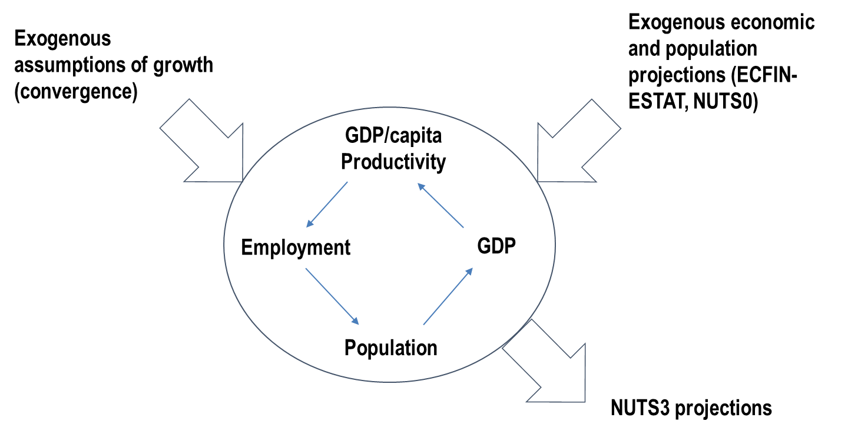
Source: All figures should have a source as well.
These are the general accessibility requirements for pictures:
- Add alternative text to the meaningful pictures.
- For publications published as Microsoft (MS) Word files, pictures are accessible only if they are inserted in line with the text. Alternative text for anchored pictures is supported only by the MS Office 365 update released in 2022 and later updates.
- For publications published as PDF files (exported from MS Word), pictures can be inserted in line with the text or with different text-wrapping options.
- To set the reading order for a picture with the text wrapping, lock the anchor in front of the paragraph preceding where the image’s alternative text should appear in the reading order. The alternative text is read out after that paragraph.
- Picture title, subtitle, copyrights, source and caption text must be separated from the graphic and appear as text.
- Each picture should be a single object. If a picture consists of several elements (e.g. a chart combined with text boxes and drawings), such a picture should be created in another document. A good solution is to create an infographic or a complex chart in PowerPoint, then save the picture as an enhanced metafile and insert it as a single object in the working MS Word file.
- Ensure sufficient colour contrast (Web Content Accessibility Guidelines 2.1 level AA) for the picture elements. This does not include logos, photos and decorative images.
- Ensure that the text size in the pictures is equivalent to a minimum of 8 points after inserting and resizing the picture.
- The resolution of pictures should be 150 pixels per inch or higher. If a publication is also being printed, the resolution of pictures should be 200–300 pixels per inch.
        - Second subheading 4
Nunc vestibulum condimentum nisi. Nam erat diam, suscipit vitae nisl eget, tempus tempus eros. Proin vel diam convallis, bibendum mi id, faucibus eros. Donec mi nisl, auctor quis aliquet a, ultricies vel metus. Ut rhoncus nulla augue, in egestas metus fringilla non. Sed sit amet felis dignissim, ornare elit vel, mattis augue. In adipiscing euismod purus id rutrum. Nulla facilisi.
Add an equation as a single image, for example copied and pasted as a picture enhanced metafile, and add alternative text to it.

Equation 1. Title of the equation
      - Second subheading 3
Nunc vestibulum condimentum nisi. Nam erat diam, suscipit vitae nisl eget, tempus tempus eros. Proin vel diam convallis, bibendum mi id, faucibus eros. Donec mi nisl, auctor quis aliquet a, ultricies vel metus. Ut rhoncus nulla augue, in egestas metus fringilla non. Sed sit amet felis dignissim, ornare elit vel, mattis augue. In adipiscing euismod purus id rutrum. Nulla facilisi. Nulla vitae dui lectus. (Please set space after to 12 pt as direct formatting to increase the space between the text and the following box.)
Box 1. This is a box title (manually add ‘Strong’ character style to the numbering)
This is a box text … Nunc vestibulum condimentum nisi. Nam erat diam, suscipit vitae nisl eget, tempus tempus eros. Proin vel diam convallis, bibendum mi id, faucibus eros. Donec mi nisl, auctor quis aliquet a, ultricies vel metus. Ut rhoncus nulla augue, in egestas metus fringilla non. Sed sit amet felis dignissim, ornare elit vel, mattis augue. In adipiscing euismod purus id rutrum. Nulla facilisi. Nulla vitae dui lectus.
If the box like this (which is constructed based on a paragraph style) is split between two pages, the box border towards the edge of a page is not added. You may try to insert a larger white space before the box to force it to move onto a single page, or you can use a single cell table with table style JRC_Table_Box for long boxes (see Box 2 as an example).
- And sometimes you may want to make a list inside a box.
- This bulleted list style with em-dashes is specifically made for this box.
Sed sit amet felis dignissim, ornare elit vel, mattis augue. In adipiscing euismod purus id rutrum. Nulla facilisi. Nulla vitae dui lectus.
Donec mi nisl, auctor quis aliquet a, ultricies vel metus. (Please set space before and space after to 12 pt as direct formatting to increase the space between text and boxes.)
Box 2. This is a box title (manually add ‘Strong’ character style to the numbering)
This is a box text … Nunc vestibulum condimentum nisi. Nam erat diam, suscipit vitae nisl eget, tempus tempus eros. Proin vel diam convallis, bibendum mi id, faucibus eros. Donec mi nisl, auctor quis aliquet a, ultricies vel metus. Ut rhoncus nulla augue, in egestas metus fringilla non. Sed sit amet felis dignissim, ornare elit vel, mattis augue. In adipiscing euismod purus id rutrum. Nulla facilisi. Nulla vitae dui lectus.
Only use a single cell table structure for a box if you need it to contain elements that are not possible to format using just a paragraph style. Afterwards, to make the PDF file completely accessible, the table tags should be removed manually in the PDF tags structure using Acrobat Pro software.
- And sometimes you may want to make a list inside a box.
- This bulleted list is the same as used elsewhere in the document:
  - the second level of a bulleted list uses bullet points;
  - lorem ipsum dolor sit amet, consectetur adipiscing elit.
Sed sit amet felis dignissim, ornare elit vel, mattis augue. In adipiscing euismod purus id rutrum. Nulla facilisi. Nulla vitae dui lectus.
(Format the following paragraph after a table by setting space before to 12 pt to increase the space between the text and the preceding box.) Proin vel diam convallis, bibendum mi id, faucibus eros. Donec mi nisl, auctor quis aliquet a, ultricies vel metus. Ut rhoncus nulla augue, in egestas metus fringilla non. Sed sit amet felis dignissim, ornare elit vel, mattis augue. In adipiscing euismod purus id rutrum. Nulla facilisi. Nulla vitae dui lectus.
Nunc vestibulum condimentum nisi. Nam erat diam, suscipit vitae nisl eget, tempus tempus eros. Proin vel diam convallis, bibendum mi id, faucibus eros. Donec mi nisl, auctor quis aliquet a, ultricies vel metus. Ut rhoncus nulla augue, in egestas metus fringilla non. Sed sit amet felis dignissim, ornare elit vel, mattis augue. In adipiscing euismod purus id rutrum. Nulla facilisi. Nulla vitae dui lectus.
This is a new section with a horizontal page layout. This should mainly be used for the insertion of large, complex tables or graphics.
Insert two section breaks (Next Page), and then change the page orientation for this section only. Remember to change the page numbering format, so that it is continuous from the previous section (this has to be done twice: for the new, horizontal section and for the section that follows it).

Table 2. Large table in horizontal layout
Column 1 | Column 2 | Column 3 | Column 4 | Column 5 | Column 6 | Column 7 | Column 8 | Column 9 | Column 10
First column | Data | Data | Data | Data | Data | Data | Data | Data | Data
First column | Data | Data | Data | Data | Data | Data | Data | Data | Data
First column | Data | Data | Data | Data | Data | Data | Data | Data | Data
First column | Data | Data | Data | Data | Data | Data | Data | Data | Data
Source: xxxxxxxxxxxxx.

- Methodology

3.1 Material
Three SNF samples were used to generate the leachate under oxidizing conditions in a hot-cell. The leaching solution was BICarbonated (BIC) water, a reference solution employed in SNF leaching experiments at JRC Kalrsuhe (JRC-KA) [Serrano2012, Martinez2018, Kokinda2025]. Its composition was:
  - 19 mM NaCl,
  - 1.1mM NaHCO₃
The leaching time was 165 days . The SNF originated from a commercial pressurized water reactor (PWR) and had been irradiated at a linear power density of 255 W/cm. The average burnup of the fuel rod was 63 MWd/kgU. It is to be noted that the 3 SNF samples were already used in another leaching experiment, reported in [20].
The bentonite used in the adsorption experiments is a candidate buffer material for the Swedish DGR concept [SKB2019]. It is a red bentonite from Sardinia, supplied by SKB in granular form (~mm size). The material was quartered, milled, and sieved to obtain a particle size fraction below 200 μm.

3.2 Preparation of the modified SNF Leachate
In order to transfer the SNF leachate from the hot-cell to a glove-box for the sorption experiments, a reduction of the external gamma dose was required. This was achieved by removing radioactive Caesium (Cs) from the leachate using AMP-PAN resin (Triskem), with a particle size range of 100–600 μm.
The separation was carried out in the hot cell using a closed-system column connected to a peristaltic pump, allowing the leachate to pass through the resin bed and be collected. Provided the high Cs-removal efficiency [19, and maybe more referernces???] of AMP-PAN resin and the relatively low Cs concentration in the leachate (ppm range), a bed volume of 0.4mL was selected. The flow rate was fixed at 1 mL·min⁻¹ to prevent pressure buildup in the column. Prior to use, the resin was equilibrated with BIC water by passing 10 bed volumes of solution through the column.
After the removal, the modified leachate was transferred to a glove-box where stable Cs was added by using a CsCl solution (1.27g/L). This procedure allowed the Cs concentration to be restored without introducing additional complexing agents or significantly altering the pH of the solution.

3.3. Batch adsorption experiments
Batch adsorption experiments were conducted under oxidizing conditions in a glove-box using a solid/liquid ratio of 5 g/L, with a temperature of $T=25±5$°C . The influence of the leachate concentration was investigated by preparing a series of dilutions of the modified-SNF leachate in BIC water, with dilution factors ranging from 100 to1. Accordingly, the undiluted modified-SNF leachate represent the most concentrated system.
For each experiment, 50 mL of solution were mixed with 250 mg of bentonite in polypropylene tubes and agitated horizontally at 500 rpm using an IKA Vibrax BKR (IKA, Germany) for 10 days. After equilibration, the suspensions were centrifuged with a Hettlich D-78532 centrifuge (Hettlich, Germany) at 6000 rpm for 25 min and filtered using 0.8 μm syringe filters. The supernatants were collected, and alliquots were further filtrated to 0.2 μm and acidified with HNO₃ 1M for elemental analysis. The pH was not controlled during the experiment. All samples were performed in triplicate.

From the initial concentration $C_{0}$ and the equilibrium concentration $C_{e}$, the removal percetange, the sorbed quantity at the equilibrium $Q_{e}$ and the equilbirum constant $K_{d}$were computed:
Equation 2. Adsorption magnitudes.

where $m$ is the mass of bentonite and $V$ the supernatant volume.

Adsorption isotherms were constructed and fitted to the Langmuir and Freundlich models. The Langmuir model [Lang1918, Wang2020] assumes monolayer adsorption on a homogeneous surface with identical sorption sites:
Equation 3. Langmuir isotherm model, including its linearization.

where $K_{L}$ is the Langmuir equilibrium constant and $Q_{max}$is the maximum sorption quantity. The Freundlich isotherm model is an empirical model used to describe adorption on heterogeneus surfaces [Alghouti2020, Saadi2015, Freundlich1907]:
Equation 4. Freundlich isotherm model, including its linearization.

where $n$ is a dimensionless constant, and $K_{F}$ the Freundlich equilibirum constant. For $n=1$, a linear equation is obtained, which correpond to the case of an adsorbant with many adsorption sites so that the coverage fraction is always low. [Wang2020] showed that this model could as well be derived from the Langmuir theory by assuming a coverage fraction of active sites at the equilibrium of 50%

Potential wall sorption was also evaluated by creating samples without added bentonite. The effect was tested with a solution containing U, La, Eu, Cs and Sr in ppm to pbb levels. No significant loss of solutes was detected within the ICP-MS uncertainty.

3.4 Characterization techniques
The elemental composition of the solutions were characterized by ICP-MS using a Thermo Element XP instrument (Thermo Electron Corporation, Germany). Calibration curves were produced using a series of certified multi-elemental standard solutions in the concentration range of the major elements in the solution. Co, In, Ho and Th were used as internal standards in the sample measurements. The concentration of the elements were calculated considering all the isotopes of each radionuclide. Isobaric interferences were corrected based on isotopic ratios previously calculated with the KORIGEN2 code as reference.
The pH was measured with a SG2 pH metter (Mettler Toledo, USA) with a Inlab expert pro electrode (Mettler Toledo, USA). The pH meter was calibrated using commercial pH buffer solutions (Mettler Toledo, USA); pH 4.01, pH 7.00 and pH 9.21.
After adsorption, the solid samples were dried and ground using a mortar with a few drops of acetone. Fourier Transform InfrarRed (FTIR) spectroscopy was performed using a Bruker Alpha I spectrometer (Bruker, Germany) equipped with a diamond crystal. For each measurements, 64 scans were collected, with a resolution of 2cm⁻¹.
X-Ray diffraction (XRD) were performed with a bruker AXS D8 advanced diffractometer with a Platinum filament (Bruker, Germany) using the Kalpha Cu emission, operated at a voltage of 40 kV and a intensity of 40 mA. Measurements were conducted in a nitrogen-filled glove box. The sample preparation involved further grounding with isopropanol and mounting that mix into the Platinum filament of the diffractometer. Data was collected in step mode, with a step size of 0.01 ° per step and 10 s per step.
Scanning electron microscopy (SEM) was performed using a Thermo Scientific Quattro SEM instrument (Thermo electron corporation, USA) with a Field Emission Gun (FEG) electron source and equipped with an EDS XFlash 6/30 and EBSD e-Flash HD detectors. Uncoated fragments of the bentonites were analyzed.

3.5 Radioactivity characterization
Alpha and gamma spectrometry was performed to assess the radioactivity of the solutions. Alpha spectrometry was performed with an Alpha duo detector (Ortec, Germany). A volumne of 0.1 mL of solution was deposited in a metallic planchet, evaporated to dryness, and counted for 10 h. The total alpha activity was calculated by integrating the peaks and correcting for the detector efficiency (13%). These values were used to determine the relative alpha-activity reduction achieved by Cs removal.

INCLUDE HERE eq?
Gamma was performed with
I need info from both Ana and Joszef!!
- Findings
Quadratic uncertainty propagation was performed for all derived magntiudes. For derived magnitudes, its uncertainty is presented with one significative figure if it is higher than three, and with two significative figures otherwise. The significative figures of the uncertainty defines the significative figures of the magnitude.

4.2 Cs removal of the SNF leachate
Prior to the actual use of the column to remove the radioactive Cs from SNF leachate, its performance was tested using BIC water and a solution of BIC water spiked with U, Cs, La, Eu and Sr (ppm-ppb range). Minor leaching of resin constituents, P and Mo, was observed at trace levels (ppm). Cs retention was nearly complete, ~99%, while moderate retention was observed for lanthanides (~50%) and U (~30). [Reynier2019] reported a U retention of 10%, with a pH of 1.5 to 2, having a BV of 50 mL and a U concentation of 58.24 mg/L. Rickard also told me this, that for neutral to high pH I would lose U, Pu due to hydrolisis and complexaion effects. It could have been prevented by reducing the pH, but since we did not wanted to alter the matrix of the SNF, no acidification of the column was done. THINK ABOUT HOW TO SAY THIS!!!
Following validation, the column was refilled with fresh resin, equilibrated with BIC water, and set-up at a hot cell (see Figure X). The concentrations of Cs, La, Sr, and actinides before and after treatment are presented in Table 20, along with P and Mo, the primary leached elements. Cs was almost entirely removed, with residual concentrations comparable to measurement uncertainty. Actinide removal ranged from 20% to 50%. The solution pH remained neutral throughout the process, with a value of $7.6±0.2$.

Figure 2. Closed-system column for the Cs separation (left) and Cs-removal set-up in a hot-cell (right). The left bottle contains the SNF leachate, and the right one collects the filtered leachate. MAYBE MARK THE FILTER??
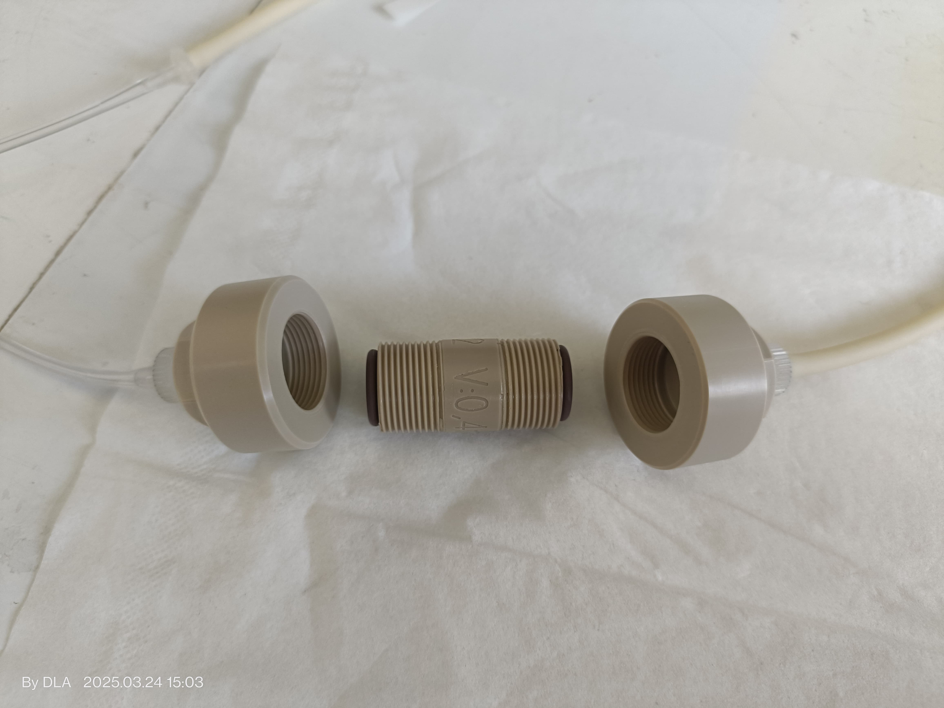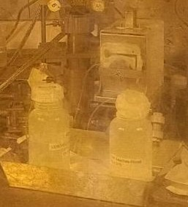
Source: JRC.

Table 20. Elemental concentration before and after the Cs removal, as well as the removal percentage for some elements of the leachate. Mo, and P, the main elements leached by the resin are also included. Averaging the 3 samples measured (no BIC substraction)!.
Element | Initial concentration [uM] | Concentration after the Cs removal [uM] | Removal [%]
Sr | $0.66±0.24$ | $$0.41±0.15$$ | $$38±18$$
Cs | $21±6$ | $$0.6±0.9$$ | $$(10±4)⋅10$$
La | $$(2.0±0.4)⋅{10}^{−2}$$ | $$(1.4±0.3)⋅{10}^{−2}$$ | $$30±9$$
U | $12±3$ | $$9.8±2.3$$ | $$21±7$$
Pu | $$(5.1±1.3)⋅{10}^{−2}$$ | $$(2.7±0.7)⋅{10}^{−2}$$ | $$48±16$$
Np | $$(4.2±1.1)⋅{10}^{−3}$$ | $$(3.0±0.9)⋅{10}^{−3}$$ | $$28±9$$
Am | $$(6.9±1.1)⋅{10}^{−2}$$ | $$(5.0±1.2)⋅{10}^{−2}$$ | $$28±10$$
Cm | $\left(8.6±2.8\right)⋅{10}^{−3}$ | $$\left(2.6±2.0\right)⋅{10}^{−3}$$ | $$28±13$$
P | $12±5$ | $$31±8$$ | ----
Mo | $0.24±0.08$ | $$\left(27±7\right)⋅{10}^{2}$$ | ----
Source: JRC.

4.3 Adsorption experiment
All batch adsorption experiments were conducted at near-neutral pH. The pH of all the mother solutions ranged between $7.8±0.2$ and $8.0±0.2$. The superantants had sligthly higher pH, from $8.2±0.2$ to $8.8±0.2$ . The results resported are the average of the 3 replicates. The uncertainty shown is the greatest one from i) The uncertainty from the averaging or ii) The mean value of the uncertainty of each measurement.

Figure X show the removal
Digure XX shown the adsorption isotherms
Figure XXX shown the Fre fit
Fir XXXXX show the Lang fit
Table include the fit Fre fit param
Table include the Lang fit parameters

Cesium sorption
Cesium removal reached ~90%, across all initial concentrations with no evidence of sorbent saturation. The adsorption isotherm displayed an approximately constant slope, well described by the Freundlich model. Our sorption results are in line with literature findings [Tsai2001, Liu2016, Yildiz2011]. In literature experiments fitting to both Freundlich [Yildiz2011, Liu2016, Atun2002, Tsai2022] and Langmuir [Yang2014, Galambo2010] models can be found, depending on the experimental parameters. The parameters resemble those of [Atun2002], who found the Freundlich model superior to the Langmuir model.

Actinides sorption
All the actinides (U, Np, Pu, Am, Cm) were retained, with removal efficiencies between 40 and 95% as can be seen in figure REF FIGURE!. Except for Np, remval decreased with increasing concentration, indicating progressive site saturation. Np retention remained constant, suggesting a sorption mechanism analogous to Cs⁺ . For the studied conditions, Np exist mainly as as NpO₂⁺ [Benedicto2014, Zavarin2012], a monovalent linear molecule with a low hydrolisis ability [Grente2020], as is the case for the monovalent cation Cs⁺ .

U sorption with similar results could be found in the literature [Pabalan1997, Wang2017]. [Turner1998] also reported log(K_{d}[L/kg]) ~2 for neutral to basic pH. [Leng2016] peformed sorption experiments with Pu, obtaining similar K_{d} values. [Frohlich2018] performed a sistematic review of the Am sorption studies with different materials, reporting log(K_{d}[L/kg]) between 3 and 4 for bentonites, inline with our findings. [Frohlich2015] performed a sistematic review of the Np sorption studies with different materials, reporting log(K_{d}[L/kg]) ~ 2 for Montmorillonite and bentonite clays.
Cm????? For Cm, there is limited published literature. [Rabung2005] obtained log(K_{d}[L/kg]) ~6.
The adsorption isotherm are shown on figure REF FIGURE! The observed decrease of the equilibirium constant as the concentration increase reveals the progressive saturation of the bentonite, except for Np. Langmuir and Freundlich fit models were used to fit the experimental data in order to understand the sorption mechanism [Wang2020]. The freundlich model was found to provide the best fit for all the actinides except for Pu, which followed the Langmuir model. The fit are shown on figure REF FIGURE!
For Pu, the most concentrated sample exhibited a higher removal than the rest of the samples, more clear in the adsorption isotherms. This increase is associated with Pu precipitation, since for concentration around nM to uM Pu precipitation is likely for neutral to basic pH, as several studies already reported [Begg2013, Kokinda2025 (refer Wang2017), Wang2017]. SPECTIATION CALCS SEEM TO CONFIRM THIS; BUT MORE WORK IS NEEDED; PHREQQC CODE TRIED

Lanthanides sorption
The lanthanides were also sorbed, with a removal ranging from 40 to 90%. As for the actinides, the removal decreased as the initial concentration increased, indicating again saturation signs, but again without truly reaching the saturation point.
Literature with compaable sorption variables can also be found, such as [Coppin2002, Galunin2010]. From the isoterm fitting, the Langmuir model provided better results than the Freundlich fit model. Langmuir model is quite used to model lanthanides sorption [Chen2012, Zhou2024 , Galunin2010 for La, and for Eu, 38, 40Hu2020].

Sr sorption
Blank experiments revealed Sr leaching from bentonite in contact with BIC water, indicating exchange of interlayer Sr²⁺ with Na⁺ ions. When contacted with SNF leachate containing radioactive Sr-90, partial re-exchange was observed at higher concentrations. However, for dilute samples, high relative uncertainties prevent quantitative conclusions. The sorption resuts obtained are in agreement with published literature [Izosimova (2002) and Saleh (2025)]

Should I include these results????

Tables X and Y includes the parameters of the Freundlich and langmuir fits respectively. The high uncertainty obtained for the Freundlich constant $K_{F}$ is due to the fact that the fit has a low intercept $b$;$K_{F}$ is proportional to $b^{−1}$ but its standatd deviation $σ\left(K_{F}\right)$is proportional to $b^{−2}$, hence leading to standard deviation comparable or even higher than the magnitude $K_{F}$ when low intercepts are obtained. We can see that both Cs and Np have similar $n$, closer to 1 than the other elements, further indicating these 2 elements are sorbed differently than the other elements. Langmuir fit provided a better fit for both lanthanides and for Pu.

Figure 4. Removal rate as a function of its initial concentration. Replicates averaged.
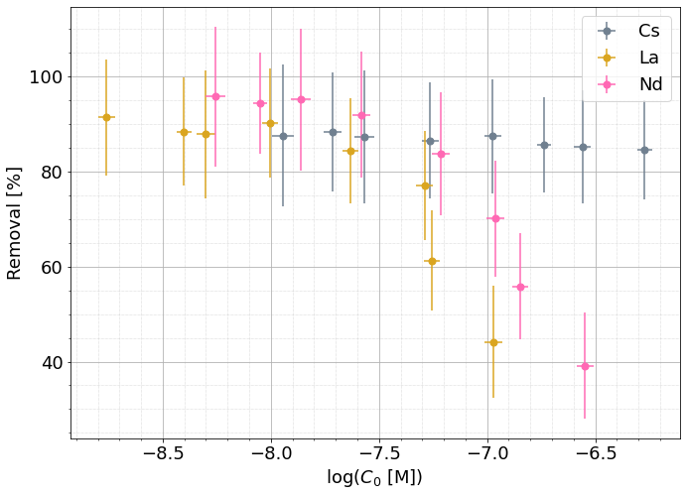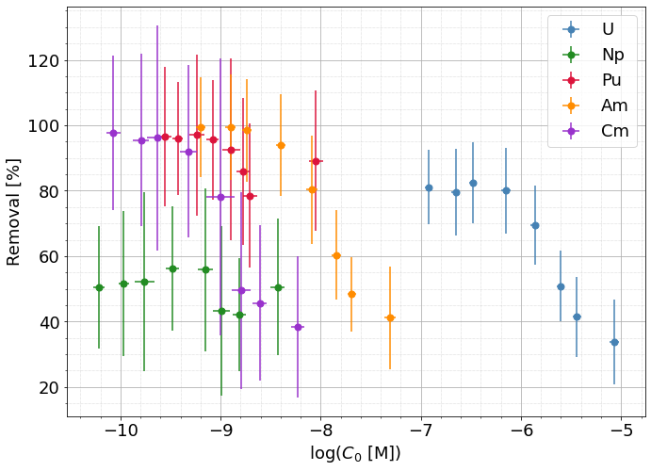
Source: JRC.

Figure 5. Adsorption isotherms with the equilibrium constant (dots) for the elements of interest.
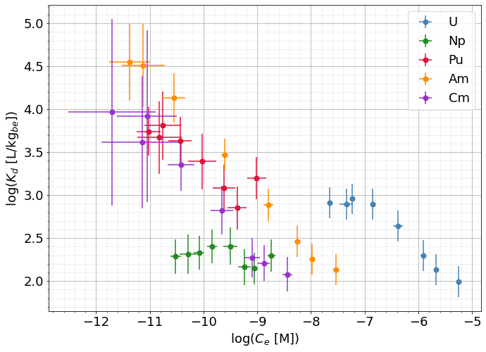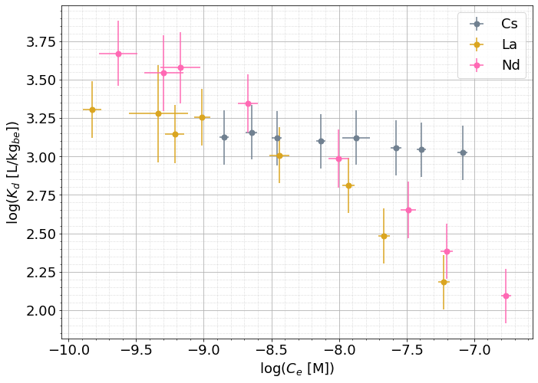
Source: JRC.

Figure 6. Adsorption isotherms (dots) including Freundlich fits (discontinuous lines) for the elements of interest. For Pu, the last sample was excluded for the fit.
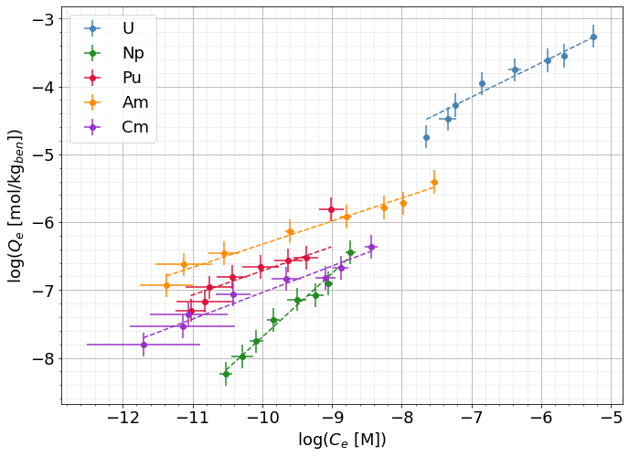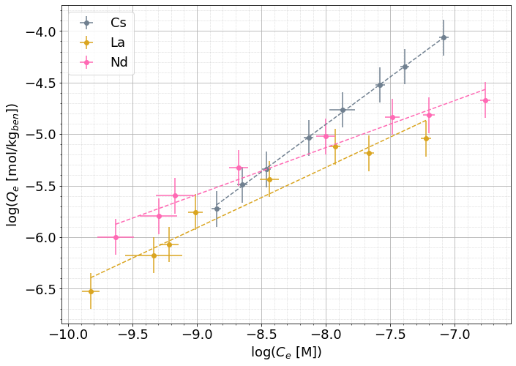
Source: JRC.

How to include the Sr? Inside those plots?? outside? Note only 3 points, with high errorbars!!

Figure 7. Adsorption isotherms (dots) including Langmuir fit (discontinuous lines) for La, U and Pu. For Pu, the last sample was excluded for the fit.
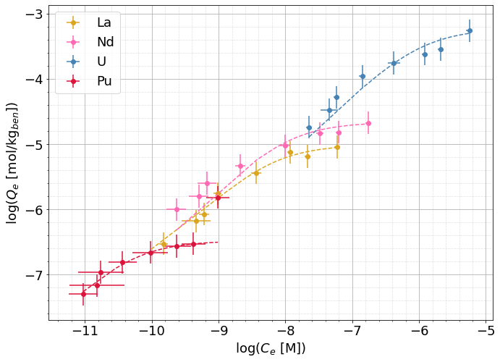
Source: JRC.

Table 21. Langmuir fit parameters for the elements in which the Langmuir model provided a good fit, including the correlation coefficient $r$. Both linear and not linear fit were tried, including here the best fit.
Element | $$r$$ | $$Q_{max}\left[{mol}/{{kg}_{be}}\right]$$ | $$K_{L}\left[M^{−1}\right]$$
La | $$0.99$$ | $$(9.8±0.4)⋅{10}^{−6}$$ | $$(1.7±0.3)⋅{10}^{8}$$
Nd | $$0.98$$ | $$(2.17±0.12)⋅{10}^{−5}$$ | $$(10±3)⋅{10}^{7}$$
U | $$0.9$$ | $$(5.9±0.8)⋅{10}^{−4}$$ | $$(9±3)⋅{10}^{5}$$
Pu | $$0.998$$ | $$(3.30±0.07)⋅{10}^{−7}$$ | $$(2.12±0.18)⋅{10}^{10}$$
Source: JRC.

Table 22. Freundlich fit parameters, including the correlation coefficient $r$. Both linear and not linear fit were tried, including here the best fit.
Element | $$r$$ | $$n$$ | $$K_{F}\left[L^{n}{{mol}^{1−n}}/{{kg}_{be}}\right]$$
Cs | $$0.9998$$ | $$(1.08±0.10)$$ | $$(35±7)⋅10$$
La | $$0.94$$ | $$(1.70±0.108)$$ | $$(0.24±0.29)$$
Nd | $$0.94$$ | $$(2.93±0.28)$$ | $$(4.5±2.5)⋅{10}^{−3}$$
U | $$0.98$$ | $$(1.98±0.16)$$ | $$(2.4±1.2)⋅{10}^{−1}$$
Np | $$0.98$$ | $$(1.07±0.06)$$ | $$(5±6)⋅{10}^{1}$$
Pu | $$0.93$$ | $$(2.8±0.4)$$ | $$(7±8)⋅{10}^{−4}$$
Am | $$0.97$$ | $$(2.93±0.20)$$ | $$(1.2±0.6)⋅{10}^{−3}$$
Cm | $$0.96$$ | $$(2.56±0.22)$$ | $$(7±6)⋅{10}^{−4}$$
Source: JRC.

Bentonite characterization before and after the experiment

The XRD of the bentonite before the sorption experiments is shown on figure. The peaks at 39,79°, 46,28° and 67,52° degrees are the Pt-Background peaks of the Filament. Further characterization??? The bentonite peak corresponding to the {001} reflection, usually located from 4° to 6°, is not appretiable. This is attributed to the vaccum existing in the N₂ atmosphere. [Kelch2021] reported the dissapearance of the cited peak for a RH of 10%, in line with our findings. No changes were appretiated in the spectra performed of the bentonite after the sorption experiments.

[TR 19-25]
XRD did not also reveal any significant change in the bentonite. This is not strange since these techniques have a precision in the percentage levels, while our concentration are in ppm levels.

FTIR spectra of the raw, BIC-contacted, and leachate-contacted bentonite are shown on figure X. The major difference is the peak at 1500 cm⁻¹, attributed to CO₃ stretching vibrations [Roonasi2010, Wijnja2001], which is only present in the initial sample. This indicates a decrease in the surface-carbonates edges of the bentonite, but since it is also present in the bentonite sample which was in contact with BIC solution, is not an indicator of nuclide sorption.

Two SEM images of the initial bentonite are shown on figure X. The bentonite presented a granular structure, with plate-like structures. SEM characterization after the sorption experiment did not reveal any remarkable differences.

State that more evaluation to be done...

Figure 8. XRD spectra of the bentonite used for the experiments. The peaks at 39,79°, 46,28° and 67,52° degrees are the Pt-Background peaks of the filament of the XRD device.
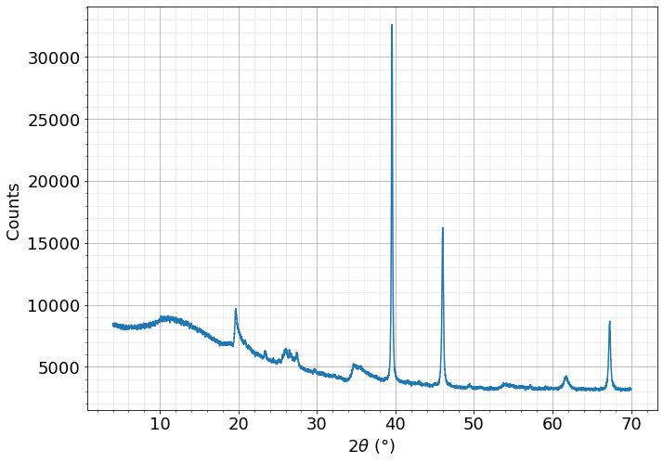
Source: JRC.

Figure 9. FTIR spectra of the bentonite before the sorption experiment, after being in contact with BIC water and after being in contact with the leachate.
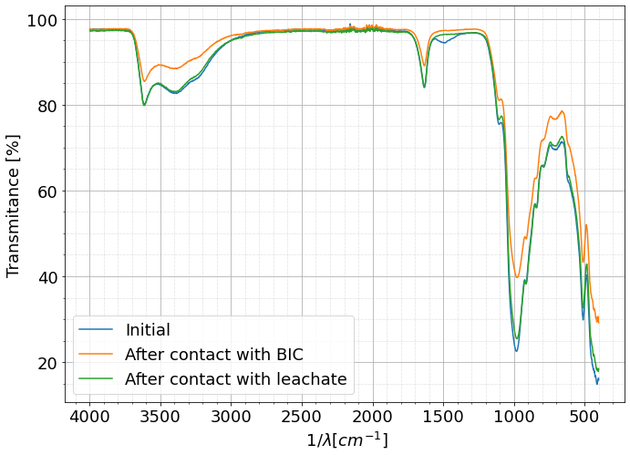
Source: JRC.

Figure 10. SEM images of the initial bentonite.
Source: JRC.

4.4. Radioactivity characterization
The alpha spectra of the treated SNF leachate (Figure X) exhibited two main peaks: one corresponding to the Pu–Am sum peak and another to the Am–Cm sum peak.
Figure XX shows the overall alpha activity removal efficiency, with the regions of interest (ROI) used for peak integration indicated. Gamma-ray analysis have not yet being obtained..
Figure 11. Alpha spectra of the modified SNF leachate, showing the ROIs used for the peak integration.
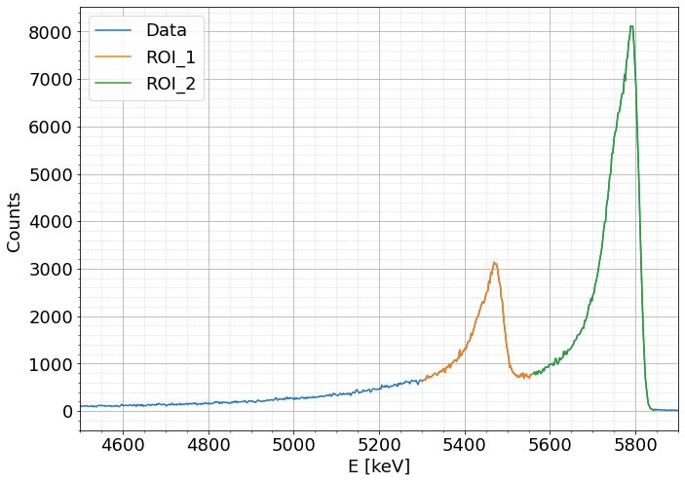
Source: JRC.

Figure 12. Removal of the alpha activity after the adsorption experiments.
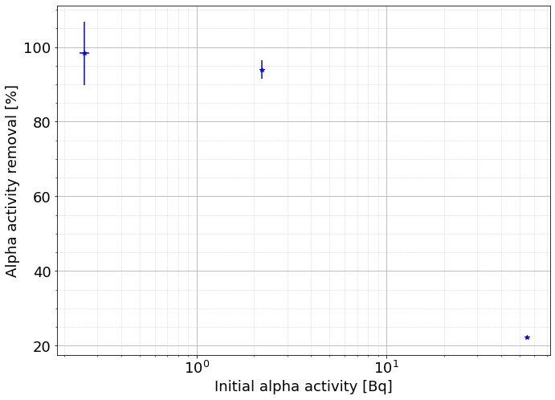
Source: JRC.

Gamma measurements analysis to be included...
- Conclusions <mandatory element>
This chapter discusses and interprets the study/research results and findings in the light of the policy question and the objectives of the study/research presented in the introduction. It should also present the recommendations when appropriate. The author is free to organise the body text under subheadings in order to improve the presentation and readability.
A filtering system to reduce the radioactive dose of SNF leachate was commisioned and vaidated, using AMP-Pan resin to remove Cs. The filtration was successfully reduced by filtering out Cs at a hot cell. Natural Cs was added not t alter the SNF elemental composition. This filtration resulted as well in a moderate actinides retention, as well as the addition of Mo and P, main constituing elements of the cited resin.

With the modified SNF leachate, batch adsorption experiments were conducted at a glove-box with oxidizing conditions. The results showed that most actinides, as well as Cs and lanthanides were retained by bentonite, with a removal efficiency ranging from 40 to 90%. Saturation signs were obtained for all the elements except for Np and Cs. Adsorption isotherm fitting revealed that lanthanides and Pu sorption could be fitted by the Langmuir model, while the rest of the elements of interest could be fitted by the Freundlich model.
The bentonite was characterized before and after the sorption experiments, obtaining negligible differences, indicating no major effect could be appretiated in the bentonite.
Alpha and gamma spectrometry were also performed to both the supernatant and the bentonite after the experiments. Alpha results revealed a decrease in the activity of the solutions after being in contact with the bentonite. Gamma results are to be obtained.

Additional experiments such as desorption might reveal additional insights into the sorption mechanisms, as Sabodina2006 did.

References <mandatory element>
This section should contain a complete list of works cited in the report. Please see the rules of the Interinstitutional Style Guide at https://style-guide.europa.eu/en/content/-/isg/topic?identifier=5.9.4-bibliographic-references.

[1] IAEA. Classification of Radioactive Waste. techreport. IAEA, 2009
[2] SKB, Programme for research, development and demonstration of methods for the management and disposal of nuclear waste, TR 22-11. Techreport, 2022
[3] Posiva OY, Safey functions. Performance targets and technical design requirements for a KBS-3V repository. Techreport, 2001
[4] Nagra, The Nagra Research, Development and Demonstration Plan for the Disposal of Radioactive Waste in Switzerland, NTB 21-02, Techreport, 2021
[5] Enresa, Almacenamiento geológico profundo de residuos radioactivos de alta actividad (AGP). Disenos conceptuales genéricos, 11/95, Techreport, 1995
[6] Ahn; Joonhong, Geological repository systems for safe disposal of spent nuclear fuels and radioactive waste, Woodhead publishing, 2017
[7] P. Sellin et al, Clays and Clay Minerals (2013) 61 (6):477–498
[8] E. Galunin et al, Geochimica et Cosmochimica (2010) 74 (3): 862–875
[9] Y. Zhang et al, Environmental Earth Sciences (2021) 80: 80-791
[10] H. Jun, et al. Sci China Chem June (2010) 53 (6): 1420-1428
[11] M. Murali et al, Journal of Radioanalytical and Nuclear Chemistry (2002), 254 (1): 129–136
[12] F. Coppin et al, Chemical Geology (2002) 182: 57–68
[13] N.A. Chapman et al, Chemical Geology (1986) 55: 167—173
[14] Mater. Res. Soc. Symp. Proc. (2009) 1124
[15] P.Li et all, Journal of Molecular Liquids (2015) 206: 285–292
[16] Journal of Nuclear Materials (2000) 277: 208-214
[17] M. Marimon et al, Radiochim. (2002) 90: 753–760
[18] M.V. Villar et al, Journal of Iberian Geology (2006) 32 (1): 15-36
[19] T.A. Todd et al, Journal of Radioanalytical and Nuclear Chemistry (2002), 254 (1): 47–52
[20] Iglesias 2023. The paper of my pellets!!
21 Reynier2019
22 [Lang1918,
23 Wang2020]
24 [Badbury1997 pat II],
24Alghouti2020,
25Saadi2015,
26Freundlich1907
27[Pabalan1997,
28Wang2017]
29 [Turner1998]
30[Frohlich2018]
28 [Frohlich2015]
32Saleh2025
[30] Izosimova2002
34[Begg2013,
32Kokinda2025 (refer Wang2017),
36Wang2017].
34[Chen2012,
38Zhou2024 ,
36 Hu2020, ],
40[Tsai2001,
38Liu2016,
42Yildiz2011]
F40 Atun20202,
44Tsai2022]
45Yang2014,
[Benedicto2014,
Zavarin2012]
Grente2020 Np hydrolisis
[TR 19-25]
[Kelch2021]

#------------------ Garbage
From the 001 peak the interlaminar space of the Montmorillonite $d_{001}$ was calculated

List of abbreviations and definitions <mandatory when report contains abbreviations and definitions>
Abbreviations | Definitions
SNF | Spent Nuclear Fuel
BAGSFUL | Bentonite Adsorption Experiments using Genuine Spent Nuclear Fuel Leachate
ΗΘΙ | Eta Theta Iota
ROI | Region of Interest
XRD | X-Ray diffraction
FTIR | Fourier Transform InfraRed

List of boxes <mandatory when report contains boxed text>
Use the built-in function to generate a table of figures (References > Captions > Insert Table of Figures), or simply use the example in the template and update it (click on table field and press F9) when the report is complete.
Box 1. This is a box title (manually add ‘Strong’ character style to the numbering) 2
Box 2. This is a box title (manually add ‘Strong’ character style to the numbering) 2

List of figures <mandatory when report contains figures>
Use the built-in function to generate a table of figures (References > Captions > Insert Table of Figures), or simply use the example in the template and update it (click on table field and press F9) when the report is complete.
Note: Word does not distinguish between these tables; therefore, when it asks if you want to replace the already inserted table (for boxes or tables), answer No.
Figure 1. Simplified diagram of the convergence model Figure title is inserted above the figure. 15
Figure 2. Closed-system column for the Cs separation (left) and Cs-removal set-up, installed at a hot-cell and in operation (right). The left bottle contains the SNF leachate, and the right one collects the filtered leachate. MAYBE MARK THE FILTER?? 25
Figure 4. Removal of a given element as a function of its initial concentration. Replicates averaged. 29
Figure 5. Adsorption isotherms with the equilibrium constant (dots) for the elements of interest. 30
Figure 6. Adsorption isotherms (dots) including Freundlich fits (discontinuous lines) for the elements of interest. For Pu, the last sample was excluded for the fit. 31
How to include the Sr? Inside those plots?? outside? Note only 3 points, with high errorbars!! 31
Figure 7. Adsorption isotherms (dots) including Langmuir fit (discontinuous lines) for La, U and Pu. For Pu, the last sample was excluded for the fit. 32
Figure 8. XRD spectra of the bentonite used for the experiments. Parameters: step mode, 0.01deg per step, 10s per step. The peaks at 39,79; 46,28 and 67,52 degrees are the Pt-Background peaks of the filament of the XRD device. 34
Figure 9. FTIR spectra of the bentonite before the sorption experiment, after being in contact with BIC water and after being in contact with the leachate. Parameters: 64 scans, resolution of 2cm⁻¹. 35
Figure 10. SEM images of the initial bentonite. 36
Figure 11. Alpha spectra of the modified SNF leachate, showing the ROIs used for the peak integration. 37
Figure 12. Removal of the alpha activity after the adsorption experiments. 37
From the 001 peak the interlaminar space of the Montmorillonite was calculated 40

List of tables <mandatory when report contains tables>
Use the built-in function to generate a table of figures (References > Captions > Insert Table of Figures), or simply use the example in the template and update it (click on table field, press F9, update entire table) when the report is complete.
Note: Word does not distinguish between these tables; therefore, when it asks if you want to replace the already inserted table (for boxes or figures), answer No.
Table 1. Nunc vestibulum condimentum nisi Table title is inserted above the table. 13
Table 2. Large table in horizontal layout 18
Table 20. Elemental concentration before and after the Cs removal, as well as the removal percentage for some elements of the leachate. Mo, and P, the main elements leached by the resin are also included. Averaging the 3 samples measured (no BIC substraction)!. 25

Annexes <optional>

Annex 1. Title of annex <numbering of annexes is mandatory, if there is more than one>
Each annex has a numbered title. They do not start on new pages.

Steps to format your report
For the branding of JRC outputs, it is essential that each JRC report has the same look and feel, in accordance with the following specifications.
- Use EN (United Kingdom) spelling for reports written in English.
- Styles to be used in these reports are preceded by ‘JRC_’. They are available from the quick style gallery on the Home banner, or you can click on the small arrow in the bottom right corner of the Styles panel to open the Styles window, which can be displayed to the right of your document.
- Please do not modify the styles.
- In this template the character style ‘Strong’ is formatted bold. The character style ‘Emphasis’ is formatted italic. Bold italic formatting is available with the character style ‘Intense Emphasis’.
- Do not add empty paragraphs – spacing is set in the definition of the styles. Only add page breaks when necessary to keep elements together that will otherwise be separated.
- On the front cover, use line breaks (SHIFT + Enter) to break titles that are too long for one line.
- Each main section (Level-1 heading) starts on a new page (this is included in the style definition, so it is not necessary to add a page break).
- The template provides for five levels of heading. It should not be necessary to divide the text further.
- Use the style ‘JRC_Text’ for regular paragraphs (EC Square Sans Pro font size 11, 8 pt spacing before and after, 1.1 line spacing).
- The template provides for two list types – bulleted and numbered – both with two levels (styles ‘JRC_Text_bulleted_list1/2’ and ‘JRC_Text_numbered_list1/2’). Do not use the built-in function in Word to create lists.
- Use the built-in function in Word to insert footnotes (References > Insert Footnote). Footnotes appear at the bottom of the page, and the text should be preceded by a tab in order to align it properly; see the examples in this document. Footnote markers are formatted in accordance with rules in the Interinstitutional Style Guide (preceded by a non-breaking space in the text.
- References should be listed at the end of the document in alphabetical and chronological order; please see Section 5.9.4 of the Interinstutional Style Guide for examples of how to cite references’.
- If formulae are needed, but they cannot be written using Word, then they should instead be copied and pasted (e.g. as an image) from the programme (e.g. LaTeX) that you usually use to write them. Use the ‘JRC_Equation’ style for both Word-generated formulae and inserted images.
- Table titles should be inserted above the table, aligned to the left (use the style ‘JRC_Table_title’; manually add bold to the numbering ‘Table #.’ only).
- Tables should be inserted using the Word function Insert > Table. Tables should be aligned to the left, even if they do not fill up the entire text width.
- Table notes should be added manually below the table (use the style ‘JRC_Table_note’; do not use the built-in Word function for this).
- Figure captions should be inserted above the figure (use the style ‘JRC_Figure_caption’; manually add bold to the numbering ‘Figure #.’ only).
- Each figure, table, infographic and graph should list the source(s) underneath and note if it is a JRC analysis (e.g. ‘Sources: Eurostat, World Bank, JRC analysis’).
- Only use section breaks if pages with landscape orientation are needed. Add a section break (Next Page) before and after the landscape page(s) and make sure pagination is included and is continuous from the previous section.
- Page numbers appear at the bottom of the page, in the middle of the footer. The cover pages (the front cover, bibliographical information page, Europe Direct page and back cover) have no numbering. Pages are numbered with Arabic numerals starting at the contents page from 1. This is all already applied in the template.
- If photos from third parties are used, make sure to respect copyright rules and list the copyright/credit/source on the second page as requested. The so-called 'royalty free' images or photos found on the internet or purchased on CD-ROM are not public domain. They are copyright protected. Therefore, it is essential to respect all terms of use specified. For more info see http://ec.europa.eu/ipg/basics/legal/notice_copyright/index_en.htm and/or write to op-info-copyright@publications.europa.eu.

Steps to make your publication accessible

Write clear and structured content
The accessibility of the publication is also evaluated by how easy it is to understand it. There is no actual standard on how to do this, but the World Wide Web Consortium gives the following tips for writing for accessibility.
- Use simple and straightforward language and formatting.
- Write in short, clear sentences and paragraphs without complex grammar.
- Avoid using unnecessarily complex words and phrases. Consider providing a glossary for terms readers may not know.
- Expand acronyms on first use.
- Consider providing a glossary for terms readers may not know.
- Use list formatting as appropriate.
- Consider using images, illustrations, video, audio and symbols to help clarify meaning.
- Check out the Commission’s Clear Writing Guide available on the writer’s toolbox page on the intranet and the older edition published by the Publications Office.
To ensure that the publication is easily operable by assistive technology, write the structured content and apply proper heading paragraph styles without skipping heading levels. Use paragraph styles consistently and apply list and table styles, considering the requirements for accessibility.

Text formatting
Left alignment of the text and wide white space between lines, paragraphs and layout elements are recommended for better accessibility.
Underlined text is usually understood as a hyperlink. Therefore, it is recommended to emphasise the text using the bold font effect. In this template the character style ‘Strong’ is formatted bold.
Text in italics is considered hard to read. Therefore, do not format large parts of a text with the italic font effect. In this template the character style ‘Emphasis’ is formatted italic.
Bold italic formatting is available with the character style ‘Intense Emphasis’.
Avoid adding empty paragraphs. Apply the correct language for text and text styles.
You also need to add a non-breaking space before the opening footnote number in the text and a tab character after the number in the footnote. The same applies to endnotes.

Add alternative text to images
Alternative text provides a textual alternative to an image. It is needed for those who cannot read but rely on assistive technology, such as screen readers.
Not all images need alternative text, because some are added purely for decorative purposes. With Office 365, we can mark such images as decorative instead of writing the alt text.
For more information, watch the video on how to design a good alternative text and see the handout with tips and tricks.

Use of colour and sufficient colour contrast
Make sure that colour is not the only means used to convey information.
Check that the colour contrast for text, charts and infographics is sufficient and in accordance with Web Content Accessibility Guidelines 2.1 requirements.
Recommended tool for colour contrast check: Adobe Color Contrast Checker.

Accessibility checker integrated with Microsoft Word
Please check your document for potential accessibility issues before exporting to PDF:
- in the Microsoft (MS) Word document, select the File tab;
- select Info from the left-hand menu;
- click the ‘Check for Issues’ button;
- select Check Accessibility from the drop-down menu and review the list of potential errors in the Accessibility Checker panel.
Try to fix as many errors as possible. However, remember that not all errors are critical for accessibility if the final format for publishing is PDF.
For example:
- alternative text for tables is not exported to PDF; it has to be added manually after the PDF export, using Adobe Acrobat Pro;
- if a single-cell table is used as a container for box content, it cannot have a header row;
- objects with text wrapping can be used if the publishing format is PDF;
- MS Office 2016 will bring up the ‘Missing Alt Text’ error for decorative images marked as such with MS Office 365.

Exporting to PDF
If you have Adobe Acrobat (professional version), you just need to click on ‘Save as Adobe PDF’, embedded into your MS Word:
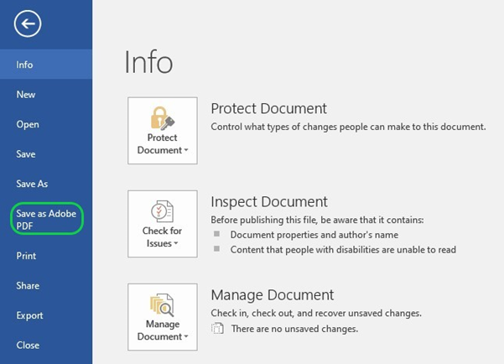
Otherwise, PDF CoDe is a central PDF conversion service powered by the Directorate-General for Digital Services. It allows you to convert Office documents into PDF format by just sending them to a special mailbox. The service is open to everyone within the Commission.
If you wish to use this service, please send an email with the file you wish to convert as an attachment to EC-PDF-CODE-WEB@ec.europa.eu to optimise it for viewing on screen. No explanation is needed in the email.
Please avoid other conversion options (Print > PDF / Save as > PDF / Export > PDF) because they lose some accessibility features and/or the European Commission font.

Final actions and checks in PDF
The primary tool to check the accessibility of PDF files is Adobe Acrobat Pro. Use its automatic accessibility checker to detect accessibility issues.
You may check the primary reading order using the Acrobat Pro tags panel.
Additional tools to check accessibility are the Callas pdfGoHTML2 plug-in for Adobe Acrobat Pro and PDF Accessibility Checker 2021. The recommended screen reader to test the accessibility is Non-visual Desktop Access (NVDA).
Carry out the following actions and checks in PDF:
- add document title and author metadata;
- set the correct document language;
- check if the navigation with bookmarks and table of contents works properly;
- check if the reading order is accurate;
- check if the alternative text is added to all meaningful images;
- check if all decorative objects are tagged as artefacts;
- if necessary, set the table header cells as header cells and fix their scope (row headers or column headers);
- add table summary to complex tables if necessary;
- check the primary reading order (used by the most popular screen readers) using the Acrobat Pro tags panel and pdfGoHTML2 plug-in;
- check the secondary reading order (used by less popular screen readers) using the Acrobat Pro order panel;
- check semantic tagging and the heading hierarchy;
- check the colour contrast (if not already checked while working in MS Word);
- fix errors reported by the Acrobat Accessibility Checker.
To add back covers to your document use Generate Cover pages function in Pubsy
If your publication will be disseminated with identifiers (ISBN, ISSN, doi, etc.), please generate the covers after the identifiers have been assigned.
See: PUBSY: Automated Generate cover pages – Easier.Simpler.Faster

Footnote text (please always insert <tab> at the beginning).
Footnote text (please always insert <tab> at the beginning). When the text is longer than one line, it is indented for a more reader-friendly layout.

