KARUNYA INSTITUTE OF TECHNOLOGY AND SCIENCES
Department of Computer Science and Engineering
WEB TECHNOLOGY MICRO-PROJECT REPORT
ParkFinder
Smart Parking Discovery and Availability Monitoring System
Subject: Web Technology
Submitted by
Name | Register Number
DANIEL S | URK26CS1083
GLADYS JOYSELIN W | URK26CS1063
MONICA S | URK26CS1068
SARAVANAN M | URK26CS1090

Under the guidance of
[Faculty Name, Designation]
Academic Year: 2026 – 2027

1. OVERVIEW

1.1 Introduction
ParkFinder is a single-page web application that helps a driver find a parking location in Coimbatore before leaving for the destination. When the page opens, the user sees twelve parking locations spread across the city, in areas such as RS Puram, Gandhipuram, Town Hall, Race Course, Peelamedu and Saravanampatti. They appear both as a list of cards and as numbered markers on an interactive map. For every location the page shows how many slots are free, the price per hour, the opening hours, the vehicles it accepts, its facilities and how far away it is. The user can search by area or road name, narrow the results with filters, save locations they use often, and open Google Maps directions to the one they choose.
The project was built for the Web Technology course using HTML5, CSS3 and plain JavaScript (ES6). Leaflet.js is the only external library, and it is used for the map. There is no server-side code and no database. The whole application runs inside the browser, and during development we ran it with the Live Server extension of Visual Studio Code.
One point needs to be stated at the start because it affects how the output should be read. The parking records in ParkFinder are demonstration data that we wrote ourselves, and the changing slot counts are produced by a JavaScript timer in the browser. The application is not connected to parking sensors or to any live parking database. The page says this itself, in the hero text and in a “Demo data” notice placed above the filters.

1.2 The Parking Problem
Anyone who has travelled through the centre of Coimbatore by car or two-wheeler has seen the problem. In Gandhipuram, the bus stands, Cross Cut Road and the surrounding shopping streets attract crowds for most of the day. In RS Puram, DB Road is lined with shops, restaurants and offices. Roadside parking in both areas fills quickly, and the paid parking lots are often a street or two away from the main road. A driver who arrives without information cannot tell which lot still has space. The usual approach is to circle the block, try one lot, and move on to the next if it is full.
This trial-and-error search wastes time and fuel, and the extra vehicles moving slowly through already congested streets make the traffic worse. What a driver needs to know is simple: where the parking is, whether it has space, what it costs and how to reach it. The difficulty is that this information is not available in one place. ParkFinder was designed around these four questions.

1.3 Proposed Solution
ParkFinder brings the parking information together on one page that works on a laptop or a phone. The top of the page shows four summary figures for the whole city: the number of parking locations, the free slots, the occupied slots and the average price per hour. Below them, a filter bar sits above three panels: the parking list, the map and a details panel. On a desktop screen these panels are placed side by side, so a user can compare locations without moving to another page. Selecting a location on the list or on the map highlights it in both places and fills in the details panel. From there the user can open directions in Google Maps or save the location as a favourite.
Availability is shown in three states. A location with no free slots is Full (red). A location with more than 40% of its slots free is Available (green), and anything in between is Filling fast (orange). Each state is shown as text as well as colour, and every map marker displays the number of free slots, so a user does not have to rely on colour alone.

1.4 Objectives
- To display parking locations in Coimbatore on an interactive map together with a searchable list.
- To show the free slots, capacity, price, opening hours, accepted vehicles and facilities of each location.
- To let users narrow the results by search text, availability, vehicle type and maximum price, and to sort them by distance, price or free slots.
- To find the nearest parking from the user’s position when the user allows it, and to say clearly when the position is not available.
- To remember favourite locations between visits using the browser’s LocalStorage.
- To demonstrate changing availability through a clearly labelled simulation.
- To build a layout that works on desktop, tablet and mobile screens.

1.5 Technologies Used
Each technology in the project has a specific job. Table 1.1 lists them with the part of ParkFinder each one is responsible for.
Table 1.1: Technologies and their role in ParkFinder
Technology | Role in ParkFinder
HTML5 | Structure of the page: navigation bar, hero with the search form, statistics, filter form, parking list, map container, details panel and footer (index.html).
CSS3 | All visual styling and the responsive layout: colour variables, Flexbox, CSS Grid, hover and focus states and three media-query breakpoints (css/style.css).
JavaScript (ES6) | Application logic: data validation, statistics, search, filters, sorting, card rendering, selection, favourites, Near me, distance calculation and the availability simulation (js/data.js, js/map.js, js/script.js).
Leaflet.js 1.9.4 | Interactive map: panning, zooming, markers and popups. Loaded from the unpkg CDN with an integrity hash.
OpenStreetMap | The map tiles (background map images) that Leaflet displays, with the required attribution.
Browser LocalStorage | Keeps the ids of saved parking locations so that favourites survive a page refresh.

Two built-in browser features are also used. The Geolocation API (navigator.geolocation) is used for the Near me button, and an ordinary Google Maps directions URL is used for the Get directions button. Neither needs an API key or any code running outside the browser.

1.6 Working Principle
The JavaScript is split into three files with separate jobs. data.js holds only data: an APP_CONFIG object with settings, and the PARKING_SPOTS array with the twelve parking records. map.js contains everything related to the Leaflet map. script.js contains the rest of the logic and starts the application. The files are loaded in that order with the defer attribute, so each file can use what the earlier files define.
When the browser has finished reading the HTML, the DOMContentLoaded event calls initApp(). This function checks the dataset, calculates the distance to every location, connects all the buttons and form controls to their event handlers, creates the map with one marker per location, and draws the first list of cards. It then starts a timer for the simulated availability updates.
After that, every user action follows the same path. Typing in the search box, ticking a filter, moving the price slider, changing the sort order or saving a favourite all call one function, updateParkingList(). It reads the current values of the controls, filters the parking data, sorts the result, and then redraws the parking cards, the map markers and the details panel together. Because all three are redrawn from the same filtered list, they always show the same locations. The simulation timer uses the same function every five seconds, after changing the free-slot counts of three random locations.
Distances are calculated from the coordinates of each location using the Haversine formula. Until the user presses Near me, they are measured from a fixed demo reference point (Town Hall, Coimbatore), and the list states this clearly above the cards. After the user allows location access, distances are measured from the user’s actual position.

1.7 Scope and Limitations
ParkFinder is a front-end demonstration, and we have tried to be clear about what it does not do. The twelve locations, their capacities, prices and facilities are sample data. The area and road names are real places in Coimbatore, but the coordinates are approximate. The changing availability is generated by setInterval() and does not reflect real parking. Distances are straight-line distances, not road distances. An internet connection is needed to load Leaflet and the map tiles. Favourites are stored only in the browser where they were saved. The browser allows the Near me feature only on a secure page (https://, localhost or 127.0.0.1). Booking and payment are not part of the project.

2. TAG DESCRIPTION

2.1 Tag Count
We counted the tags in index.html, the only HTML file in the project, with an HTML parser rather than by hand. The file contains 199 HTML element occurrences built from 35 unique tag types. “Occurrences” counts every element on the page (the 35 div elements count as 35), while “unique tag types” counts each different tag once. The <!DOCTYPE html> line at the top is a declaration, not an element, so it is not included.
The twelve parking cards are not part of this count. They are generated by the JavaScript function createParkingCardHTML() after the page loads, using li, article, h3, div, span and p elements. The same is true for the facility tags in the details panel and the content of the map popups. The static count therefore describes the page skeleton, while the cards are added at run time.
Table 2.1: Tags grouped by purpose
Category | Unique tag types | Element occurrences
Structural tags | 10 | 49
Text and content tags | 10 | 91
Form and input tags | 8 | 32
Interactive tags | 2 | 15
Media and external resource tags | 5 | 12
Total | 35 | 199

2.2 Structural Tags
These tags form the outline of the page. We used the semantic tags (header, nav, main, section, aside and footer) wherever an area has a clear meaning, because they describe what each part of the page is. Screen readers use them to let a user jump between regions. The div tag carries no meaning of its own and is used only where we needed a box for layout, which is why it is the most frequent tag in the file.
Table 2.2: Structural tags
Tag | Count | Purpose | How it is used in ParkFinder
<html> | 1 | Root element of the document | Wraps the whole page; lang="en" tells browsers and screen readers the language
<head> | 1 | Information about the page | Holds the meta tags, title, favicon link, Leaflet stylesheet and style.css
<body> | 1 | Everything visible on the page | Contains the header, main content, footer, toast message and scripts
<header> | 1 | Introductory bar of the page | The sticky navigation bar with the logo, links, Menu button and Near me button
<nav> | 1 | Main navigation block | Groups the logo and section links; aria-label="Main navigation" names it for screen readers
<main> | 1 | Main content of the page | Contains the hero, statistics and Find Parking dashboard; id="top" is the logo link’s target
<section> | 6 | A thematic part of the page | Hero, statistics, Find Parking area, filter panel, parking list panel and map panel
<aside> | 1 | Content related to the main area | The Selected parking panel that shows the chosen location’s details
<footer> | 1 | Closing part of the page | About section with the project description, team, technologies and map credit
<div> | 35 | Generic container | Layout boxes: .container, stat cards, filter groups, .dashboard-grid, the rows inside the details list

2.3 Text and Content Tags
Most of the visible text sits in these tags. Many of them start with a placeholder (a dash or “Loading…”) and are filled in by JavaScript once the data has been processed. A good example is the description list in the details panel: each dt holds a fixed label such as “Price”, and the matching dd has an id that renderInfoPanel() uses to write the value.
Table 2.3: Text and content tags
Tag | Count | Purpose | How it is used in ParkFinder
<h1> | 1 | Main heading of the page | “Find a parking spot in Coimbatore” in the hero
<h2> | 6 | Section headings | Filters, Parking locations, the selected parking name (#info-title) and three footer headings
<p> | 25 | Paragraph of text | Hero text, statistic labels, values and notes, the demo notice, the distance note, map status and footer text
<span> | 26 | Small inline container | Logo text, coloured dots, vehicle option labels, legend items, result count, and the Near me and Save labels
<strong> | 1 | Text of strong importance | “Demo data:” at the start of the simulation notice
<ul> | 5 | Unordered list | Navigation links, #parking-list, the facility tags and two footer lists
<li> | 12 | List item | Four navigation links, the list’s loading message, four team members and three technology lines
<dl> | 1 | Description list | The detail rows of the Selected parking panel
<dt> | 7 | Term in a description list | Available, Occupied, Total capacity, Price, Opening hours, Distance, Vehicles
<dd> | 7 | Value of a term | Filled by renderInfoPanel(), e.g. “42 slots (70% free)”

2.4 Form and Input Tags
ParkFinder has two forms: the search form in the hero and the filter form above the dashboard. Neither sends data to a server. JavaScript calls preventDefault() on their submit events and reads the control values directly. Every input has a label; the search box has a visually hidden one so that screen-reader users still hear what the box is for. Related checkboxes and radio buttons are grouped with fieldset and legend.
Table 2.4: Form and input tags
Tag | Count | Purpose | How it is used in ParkFinder
<form> | 2 | Groups controls that belong together | #search-form in the hero and #filter-form in the filter panel
<label> | 10 | Caption linked to a control | Search box (hidden label), three availability options, three vehicle options, Max price, Sort by, Show saved only
<input> | 9 | Data entry control | One type="search" box, three status checkboxes, three vehicle radio buttons, one type="range" price slider, one saved-only checkbox
<fieldset> | 3 | Groups related controls | Availability, Vehicle type and Favourites groups
<legend> | 3 | Caption of a fieldset | “Availability”, “Vehicle type” and “Favourites”
<select> | 1 | Drop-down list | #sort-select for choosing the sort order
<option> | 3 | Choice inside a drop-down | Nearest first (distance), Cheapest first (price), Most available first (available)
<output> | 1 | Displays a result | Shows the current maximum price next to the slider; updated by updatePriceLabel()

2.5 Interactive Tags
We used button for actions that change something on the page and a for anything that navigates to another place. The Get directions control looks like a button but is a link, because it opens Google Maps in a new tab. It carries rel="noopener noreferrer" so that the new tab cannot control our page.
Table 2.5: Interactive tags
Tag | Count | Purpose | How it is used in ParkFinder
<button> | 6 | Clickable action | Menu, Near me, Search, Reset filters, Pause updates and Save to favourites
<a> | 9 | Hyperlink | Logo link to #top, four section links, Get directions (target="_blank") and three external links in the footer

2.6 Media and External Resource Tags
These tags connect the page to files outside it: the stylesheets, the scripts and the logo. The two Leaflet resources are loaded from the unpkg CDN with an integrity hash, so the browser refuses the file if its contents have been changed.
Table 2.6: Media and external resource tags
Tag | Count | Purpose | How it is used in ParkFinder
<meta> | 3 | Page metadata | charset="UTF-8", the viewport setting for mobile screens, and a page description
<title> | 1 | Text in the browser tab | “ParkFinder | Smart City Parking Finder”
<link> | 3 | Connects an external resource | Favicon (assets/icons/logo.svg), Leaflet’s CSS and our css/style.css
<script> | 4 | Loads JavaScript | Leaflet, then data.js, map.js and script.js, all with defer
<img> | 1 | Embeds an image | The logo in the navigation bar; alt="" because the word ParkFinder is printed beside it

Apart from the tags themselves, several attributes do important work in ParkFinder. aria-live="polite" on the result count and on the toast message makes screen readers announce the new value when it changes. aria-expanded on the Menu button and aria-pressed on the Save button report their state. The hidden attribute hides the empty-state message and the map status until JavaScript needs them.

3. HTML CODE
This section walks through index.html from top to bottom. The listings are taken directly from the project file, and the line numbers refer to that file. The complete file is reproduced in Appendix A.

3.1 Document Structure
Listing 3.1: Document head (index.html, lines 1–20)
<!DOCTYPE html>
<html lang="en">
<head>
<!-- ===== Basic page settings ===== -->
<meta charset="UTF-8">
<meta name="viewport" content="width=device-width, initial-scale=1.0">
<meta name="description" content="ParkFinder - a student project for finding parking in Coimbatore on an interactive map. Parking data is simulated.">
<title>ParkFinder | Smart City Parking Finder</title>
<link rel="icon" type="image/svg+xml" href="assets/icons/logo.svg">

<!-- Leaflet stylesheet from Leaflet's official CDN (unpkg).
Needed so map tiles, markers, popups and zoom buttons display correctly. -->
<link rel="stylesheet"
href="https://unpkg.com/leaflet@1.9.4/dist/leaflet.css"
integrity="sha256-p4NxAoJBhIIN+hmNHrzRCf9tD/miZyoHS5obTRR9BMY="
crossorigin="">

<!-- Our stylesheet. Loaded last so it can override Leaflet's styles. -->
<link rel="stylesheet" href="css/style.css">
</head>
The page starts with the HTML5 doctype and lang="en". The viewport meta tag is what makes the responsive layout possible: without it, a phone would draw the page at desktop width and shrink it. Leaflet’s stylesheet is linked before ours on purpose. When two rules are equally specific, the later one wins, so our style.css can override Leaflet’s defaults where needed, for example the font used inside the map.

3.2 Navigation Bar
Listing 3.2: Navigation bar (index.html, lines 29–55)
<header class="navbar">
<nav class="container navbar-inner" aria-label="Main navigation">

<a href="#top" class="logo">
<img src="assets/icons/logo.svg" alt="" class="logo-mark" width="28" height="28">
<span class="logo-text">Park<span class="logo-accent">Finder</span></span>
</a>

<button class="nav-toggle" id="nav-toggle" type="button"
aria-expanded="false" aria-controls="nav-menu">
Menu
</button>

<div class="nav-menu" id="nav-menu">
<ul class="nav-links">
<li><a href="#overview" class="nav-link">Overview</a></li>
<li><a href="#locations" class="nav-link">Find Parking</a></li>
<li><a href="#map-area" class="nav-link">Live Map</a></li>
<li><a href="#about" class="nav-link">About</a></li>
</ul>
<!-- Asks for the user's location only when clicked (never on page load) -->
<button type="button" class="btn btn-accent" id="locate-btn">
<span id="locate-label">Near me</span>
</button>
</div>
</nav>
</header>
The navigation bar contains the logo, four links that jump to sections of the same page (#overview, #locations, #map-area and #about) and the Near me button. On narrow screens the links are hidden and the Menu button appears instead. The button’s aria-expanded attribute starts as false and is switched by setupNavToggle() in script.js when the menu opens, together with the button text (Menu or Close). The comment above the Near me button records a decision we made: the location is requested only when the user clicks the button, never when the page loads.

3.3 Hero Section and Search Form
Listing 3.3: Hero section with the search form (index.html, lines 62–77)
<section class="hero" aria-labelledby="hero-title">
<div class="container">
<h1 class="hero-title" id="hero-title">Find a parking spot in Coimbatore</h1>
<p class="hero-text">
Search parking locations by name, area or road, compare free slots and prices
on the map, and get directions. All parking data in this student project is simulated.
</p>

<form class="search-bar" id="search-form" role="search">
<label for="search-input" class="visually-hidden">Search parking by name, area or road</label>
<input type="search" id="search-input" class="search-input"
placeholder="e.g. Gandhipuram or RS Puram" autocomplete="off">
<button type="submit" class="btn btn-accent">Search</button>
</form>
</div>
</section>
The hero contains the only h1 on the page, a short description that already mentions that the data is simulated, and the search form. The form has role="search", which marks it as a search region for assistive technology. Its label is hidden visually with the visually-hidden class but is still read aloud. autocomplete="off" stops the browser from showing earlier entries over the results. Typing in the box filters the list immediately, and pressing Enter or the Search button also scrolls down to the results.

3.4 Parking Statistics Section
Listing 3.4: Statistics section (index.html, lines 85–106)
<section class="stats container" id="overview" aria-label="Parking overview">
<div class="stat">
<p class="stat-label">Parking locations</p>
<p class="stat-value" id="stat-total">&ndash;</p>
<p class="stat-note" id="stat-capacity-note">Total capacity</p>
</div>
<div class="stat">
<p class="stat-label">Available slots</p>
<p class="stat-value stat-available" id="stat-available">&ndash;</p>
<p class="stat-note" id="stat-available-note">Free now</p>
</div>
<div class="stat">
<p class="stat-label">Occupied slots</p>
<p class="stat-value stat-occupied" id="stat-occupied">&ndash;</p>
<p class="stat-note" id="stat-occupied-note">Occupancy</p>
</div>
<div class="stat">
<p class="stat-label">Average price</p>
<p class="stat-value" id="stat-price">&ndash;</p>
<p class="stat-note">Per hour, all locations</p>
</div>
</section>
The four statistic cards are written with placeholder values (an en dash). None of the numbers are typed into the HTML. renderDashboardStats() calculates them from PARKING_SPOTS when the page starts and again after every simulated update, and writes them into the elements with the ids stat-total, stat-available, stat-occupied and stat-price. The notes below each value, such as “43% of capacity free”, are produced in the same way.

3.5 Demo Notice and Filter Controls
Listing 3.5: Demo-data notice (index.html, lines 114–123)
<div class="demo-bar" role="note">
<p class="demo-bar-text">
<strong>Demo data:</strong> slot availability is simulated in the browser and changes every few seconds.
It does not come from real parking sensors.
</p>
<div class="demo-bar-actions">
<span class="demo-bar-time" id="sim-last-update">Waiting for first update&hellip;</span>
<button type="button" class="btn btn-outline btn-sm" id="sim-toggle">Pause updates</button>
</div>
</div>
The demo notice is the first thing in the dashboard, so the user reads it before looking at any availability figure. It shows the time of the last simulated update and holds the Pause updates button.
Listing 3.6: Filter panel (index.html, lines 126–184)
<section class="panel filters" aria-labelledby="filters-title">
<div class="panel-header">
<h2 class="panel-title" id="filters-title">Filters</h2>
<button type="button" class="link-btn" id="reset-filters">Reset filters</button>
</div>

<form class="filter-form" id="filter-form">
<fieldset class="filter-group">
<legend class="filter-label">Availability</legend>
<div class="check-row">
<label class="check">
<input type="checkbox" name="status" value="available" checked>
<span class="dot dot-available" aria-hidden="true"></span> Available
</label>
<label class="check">
<input type="checkbox" name="status" value="limited" checked>
<span class="dot dot-limited" aria-hidden="true"></span> Filling fast
</label>
<label class="check">
<input type="checkbox" name="status" value="full" checked>
<span class="dot dot-full" aria-hidden="true"></span> Full
</label>
</div>
</fieldset>

<fieldset class="filter-group">
<legend class="filter-label">Vehicle type</legend>
<div class="segmented">
<label><input type="radio" name="vehicle" value="all" checked><span>All</span></label>
<label><input type="radio" name="vehicle" value="car"><span>Car</span></label>
<label><input type="radio" name="vehicle" value="bike"><span>Bike</span></label>
</div>
</fieldset>

<div class="filter-group">
<label for="price-range" class="filter-label">
Max price: <output id="price-output" for="price-range">&#8377;100/hr</output>
</label>
<input type="range" id="price-range" name="maxPrice" min="0" max="100" step="5" value="100">
</div>

<div class="filter-group">
<label for="sort-select" class="filter-label">Sort by</label>
<select id="sort-select" name="sort" class="select">
<option value="distance">Nearest first</option>
<option value="price">Cheapest first</option>
<option value="available">Most available first</option>
</select>
</div>

<fieldset class="filter-group">
<legend class="filter-label">Favourites</legend>
<label class="check">
<input type="checkbox" name="savedOnly" id="saved-only">
<span>Show saved only (<span id="saved-count">0</span>)</span>
</label>
</fieldset>
</form>
</section>
All filter controls sit inside one form, #filter-form, which lets script.js listen for changes with a single input listener on the form instead of one per control. The availability checkboxes share name="status", so getFilterValues() can collect every ticked value with one selector. Their value attributes (available, limited, full) match the strings returned by getAvailabilityStatus(). The vehicle options are radio buttons sharing name="vehicle", so only one can be chosen. CSS styles them as a segmented control. The price slider runs from 0 to 100 in steps of 5, and its current value is shown in the output element. The starting values written in the HTML (checked, value="100", the first option) are also what the Reset filters button returns to, because resetFilters() simply calls the form’s reset() method.

3.6 Parking List, Map Container and Selected-Parking Panel
Listing 3.7: Parking list and map panels (index.html, lines 190–218)
<section class="panel listing" aria-labelledby="listing-title">
<div class="panel-header">
<h2 class="panel-title" id="listing-title">Parking locations</h2>
<!-- aria-live: screen readers announce the new count when it changes -->
<span class="result-count" id="result-count" aria-live="polite">&ndash; results</span>
</div>
<p class="list-note" id="distance-basis">Distances from Town Hall, Coimbatore (demo reference point)</p>
<ul class="parking-list" id="parking-list">
<li class="list-message">Loading parking locations&hellip;</li>
</ul>
</section>

<!-- Map: map.js tells Leaflet to draw inside #map -->
<section class="panel map-card" id="map-area" aria-label="Parking map">
<div id="map" class="map">
<p class="map-placeholder">Loading map&hellip;</p>
</div>

<!-- Loading / error message for map tiles (controlled by map.js) -->
<p class="map-status" id="map-status" role="status" hidden></p>

<div class="map-legend" aria-label="Map legend">
<span><span class="dot dot-available"></span> Available</span>
<span><span class="dot dot-limited"></span> Filling fast</span>
<span><span class="dot dot-full"></span> Full</span>
<span id="legend-user" hidden><span class="dot dot-user" id="legend-user-dot"></span> <span id="legend-user-label">You</span></span>
<span class="legend-hint">Number = free slots</span>
</div>
</section>
The parking list starts with a single “Loading parking locations…” item. renderParkingList() replaces it with the generated cards. The result count uses aria-live="polite", so a screen reader announces “4 results” after a filter change. The line #distance-basis tells the user what the distances are measured from: the demo reference point, or the user’s own location after Near me. The map is an empty div with the id map; Leaflet draws the map inside it when initMap() runs. The legend explains the three marker colours and that the number on a marker is the number of free slots. A hidden legend entry (#legend-user) is shown only after Near me has been used.
Listing 3.8: Selected-parking panel (index.html, lines 221–266)
<aside class="panel info-panel" id="info-panel" aria-labelledby="info-title">
<p class="info-eyebrow">Selected parking</p>

<p class="info-empty" id="info-empty" hidden>
No parking location selected. Try a different search or reset the filters.
</p>

<div id="info-content">
<div class="info-heading">
<h2 class="info-title" id="info-title">&ndash;</h2>
<span class="badge" id="info-badge">&ndash;</span>
</div>
<p class="info-address" id="info-address"></p>

<div class="occupancy" id="info-occupancy" style="--fill: 0%">
<div class="occupancy-bar"><span></span></div>
</div>

<!-- <dl> = description list: pairs of a term (dt) and its value (dd) -->
<dl class="info-details">
<div><dt>Available</dt><dd id="info-available">&ndash;</dd></div>
<div><dt>Occupied</dt><dd id="info-occupied">&ndash;</dd></div>
<div><dt>Total capacity</dt><dd id="info-capacity">&ndash;</dd></div>
<div><dt>Price</dt><dd id="info-price">&ndash;</dd></div>
<div><dt>Opening hours</dt><dd id="info-hours">&ndash;</dd></div>
<div><dt>Distance</dt><dd id="info-distance">&ndash;</dd></div>
<div><dt>Vehicles</dt><dd id="info-vehicles">&ndash;</dd></div>
</dl>

<p class="info-label">Facilities</p>
<ul class="tag-list" id="info-facilities" aria-label="Facilities"></ul>

<div class="info-actions">
<!-- A link styled as a button. script.js sets its href to a Google Maps
directions URL. rel="noopener noreferrer": the new tab can't control this page -->
<a class="btn btn-primary" id="directions-link" href="#" target="_blank" rel="noopener noreferrer">
Get directions
</a>
<!-- aria-pressed tells screen readers whether this spot is saved -->
<button type="button" class="btn btn-outline save-btn" id="save-btn" aria-pressed="false">
<span id="save-label">Save to favourites</span>
</button>
</div>
<p class="info-note">Directions open in Google Maps in a new tab.</p>
</div>
</aside>
The details panel is an aside because it supports the main list rather than standing on its own. It contains two alternative blocks: #info-empty, shown only when no location matches the filters, and #info-content with the details. The occupancy bar gets its width from the CSS custom property --fill, which JavaScript changes for each location. The Get directions link starts with href="#", and renderInfoPanel() replaces it with a Google Maps URL for the selected location.

3.7 Footer
Listing 3.9: Footer (first column) (index.html, lines 275–285)
<footer class="footer" id="about">
<div class="container footer-grid">
<div>
<h2 class="footer-heading">About ParkFinder</h2>
<p>
ParkFinder is a Web Technology micro-project. It shows 12 example parking locations in
Coimbatore with search, filters, an interactive map, "Near me" and favourites.
The parking records and their availability are simulated for demonstration and are
not real parking information.
</p>
</div>
The footer is the About section that the last navigation link points to. Its first column repeats, in plain words, that the parking records are simulated. The remaining two columns list the team members with their register numbers and the technologies used. A bottom row gives the OpenStreetMap attribution, which the OpenStreetMap licence requires on any map that uses its tiles.

3.8 Connecting CSS and JavaScript
Listing 3.10: Script tags at the end of the body (index.html, lines 319–324)
<script src="https://unpkg.com/leaflet@1.9.4/dist/leaflet.js"
integrity="sha256-20nQCchB9co0qIjJZRGuk2/Z9VM+kNiyxNV1lvTlZBo="
crossorigin="" defer></script>
<script src="js/data.js" defer></script>
<script src="js/map.js" defer></script>
<script src="js/script.js" defer></script>
The stylesheets are connected in the head (Listing 3.1), and the scripts are placed at the end of the body. All four scripts use defer, which means the browser downloads them while it reads the HTML but runs them only after the whole document has been parsed, in the order they are written. The order matters: data.js defines PARKING_SPOTS, which map.js and script.js use; map.js calls helpers from script.js only after everything has loaded; and script.js finally starts the application. The Leaflet script has an integrity hash and crossorigin, so the browser checks that the downloaded file is the expected version.

4. CSS CODE
All styling is in a single file, css/style.css (1035 lines). The file is divided into thirteen numbered sections, listed in its opening comment: colours and sizes, base styles, reusable pieces, navigation bar, hero and search, statistics, dashboard layout, demo bar and filters, parking list and cards, map, selected parking panel, footer, and responsive design. We used no CSS framework.

4.1 CSS Variables and Colour Selection
Listing 4.1: Colour and size variables (css/style.css, lines 24–49)
:root {
--navy: #0b1f3a; /* primary colour */
--navy-light: #e9eef5;
--teal: #0d9b8e; /* accent colour */
--teal-dark: #0a7c72; /* darker teal for white text on buttons (better contrast) */
--teal-light: #e7f5f3;

--green: #16a34a; /* Available */
--green-bg: #e6f6ec;
--orange: #f59e0b; /* Filling fast */
--orange-bg: #fdf2dc;
--orange-text: #92400e; /* dark orange text, readable on light backgrounds */
--red: #dc2626; /* Full */
--red-bg: #fdeaea;
--blue: #2563eb; /* user's location on the map */

--bg: #f3f5f8; /* page background */
--white: #ffffff;
--text: #1c2735;
--muted: #546070; /* secondary text (passes contrast on white) */
--border: #d6dce4;

--radius: 6px;
--font: system-ui, -apple-system, "Segoe UI", Roboto, Arial, sans-serif;
--nav-height: 56px;
}
Every colour used on the page is defined once as a custom property on :root and used everywhere else through var(). This kept the design consistent and made colour changes easy during development. Navy (--navy) is the main colour, used for the hero, headings and the primary button. Teal is the accent colour. The three status colours (green, orange and red) are used only for availability, so a colour on the page always means the same thing.
Some variables exist because of contrast checks. White text on the normal teal was not dark enough for buttons, so we added --teal-dark for button backgrounds. Orange text on a light background was hard to read, so badges use --orange-text, a dark brown, instead. --muted is the darkest grey that still looks secondary while staying readable on white.

4.2 Typography and Spacing
Listing 4.2: Base styles (css/style.css, lines 55–89)
*,
*::before,
*::after {
box-sizing: border-box; /* width includes padding and border */
margin: 0;
padding: 0;
}

html {
scroll-behavior: smooth;
/* when a nav link jumps to a section, leave room for the sticky navbar */
scroll-padding-top: calc(var(--nav-height) + 12px);
}

body {
font-family: var(--font);
font-size: 15px;
line-height: 1.5;
color: var(--text);
background: var(--bg);
}

img { display: block; }
ul { list-style: none; }
a { color: inherit; }

button,
input,
select {
font: inherit;
color: inherit;
}

/* The HTML "hidden" attribute must always hide the element */
[hidden] { display: none !important; }
We used the system font stack stored in --font instead of a downloaded web font. The page then looks native on each operating system and loads no extra files. The body text is 15 px with a line height of 1.5. box-sizing: border-box makes padding part of an element’s width, which makes the grid columns easier to size. scroll-padding-top leaves room for the sticky navigation bar, so a section reached through a navigation link is not hidden underneath it. The [hidden] rule makes sure that the HTML hidden attribute always wins over any display value set elsewhere. Without it, an element styled with display: flex would stay visible even after JavaScript hides it.
Listing 4.3: Page container (css/style.css, lines 113–116)
.container {
width: min(100% - 32px, 1280px);
margin-inline: auto;
}
.container limits the content to 1280 px on large screens and keeps a 16 px gap on each side on small screens, using a single min() expression instead of a media query.

4.3 Navigation Bar
Listing 4.4: Sticky navigation bar (css/style.css, lines 210–216)
.navbar {
position: sticky;
top: 0;
z-index: 2000; /* above the Leaflet map */
background: var(--white);
border-bottom: 1px solid var(--border);
}
Listing 4.5: Navigation row (css/style.css, lines 218–225)
.navbar-inner {
min-height: var(--nav-height);
display: flex;
align-items: center;
justify-content: space-between;
flex-wrap: wrap; /* lets the mobile menu drop onto its own line */
gap: 16px;
}
position: sticky keeps the bar at the top of the window while the page scrolls. The high z-index (2000) was needed because Leaflet gives its map panes z-index values in the hundreds, and without it the map would scroll over the navigation bar. The navigation row is a Flexbox row with justify-content: space-between, which pushes the logo to the left and the menu to the right. flex-wrap: wrap matters on mobile: when the menu opens, it drops onto its own line inside the header and pushes the page down instead of covering it.

4.4 Search Bar and Buttons
Listing 4.6: Search bar (css/style.css, lines 309–313)
.search-bar {
display: flex;
gap: 8px;
max-width: 600px;
}
Listing 4.7: Search input (css/style.css, lines 315–323)
.search-input {
flex: 1; /* take the remaining width */
min-width: 0; /* allow it to shrink on small screens */
padding: 9px 12px;
border: 1px solid transparent;
border-radius: 4px;
background: var(--white);
color: var(--text);
}
The search bar is a flex row. flex: 1 lets the input take all the width the button does not need, and min-width: 0 allows it to shrink on very narrow phones; otherwise a flex item never becomes narrower than its content.
Listing 4.8: Button variants (css/style.css, lines 155–162)
.btn-primary { background: var(--navy); color: var(--white); }
.btn-primary:hover { background: #17345d; }
.btn-accent { background: var(--teal-dark); color: var(--white); }
.btn-accent:hover { background: #08665e; }
.btn-outline { background: var(--white); border-color: var(--border); color: var(--text); }
.btn-outline:hover { border-color: var(--teal); color: var(--teal-dark); }
.btn-sm { padding: 5px 10px; font-size: 0.82rem; }
.btn:disabled { opacity: 0.65; cursor: wait; }
All buttons share the .btn class for size, padding and font, and a second class sets the colour: btn-primary (navy, used for Get directions), btn-accent (dark teal, used for Search and Near me) and btn-outline (white with a border, used for Save and Pause). Each one has a slightly darker :hover colour. .btn:disabled dims the Near me button and shows a waiting cursor while the browser is looking up the location.

4.5 Parking Cards
Listing 4.9: Parking card, hover and selected states (css/style.css, lines 573–588)
.parking-card {
padding: 10px 12px;
border: 1px solid var(--border);
border-radius: var(--radius);
cursor: pointer;
}

.parking-card:hover {
border-color: var(--teal);
}

.parking-card.is-selected {
border-color: var(--teal);
box-shadow: inset 4px 0 0 var(--teal); /* teal stripe on the left */
background: var(--teal-light);
}
A card is a bordered box. On hover the border turns teal, so the user can see that it is clickable. The selected card gets a light teal background, a teal border and a teal stripe on the left. The stripe is drawn with an inset box-shadow rather than a thicker border, so the card does not change size and the list does not jump when the selection moves. Inside the card, .parking-card-top uses Flexbox to put the name on the left and the status badge on the right.

4.6 Availability Indicators
Listing 4.10: Status badges (css/style.css, lines 186–188)
.badge-available { background: var(--green-bg); color: #15803d; }
.badge-limited { background: var(--orange-bg); color: var(--orange-text); }
.badge-full { background: var(--red-bg); color: #b91c1c; }
Listing 4.11: Map markers (css/style.css, lines 732–747)
.map-marker {
display: grid;
place-items: center;
width: 30px;
height: 30px;
border-radius: 50%;
border: 2px solid var(--white);
font-size: 11px;
font-weight: 700;
color: var(--white);
box-shadow: 0 1px 3px rgba(0, 0, 0, 0.4);
}

.marker-available { background: var(--green); }
.marker-limited { background: var(--orange); color: #1c1300; } /* dark text on orange is easier to read */
.marker-full { background: var(--red); }
Availability appears in three places: as a badge on the card and in the details panel, as a coloured marker on the map, and as the colour of the occupancy bar. The class names are built by JavaScript from the status, for example badge-${status} and marker-${status}, so the same three words (available, limited, full) connect the data to the styling. The markers are drawn by CSS instead of image files. .map-marker makes a 30 px circle and centres the free-slot number in it with display: grid; place-items: center. Orange markers use dark text, because white text on orange was difficult to read.

4.7 Progress (Occupancy) Bars
Listing 4.12: Occupancy bar (css/style.css, lines 629–645)
.occupancy-bar {
flex: 1;
height: 6px;
background: #e3e7ed;
border-radius: 3px;
overflow: hidden;
}

.occupancy-bar span {
display: block;
height: 100%;
width: var(--fill, 0%);
background: var(--green);
}

.occupancy-limited .occupancy-bar span { background: var(--orange); }
.occupancy-full .occupancy-bar span { background: var(--red); }
The occupancy bar shows the share of free slots. CSS cannot know the percentage, and we did not want JavaScript to set pixel widths directly. JavaScript therefore sets one custom property on the bar’s container, for example style="--fill: 70%", and CSS uses it as the width of the inner span. The colour comes from the occupancy-limited or occupancy-full class, so a nearly full location shows a short red or orange bar.

4.8 CSS Grid for the Main Dashboard
Listing 4.13: Statistics grid (css/style.css, lines 335–340)
.stats {
display: grid;
grid-template-columns: repeat(4, 1fr);
gap: 12px;
margin-top: 20px;
}
Listing 4.14: Dashboard grid (css/style.css, lines 390–395)
.dashboard-grid {
display: grid;
grid-template-columns: 320px minmax(0, 1fr) 300px;
grid-template-rows: 600px;
gap: 16px;
}
Listing 4.15: Filter bar grid (css/style.css, lines 433–438)
.filter-form {
display: grid;
grid-template-columns: repeat(auto-fit, minmax(190px, 1fr));
gap: 12px 24px;
align-items: start;
}
CSS Grid is used for three layouts. The statistics use four equal columns (repeat(4, 1fr)). The main dashboard uses three columns: a fixed 320 px column for the parking list, a flexible middle column for the map, and a fixed 300 px column for the details panel. We wrote the middle column as minmax(0, 1fr) instead of 1fr because a plain 1fr column will not shrink below the width of its content, and the Leaflet map could then push the grid wider than the screen. The row has a fixed height of 600 px. The list and the details panel scroll inside their own boxes, so a long list does not stretch the map and the other columns.
The filter bar uses repeat(auto-fit, minmax(190px, 1fr)). This asks the browser to fit as many filter groups on a row as it can, each at least 190 px wide, and to wrap the rest onto the next row. As a result, the filter bar adapts to every screen width without a media query of its own.

4.9 Flexbox for Alignment
Flexbox is used for one-dimensional alignment, where items sit in a single row or column. The stylesheet contains 23 rules with display: flex. Typical examples are the panel headers (title on the left, count or link on the right), the search bar, the rows inside a card, and the occupancy bar with its text. The panel header rule below is a representative example.
Listing 4.16: Panel header (css/style.css, lines 126–132)
.panel-header {
display: flex;
align-items: center;
justify-content: space-between;
gap: 8px;
margin-bottom: 12px;
}
In general, we used Grid when items had to line up in rows and columns at the same time, and Flexbox when they only had to line up along one direction.

4.10 Hover, Focus and Selected States
Listing 4.17: Keyboard focus outline (css/style.css, lines 92–95)
:focus-visible {
outline: 2px solid var(--teal-dark);
outline-offset: 2px;
}
Listing 4.18: Segmented vehicle control (css/style.css, lines 515–523)
.segmented input:checked + span {
background: var(--navy);
color: var(--white);
}

.segmented input:focus-visible + span {
outline: 2px solid var(--teal-dark);
outline-offset: -2px;
}
:focus-visible draws a clear outline around any control reached with the keyboard, but not around controls clicked with the mouse. The vehicle selector shows how CSS can style a native form control. The real radio buttons are made invisible but stay in the page, so they still work with the keyboard and screen readers. The selector input:checked + span then styles the span that comes right after the checked radio button, turning the chosen option navy. The selected parking card and the selected map marker (.map-marker.is-selected, which is scaled up and given a navy ring) are the two “selected” states that JavaScript switches by adding the is-selected class.

4.11 Media Queries and Responsive Design
The layout is written for desktop first and then adjusted at three breakpoints. Table 4.1 summarises what happens at each width, and the listings below show the actual rules.
Table 4.1: Breakpoints in style.css
Screen width | Layout
1200 px and wider (desktop) | Three columns: list | map | details. Four statistics in one row. Full navigation links.
Up to 1199 px (small laptop) | Two columns: list | map. The details panel moves below them and spans the full width.
Up to 959 px (tablet) | Navigation links are hidden behind a Menu button. Statistics become a 2 × 2 grid. List column narrows to 260 px.
Up to 767 px (mobile) | Single column in the order map, details, list. Larger tap targets (about 40 px). Footer columns stack.

Listing 4.19: Breakpoint at 1199 px (css/style.css, lines 951–966)
@media (max-width: 1199px) {
.dashboard-grid {
grid-template-columns: 300px minmax(0, 1fr);
grid-template-rows: 560px auto;
}

.info-panel {
grid-column: 1 / -1; /* span both columns */
}

.info-details {
grid-template-columns: repeat(auto-fit, minmax(140px, 1fr));
}

.info-actions .btn { flex: 0 1 auto; }
}
Listing 4.20: Breakpoint at 959 px (css/style.css, lines 969–999)
@media (max-width: 959px) {
.nav-toggle { display: block; }

/* The menu is hidden until script.js adds "is-open".
It takes the full width under the logo row, so it pushes
the page down instead of covering the hero. */
.nav-menu {
display: none;
width: 100%;
flex-direction: column;
align-items: stretch;
gap: 8px;
padding: 4px 0 12px;
}

.nav-menu.is-open { display: flex; }

.nav-links { flex-direction: column; }

.nav-link { padding: 10px 8px; }

.stats { grid-template-columns: repeat(2, 1fr); }

.dashboard-grid {
grid-template-columns: 260px minmax(0, 1fr);
grid-template-rows: 520px auto;
}

.footer-grid { grid-template-columns: 1fr 1fr; }
.footer-grid > div:first-child { grid-column: 1 / -1; }
}
Listing 4.21: Breakpoint at 767 px (css/style.css, lines 1002–1035)
@media (max-width: 767px) {
.hero { padding: 20px 0; }
.hero-title { font-size: 1.35rem; }

.dashboard-grid {
grid-template-columns: 1fr;
grid-template-rows: none;
}

/* order: map, then details, then the list */
.map-card { order: 1; height: 360px; }
.info-panel { order: 2; overflow: visible; }
.listing { order: 3; }

.parking-list {
flex: none;
max-height: 480px;
}

/* Bigger touch targets (about 40px) */
.btn { padding: 10px 16px; }
.btn-sm { padding: 8px 12px; }
.check { min-height: 40px; }
.segmented span { padding: 9px 16px; }
.link-btn { padding: 10px 0; }
.select { padding: 9px 8px; }

.demo-bar-actions {
width: 100%;
justify-content: space-between;
}

.footer-grid { grid-template-columns: 1fr; }
}
The three-column layout needs at least 320 + 300 px for the side columns plus a usable map, so it does not fit on a tablet, let alone a 390 px phone. Squeezing three columns into that width would make each one too narrow to read. At 1199 px we first move the details panel under the other two, because it is the least important while browsing. At 767 px the grid becomes a single column (grid-template-columns: 1fr). The order property then rearranges the panels without changing the HTML: the map comes first, because on a phone the user usually wants to see where the parking is, followed by the details of the selected location and then the full list. The map is given a fixed height of 360 px in this layout, because Leaflet needs a height to draw into. Buttons and checkboxes get extra padding so that each one is roughly 40 px tall and easy to tap with a finger.

5. JAVASCRIPT CODE
The JavaScript is divided into three files: js/data.js (241 lines), js/map.js (326 lines, 12 functions) and js/script.js (1148 lines, 61 functions). This section explains the logic behind each feature using code from these files. Short helper functions are mentioned by name where they matter, but not every one is reproduced.

5.1 Overall Execution Flow
Before looking at the individual features, it helps to see how they fit together. Every user action, and every tick of the simulation timer, ends in the same function, updateParkingList(), which carries out the following sequence:
User action → Read filter values → Filter parking data → Sort results → Update parking cards → Update map markers → Update information panel
Listing 5.1: The main refresh function (js/script.js, lines 933–954)
function updateParkingList({ focusMap = true, keepScroll = false } = {}) {
const filters = getFilterValues();
const filteredSpots = filterParkingSpots(PARKING_SPOTS, filters);
const sortedSpots = sortParkingSpots(filteredSpots, filters.sortBy);

const previousSelectedId = selectedSpotId;
selectedSpotId = getSyncedSelectionId(sortedSpots, selectedSpotId);
const selectedSpot = sortedSpots.find((spot) => spot.id === selectedSpotId) || null;

renderParkingList(sortedSpots, selectedSpotId, getEmptyMessage(filters), keepScroll);
renderInfoPanel(selectedSpot);
document.getElementById("distance-basis").textContent = getDistanceBasisText();

// Map: show only the matching markers (map.js)
updateMapMarkers(sortedSpots, selectedSpotId);

// If filtering picked a NEW spot, move the map to it
const selectionChanged = selectedSpotId !== previousSelectedId;
if (focusMap && selectionChanged && selectedSpot) {
focusMapOnSpot(selectedSpot);
}
}
getFilterValues() reads the controls, filterParkingSpots() keeps the matching locations, and sortParkingSpots() orders them. getSyncedSelectionId() decides which location should be selected. renderParkingList(), renderInfoPanel() and updateMapMarkers() then draw the cards, the details panel and the markers from the same sorted array. Because one function draws all three views from one list, the list, the map and the panel cannot disagree with each other.
The application is started by initApp(), which runs once when the HTML has been parsed:
Listing 5.2: Application start-up (js/script.js, lines 1112–1144)
function initApp() {
console.log(`${APP_CONFIG.appName} started with ${PARKING_SPOTS.length} parking spots.`);

const problems = validateDataset(PARKING_SPOTS);
if (problems.length > 0) {
console.warn("Problems found in data.js:\n" + problems.join("\n"));
}

// Distances from the demo reference point (needed by the cards and popups)
calculateDistances();

setupNavToggle();
setupActiveNavLink();
setupSearchForm();
setupFilterControls();
setupCardSelection();
setupFavourites(); // load saved ids BEFORE the first list is drawn
setupNearMe();

// Create the map + markers BEFORE the first list update,
// so updateParkingList() can show/hide the markers.
// handleMarkerSelect is passed in so map.js can tell us about marker clicks.
initMap(handleMarkerSelect); // from map.js

// Statistics describe the whole city, so they use the full dataset
renderDashboardStats(PARKING_SPOTS);

updatePriceLabel();
updateParkingList(); // fills the list, the info panel and the map markers
scrollCardIntoView(selectedSpotId); // show the selected card inside the list

setupSimulationControls(); // starts the simulated availability updates
}
Listing 5.3: Starting point (js/script.js, line 1148)
document.addEventListener("DOMContentLoaded", initApp);
The order inside initApp() matters. Favourites are loaded before the first list is drawn, so saved locations are marked straight away. The map and its markers are created before updateParkingList() runs, because that function shows and hides markers. handleMarkerSelect is passed into initMap() as a callback, so map.js can report marker clicks without knowing how the rest of the page works.

5.2 Parking Data Management
Listing 5.4: Application settings (js/data.js, lines 10–43)
const APP_CONFIG = {
appName: "ParkFinder",
city: "Coimbatore",
currencySymbol: "₹",

// Distances are calculated from the parking coordinates (Haversine formula).
// Until the user shares their location with "Near me", they are measured
// from this DEMO reference point in the city centre - not the user's location.
referencePoint: {
name: "Town Hall, Coimbatore",
latitude: 10.9946,
longitude: 76.9614,
},

// Map settings used by map.js
map: {
// [latitude, longitude] of central Coimbatore, near the middle of our 12 spots
center: [11.022, 76.975],
zoom: 13, // starting zoom on large screens (bigger number = closer)
mobileZoom: 12, // starting zoom on phones, so more spots fit on screen
focusZoom: 15, // zoom used when the user selects a parking spot
userZoom: 14, // zoom used to show the user's location after "Near me"
},

// Simulated availability demo (script.js, section 8)
simulation: {
intervalMs: 5000, // update every 5 seconds
spotsPerUpdate: 3, // how many parking spots change each time
maxChange: 3, // each change is between -3 and +3 slots
},

// Name of the LocalStorage entry that keeps the saved (favourite) spot ids
favouritesStorageKey: "parkfinder-favourites",
};
Listing 5.5: First record of the dataset (js/data.js, lines 72–86)
const PARKING_SPOTS = [
{
id: 1,
name: "RS Puram Multi-Level Parking",
area: "RS Puram",
address: "DB Road",
availableSlots: 42,
totalSlots: 60,
price: 30,
latitude: 11.0096,
longitude: 76.9502,
vehicleTypes: ["car", "bike"],
openingHours: "6:00 AM – 11:00 PM",
facilities: ["CCTV", "Covered", "EV charging", "Security guard"],
},
PARKING_SPOTS is an array of twelve objects with identical fields: id, name, area, address, availableSlots, totalSlots, price, latitude, longitude, vehicleTypes, openingHours and facilities. It is the single source of truth for the application. Every number on the screen, including the statistics, the cards, the markers and the details panel, is calculated from this array, and nothing is typed into the HTML. Distances are deliberately not stored in the data. An early version had a typed-in distance field, and we found that some of those values did not match the coordinates on the map. They are now calculated from latitude and longitude instead (Section 5.14). All configurable values, such as the simulation interval and the map zoom levels, are kept in APP_CONFIG rather than scattered through the code.

5.3 Dataset Validation
Listing 5.6: Dataset validation (js/script.js, lines 33–59)
function validateDataset(spots) {
const problems = [];
const seenIds = new Set();

spots.forEach((spot) => {
const label = `Spot ${spot.id} (${spot.name})`;

if (seenIds.has(spot.id)) problems.push(`${label}: duplicate id`);
seenIds.add(spot.id);

if (typeof spot.name !== "string" || spot.name.trim() === "") problems.push(`${label}: missing name`);
if (!(spot.latitude >= -90 && spot.latitude <= 90)) problems.push(`${label}: invalid latitude`);
if (!(spot.longitude >= -180 && spot.longitude <= 180)) problems.push(`${label}: invalid longitude`);
if (!Number.isInteger(spot.totalSlots) || spot.totalSlots <= 0) problems.push(`${label}: totalSlots must be a whole number above 0`);
if (!Number.isInteger(spot.availableSlots) || spot.availableSlots < 0 || spot.availableSlots > spot.totalSlots) {
problems.push(`${label}: availableSlots must be between 0 and totalSlots`);
}
if (!(spot.price >= 0)) problems.push(`${label}: price cannot be negative`);
if (typeof spot.openingHours !== "string" || spot.openingHours.trim() === "") problems.push(`${label}: missing openingHours`);
if (!Array.isArray(spot.vehicleTypes) || spot.vehicleTypes.length === 0 ||
!spot.vehicleTypes.every((type) => VALID_VEHICLES.includes(type))) {
problems.push(`${label}: vehicleTypes must contain "car" and/or "bike"`);
}
});

return problems;
}
Because the data is typed by hand, a mistake such as a duplicate id or more available slots than total slots would quietly produce wrong statistics. validateDataset() checks every record when the application starts. It looks for duplicate ids (using a Set), a missing name, invalid coordinates, a capacity that is not a positive whole number, available slots outside the range 0 to totalSlots, a negative price, missing opening hours, and vehicle types other than car and bike. Problems are listed in the browser console by initApp(); the page still loads, but the developer sees what needs to be fixed.

5.4 Availability Status Calculation
Listing 5.7: Free-slot ratio and status (js/script.js, lines 88–103)
function getFreeRatio(spot) {
if (spot.totalSlots === 0) return 0; // avoid dividing by zero
return spot.availableSlots / spot.totalSlots;
}

/**
* Decides the status of a parking spot (available / limited / full).
* "full" -> 0 slots free
* "available" -> more than 40% free
* "limited" -> anything in between (above 0%, up to 40%)
*/
function getAvailabilityStatus(spot) {
if (spot.availableSlots === 0) return "full";
if (getFreeRatio(spot) > AVAILABLE_THRESHOLD) return "available";
return "limited";
}
The status is decided in a fixed order. Zero free slots always means full. Otherwise, if more than 40% of the slots are free (AVAILABLE_THRESHOLD = 0.4), the location is available. Everything else is limited, which is shown to the user as “Filling fast” through the STATUS_LABELS object. The comparison uses “greater than”, so a location with exactly 40% free counts as Filling fast. Ganapathy Market Parking (20 of 50 slots) was added to the data partly to test this boundary. getFreeRatio() also guards against division by zero.
Listing 5.8: Dashboard statistics (js/script.js, lines 125–148)
function calculateDashboardStats(spots) {
const totalLocations = spots.length;
const totalSlots = sumField(spots, "totalSlots");
const availableSlots = sumField(spots, "availableSlots");
const occupiedSlots = totalSlots - availableSlots;

// Guard against an empty list (dividing by 0 gives NaN)
const averagePrice = totalLocations > 0
? sumField(spots, "price") / totalLocations
: 0;
const occupiedPercent = totalSlots > 0
? (occupiedSlots / totalSlots) * 100
: 0;

return {
totalLocations,
totalSlots,
availableSlots,
occupiedSlots, // = totalSlots - availableSlots
occupiedPercent, // = occupiedSlots / totalSlots x 100
freePercent: 100 - occupiedPercent, // = availableSlots / totalSlots x 100
averagePrice,
};
}
The statistics use reduce() through the helper sumField() to add up a field across all locations. With the starting data this gives 12 locations, 1,105 total slots, 480 available and 625 occupied, with an average price of ₹27 per hour. When the percentages are displayed, renderDashboardStats() rounds the free percentage and shows the occupancy as 100 minus that value. During testing we noticed that rounding both numbers separately could make them add up to 101%, and this approach avoids that.

5.5 Reading the Filter Values
Listing 5.9: Reading every control (js/script.js, lines 218–239)
function getFilterValues() {
const searchInput = document.getElementById("search-input");
const priceRange = document.getElementById("price-range");
const sortSelect = document.getElementById("sort-select");

// All ticked availability checkboxes -> their values, e.g. ["available", "full"]
const checkedBoxes = document.querySelectorAll('input[name="status"]:checked');
const statuses = Array.from(checkedBoxes).map((box) => box.value);

// The one selected vehicle radio button
const vehicle = document.querySelector('input[name="vehicle"]:checked').value;

return {
// trim() removes spaces at the start/end; toLowerCase() makes the search case-insensitive
searchText: searchInput.value.trim().toLowerCase(),
statuses,
vehicle, // "all", "car" or "bike"
maxPrice: Number(priceRange.value), // input values are text, so convert to a number
sortBy: sortSelect.value, // "distance", "price" or "available"
savedOnly: document.getElementById("saved-only").checked,
};
}
This function collects the state of every control into one plain object. The checked availability boxes are found with the selector input[name="status"]:checked and turned into an array of their values. The search text is trimmed and converted to lower case once here, so the comparison later is case-insensitive. The slider value is converted with Number(), because input values are always text.

5.6 Search Functionality
Listing 5.10: Matching the search text (js/script.js, lines 245–250)
function matchesSearch(spot, searchText) {
if (searchText === "") return true;

const searchableText = `${spot.name} ${spot.area} ${spot.address}`.toLowerCase();
return searchableText.includes(searchText);
}
Listing 5.11: Search form events (js/script.js, lines 1053–1065)
function setupSearchForm() {
const form = document.getElementById("search-form");
const input = document.getElementById("search-input");

// Arrow function so the event object isn't passed in as updateParkingList's options
input.addEventListener("input", () => updateParkingList());

form.addEventListener("submit", (event) => {
event.preventDefault(); // a form normally reloads the page on submit
updateParkingList();
document.getElementById("locations").scrollIntoView({ behavior: "smooth" });
});
}
A location matches when the search text appears anywhere in its name, area or address. These three fields are joined into one lower-case string and checked with includes(), so “gandhi”, “Gandhipuram” and “cross cut” all find Gandhipuram Central Parking. An empty search matches everything. Two events are used: input fires on every keystroke, so the results update while the user types, and submit handles the Enter key and the Search button. event.preventDefault() stops the browser from reloading the page, which is what a form normally does when it is submitted.

5.7 Availability, Vehicle-Type and Maximum-Price Filtering
Listing 5.12: Applying all filters (js/script.js, lines 256–266)
function filterParkingSpots(spots, filters) {
return spots.filter((spot) => {
const passesSearch = matchesSearch(spot, filters.searchText);
const passesStatus = filters.statuses.includes(getAvailabilityStatus(spot));
const passesVehicle = filters.vehicle === "all" || spot.vehicleTypes.includes(filters.vehicle);
const passesPrice = spot.price <= filters.maxPrice;
const passesSaved = !filters.savedOnly || isFavourite(spot.id);

return passesSearch && passesStatus && passesVehicle && passesPrice && passesSaved;
});
}
filter() creates a new array containing only the locations for which the callback returns true. Each condition is computed separately and then combined with &&, so a location must pass all of them:
- Availability: the location’s current status must be one of the ticked statuses. If the user unticks Filling fast and Full, only green locations remain.
- Vehicle type: if “All” is selected the check passes; otherwise the location’s vehicleTypes array must include car or bike.
- Maximum price: the hourly price must be less than or equal to the slider value.
- Saved only: when the checkbox is ticked, the location’s id must be in the favourites set.
filterParkingSpots() never modifies PARKING_SPOTS; it always returns a new array, so the original data stays intact for the next search. The controls are connected in setupFilterControls() with a single input listener on the whole filter form. Events from any checkbox, radio button, slider or drop-down bubble up to the form, so one listener covers all of them.

5.8 Sorting Parking Locations
Listing 5.13: Sort comparators (js/script.js, lines 272–276)
const SORT_COMPARATORS = {
distance: (a, b) => getSpotDistance(a) - getSpotDistance(b),
price: (a, b) => a.price - b.price || getSpotDistance(a) - getSpotDistance(b),
available: (a, b) => b.availableSlots - a.availableSlots || getSpotDistance(a) - getSpotDistance(b),
};
Listing 5.14: Sorting a copy (js/script.js, lines 282–285)
function sortParkingSpots(spots, sortBy) {
const compare = SORT_COMPARATORS[sortBy] || SORT_COMPARATORS.distance;
return [...spots].sort(compare);
}
Each sort option is a compare function stored in an object, looked up by the value of the selected option. A compare function returns a negative number when a should come first, so a.price - b.price sorts the cheapest first and b.availableSlots - a.availableSlots sorts the most free slots first. When two locations have the same price or the same number of free slots, the || operator falls back to distance, so the nearer one is listed first. sort() changes the array it is called on, so we sort a copy made with the spread syntax [...spots].

5.9 Dynamic Parking-Card Generation
Listing 5.15: Building one card (js/script.js, lines 327–353)
function createParkingCardHTML(spot, isSelected) {
const status = getAvailabilityStatus(spot);
const selectedClass = isSelected ? " is-selected" : "";
const savedMark = isFavourite(spot.id) ? ' · <span class="saved-mark">&#9829; Saved</span>' : "";

// Template literal (backticks) lets us write HTML with ${...} gaps
// that JavaScript fills with values from the spot object.
return `
<li>
<article class="parking-card${selectedClass}" data-id="${spot.id}" data-status="${status}" tabindex="0">
<div class="parking-card-top">
<h3 class="parking-name">${escapeHTML(spot.name)}</h3>
<span class="badge badge-${status}">${STATUS_LABELS[status]}</span>
</div>
<p class="parking-area">${escapeHTML(spot.area)}${savedMark}</p>
<div class="occupancy occupancy-${status}" style="--fill: ${getFreePercent(spot)}%">
<div class="occupancy-bar"><span></span></div>
<span class="occupancy-text">${spot.availableSlots} / ${spot.totalSlots} free</span>
</div>
<div class="parking-meta">
<span>${formatPrice(spot.price)}</span>
<span>${formatDistance(spot)}</span>
</div>
</article>
</li>
`;
}
Each card is built as an HTML string using a template literal, with ${...} placeholders filled from the location object. The status class (badge-${status}, occupancy-${status}) connects the card to the CSS described in Section 4.6. data-id stores the location’s id on the card so that a click can be traced back to the data, and tabindex="0" makes the card reachable with the Tab key. Text that comes from data is passed through escapeHTML() before being inserted, so characters such as < are shown as text instead of being interpreted as HTML.
renderParkingList() turns the whole sorted array into cards with map() and join("") and writes them into #parking-list in one step. When the list is empty, it writes the empty-state message instead. For background updates (the simulation or saving a favourite) it keeps the list’s scroll position and the keyboard focus, so the list does not jump while the user is reading it.
Listing 5.16: Card clicks through event delegation (js/script.js, lines 572–592)
function setupCardSelection() {
const listElement = document.getElementById("parking-list");

// Handles both mouse clicks and the keyboard (Enter / Space)
const handleCardActivation = (event) => {
// closest() walks up from the clicked element to find the card around it
const card = event.target.closest(".parking-card");
if (!card) return; // clicked on empty space, not a card

// data-id="5" in HTML -> card.dataset.id is the TEXT "5" -> Number() makes it 5
selectParkingSpot(Number(card.dataset.id));
};

listElement.addEventListener("click", handleCardActivation);
listElement.addEventListener("keydown", (event) => {
if (event.key === "Enter" || event.key === " ") {
event.preventDefault(); // stop Space from scrolling the page
handleCardActivation(event);
}
});
}
Since the cards are recreated whenever the filters change, attaching a click listener to each card would mean re-attaching listeners every time. Instead, one listener is attached to the list itself (event delegation). event.target.closest(".parking-card") finds the card that contains the clicked element, and card.dataset.id gives its id. Enter and Space are handled as well, so a keyboard user can select a card.

5.10 Selected-Parking Information Panel
Listing 5.17: Keeping the selection valid (js/script.js, lines 907–913)
function getSyncedSelectionId(visibleSpots, currentId) {
// some() returns true if AT LEAST ONE item passes the test
const isStillVisible = visibleSpots.some((spot) => spot.id === currentId);
if (isStillVisible) return currentId;

return visibleSpots.length > 0 ? visibleSpots[0].id : null;
}
After filtering, the previously selected location may no longer be in the results. getSyncedSelectionId() keeps the selection if it is still visible, switches to the first result if it is not, and returns null if there are no results. We added this function after finding a bug in an early version: after searching for “Gandhipuram”, the details panel still showed RS Puram, which was no longer in the list.
Listing 5.18: Selecting a location (js/script.js, lines 525–544)
function selectParkingSpot(spotId, { focusMap = true } = {}) {
const spot = findSpotById(spotId);
if (!spot) return;

selectedSpotId = spotId;

// Move the highlight without rebuilding the list (keeps the scroll position).
// classList.toggle(name, condition) adds the class if condition is true, removes it if false.
document.querySelectorAll(".parking-card").forEach((card) => {
card.classList.toggle("is-selected", Number(card.dataset.id) === spotId);
});

renderInfoPanel(spot);

if (focusMap) {
focusMapOnSpot(spot); // from map.js: centre map, highlight marker, open popup
} else {
highlightMapMarker(spotId); // from map.js: highlight only
}
}
selectParkingSpot() is shared by card clicks and marker clicks, so both behave the same way. It moves the highlight by toggling the is-selected class without rebuilding the list, fills the details panel, and asks map.js to centre the map on the location and open its popup. When a marker is clicked, handleMarkerSelect() also scrolls the list so that the matching card is visible.
Listing 5.19: Filling the details panel (first part) (js/script.js, lines 423–443)
function renderInfoPanel(spot) {
const infoContent = document.getElementById("info-content");
const infoEmpty = document.getElementById("info-empty");

// The "hidden" property shows/hides an element (same as the HTML hidden attribute)
infoContent.hidden = spot === null;
infoEmpty.hidden = spot !== null;
if (spot === null) return;

const status = getAvailabilityStatus(spot);
const freePercent = getFreePercent(spot);
const occupiedSlots = spot.totalSlots - spot.availableSlots;

document.getElementById("info-title").textContent = spot.name;
document.getElementById("info-address").textContent =
`${spot.address}, ${spot.area}, ${APP_CONFIG.city}`;

// Badge: change both the words and the colour class
const badge = document.getElementById("info-badge");
badge.textContent = STATUS_LABELS[status];
badge.className = `badge badge-${status}`;
renderInfoPanel() writes the name, address, status badge, occupancy bar, slot counts, price, opening hours, distance, vehicles and facility tags into the panel, and sets the Get directions link. It writes text with textContent, which cannot be interpreted as HTML. When it receives null, it hides the details and shows the empty-state message instead.

5.11 Interactive Map Using Leaflet.js
Listing 5.20: Creating the map (js/map.js, lines 164–214)
function initMap(onMarkerSelect) {
const mapElement = document.getElementById("map");

// "L" is the global object that Leaflet provides. If the CDN
// could not be reached, it doesn't exist and we show a message instead.
if (typeof L === "undefined") {
console.error("Leaflet did not load. Check your internet connection.");
mapElement.querySelector(".map-placeholder p").textContent =
"The map could not load. Check your internet connection and refresh the page.";
return;
}

mapElement.innerHTML = ""; // remove the placeholder; Leaflet fills this div

const { center, zoom, mobileZoom } = APP_CONFIG.map;
const startZoom = window.innerWidth < 768 ? mobileZoom : zoom;

// 1. The map itself. zoomControl adds the + / - buttons.
parkingMap = L.map(mapElement, { zoomControl: true }).setView(center, startZoom);

// 2. The background picture, made of 256×256 px square "tiles"
const tileLayer = L.tileLayer(TILE_URL, {
maxZoom: 19,
attribution: TILE_ATTRIBUTION,
}).addTo(parkingMap);

// Tile loading feedback
let failedTiles = 0;
setMapStatus("Loading map…");
tileLayer.on("loading", () => { failedTiles = 0; });
tileLayer.on("tileerror", () => { failedTiles += 1; });
tileLayer.on("load", () => {
// "load" fires when every visible tile has finished (loaded or failed)
if (failedTiles > 0) {
setMapStatus("Some map tiles failed to load. Check your internet connection.", true);
} else {
setMapStatus("");
}
});

// Leaflet measures the map's size once, when it is created. Our grid layout
// can change that size later (the list fills in, the window is resized,
// the layout switches to mobile). ResizeObserver tells us whenever the
// map box changes size, and invalidateSize() makes Leaflet re-measure
// and load any missing tiles.
const resizeObserver = new ResizeObserver(() => parkingMap.invalidateSize());
resizeObserver.observe(mapElement);

// 3. A layer group to hold the markers, then the markers themselves
markerLayer = L.layerGroup().addTo(parkingMap);
createAllMarkers(onMarkerSelect);
L is the global object that Leaflet creates when its script loads. If the CDN cannot be reached, L does not exist; initMap() then shows a message inside the map box, and the rest of the page keeps working. L.map() creates the map in the #map element at the centre and zoom level from APP_CONFIG (a lower zoom is used on phones). L.tileLayer() loads the OpenStreetMap tiles with the required attribution, and the tile events show a message over the map if tiles fail to load.
The ResizeObserver was added to fix a problem we saw during testing. Leaflet measures the size of its container once, when the map is created. In our grid layout, the map box can change size afterwards, for example when the list fills in or when the window is resized. When that happened, part of the map stayed grey. The observer calls invalidateSize() whenever the box changes size, so Leaflet measures it again and loads the missing tiles.

5.12 Map Markers and Popups
Listing 5.21: Marker icon (js/map.js, lines 73–84)
function createMarkerIcon(spot, isSelected) {
const status = getAvailabilityStatus(spot); // from script.js
const selectedClass = isSelected ? " is-selected" : "";

return L.divIcon({
className: "map-marker-wrapper", // replaces Leaflet's default white box
html: `<span class="map-marker marker-${status}${selectedClass}">${spot.availableSlots}</span>`,
iconSize: [30, 30], // size in pixels
iconAnchor: [15, 15], // which pixel sits on the exact location (the centre)
popupAnchor: [0, -16], // where the popup's arrow points, relative to the anchor
});
}
Listing 5.22: Popup content (js/map.js, lines 87–99)
function createPopupHTML(spot) {
const status = getAvailabilityStatus(spot);

return `
<div class="map-popup">
<p class="map-popup-title">${escapeHTML(spot.name)}</p>
<p class="map-popup-row">${escapeHTML(spot.area)}</p>
<span class="badge badge-${status}">${STATUS_LABELS[status]}</span>
<p class="map-popup-row"><strong>${spot.availableSlots}</strong> of ${spot.totalSlots} slots free</p>
<p class="map-popup-row"><strong>${formatPrice(spot.price)}</strong> · ${formatDistance(spot)}</p>
</div>
`;
}
Listing 5.23: Creating all markers once (js/map.js, lines 128–152)
function createAllMarkers(onMarkerSelect) {
PARKING_SPOTS.forEach((spot) => {
const marker = L.marker([spot.latitude, spot.longitude], {
icon: createMarkerIcon(spot, false),
title: spot.name, // tooltip on hover + name for screen readers
alt: spot.name,
keyboard: true, // marker can be reached with the Tab key
riseOnHover: true, // hovered marker comes to the front
});

// autoPan: false -> the popup doesn't move the map by itself.
// focusMapOnSpot() already centres the map on the selected spot, and two
// movements at once would cancel each other out.
marker.bindPopup(createPopupHTML(spot), { autoPan: false });

// Tell script.js which spot was chosen; script.js does the rest.
marker.on("click", () => onMarkerSelect(spot.id));
marker.on("keypress", (event) => {
if (event.originalEvent.key === "Enter") onMarkerSelect(spot.id);
});

markersById.set(spot.id, marker);
markerLooks.set(spot.id, getMarkerLook(spot, false));
});
}
L.divIcon lets us draw a marker with our own HTML and CSS instead of an image. Each marker is a coloured circle showing the number of free slots. The popup shows the name, area, status badge, free slots, price and distance.
The markers are created only once, when the map starts, and stored in a Map keyed by location id (markersById). updateMapMarkers() then shows or hides them by adding them to or removing them from a Leaflet layer group, according to the filtered list. If the markers were rebuilt on every filter change, a new click listener would be added each time. The popup is bound with autoPan: false because focusMapOnSpot() already centres the map; when both moved the map at the same time, the two movements interfered with each other.
Listing 5.24: Showing only the filtered markers (js/map.js, lines 242–261)
function updateMapMarkers(visibleSpots, selectedId) {
if (!parkingMap) return;

// A Set is a list with fast "is this in it?" checks via has()
const visibleIds = new Set(visibleSpots.map((spot) => spot.id));

markersById.forEach((marker, spotId) => {
if (visibleIds.has(spotId)) {
markerLayer.addLayer(marker); // safe to call even if already shown
// Refresh popup text so it always matches the current data
// (if the popup is open, the user sees the new numbers straight away)
const spot = PARKING_SPOTS.find((item) => item.id === spotId);
marker.setPopupContent(createPopupHTML(spot));
} else {
markerLayer.removeLayer(marker); // also closes its popup if open
}
});

highlightMapMarker(selectedId);
}
Because the simulation changes the numbers every five seconds, refreshMarkerIcon() (called by highlightMapMarker()) compares a short description of each marker’s look, its status, number and selection, with the previous one. It calls setIcon() only if something changed, which avoids redrawing every marker on every update and the flicker that would cause.

5.13 Near Me Using Browser Geolocation
Listing 5.25: Requesting the user’s position (js/script.js, lines 774–791)
function requestUserLocation() {
if (!navigator.geolocation) {
useDemoReferencePoint("This browser does not support location.");
return;
}
// Browsers only allow location on https:// or http://localhost / 127.0.0.1
if (!window.isSecureContext) {
useDemoReferencePoint("Location only works on a secure page (open the project with Live Server).");
return;
}

setLocateButtonBusy(true);
navigator.geolocation.getCurrentPosition(handleLocationFound, handleLocationError, {
enableHighAccuracy: false, // a rough position is enough and is faster
timeout: 10000, // give up after 10 seconds
maximumAge: 60000, // a position up to 1 minute old is fine
});
}
The Near me button calls requestUserLocation(). It first checks that the browser supports geolocation and that the page is in a secure context, since browsers allow location only on https://, localhost or 127.0.0.1. It then calls navigator.geolocation.getCurrentPosition() with two callbacks, one for success and one for failure. The browser shows its own permission prompt. While waiting, the button is disabled and shows “Locating…”.
Listing 5.26: Position found (js/script.js, lines 736–748)
function handleLocationFound(position) {
setLocateButtonBusy(false);
const { latitude, longitude } = position.coords;
const nearest = useDistanceOrigin(latitude, longitude, true);

if (!nearest) {
showToast("Location found. No parking matches the current filters.");
} else if (getSpotDistance(nearest) > 50) {
showToast(`You seem to be outside ${APP_CONFIG.city}. Nearest listed parking: ${nearest.name}, ${formatDistance(nearest)} away.`);
} else {
showToast(`Nearest parking: ${nearest.name}, ${formatDistance(nearest)} away (straight line).`);
}
}
Listing 5.27: Position not available (js/script.js, lines 754–771)
function useDemoReferencePoint(reason) {
const { latitude, longitude, name } = APP_CONFIG.referencePoint;
useDistanceOrigin(latitude, longitude, false);
showToast(`${reason} Showing distances from ${name} (demo reference point) instead.`, true);
}

/** Runs when the browser could not give us a position. */
function handleLocationError(error) {
setLocateButtonBusy(false);

// error.code tells us why: 1 = permission denied, 2 = unavailable, 3 = timeout
const reasons = {
1: "Location permission was denied.",
2: "Your location could not be found.",
3: "Finding your location took too long.",
};
useDemoReferencePoint(reasons[error.code] || "Your location could not be found.");
}
If the position is found, useDistanceOrigin() makes it the new starting point for distances, recalculates every distance, places a blue “You” marker on the map, sorts the list nearest first and selects the nearest visible location. A message then names that location and its distance. If the user refuses permission, the position cannot be found, or the request times out (after 10 seconds), the error code is turned into a clear message. The distances stay measured from the demo reference point, which is shown as a grey marker labelled “Demo reference point”. The application never claims to know the user’s location when it does not, and the position is kept only in memory and never saved.

5.14 Distance Calculation Using the Haversine Formula
Because the Earth is round, the distance between two latitude–longitude points cannot be found with the ordinary Pythagoras formula. The Haversine formula gives the great-circle (straight-line) distance between them:
a = sin²(Δφ / 2) + cos φ₁ · cos φ₂ · sin²(Δλ / 2)
c = 2 · atan2(√a, √(1 − a))
d = R · c, where R = 6371 km
Here φ is latitude and λ is longitude, both in radians, and Δ means the difference between the two points.
Listing 5.28: Haversine distance (js/script.js, lines 161–172)
function haversineDistanceKm(lat1, lng1, lat2, lng2) {
const EARTH_RADIUS_KM = 6371;
const deltaLat = toRadians(lat2 - lat1);
const deltaLng = toRadians(lng2 - lng1);

const a =
Math.sin(deltaLat / 2) ** 2 +
Math.cos(toRadians(lat1)) * Math.cos(toRadians(lat2)) * Math.sin(deltaLng / 2) ** 2;
const c = 2 * Math.atan2(Math.sqrt(a), Math.sqrt(1 - a));

return EARTH_RADIUS_KM * c;
}
Listing 5.29: Distances to every location (js/script.js, lines 188–193)
function calculateDistances() {
PARKING_SPOTS.forEach((spot) => {
const km = haversineDistanceKm(distanceOrigin.latitude, distanceOrigin.longitude, spot.latitude, spot.longitude);
spotDistances.set(spot.id, km);
});
}
toRadians() converts degrees to radians, because Math.sin() and Math.cos() work in radians. calculateDistances() stores the result for every location in a Map (spotDistances), so sorting and display only have to look the value up. The starting point, distanceOrigin, is the demo reference point from APP_CONFIG until Near me succeeds. getDistanceBasisText() writes the matching explanation above the list: either “Distances from Town Hall, Coimbatore (demo reference point, not your location)” or “Distances from your location (straight line)”.

5.15 Favourites Using a JavaScript Set and LocalStorage
Listing 5.30: Loading favourites (js/script.js, lines 611–626)
function loadFavourites() {
try {
const storedText = localStorage.getItem(APP_CONFIG.favouritesStorageKey);
if (storedText === null) return new Set(); // nothing saved yet

const storedIds = JSON.parse(storedText); // text -> array
if (!Array.isArray(storedIds)) return new Set();

// Keep only ids of spots that really exist in our dataset
const validIds = storedIds.filter((id) => Number.isInteger(id) && findSpotById(id));
return new Set(validIds);
} catch (error) {
console.warn("Could not read favourites from LocalStorage:", error);
return new Set();
}
}
Listing 5.31: Saving favourites (js/script.js, lines 629–638)
function saveFavourites() {
try {
// JSON.stringify turns the array [1, 5] into the text "[1,5]"
localStorage.setItem(APP_CONFIG.favouritesStorageKey, JSON.stringify([...favouriteIds]));
return true;
} catch (error) {
console.warn("Could not save favourites to LocalStorage:", error);
return false;
}
}
Favourite ids are held in a Set, which cannot contain the same value twice, so a location can never be saved twice. LocalStorage stores only text, so the set is converted to an array and then to a JSON string, for example "[1,5]", under the key parkfinder-favourites. Only ids are stored, with no personal information. When the page loads, loadFavourites() reverses this with JSON.parse(). It does not trust the stored text: it checks that the result is an array and keeps only whole numbers that match an existing location. Both functions are wrapped in try...catch, because LocalStorage can be blocked by strict privacy settings. In that case toggleFavourite() shows a message that favourites will be lost after a refresh.
Listing 5.32: Saving or removing the selected location (js/script.js, lines 661–683)
function toggleFavourite(spotId) {
const spot = findSpotById(spotId);
if (!spot) return;

const wasSaved = isFavourite(spotId);
if (wasSaved) {
favouriteIds.delete(spotId);
} else {
favouriteIds.add(spotId);
}

const stored = saveFavourites();
renderSavedCount();
updateParkingList({ focusMap: false, keepScroll: true }); // hearts on cards + "saved only" filter

if (!stored) {
showToast("Your browser blocked saving. Favourites will be lost after a refresh.", true);
} else if (wasSaved) {
showToast(`Removed "${spot.name}" from favourites.`);
} else {
showToast(`Saved "${spot.name}" to favourites.`);
}
}
After a change, the saved count in the filter (“Show saved only (2)”) is updated, the list is redrawn so that “♥ Saved” appears on the card, and the button text switches between Save to favourites and Remove from favourites.

5.16 Simulated Availability Updates Using setInterval()
As stated in the overview, ParkFinder has no connection to real parking sensors. To show how the interface would react to changing availability, the free-slot counts are changed by a timer in the browser. The demo notice on the page says this, and the time of the last simulated update is displayed next to it.
Listing 5.33: One simulated update (js/script.js, lines 834–849)
function simulateAvailabilityUpdate() {
const { spotsPerUpdate, maxChange } = APP_CONFIG.simulation;

pickRandomSpots(spotsPerUpdate).forEach((spot) => {
let change = 0;
while (change === 0) {
change = getRandomInteger(-maxChange, maxChange); // e.g. -3 ... +3, but not 0
}
spot.availableSlots = clamp(spot.availableSlots + change, 0, spot.totalSlots);
});

refreshAfterDataChange();

const time = new Date().toLocaleTimeString();
document.getElementById("sim-last-update").textContent = `Last simulated update: ${time}`;
}
Listing 5.34: Helper functions (js/script.js, lines 815–828)
function clamp(value, min, max) {
return Math.min(Math.max(value, min), max);
}

/** Picks `count` different spots at random. */
function pickRandomSpots(count) {
const pool = [...PARKING_SPOTS]; // copy, so we can remove from it
const picked = [];
while (picked.length < count && pool.length > 0) {
const index = getRandomInteger(0, pool.length - 1);
picked.push(pool.splice(index, 1)[0]); // splice removes it, so it can't be picked twice
}
return picked;
}
Every 5 seconds (intervalMs: 5000), pickRandomSpots() chooses three different locations. It copies the array and removes each chosen item with splice(), so the same location cannot be picked twice. Each chosen location changes by a random whole number between −3 and +3, and the loop skips 0 so that something always changes. clamp() keeps the result between 0 and the location’s capacity, so the count can never become negative or exceed the number of slots. refreshAfterDataChange() then recalculates the statistics and calls updateParkingList() without moving the map or the list’s scroll position. The statuses, badge colours, marker numbers and popups update together.

5.17 Pause and Resume Using clearInterval()
Listing 5.35: Starting and stopping the timer (js/script.js, lines 862–871)
function startSimulation() {
if (simulationTimerId !== null) return; // already running: never start two timers
simulationTimerId = setInterval(simulateAvailabilityUpdate, APP_CONFIG.simulation.intervalMs);
}

/** Stops the simulated updates (clearInterval). */
function stopSimulation() {
clearInterval(simulationTimerId);
simulationTimerId = null;
}
Listing 5.36: Pause / Resume button (js/script.js, lines 874–893)
function setupSimulationControls() {
const toggleButton = document.getElementById("sim-toggle");
const demoBar = document.querySelector(".demo-bar");

toggleButton.addEventListener("click", () => {
const isRunning = simulationTimerId !== null;
if (isRunning) {
stopSimulation();
} else {
startSimulation();
}
toggleButton.textContent = isRunning ? "Resume updates" : "Pause updates";
demoBar.classList.toggle("is-paused", isRunning);
document.getElementById("sim-last-update").textContent = isRunning
? "Updates paused"
: "Updates resumed";
});

startSimulation();
}
setInterval() returns an id, which is kept in simulationTimerId; clearInterval() needs this id to stop the timer. A value of null means the timer is not running. startSimulation() returns immediately if a timer already exists, so two timers can never run at the same time (which would make the numbers change twice as often). The button text alternates between Pause updates and Resume updates, and the demo notice gets a grey border while paused. Pausing is useful during a demonstration, when the numbers should stay still while they are being explained.

5.18 Google Maps Directions Integration
Listing 5.37: Directions link (js/script.js, lines 480–482)
function getDirectionsURL(spot) {
return `https://www.google.com/maps/dir/?api=1&destination=${spot.latitude},${spot.longitude}`;
}
Directions use Google’s documented URL format with the location’s coordinates as the destination. No API key is involved: the URL is simply placed in the href of the Get directions link by renderInfoPanel() each time a location is selected. The link opens in a new tab (target="_blank"), where Google Maps asks for a starting point or uses the device’s location. Route calculation is done entirely by Google Maps, outside our application.

5.19 Handling Empty Search Results
Listing 5.38: Empty-state message (js/script.js, lines 916–925)
function getEmptyMessage(filters) {
if (filters.savedOnly && favouriteIds.size === 0) {
return "You haven't saved any parking locations yet. Select a location and press Save.";
}
// Use the original (not lower-cased) text in the message
const typedText = document.getElementById("search-input").value.trim();
return typedText
? `No parking locations match "${typedText}" with the current filters.`
: "No parking locations match the current filters.";
}
When no location passes the filters, the user gets an explanation rather than a blank list. getEmptyMessage() chooses the text based on why the list is empty. If “Show saved only” is ticked and nothing has been saved, it tells the user how to save a location. If a search term was typed, the message repeats it, for example: No parking locations match “airport” with the current filters. The typed text is passed through escapeHTML() before being displayed. At the same time, getSyncedSelectionId() returns null, so the details panel shows “No parking location selected. Try a different search or reset the filters.”, and every marker is removed from the map. The Reset filters button restores all controls, clears the search box and returns the map to its starting view.

5.20 Implemented Features and Future Enhancements
Table 5.1 separates what the submitted application actually does from ideas that would need further work, mostly a backend server. None of the items in the second column exist in the current project.
Table 5.1: Implemented features compared with possible future enhancements
Implemented in ParkFinder | Possible future enhancement (not implemented)
Simulated availability changed by setInterval() in the browser | Real availability from parking sensors, sent through a backend server
Twelve sample locations in data.js | Parking data loaded from a database or an open-data service, covering more cities
Straight-line distance using the Haversine formula | Road distance and travel time from a routing service
Favourites stored in one browser with LocalStorage | User accounts with favourites synchronised across devices
Directions handed over to Google Maps | Online slot reservation and payment
Static data edited in a file | A dashboard for parking operators to update slots and prices

6. SAMPLE OUTPUT
The screenshots in this section were captured from the running application in Google Chrome, with the project served locally. Because the availability is simulated, the free-slot counts differ slightly from one screenshot to another. In most screenshots the simulation was paused so that the numbers stayed still while the screenshot was taken, which is why the demo notice shows “Updates paused”.

6.1 Main Desktop Interface
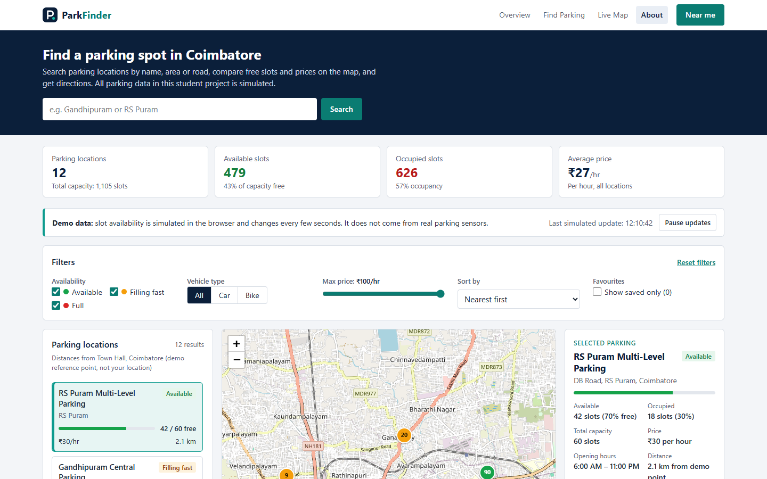
Figure 6.1: ParkFinder landing page on a desktop screen (1440 × 900 px)
Figure 6.1 shows what a user sees on opening the page. The navigation bar at the top holds the section links and the Near me button. Below it, the navy hero contains the heading, a description that mentions the simulated data, and the search bar. The four statistic cards show 12 locations with a total capacity of 1,105 slots, the available and occupied slots with their percentages, and the average price of ₹27 per hour. The demo-data notice sits directly above the filter bar and shows the time of the last simulated update. At the bottom, the parking list, the map and the selected-parking panel begin. RS Puram Multi-Level Parking is selected by default, and its card is highlighted in teal.
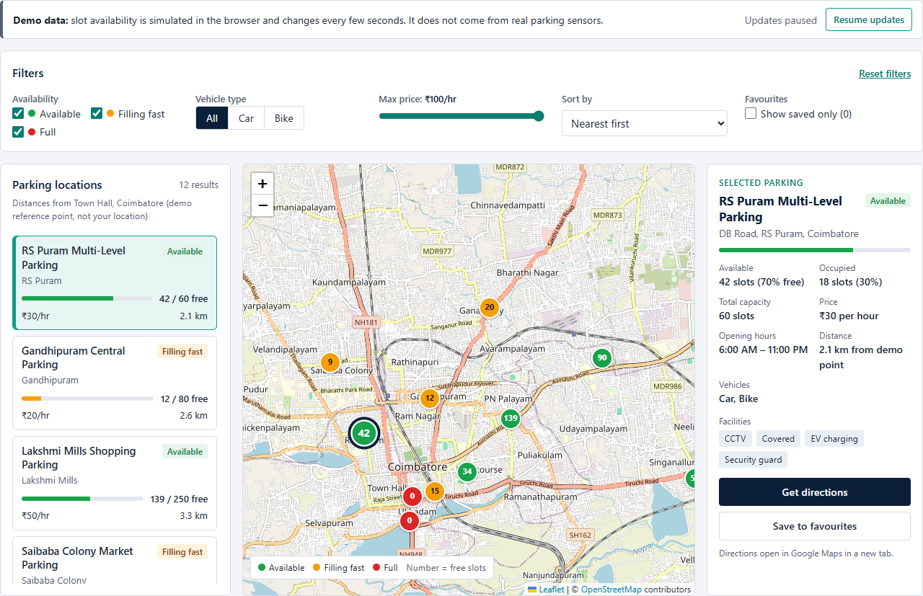
Figure 6.2: Dashboard with filters, parking list, map and selected-parking panel
Figure 6.2 shows the full dashboard. The three availability states are visible together: RS Puram and Lakshmi Mills are Available (green), Gandhipuram Central and Saibaba Colony are Filling fast (orange), and two red markers labelled 0 near Town Hall and Ukkadam are Full. Each marker displays its number of free slots. The selected location (42 free) is enlarged and has a navy ring. The details panel lists the available and occupied slots with percentages, capacity, price, opening hours, distance from the demo point, accepted vehicles and facilities, with the Get directions and Save to favourites buttons below them.

6.2 Search Functionality
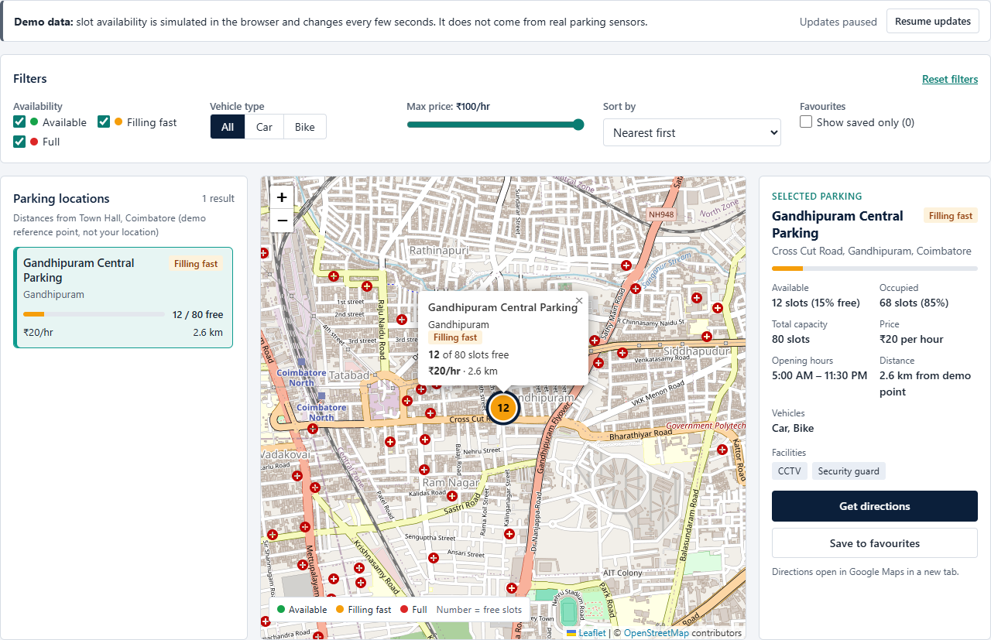
Figure 6.3: Result of searching for “Gandhipuram”
In Figure 6.3, “Gandhipuram” has been typed into the search box. The result count shows 1 result, and the list contains only Gandhipuram Central Parking. The map hides all other markers, centres on the matching location and opens its popup (12 of 80 slots free, ₹20/hr, 2.6 km). The details panel has switched to the same location. This is the result of filterParkingSpots(), getSyncedSelectionId() and focusMapOnSpot() working together (Sections 5.6 and 5.10).

6.3 Availability and Vehicle-Type Filters
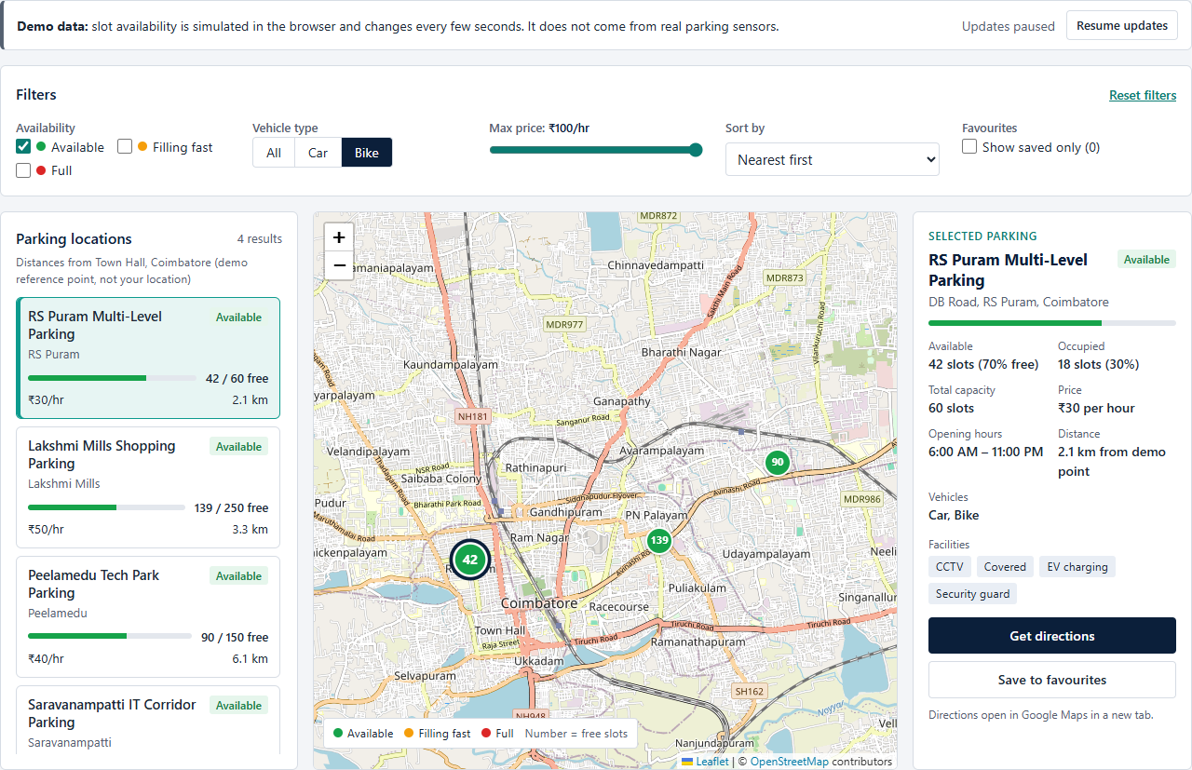
Figure 6.4: Filters set to Available only and vehicle type Bike
Figure 6.4 shows two filters used together. Only the Available checkbox is ticked and Bike is selected in the vehicle control. Four locations satisfy both conditions: RS Puram, Lakshmi Mills, Peelamedu Tech Park and Saravanampatti IT Corridor. The map shows only their four green markers. Locations that accept bikes but are Filling fast or Full, such as Gandhipuram Central and Town Hall Street, have been removed, as have car-only locations such as Race Course.

6.4 Near Me Functionality
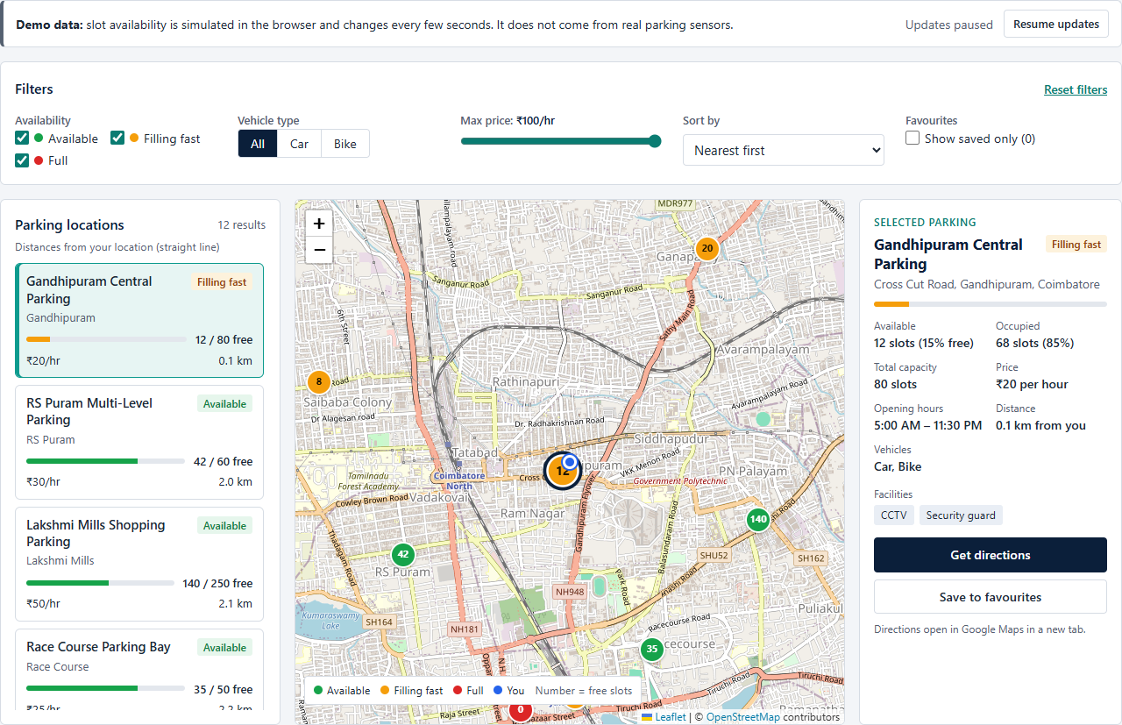
Figure 6.5: List and map after Near me with location permission granted
Figure 6.5 shows the page after Near me has been used and location access has been allowed. For this screenshot the browser was given a test position near Gandhipuram. The note above the list now reads “Distances from your location (straight line)”, the list is sorted nearest first, and the nearest location, Gandhipuram Central Parking at 0.1 km, has been selected. The blue “You” marker appears on the map next to it, and the legend has gained a “You” entry. If permission is refused, the page instead shows a message and keeps measuring from the grey demo reference point (Section 5.13).

6.5 Favourite Parking Locations
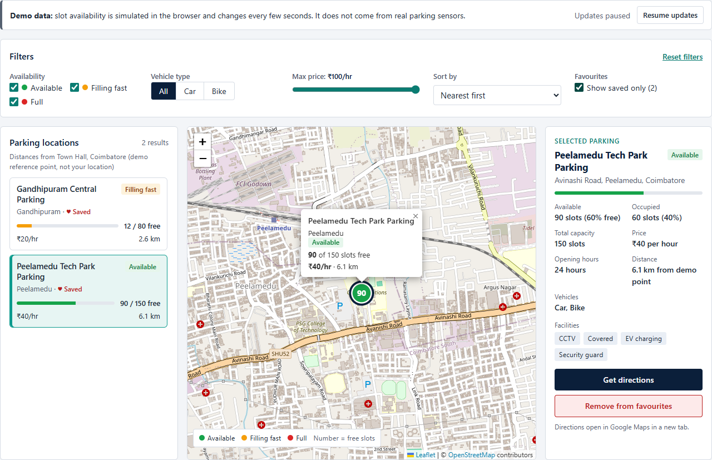
Figure 6.6: Two saved locations shown with “Show saved only”
In Figure 6.6, two locations have been saved as favourites. Their cards show “♥ Saved” next to the area name. The filter label reads “Show saved only (2)”, and with the box ticked, the list contains only the two saved locations. Because the selected location (Peelamedu Tech Park) is already a favourite, its button reads Remove from favourites. These ids are kept in LocalStorage, so the same two locations are still saved after the page is refreshed.

6.6 Interactive Map Markers and Popup
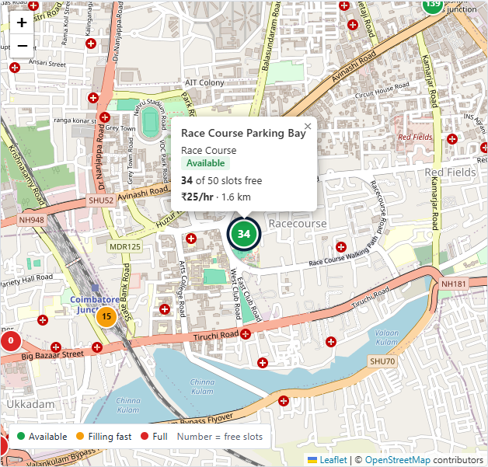
Figure 6.7: Popup of the Race Course Parking Bay marker
Figure 6.7 is a close view of the map after clicking the Race Course marker. The popup created by createPopupHTML() shows the name, the area, the status badge, the free slots (34 of 50), the price and the distance. Other markers are visible around it: an orange marker showing 15 and a red marker showing 0 at the left edge. The legend at the bottom explains the colours and states that the number is the number of free slots. The zoom buttons and the OpenStreetMap attribution are provided by Leaflet.

6.7 Empty Search Results
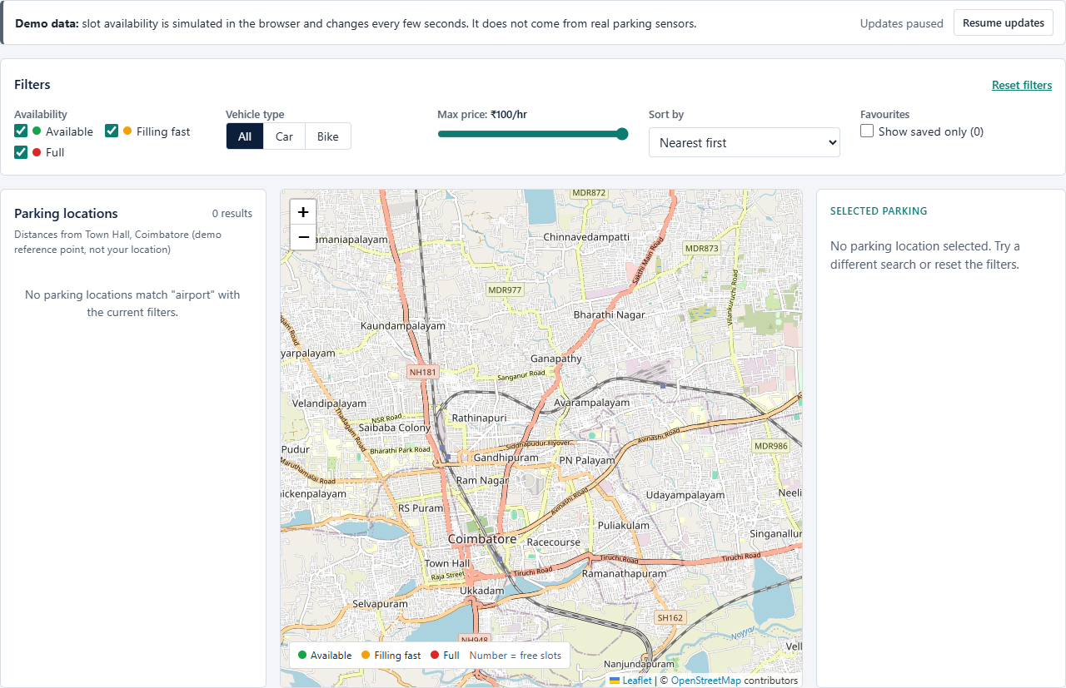
Figure 6.8: Empty state after searching for “airport”
Figure 6.8 shows what happens when nothing matches. The search for “airport” returns 0 results. The list explains this using the user’s own search text, the details panel shows its empty-state message, and no markers are drawn on the map. The user can correct the search or press Reset filters (Section 5.19).

6.8 Responsive Interface on Tablet and Mobile
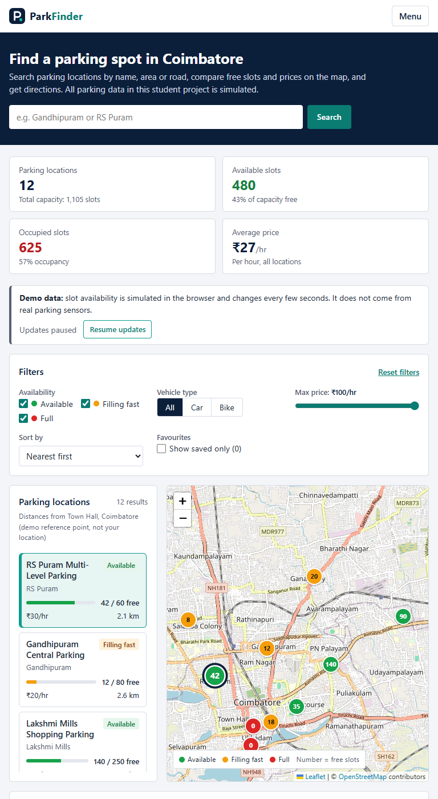
Figure 6.9: Tablet layout at 768 px width (upper part of the page)
At 768 px (Figure 6.9), the 959 px breakpoint is active. The navigation links are replaced by a Menu button, the statistics form a 2 × 2 grid, the filter groups wrap onto two rows, and the list and the map share the width while the details panel continues below them.
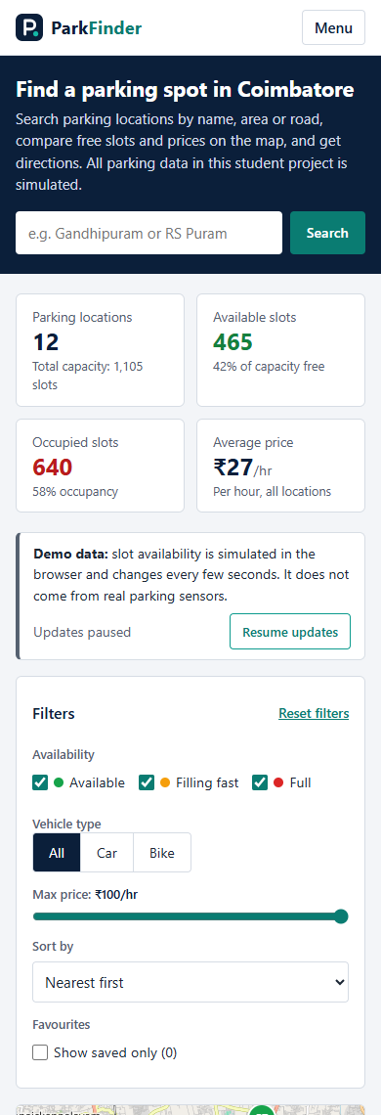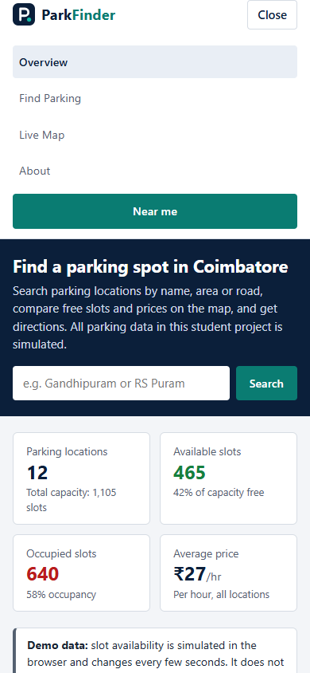
Figure 6.10: Mobile layout at 390 px: page view (left) and with the menu open (right)
On a 390 px phone (Figure 6.10), the 767 px breakpoint turns the dashboard into a single column. The filters are stacked, and the map, the details panel and the list follow in that order further down the page. The right-hand image shows the menu opened with the Menu button: the links and the Near me button appear inside the header and push the hero down rather than covering it. The button now reads Close, and pressing it, choosing a link or pressing Esc closes the menu again.

APPENDIX A: COMPLETE SOURCE OF index.html
Listing A.1: Complete HTML file (index.html, lines 1–326)
<!DOCTYPE html>
<html lang="en">
<head>
<!-- ===== Basic page settings ===== -->
<meta charset="UTF-8">
<meta name="viewport" content="width=device-width, initial-scale=1.0">
<meta name="description" content="ParkFinder - a student project for finding parking in Coimbatore on an interactive map. Parking data is simulated.">
<title>ParkFinder | Smart City Parking Finder</title>
<link rel="icon" type="image/svg+xml" href="assets/icons/logo.svg">

<!-- Leaflet stylesheet from Leaflet's official CDN (unpkg).
Needed so map tiles, markers, popups and zoom buttons display correctly. -->
<link rel="stylesheet"
href="https://unpkg.com/leaflet@1.9.4/dist/leaflet.css"
integrity="sha256-p4NxAoJBhIIN+hmNHrzRCf9tD/miZyoHS5obTRR9BMY="
crossorigin="">

<!-- Our stylesheet. Loaded last so it can override Leaflet's styles. -->
<link rel="stylesheet" href="css/style.css">
</head>
<body>

<!-- =====================================================
1. NAVIGATION BAR
On small screens the links are hidden behind the "Menu"
button. When opened, the menu is part of the header and
pushes the page down (it does not cover the content).
===================================================== -->
<header class="navbar">
<nav class="container navbar-inner" aria-label="Main navigation">

<a href="#top" class="logo">
<img src="assets/icons/logo.svg" alt="" class="logo-mark" width="28" height="28">
<span class="logo-text">Park<span class="logo-accent">Finder</span></span>
</a>

<button class="nav-toggle" id="nav-toggle" type="button"
aria-expanded="false" aria-controls="nav-menu">
Menu
</button>

<div class="nav-menu" id="nav-menu">
<ul class="nav-links">
<li><a href="#overview" class="nav-link">Overview</a></li>
<li><a href="#locations" class="nav-link">Find Parking</a></li>
<li><a href="#map-area" class="nav-link">Live Map</a></li>
<li><a href="#about" class="nav-link">About</a></li>
</ul>
<!-- Asks for the user's location only when clicked (never on page load) -->
<button type="button" class="btn btn-accent" id="locate-btn">
<span id="locate-label">Near me</span>
</button>
</div>
</nav>
</header>

<main id="top">

<!-- =====================================================
2. HERO: heading, short description, search
===================================================== -->
<section class="hero" aria-labelledby="hero-title">
<div class="container">
<h1 class="hero-title" id="hero-title">Find a parking spot in Coimbatore</h1>
<p class="hero-text">
Search parking locations by name, area or road, compare free slots and prices
on the map, and get directions. All parking data in this student project is simulated.
</p>

<form class="search-bar" id="search-form" role="search">
<label for="search-input" class="visually-hidden">Search parking by name, area or road</label>
<input type="search" id="search-input" class="search-input"
placeholder="e.g. Gandhipuram or RS Puram" autocomplete="off">
<button type="submit" class="btn btn-accent">Search</button>
</form>
</div>
</section>

<!-- =====================================================
3. STATISTICS
The "–" values are placeholders. script.js calculates
the numbers from PARKING_SPOTS (data.js) and updates
them after every simulated availability change.
===================================================== -->
<section class="stats container" id="overview" aria-label="Parking overview">
<div class="stat">
<p class="stat-label">Parking locations</p>
<p class="stat-value" id="stat-total">&ndash;</p>
<p class="stat-note" id="stat-capacity-note">Total capacity</p>
</div>
<div class="stat">
<p class="stat-label">Available slots</p>
<p class="stat-value stat-available" id="stat-available">&ndash;</p>
<p class="stat-note" id="stat-available-note">Free now</p>
</div>
<div class="stat">
<p class="stat-label">Occupied slots</p>
<p class="stat-value stat-occupied" id="stat-occupied">&ndash;</p>
<p class="stat-note" id="stat-occupied-note">Occupancy</p>
</div>
<div class="stat">
<p class="stat-label">Average price</p>
<p class="stat-value" id="stat-price">&ndash;</p>
<p class="stat-note">Per hour, all locations</p>
</div>
</section>

<!-- =====================================================
4. FIND PARKING: demo notice, filters, list, map, details
===================================================== -->
<section class="dashboard container" id="locations" aria-label="Find parking">

<!-- Demo notice: the availability numbers are simulated -->
<div class="demo-bar" role="note">
<p class="demo-bar-text">
<strong>Demo data:</strong> slot availability is simulated in the browser and changes every few seconds.
It does not come from real parking sensors.
</p>
<div class="demo-bar-actions">
<span class="demo-bar-time" id="sim-last-update">Waiting for first update&hellip;</span>
<button type="button" class="btn btn-outline btn-sm" id="sim-toggle">Pause updates</button>
</div>
</div>

<!-- ----- Filters ----- -->
<section class="panel filters" aria-labelledby="filters-title">
<div class="panel-header">
<h2 class="panel-title" id="filters-title">Filters</h2>
<button type="button" class="link-btn" id="reset-filters">Reset filters</button>
</div>

<form class="filter-form" id="filter-form">
<fieldset class="filter-group">
<legend class="filter-label">Availability</legend>
<div class="check-row">
<label class="check">
<input type="checkbox" name="status" value="available" checked>
<span class="dot dot-available" aria-hidden="true"></span> Available
</label>
<label class="check">
<input type="checkbox" name="status" value="limited" checked>
<span class="dot dot-limited" aria-hidden="true"></span> Filling fast
</label>
<label class="check">
<input type="checkbox" name="status" value="full" checked>
<span class="dot dot-full" aria-hidden="true"></span> Full
</label>
</div>
</fieldset>

<fieldset class="filter-group">
<legend class="filter-label">Vehicle type</legend>
<div class="segmented">
<label><input type="radio" name="vehicle" value="all" checked><span>All</span></label>
<label><input type="radio" name="vehicle" value="car"><span>Car</span></label>
<label><input type="radio" name="vehicle" value="bike"><span>Bike</span></label>
</div>
</fieldset>

<div class="filter-group">
<label for="price-range" class="filter-label">
Max price: <output id="price-output" for="price-range">&#8377;100/hr</output>
</label>
<input type="range" id="price-range" name="maxPrice" min="0" max="100" step="5" value="100">
</div>

<div class="filter-group">
<label for="sort-select" class="filter-label">Sort by</label>
<select id="sort-select" name="sort" class="select">
<option value="distance">Nearest first</option>
<option value="price">Cheapest first</option>
<option value="available">Most available first</option>
</select>
</div>

<fieldset class="filter-group">
<legend class="filter-label">Favourites</legend>
<label class="check">
<input type="checkbox" name="savedOnly" id="saved-only">
<span>Show saved only (<span id="saved-count">0</span>)</span>
</label>
</fieldset>
</form>
</section>

<!-- ----- List | Map | Details ----- -->
<div class="dashboard-grid">

<!-- Parking list: cards are built by script.js from data.js -->
<section class="panel listing" aria-labelledby="listing-title">
<div class="panel-header">
<h2 class="panel-title" id="listing-title">Parking locations</h2>
<!-- aria-live: screen readers announce the new count when it changes -->
<span class="result-count" id="result-count" aria-live="polite">&ndash; results</span>
</div>
<p class="list-note" id="distance-basis">Distances from Town Hall, Coimbatore (demo reference point)</p>
<ul class="parking-list" id="parking-list">
<li class="list-message">Loading parking locations&hellip;</li>
</ul>
</section>

<!-- Map: map.js tells Leaflet to draw inside #map -->
<section class="panel map-card" id="map-area" aria-label="Parking map">
<div id="map" class="map">
<p class="map-placeholder">Loading map&hellip;</p>
</div>

<!-- Loading / error message for map tiles (controlled by map.js) -->
<p class="map-status" id="map-status" role="status" hidden></p>

<div class="map-legend" aria-label="Map legend">
<span><span class="dot dot-available"></span> Available</span>
<span><span class="dot dot-limited"></span> Filling fast</span>
<span><span class="dot dot-full"></span> Full</span>
<span id="legend-user" hidden><span class="dot dot-user" id="legend-user-dot"></span> <span id="legend-user-label">You</span></span>
<span class="legend-hint">Number = free slots</span>
</div>
</section>

<!-- Selected parking details (filled by renderInfoPanel in script.js) -->
<aside class="panel info-panel" id="info-panel" aria-labelledby="info-title">
<p class="info-eyebrow">Selected parking</p>

<p class="info-empty" id="info-empty" hidden>
No parking location selected. Try a different search or reset the filters.
</p>

<div id="info-content">
<div class="info-heading">
<h2 class="info-title" id="info-title">&ndash;</h2>
<span class="badge" id="info-badge">&ndash;</span>
</div>
<p class="info-address" id="info-address"></p>

<div class="occupancy" id="info-occupancy" style="--fill: 0%">
<div class="occupancy-bar"><span></span></div>
</div>

<!-- <dl> = description list: pairs of a term (dt) and its value (dd) -->
<dl class="info-details">
<div><dt>Available</dt><dd id="info-available">&ndash;</dd></div>
<div><dt>Occupied</dt><dd id="info-occupied">&ndash;</dd></div>
<div><dt>Total capacity</dt><dd id="info-capacity">&ndash;</dd></div>
<div><dt>Price</dt><dd id="info-price">&ndash;</dd></div>
<div><dt>Opening hours</dt><dd id="info-hours">&ndash;</dd></div>
<div><dt>Distance</dt><dd id="info-distance">&ndash;</dd></div>
<div><dt>Vehicles</dt><dd id="info-vehicles">&ndash;</dd></div>
</dl>

<p class="info-label">Facilities</p>
<ul class="tag-list" id="info-facilities" aria-label="Facilities"></ul>

<div class="info-actions">
<!-- A link styled as a button. script.js sets its href to a Google Maps
directions URL. rel="noopener noreferrer": the new tab can't control this page -->
<a class="btn btn-primary" id="directions-link" href="#" target="_blank" rel="noopener noreferrer">
Get directions
</a>
<!-- aria-pressed tells screen readers whether this spot is saved -->
<button type="button" class="btn btn-outline save-btn" id="save-btn" aria-pressed="false">
<span id="save-label">Save to favourites</span>
</button>
</div>
<p class="info-note">Directions open in Google Maps in a new tab.</p>
</div>
</aside>

</div>
</section>
</main>

<!-- =====================================================
5. FOOTER / ABOUT
===================================================== -->
<footer class="footer" id="about">
<div class="container footer-grid">
<div>
<h2 class="footer-heading">About ParkFinder</h2>
<p>
ParkFinder is a Web Technology micro-project. It shows 12 example parking locations in
Coimbatore with search, filters, an interactive map, "Near me" and favourites.
The parking records and their availability are simulated for demonstration and are
not real parking information.
</p>
</div>
<div>
<h2 class="footer-heading">Team</h2>
<ul class="footer-list">
<li>DANIEL S (URK26CS1083)</li>
<li>GLADYS JOYSELIN W (URK26CS1063)</li>
<li>MONICA S (URK26CS1068)</li>
<li>SARAVNA M (URK26CS1090)</li>
</ul>
</div>
<div>
<h2 class="footer-heading">Built with</h2>
<ul class="footer-list">
<li>HTML5, CSS3, JavaScript (ES6)</li>
<li><a href="https://leafletjs.com" target="_blank" rel="noopener noreferrer">Leaflet.js</a> and
<a href="https://www.openstreetmap.org" target="_blank" rel="noopener noreferrer">OpenStreetMap</a></li>
<li>Browser LocalStorage (favourites)</li>
</ul>
</div>
</div>
<div class="container footer-bottom">
<p>&copy; 2026 ParkFinder student project.</p>
<p>Map data &copy; <a href="https://www.openstreetmap.org/copyright" target="_blank" rel="noopener noreferrer">OpenStreetMap</a> contributors</p>
</div>
</footer>

<!-- Short feedback messages ("Saved", "Location denied", ...).
role="status" + aria-live: screen readers read the message aloud. -->
<div class="toast" id="toast" role="status" aria-live="polite" hidden></div>

<!-- =====================================================
SCRIPTS - order matters: later files use earlier ones.
"defer" = run after the HTML has finished loading.
===================================================== -->
<script src="https://unpkg.com/leaflet@1.9.4/dist/leaflet.js"
integrity="sha256-20nQCchB9co0qIjJZRGuk2/Z9VM+kNiyxNV1lvTlZBo="
crossorigin="" defer></script>
<script src="js/data.js" defer></script>
<script src="js/map.js" defer></script>
<script src="js/script.js" defer></script>
</body>
</html>

APPENDIX B: COMPLETE SOURCE OF js/data.js
Listing B.1: Complete dataset file (js/data.js, lines 1–240)
/* =========================================================
data.js - App settings and parking data
---------------------------------------------------------
Job: hold DATA only. No calculations, no page code.
script.js and map.js read from here.
========================================================= */

// General settings for the app.
// "const" means the variable can't be pointed at something else later.
const APP_CONFIG = {
appName: "ParkFinder",
city: "Coimbatore",
currencySymbol: "₹",

// Distances are calculated from the parking coordinates (Haversine formula).
// Until the user shares their location with "Near me", they are measured
// from this DEMO reference point in the city centre - not the user's location.
referencePoint: {
name: "Town Hall, Coimbatore",
latitude: 10.9946,
longitude: 76.9614,
},

// Map settings used by map.js
map: {
// [latitude, longitude] of central Coimbatore, near the middle of our 12 spots
center: [11.022, 76.975],
zoom: 13, // starting zoom on large screens (bigger number = closer)
mobileZoom: 12, // starting zoom on phones, so more spots fit on screen
focusZoom: 15, // zoom used when the user selects a parking spot
userZoom: 14, // zoom used to show the user's location after "Near me"
},

// Simulated availability demo (script.js, section 8)
simulation: {
intervalMs: 5000, // update every 5 seconds
spotsPerUpdate: 3, // how many parking spots change each time
maxChange: 3, // each change is between -3 and +3 slots
},

// Name of the LocalStorage entry that keeps the saved (favourite) spot ids
favouritesStorageKey: "parkfinder-favourites",
};

/* ---------------------------------------------------------
PARKING DATASET (SIMULATED DEMO DATA)
---------------------------------------------------------
IMPORTANT: Everything below is made up for this student
project. The names, slot counts, prices, hours and facilities are
NOT real parking inventory and have not been verified.
Area and road names are real Coimbatore places, and the
latitude/longitude values are approximate points in those
areas, so the markers will land in sensible places on the map.
Distances are NOT stored here: script.js calculates them from
latitude/longitude, so they always agree with the map.

Field guide (every record has the same fields):
id unique number used to identify the spot
name display name of the parking location
area neighbourhood of Coimbatore
address street / road (the area is stored separately)
availableSlots free slots right now (simulated; script.js changes
this number every few seconds in the demo)
totalSlots total capacity
price cost per hour, in rupees (₹)
latitude north–south map position
longitude east–west map position
vehicleTypes vehicles accepted: "car" and/or "bike"
openingHours opening hours (display text)
facilities list of facilities, shown as tags
--------------------------------------------------------- */
const PARKING_SPOTS = [
{
id: 1,
name: "RS Puram Multi-Level Parking",
area: "RS Puram",
address: "DB Road",
availableSlots: 42,
totalSlots: 60,
price: 30,
latitude: 11.0096,
longitude: 76.9502,
vehicleTypes: ["car", "bike"],
openingHours: "6:00 AM – 11:00 PM",
facilities: ["CCTV", "Covered", "EV charging", "Security guard"],
},
{
id: 2,
name: "Gandhipuram Central Parking",
area: "Gandhipuram",
address: "Cross Cut Road",
availableSlots: 12,
totalSlots: 80,
price: 20,
latitude: 11.0177,
longitude: 76.9658,
vehicleTypes: ["car", "bike"],
openingHours: "5:00 AM – 11:30 PM",
facilities: ["CCTV", "Security guard"],
},
{
id: 3,
name: "Town Hall Street Parking",
area: "Town Hall",
address: "Big Bazaar Street",
availableSlots: 0,
totalSlots: 40,
price: 15,
latitude: 10.9947,
longitude: 76.9617,
vehicleTypes: ["bike"],
openingHours: "8:00 AM – 9:00 PM",
facilities: ["Attendant"],
},
{
id: 4,
name: "Race Course Parking Bay",
area: "Race Course",
address: "West Club Road",
availableSlots: 35,
totalSlots: 50,
price: 25,
latitude: 11.0005,
longitude: 76.9746,
vehicleTypes: ["car"],
openingHours: "6:00 AM – 10:00 PM",
facilities: ["CCTV", "Shaded"],
},
{
id: 5,
name: "Peelamedu Tech Park Parking",
area: "Peelamedu",
address: "Avinashi Road",
availableSlots: 90,
totalSlots: 150,
price: 40,
latitude: 11.0272,
longitude: 77.0068,
vehicleTypes: ["car", "bike"],
openingHours: "24 hours",
facilities: ["CCTV", "Covered", "EV charging", "Security guard"],
},
{
id: 6,
name: "Saibaba Colony Market Parking",
area: "Saibaba Colony",
address: "NSR Road",
availableSlots: 8,
totalSlots: 45,
price: 20,
latitude: 11.0262,
longitude: 76.9420,
vehicleTypes: ["bike"],
openingHours: "7:00 AM – 10:00 PM",
facilities: ["Attendant"],
},
{
id: 7,
name: "Ukkadam Bus Terminus Parking",
area: "Ukkadam",
address: "Palakkad Main Road",
availableSlots: 0,
totalSlots: 70,
price: 15,
latitude: 10.9890,
longitude: 76.9610,
vehicleTypes: ["car", "bike"],
openingHours: "24 hours",
facilities: ["CCTV", "Security guard"],
},
{
id: 8,
name: "Singanallur Lake View Parking",
area: "Singanallur",
address: "Trichy Road",
availableSlots: 55,
totalSlots: 90,
price: 20,
latitude: 10.9990,
longitude: 77.0290,
vehicleTypes: ["car"],
openingHours: "6:00 AM – 9:00 PM",
facilities: ["Shaded", "Washroom"],
},
{
id: 9,
name: "Railway Junction Parking",
area: "Gopalapuram",
address: "State Bank Road",
availableSlots: 18,
totalSlots: 120,
price: 30,
latitude: 10.9960,
longitude: 76.9670,
vehicleTypes: ["car", "bike"],
openingHours: "24 hours",
facilities: ["CCTV", "Covered", "Security guard"],
},
{
id: 10,
name: "Lakshmi Mills Shopping Parking",
area: "Lakshmi Mills",
address: "Avinashi Road",
availableSlots: 140,
totalSlots: 250,
price: 50,
latitude: 11.0130,
longitude: 76.9850,
vehicleTypes: ["car", "bike"],
openingHours: "9:00 AM – 11:00 PM",
facilities: ["CCTV", "Covered", "EV charging", "Valet"],
},
{
id: 11,
name: "Saravanampatti IT Corridor Parking",
area: "Saravanampatti",
address: "Sathy Road",
availableSlots: 60,
totalSlots: 100,
price: 35,
latitude: 11.0780,
longitude: 77.0000,
vehicleTypes: ["car", "bike"],
openingHours: "24 hours",
facilities: ["CCTV", "Covered", "EV charging"],
},
{
id: 12,
name: "Ganapathy Market Parking",
area: "Ganapathy",
address: "Sathy Road",
availableSlots: 20, // exactly 40% free -> should show "Filling fast"
totalSlots: 50,
price: 20,
latitude: 11.0390,
longitude: 76.9800,
vehicleTypes: ["bike"],
openingHours: "6:00 AM – 10:00 PM",
facilities: ["Attendant"],
},
The complete stylesheet (css/style.css) and the two remaining script files (js/map.js and js/script.js) are included in the project folder submitted with this report. The sections of them discussed above are reproduced in Sections 4 and 5.

