# Chapter One

# Introduction

Our project tittle is Automating the current system of Woldia university Student Lounge Management system. This project is mainly designed for Woldia university student lounge system.as we know an old information management system is so bored and resource intensive. Most people in the past store data’s in the form of paper and card. This method takes so many things human power, resources, also we can’t retrieve the data fast when we want and other things.so to solve those problems we have to design database.

The project can help the university and Directorate office so that the manual data handling can turn to computerized data handling, therefore there will not be a loss of data and consistency .Then the computerized System can help the officers to accesses the data easily and reduce time.

# Background

The Woldia university student lounge established around 2004 E.c. At that time the lounge were serving for small number of students and it had small number of employee. And also it had a small number suppliers since it was starting the capital, but now these lounge grows in terms of number of employee, number of customers, capital and other characteristics.

# Statement of the problem

## 3.1 Problem of the existing system

* The data is organized manually so it produces the problem of disappearing or loses of data’s about material.
* The manual system takes long period of time to trace the data of the employee, foods, and, customers.
* They could be misunderstanding due to carelessness in documentation unclear hand writing.
* It is hard to move the file from place to place.
* It is hard to know whether the Machines is failed to work or not.
* There may occur data redundancy
* The systems do not allow to access for illiterate employee, customer and manager.
* Also difficult to use for beginners.
* Difficult for troubleshooting when problem is occur.
* Difficult to trouble shoot when the error is occurred simply it needs the skilled person to trouble shoot.
* Difficulties to cross check, to order, the availability of the product in the system.

# Team composition

In our project we use ***mixed*** team composition

|  |
| --- |
| **General Manger**  Daniel Tefera |

|  |
| --- |
| **Data gathering Manager**  Sindew Yimer |

|  |
| --- |
| **Code developers Manger**  Daniel Tefera |

|  |  |  |
| --- | --- | --- |
| Yimenu Fente |  | Desale Shegaw |

|  |  |  |
| --- | --- | --- |
| Getahun Mebre |  | Gedefaw Aschale |

# Objective of the Project

## 5.1 General objectives

The main aim of the system is to facilitate and automate the lounge management system Register main and redundant activities in order to improve efficiency and enforce university’s constraints.

## 5.2 Specific objective

* Decreasing Human resource(employees)
* Increasing Efficiency and effectiveness
* Decreasing cost
* Decreasing redundancy

# Feasibility Study

After finishing the project will be feasible on

* Economically
* Operationally
* Technical

## 6.1 Technical Feasibility

Our project is technically feasible when the availability, reliability of network, hard ware and software is functional.

## 6.2 Economic Feasibility

Economically feasible when the project after developed it has the following advantage on economically

* The lounge management system must be cost saving
* Decrease investment for payment of worker
* Increase profit

Generally economic feasibility is relatively comparisons are between estimated cost and gain.

## 6.3 Operational Feasibility

* The system is performed all tasks with well-organized and functional.
* All the hard ware and software component part is functional working together.

# Scope of the project

There are a number of operations performed in lounge management office, but the new lounge management system only focus on solving main problems of the processes. Therefore, the new system scope is defined for the following processes:

* Adding and modification of ‘foods, ‘lounge’, and employees information
* Protecting Invalid data entry
* Allow the employee to enter data.
* Allow the manager to generate reports.
* Allow the customer to record data’s what they eat per day especially for non-cafe students.
* Control unnecessary deletion of data.
* The system support user account management.
* The system prevent from unnecessary deletion of data from the system.
* The user can search from the system by their unique primary key.

# Rational of the project

Changing the current manual registration system by modern (computerized) registration systems to level the lounge in the modern stage (DBM).

## 8.1Significant of the project

* Decreasing bureaucracy
* Decreasing data redundancy
* Decreasing of time to find data
* Replace the old manual lounge system by a new database system
* Give special works for customer, employees also for the manager.
* To decrease the overall resource that is needed by customer, manager and also employees. Like time, money ….

## 8.2 Business benefit

* Easy to manage
* Easy to access any information about the employee, Non Café Customers, …
* User friendly
* Automating the system(WDULaunch system)
* Providing easy communication between customer and employee also between employee and supplier.
* Generating reports for the authorized user when needed.

#### 8.2.1 Tangible benefit

* Easy to communicate with the system
* Store large amount of data

#### 8.2.2 Intangible benefit

* High Speed
* Less time

# Beneficiaries of the project

From our project there are many beneficiaries these are:

1. The system employee will never consume his time by searching data.
2. The university will never consume more man power much paper to store data
3. Control unnecessary deletion of data.
4. The system support user account management.
5. The system prevent from unnecessary deletion of data from the system.
6. The user can search from the system by their unique primary key.

# Methodology

## Data gathering method

* Direct observation
* Interview
* Existing document review

# Development tools

## 11.1 Case Tools

* + MySQL server 5.5
  + Xamp
  + Net Beans IDE(6.9 up to version 8.2)
  + Sublime text Editor
  + Notepad**++**
  1. Programming Tools
* Html
* CSS For Client Side/front end
* Java Script
* PHP
* Sql For Server side/back end

# Testing Procedure

In this portion we have test our programs in several types or procedure s of testing this tests are

1. **Unit testing**- We choose this type of testing to maintain the problems step by step .for example we test our system plan after we finished each chapter.
2. **Integration testing**-in this type of test we have test our project in each step contacting with the directorate officers by asking and checking whether they changed their requirement or not.
3. **Systems testing**-in this step we have compare the functional and non-functional requirements are fulfilled based on the directorate officer’s requirement.
4. **Acceptance testing**-in this testing will check the acceptance of our project by set up some trial time for the directorate office and customers by using ***beta testing***.

# Implementation

In this section we will discuss how our program will work and what types of software’s and programing languages. Our programs and our programing languages are divide into***Backend*** and ***Frontend*** programs

**Frontend**:-in this end we will mention programing languages which is appear in front this are:

* ***HTML5***we choose this language because of the language is more flexible , the most common , adoptable with the user and the program must work with network program.
* ***CSS***we choose this language because it mainly helps for the design part of the front end easily and efficiently.
* ***Java Script***we choose this language for form validation different pages that when the user enters wrong data.

**Backend:-**in this end we will mention the programs and programing languages which appear in back or rear side languages.

* ***MYSQL VERSION 5.5***we choose this type because most common and much known language in database management system. And we use this language for the database management system.
* ***PHP*** we choose this type for backend manipulation and the database connectivity also.

# Limitation of the project

The new lounge system will address most basic and redundant operations, but the system is limited to deal with the following processes

* It will not check employee performance
* This system doesn’t allow the manager to pay his annual tax online.
* This system does not allow the employee to receive their salary online.
* We can’t get data about the material online with internet system.

# Risk and contingency Plan

## Challenges

* Insufficiency of information
* Complex bureaucracy
* Shortage of budget
* Power fluctuation makes the plan to delay from the expected time
* Course overloading on members make the project difficult to finished with in the planed time
* Our scope and the raw data that they gave us does not feet
* NO CONNECTION – our main challenge

## Contingency or solutions

* Try to get information by observing the steps they do
* Tolerating the bureaucracy
* Try to balance the expected fund with the new one
* Try to plan appropriate method to gather and organize the plan

# Chapter two

# Description of the existing system

The existing system done manually in this case we get information very difficult to know about the activity & done by the system.

1. Players of the existing system and their function

A. ***Lounge manger***

Some of the functions of Lounge manager on the system are

* Evaluate employee of the lounge.
* Control day to day activity of the employee
* Allow the manager to register the customer information especially non cafe student customer.
* Allow the manager to register the employee’s information.
* Allow the manager to register the product information.
* Allow the manager to order the supplier.
* Allow the manager to generate reports when wants.

Generally lounge manager manages the overall activity of the lounge employee.

B. ***Cashier***

Some functions of Cashier on the system

* Allow the cashier to calculate the annual income and outcome of the lounge.
* Allow the cashier to enter data.

C. ***Customer***

***D. Employee***

***E. Supplier***

## Business rule of the existing system

Business rule means that describes the rule and regulations of the lounge management system which implies the user, employee, as well as managers of the lounge is followed to perform different tasks

Some business rules are

* gghghhjhjhjh
* hjhjhjhjhjhj

# Practice to be reserved

All most we have changed the existing system because of the existing system uses paper manually but we have reserve the two of three actors from the existing system this are:-

* The manager of the lounge
* The employee

# Proposed system

* + Organizing Easy way to search information about the material specifically
  + Organizing the data in to computer system.
  + Trace data easily, efficiently and effectively.
  + Decrease the time to manage
  + Removing data redundancy
  + Reducing data consistency

# Requirement of proposed system

Because the requirements are constant, we will implement traditional water fall process model.

Requirement Analysis

System Design

Implementation

Testing

Maintenance

### Project Timeline and Budget

#### 5.1.1 Schedule of the project

|  |  |  |  |  |
| --- | --- | --- | --- | --- |
| No | Task Name | Start | Finish | Duration |
|  |  |  |  |  |
| 1 | Preparation of proposal | 03/3/2010 | 17/2/2010 | 2w |
| 2 | Information gathering | 17/3/2010 | 30/8/2010 | .2w |
| 3 | Requirement Analysis | 01/04/2010 | 18/4/2010 | .2w |
| 4 | Design | 19/4/2010 | 08/5/2010 | 3w |
| 5 | Implementation | 08/4/2010 | 27/4/2010 | 3w |
| 6 | Testing and maintenance | 27/4/2010 | 1/05/2010 | 2w |
| 7 | Preparing for presentation | 05/5/2010 | 12/5/2010 | 1w |
| 8 | Final Proposal | 12/5/2010 | 14/5/2010 | 1w |

Table 1.Schedul

### 5.2 Necessary software development Cost in the project

The following table shows cost of soft ware

|  |  |
| --- | --- |
| ***Types of material*** | ***Price*** |
| ***SMADAV antivirus*** | ***Free cost*** |
| ***Microsoft Office*** | ***Free cost*** |
| ***My Sql*** | ***Free cost*** |
| ***Net Beans IDE*** | ***Free cost*** |
| ***Notepad++*** | ***Fee cost*** |
| ***Xamp*** | ***Free cost*** |
| ***Telephone*** | ***200*** |
| ***Stationery*** | ***256*** |
| ***Internet*** | ***0*** |
| ***Human resource*** | ***4000*** |
| ***Total*** | ***4456*** |

Table 2: Budget

# Chapter Three

# System analysis and modeling

I**n** this portion we will discuss the system front end back end program designs so we will show some steps in front end and the design it self

The first one is adding an employee account for the director manager and store manger the picture below shows this page

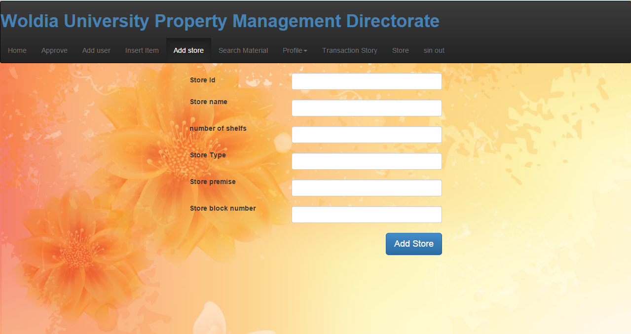

The second one is the managerial home page in this page the directorate manger can write and post a message for the department officers;-

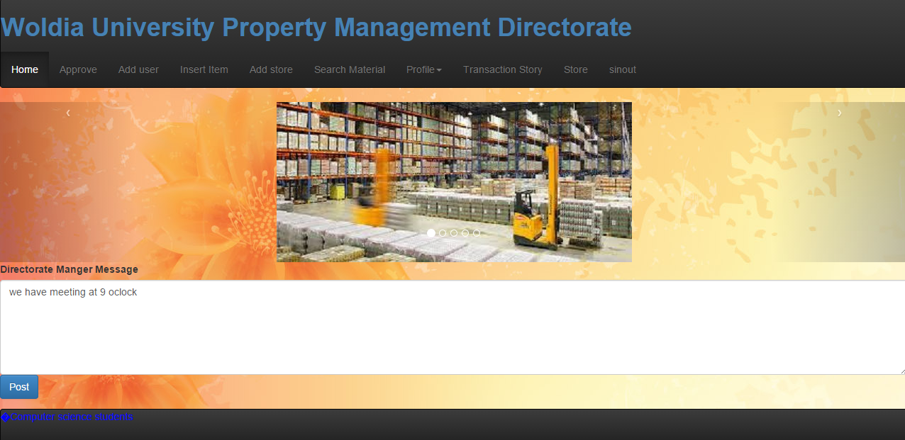

The third one is the checking of the approval of the material is permitted to the given customer id or not.

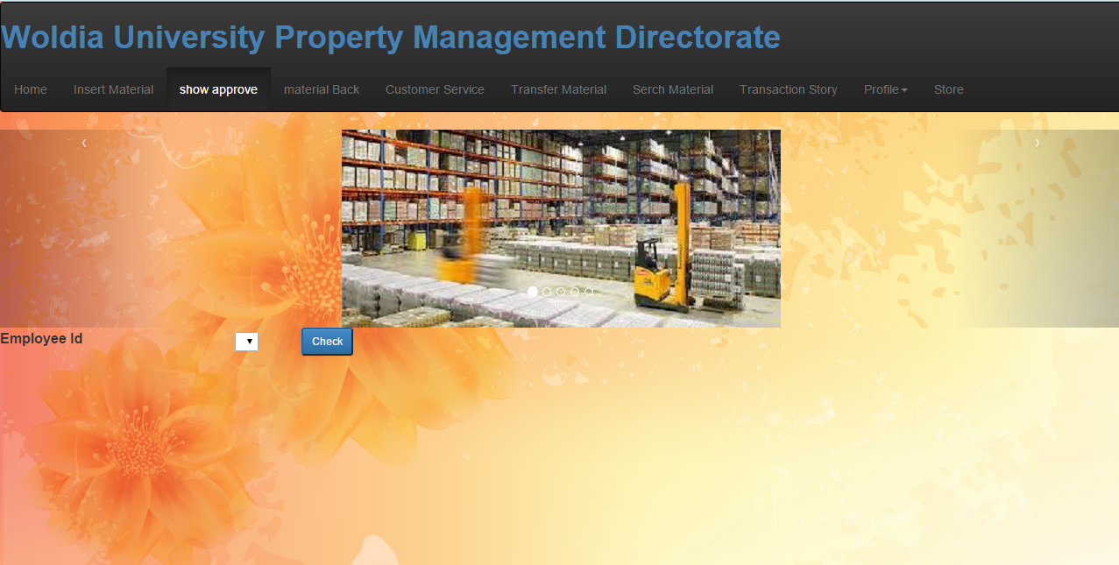

The fourth one is transferring material from one person to another one

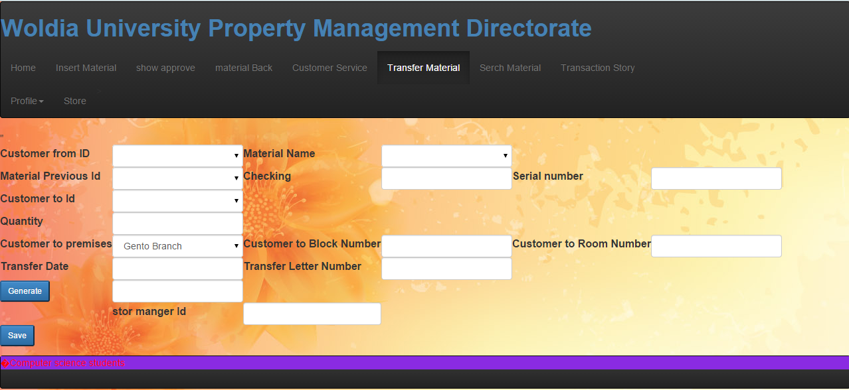

The fifth one is material back page on this page the store manger record the material which is returned from the user

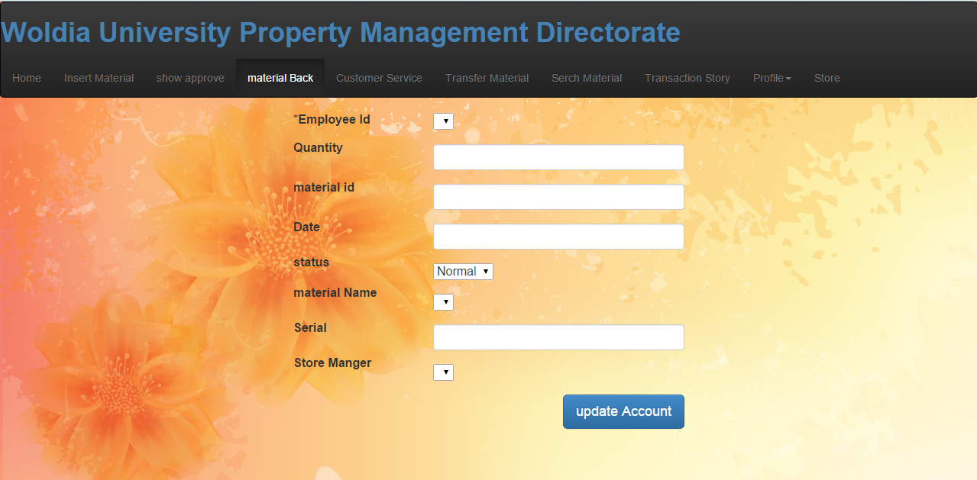

The above are some examples of front end programs and next we will mention the back end programs and designs

### Database design

Our database design has 5 Entities:

* Store table
* Material table
* Customer Service table
* Employee table
* System Employee table
* Approval table
* Transfer table
* Post
* Item
* Material Back

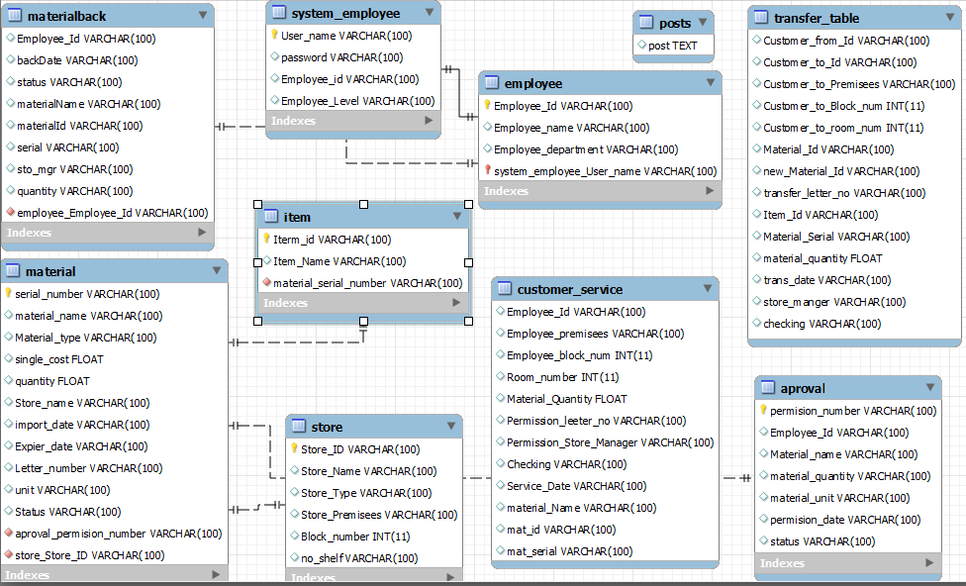

Figure 1: Database Diagram

# System requirement specification

## Business rule of the proposed system

In or project Employee are divide in to 2 levels:

* Directorate manger
* Store Manger

**Directorate manger**: - he/she give permission to the customer to get service and he also can check whether the material is in the store or not but he can’t update material or store information

**Store manager**: - he/she can give the service for the customer when he/she gets permission later from the manger and he/she also can update the information of the material with the approval of the manger.

# Requirement analysis

Requirement analysis is a process used to system analysts to analyze and identify the system problem and solution requirement private by user of the system. Requirement analysis is done in order to acquire a complete and depth knowledge of the business system.it helps to for as to simplify complex requirement into smaller units that can be clearly destined and reviewed.

* + 1. Functional Requirements

The following lists of requirements are some of the major requirements that the new system must perform in order to satisfy stakeholders’ needs.

* Store materials data
* Store transfers data
* Store Customer services
* Store directorate Employee data’s
  + 1. Non-Functional Requirements
* Speed**:** the system response the information quickly
* Error handling**:** the system easily correct the error
* Capacity: the system has high data accept capacity
* Flexibility: the system should be flexible with the users need

# Use case diagram

Use case diagram is a diagram which shows int the proposed system the system and the actores are how interact and what procedures will they follow.

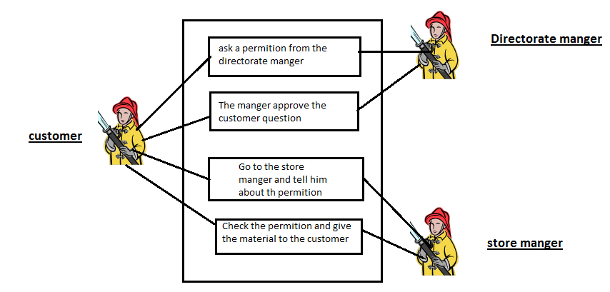

In above diagram we have the system and the actors

The actors: - are the customers or the university employee

-The directorate manger

-The store manger

So in our proposed system the customer (employee of the university) will ask a permission from the directorate manger then the directorate manger checks weather the material is in the store or not and is the material is available for the customer based on the rule of the university and the rule of the directorate office then he permit the material on the approval page and send approve message for the store manager and randomly generated number which is unique number with the attachment of the customer id department .

Then the customer goes to store manager and ask the approved material and wait until the store manager check whether the material is approved for the given customer id then record the customer identification and customer data then gives the university serial number to the material from the system then give the material.

# Summary

This system documentation is prepared for WOLDIA UNIVERSITY PROPERTY MANGMENT System. Woldia university property management system is currently using file based approach and paper based approach. The new registrar system proposed is computerized system which automates repetitive and critical jobs to facilitate work, reduce errors, and enforce constraints or rules in the registrar office.

# Recommendation

The system designed and presented in this document is more effective and efficient if the proper or good performance infrastructure is present within the organization. The system uses same rules But if it is required to combine and centralized the entire property data.