Lab #1

Operating Systems 1

**Instructions:**

|  |
| --- |
| 1. Read the problem carefully on the following page  2. Read it again  3. Figure out a rough ordering of items |
| 4. Chat with 3 or 4 classmates discuss for about 15 minutes the correct ordering of these items (include the list of people’s names you spoke to in your submission). |
| 5. Settle on a final ordering of these items for yourself |
| 6. Create a new blog by going to the website <http://www.blogger.com> and create a blog with the following naming (replacing your name with mine):    Title: DT2XX Damian Gordon Portfolio  Address: DT2XX-DamianGordon.blogspot.com  7. e-mail your blog address to Damian.Gordon@dit.ie with a subject heading of OPERATING SYSTEMS 1 LAB #1 and in the message of your e-mail please let me know your full name, your student number, the name of your programme, the programme code, the name of the module, the year you are in (first year), and your assignment website address. |

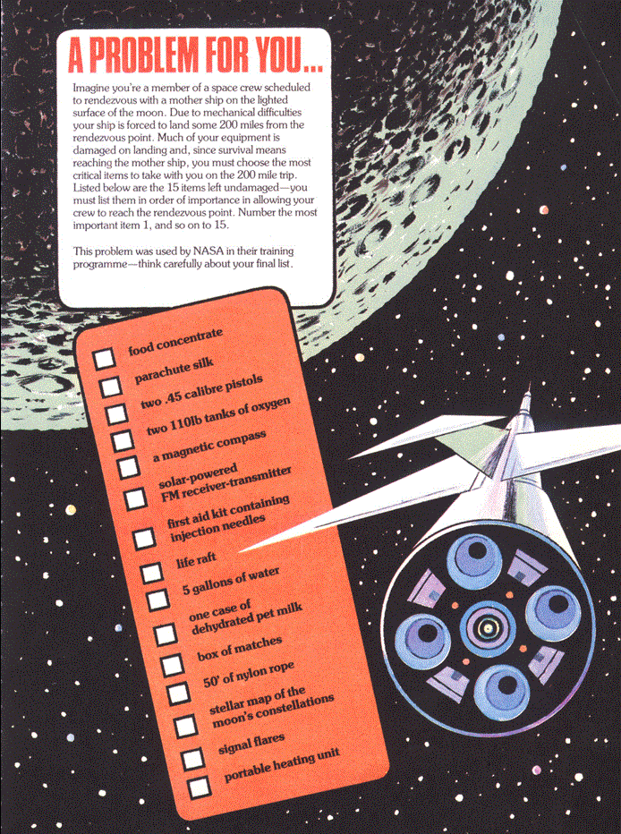

|  |
| --- |
| **Marking:** Please note, this lab is due for submission at 5pm on the 31st of January. As long as you have a ranking beside each item, and any reason you want why you've put it there for each one, you'll get full marks for this first lab.  The labs contributes to 40% of your final result in the continuous assessment for this module, so it's best to get the earlier ones done as well as you can, because as the labs continue on they will get harder, so you might as well pick up the easy marks early on. |