[**http://www.freelinuxconsole.info/**](http://www.freelinuxconsole.info/)

**Click on “*TERMINAL*”:**

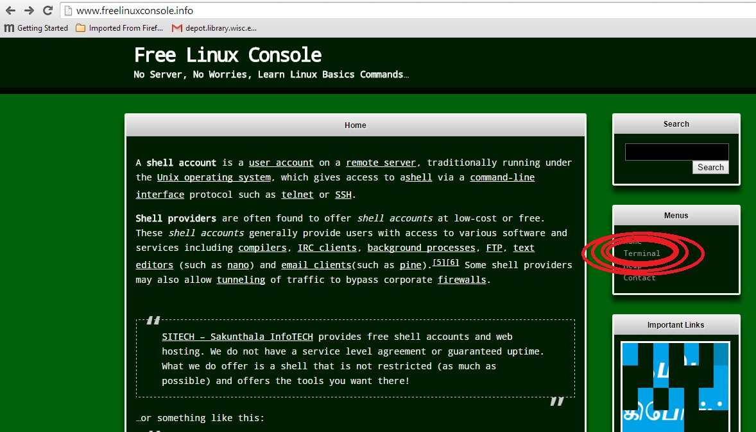

**Click on “*Click Here to Open Terminal*”**

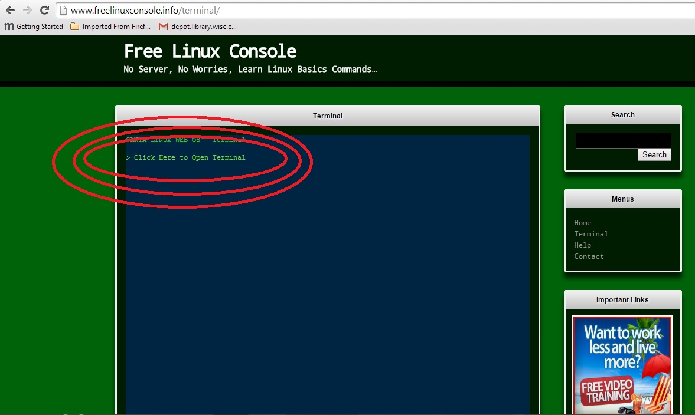

**Login as “guest”**