**Mobile Software Development Design Document**

**Name:** Daniel Tilley

**Student Number:** C14337041

**Application Name:** Time2Work

Table of Contents

Introduction 3

Topic Description 3

Requirements 4

Use Cases 4

Screen Flows 5

Class Diagram 6

Database ERD 6

# Introduction

## Topic Description

I have based my app on an idea I had about a year ago. I wanted to create a timekeeping app for people working part time that will allow users to record hours worked per month to make it easier to keep track of them. From personal experience there have been times where I have scribbled my hours on a post-it note, only to loss it when I had to hand in my hour’s report at the end of the month.

Why stop at having a simple app that only allows users to record time? Why not add some extra functionality? I plan to also add in a section that can assist the user with tax calculation as this can be confusing for a lot of people who do not know enough about the area. I want to help people understand what their limits are for tax exemption, how much they are paying for certain areas and where they can go to claim tax back if they want to.

Finally, I have considered adding in an option that will export a csv file of the hours worked for the previous / current month. This should make it easier to show a breakdown if needed to an employer. There will also be an option to display data for each month in either a list view or graph view depending on the user’s choice.

# Requirements

## Use Cases

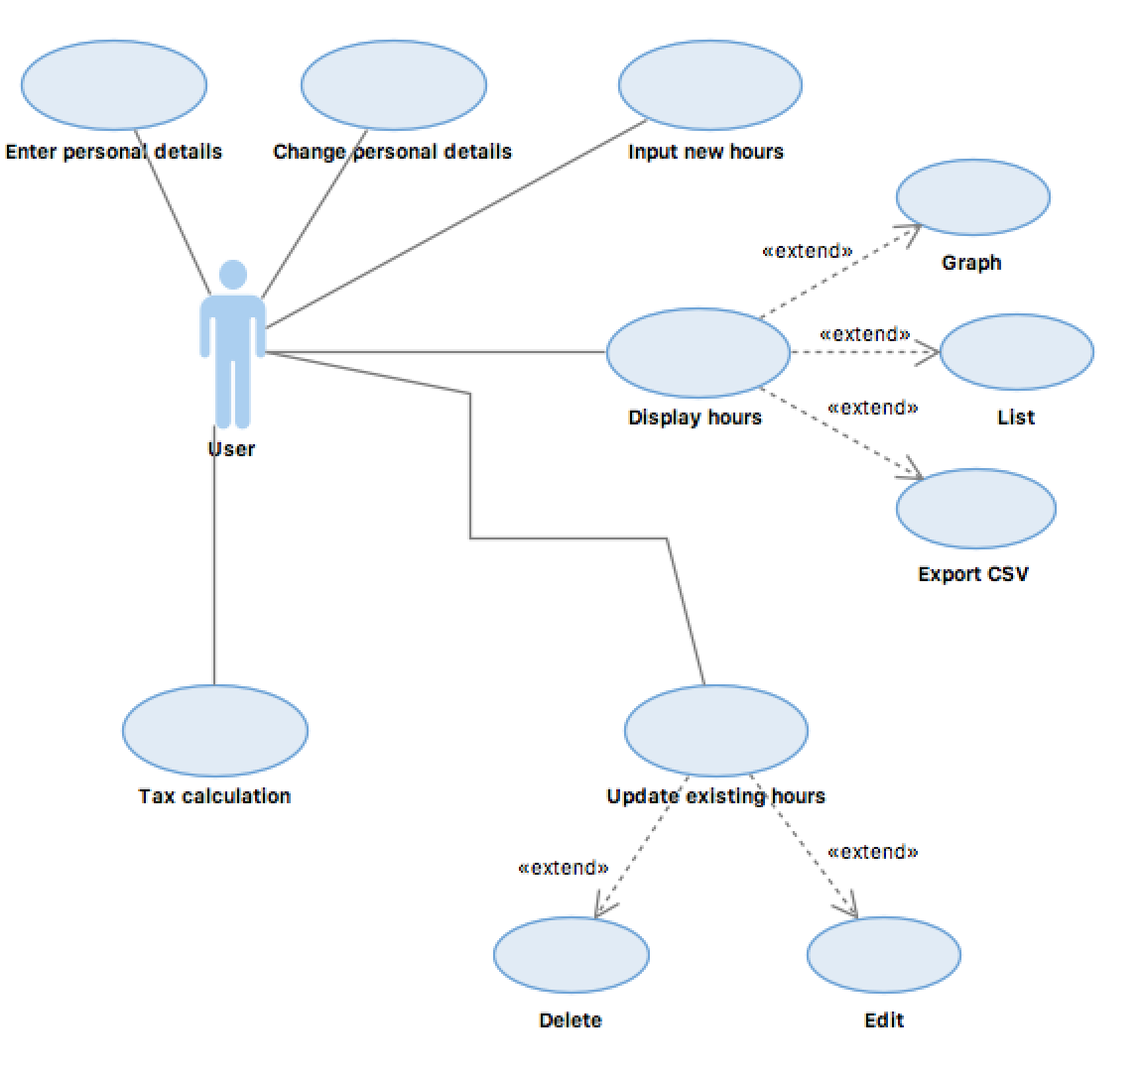

There are several use cases in the above diagram. They can be broken down into 3 areas:

1. Personal details
2. Hours
3. Tax

The personal details section deals with things such as entering and updating name, work place, base wage rate etc.

The hours section deals with recording, updating and deleting timestamps, as well as displaying them in either graph or list form.

The tax section deals with calculation a tax threshold, showing the user where they can claim tax back etc.

## Screen Flows

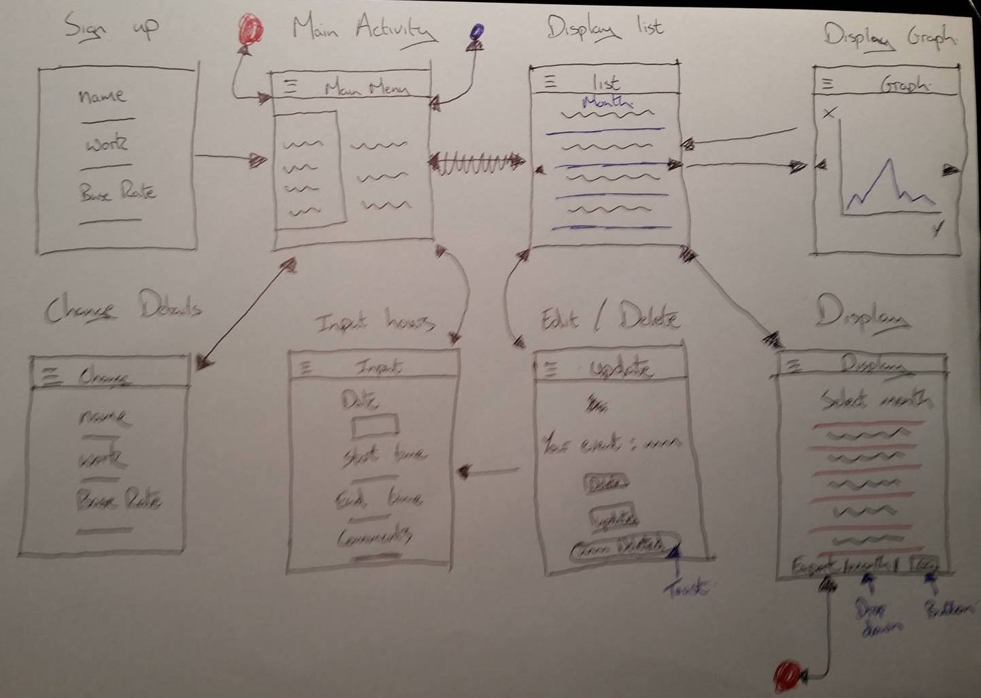

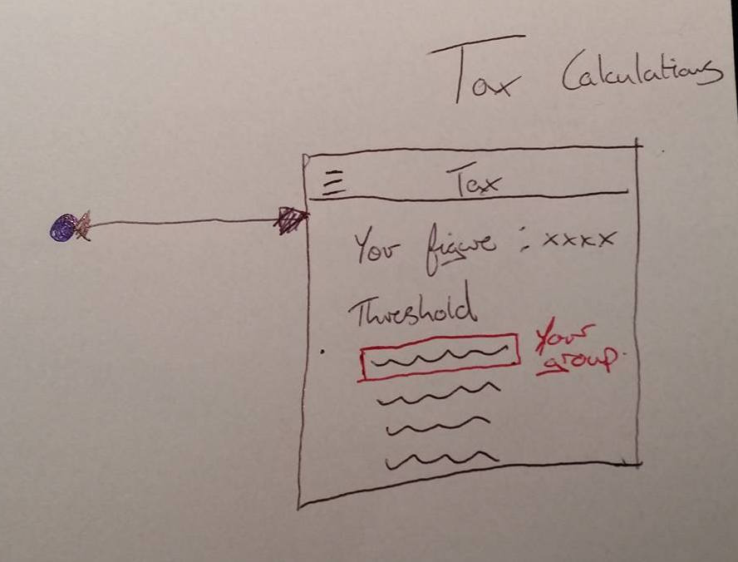

## Class Diagram

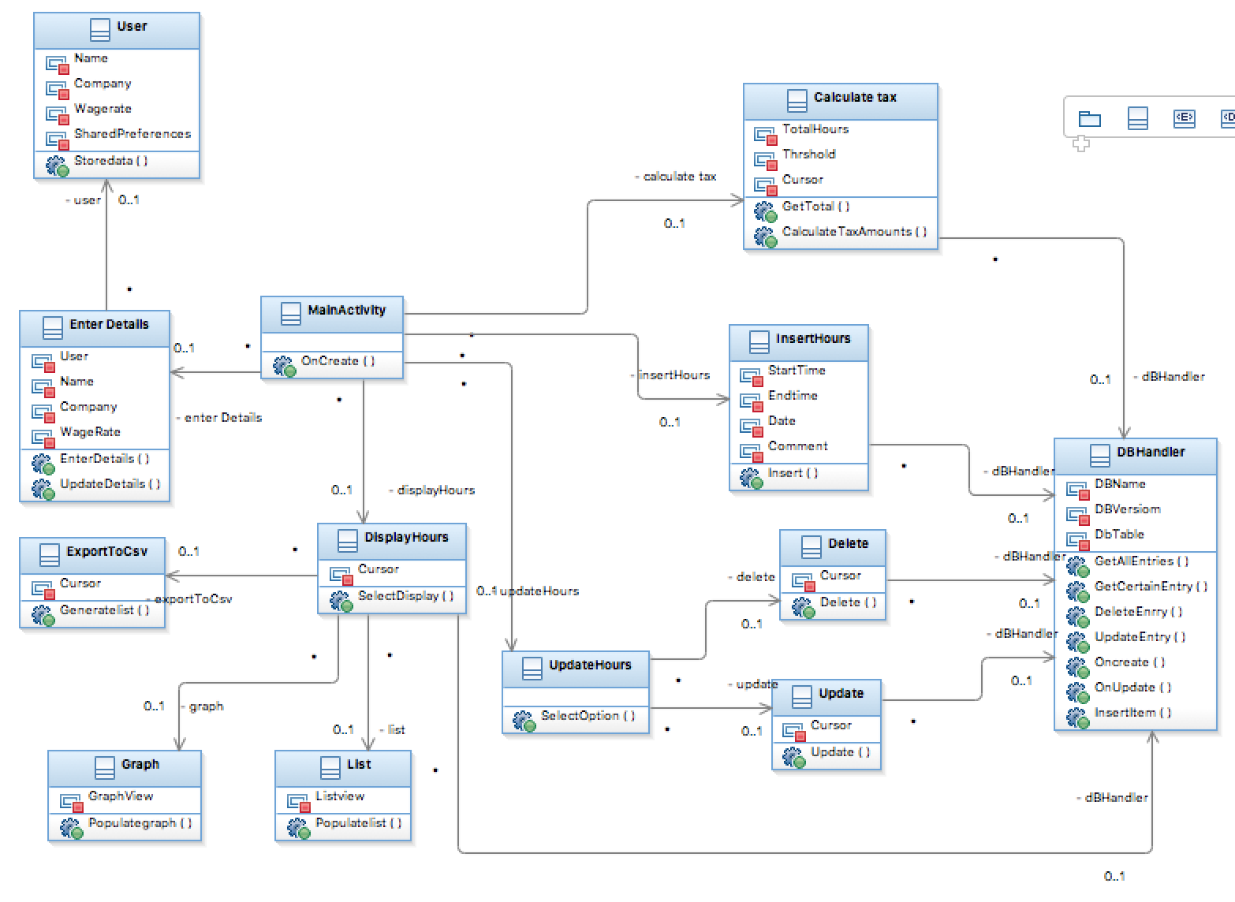

## Database ERD

I will be using one table for my app. It will be used to store entries or timestamps.

Work Entry table

|  |
| --- |
| Entry_ID - Number - (PK) |
| Date_Worked – Date |
| Start_Time – Time |
| End_Time – Time |
| Comments – Varchar(50) |