**Business Systems Intelligence Assignment**

*Daniel Tilley – C14337041*

**Introduction**

For this assignment I have chosen Starbucks as my business of choice. The reason I have chosen Starbucks is because they are “the world’s largest coffee shop and have a loyalty program consisting of 6 million registered customers. Starbucks also offers [87,000](http://www.siliconindia.com/news/business/13-Fascinating-Facts-About-Starbucks-nid-136299-cid-3.html) possible drinking combinations across the globe, has almost [21,000](http://en.wikipedia.org/wiki/Starbucks?utm_source=datafloq&utm_medium=ref&utm_campaign=datafloq) stores in 62 countries, has approximately [160,000](https://www.google.com/url?sa=t&rct=j&q=&esrc=s&source=web&cd=2&cad=rja&sqi=2&ved=0CDgQFjAB&url=http%3A%2F%2Fphx.corporate-ir.net%2FExternal.File%3Fitem%3DUGFyZW50SUQ9MTY5NDc3fENoaWxkSUQ9LTF8VHlwZT0z%26t%3D1&ei=gRPEUZHJIoX3sgbvyYDgCg&usg=AFQjCNFRusrnrCPfKRrfX8ve-ofrdIxtdw&sig2=g0XjU5uHUwroVwu90XYjSw) employees worldwide, [serves](http://www.starbucks.com/responsibility/global-report/environmental-stewardship/cup-recycling) almost 4 billion cups of coffee annually and had [$ 13.3 billion](https://www.google.com/url?sa=t&rct=j&q=&esrc=s&source=web&cd=2&cad=rja&sqi=2&ved=0CDgQFjAB&url=http%3A%2F%2Fphx.corporate-ir.net%2FExternal.File%3Fitem%3DUGFyZW50SUQ9MTY5NDc3fENoaWxkSUQ9LTF8VHlwZT0z%26t%3D1&ei=gRPEUZHJIoX3sgbvyYDgCg&usg=AFQjCNFRusrnrCPfKRrfX8ve-ofrdIxtdw&sig2=g0XjU5uHUwroVwu90XYjSw) net revenue in 2012 it may be clear that Starbucks creates a lot of data.” Datafloq.com. (2018). Ultimately, Starbucks has a lot of data about its customers, products and stores, so I felt it would be an ideal choice.

**Star Schema**

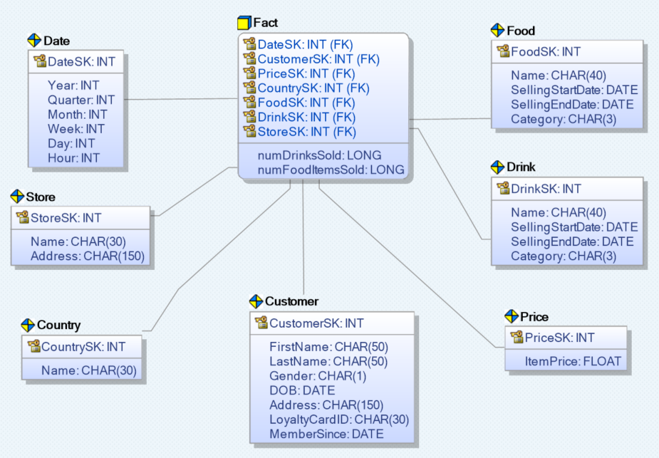

**Design Justification**

I choose to use a star schema over a snowflake schema in order to avoid the use of complex joins spanning over multiple dimensions. A snowflake schema could turn what might be a simple one layer join query in a star schema into a multi-layer join.

**Facts Justification**

The most important thing for Starbucks is profit / turnover. How do they create profit? By selling products to customers. I felt as though the number of food and drink items sold would work nicely as the key facts for my star schema. Sales revenue could be very easily generated using simple multiplication of the number of items sold and the price of the item.

**Dimensions Justification**

*Date:* This dimension stores all relevant date info right down to the hour. All are stored as INTs to save on space and to stop duplication of data.

*Store:* This dimension stores info relating to a given store such as name and address. CHAR was used to store character strings.

*Country:* This dimension stores info about a given country such as its name. It was placed in its own dimension in order to avoid duplication in store addresses.

*Customer:* This dimension stores info about customers. Key fields are DOB, MemberSince and Gender. These can be used to give a better breakdown by age, gender etc.

*Price:* This dimension stores info about the price of an item. It was placed in a different dimension as a product may have different prices at different points in time.

*Food:* This dimension stores info about all food products. Two important categories are the selling start and end date. These fields can be used for special promotions etc

*Drink:* Same as the food dimension except for drinks. The two were given separate dimensions in order to have greater clarity between the two.

**Grain Justification**

After giving it some thought, I decided that the grain of my dimensional model should be hourly. Starbucks may feel the need to analysis what the best time to sell is in order to maximise efficiency through production / number of staff in a given store.

**Example Query**

Get number of drinks sold at 9am across all stores in Ireland

SELECT SUM(numDrinksSold) as DrinksSold, Store.Name as StoreName

FROM Fact

JOIN Date ON Date.DateSK = Fact.DateSK

JOIN Store ON Store.StoreSK = Fact.StoreSK

JOIN Country ON Country.CountrySK = Fact.CountrySK

WHERE Date.Time = 9 and County.Name LIKE ‘Ireland’

GROUP BY Store.Name

**References**

Datafloq.com. (2018). Starbucks, The World Largest Coffee Shop, Grinds A Lot Of Data. [online] Available at: https://datafloq.com/read/world-largest-coffee-shop-starbucks-grinds-lot-dat/440 [Accessed 3 Mar. 2018].